THAILAND – Bangkok – Discover Bangkok by E-scooter
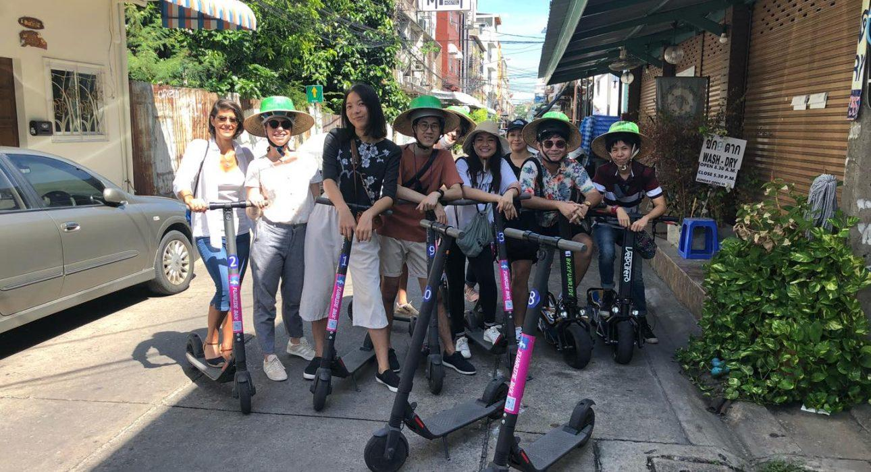

Over View

Theme
Family, Sustainable

Country - City
Thailand - Bangkok

Market segment
Thematic Leisure

Price Level
$$

Level of difficulties
LEVEL 0

Max pax
14

Seasonality
All year round

Arrival city
BANGKOK

Departure city
BANGKOK

Description

A tour using an eco-responsible means of transport, allowing a discovery of Bangkok from a different perspective. The tour begins with a safety briefing and instructions on how to use the e-scooter. Led by a guide, the tour follows different routes to discover various areas of old Bangkok, gliding through narrow sois (alleys) offering the possibility to discover hidden daily scenes and to interact with locals. From a short tour of 90 minutes to longer immersions of 3 and a half hours, the various route options allow guests to select the tour to match their needs. The activity offers an ideal opportunity to visit Bangkok away from the traffic in a more relaxing way than by bicycle or on foot, and above all ensure closer connection to everyday local life.

Selling points

- An original and convenient way to discover the heart of the city away from bustling traffic jams
- A trendy, quiet and sustainable means of transport allowing to sneak peek into unseen areas and discovery of the city and its local life from a different perspective
- Ideal for families or small groups of friends

Sustainability

Level Of The Excursion
Medium – This activity offers tangible positive contributions to the local community, culture and/or environment

The Impact Of This Excursion

Social/cultural Impact
Cultural Conservation, Empowerment and education

Environment Impact
Transportation

Economic Impact
Local individual benefits, Community benefits

Additional Information

Positive impacts
The activity uses an electric scooter which is more friendly for the environment compared to motorized vehicles, and at the same time allows for a more immersive experience. Different stops along the way allow for interaction and bring income to individuals and the community as a whole.

Negative impacts

Time And Transportation

Photos

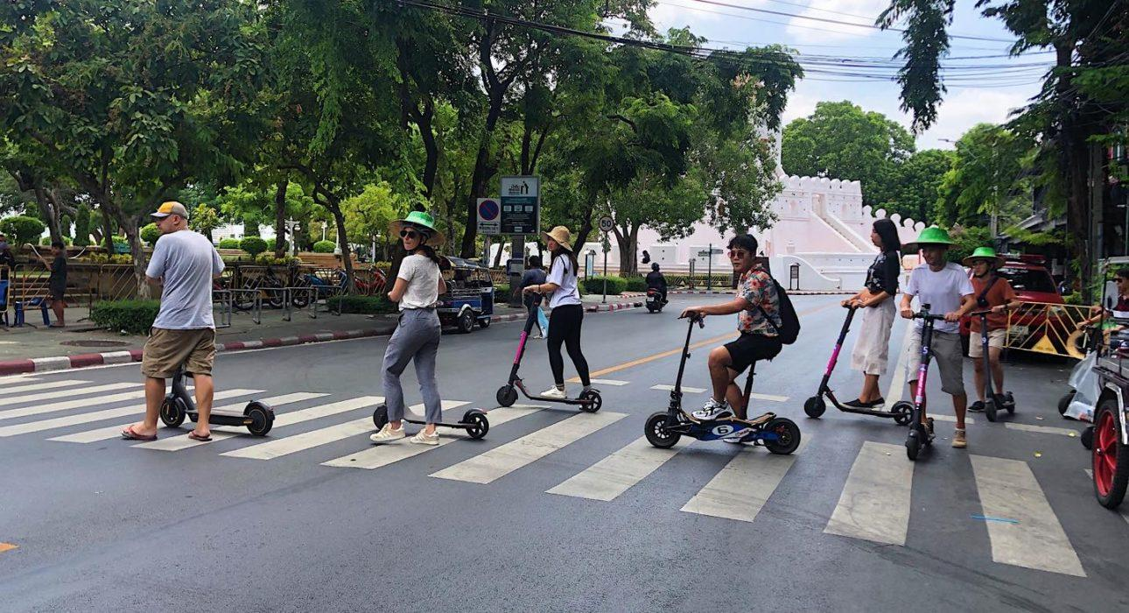
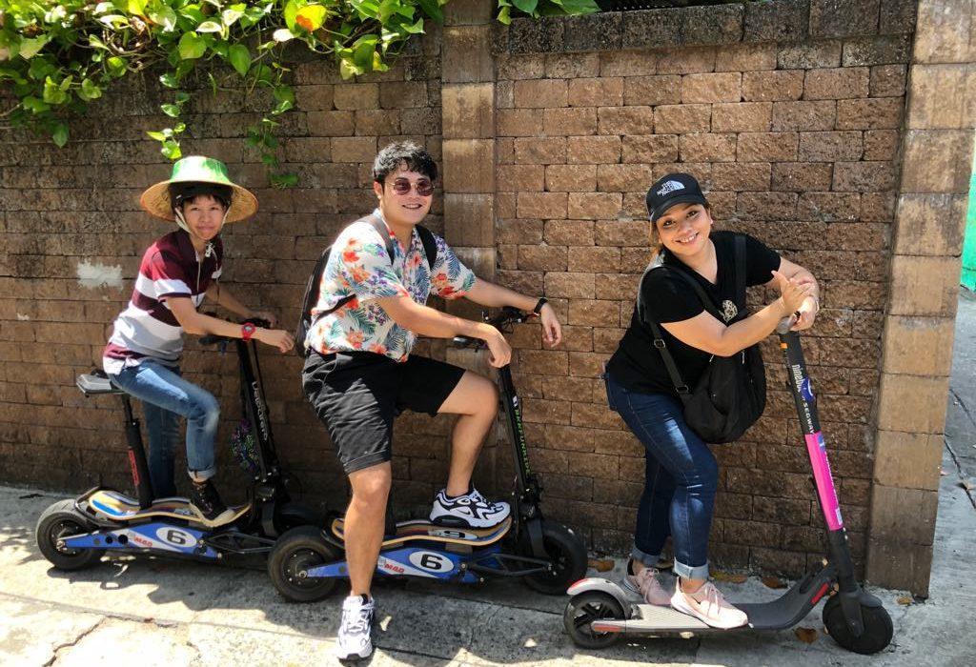
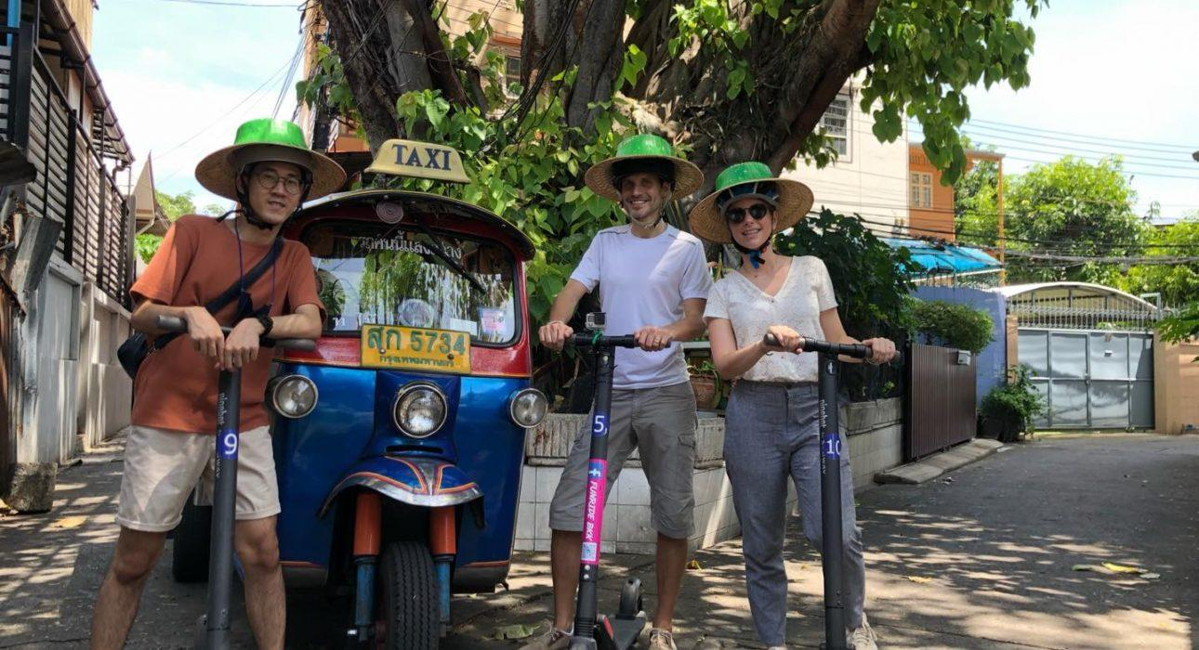
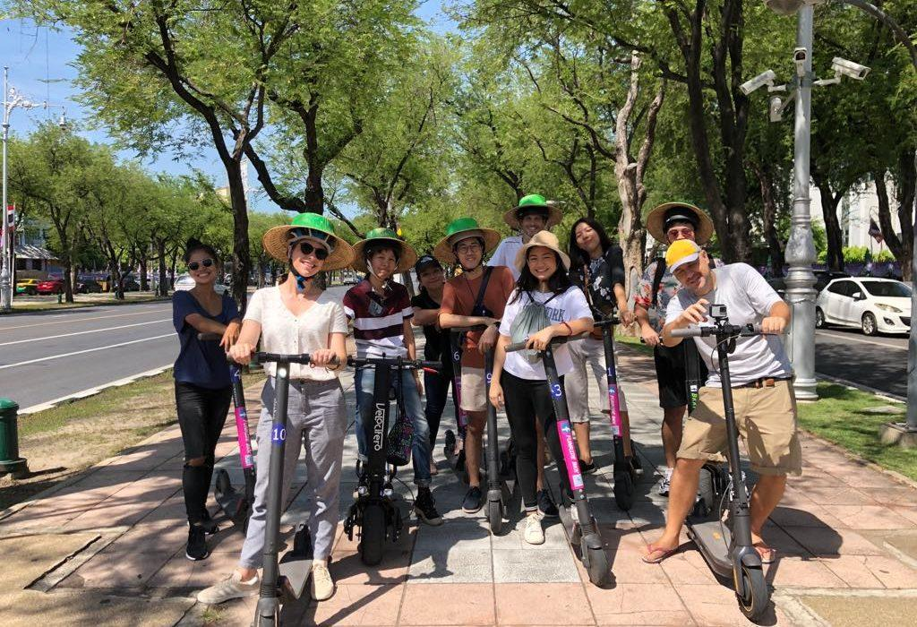
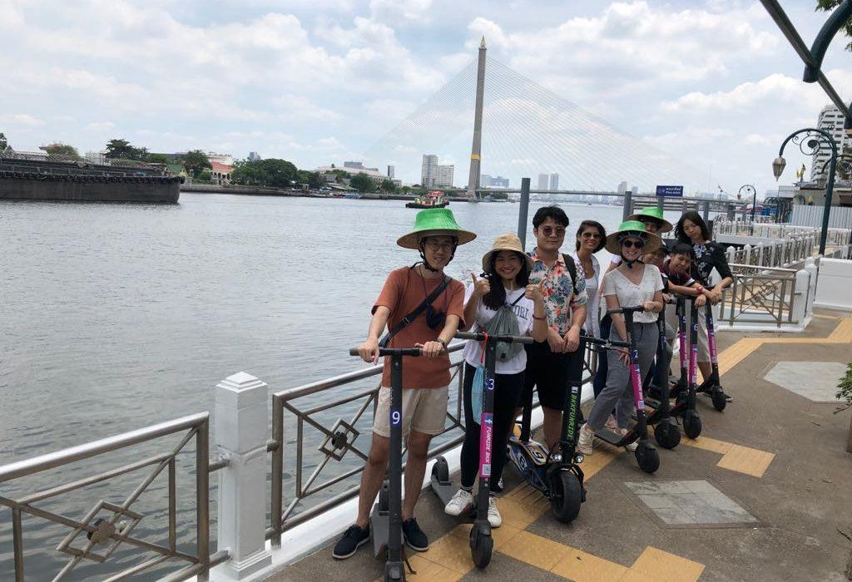
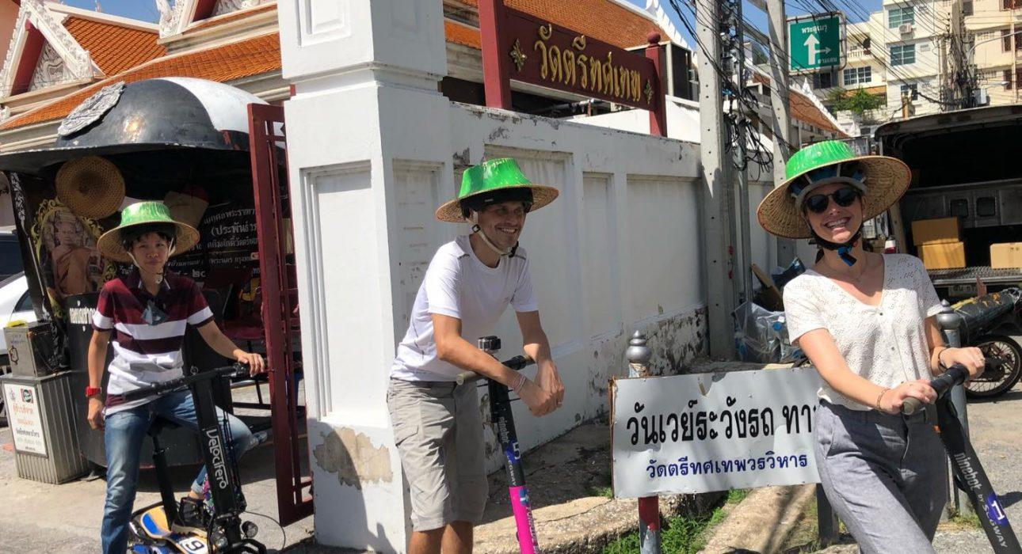

Easia Travel Head Office

