THAILAND – Nakhon Pathom – Encounter and Gastronomic Lunch Experience Along the River
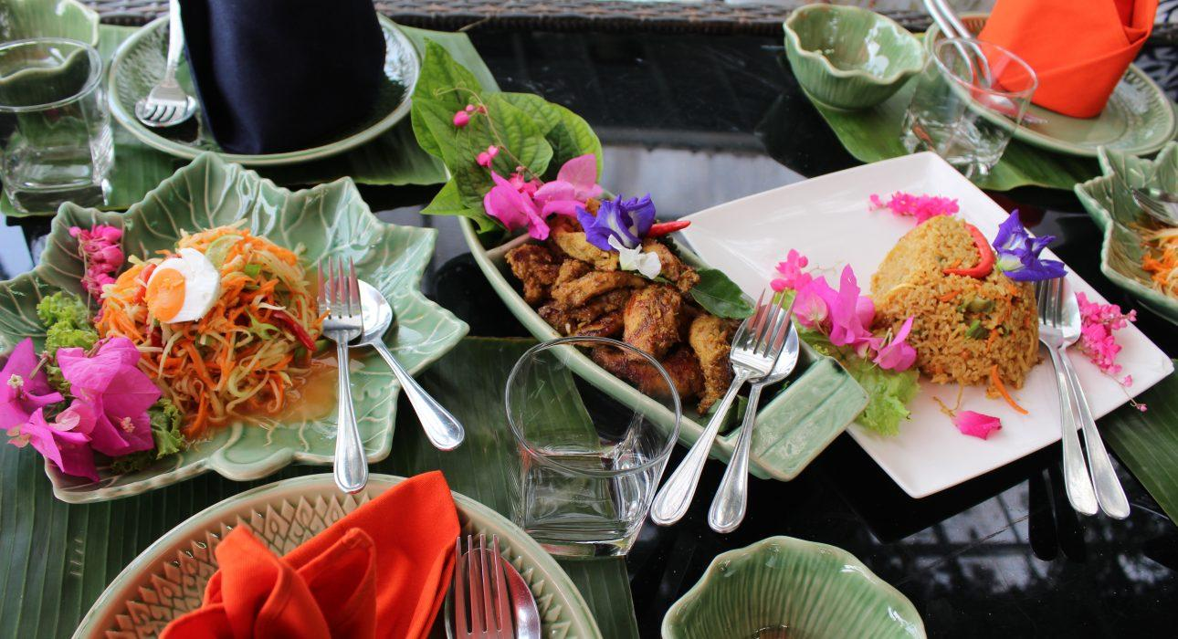

Over View

Theme
Art & Culture, Classic, Family, Gastronomy, Honeymoon, Sustainable

Country - City
Thailand - Nakhon Pathom

Market segment
Groups, Thematic Leisure

Price Level
$$$$

Max pax
30 pax

Seasonality
All year Round

Arrival city
BANGKOK / KANCHANABURI / NAKHON PATHOM / AYUTTHAYA

Departure city
BANGKOK / KANCHANABURI / NAKHON PATHOM / AYUTTHAYA

Description

An experience fit for foodies in Nakhon Pathom province, where a homely restaurant nestled along the river awaits. The host, a native of the area, welcomes guests for an authentic gastronomic experience with a creative 3-course lunch to discover and appreciate Thai flavors far beyond the classic mainstream set menus in tourist areas. The meal, set in a peaceful garden, allows the opportunity to share a special moment of connection with the unique personality of the local chef.

Can be combined with
Thematic Leisure
- THAILAND – Nakhon Pathom-Khlong Maha Sawat and Don Wai Market – Local Farmers’ Life – This gastronomic experience will replace (with extra charge) the regular normal local lunch usually included in the activity.

Selling points

- An unexpected gastronomic adventure in a pleasant home hidden in the countryside.
- A creative range of dishes based on traditional Thai flavors and ingredients: ideal for discovering Thai gastronomy.
- A combination of culture, gastronomy and an encounter with a passionate character
- Peaceful setting and lovely scenery at a homely place nestled in a tropical garden overlooking the river.
- Perfect for a relaxing stop on the way from/to Kanchanaburi, Nakhon Pathom, Ayutthaya

Sustainability

Level Of The Excursion
Low - This activity impacts local community, culture and/or environment in a small but meaningful way

The Impact Of This Excursion

Social/cultural Impact
Empowerment and education

Economic Impact
Local individual benefits

Additional Information

Positive impacts
The meal is cooked by a local chef who uses locally sourced produce wherever possible and aims to bring new life to traditional, regional dishes and recipes.

Negative impacts
No negative.

Time And Transportation

From | To | Km | Duration | Road condition
Sukhumvit Area | Don Wai(Nakhon Patom Province) | 40 | 40 minutes – 1 hour | Car – Often Traffic Jam
Silom/Sathorn Area | Don Wai(Nakhon Pathom Province) | 35 | 35 minutes – 1 hour | Car – Often Traffic Jam
Riverside Area | Don Wai(Nakhon Pathom Province) | 30 | 40 minutes | Car Often Traffic Jam
BTS Siam(Sukhumvit area) | BTS Bang Wa | 15 – 25 | 50 minutes | BTS (Sky Train)
BTS Saphan Taksin(Riverside) | BTS Bang Wa | 10 | 20 minutes | BTS (Sky Train)
BTS Bang Wa | Don Wai | 30 | 35 minutes – 50 minutes | Car – Often Traffic Jam
Don Wai | Kanchanaburi | 140 | 1h 50min – 2 hours | Car – Often Traffic Jam
Don Wai | Sai Yoke | 195 | 2h 50min – 3h 10min | Car
Don Wai | Ayuthaya | 105 | 1h15 – 1h30 | Car

Photos

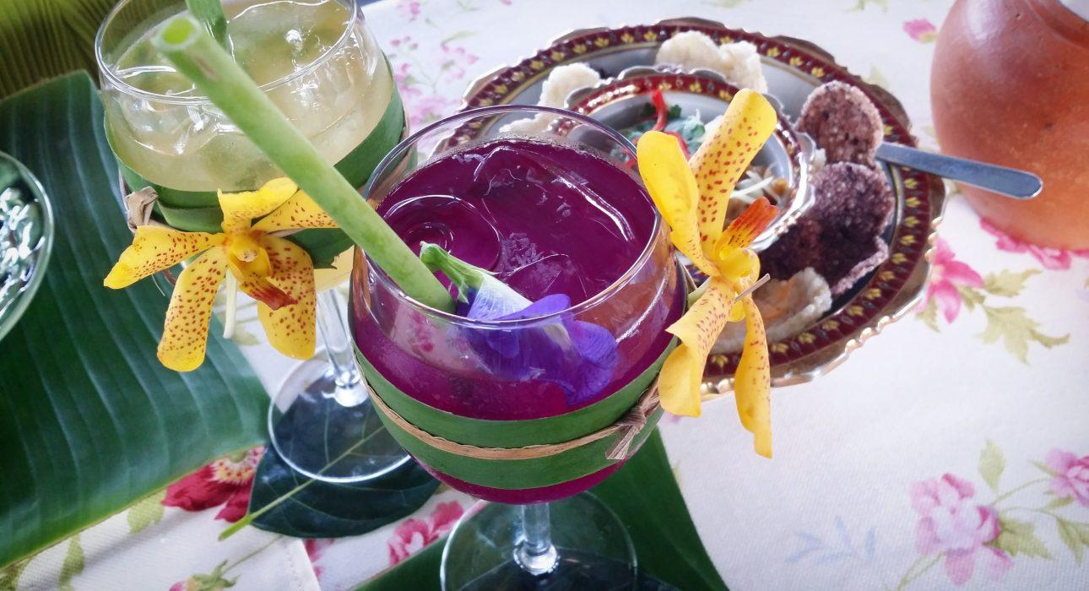
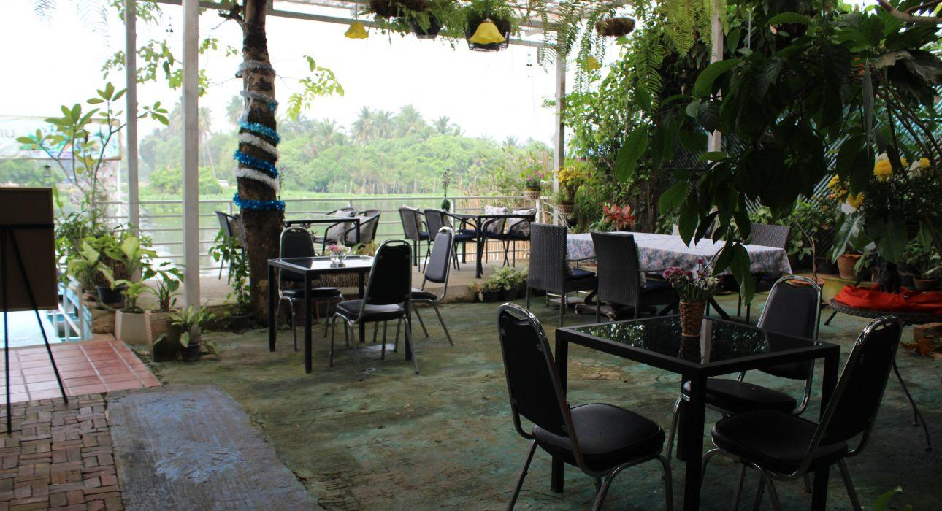
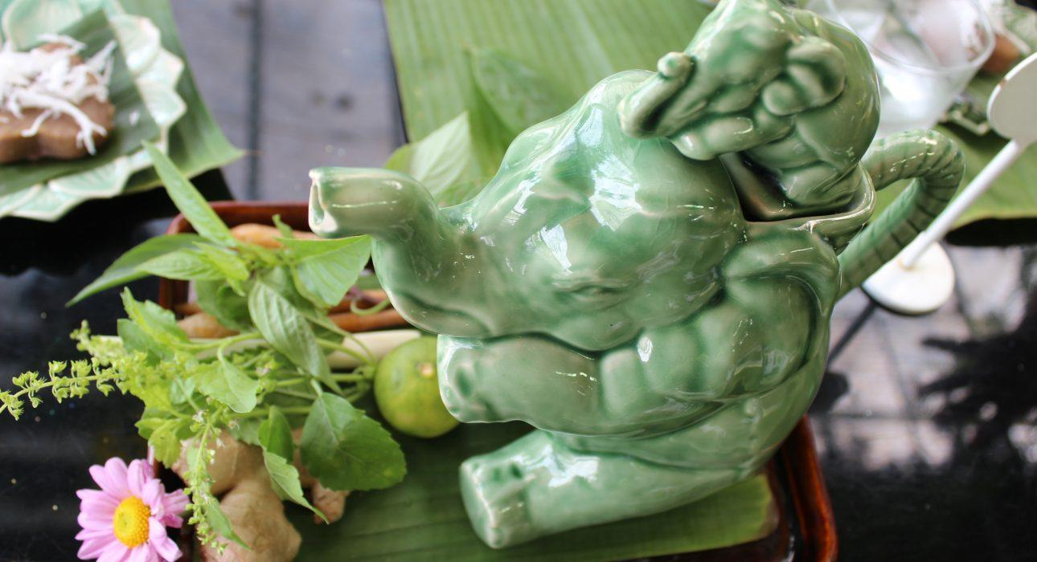
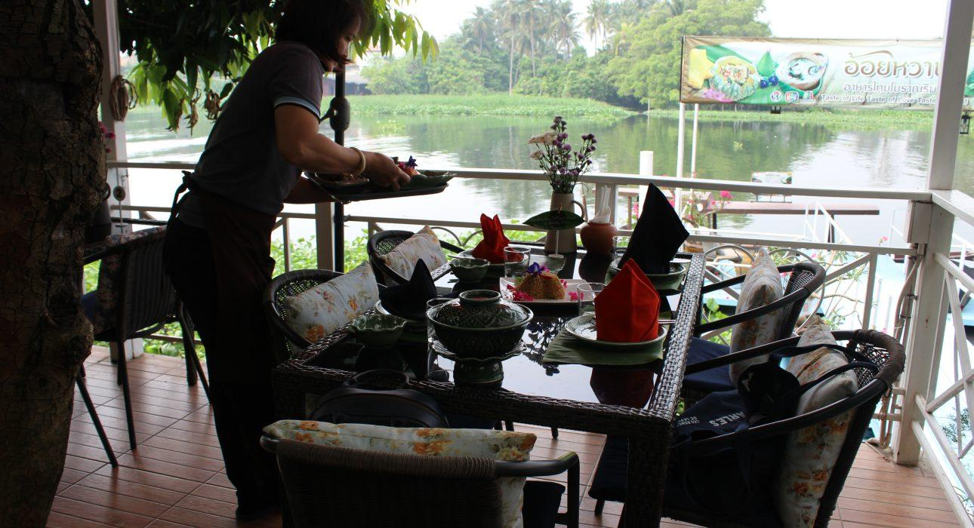
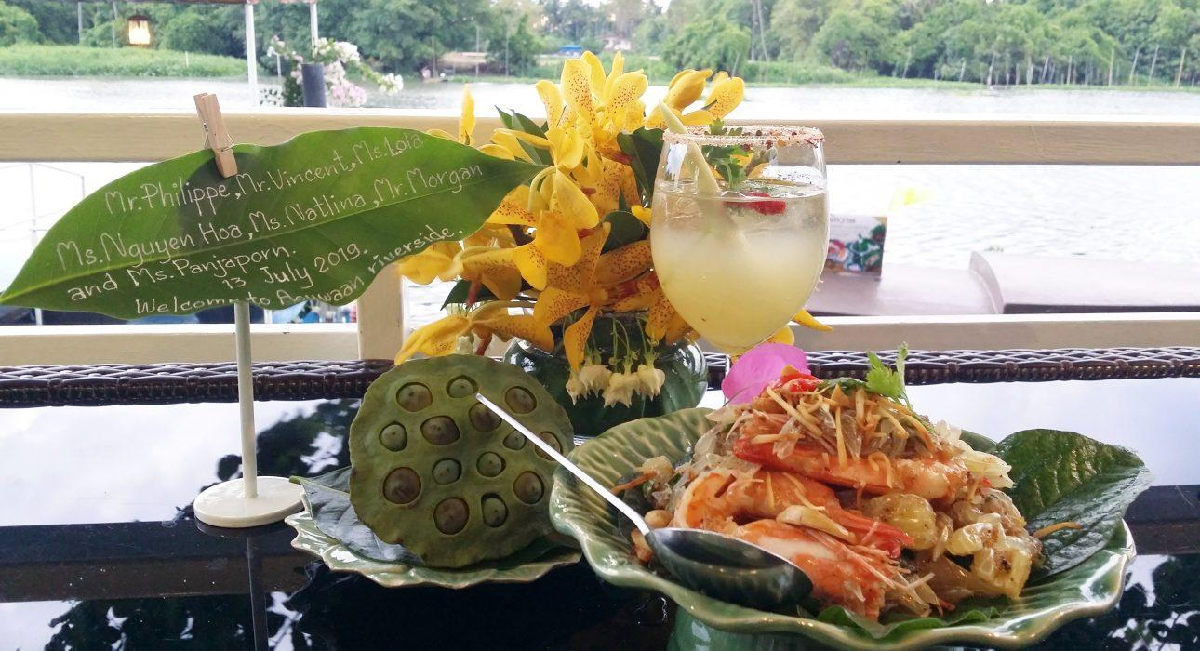
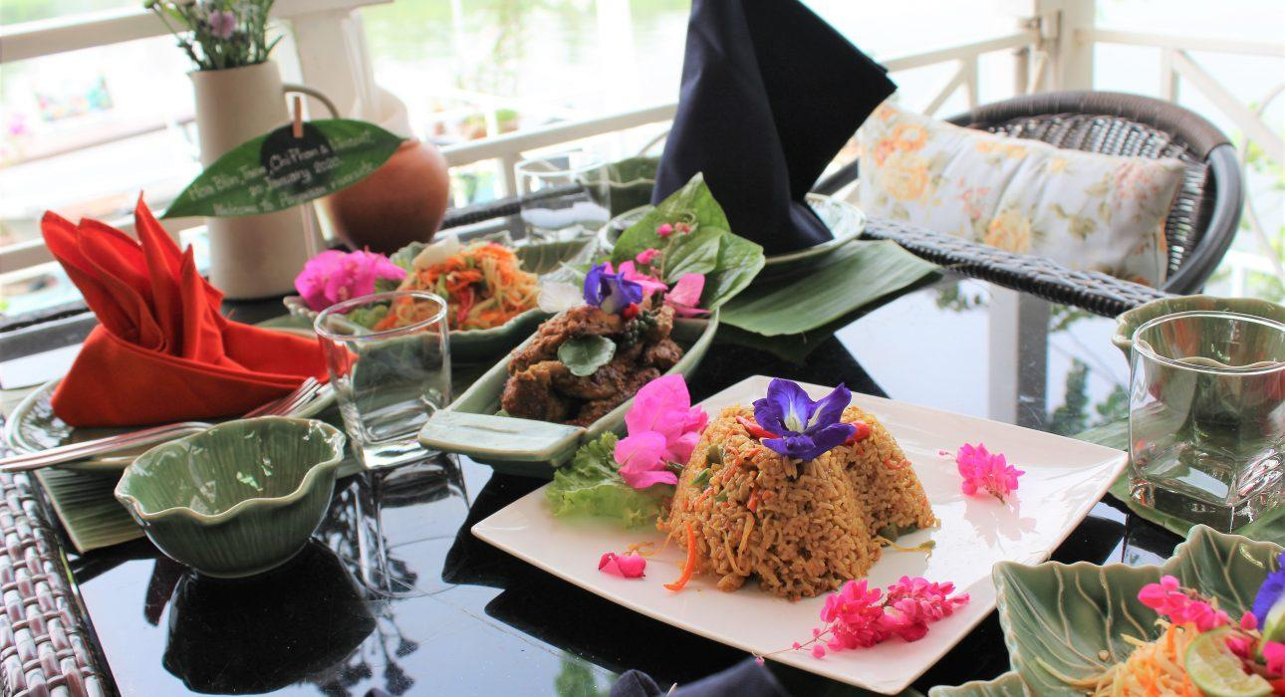
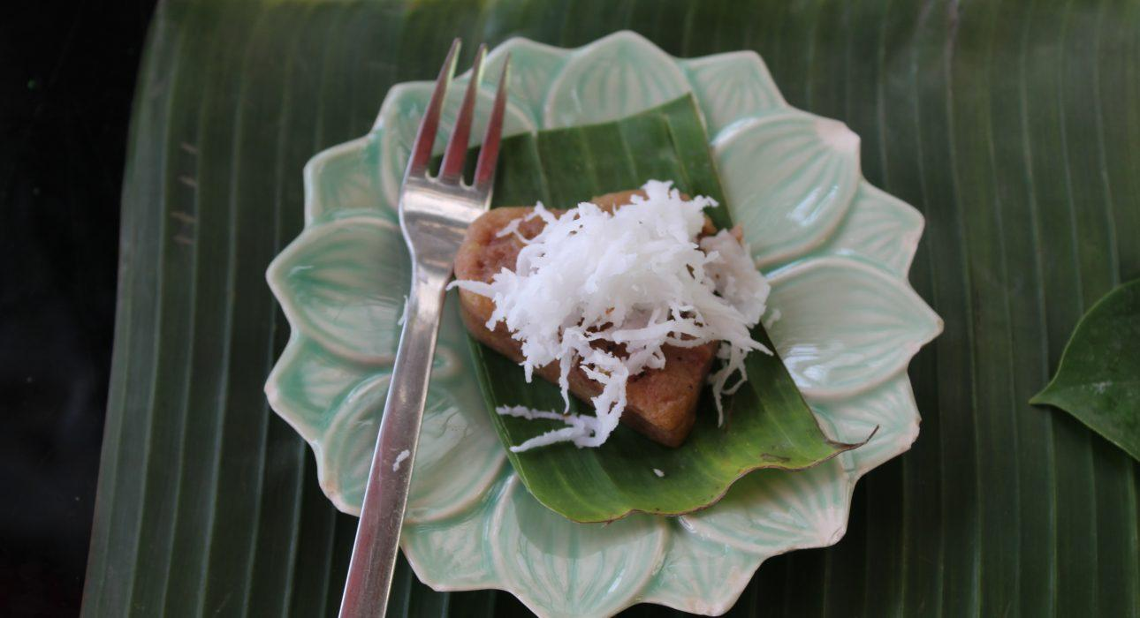
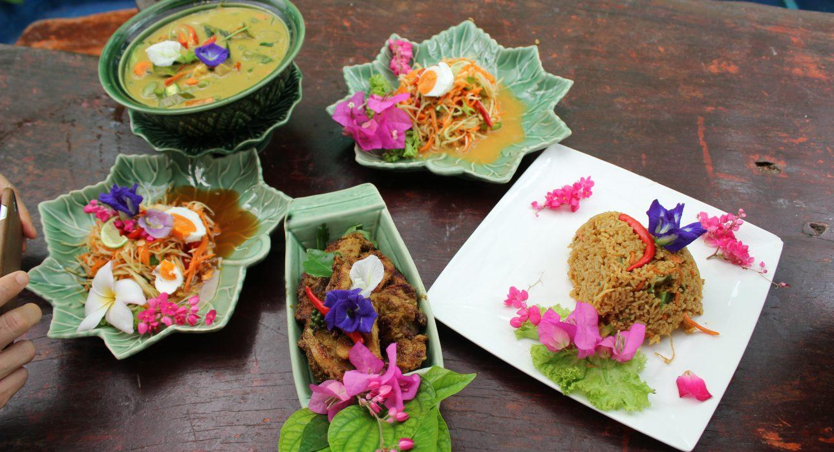

Easia Travel Head Office

Vietnam Head OfficeC/o: ATS Hotel, Suite 326 &327, 33B Pham Ngu Lao Street, Hanoi, VietnamTel: +84 24-39 33 13 62www.easia-travel.com

