THAILAND – Bangkok – Bangkok Family Discovery
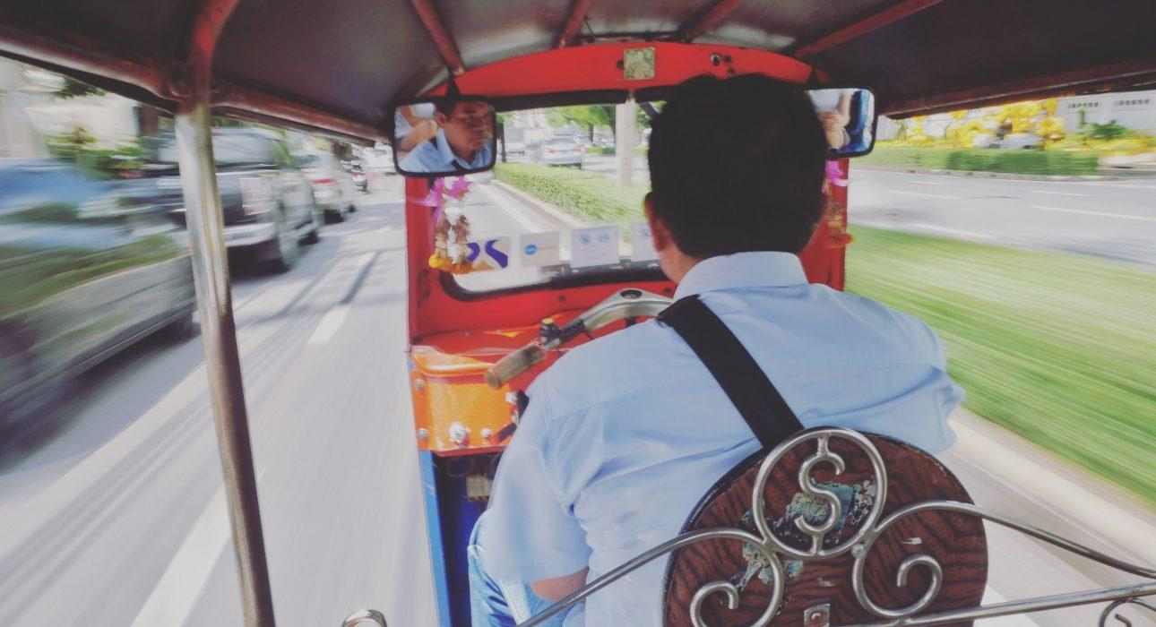

Over View

Theme
Art & Culture, Classic, Family, Gastronomy, Honeymoon, Sustainable

Country - City
Thailand - Bangkok

Market segment
Thematic Leisure

Price Level
$$$

Max pax
8

Seasonality
All Year Long – Might be hot in April

Arrival city
BANGKOK

Departure city
BANGKOK

Description

A family-focused Bangkok highlight discovery tour. The tour will start in the afternoon with a peaceful stroll along the Bangkok Yai Canal to a charming 200-year-old traditional house by the Khlong. Kids and parents can put their skills and creativity to the test while decorating their souvenirs.Once back on the old Bangkok riverbank, there will be a chance to discover the colorful Pak Khlong Talad, Bangkok’s biggest wholesale and retail fresh flower market. It will be an occasion to buy flowers and have a family competition to see who is the most talented in flower folding, an art in which all Thai people are initiated from an early age. The exploration continues after a scenic tuk-tuk ride to the Golden Mount temple, from where there will be a nice view over the city at the end of the afternoon. The tour will finish amongst locals while savoring one of the delicious local dishes in a little family restaurant that Michelin has recommended.

Selling points

- A different approach to discovering Bangkok by combining sightseeing and guests’ creativity.
- A tour specially dedicated to families with young kids.
- It is ideal timing for a family to have a morning at leisure and finish early.
- The iconic symbols of Bangkok and Thailand are the Khlong tour with the Artist House, the Flower Market, a tuk-tuk tour, one of the loveliest temples of Bangkok, and one of the traditional street food experiences accessible even to Westerners and the kid’s palate.

Sustainability

Level Of The Excursion
Medium – This activity offers tangible positive contributions to the local community, culture and/or environment

The Impact Of This Excursion

Social/cultural Impact
Cultural Conservation, Empowerment and education

Environment Impact
Transportation

Economic Impact
Local individual benefits, Community benefits

Additional Information

Positive impacts
The activity takes guests to a lesser known area and uses local transportation, including public transportation. Along the way there are stops which benefit the people on an individual and community level.

Negative impacts
Some of the transportation used during the activity uses fossil fuel which causes Co² emissions.

Time And Transportation

From | To | Duration | km | by | Road condition
Bangkok Riverside Area | Yodpiman pier | 15 min | 5 – 6 | car | Good – Often Traffic Jam
Saphan Taksin | Yopdman pier | 12 min | 3 | Local Ferry or longtail boat | River
Bangkok Sukhumvit Area | Yodpiman Pier | 35 – 45 min | 10 – 12 | car | Often Traffic Jam
Silom/Sathorn Area | Yodpiman Pier | 20 – 30 min | 6 – 8 | car | Often Traffic Jam
Sukhumvit / Silom/Sahorn Area | Sanam Chai MRT Station | 25 min | 10 | MRT (underground) | Subway

Photos

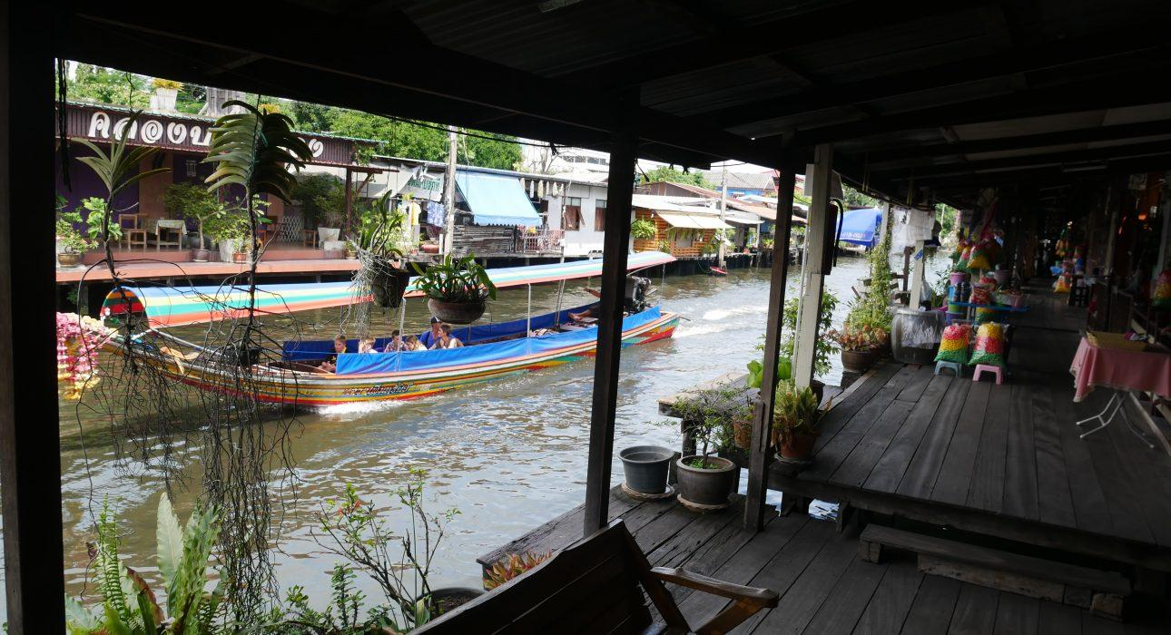
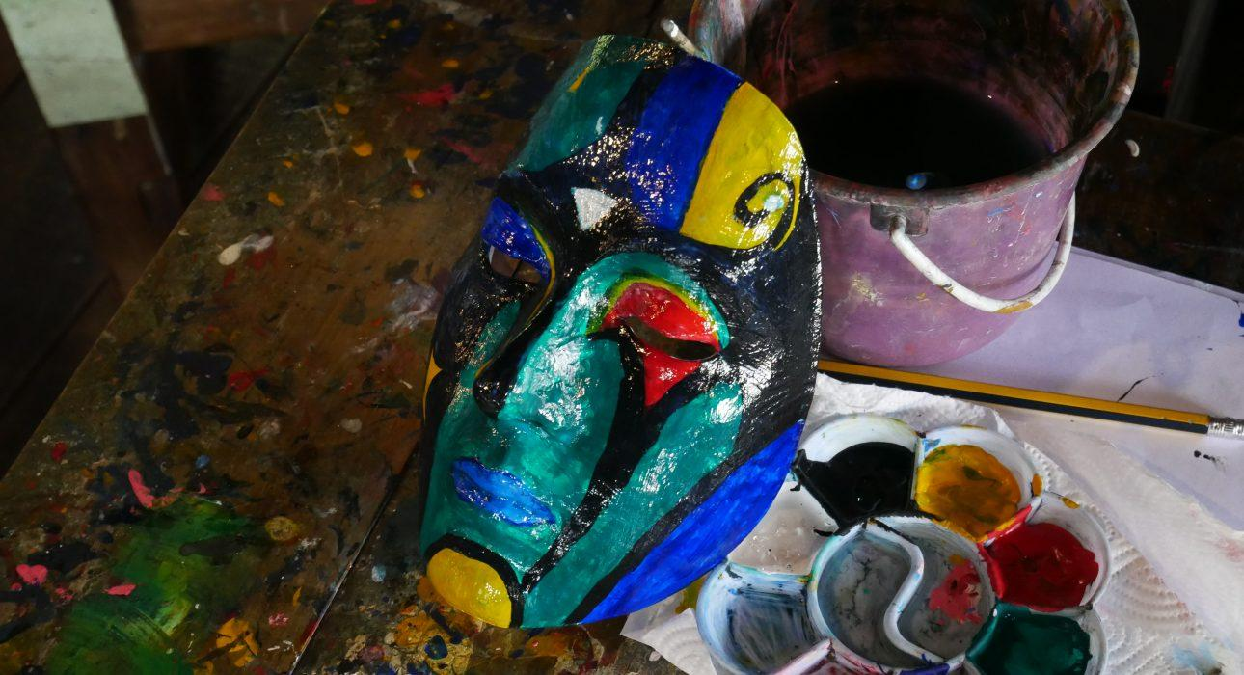
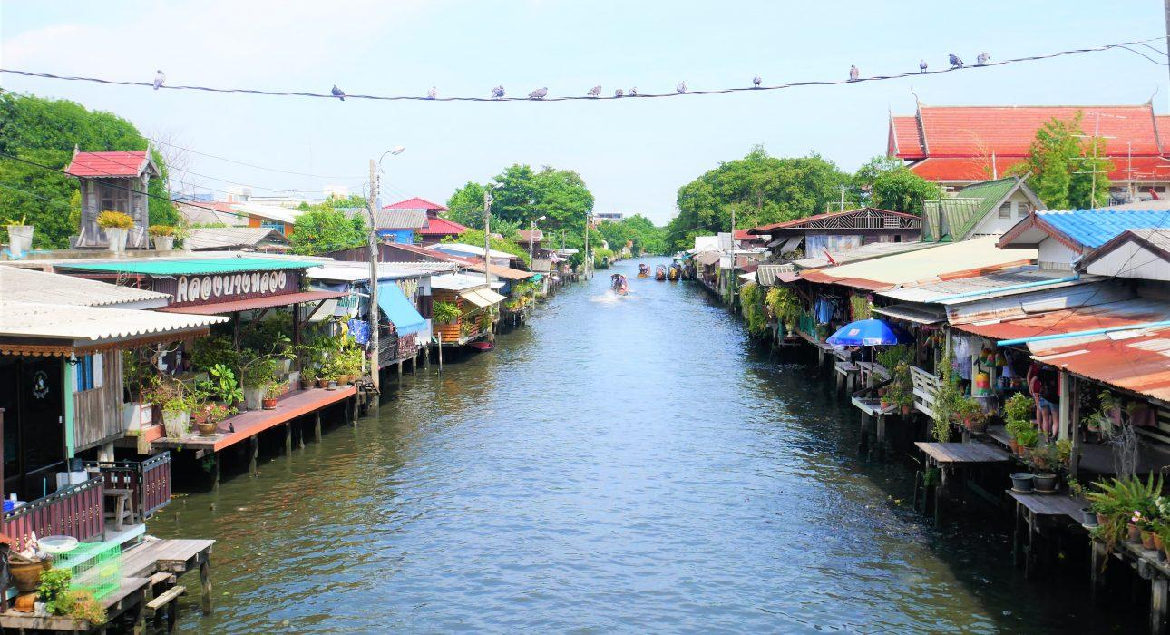
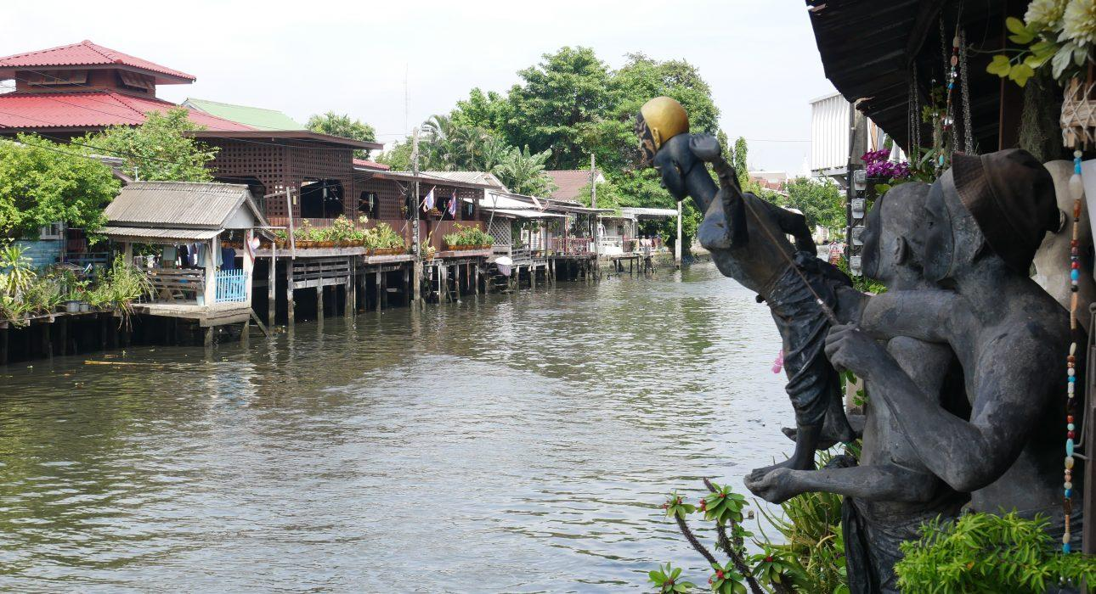
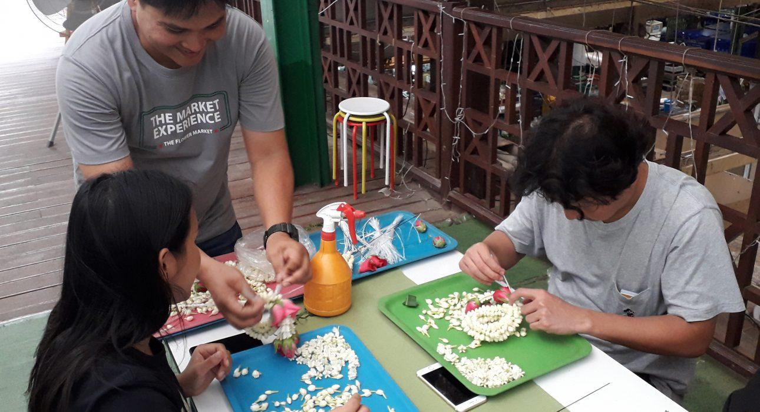
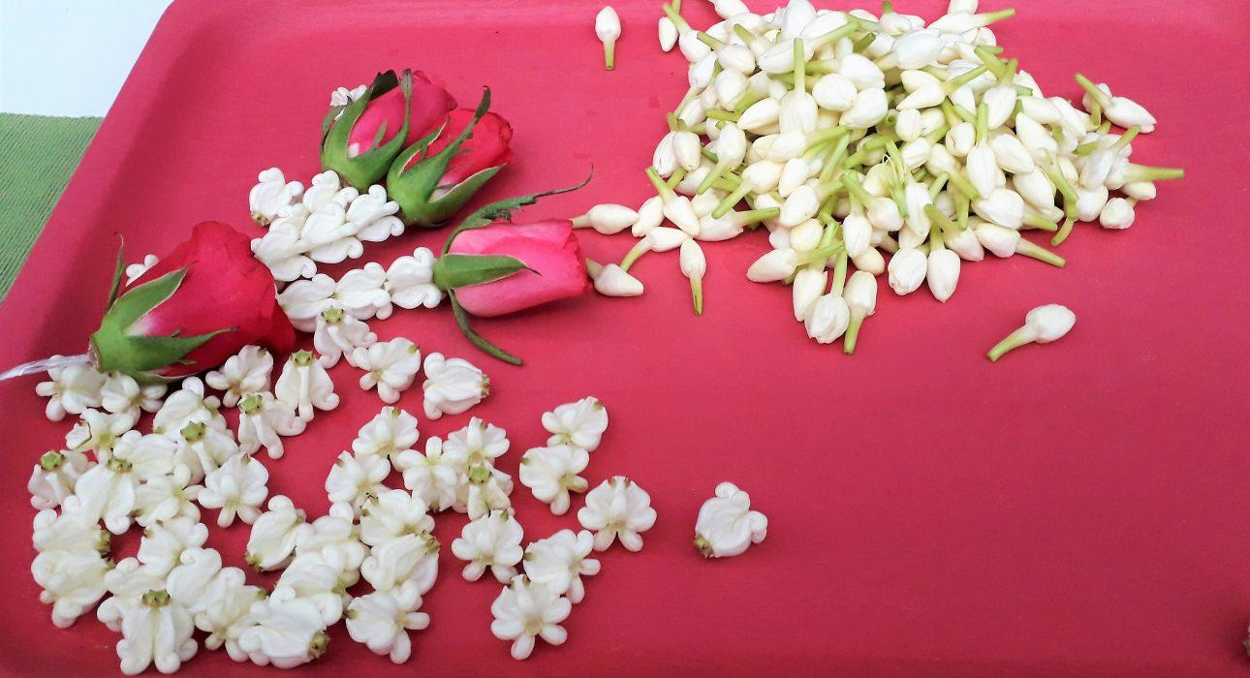
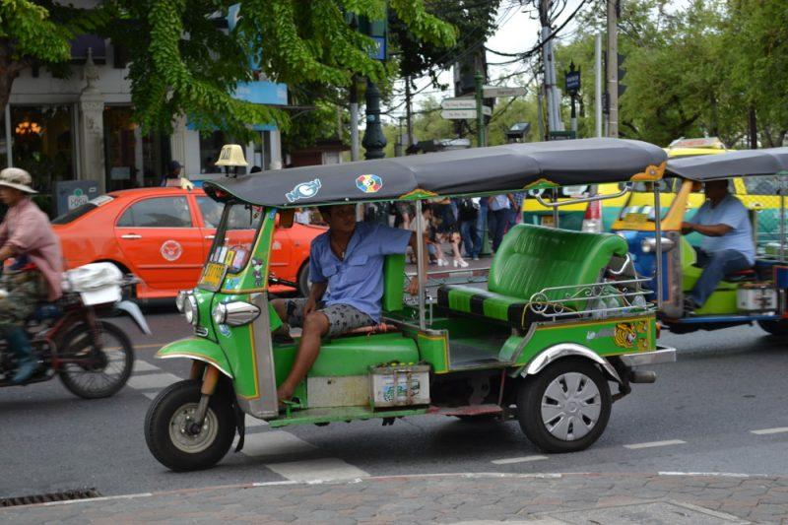
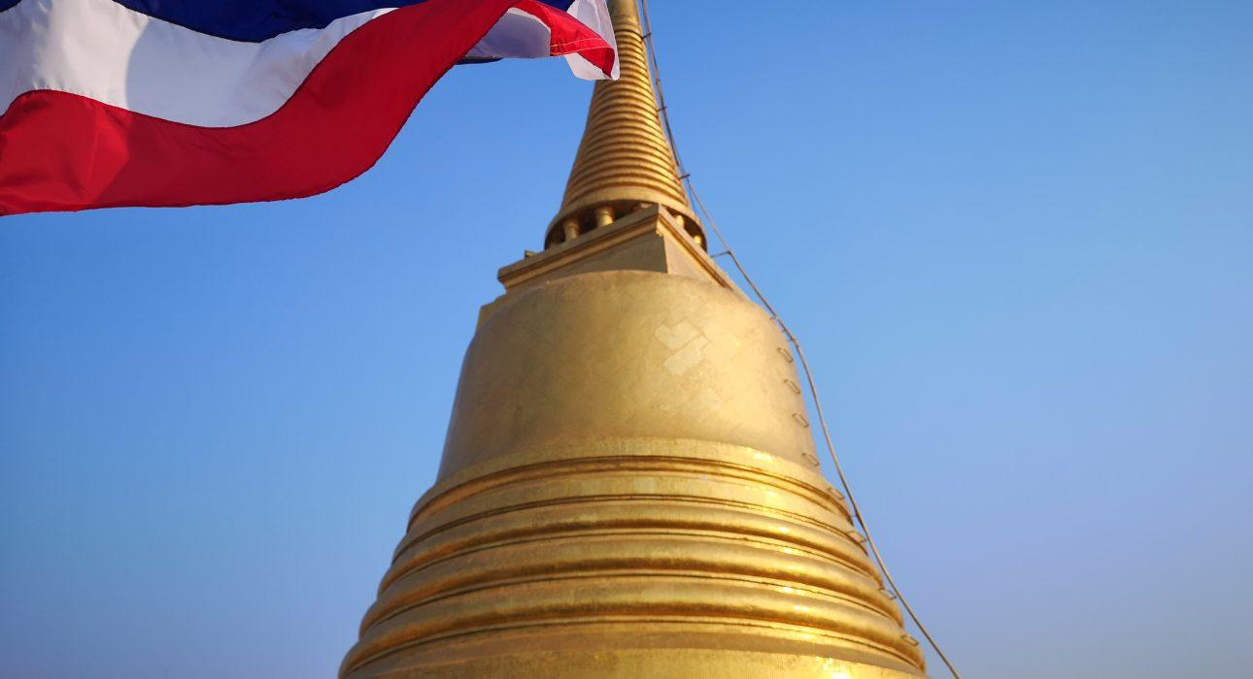
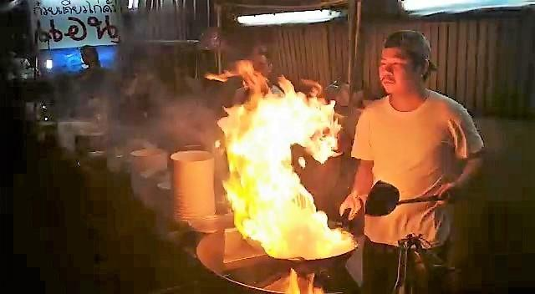

Easia Travel Head Office

