MYANMAR – Inle Lake – Lunch on Rice Carrier
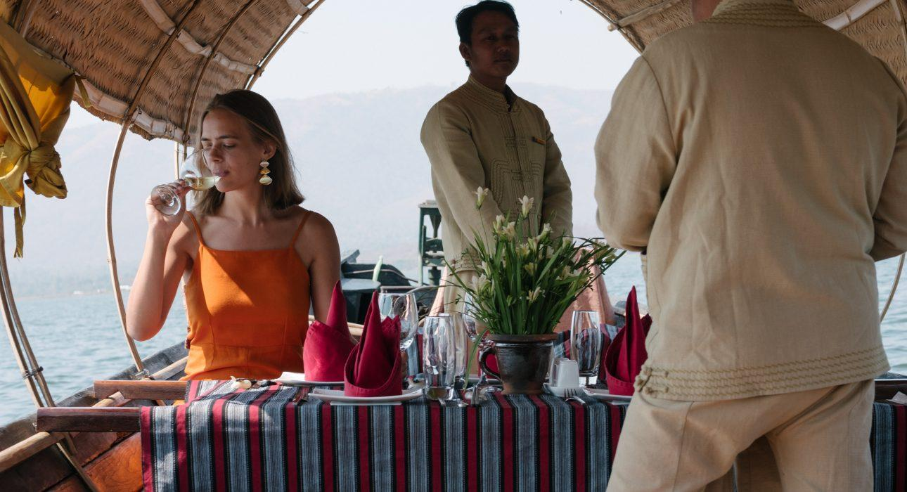

Over View

Theme
Classic, Family, Gastronomy, Honeymoon

Country - City
Myanmar - Inle Lake

Price Level
$$

Max pax
100 persons

Seasonality
All year round

Arrival city
Inle Lake

Departure city
Inle Lake

Description

A special culinary experience floating in the serene landscape of Inle Lake. A former rice-carrier boat has been refurbished as a floating restaurant serving Shan delicate cuisine. Both the backdrop and the ballet of waiters and cooks, serving the guests from traditional canoes, make this lunch one of the most unique culinary experience on Inle Lake.

Can be combined with
Exclusive
Inle Lake – Balloon flight over Inle

Selling points

- Experience unique in Myanmar – private lunch on a traditional boat in the middle of the lake
- High quality cuisine presenting a selection of Shan and Intha specialities – the ethnics living on the lake and in the region
- Private chefs on board for catering service
- Foods are freshly prepared on near-by kitchen boat and brought to the table by canoe
- More than a floating dinner, it is a surprising and impressive logistics that is performed flawlessly

Time And Transportation

Approximately 20-30 minutes by boat to reach the location of the rice carrier from different sightseeing places.

Photos

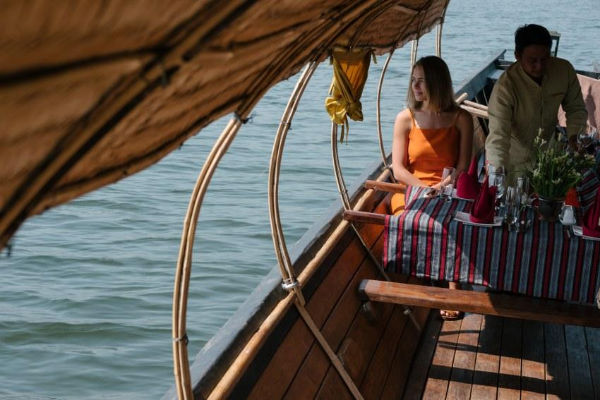
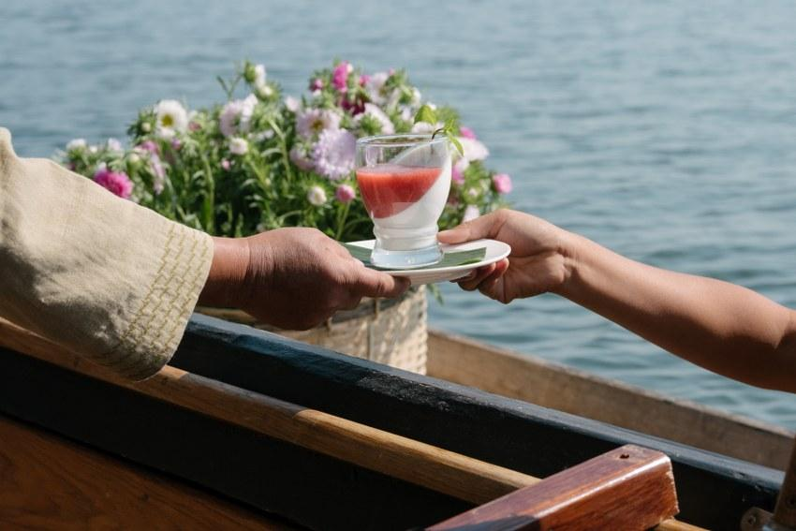
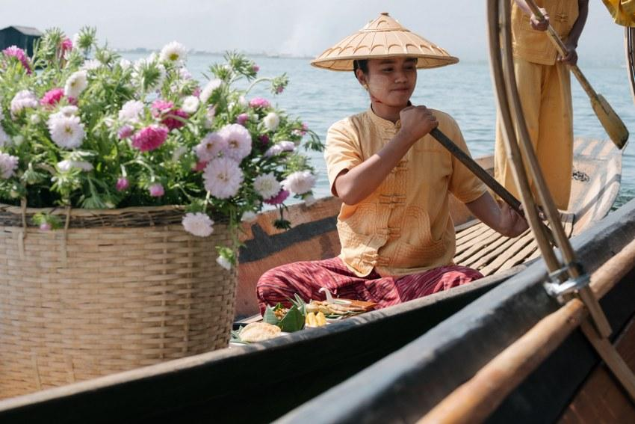
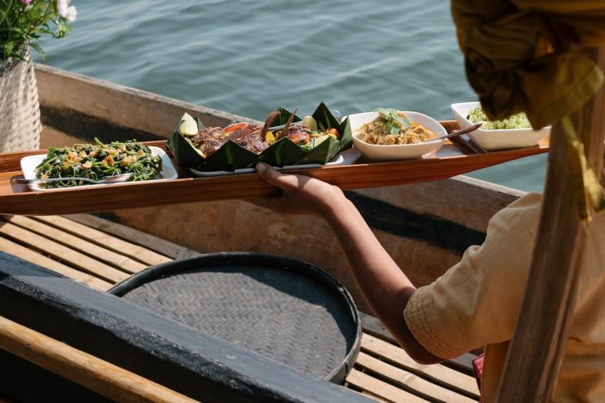
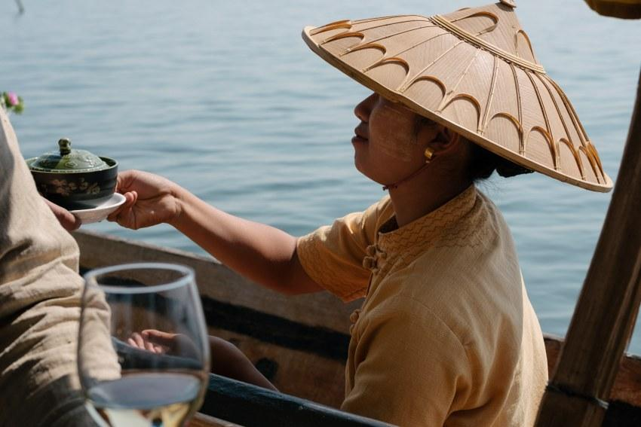
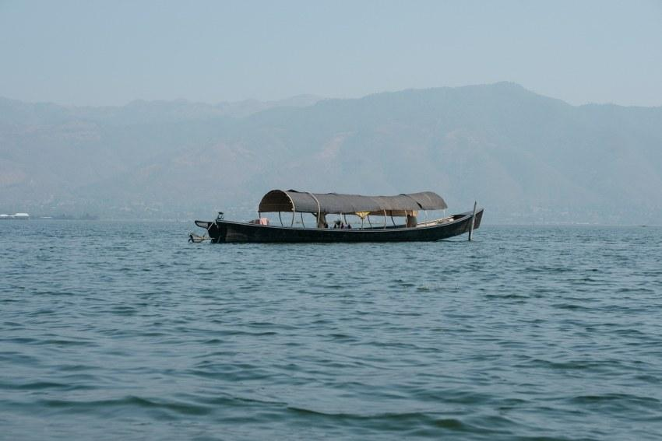

Easia Travel Head Office

Vietnam Head OfficeC/o: ATS Hotel, Suite 326 &327, 33B Pham Ngu Lao Street, Hanoi, VietnamTel: +84 24-39 33 13 62www.easia-travel.com

