THAILAND – Phuket – Observe Gentle Giants at Phuket Elephant Sanctuary
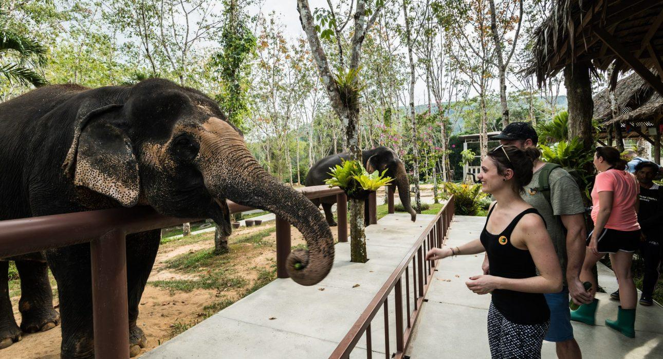

Over View

Theme
Classic, Family, Sustainable

Country - City
Thailand - Phuket

Market segment
Groups, Thematic Leisure

Price Level
$

Max pax
40

Seasonality
Possible all year round (but the best period is from November until April)

Arrival city
PHUKET

Departure city
PHUKET

Description

Elephants have been part of Thai culture for centuries, and they play a central role in the country’s history. But while local people highly respect them, they are often used to help with hard manual labor because of their size and power. After the ban on teak wood logging, these majestic elephants found a new home in the tourism industry, which unfortunately did not always mean an improvement for the elephants in terms of living standards. Luckily, several places approached elephant tourism from an ethical point of view, putting the elephants’ well-being first.Phuket Elephant Sanctuary is the first place on the island to take this approach. During a visit, there will be plenty of time to learn about these majestic creatures and how Phuket Elephant Sanctuary tries to help them. A unique opportunity to see these friendly giants up close in an ethical environment.

Selling points

- Minimal interaction, focused on observation
- A well-established elephant sanctuary in Phuket, the pioneer when it comes to ethical elephant tourism
- A nice activity for young and old

Sustainability

Level Of The Excursion
High – This activity strongly supports local communities and/or helps preserve the culture and environment

The Impact Of This Excursion

Social/cultural Impact
Empowerment and education

Environment Impact
Involving Wildlife, Waste/plastic packaging

Economic Impact
Local individual benefits

Additional Information

Positive impacts
The elephant sanctuary aims to be a haven for elephants who have previously abused. Their approach is completely hands-off and they focus on environmentally sustainable actions in general. They are also an important source of employment for the local community.

Negative impacts
No negatives.

Sensitive character
The activity involves captive wildlife. Strict rules are in place to ensure the wellbeing and safety of the animals as well as the visitors.

Time And Transportation

From | To | Distance | By | Duration
Patong | Phuket Elephant Sanctuary | 31 kilometers | Car | 55 minutes
Mai Khao | Phuket Elephant Sanctuary | 22 kilometers | Car | 35 minutes
Rawai | Phuket Elephant Sanctuary | 37 kilometers | Car | 1 hour
Phuket Town | Phuket Elephant Sanctuary | 20 kilometer | Car | 30 minutes

Photos

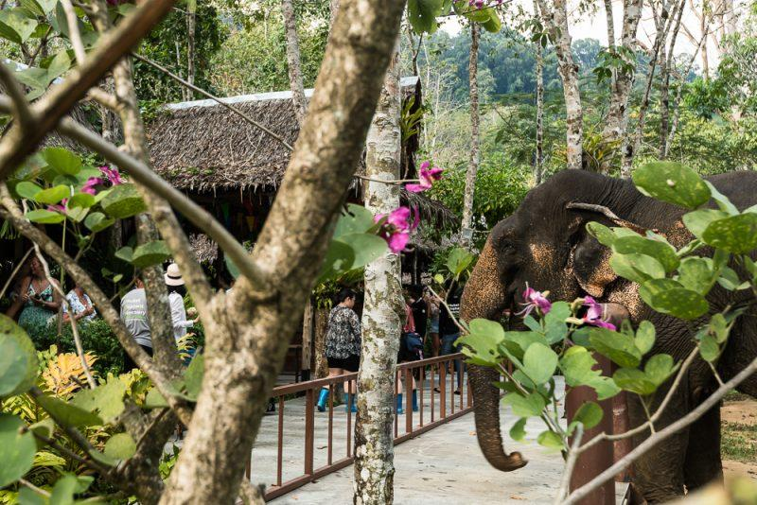
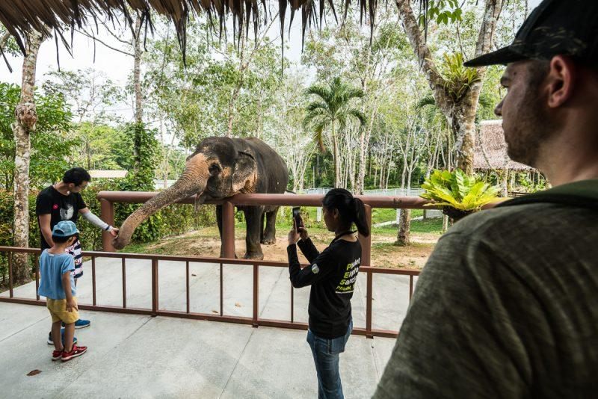
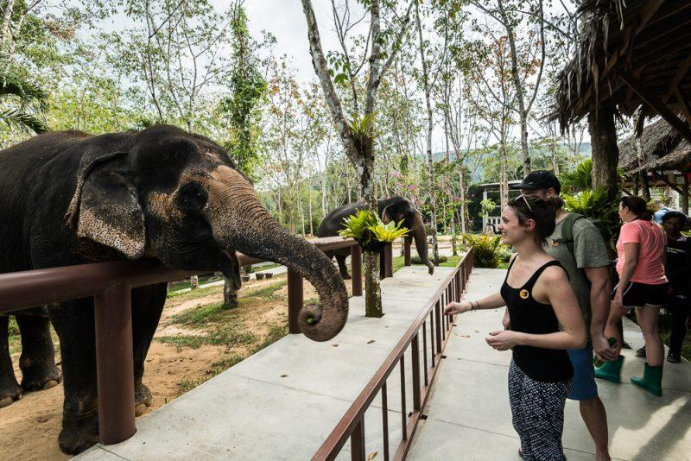
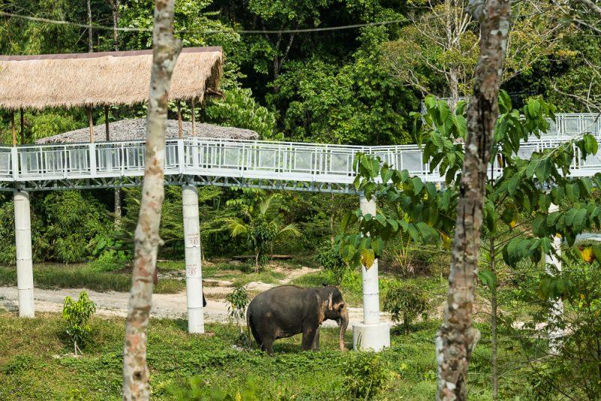
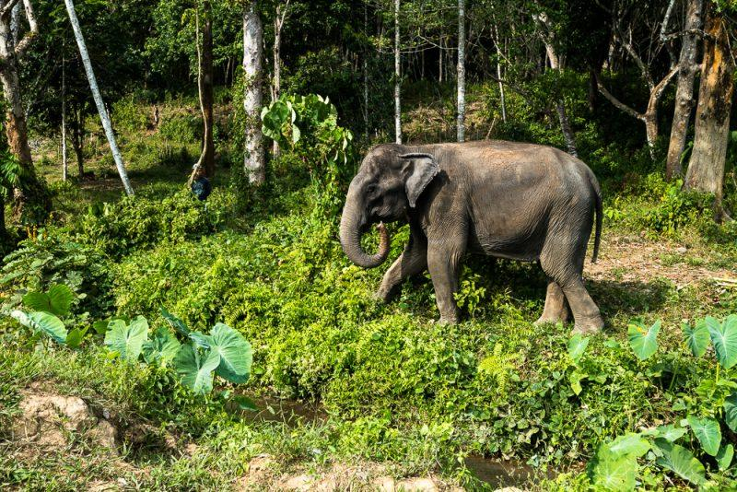
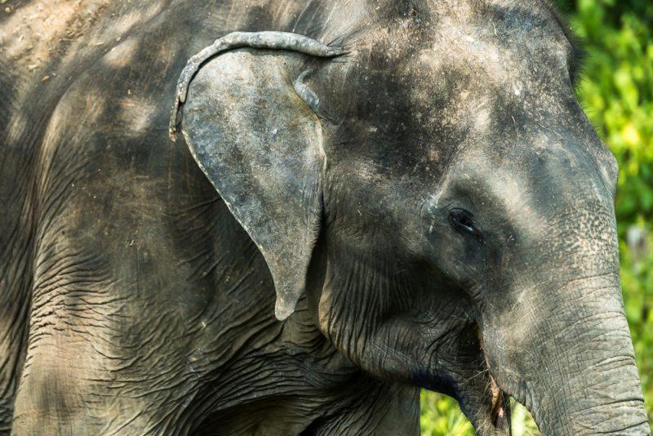
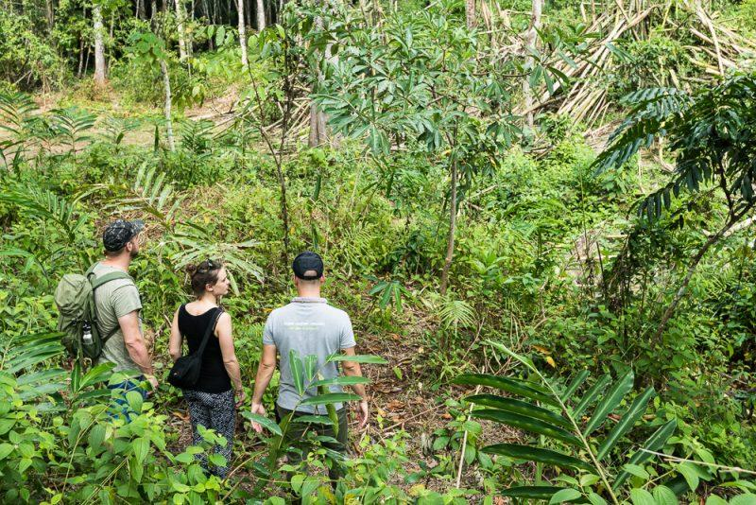
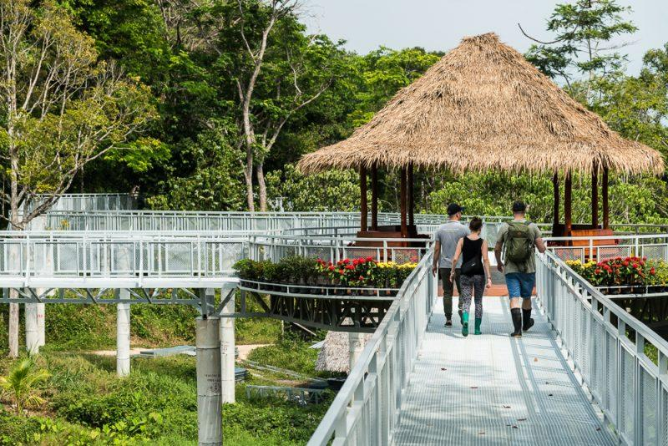

Easia Travel Head Office

