LAOS – Vientiane – Self-Guided City Tour
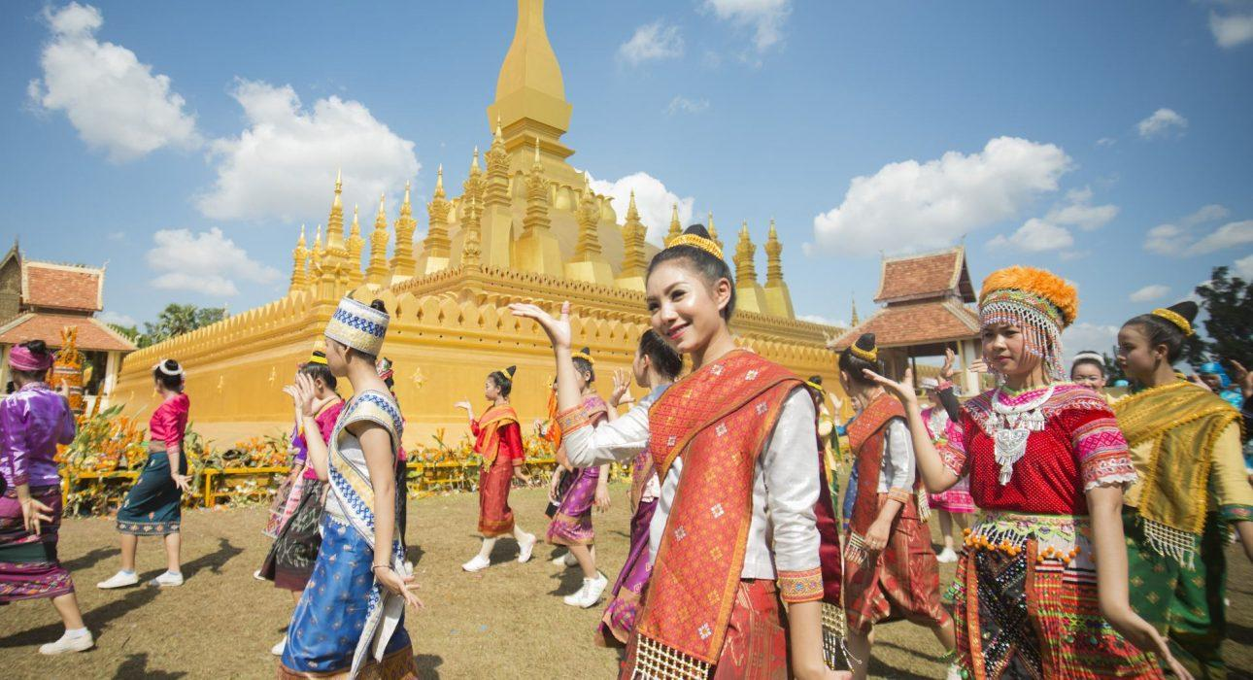

Over View

Theme
Art & Culture, Classic, Self-Guided Tours, Sustainable

Country - City
Laos - Vientiane

Market segment
Groups, Thematic Leisure

Price Level
$$

Level of difficulties
LEVEL 0

Max pax
10

Seasonality
All year round, but best from October to March

Arrival city
Vientiane

Departure city
Vientiane

Description

A self-guided exploration of Vientiane is a great way to discover the most important cultural and historical sites in Vientiane and to learn about their interesting history and the legends that surround them. It will be an interesting journey which will showcase very different sides of the city, from the ancient to the modern, from centuries old temples and stupas to towering modern skyscrapers and shopping malls that are still under construction as Vientiane tries to bring itself into the modern world.Although marked by French colonization, Vientiane retains a strong Asian identity. The city’s main sites are dotted with distinctly French-influenced buildings which stand in harmony alongside ancient monasteries and other Asian-style edifices. Highlights of this self-guided tour include Wat Sisaket temple and its thousands of Buddha statuettes; the Wat Hophakaew museum housing various sacred artworks and artefacts; the Wat That Luang, the residency of the Supreme Patriarch of Laotian Buddhism and national symbol of Laos; and Patuxay, commonly named the “Victory Gate”.

Selling points

- A carefully created full-day walking tour to explore the city’s main sites of French-influenced buildings which stand alongside ancient monasteries and other Asian-style buildings.
- An application with a GPS route, points of interest with in-depth information, and suggestions to help travelers explore Vientiane on their own and at their own pace.
- Ideal for those looking for more freedom in a tour.

Time And Transportation

From | To | Km | By | Duration | Road condition
Starting Point | Presidential Palace, Wat Sisaket, Wat Hophakaew | 1 | Walking | 10-15 minutes | Good
Presidential Palace | Wat Si Muang, Kung’s Cafe | 0.9 | Walking | 10-15 minutes | Good
Wat Si Muang | COPE Center | 0.5 | Walking | 10 minutes | Good
COPE Center | That Dam | 1.4 | Walking | 15-20 minutes | Good
That Dam | Patuxay, World Peace Gong | 1.1 | Walking | 10-15 minutes | Good
Patuxay | That Luang, Reclining Buddha | 1.7 | Walking | 25 minutes | Good

Photos

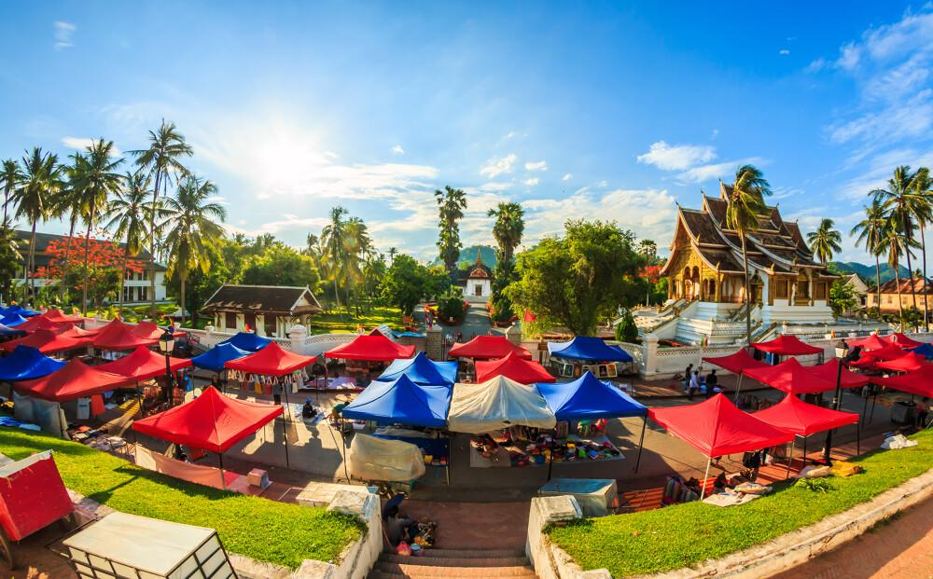
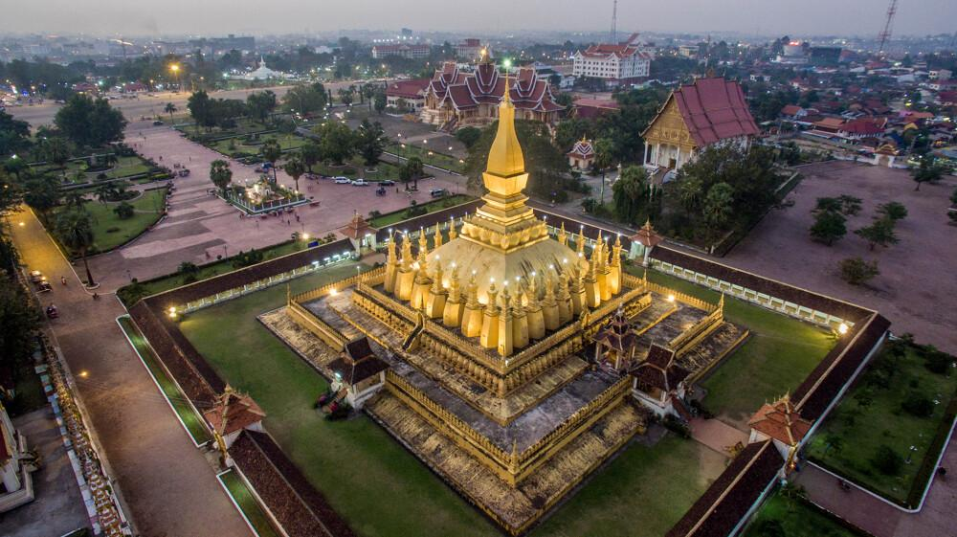
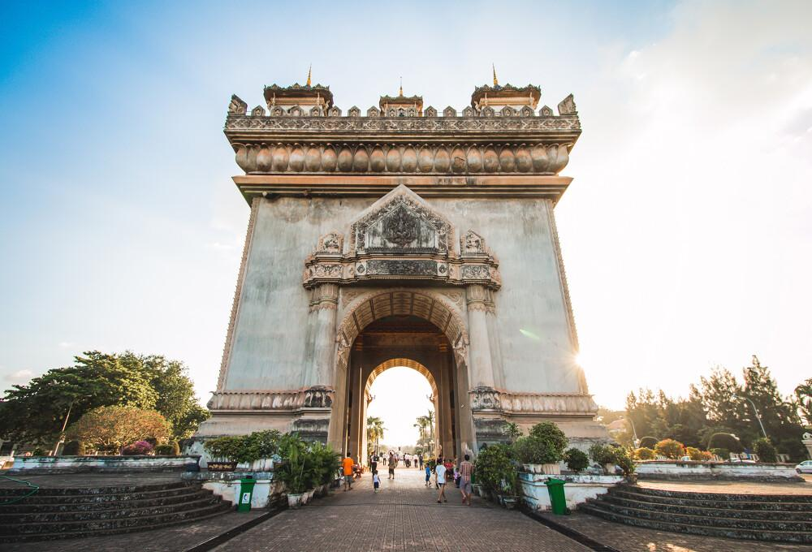
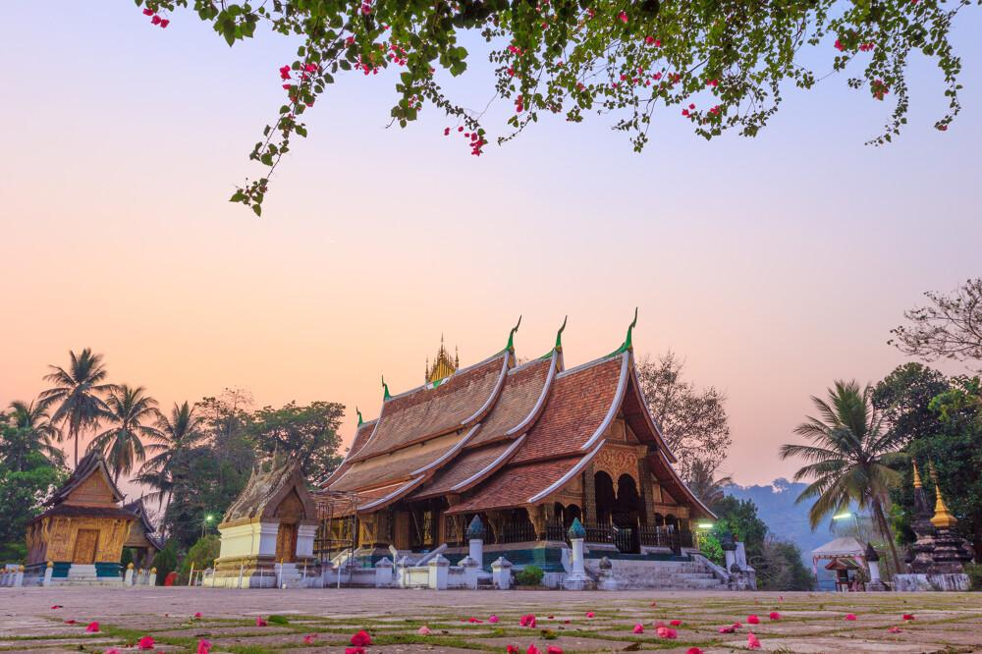
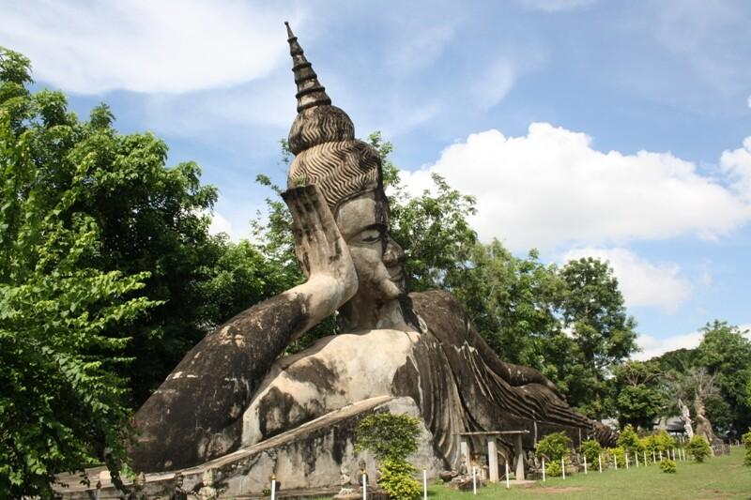
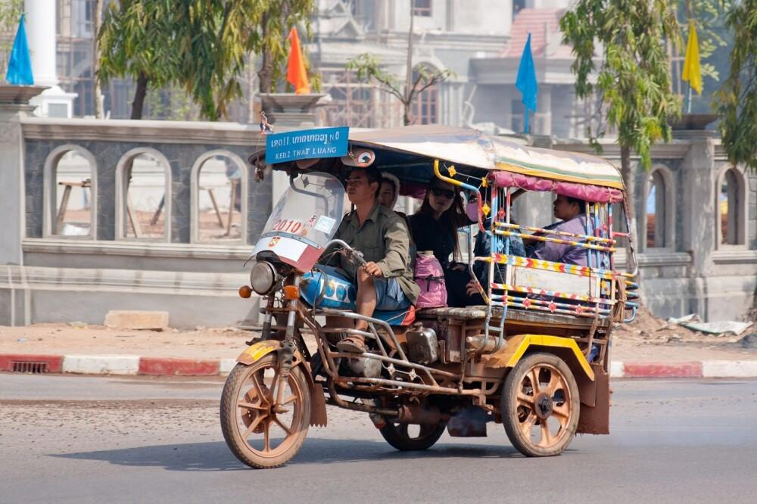
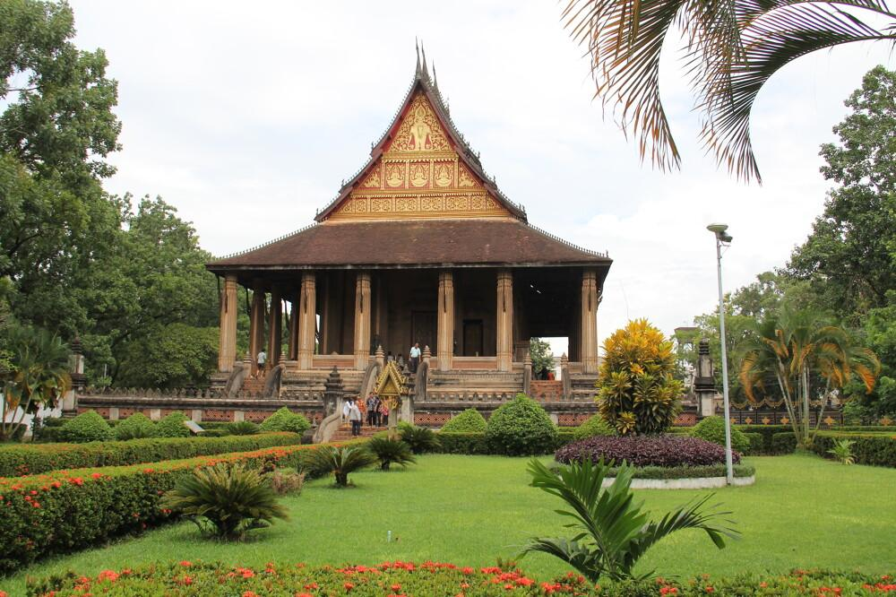
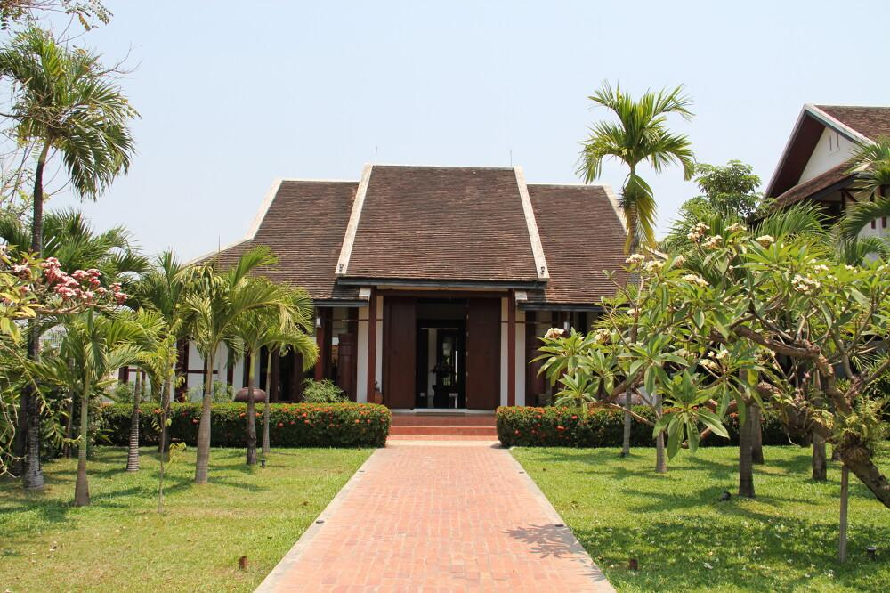
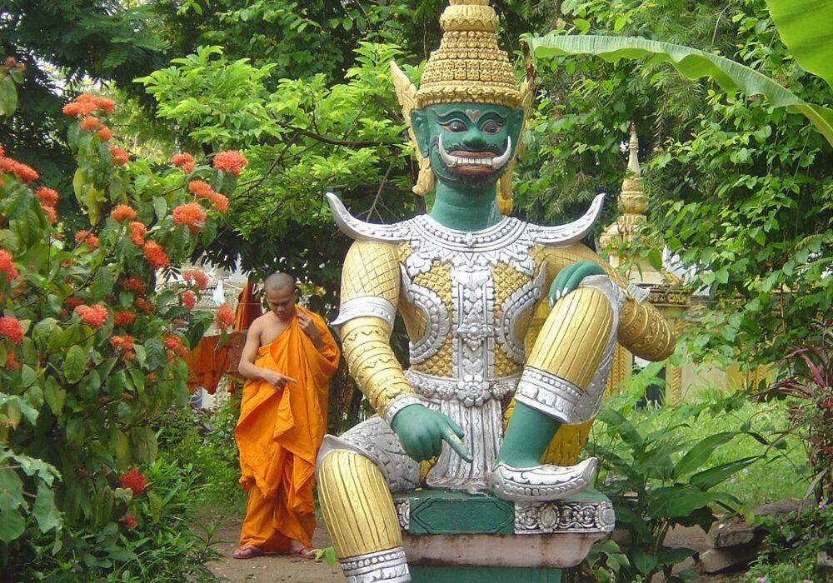
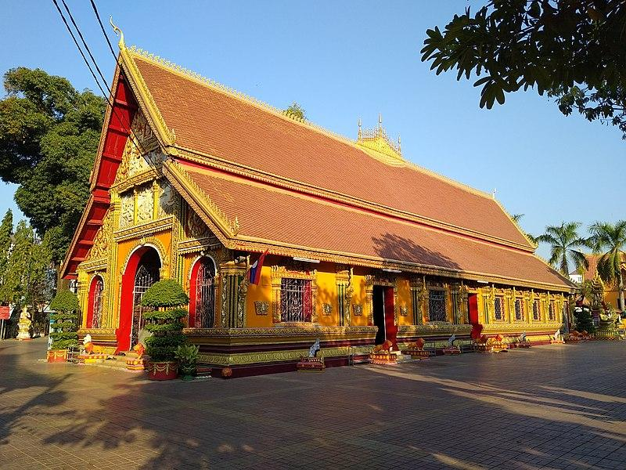
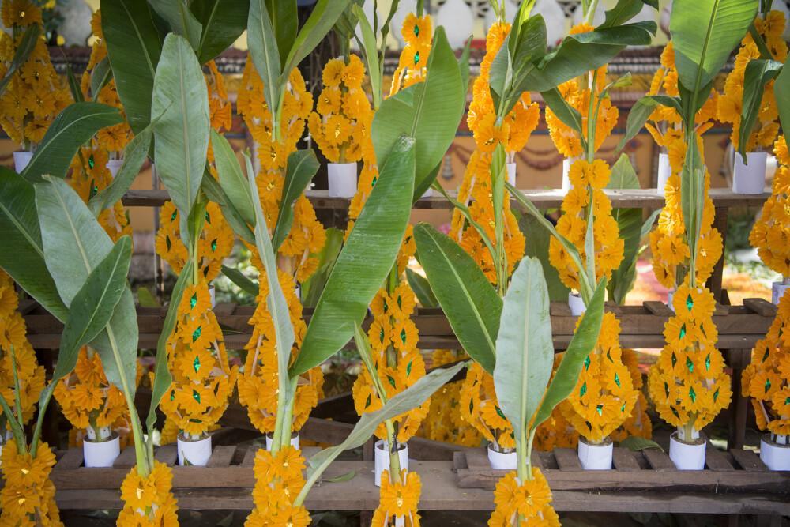

Easia Travel Head Office

Vietnam Head OfficeC/o: ATS Hotel, Suite 326 &327, 33B Pham Ngu Lao Street, Hanoi, VietnamTel: +84 24-39 33 13 62www.easia-travel.com

