THAILAND – Krabi – Hike To The Most Stunning Viewpoint Of Southern Thailand
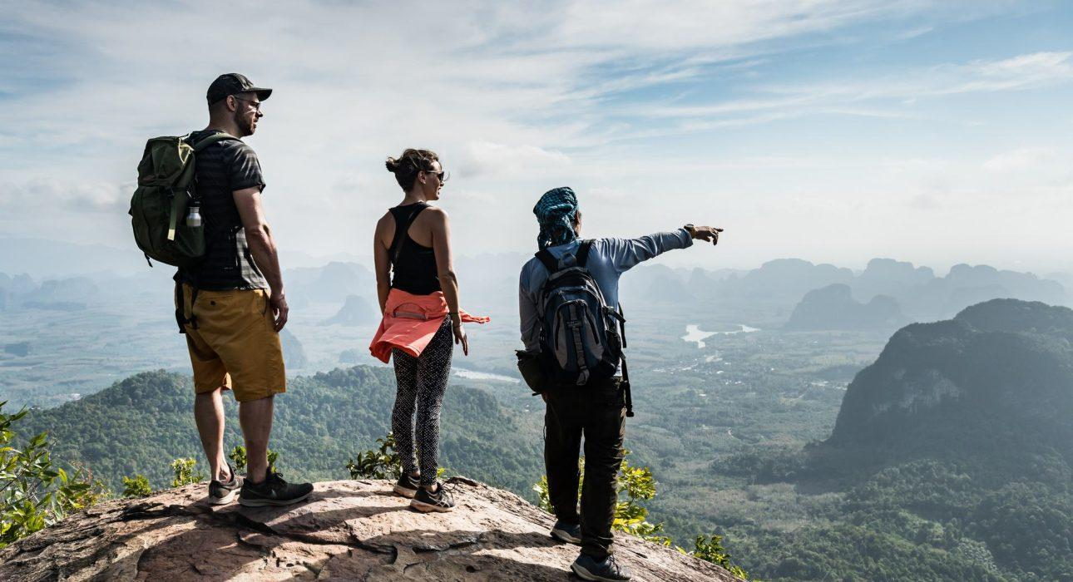

Over View

Theme
Sustainable, Wellness

Country - City
Thailand - Krabi

Market segment
Thematic Leisure

Price Level
$$$$

Level of difficulties
LEVEL 2

Max pax
20

Seasonality
Possible all year round (but best period is from November until April)

Arrival city
Krabi

Departure city
Krabi

Description

Southern Thailand is well known for its picture-perfect beaches, but stunning nature also awaits those who are willing to explore it. This hike is great for anyone who wants to stay active during a beach stay, and makes for a nice break from the hotel. Guests can enjoy the lush outdoors as they make their way up to the highlight of the day: a scenic spot that offers breathtaking views over Krabi’s rugged inland and beaches. An expert guide makes sure that no opportunity is missed to learn about the fauna and flora along the way.

Selling points

- One of the most spectacular viewpoints in Southern Thailand
- Great for people who love to be active during their beach stay
- A half-day trip that is accessible from anywhere in Krabi
- A jungle hike that takes guests to a scenic viewpoint, only accessible for people in decent physical condition

Sustainability

Level Of The Excursion
Medium – This activity offers tangible positive contributions to the local community, culture and/or environment

The Impact Of This Excursion

Social/cultural Impact
Empowerment and education

Environment Impact
Involving Wildlife, Transportation, National parks

Economic Impact
Local individual benefits

Additional Information

Positive impacts
Guests hike with a specialized guide to visit natural sites where they can observe nature and have the chance to see wildlife. Care is taken to not leave any waste an avoid using single-use plastics.

Negative impacts
No negative.

Time And Transportation

From | To | Distance | By | Duration
Ao Nang Beach | Starting point of the hike | 18 kilometers | Car | 30 minutes
Krabi town | Starting point of the hike | 30 kilometers | Car | 40 minutes
Klong Muang Beach | Starting point of the hike | 7 kilometers | Car | 15 minutes
Tubkaek Beach | Starting point of the hike | 1 kilometer | Car | 3 minutes

Photos

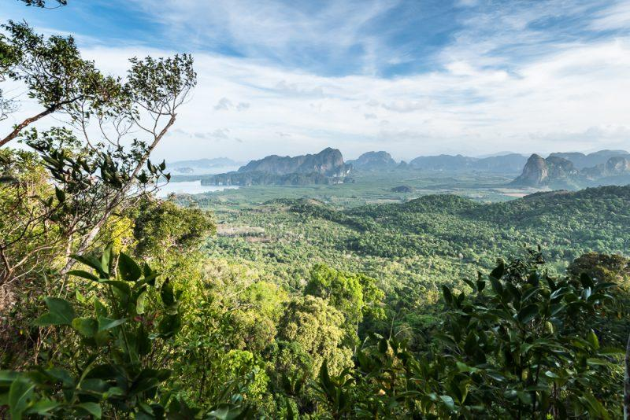
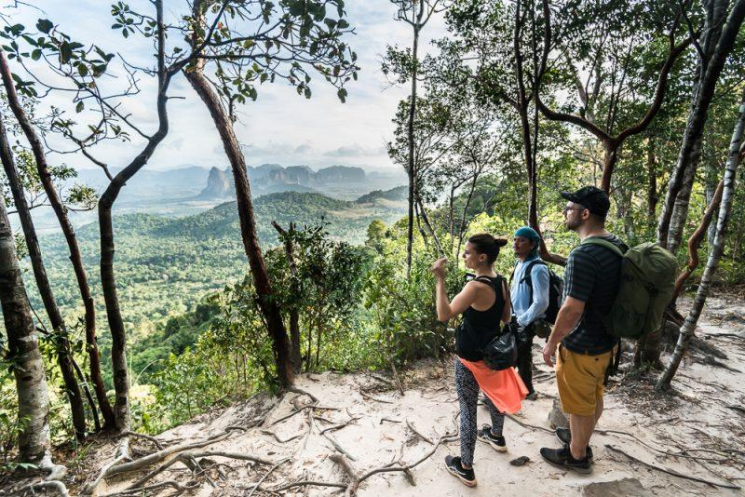
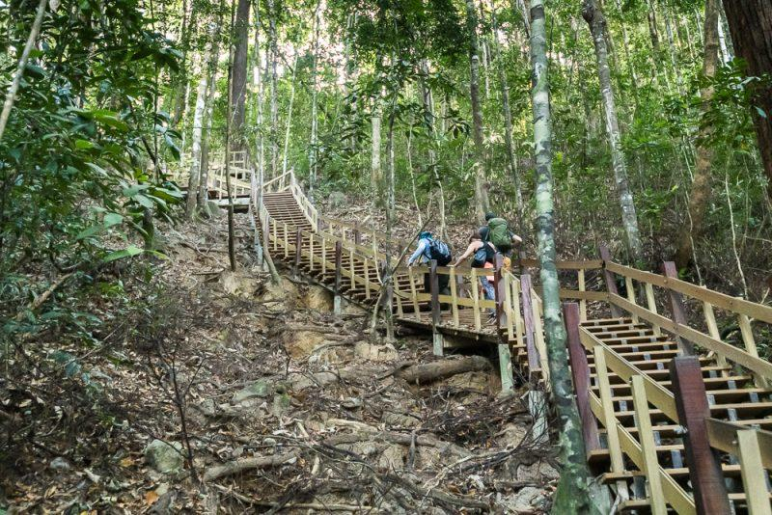
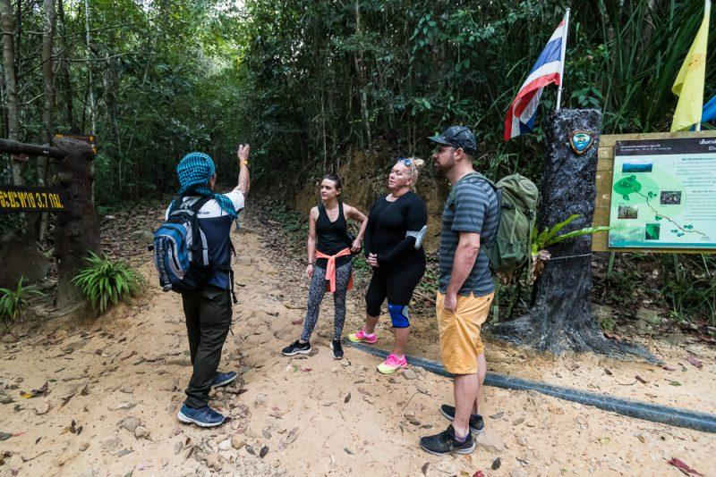
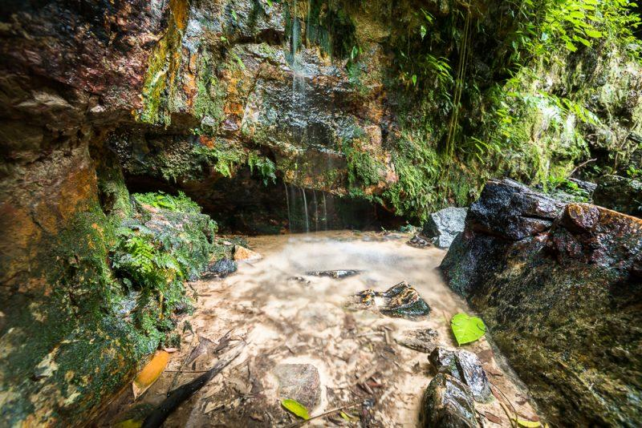
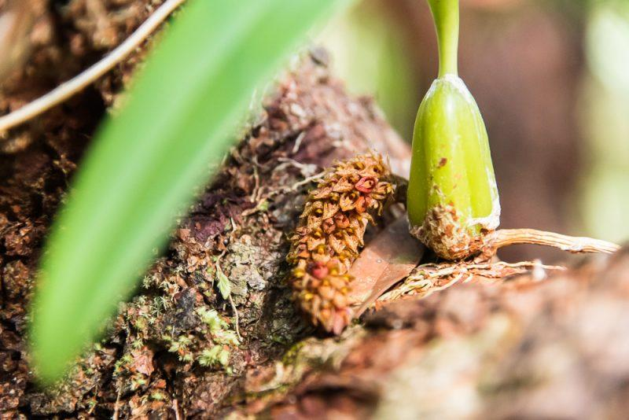
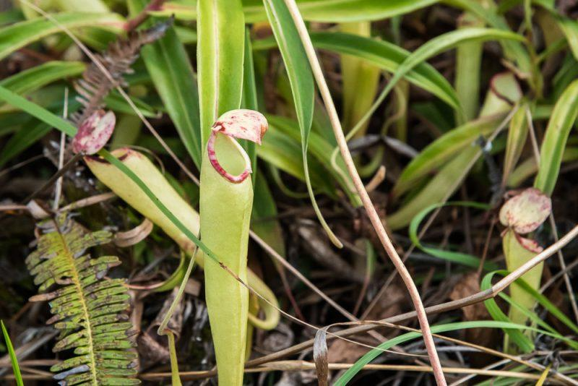
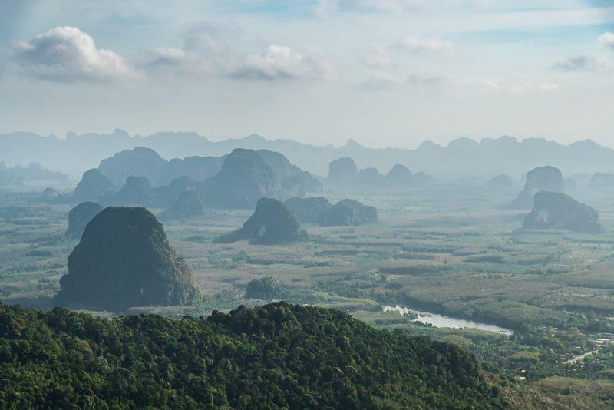
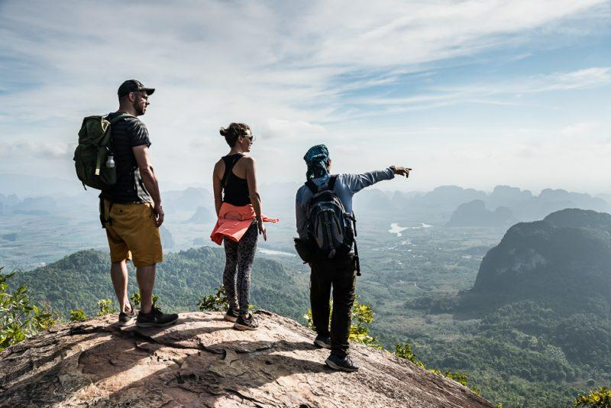

Easia Travel Head Office

Vietnam Head OfficeC/o: ATS Hotel, Suite 326 & 327, 33B Pham Ngu Lao Street, Hanoi, VietnamTel: +84 24-39 33 13 62www.easia-travel.com

