THAILAND – Phuket – Phuket From a Different Perspective
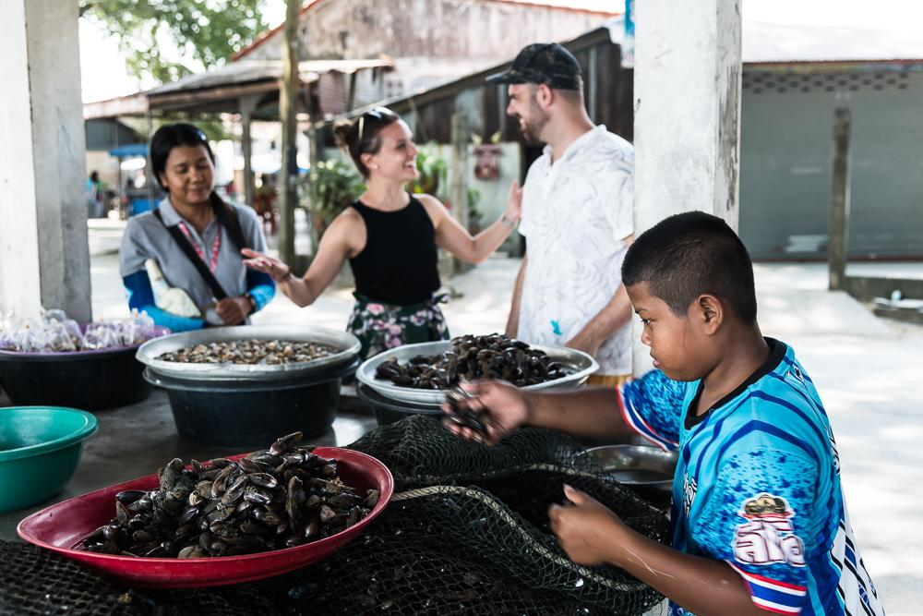

Over View

Theme
Art & Culture, Classic, Honeymoon

Country - City
Thailand - Phuket

Market segment
Groups, Thematic Leisure

Price Level
$$$$

Max pax
34

Seasonality
Possible all year round (but best period is from November until April)

Arrival city
PHUKET

Departure city
PHUKET

Description

Phuket is well known as a prime beach destination in Thailand, and rightfully so! But this activity gives travelers the opportunity to really understand the history and culture of the island that many visitors may be unaware of. From local temples with interesting history, to Phuket’s old town and rarely visited sea nomad communities, this itinerary weaves together many interesting sites that only insiders know. A must for anyone who wants to look past the main attractions for a “behind the scenes” look at the island.

Selling points

- An activity to give a different dimension to a beach stay in Phuket
- Great for a wide public, from couples to families to groups
- A full day but with a relaxed tempo (late departure and early return)
- Perfect to get an insider look of Phuket island and the local sites that can be found there
- An easily accessible activity, as the visits are combined by air-conditioned vehicle

Sustainability

Level Of The Excursion
Low - This activity impacts local community, culture and/or environment in a small but meaningful way

The Impact Of This Excursion

Social/cultural Impact
Cultural Conservation, Empowerment and education

Environment Impact
Transportation

Economic Impact
Local individual benefits

Additional Information

Positive impacts
This activity aims to show a different side of Phuket by focusing on areas that are rarely visited by tourist, but still highlighting the island’s rich history and heritage. Multiple stops along the way benefit individual sellers and the community as a whole.

Negative impacts
The transportation used during the activity uses fossil fuel which causes Co² emissions.

Time And Transportation

Photos

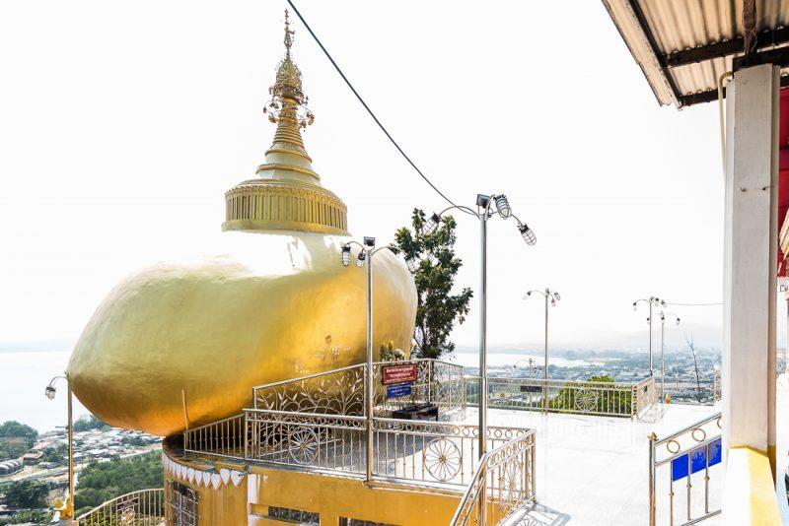
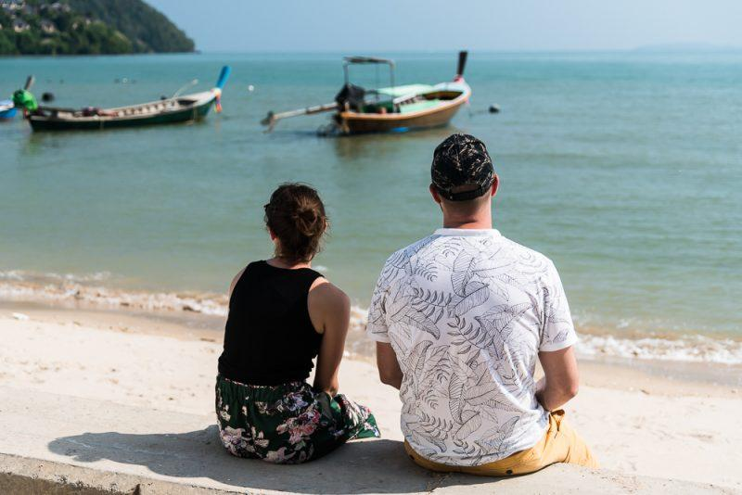
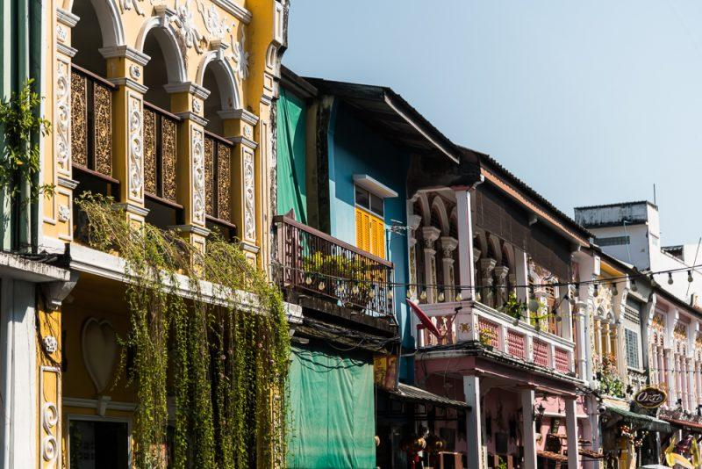
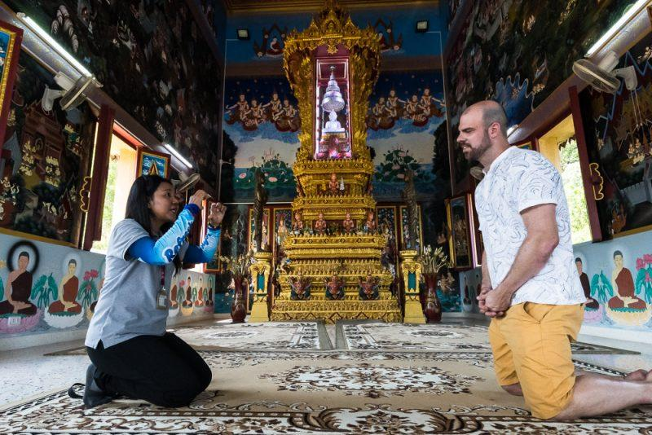
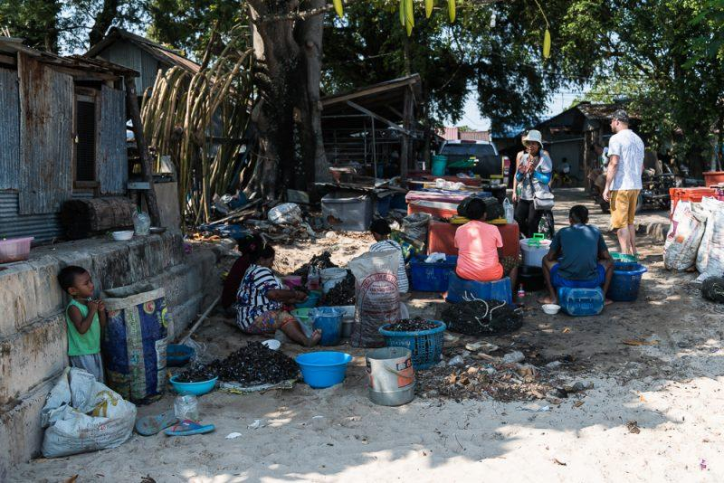
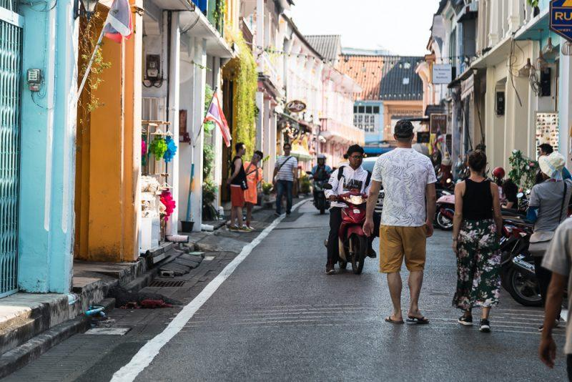
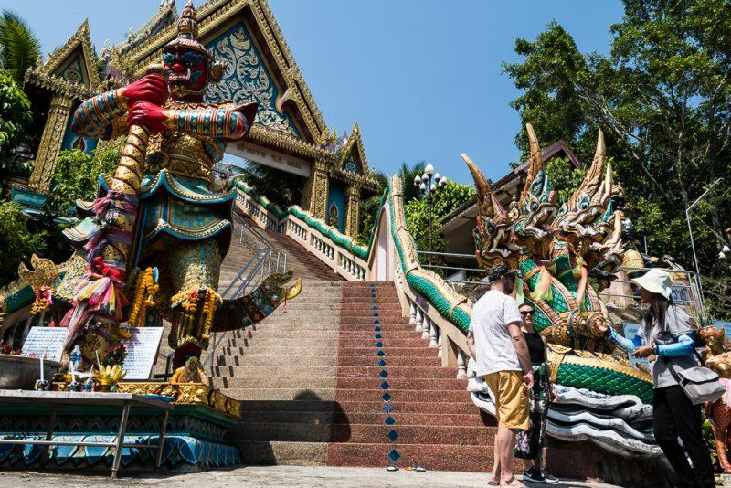
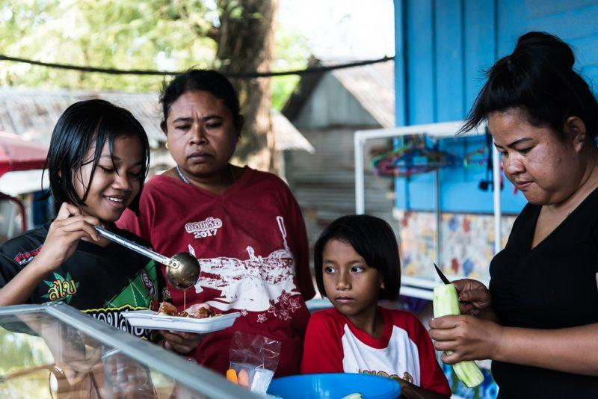

Easia Travel Head Office

Vietnam Head OfficeC/o: ATS Hotel, Suite 326 &327, 33B Pham Ngu Lao Street, Hanoi, VietnamTel: +84 24-39 33 13 62www.easia-travel.com

