THAILAND – Phuket – Peranakan Food Tour in Phuket Town
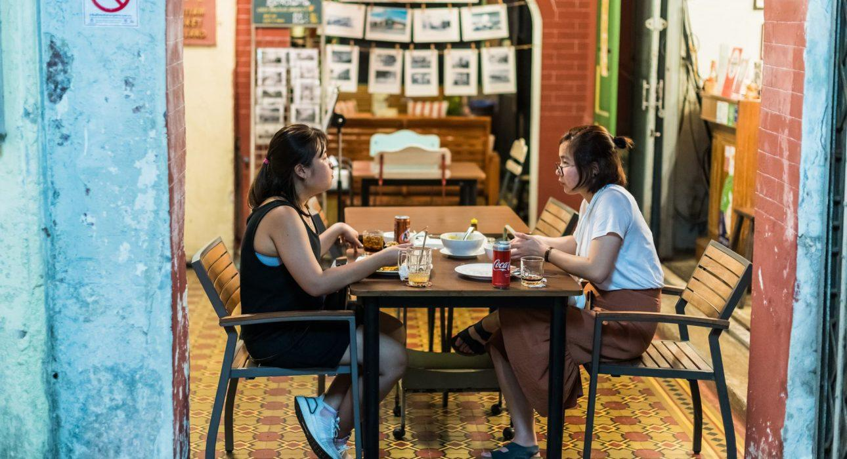

Over View

Theme
Classic, Gastronomy, Honeymoon

Country - City
Thailand - Phuket

Market segment
Thematic Leisure

Price Level
$$$$

Max pax
10

Seasonality
Possible all year round (but best period is from November until April)

Arrival city
PHUKET

Departure city
PHUKET

Description

Phuket Town is famous for its vibrant food scene – it is even classified as a UNESCO City of Gastronomy! During this culinary exploration through the charming old town of Phuket with its heritage buildings, an experienced guide will introduce some of the most sought-after local delicacies. A great choice for anyone who wants an authentic foodie experience during their stay in Phuket.

Selling points

- An authentic experience for foodies
- A great way to bring variation to a beach stay in Phuket
- Visit is in Phuket Town, which is not affected yet by mass-tourism
- The focus is on food, but Phuket Town also has a lot of cultural heritage and it is especially beautiful at night

Sustainability

Level Of The Excursion
Medium – This activity offers tangible positive contributions to the local community, culture and/or environment

The Impact Of This Excursion

Social/cultural Impact
Cultural Conservation, Empowerment and education

Environment Impact
Transportation

Economic Impact
Local individual benefits, Community benefits

Additional Information

Positive impacts
This walking food tour is focused entirely on Phuket’s heritage and traditional cuisine. Various stops along the way create income for local sellers and the wider community.

Negative impacts
No negatives.

Time And Transportation

From | To | Distance | By | Duration
Patong | Phuket Town | 15 kilometers | Car | 30 minutes
Mai Khao | Phuket Town | 35 kilometers | Car | 50 minutes
Rawai | Phuket Town | 15 kilometers | Car | 30 minutes
Kata | Phuket Town | 15 kilometers | Car | 30 minutes

Photos

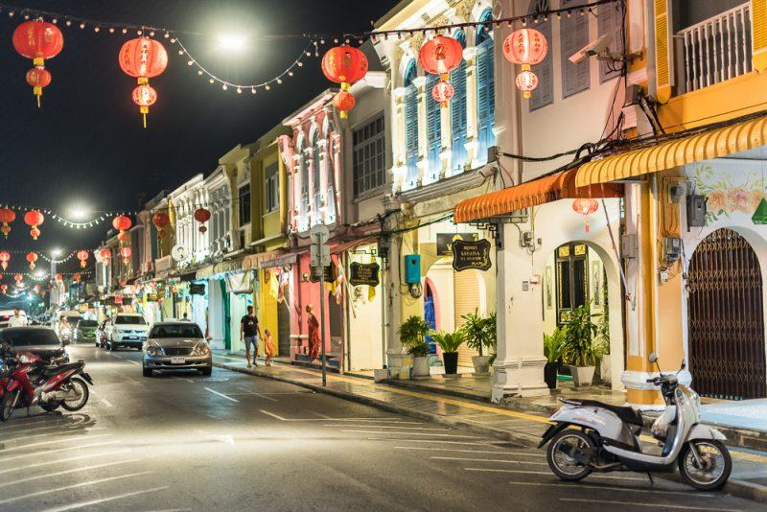
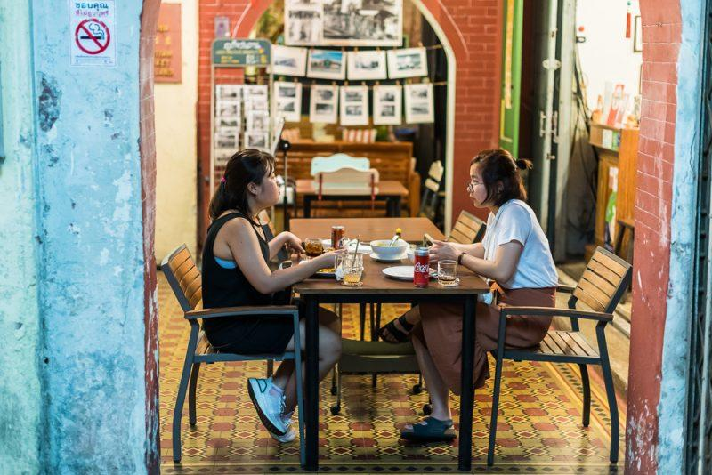
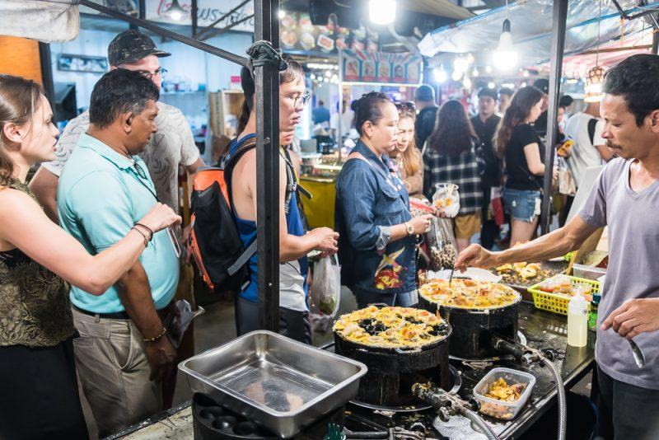
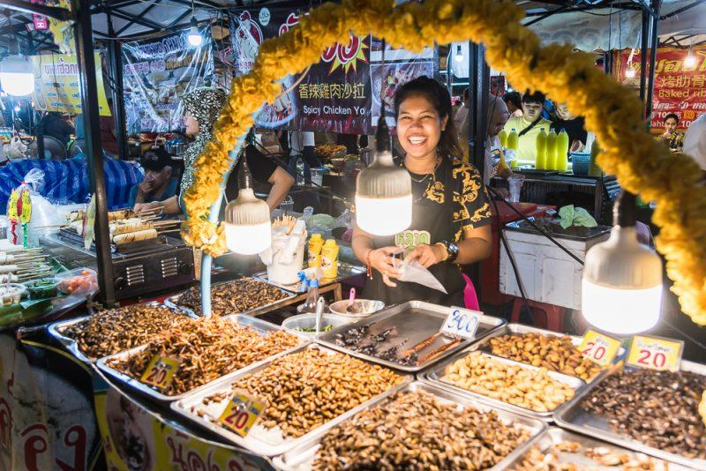
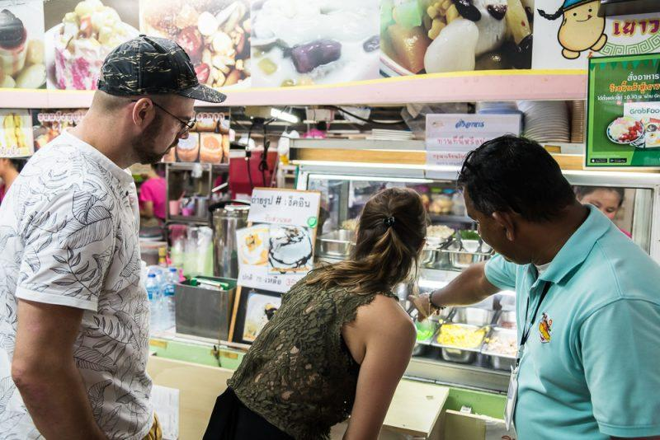
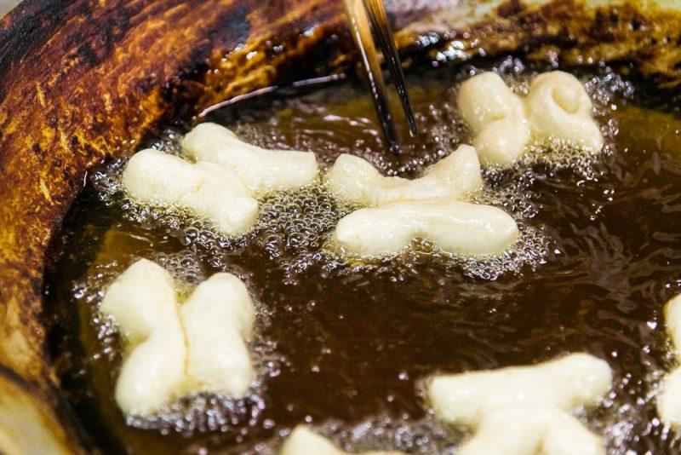
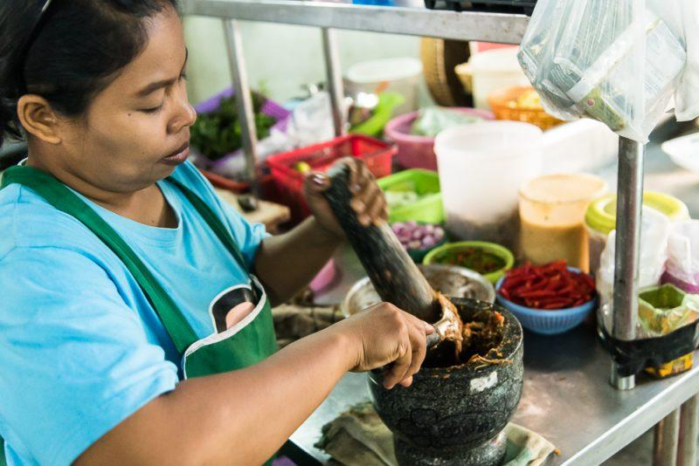
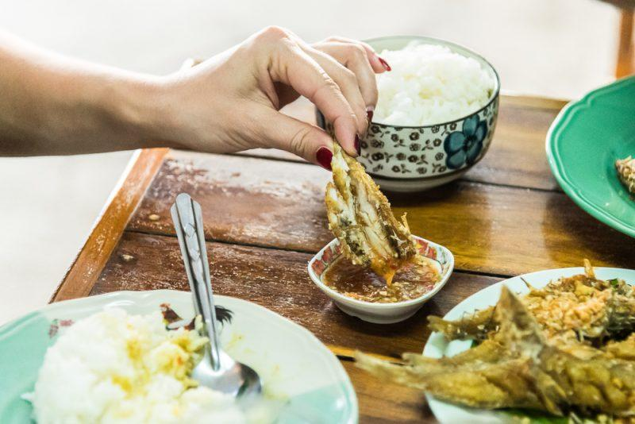
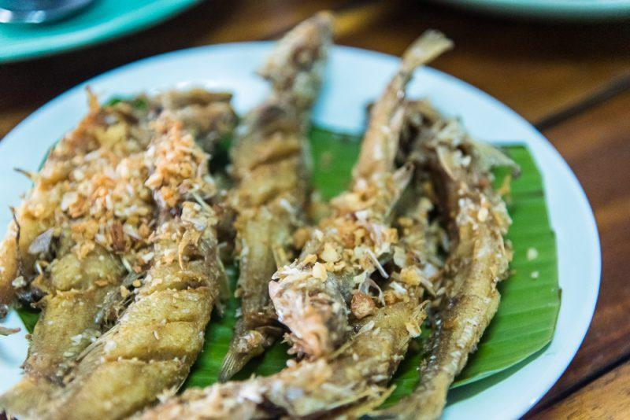

Easia Travel Head Office

Vietnam Head OfficeC/o: ATS Hotel, Suite 326 &327, 33B Pham NguLao Street, Hanoi, VietnamTel: +84 24-39 33 13 62www.easia-travel.com

