LAOS- Luang Prabang – Self-Guided Food Tour
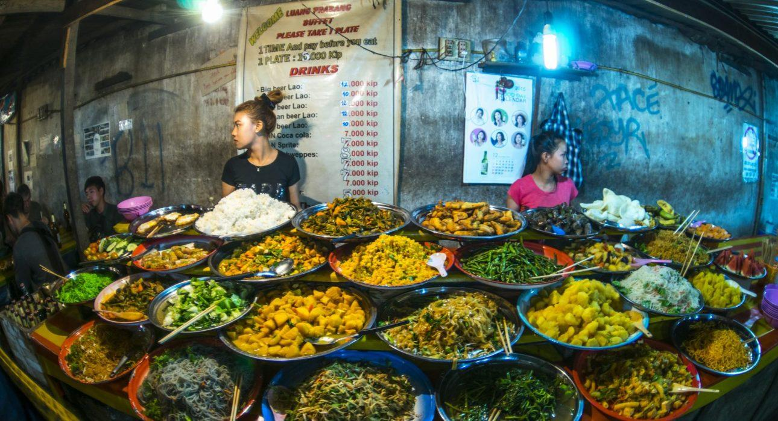

Over View

Theme
Classic, Family, Gastronomy, Self-Guided Tours, Sustainable

Country - City
Laos - Luang Prabang

Market segment
Thematic Leisure

Price Level
$$

Level of difficulties
LEVEL 0

Max pax
10

Seasonality
All Year Round

Arrival city
Luang Prabang

Departure city
Luang Prabang

Description

Eating is an essential part of Lao culture and a time when families and friends come together after a hard day of work. Self-guided exploration of Luang Prabang’s cuisine is a great way to experience the city from a different perspective. Taste buds will be awakened by tasting a selection of popular Lao dishes on a gastronomic walking tour near the city center. The adventure will start with a delicious bowl of one of the Lao staples – Khao Soi or Pho. This is one of the most popular meals in Laos and all of Southeast Asia. Then come the steamed buns, with egg and pork, called Salapao. For those wanting something a bit more refreshing, Navman is also a sweet dessert type drink especially popular when the weather is hot. After these first couple of stops, there will be a little bit of walk, along the road, through the temple, and into the smaller streets where some tasty Namejun (Spring Rolls) and Tam Makteng (Cucumber Salad), popular dishes often shared among friends as they enjoy an evening drink, will be waiting. The final walk will be to the night market area, where the culinary adventure will end with some tasty Kaojee and Khao Nom Kok!

Selling points

- A simple activity showcases some of the popular local foods in Luang Prabang and provides a different perspective of the city.
- An application with a GPS route, points of interest with in-depth information, and suggestions to help travelers explore Luang Prabang independently and at their own pace.
- An ideal activity to do in the evening before visiting the famous night market.
- The walk takes guests to parts of the town they may not visit otherwise.
- Ideal for those looking for more freedom in a tour.

Time And Transportation

From | To | Km | By | Duration | Road condition
Starting Point (Night Market Crossroads) | Khao Soi | 1 | Walking | 15 minutes | Good
Khao Soi | Salapao and Namvan | 0.3 | Walking | 5 minutes | Good
Salapao and Namvan | Naemjun and Tam Mak Taeng | 0.6 | Walking | 10 minutes | Good
Naemjun and Tam Mak Taeng | Khao Jee and Khao Nom Kok (End Point) | 0.8 | Walking | 12 minutes | Good

Photos

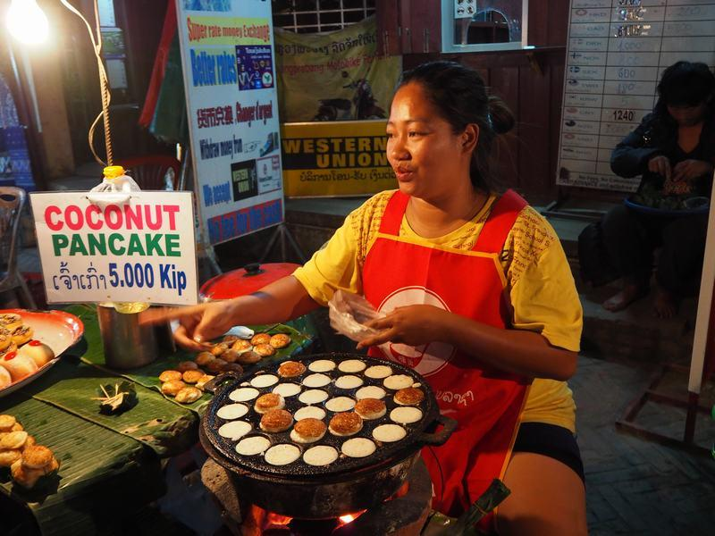
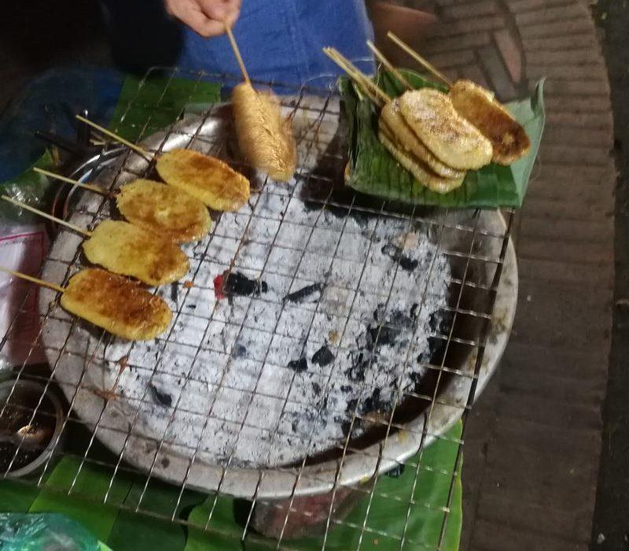
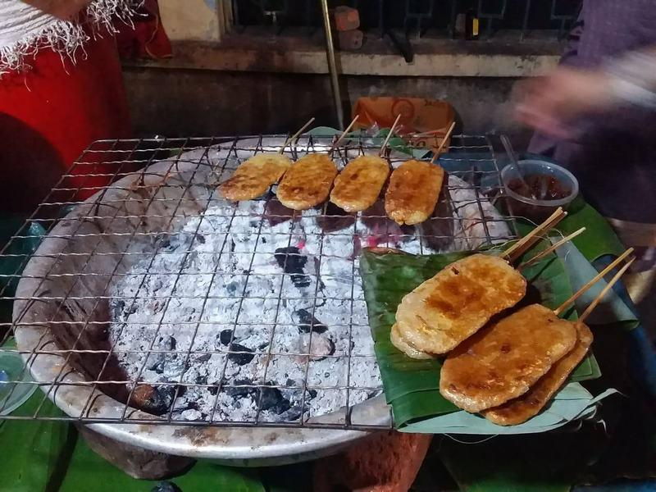
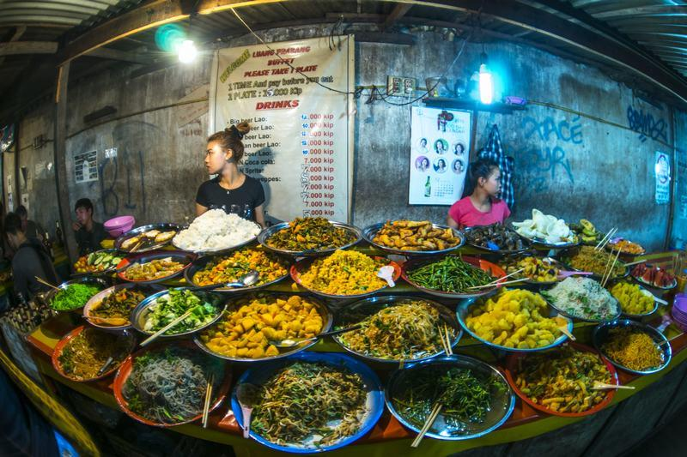
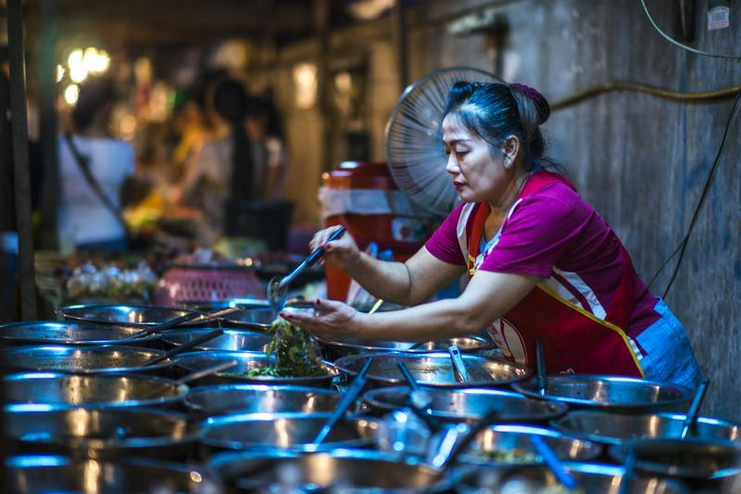
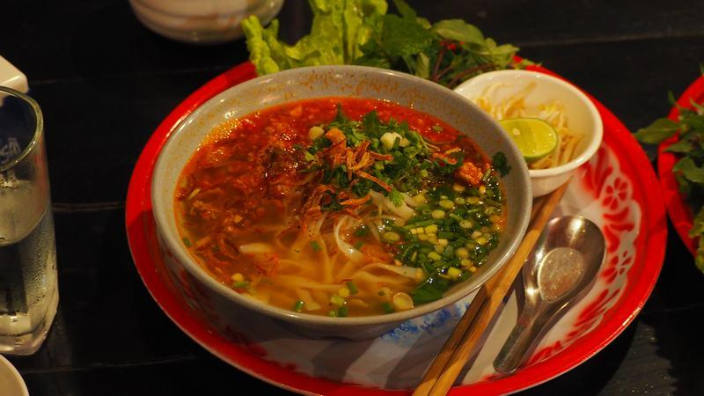
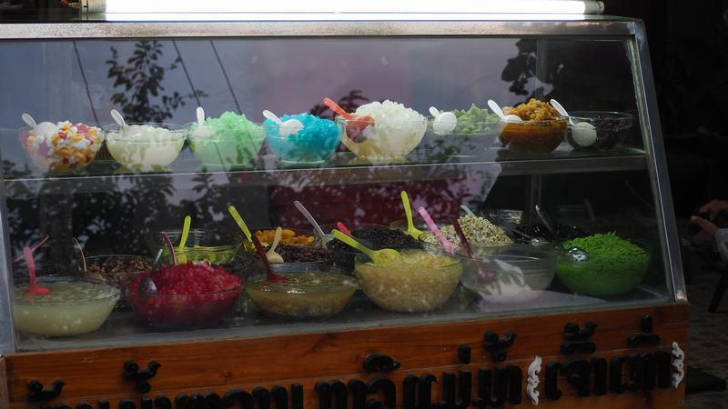
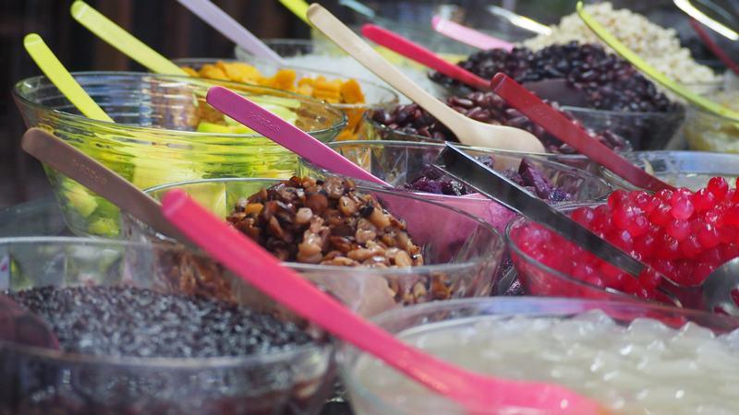

Easia Travel Head Office

Vietnam Head OfficeC/o: ATS Hotel, Suite 326 &327, 33B Pham Ngu Lao Street, Hanoi, VietnamTel: +84 24-39 33 13 62www.easia-travel.com

