LAOS – Luang Prabang – Self-Guided Hike from Ban Long Lao to Kuang Sy Waterfalls
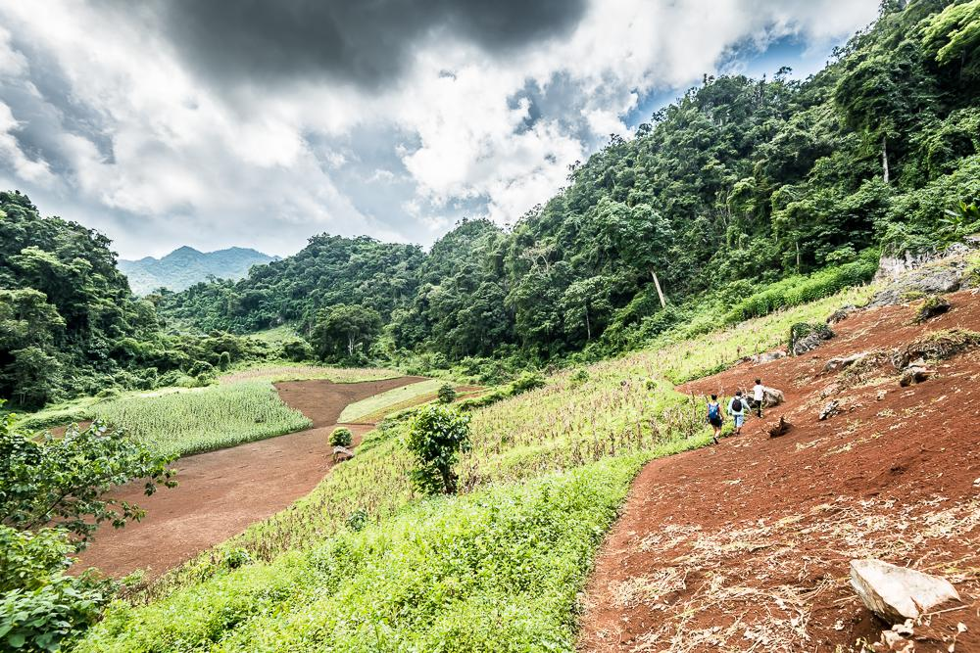

Over View

Theme
Classic, Self-Guided Tours, Sustainable

Country - City
Laos - Luang Prabang

Market segment
Groups, Thematic Leisure

Price Level
$$

Level of difficulties
LEVEL 1

Max pax
10

Seasonality
October to March

Arrival city
Luang Prabang

Departure city
Luang Prabang

Description

After an early morning drive, traveling through mountains, valleys and local villages, the ethnic Hmong village of Ban Long Lao will appear. After visiting the village, the GPS-activated directions and points of interest will lead the way on an 8-kilometer hike through vegetable gardens, rice fields and forested areas under the shade of hard wood trees, all the way to the multi-tiered turquoise waterfalls of Kuang Sy. Upon arrival at the falls there will be a chance to relax, bathe, enjoy lunch, and visit the bear rescue center before meeting the driver and heading back towards Luang Prabang. On the way back there will be a quick stop for a buffalo-milk ice cream at the Buffalo Dairy – a delicious reward after a very active morning!

Selling points

- A self-guided journey along the best short hiking route in the surroundings of Luang Prabang.
- It is a unique and amazing way to arrive at the famous Kuang Sy Waterfalls.
- It provides an opportunity to discover an ethnic village of the Hmong community.
- An easy to moderate level walk with beautiful and diverse landscapes on the way
- An application with a GPS route, directions, and points of interests for travelers to explore the countryside on their own.
- Possible to combine with other self-guided tours in Laos to create a self-guided itinerary.

Time And Transportation

From | To | Km | By | Duration | Road condition
Luang Prabang | Ban Long Lao | 20 | Minivan | 1 hour | Dirt road but fairly good condition
Kuang Sy | Luang Prabang | 30 | Minivan | 45 minutes – 1 hour | Good paved road

Photos

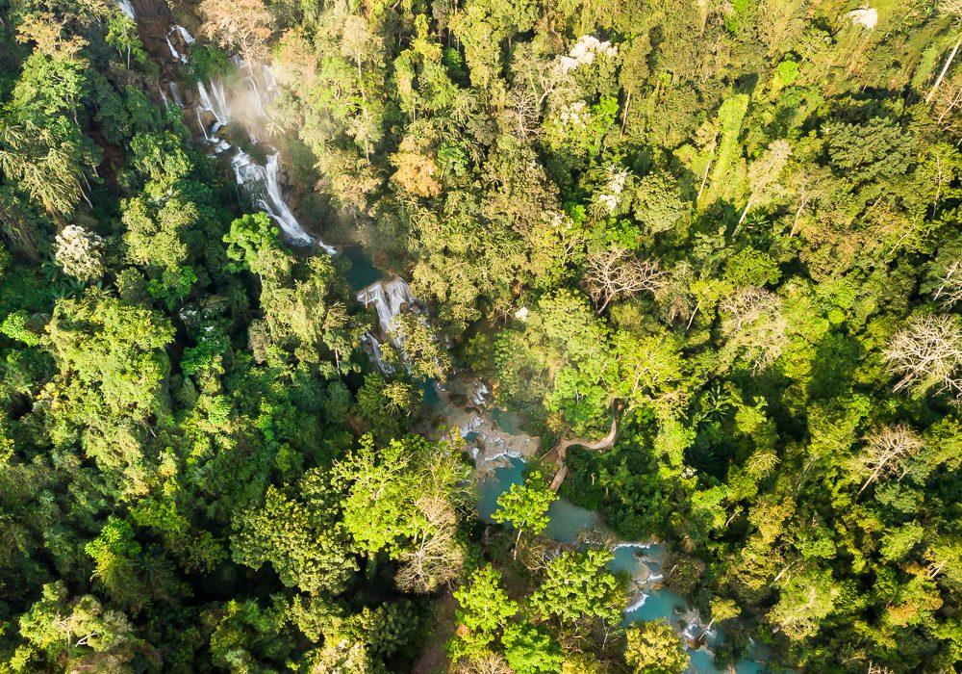
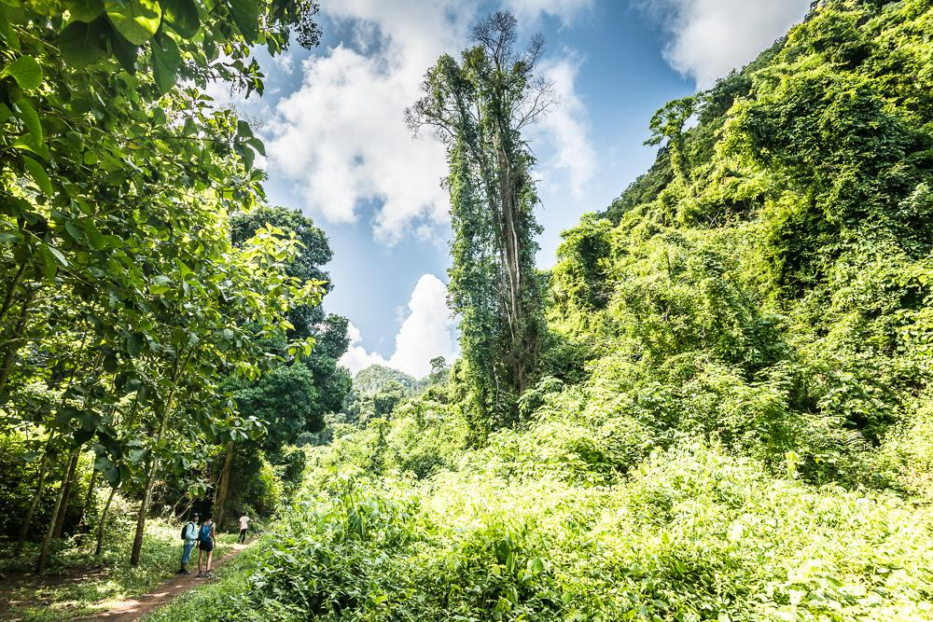
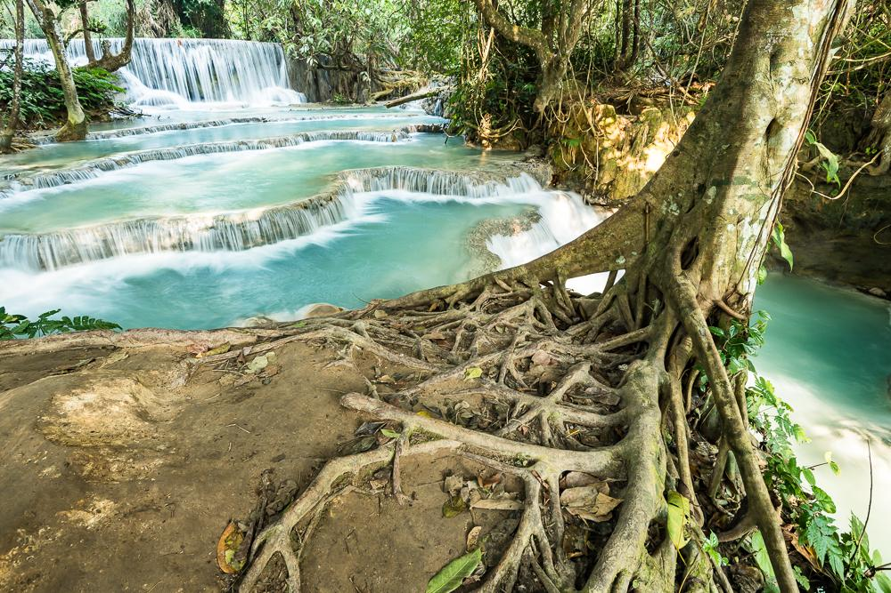
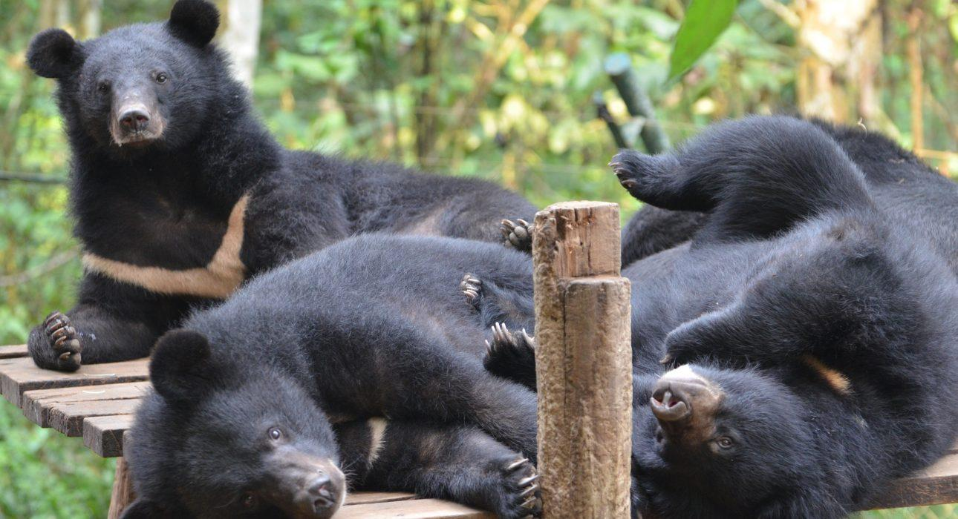
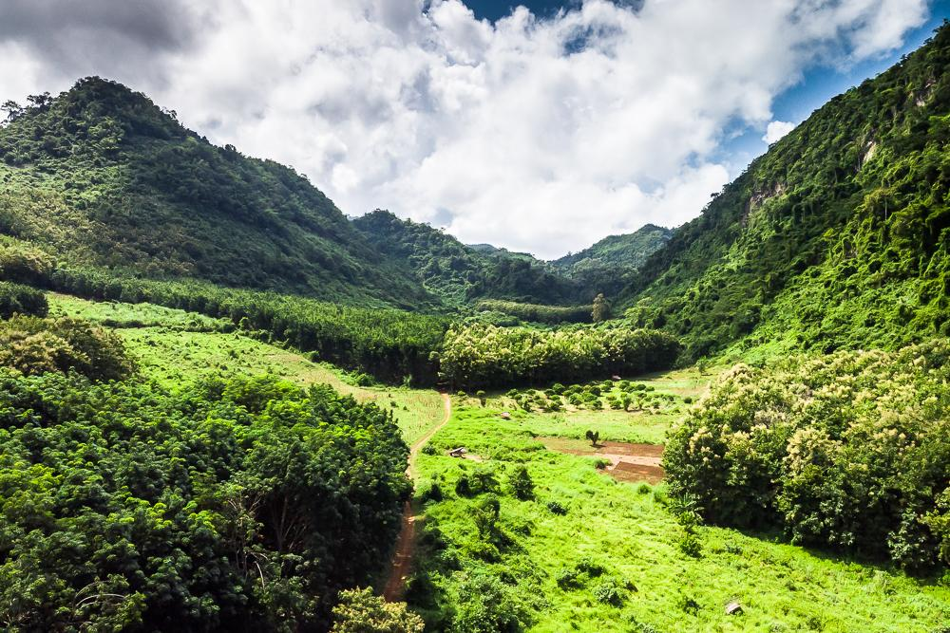
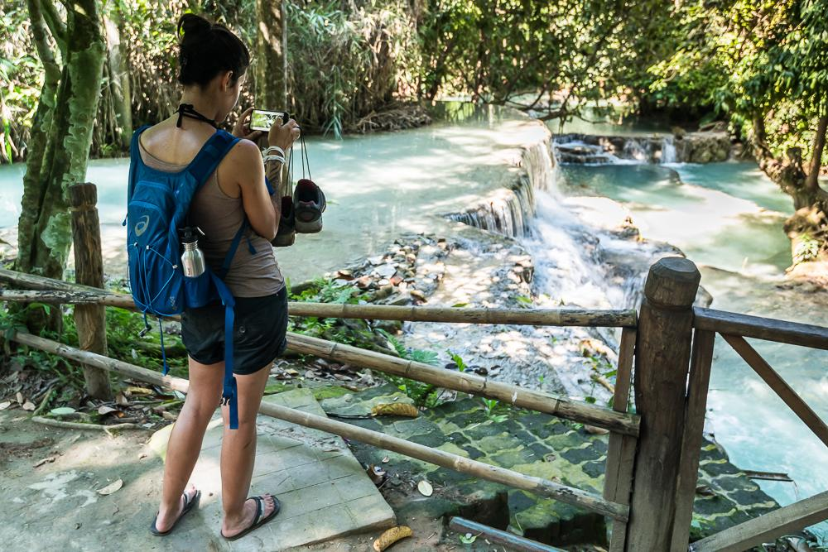
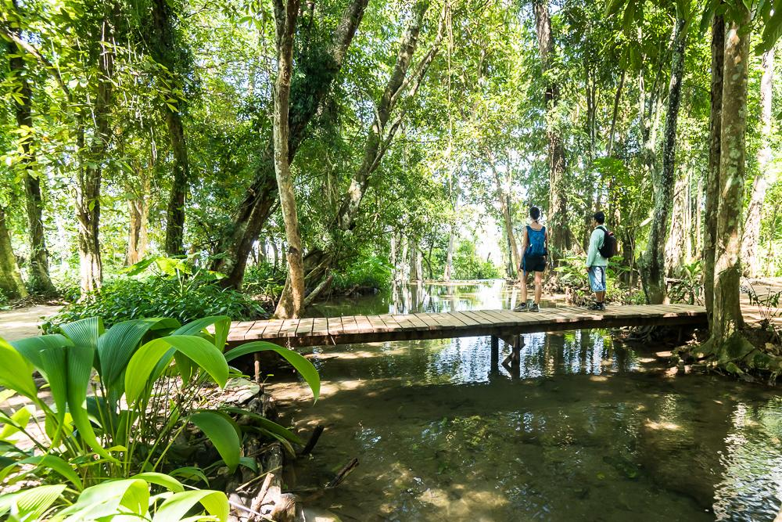
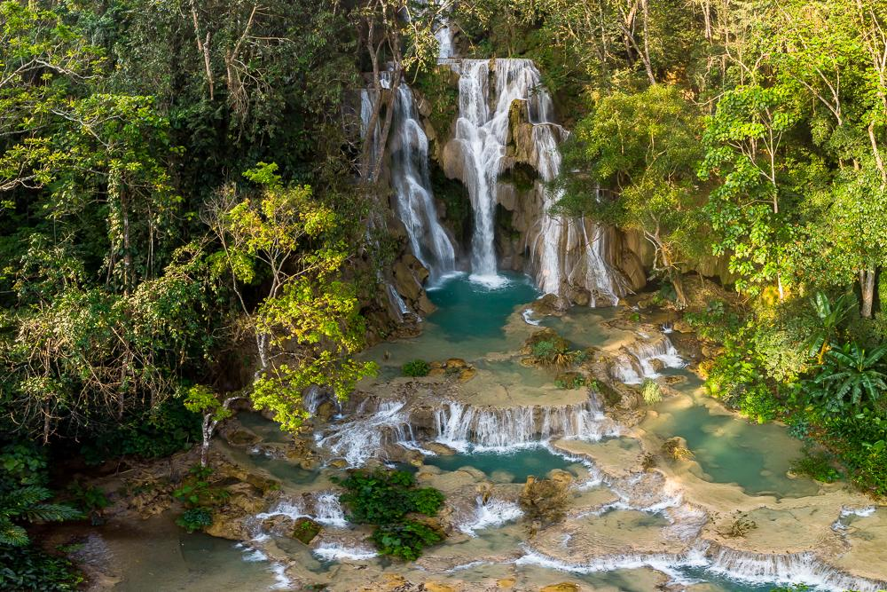
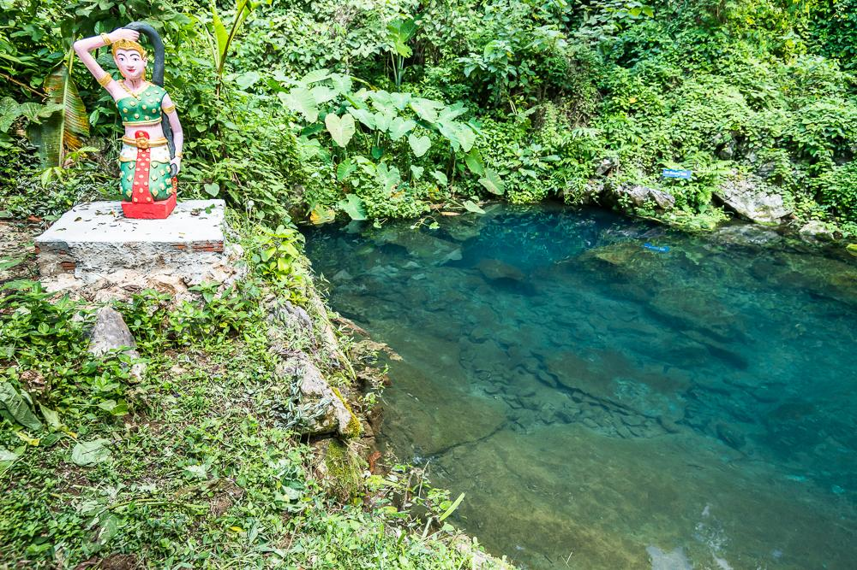
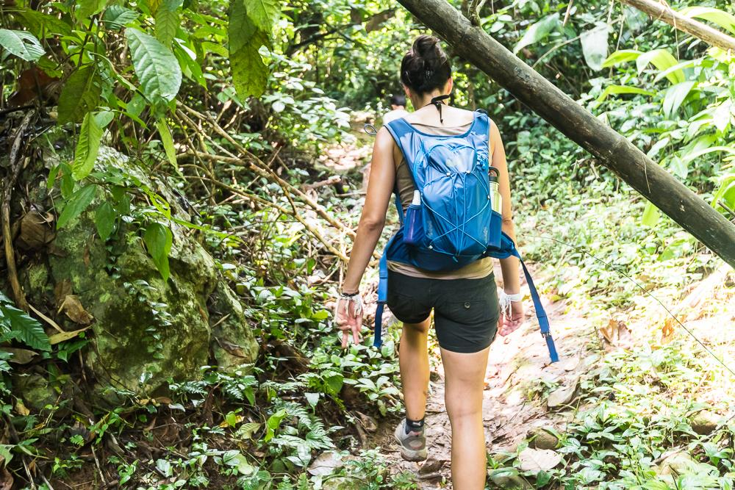
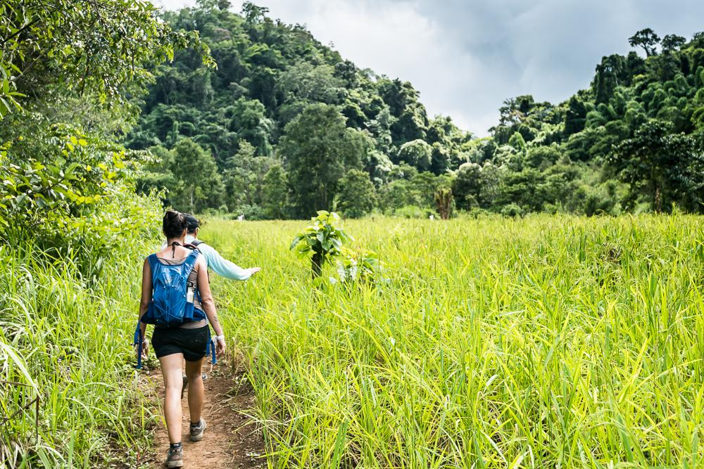

Easia Travel Head Office

Vietnam Head OfficeC/o: ATS Hotel, Suite 326 &327, 33B Pham Ngu Lao Street, Hanoi, VietnamTel: +84 24-39 33 13 62www.easia-travel.com

