CAMBODIA – Siem Reap – Discovery of Prek Toal’s Waterbirds and Floating Villages on Tonle Sap Lake
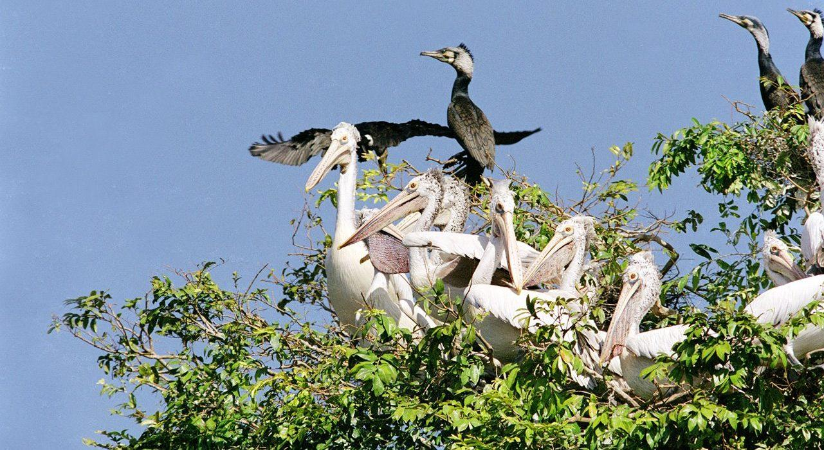

Over View

Theme
Art & Culture, Classic, Gastronomy, Sustainable

Country - City
Cambodia - Siem Reap

Market segment
Thematic Leisure

Price Level
$$$

Level of difficulties
LEVEL 0

Max pax
40

Seasonality
All year round excluding April to End of June. Best season for bird watching from Nov - Feb

Arrival city
Siem Reap

Departure city
Siem Reap

Description

Guests embark on a journey to discover the great Tonle Sap Lake, the largest freshwater lake in Southeast Asia and visit the Prek Toal floating village and an incredible bird sanctuary during this priceless experience.Dedicate your morning to a visit to the complex and biodiversity-rich Tonle Sap Lake. You will discover the secrets of Prek Toal Village and the natural and unique ecosystem of Southeast Asia’s largest waterbird breeding colony. The bird sanctuary is important for eight species of bird: the Spot-billed Pelican, Greater Adjutant, Lesser Adjutant, Milky Stork, Painted Stork, Black-headed Ibis, Oriental Darter, and Grey-headed Fish-Eagle. Thousands of commoner waterbirds also breed here, and over 150 species have been recorded.During the visit, discover the unique livelihoods of those living on the lake, where everything floats, from the pagoda to the school to the pharmacy!Experience locally cooked lunch in a floating restaurant managed by a local NGO and create a final memory: a water hyacinth handicraft workshop. A villager will teach you the traditional way of creating a colourful household item from the water hyacinth plant. Finally, you will wave goodbye to this water-world and head back to the mainland, Chong Kneas.

Can be combined with
Thematic Leisure
- CAMBODIA – Siem Reap – “Phare, The Cambodian Circus” Show
- CAMBODIA – Siem Reap – Attend a divine performance of The Sacred Dancers of Angkor
- CAMBODIA – Siem Reap – Visit the house of Mr Theam, Cambodia’s most famous artist
- CAMBODIA – Siem Reap – Savor Flavors like a Local

Selling points

- Prek Toal is the most beautiful and authentic floating village.
- Very preserved and peaceful atmosphere.
- The discovery of the Bird Sanctuary is magnificent, even for non-bird-lovers.

Sustainability

Level Of The Excursion
High – This activity strongly supports local communities and/or helps preserve the culture and environment

The Impact Of This Excursion

Social/cultural Impact
Cultural Conservation

Environment Impact
Transportation

Economic Impact
Local individual benefits

Additional Information
We combine with different local suppliers for this tour such as boat transfer, bird sanctuary, local lunch, and water hyacinth workshop with Osmos NGO. All the profits go directly to those local suppliers in Prek Toal Community.

Time And Transportation

From | To | Km | By | Duration | Road condition
Siem Reap | Chong Kneas pier | 15 | Car, Bus | 30 minutes | Good Road
Chong Kneas pier | Prek Toal |  | Boat | 1h30mins

Photos

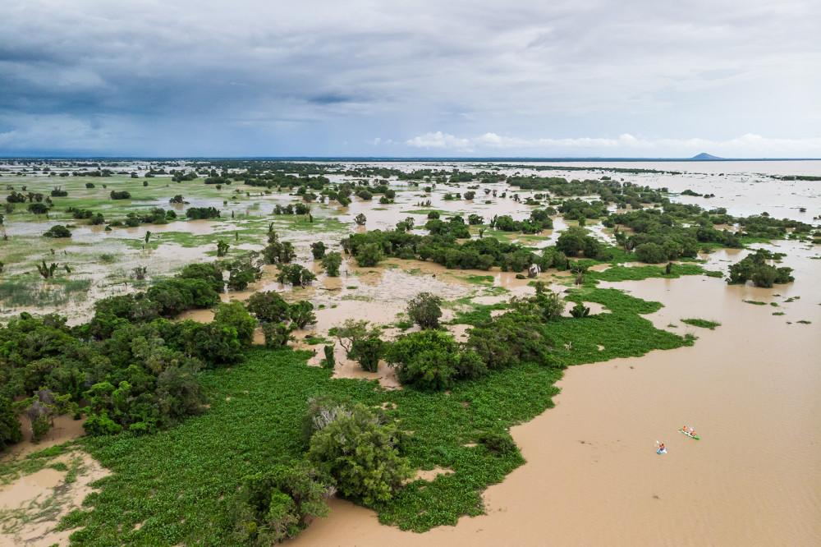
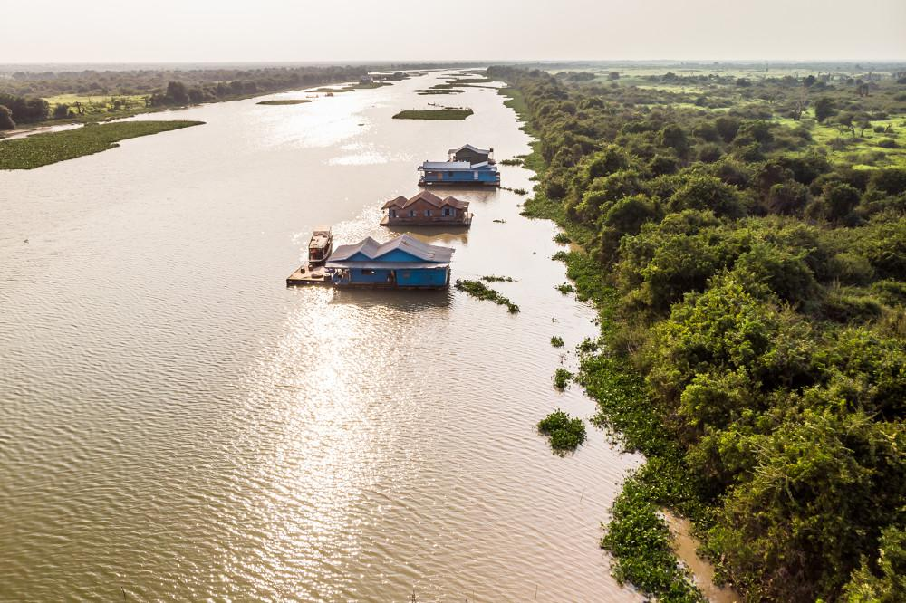
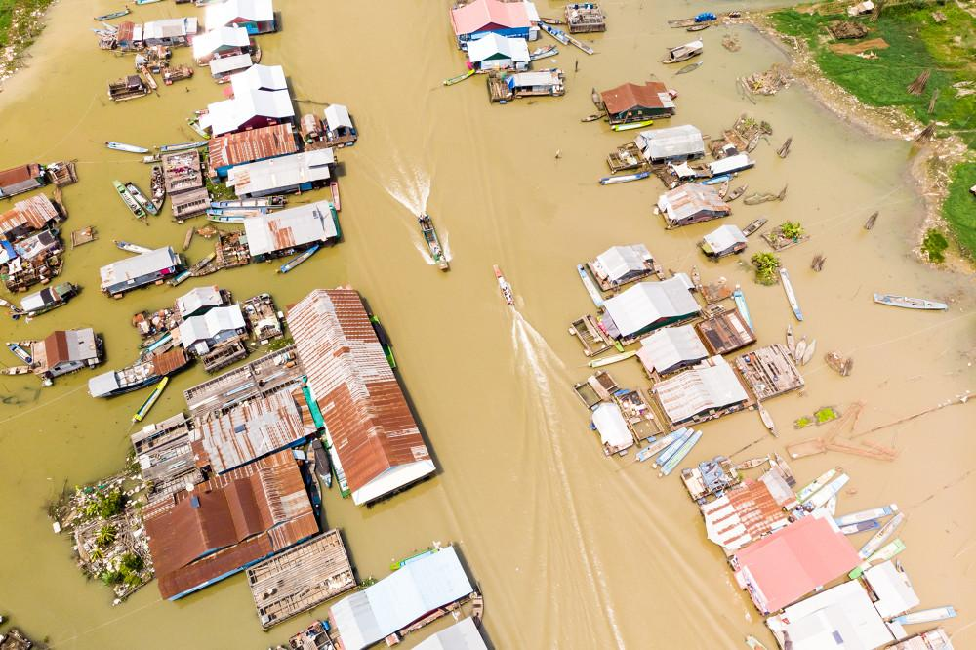
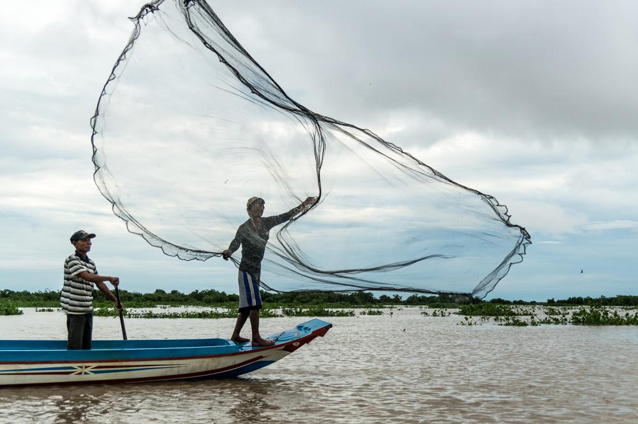
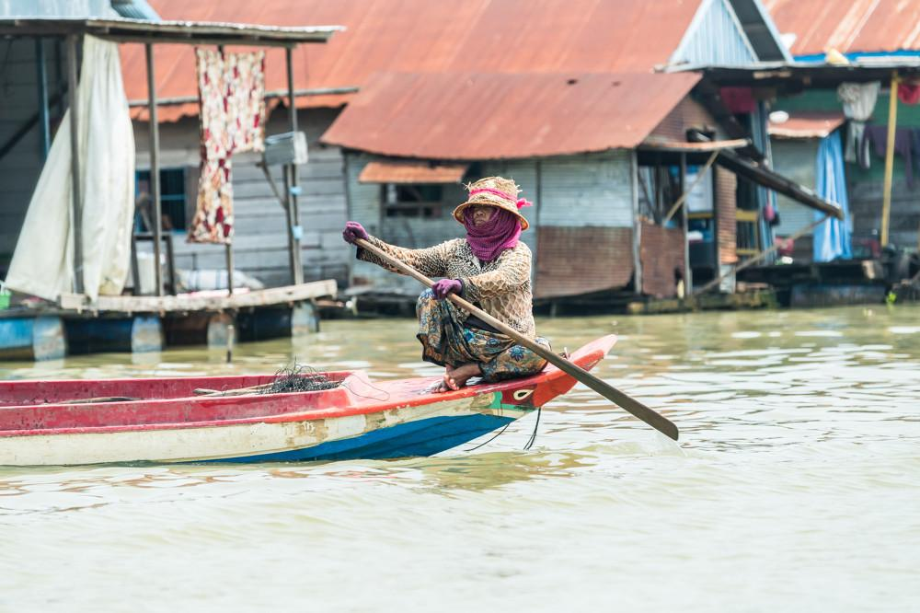
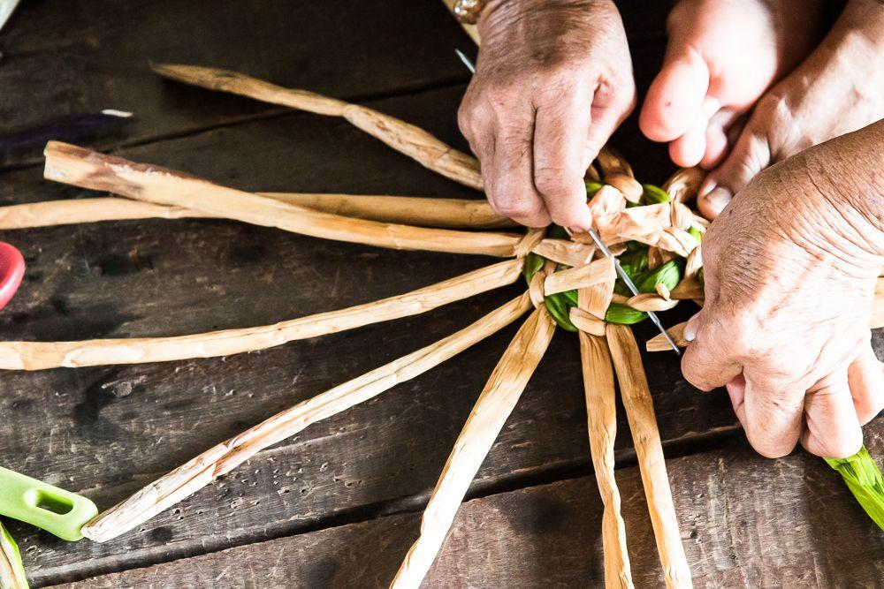
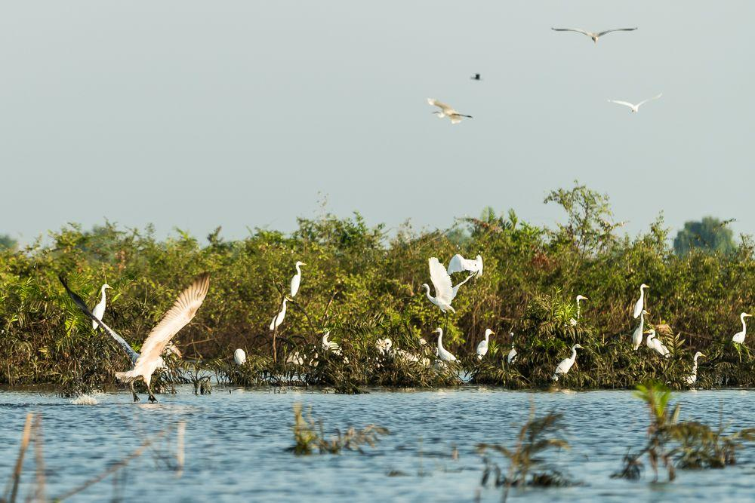

Easia Travel Head Office

