CAMBODIA – Siem Reap – Follow the Kulen Elephant Forest
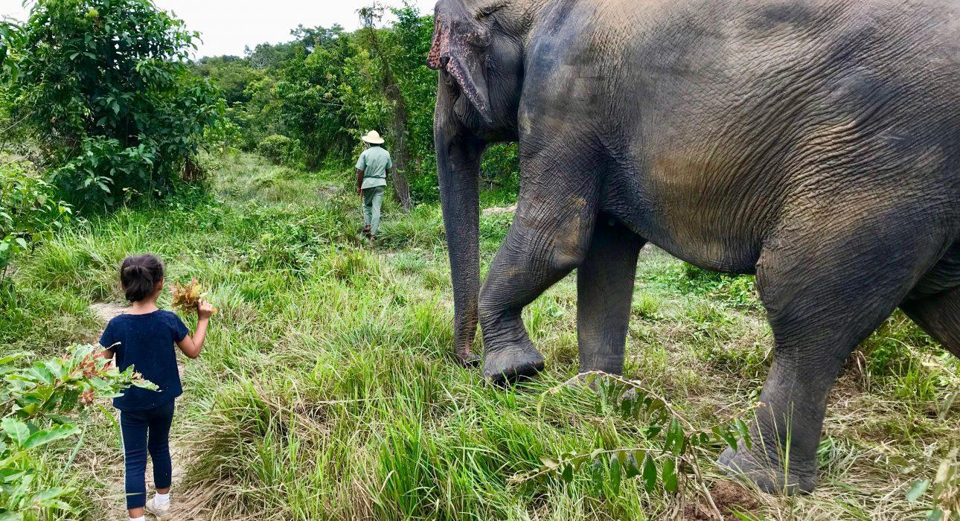

Over View

Theme
Classic, Family, Gastronomy, Sustainable

Country - City
Cambodia - Siem Reap

Market segment
Thematic Leisure

Price Level
$$$

Level of difficulties
LEVEL 0

Max pax
Elephant Session 12pax for join-in tour, 24pax for private tour, tailor-made private event for cocktail and dinner at 40pax.

Seasonality
All year long

Arrival city
Siem Reap

Departure city
Siem Reap

Description

The elephants at the Kulen Elephant Forest have spent most of their lives working in the tourism industry and are enjoying a long-awaited and well-deserved retirement.The Kulen Elephant Forest is a new retreat where the 14 retired elephants can interact freely and treat with excellent care and attention. There are no tricks, no riding at the reserve, and the elephants now roam and socialize unburdened within 400 hectares of lush forest. Here, they will rediscover relationships and natural foods they haven’t eaten in years.The visit showcases the wild’s awakening, the elephants walking out onto the field, and the forest coming to life. It was an incredible experience to meet the elephants and feed, walk with, and learn about them from charismatic, energetic, and knowledgeable guides.The main house is also memorable. The design and atmosphere; almost felt like a getaway bungalow/holiday house to serve the traveler as a lounge and dining area.

Selling points

- A fun, educational approach to elephant conservation, contributing as much as possible to preserve the remaining elephants of Cambodia.
- An easy excursion in the natural surroundings of Angkor offers an excellent addition to a temple visit.
- It is the closest place to Angkor to observe elephants.

Sustainability

Level Of The Excursion
High – This activity strongly supports local communities and/or helps preserve the culture and environment

The Impact Of This Excursion

Social/cultural Impact
Cultural Conservation, Empowerment and education

Economic Impact
Community benefits

Additional Information
The Kulen Elephant offers peaceful retirement to the elephants of Angkor but also supports the local community through sustainable development initiatives such as purchasing 3 tons of agricultural products a day to feed the elephants. Moreover, people of the community are prioritized for gainful employment, plus provide resources to the community fund to finance local projects.

Time And Transportation

From | To | Km | By | Duration | Road condition
Siem Reap Town | Kulen Elephant Forest Sanctuary | 40 | Car / Minivan | 1hour | Good

Photos

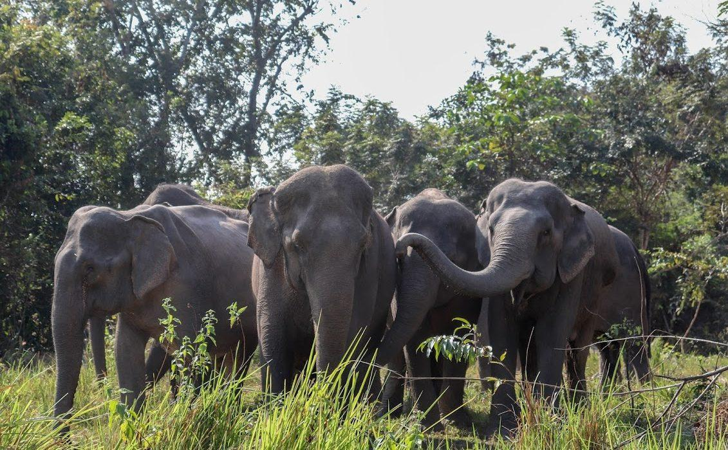
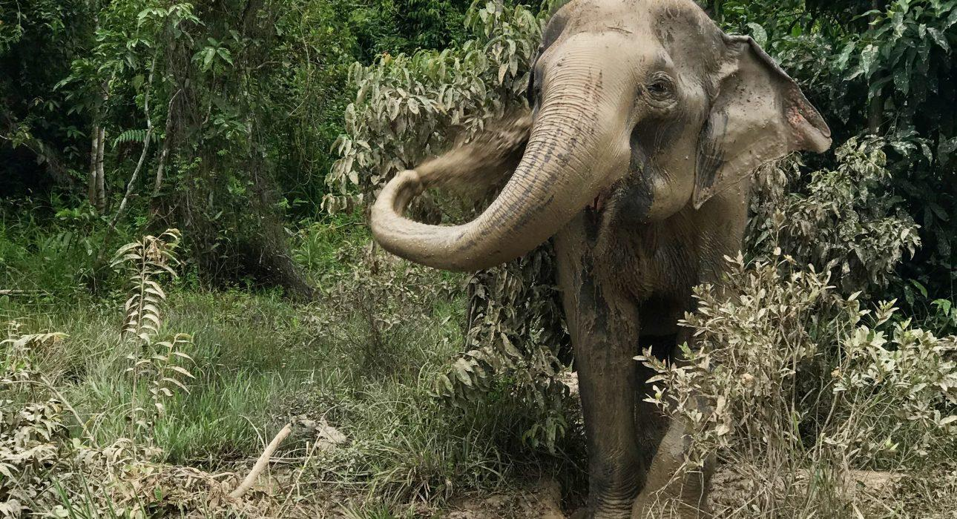
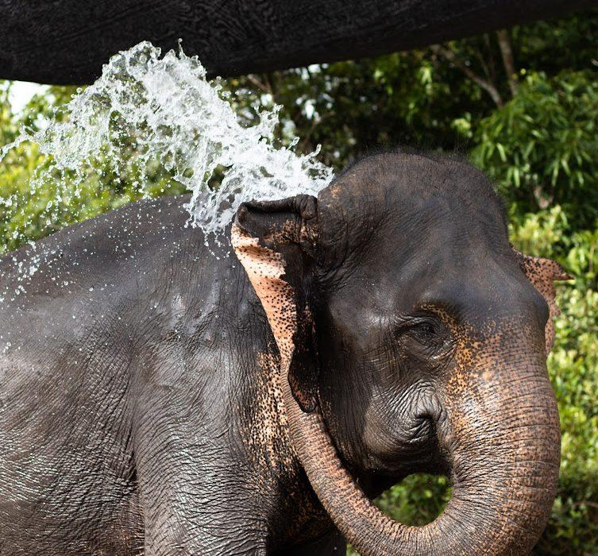
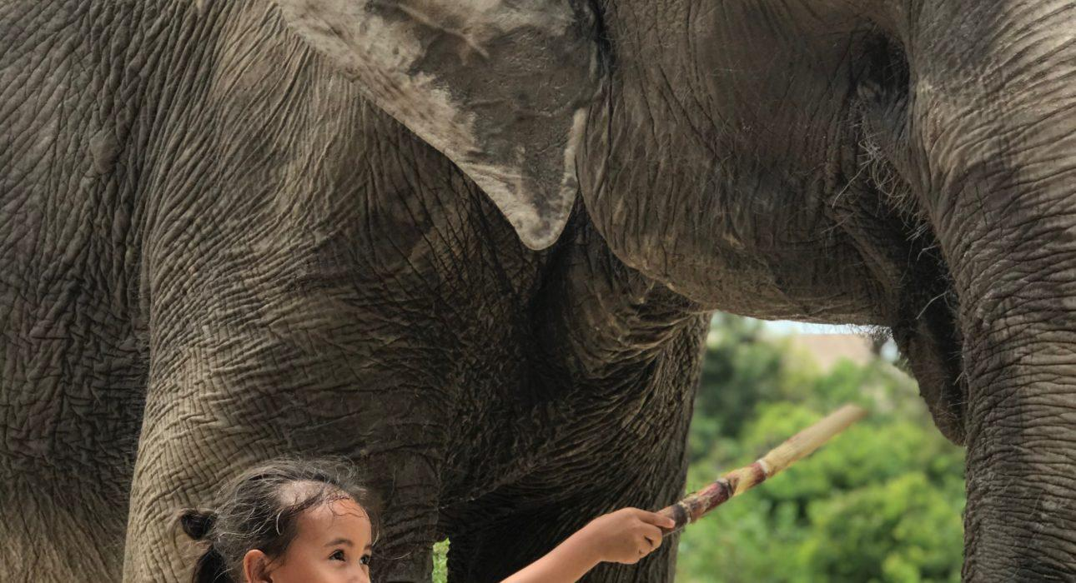
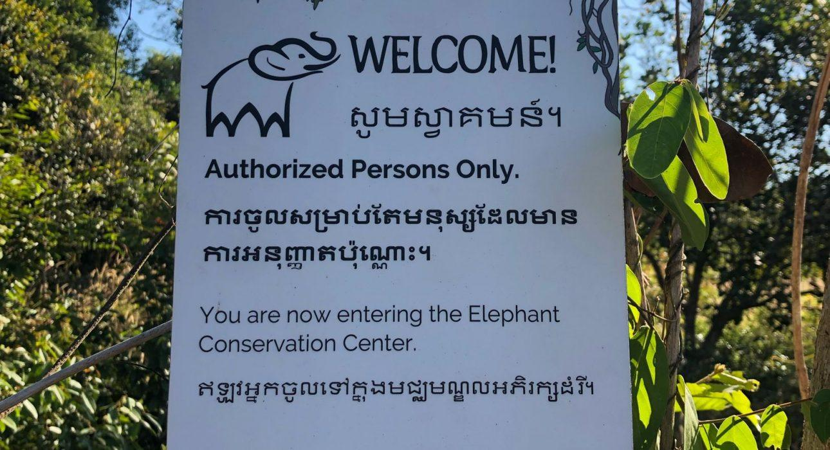
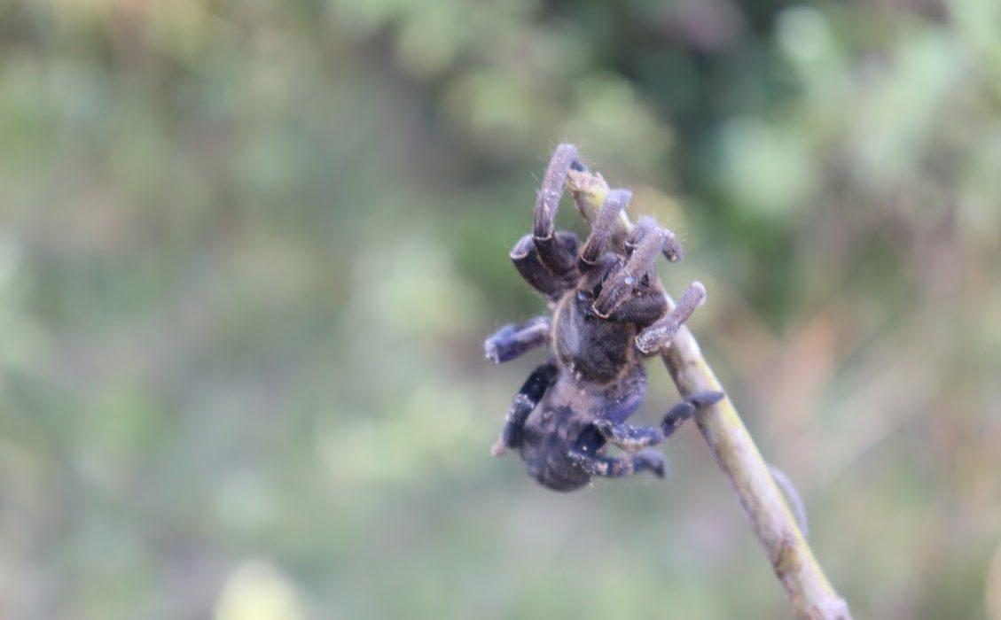
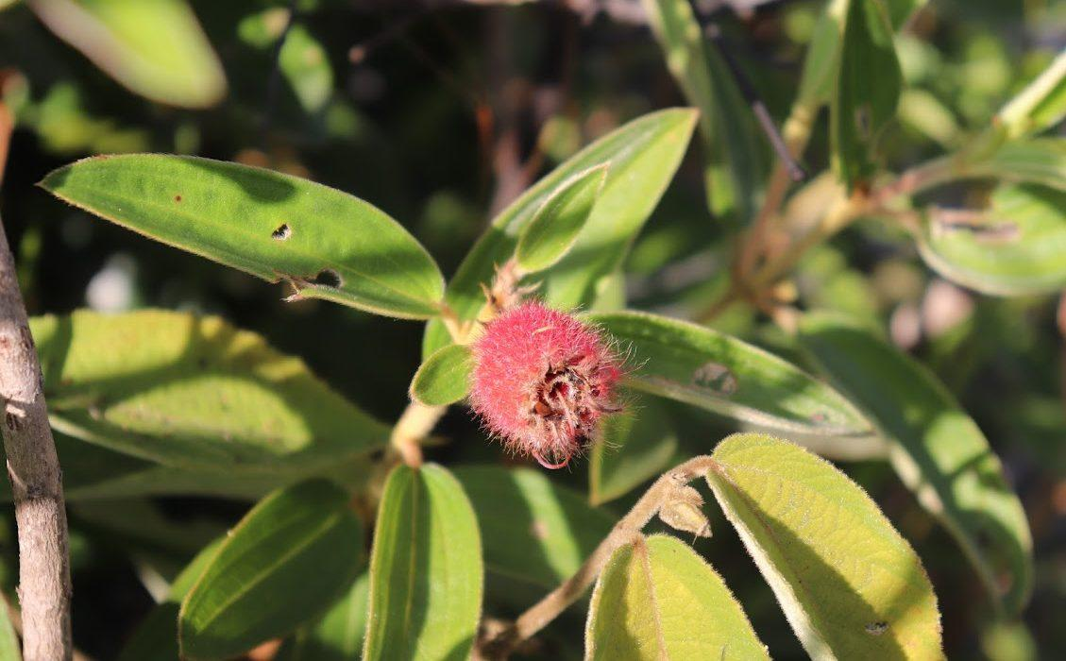
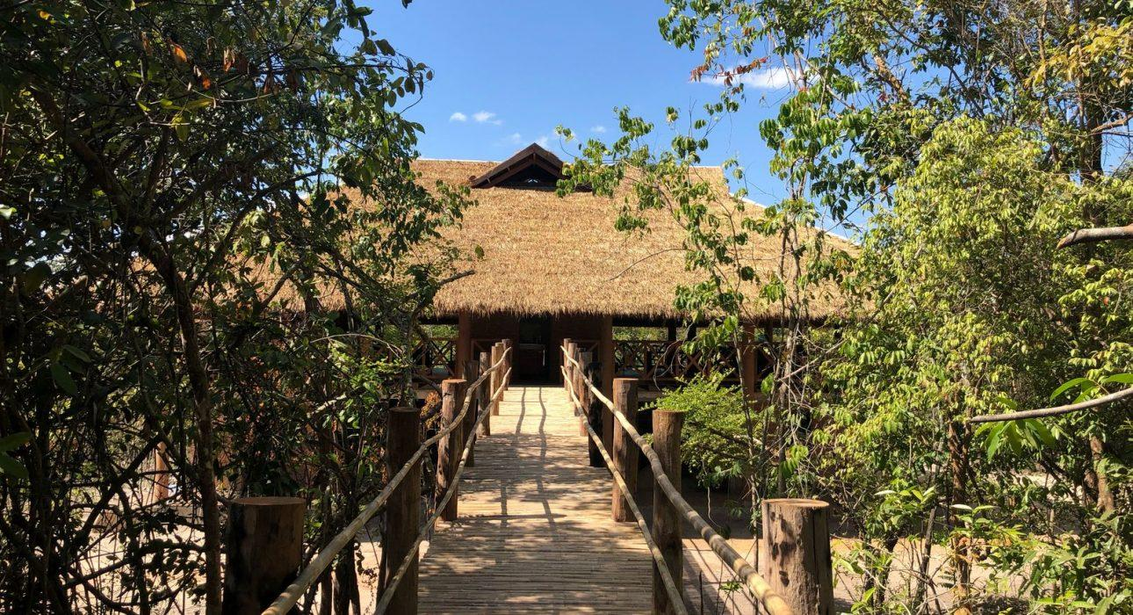
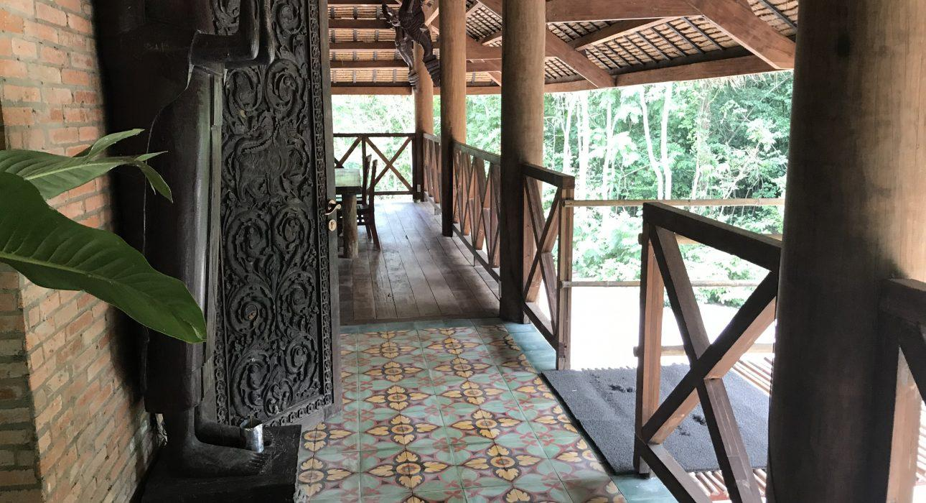
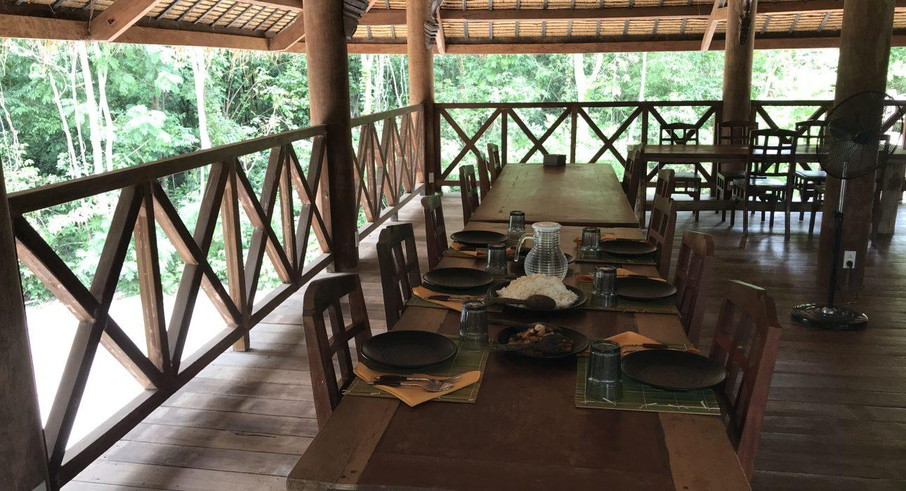

Easia Travel Head Office

