THAILAND – Phuket – Immerse in a Local Community at Coconut Island
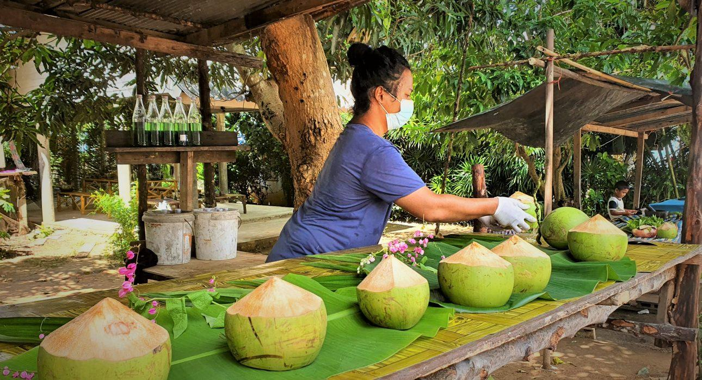

Over View

Theme
Art & Culture, Beach Stay, Classic, Family, Honeymoon, Sustainable

Country - City
Thailand - Phuket

Market segment
Groups, Thematic Leisure

Price Level
$$$$

Max pax
30

Seasonality
Possible all year round, but subject to weather conditions (best period from November to February)

Arrival city
Phuket

Departure city
Phuket

Description

Within easy reach from Phuket’s mainland, a handful of islands have been largely untouched by tourism. One of those islands is Coconut Island, home to a friendly fishing community that still adheres to their traditional lifestyle. This excursion allows escaping Phuket’s developed areas and steps back into the past as guests spend time in the community while getting hands-on experience during interactive moments with the locals. It is the perfect way to get to know local life while still staying within easy reach of Phuket’s convenience and comfort. The friendly atmosphere and the local feeling make it an unforgettable experience.

Selling points

- An authentic, community-based experience within easy reach of Phuket
- Great for a wide range of clients, from families to couples to groups with interest in local life
- It can be done as a half-day or as a full day with beach time included
- A combination of fun transportation, using a boat and motorbike side-car

Sustainability

Level Of The Excursion
Medium – This activity offers tangible positive contributions to the local community, culture and/or environment

The Impact Of This Excursion

Social/cultural Impact
Cultural Conservation, Empowerment and education

Environment Impact
Waste/plastic packaging, Transportation

Economic Impact
Local individual benefits, Community benefits

Additional Information

Positive impacts
The activity takes place in an island community where guests learn about traditions and the local way of living. There is active participation during various activities, which are all organized and taken care of by members of the community. This way income is generated while at the same time preserving traditions.

Negative impacts
The boat and trishaw used during the activity uses fossil fuel which causes Co² emissions.

Time And Transportation

From | To | By | Km | Duration | Road condition
Patong Area | Laem Hin Pier | Car | 20 | 30 minutes | - Good  - Traffic jams possible
Mai Khao Area | Laem Hin Pier | Car | 30 | 40 minutes | - Good  - Traffic jams possible
Cape Panwa Area | Laem Hin Pier | Car | 25 | 35 minutes | - Good  - Traffic jams possible
Laem Hin Pier | Coconut island | Boat | 0.8 | 5 minutes | - Good

Photos

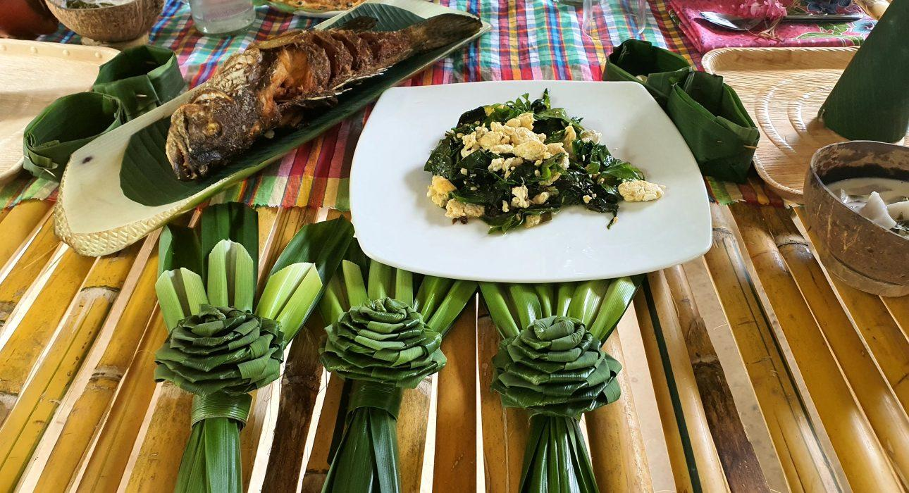
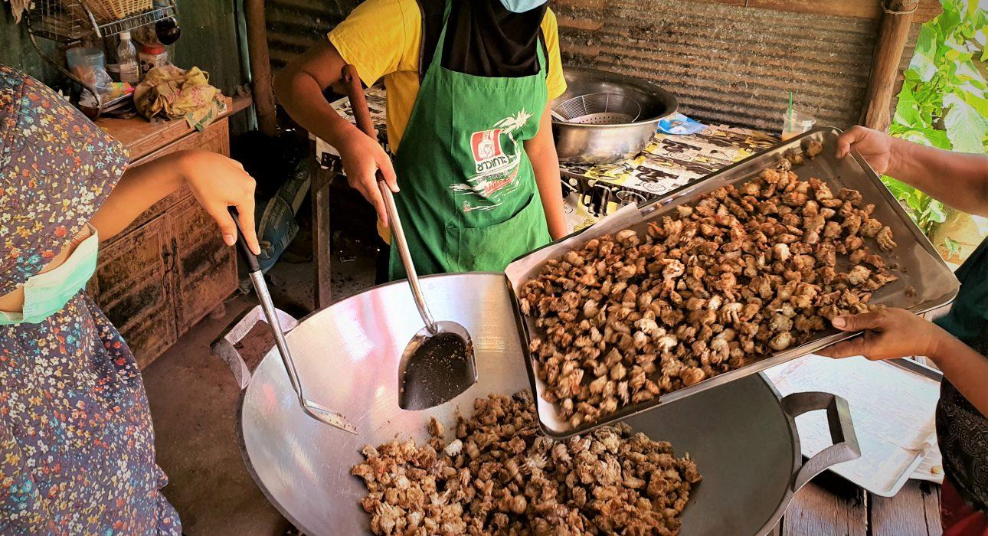
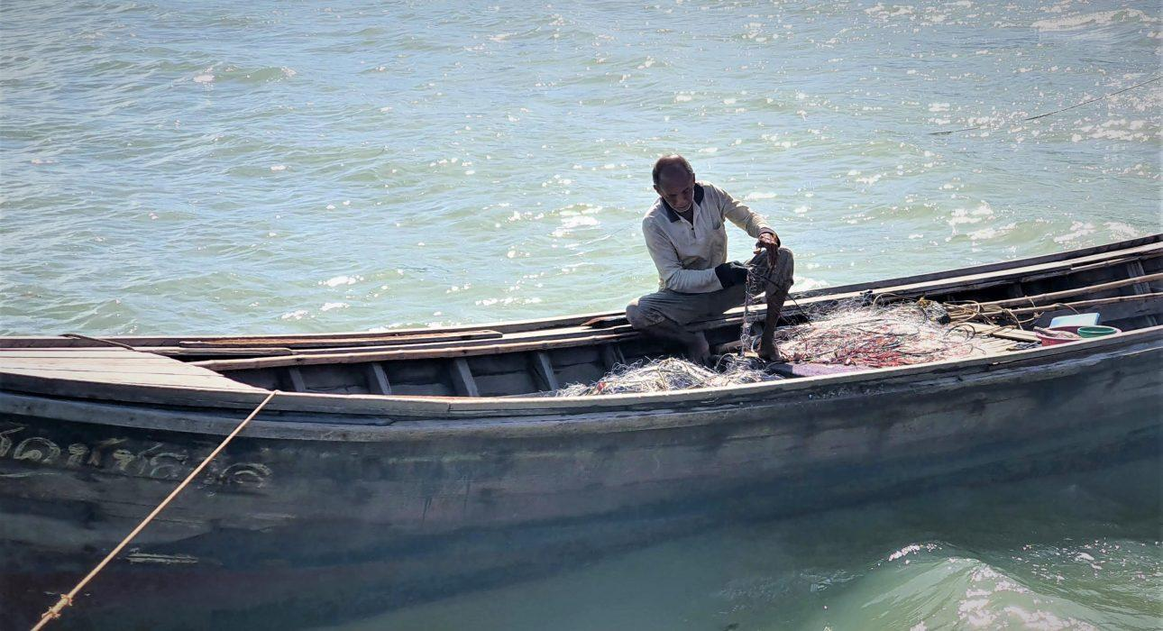
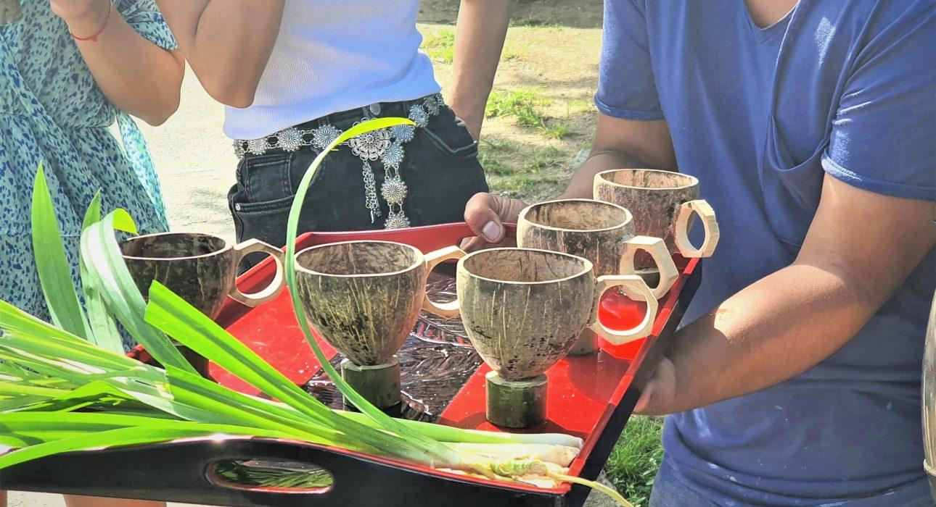
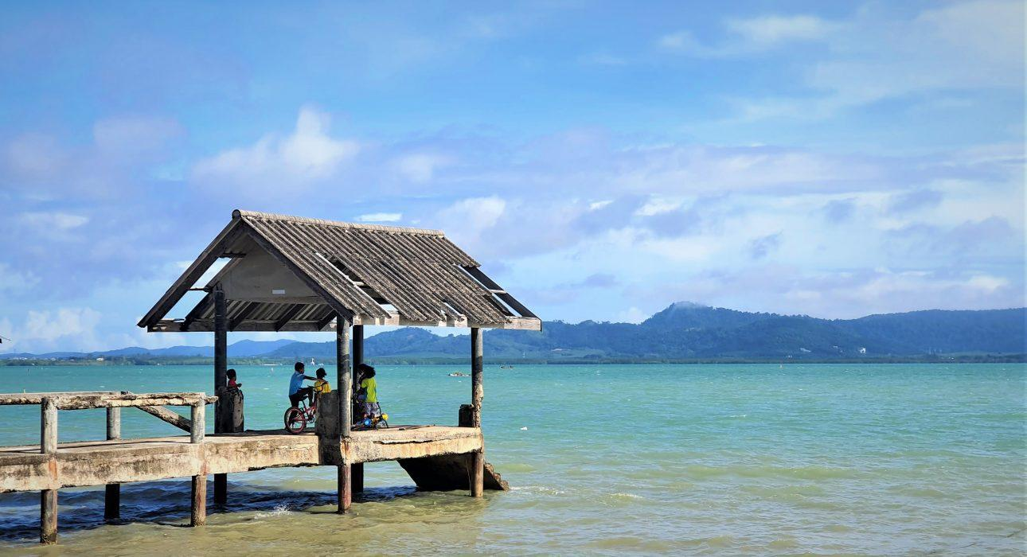
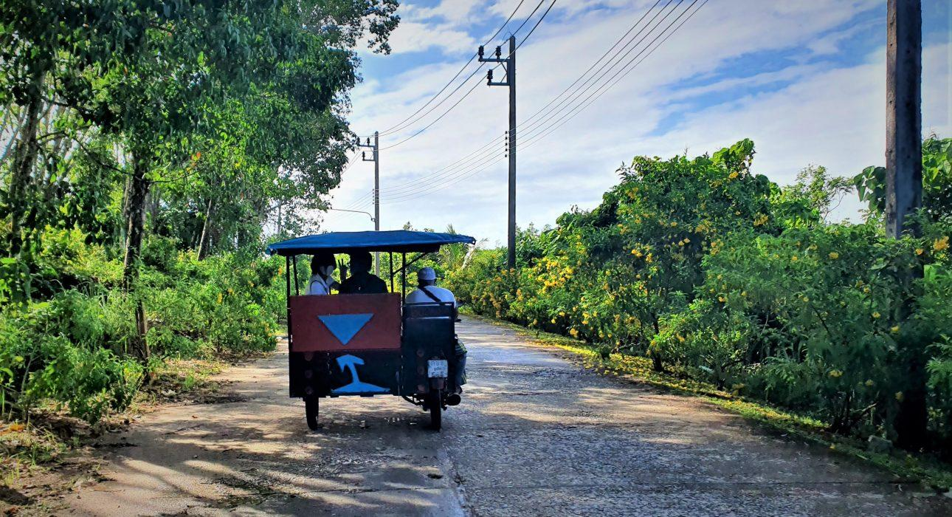

Easia Travel Head Office

Vietnam Head OfficeC/o: ATS Hotel, Suite 326 &327, 33B Pham Ngu Lao Street, Hanoi, VietnamTel: +84 24-39 33 13 62www.easia-travel.com

