CAMBODIA – Siem Reap – Tonle Sap Cruise
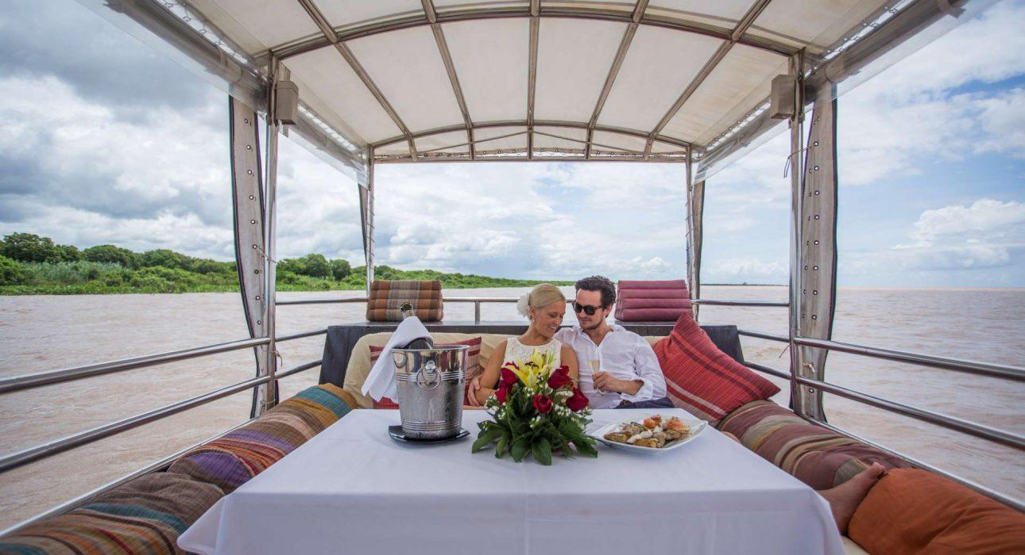

Over View

Theme
Classic, Cruise & River Cruise, Family, Gastronomy, Honeymoon, Sustainable

Country - City
Cambodia

Market segment
Thematic Leisure

Price Level
$$$$

Level of difficulties
LEVEL 0

Max pax
7 pax

Seasonality
Mid July - January

Arrival city
Siem Reap

Departure city
Siem Reap

Description

The Tonle Sap lake is the largest freshwater lake in Southeast Asia and one of the world’s most diverse and productive ecosystems. Today, travelers will experience the Tonle Sap Lake exception with a private cruise on a well-equipped boat, comfortable cushion to see the Great Lake from a different perspective.This luxury boat ride offers a cruise to Kampong Phluk village, which is stilted rather than floating, with its buildings raised upon high wooden pillars. The place is also interesting for its particular flooded forest that travelers will discover in small paddle boats. Delicious picnic onboard while admiring the immensity of the Lake.

Can be combined with
Thematic Leisure
- Savor Flavors like a Local
- A sweet moment with the NGO Bayon Pastry School
- A moment with the NGO Eco Soap Bank Cambodia
- Attend a divine performance of The Sacred Dancers of Angkor
- “Phare, The Cambodian Circus” Show

Selling points

- Discovery of the daily life on and around the great Tonle Sap Lake with a private and comfortable cruise.
- They were sightseeing the exciting village of Kampong Phluk, which is stilted rather than floating with its particular flooded forest.
- Great feeling of exclusivity and personal service.

Sustainability

Level Of The Excursion
Medium – This activity offers tangible positive contributions to the local community, culture and/or environment

The Impact Of This Excursion

Environment Impact
Transportation

Economic Impact
Local individual benefits, Community benefits

Additional Information
This tour is a combined service from an individual to a community such as Tonle sap lake community including entrance fee, boat and cooking.

Time And Transportation

From | To | Km | By | Duration | Road condition
Siem Reap | Chong Kneas pier | 15 | Car, Bus | 30 minutes | Good Road
Chong Kneas pier | Kampong Phluk Village |  | Boat | 2 hours
Kampong Phluk | Siem Reap | 32 | Car Bus | 1 hour | Good Road

Photos

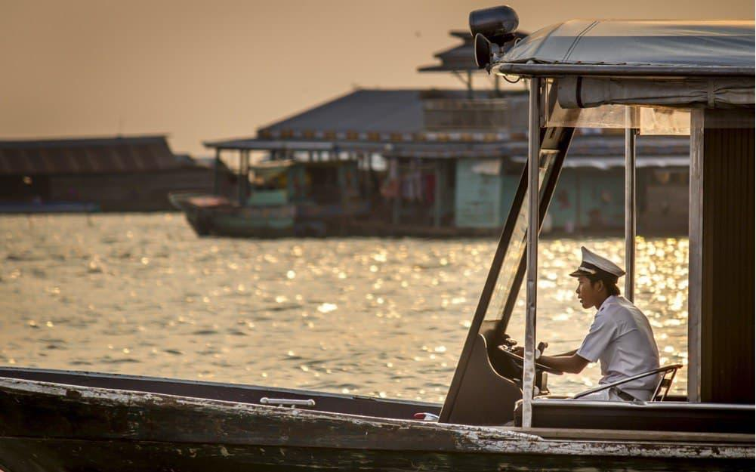
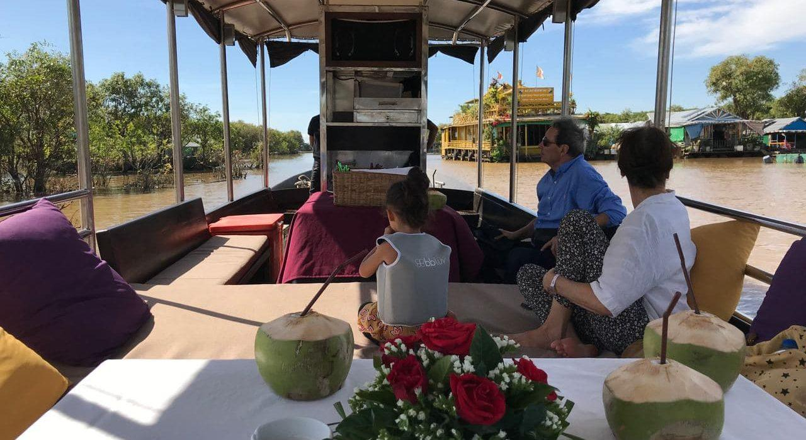
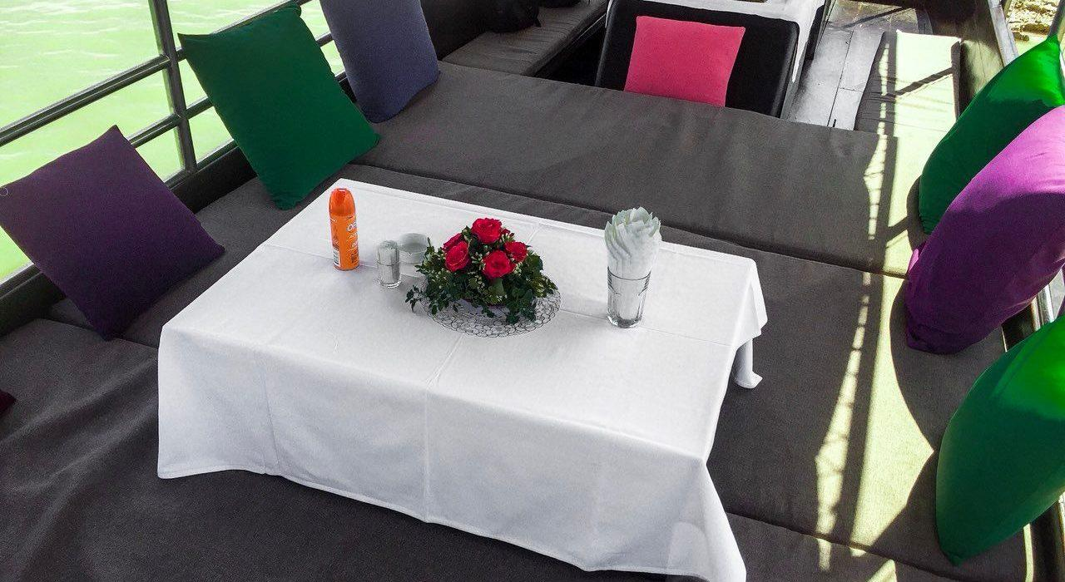
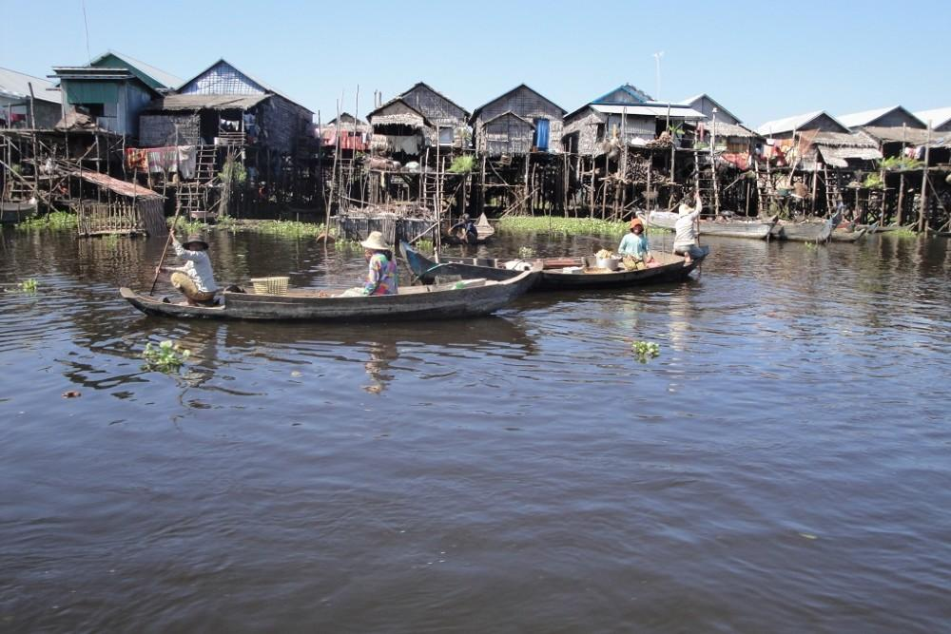
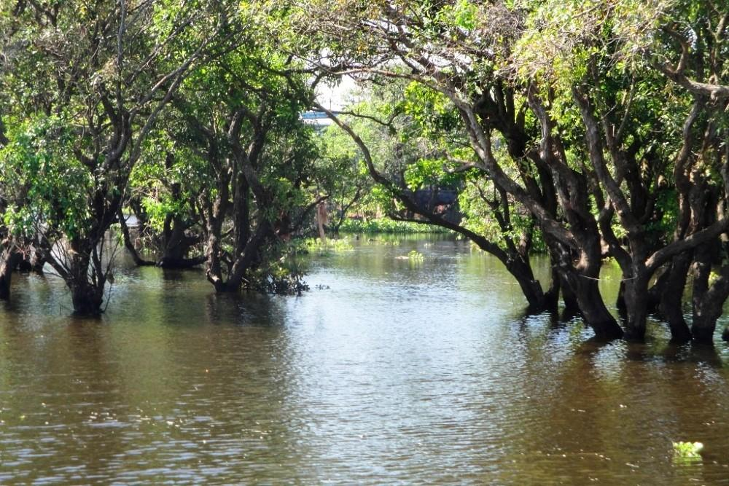

Easia Travel Head Office

