THAILAND – Bangkok – Discover Old & New at Chinatown’s “Little Market”
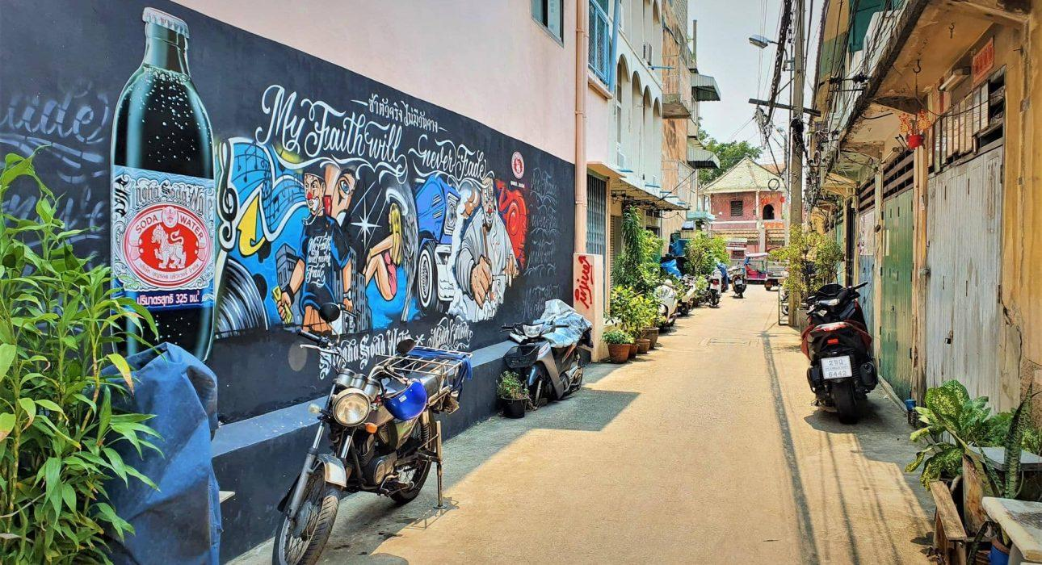

Over View

Theme
Art & Culture, Classic, Family, Honeymoon

Country - City
Thailand - Bangkok

Market segment
Thematic Leisure

Price Level
$

Level of difficulties
LEVEL 0

Max pax
10

Seasonality
Possible all year round, but subject to weather conditions

Arrival city
Bangkok

Departure city
Bangkok

Description

During this walking tour guests get to discover “Talad Noi” which translates as “Little Market”, a community located on the outskirts of Chinatown, brimming with history and local life. However, the neighborhood has more going for it than just its history; in recent years it has become a trendy place to enjoy colorful street art, sip craft coffee or try local snacks. Talad Noi is sure to surprise guests with its charm and unique mix of old and new and there are some exciting dining options that can be included before or after the walk.

Selling points

- Combines old and new, with plenty of history but also interesting new touches like street art
- A trendy neighborhood that is in full expansion
- Easy to combine with other activities in Bangkok
- Easia Signature

Sustainability

Level Of The Excursion
Medium – This activity offers tangible positive contributions to the local community, culture and/or environment

The Impact Of This Excursion

Social/cultural Impact
Cultural Conservation, Empowerment and education

Environment Impact
Transportation

Economic Impact
Local individual benefits, Community benefits

Additional Information

Positive impacts
The activity takes place in local a community and is done by walking which does not have a negative impact on the environment. Moreover, multiple visits to shops and shrine bring some income to local businesses and the community.

Negative impacts
No negative.

Time And Transportation

From | To | By | Km | Duration | Road condition
Grand Palace | Chinatown gate | Car | 3 | 20 minutes | - Good  - Traffic jams are likely
Siam Square | Chinatown gate | Car | 4 | 15 minutes | - Good  - Traffic jams are likely
Suvarnabhumi Airport | Chinatown gate | Car | 30 | 35 minutes | - Good  - Traffic jams possible

Photos

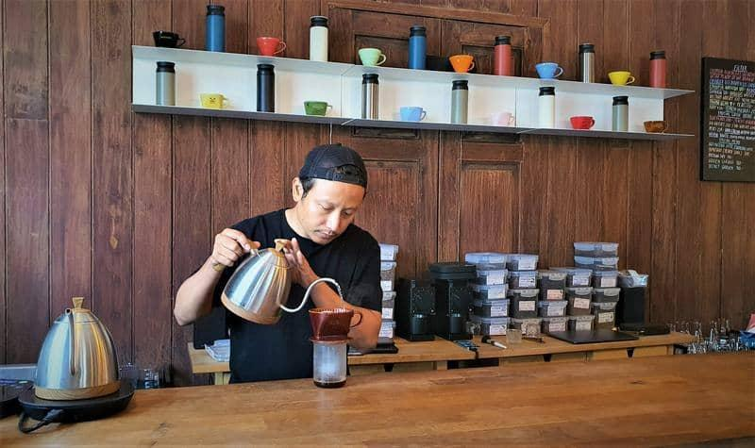
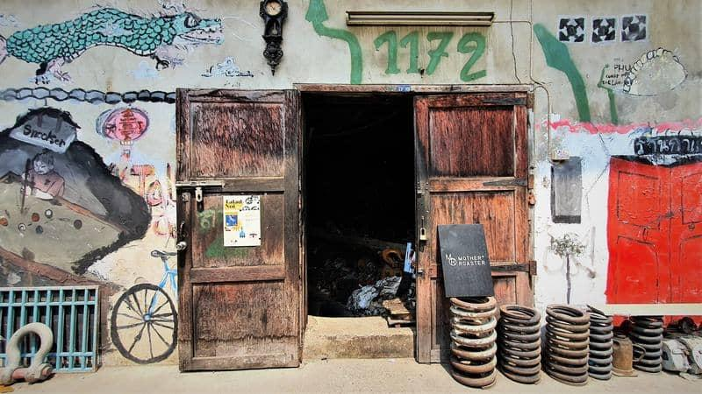
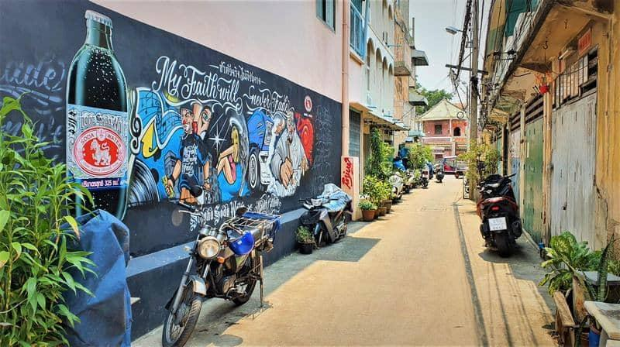
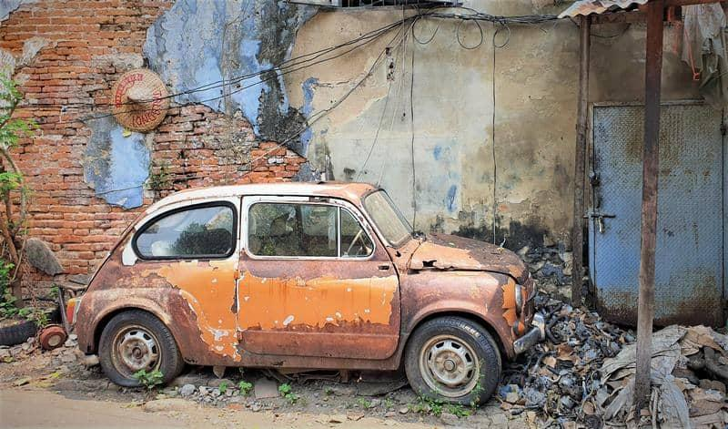
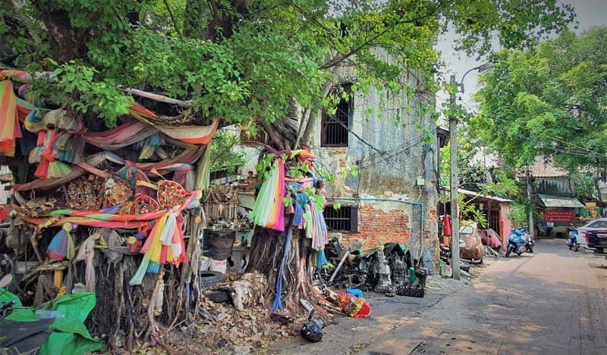
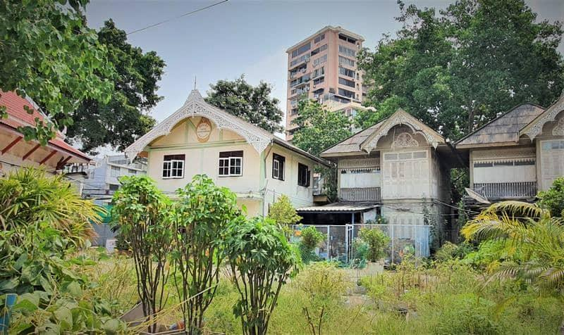
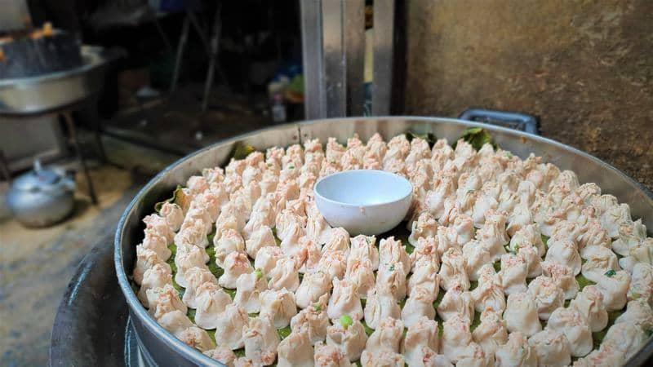
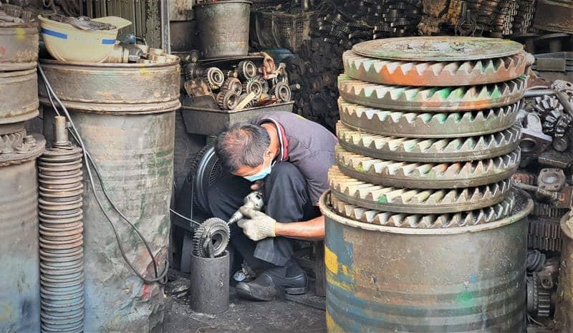

Easia Travel Head Office

