CAMBODIA – Siem Reap – A Quiet Escape in a Countryside
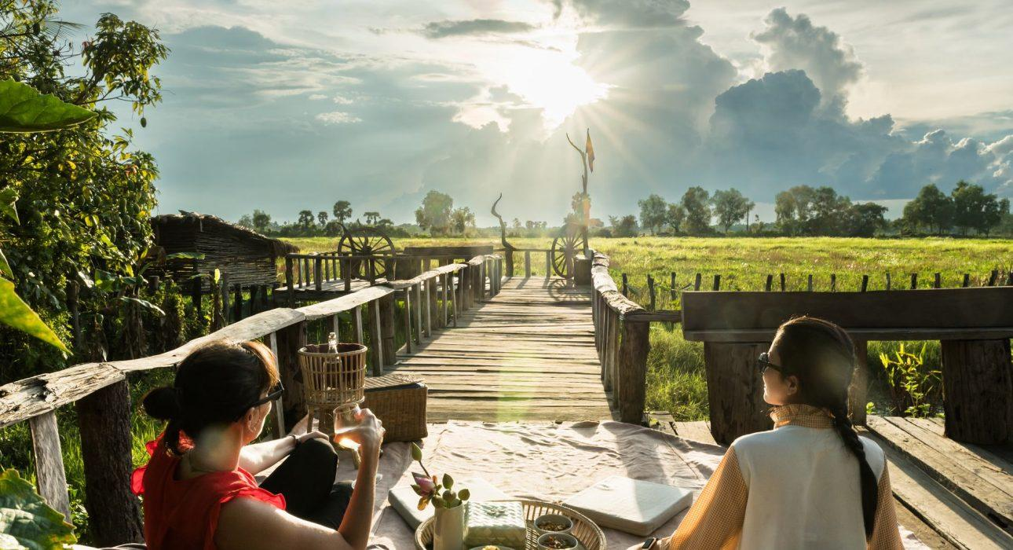

Over View

Theme
Art & Culture, Classic, Family, Honeymoon

Country - City
Cambodia - Siem Reap

Market segment
Groups, Thematic Leisure

Price Level
$$$

Level of difficulties
LEVEL 0

Max pax
16pax max for lunch, breakfast, and yoga. 40pax max for aperitif &amp; buffet dinner, 70pax max for aperitif

Seasonality
Lunch, breakfast and yoga all year long. For aperitif &amp; Dinner preferably from October to May

Arrival city
Siem Reap

Departure city
Siem Reap

Description

Located a few kilometers from the temples of Angkor and Siem Reap, a peaceful and green place awaits the traveler at the end of his day of discovery for a moment of relaxation.BreakfastThe friendly inhabitants of the village will welcome you with a smile and “Chum Reab Sou” (‘Hello’ in Khmer) while a Khmer gourmet breakfast will await you. Num banh chok,”Khmer noodles,” is a traditional Cambodian dish you can try for breakfast today. The rice noodles are hand-made using stone or wooden mills and then topped with fish gravy and fresh vegetables such as banana blossoms, cucumbers, and water lily stems. Fresh bread, jam, and tropical fruits are also available, while hot tea and coffee are served for this pleasant, serene moment.LunchLocated on the edge of a large field that stays green year-round, it is the perfect setting to relax and escape the midday heat while enjoying a delicious meal. Lunch is served in traditional ware and consists of three courses, including freshly grilled bread and a typical Khmer stew as the main course.Dinner This evening, you leave the hustle and bustle of the city behind to immerse yourself in the Cambodian countryside and enjoy a buffet dinner under the stars. In a village north of Angkor, surrounded by lush vegetation in the softness of the night, all the elements are brought together to share a peaceful, rural moment with exotic flavors.Sunset AperitifA peaceful and green place awaits the traveler at the end of his day of discovery for a moment of relaxation around a drink and some amuse-bouche. The sky is colored, the lights are rays, and the day gives way to dusk in the beautiful Cambodian countryside; the moment is perfect and unforgettable.YogaNestled in the countryside, located on the edge of a large field, an ancient baray that remains green all year round, it is the perfect spot for yoga practitioners of all levels. Here, a professional yoga instructor will lead you to develop greater strength and flexibility with a series of exercises designed to bring you closer to self-discovery and a healthy way of living. Let the peaceful yoga experience unite the energy that flows through your mind, body, and spirit.

Selling points

- A magic moment to enjoy easily combined with temple discovery
- The beautiful view of Cambodian countryside
- Green all year long
- Easia Signature Activity
- Always private, suitable for FIT or GIT/MICE depending on the activity chosen
- Easy and short access from the temple area

Sustainability

Level Of The Excursion
Medium – This activity offers tangible positive contributions to the local community, culture and/or environment

The Impact Of This Excursion

Economic Impact
Local individual benefits

Additional Information
This activity combines different individual local supplies such as drinks, meals, as well as the location in a preservation area.

Time And Transportation

From | To | km | By | Duration | Road Condition
Siem Reap | Preah Dak Land | 15km | vehicle | 30 minutes | Good
Srah Srang | Preah Dak Land | 5km | vehicle | 10 minutes | Good

Photos

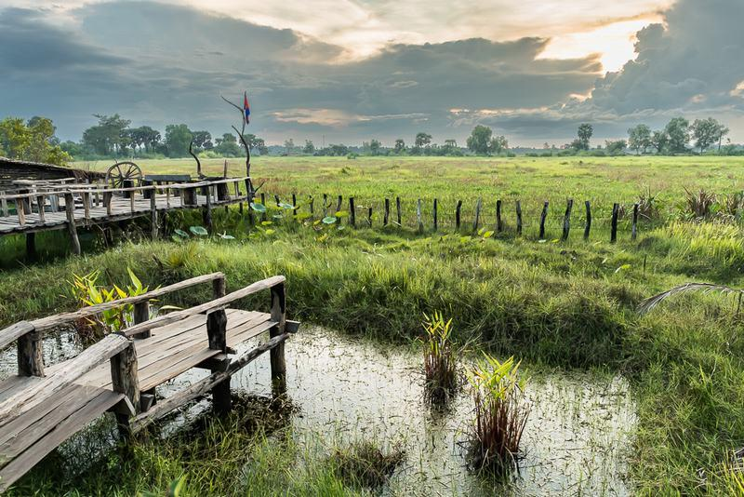
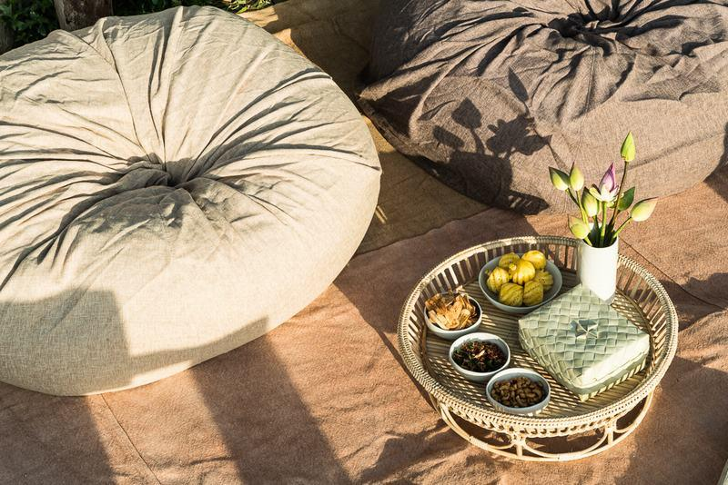
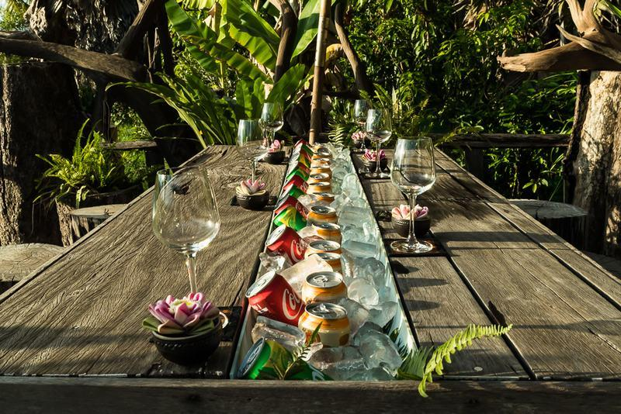
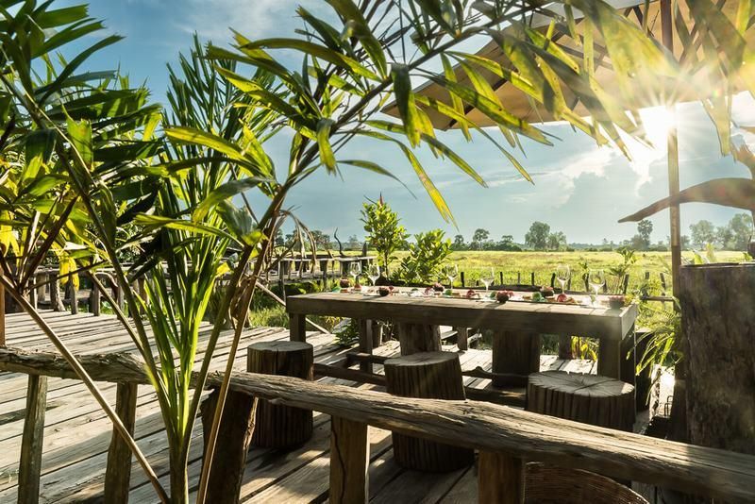
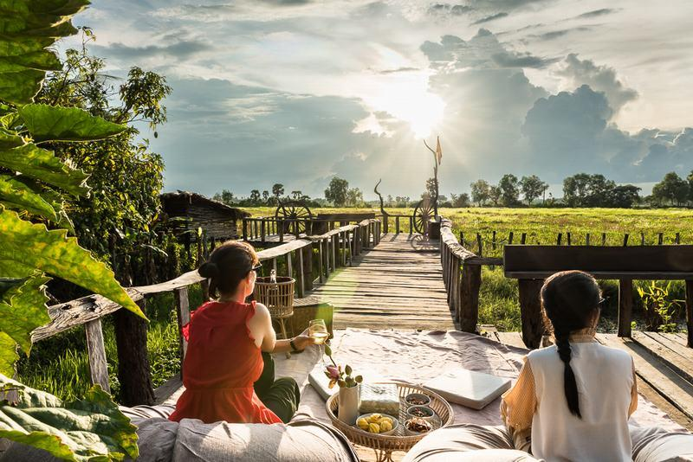
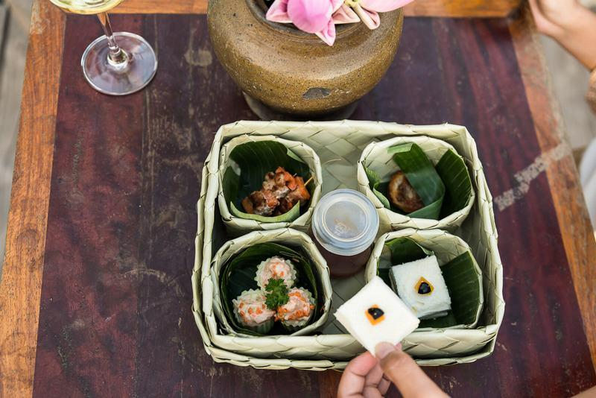
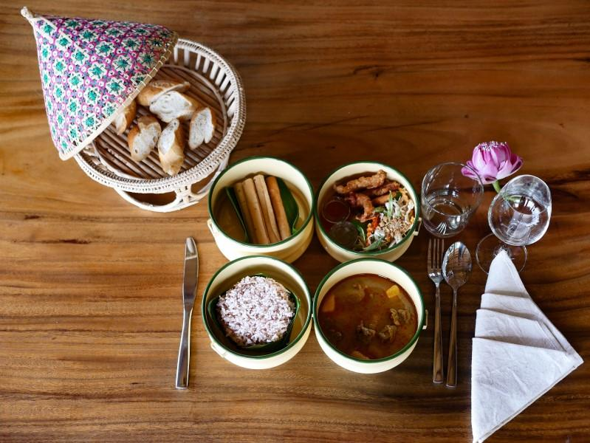
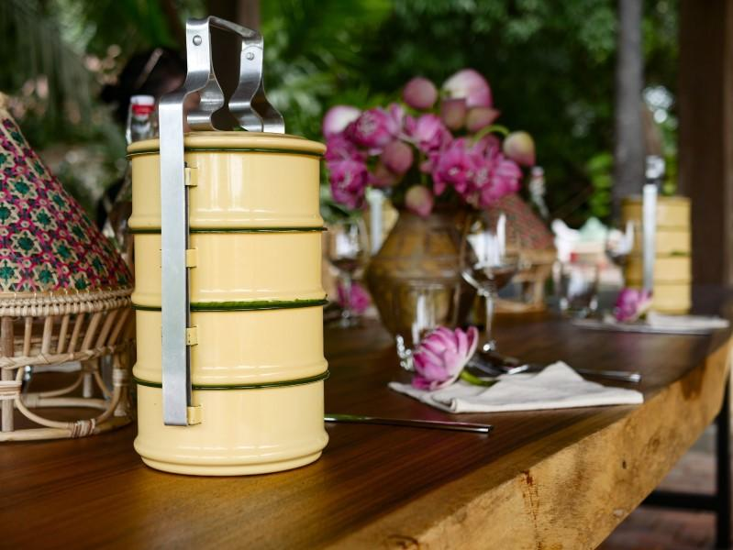
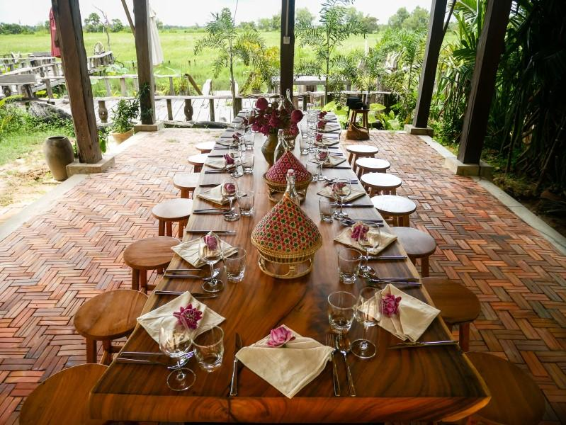
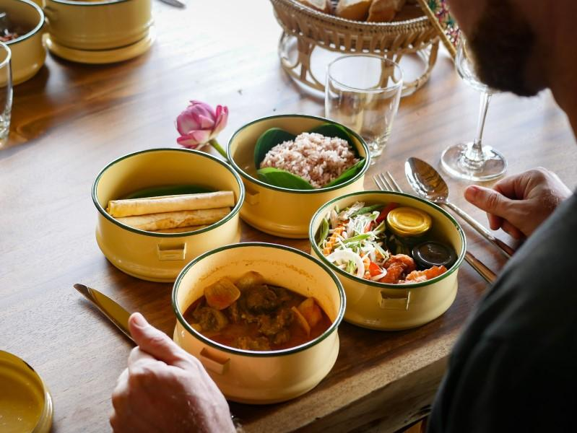
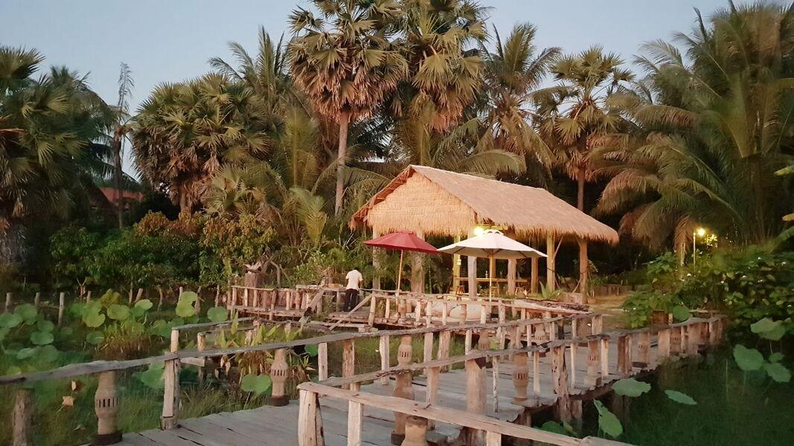
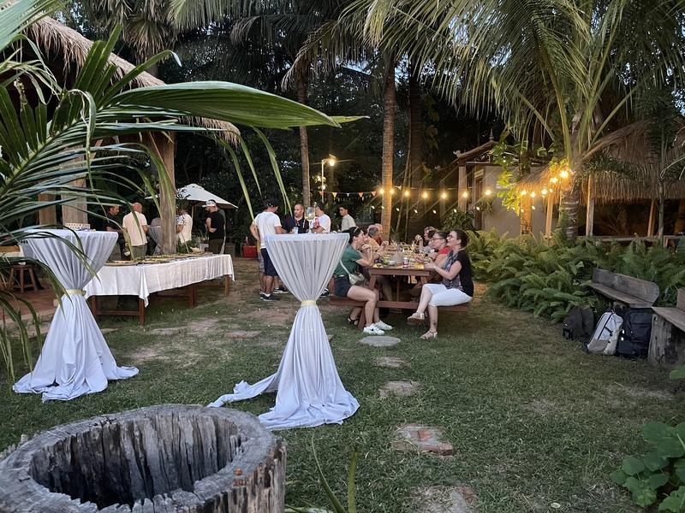
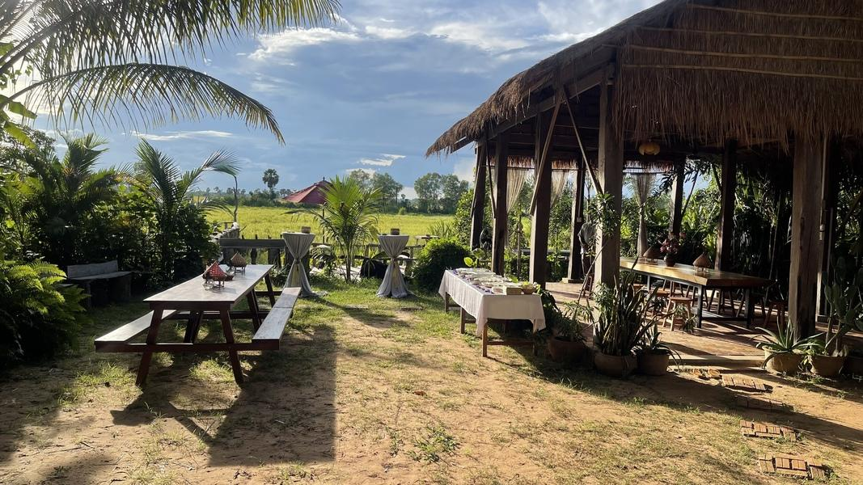

Easia Travel Head Office

Siem Reap Branch Charming City, No. R32 – R34, Road Rolouse, Trorpeangses Village, Sangkat Koukchork, Siem Reap Province – Cambodia Tel: (855-63) 76 14 58 Fax: (855-63) 76 14 58

