THAILAND – Bangkok – Private Monk Blessing
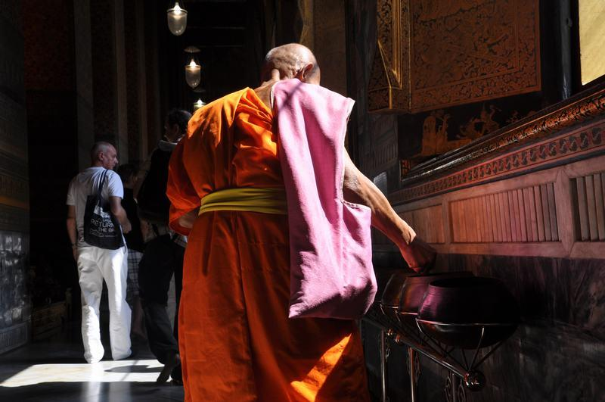

Over View

Theme
Art & Culture, Classic, Honeymoon

Country - City
Thailand - Bangkok

Market segment
Thematic Leisure

Price Level
$

Max pax
6

Seasonality
Possible all year round but may be affected by Buddhist holidays

Arrival city
Bangkok

Departure city
Bangkok

Description

Guests can experience the essential Buddhist ritual of offering alms to monks first-hand at Bangkok’s most famous temples. Together with their guide, they will meet with a resident monk and offer a donation, an act that is believed to bring prosperity and good karma. This particular moment is the perfect opportunity to learn about Buddhist practices first-hand and participate in an important local tradition.

Can be combined with
Thematic Leisure
- THAILAND – Bangkok – Visit Bangkok like a Local
- Classic visit of Wat Pho or Wat Arun

Selling points

- Easia Signature activity
- An upgrade to a regular visit of Wat Pho or Wat Arun
- Suitable for a wide range of traveler profiles
- Easy to include in programs, with different options available for different budgets

Sustainability

Level Of The Excursion
Low - This activity impacts local community, culture and/or environment in a small but meaningful way

The Impact Of This Excursion

Social/cultural Impact
Cultural Conservation, Empowerment and education

Economic Impact
Community benefits

Additional Information

Positive impacts
This activity offers a learning experience to travelers while also keeping local traditions alive.

Negative impacts
No negative.

Time And Transportation

Photos

Easia Travel Head Office

Vietnam Head OfficeC/o: ATS Hotel, Suite 326 &327, 33B Pham Ngu Lao Street, Hanoi, VietnamTel: +84 24-39 33 13 62www.easia-travel.com

