THAILAND – Bangkok / Chiang Mai / Phuket / Koh Samui – A Fun Introduction to Muay Thai at a Local Gym
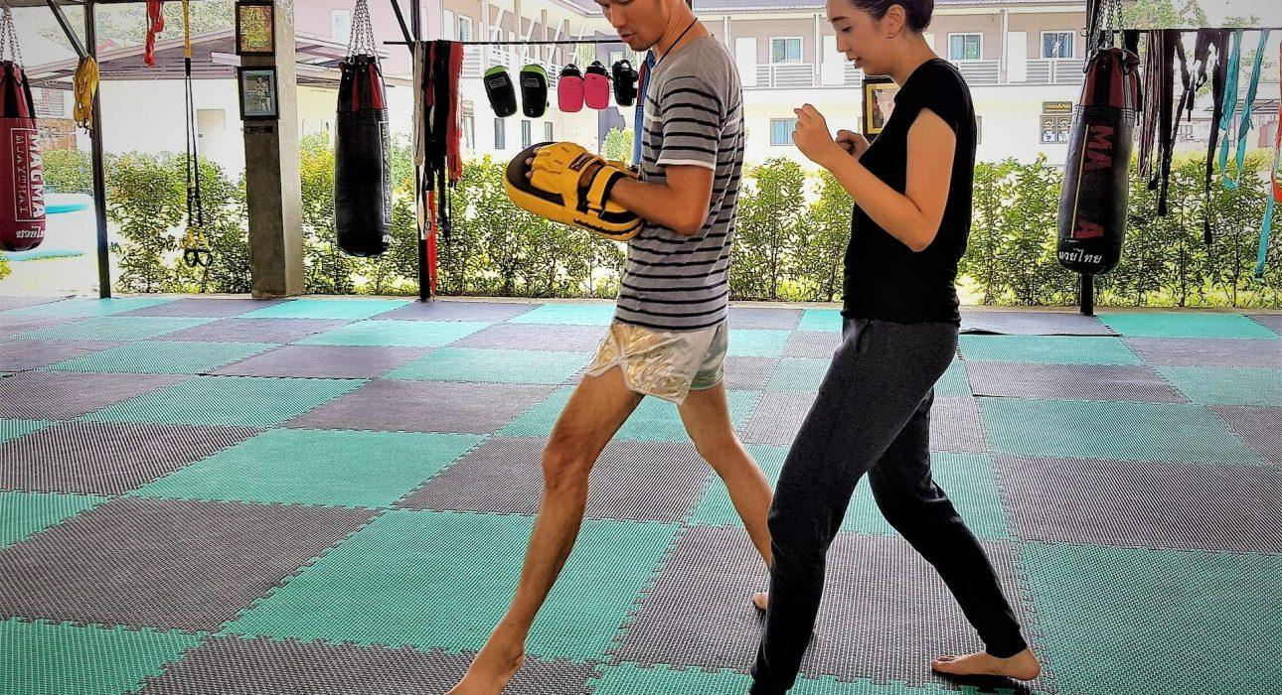

Over View

Theme
Classic, Family, Wellness

Country - City
Thailand - Chiang Mai - Phuket - Koh Samui - Bangkok

Market segment
Groups, Thematic Leisure

Price Level
$$

Level of difficulties
LEVEL 1

Max pax
30

Seasonality
Possible all-year round

Arrival city
Bangkok, Chiang Mai, Phuket, Koh Samui

Departure city
Bangkok, Chiang Mai, Phuket, Koh Samui

Description

During a fun introduction to Muay Thai, guests learn the basic techniques and appreciate the complexities of this martial art that is deeply rooted in Thai culture. Participating in a private introduction is an engaging workout which at the same time, offers a local experience. Combining the activity with watching Muay Thai fights at a local stadium is the perfect way to get a deep appreciation for Thailand’s national sport. With an experienced instructor, guests will learn the ins and outs of “the science of 8 limbs” in a safe environment. They will quickly learn that Muay Thai can also be an enjoyable workout besides being a practical martial art.

Selling points

- A fun way to get an insight into Thailand’s national sport
- Great for people who like to be active, including families
- Easy to include in the late morning or early afternoon
- It can be organized in all major cities (Bangkok, Chiang Mai, Phuket, and Koh Samui)
- It can be tailored to a private venue or for bigger groups upon request.

Time And Transportation

The distance and timing of the transportation depend on the destination and on the hotel where travelers stay.

Photos

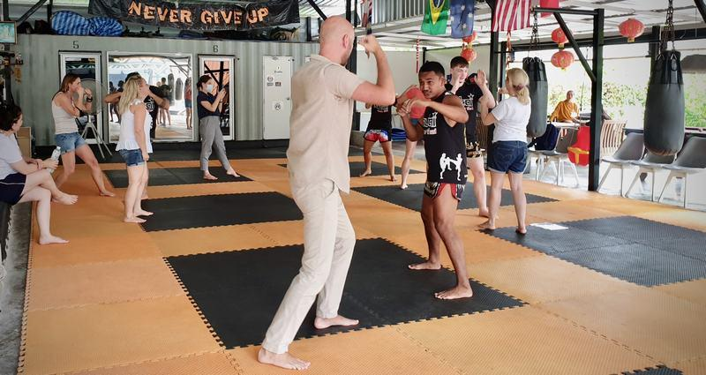
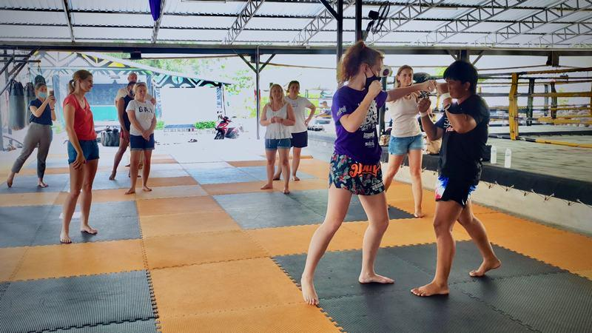
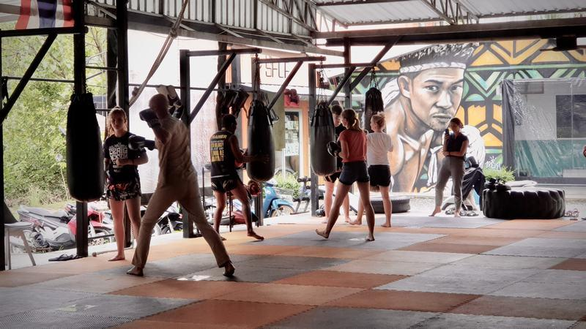
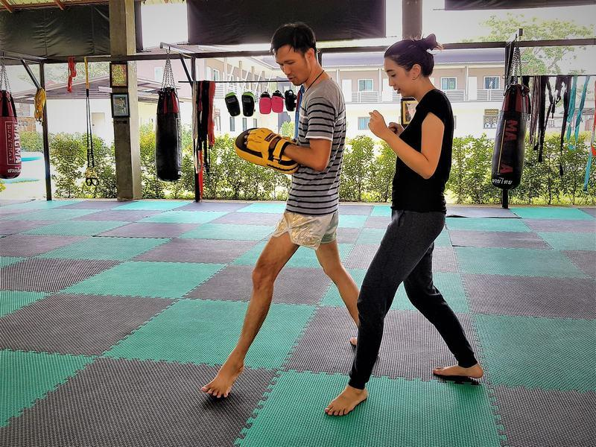

Easia Travel Head Office

Vietnam Head OfficeC/o: ATS Hotel, Suite 326 &327, 33B Pham Ngu Lao Street, Hanoi, VietnamTel: +84 24-39 33 13 62www.easia-travel.com

