CAMBODIA – Siem Reap – A Taste of Cambodian Cuisine
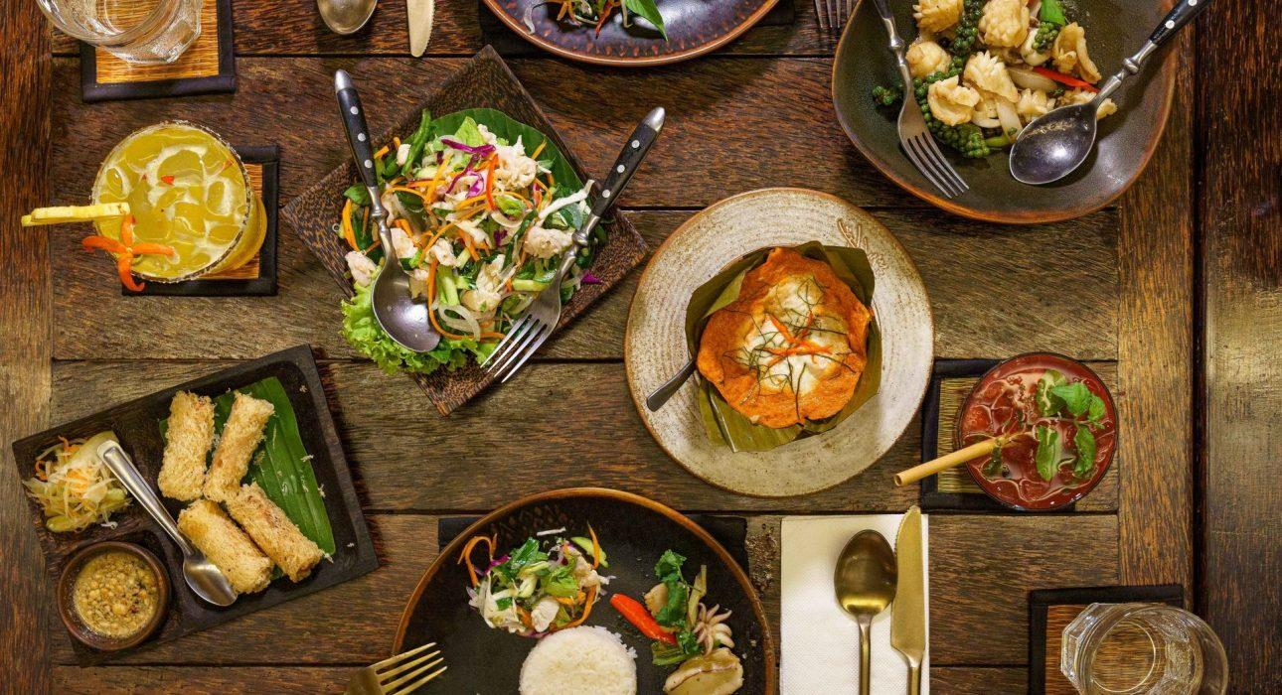

Over View

Theme
Art & Culture, Classic, Family, Gastronomy

Country - City
Cambodia - Siem Reap

Market segment
Thematic Leisure

Price Level
$$$$

Level of difficulties
LEVEL 0

Max pax
25

Seasonality
All year round

Arrival city
Siem Reap

Departure city
Siem Reap

Description

By blending subtle flavors and spices, Cambodian cuisine sets itself apart from the many other styles of food in Southeast Asia. We choose the best place to eat when traveling is not always easy. Still, we offer a “three in one” solution where we taste different flavors and atmospheres in one evening with a professional Tuk Tuk driver. This is a great way to explore Cambodian gastronomy, savoring local specialties in three curated venues.

Selling points

- A food tour to discover three restaurants and their specialties in one single evening
- Immersive dining in Cambodian cuisine
- The charm of the transportation by tuk-tuk in Siem Reap city

Time And Transportation

From | To | KM | Duration | Road condition
Hotel in town | Pou restaurant | 2km | 8 minutes | Good
Pou restaurant | The Sugar Palm restaurant | 800 meters | 4 minutes | Good
The Sugar Palm restaurant | Malis restaurant | 1km | 3 minutes | Good

Photos

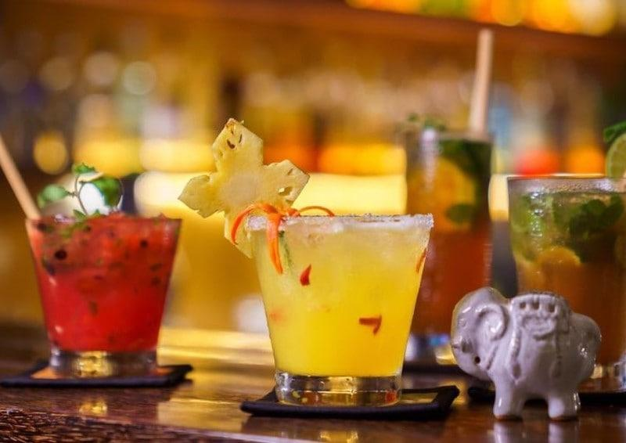
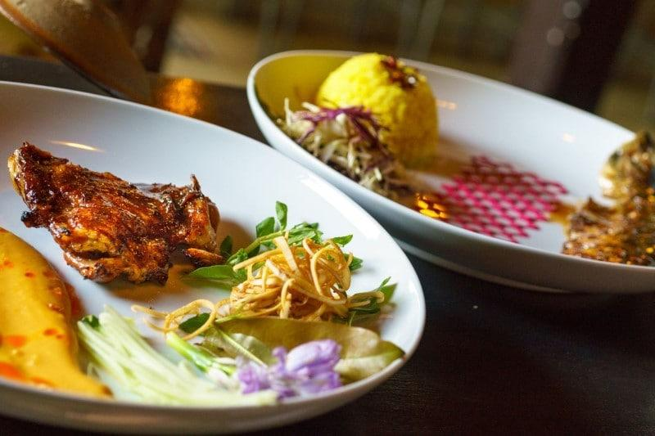
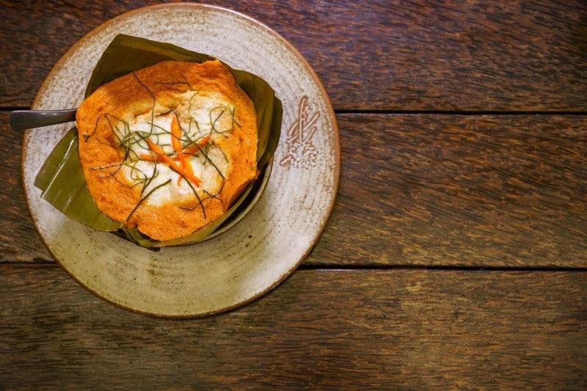
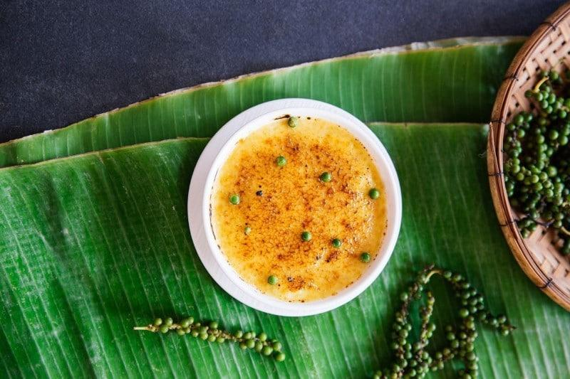
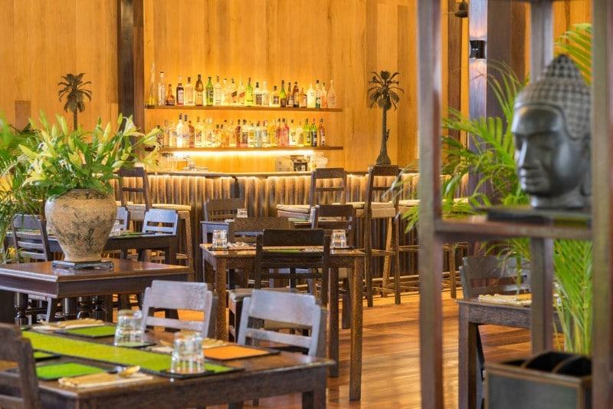
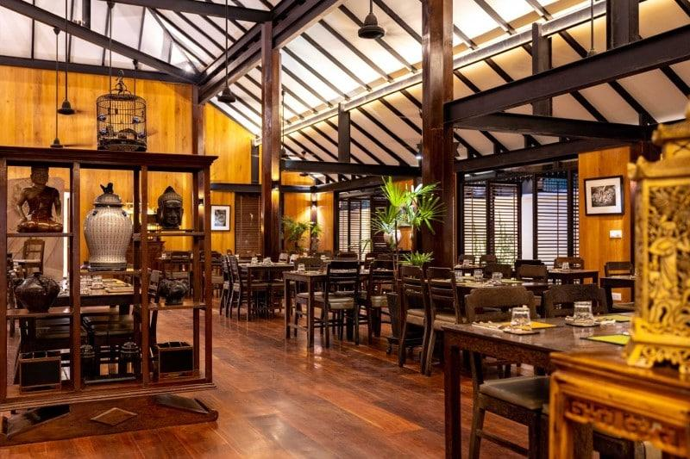
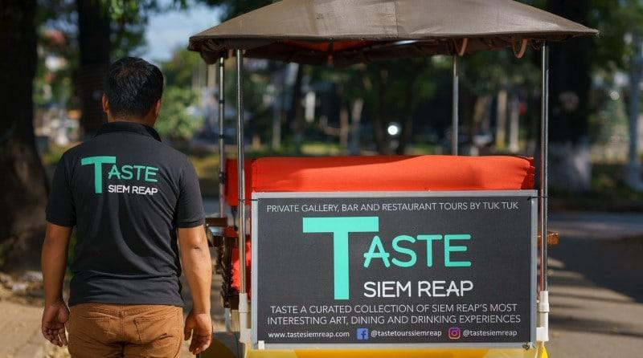
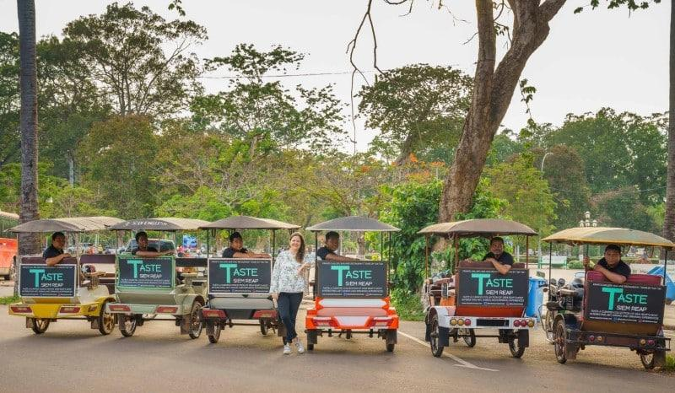

Easia Travel Head Office

