THAILAND – Koh Samui – Discover Koh Samui’s Local Areas by Bicycle
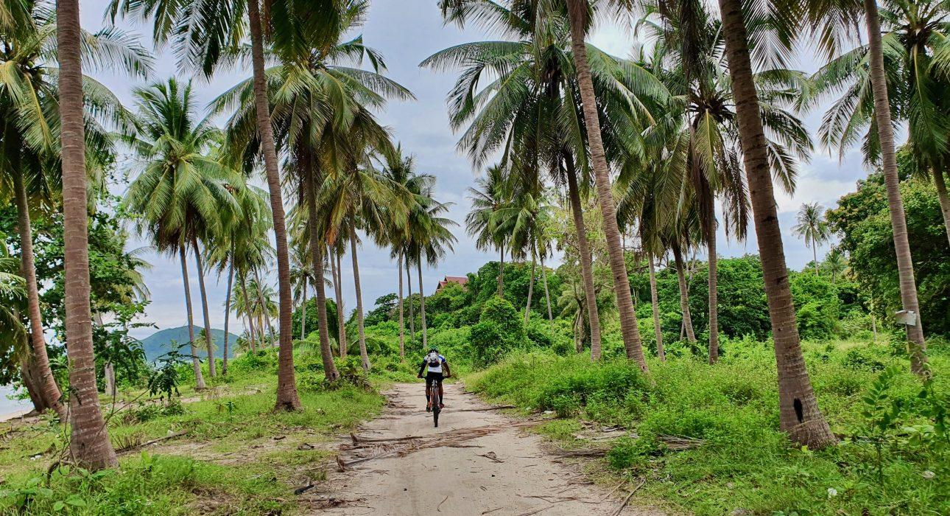

Over View

Theme
Art & Culture, Beach Stay, Classic, Honeymoon, Sustainable

Country - City
Thailand - Koh Samui

Market segment
Thematic Leisure

Price Level
$

Level of difficulties
LEVEL 1

Max pax
10

Seasonality
Possible all year round but subject to weather conditions

Arrival city
Koh Samui

Departure city
Koh Samui

Description

Koh Samui and the surrounding islands are well-known for their beautiful beaches and crystal-clear waters. Still, with a seemingly endless choice of comfortable hotels, one might forget that a very authentic side of the island is waiting to be explored. This excursion allows guests to explore this lesser-visited side of Koh Samui as they embark on a cycling trip through local communities and green, untouched areas. Along the route, plenty of photo opportunities and exciting stops will make them understand why Koh Samui is sometimes referred to as “coconut island.”

Selling points

- A nice change from well-known excursions that are focused on the sea and beaches
- The route can be adapted depending on the fitness level of guests, making it accessible to a wide range of people.
- Shows a lesser-known area of Koh Samui
- A great addition to a beach stay for guests who like to be active during their holiday

Time And Transportation

From | To | Km | By | Duration | Road condition
Bophut Beach | Starting point | 25 | Car | 35 minutes | good
Choengmon Beach | Starting point | 30 | Car | 45 minutes | good
Chaweng Beach | Starting point | 20 | Car | 30 minutes | good
Lamai Beach | Starting point | 10 | Car | 15 minutes | good

Photos

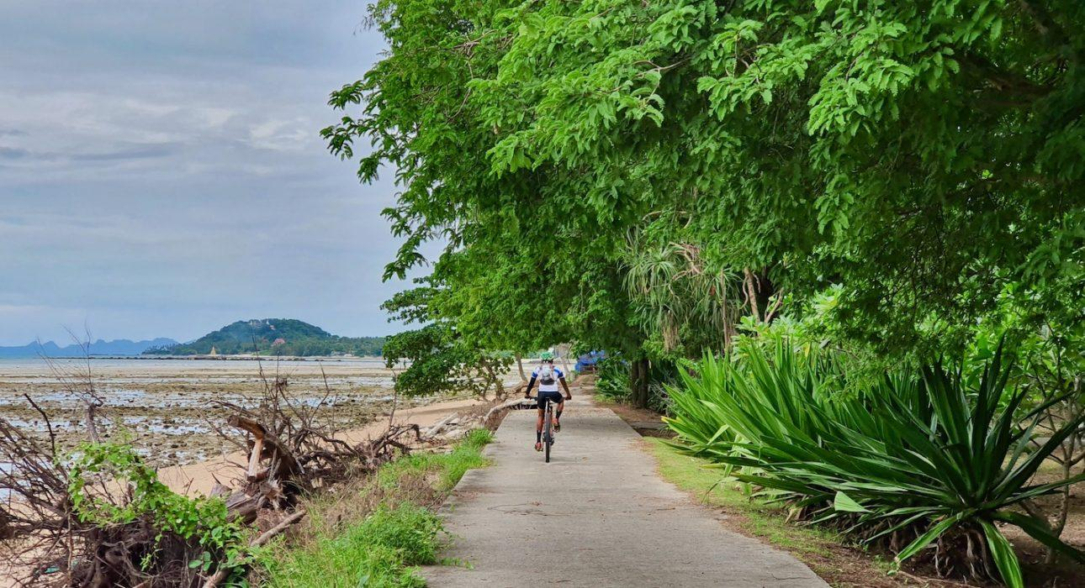
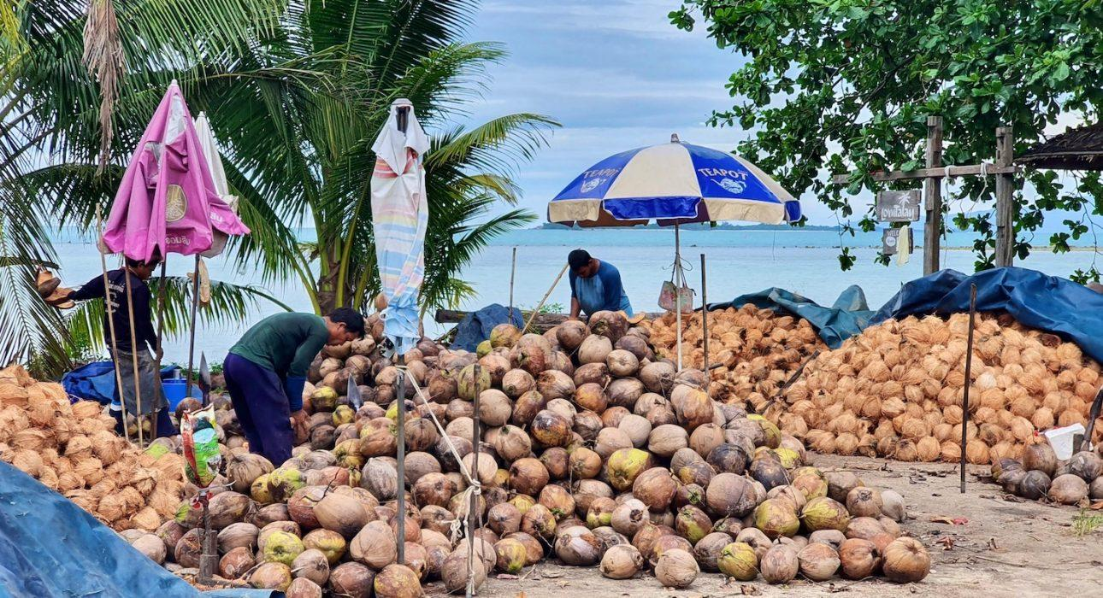
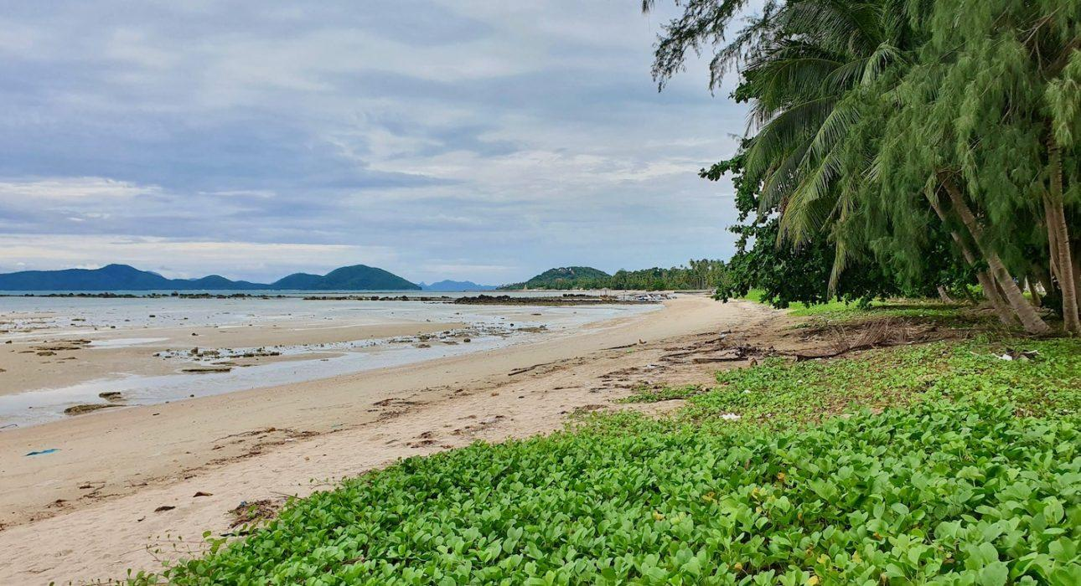
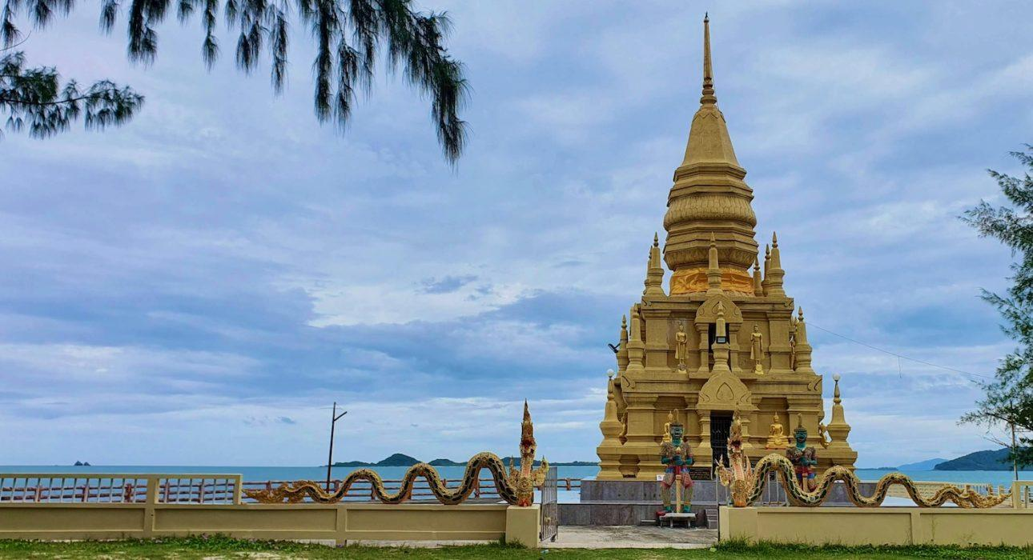
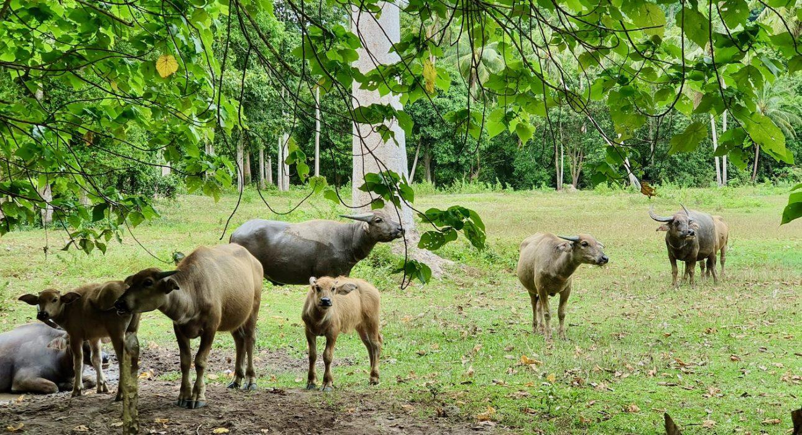
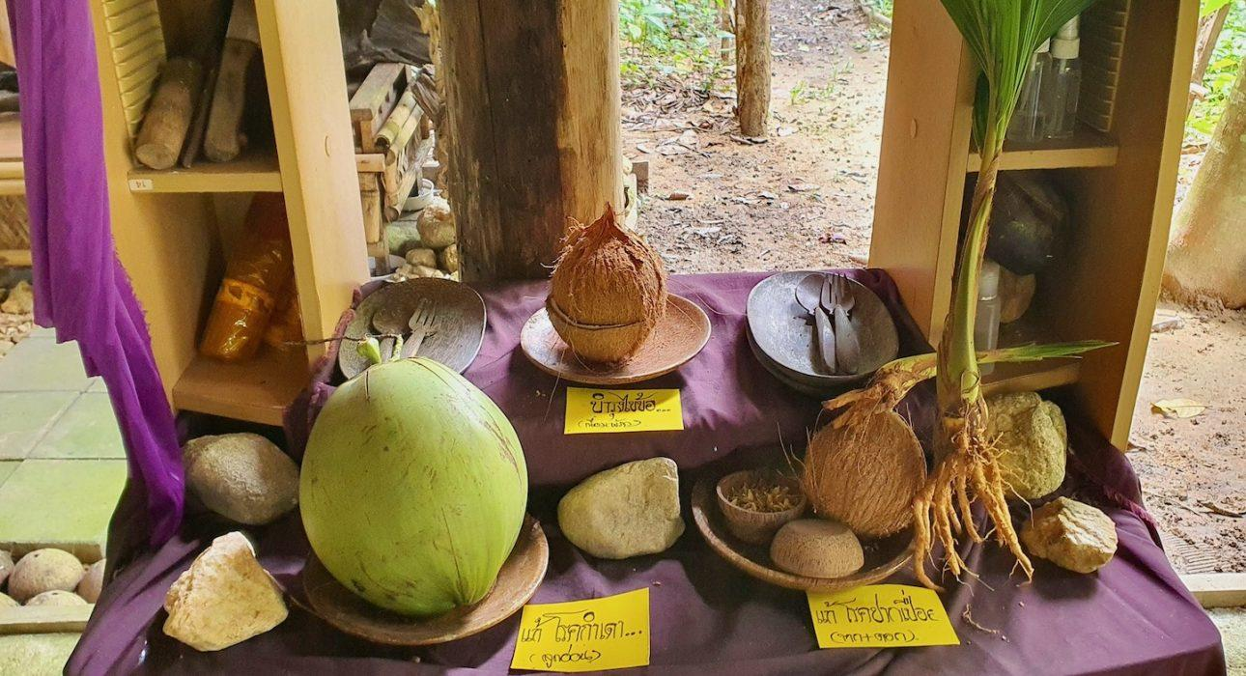
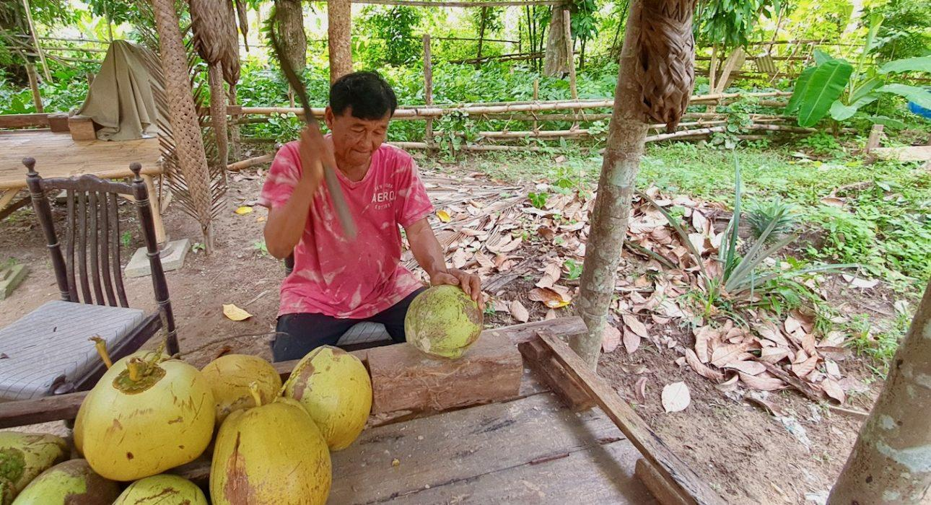

Easia Travel Head Office

