LAOS – Hinboun – Kayaking on the Hinboun River
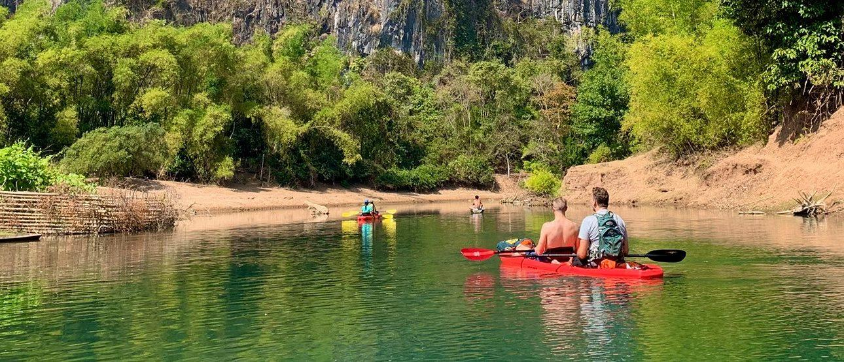

Over View

Theme
Classic, Family, Sustainable

Country - City
Laos - Hinboun

Market segment
Groups, Thematic Leisure

Price Level
$$

Level of difficulties
LEVEL 0

Max pax
12

Seasonality
All Year Round (but best from October to June)

Arrival city
Ban Tiou (Spring River Resort) near Konglor Cave

Departure city
Ban Tiou (Spring River Resort) near Konglor Cave

Description

Kayak peacefully down the Nam Hinboun River, surrounded by the stunning limestone landscape of the Phou Hinboun National Protected Area. Pass small local villages and see how people live in this untouched part of the world – villagers tending to their vegetable gardens along the riverbank, the buffaloes bathing in the shallow waters, children fishing and playing in the river, and the village ladies washing their clothes in the crystal clear waters of this stunning waterway.
- Level: 0. Accessible to everyone.
- Distance and duration of the kayaking: 15 kilometers. Approximately 2-5 hours kayaking depending on conditions.

Can be combined with
Thematic Leisure
- LAOS – Hinboun – Morning Hike from Ban Tew to Ban Konglo
- LAOS – Hinboun – Boat cruise on the Nam Hinboun River
- LAOS – Hinboun – Full Day Tour on the Other Side of Konglor Cave
- LAOS – Hinboun – A Taste of Lao Hospitality
- LAOS – Hinboun – Expedition into Laos’ Longest Cave

Selling points

- An excellent way to spend an extra day in the magical Hinboun area – the scenery on this kayaking trip is stunningly beautiful!
- An easy activity suitable for people of all kayaking abilities – perfect for active leisure travelers in groups of up to 12 people.
- Suitable for families with older children over 14+.
- It can be done as a morning or afternoon activity, or even over lunch with a picnic taken along.
- A glimpse into the life of the villagers who live beside the river in authentic rural Laos.
- The area is untouched and undeveloped, unlike some other areas in Laos that are popular for kayaking.

Sustainability

Level Of The Excursion
Medium – This activity offers tangible positive contributions to the local community, culture and/or environment

The Impact Of This Excursion

Environment Impact
Transportation

Economic Impact
Local individual benefits, Community benefits

Additional Information
This activity provides a day of exploration with minimal impact on the environment. The only transportation involved that will have a small impact will be a songthaew (tuk-tuk) for the return to the resort.Financially, this activity supports Spring River Resort which in turn provides employment to local villagers (resort staff, guides, drivers etc.) in an area where there are few opportunities for meaningful and rewarding work.

Time And Transportation

From | To | Km | By | Duration | Road condition
Spring River Resort | Sala Hinboun | 15 | Kayak | 3-5 hours | Wet, it’s a river
Sala Hinboun | Spring River Resort | 15 | Songthaew | 30 minutes | Bumpy in places

Photos

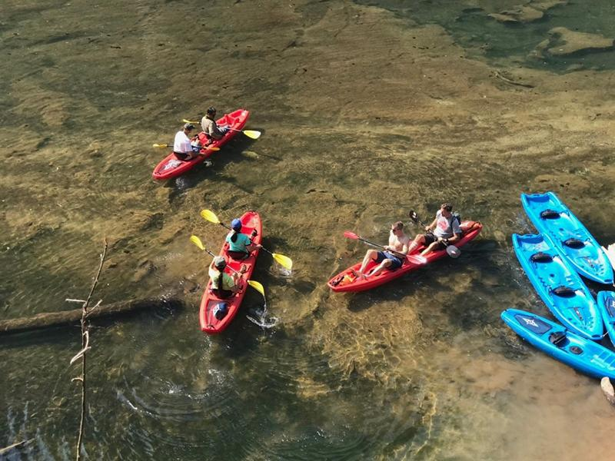
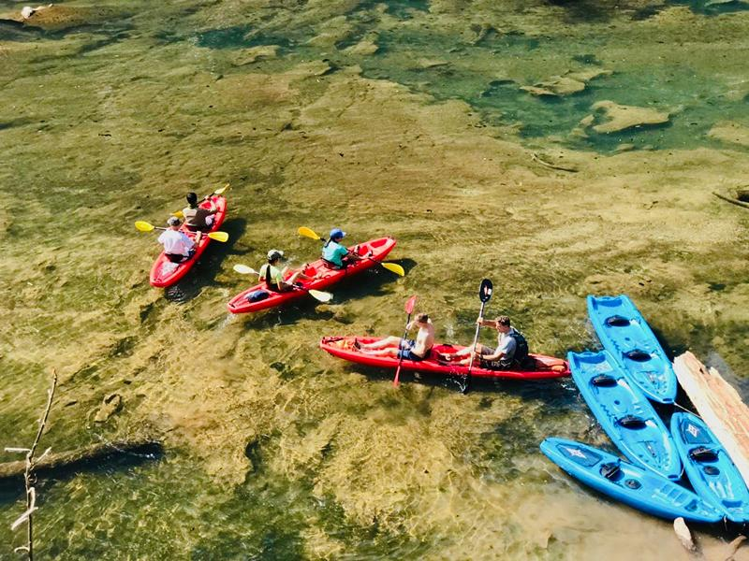
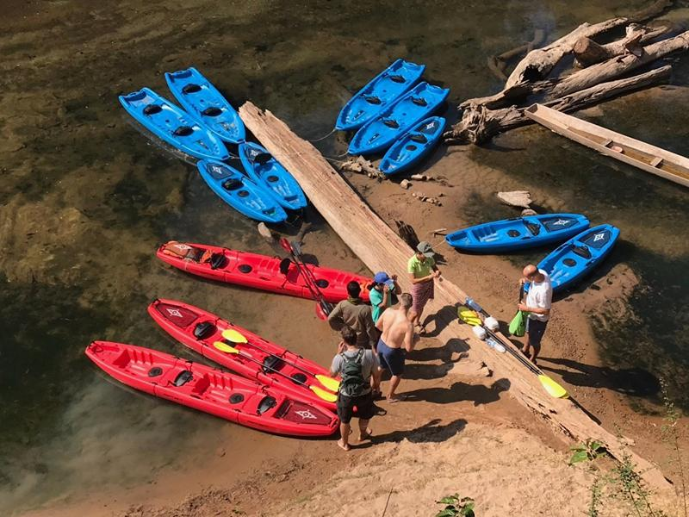
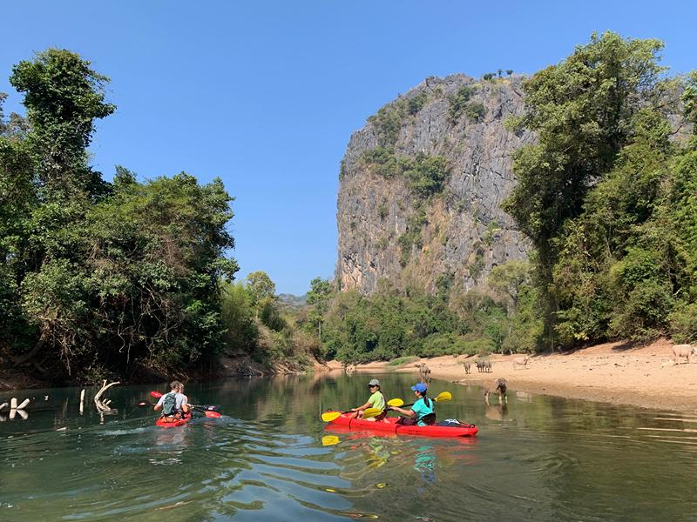
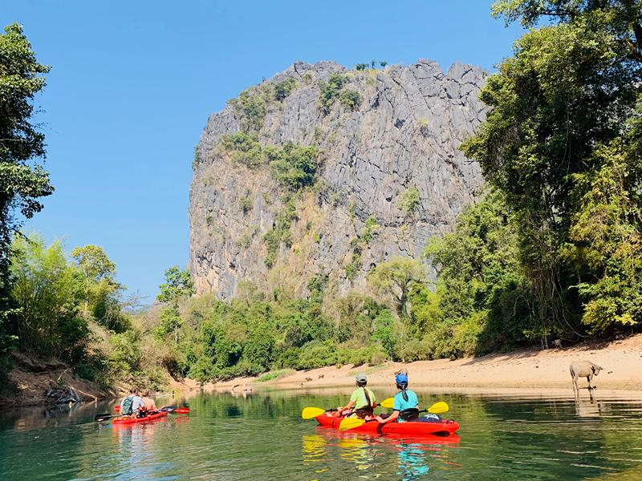
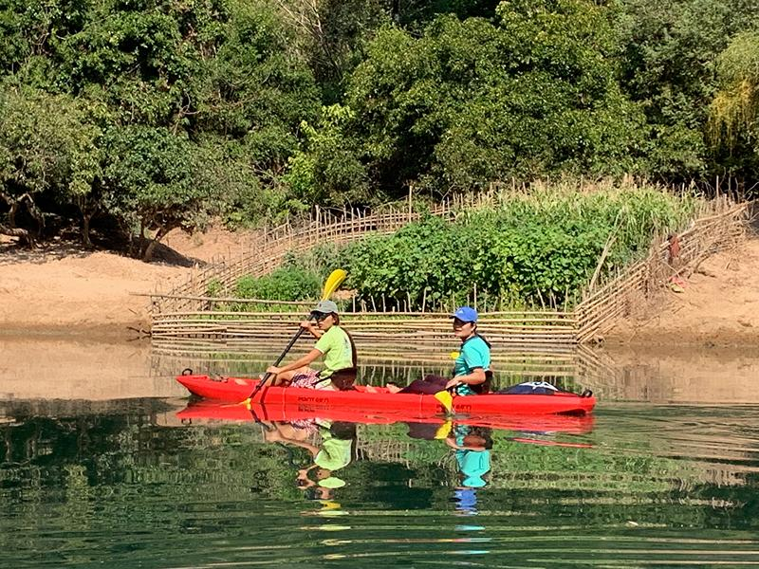
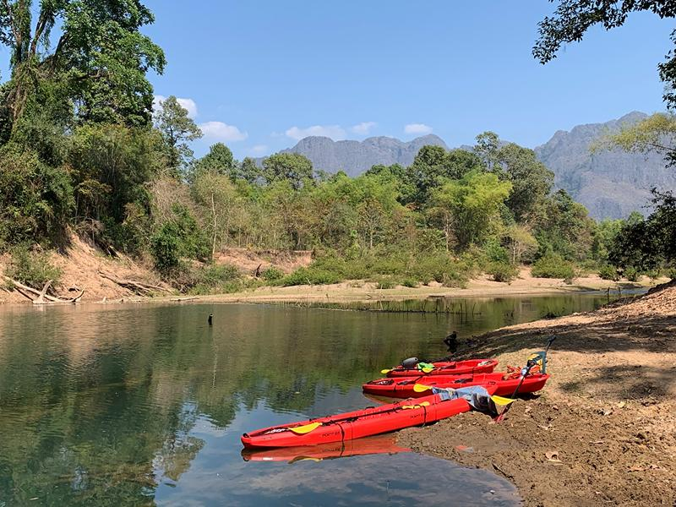
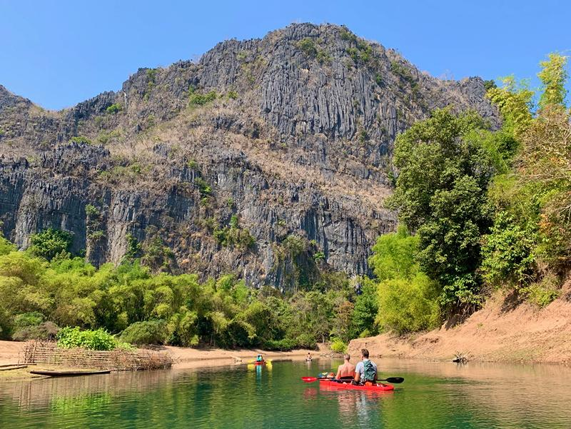

Easia Travel Head Office

Vietnam Head OfficeC/o: ATS Hotel, Suite 326 &327, 33B Pham Ngu Lao Street, Hanoi, VietnamTel: +84 24-39 33 13 62www.easia-travel.com

