VIETNAM – Hoi An – Culinary Experience at Home With Chef Duc Tran
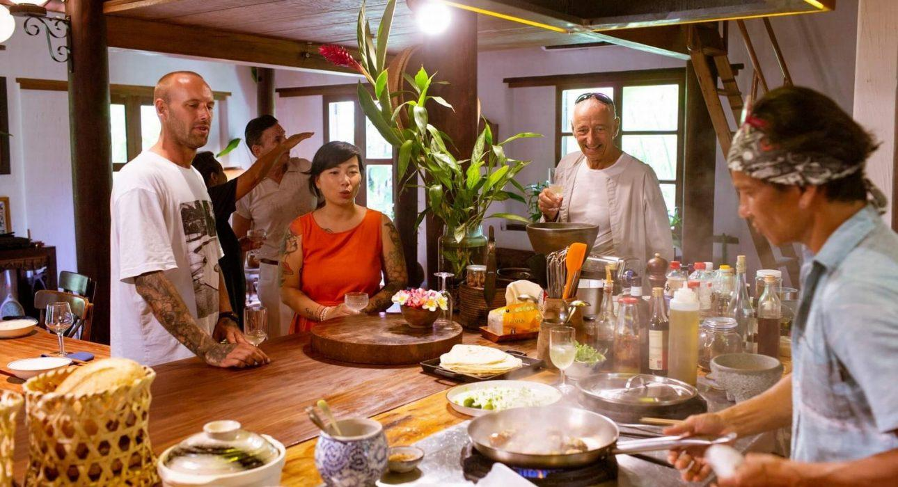

Over View

Theme
Classic, Family, Gastronomy, Honeymoon

Country - City
Vietnam - Hoi An

Price Level
$$$$

Max pax
10 guests for culinary morning &amp; lunch, 20 guests for gourmet lunch

Seasonality
Round year

Arrival city
Hoi An

Departure city
Hoi An

Description

A visit to Duc Tran’s private house at Cam Thanh village which is connected to nature at every turn reveals a signature design, green spaces, an organic garden, and an impressive kitchen and offers an opportunity to meet this local chef with a deep love of cooking. Chef Duc will inspire you with his passion as he creates dishes that combine his Vietnamese heritage with 20 years of global travels that have become his signature style of modern Vietnamese cuisine featuring fresh flavors of Vietnam, elevated with international touches.

Selling points

- A private, luxurious but very cozy atmosphere for a gastronomic experience.
- A unique cookery experience in Hoi An.
- A gourmet meal with a fresh and seasonal menu is created for each event.
- Meet with the well-known chef Duc Tran at his house and enjoy a homemade meal.

Sustainability

Level Of The Excursion
Medium – This activity offers tangible positive contributions to the local community, culture and/or environment

The Impact Of This Excursion

Social/cultural Impact
Cultural Conservation, Empowerment and education

Economic Impact
Local individual benefits

Additional Information
This activity provides a discovery of the food, and the locals’ culture when meeting a chef at home and using fresh, organic ingredients of the locals.

Time And Transportation

From | To | Km | By | Duration | Road condition
Hoi An center | Duc Tran’s house | 3 | Car | 10 minutes | Good
Four Season resort | Duc Tran’s house | 9.2 | Car | 16 minutes | Good
Cua Dai Beach hotels | Duc Tran’s house | 3.6 | Car | 12 minutes | Good

Photos

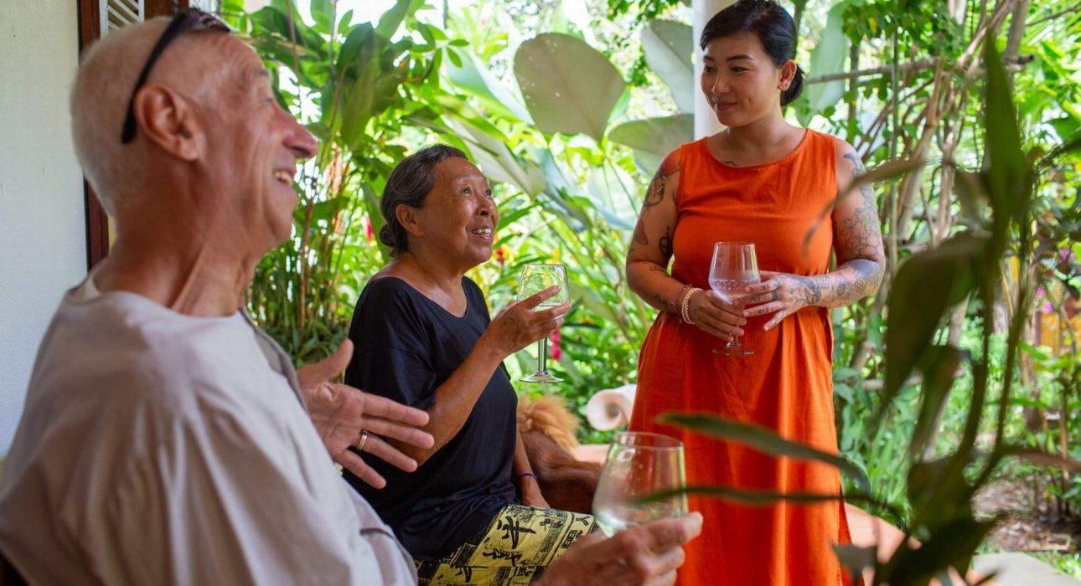
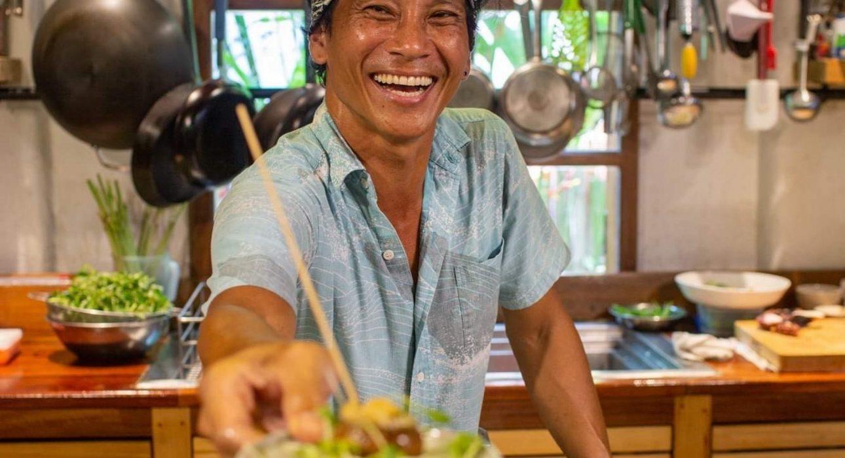
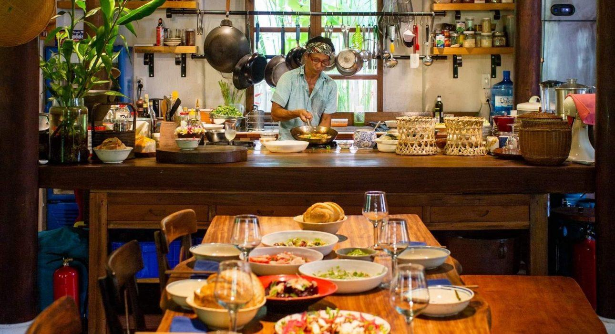
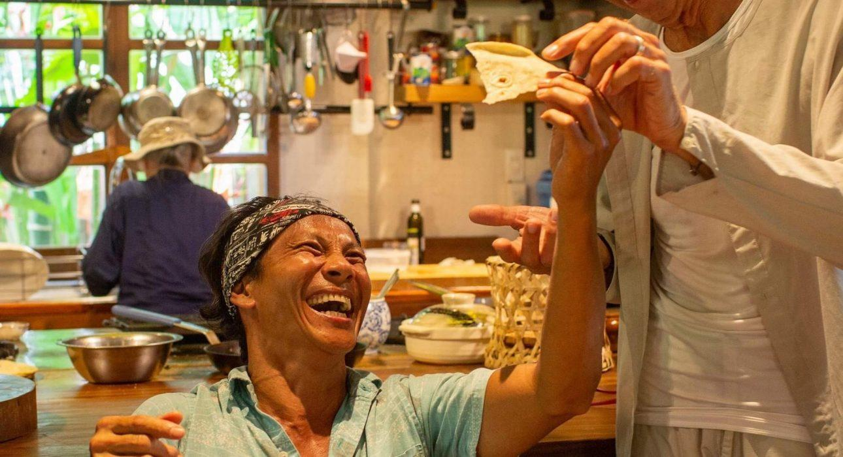
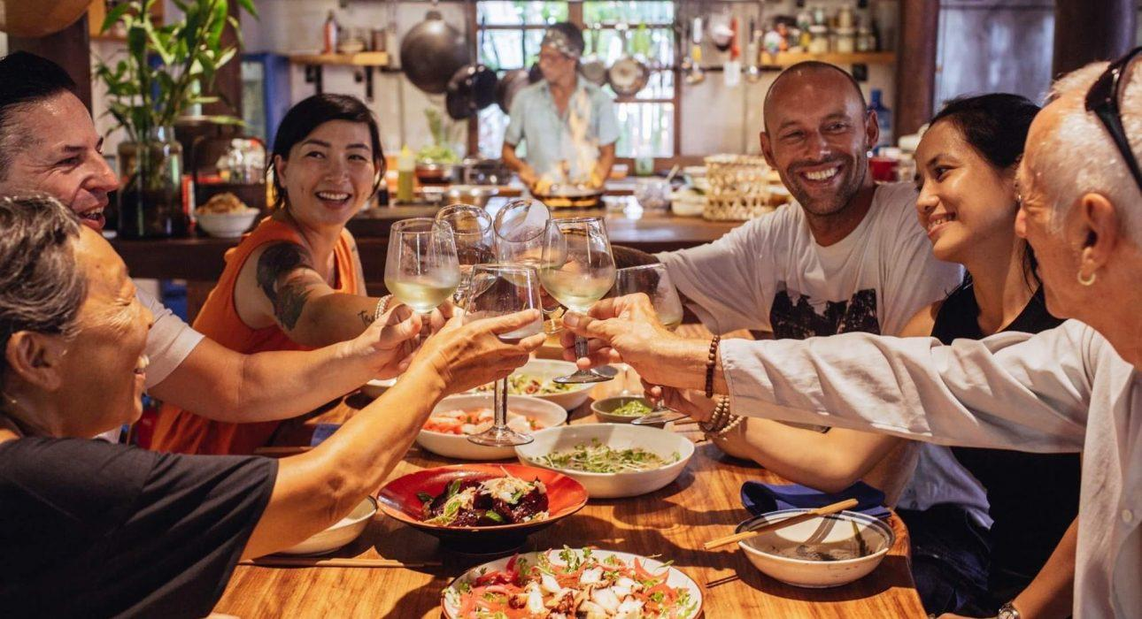
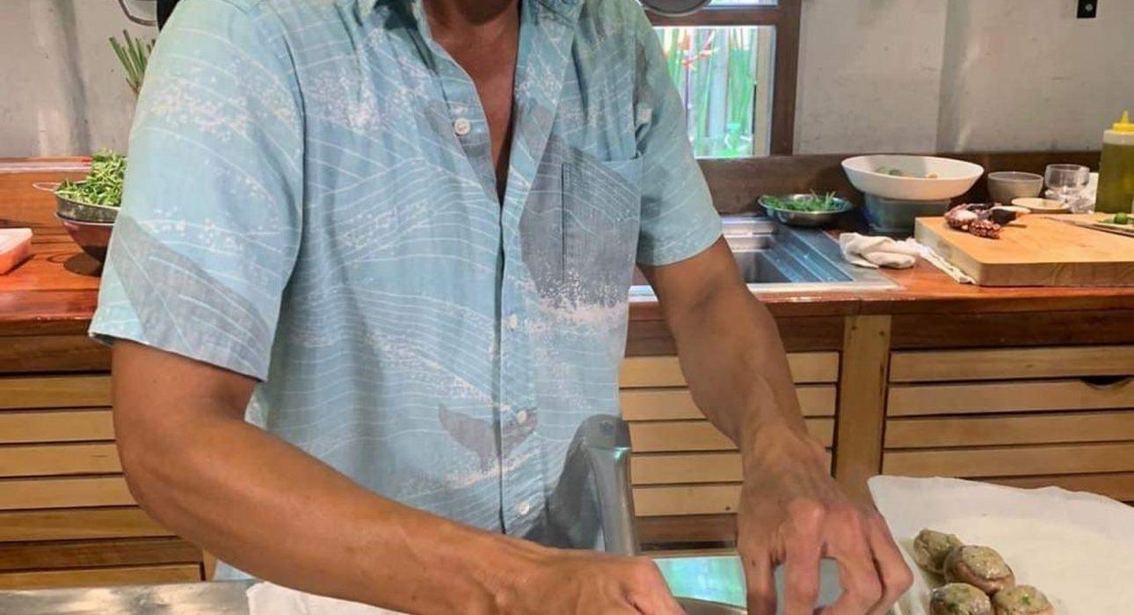
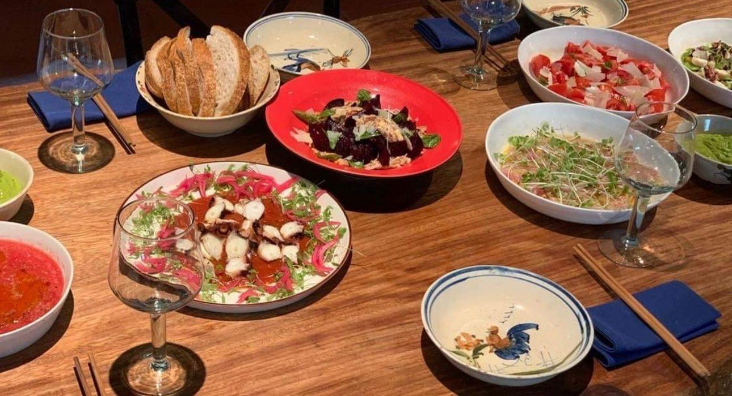
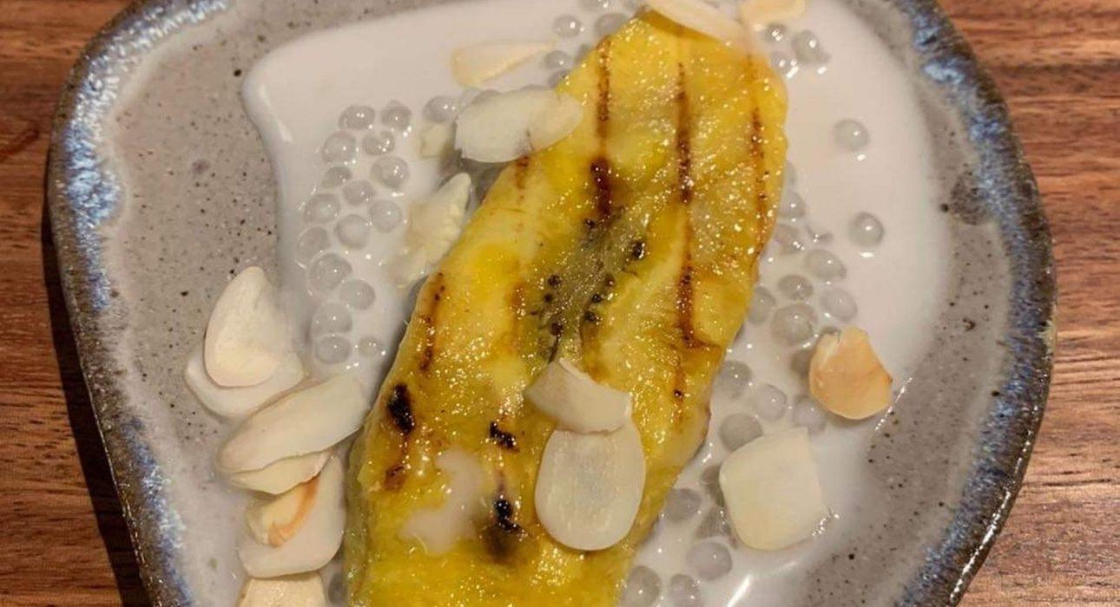
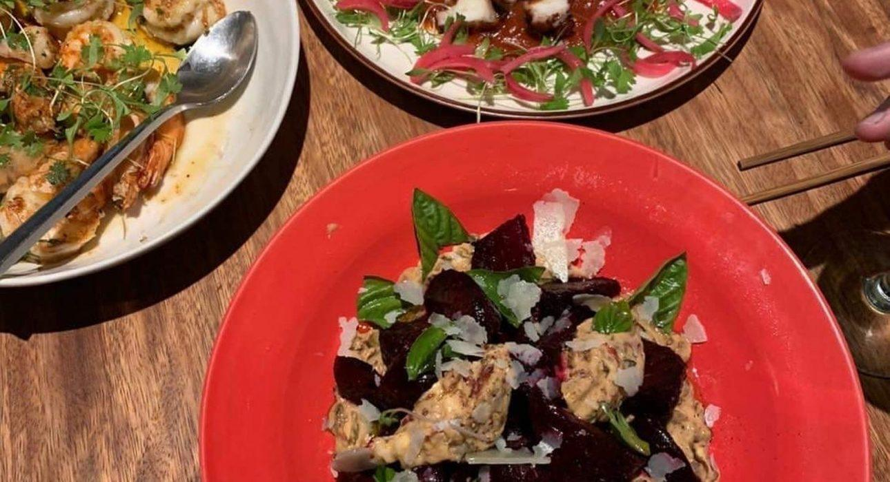
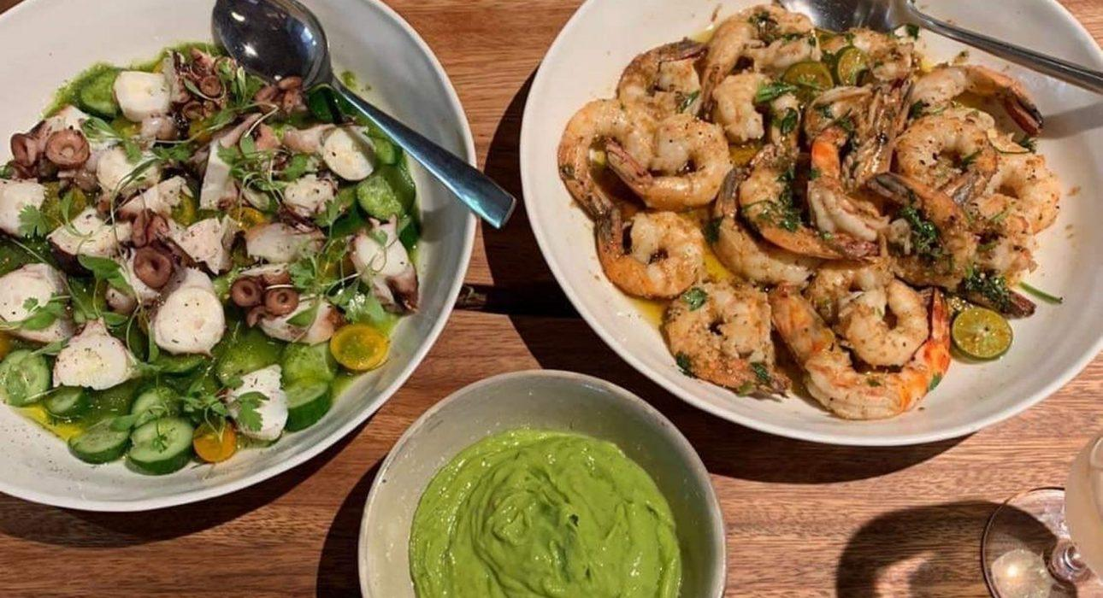
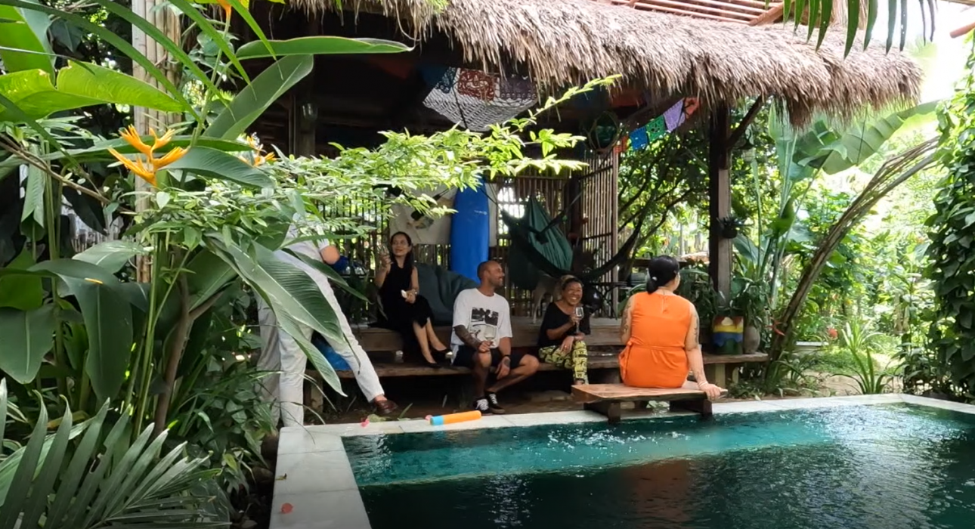

Easia Travel Head Office

Vietnam Head OfficeC/o: ATS Hotel, Suite 326 &327, 33B Pham Ngu Lao Street, Hanoi, VietnamTel: +84 24-39 33 13 62www.easia-travel.com

