LAOS – Luang Prabang – Elephants of the Mekong
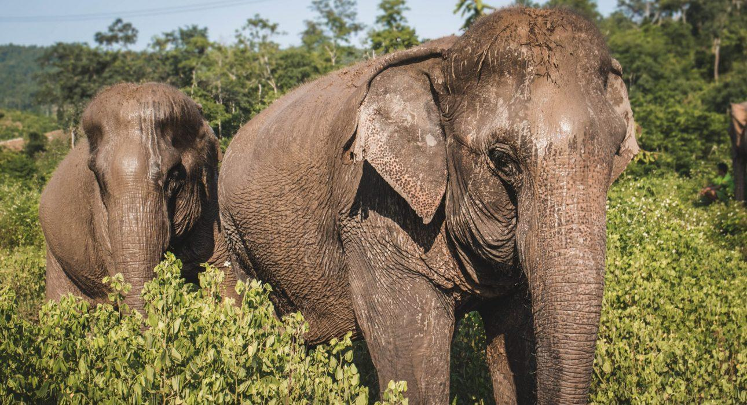

Over View

Theme
Family, Sustainable

Country - City
Laos - Luang Prabang

Market segment
Groups, Thematic Leisure

Price Level
$$

Level of difficulties
LEVEL 0

Max pax
6pax for the half-day experience/ 25pax for lunch and elephant meeting

Seasonality
All year round, trail may be slippery during the rainy season

Arrival city
Luang Prabang

Departure city
Luang Prabang

Description

Set just 40 minutes away from Luang Prabang city center, Manifa Elephant Camp is a peaceful jungle retreat on the banks of the Mekong River. The camp was founded in 2009 with just two elephants by local elephant enthusiast Vilaluck Vothivong, and now, after 13 years, Manifa has a herd of 17 elephants roaming around 200 hectares of forest. Visitors to the camp get the chance meet the elephants and their mahouts and interact with the animals, in a real-life example of sustainable conservation and coexistence.

Selling points

- A place for unique and sustainable interactions with roaming elephants.
- Supporting a locally owned elephant camp.
- Learn about how humans live alongside elephants in Laos.
- One of the few places in Laos where it’s possible to meet baby elephants.
- A chance to enjoy stunning scenery and delicious food on the Mekong River.
- Perfect to combine with a visit to Pak Ou Caves and a sunset cruise back to Luang Prabang.

Sustainability

Level Of The Excursion
Low - This activity impacts local community, culture and/or environment in a small but meaningful way

The Impact Of This Excursion

Social/cultural Impact
Empowerment and education

Environment Impact
Involving Wildlife

Economic Impact
Local individual benefits, Community benefits

Additional Information
The activities we offer at Manifa focus on the educational aspect rather than on the riding. Our tours are elephant-riding free. Our ultimate goal is to encourage the camp to discontinue the practice completely. In the past few years, it has made huge strides in terms of its sustainability and attention to animal welfare.

Time And Transportation

From | To | Km | By | Duration | Road condition
Luang Prabang | Manifa Elephant Camp | 25 | Minivan | 45 minutes | Good
Timings below are based on it being combined with a cruise to Pak Ou Caves in the morning and a return to Luang Prabang by boat at the end of the day:
From | To | Km | By | Duration | Road condition
Luang Prabang | Manifa | 27 | Boat | 1h | Wet, it’s a river
Manifa | Pak Ou | 4 | Boat | 15 minutes | Wet, it’s a river
Pak Ou | Luang Prabang | 31 | Boat | 1h 30m | Wet, it’s a river

Photos

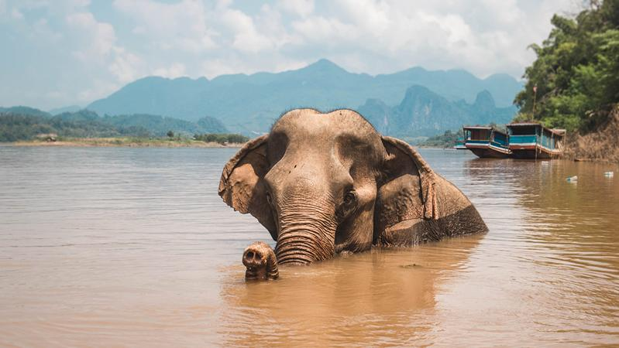
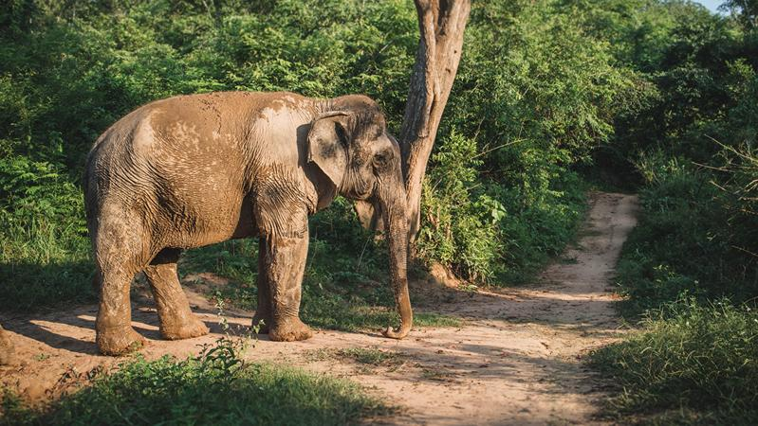
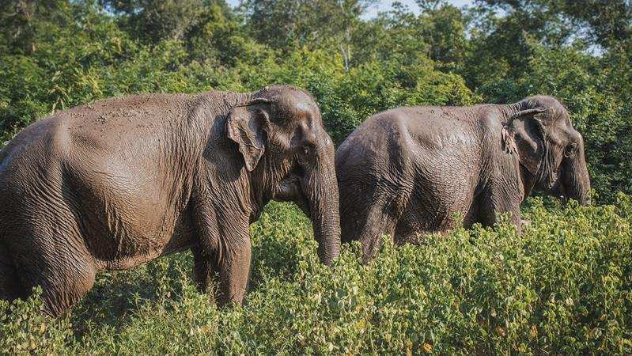
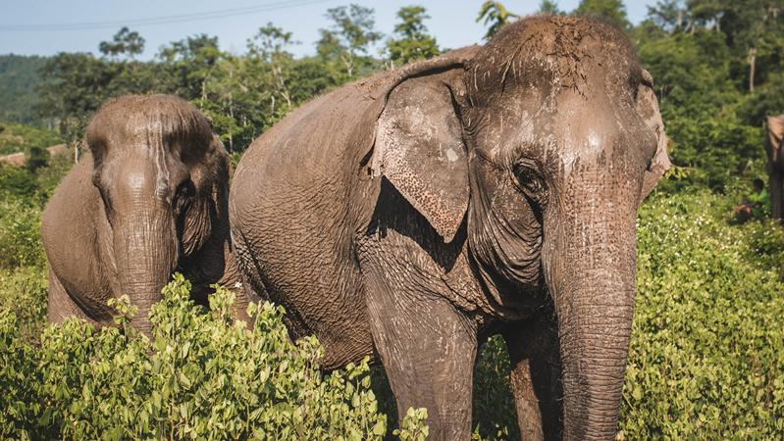
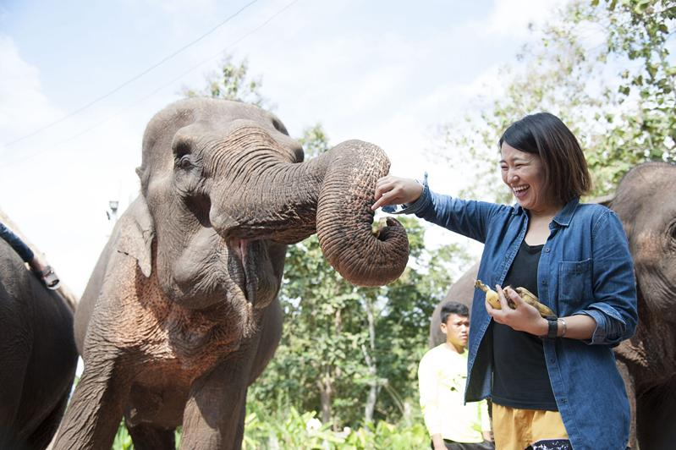
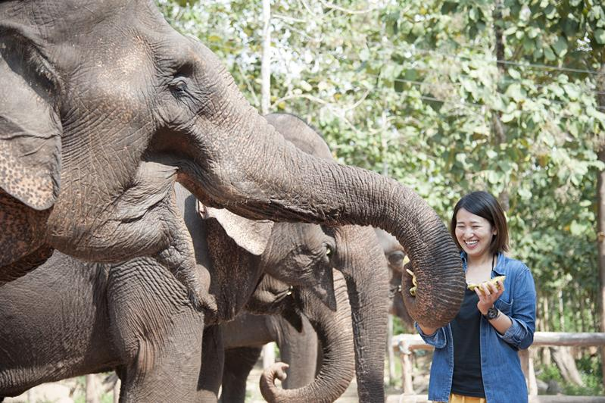
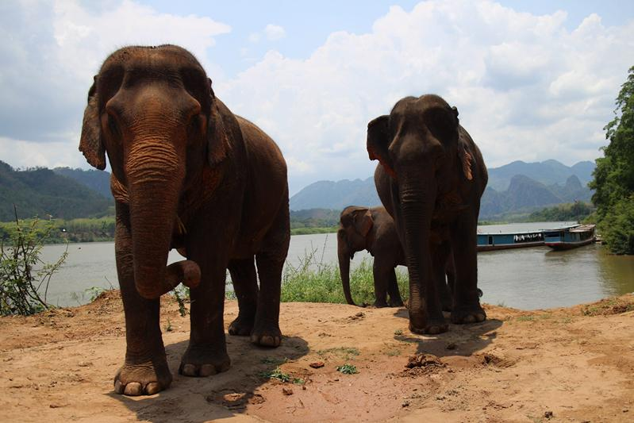
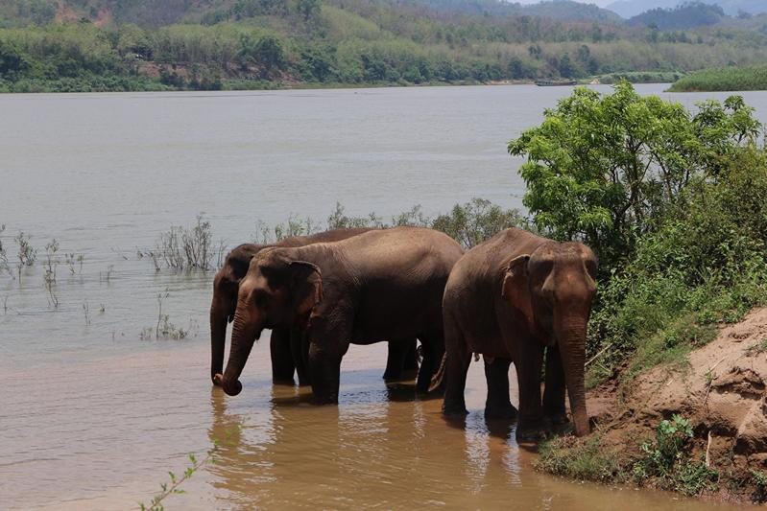
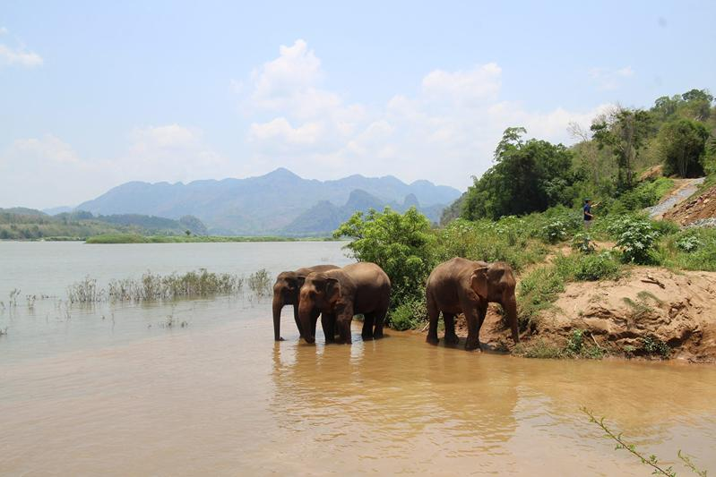
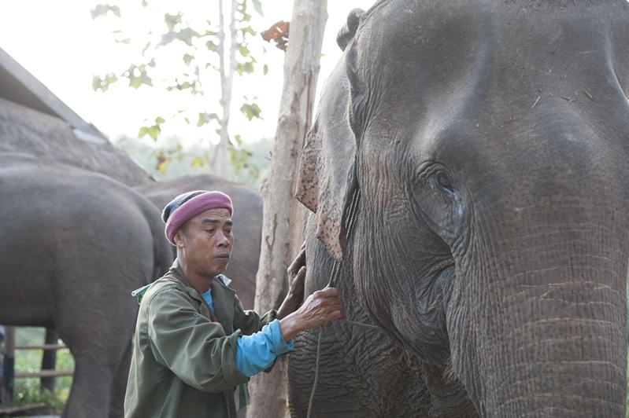

Easia Travel Head Office

Vietnam Head OfficeC/o: ATS Hotel, Suite 326 &327, 33B Pham Ngu Lao Street, Hanoi, VietnamTel: +84 24-39 33 13 62www.easia-travel.com

