Vietnam – Hue – An Art Experience day in Hue
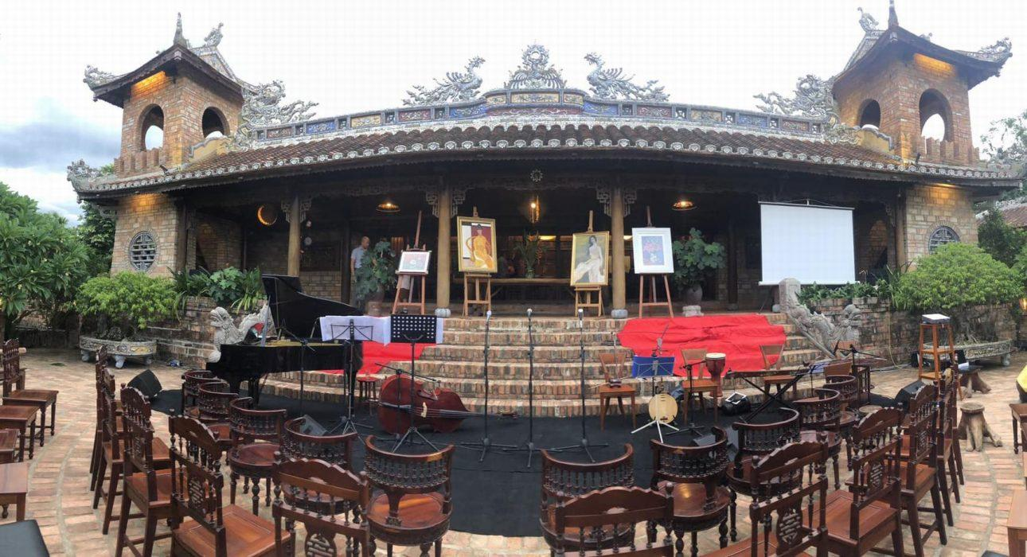

Over View

Theme
Art & Culture, Classic, Family, Sustainable

Country - City
Vietnam - Hue

Market segment
Thematic Leisure

Price Level
$$$

Max pax
15

Seasonality
Round year

Arrival city
Hue

Departure city
Hue

Description

A day of art experience in Hue offers travelers an opportunity to explore Hue from an artistic perspective, travel to traditional craft villages, meet locals keeping the time-honored crafts of their ancestors alive and experience their daily life. As well as exploring the Citadel, mausoleums and garden houses to learn about the royal architecture of the Nguyen Dynasty, this experience provides insights into the life of a famous artist and his collection as well as an opportunity to enjoy folk songs with new, modern melodies. These experiences will leave a long-lasting impression of the royal city.

Selling points

- A great chance for art lovers to explore the abundance of art in Hue.
- A real opportunity to meet local artists who continue their ancestors’ traditional crafts and also experience their daily life.
- A serene opportunity to be experienced with arts for a full day.

Sustainability

Level Of The Excursion
Medium – This activity offers tangible positive contributions to the local community, culture and/or environment

The Impact Of This Excursion

Social/cultural Impact
Cultural Conservation

Economic Impact
Local individual benefits

Additional Information
This activity helps travelers to understand the cultural importance of Hue as the former imperial capital and as a cultural capital. It also benefits several museums & locals who continue their ancestors’ traditional crafts

Time And Transportation

From | To | Km | By | Duration | Road condition
Hue center | Ben Xuan Theater | 6.6 | Car | 14 minutes | Good
Hue center | Thanh Tien village | 7 | Car | 17 minutes | Good
Hue center | Le Ba Dang Memory space | 9 | Car | 20 minutes | Good

Photos

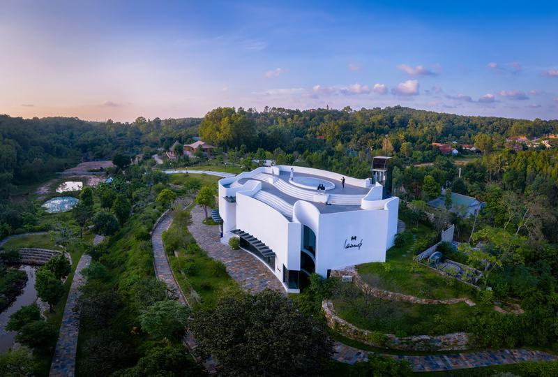
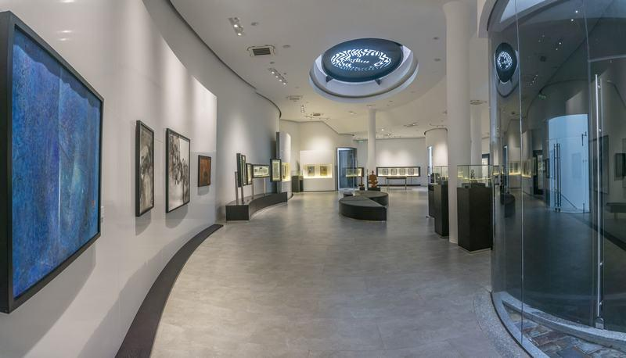
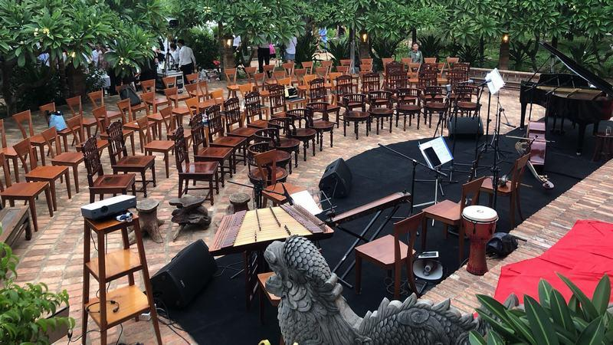
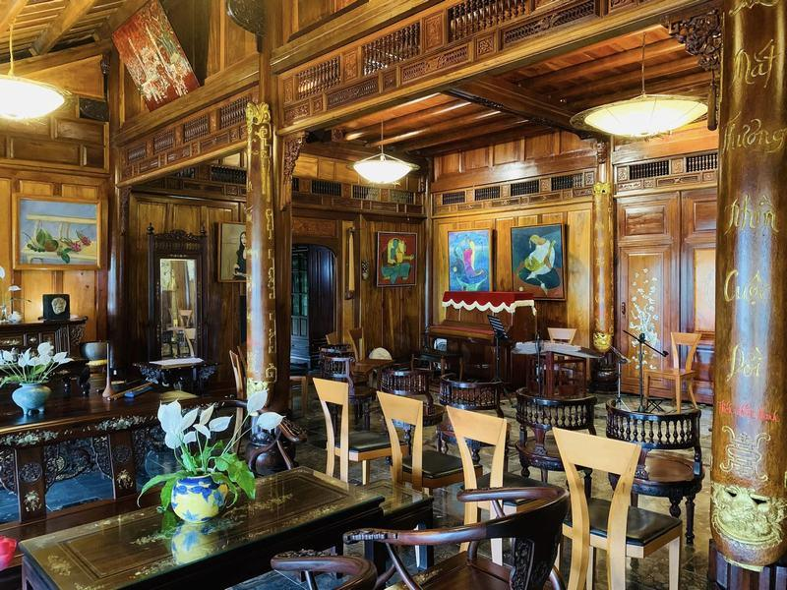
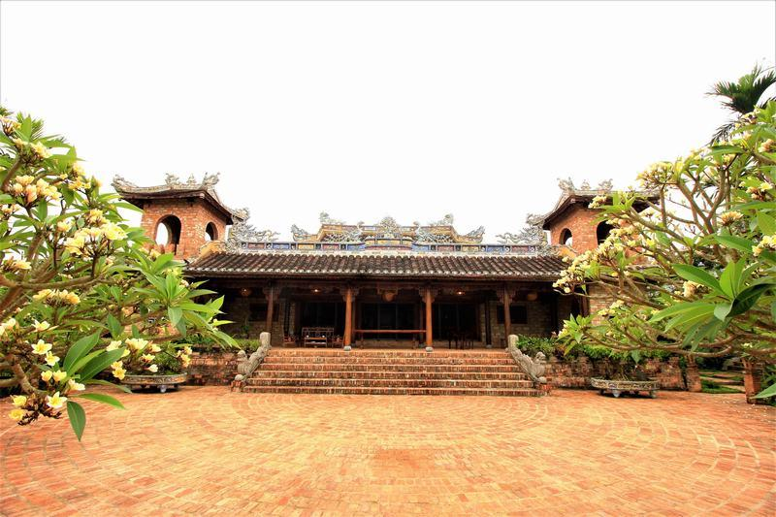
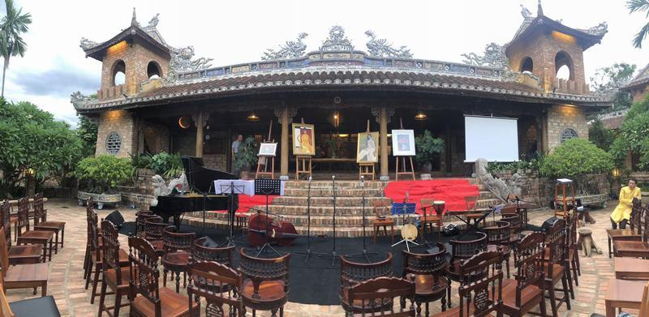
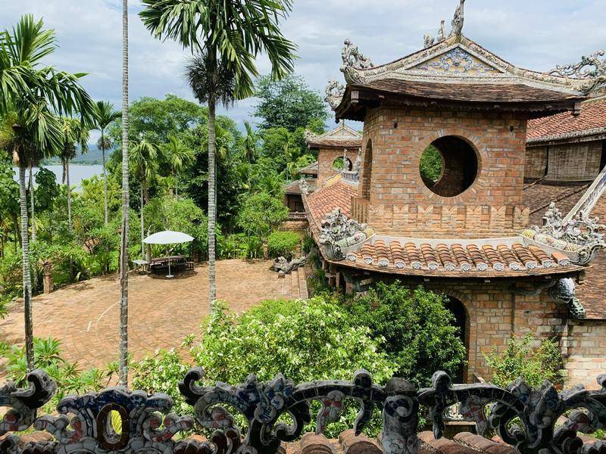
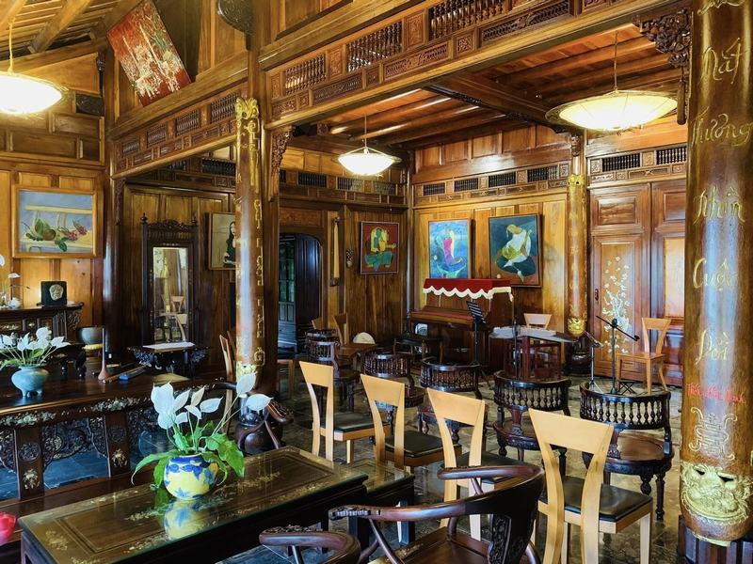
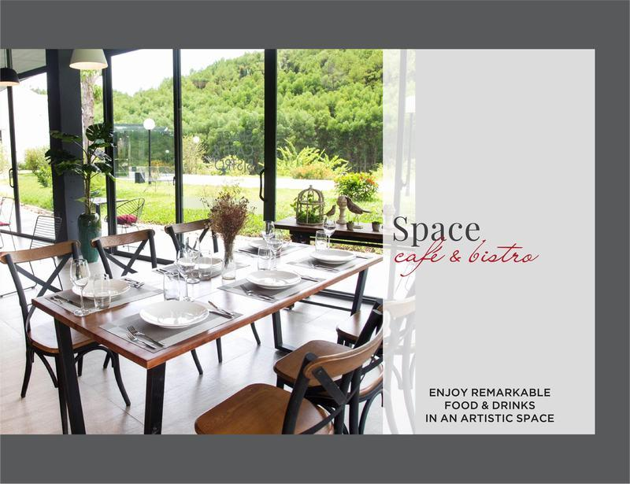

Easia Travel Head Office

Vietnam Head OfficeC/o: ATS Hotel, Suite 326 &amp;327, 33B Pham Ngu Lao Street, Hanoi, VietnamTel: +84 24-39 33 13 62www.easia-travel.com

