VIETNAM – Hue – Private Cruise on the Perfume River
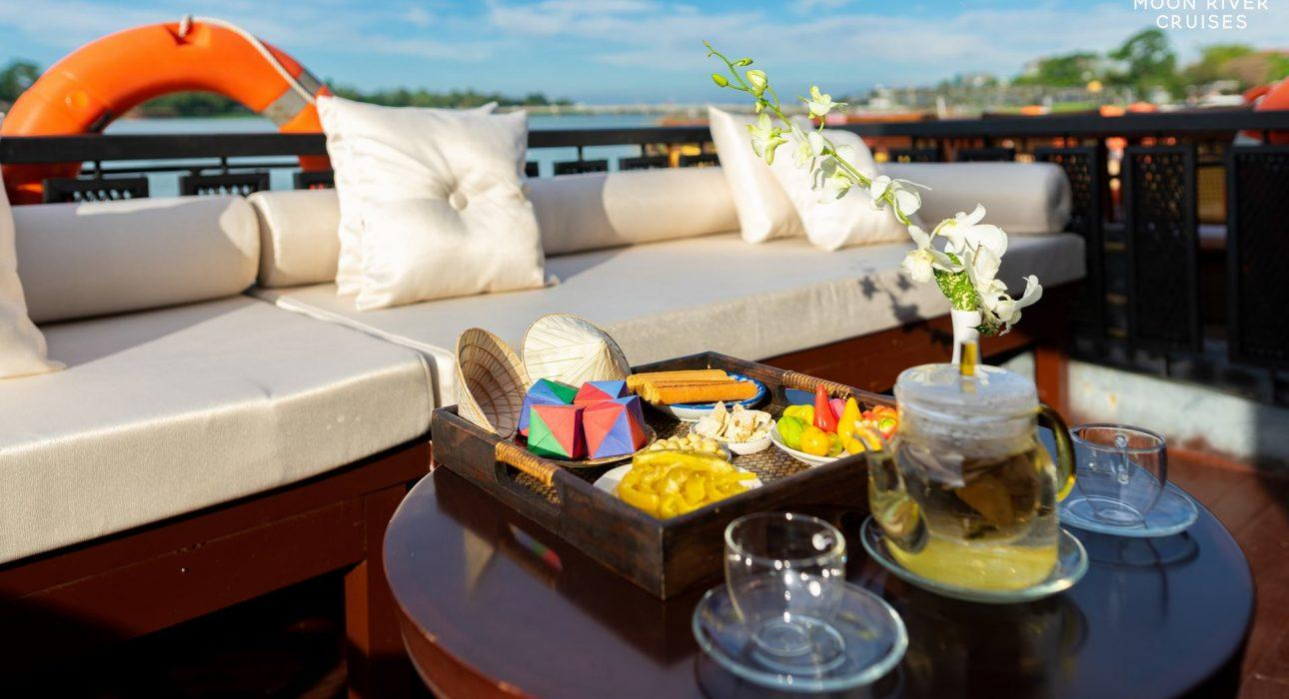

Over View

Theme
Art & Culture, Classic, Cruise & River Cruise, Family, Gastronomy, Honeymoon

Country - City
Vietnam - Hue

Market segment
Groups, Thematic Leisure

Price Level
$$$

Max pax
2 Boats Nam Xuan with maximum 18 persons each - 2 Boats Nam Binh with maximum 30 persons each

Seasonality
All year round

Arrival city
Hue

Departure city
Hue

Description

The cruise offers the opportunity to experience the breathtaking beauty of Hue from the comfort of a private wooden boat on the Perfume River. Enjoying a delicious meal, watching the sunset, relaxing with a foot massage, listening to traditional music and watching an Ao Dai performance. These unique experiences combined will provide you with a different perspective of the Perfume River and its majestic beauty.

Selling points

- A peaceful moment during lunchtime or at sunset.
- A private cruise break after exploring the City of Hue.
- To enjoy and admire the banks of the Perfume River while following the rhythm of the water.
- Perfect moment for families or honeymooners.
- Suitable for groups up to 30 persons for lunch, tea break, sunset, or dinner cruise.
- Possibility to add activities during the cruise such as foot massage, Vietnamese board games, Ao Dai show, or traditional music entertainment.

Sustainability

Level Of The Excursion
Low - This activity impacts local community, culture and/or environment in a small but meaningful way

The Impact Of This Excursion

Social/cultural Impact
Cultural Conservation

Environment Impact
Transportation

Economic Impact
Local individual benefits

Additional Information
Positive Impact:This activity provides direct income to the boat owner.Negative Impact:Boat engines run on diesel fuel, resulting in increased emissions and negatively impacting the environment.

Time And Transportation

From | To | Km | By | Duration | Road condition
Tu Duc Tomb | Thang wharf | 3 kilometers | Car | 10 minutes | Good
Thang wharf | 05 Le Loi wharf |  | Boat | 2 hours

Photos

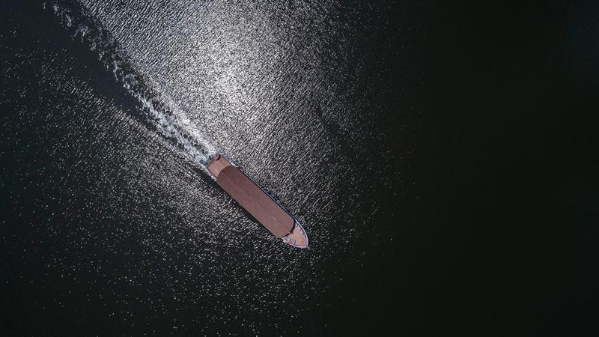
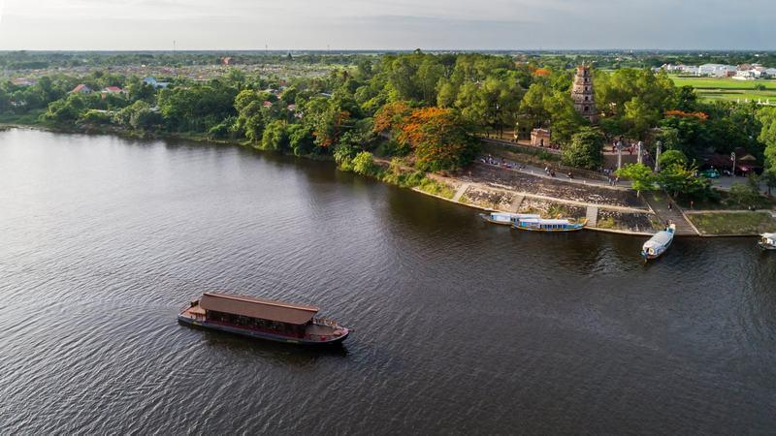
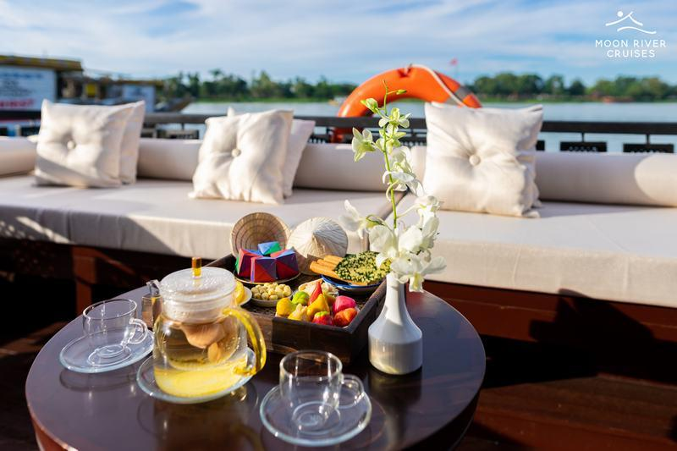
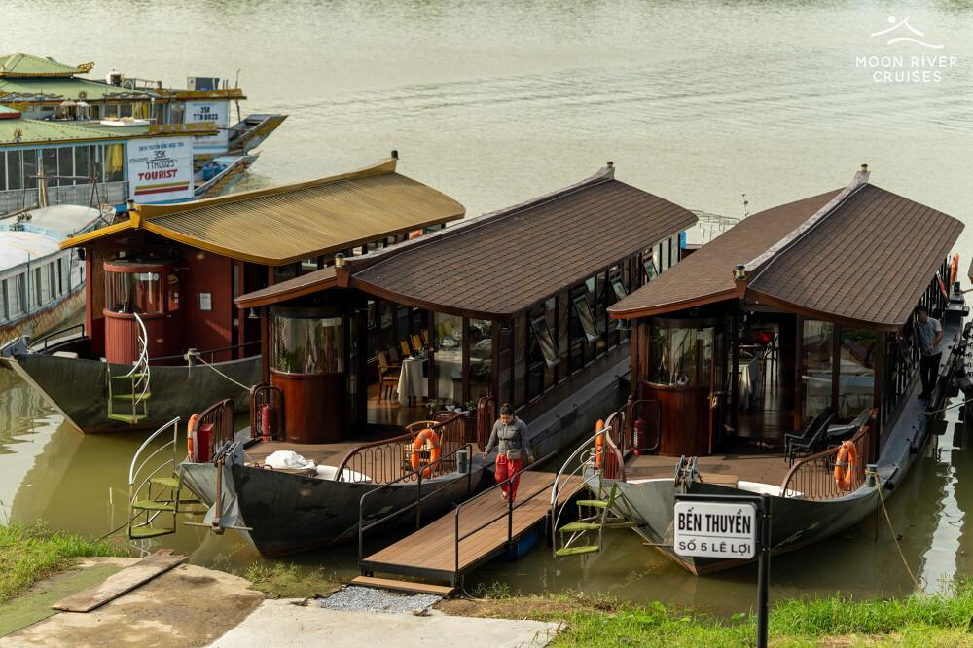
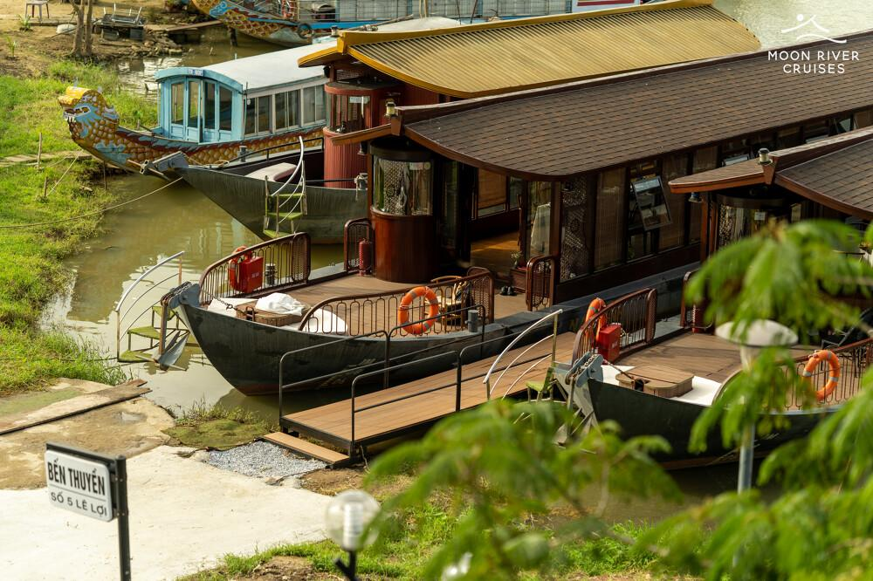
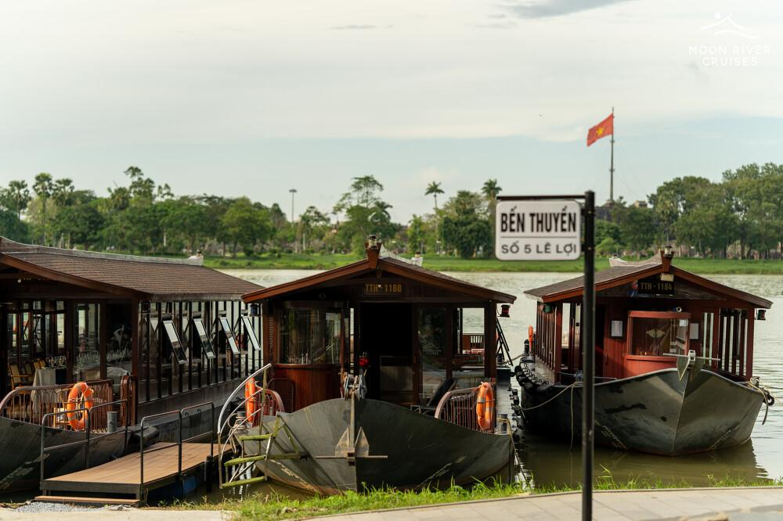
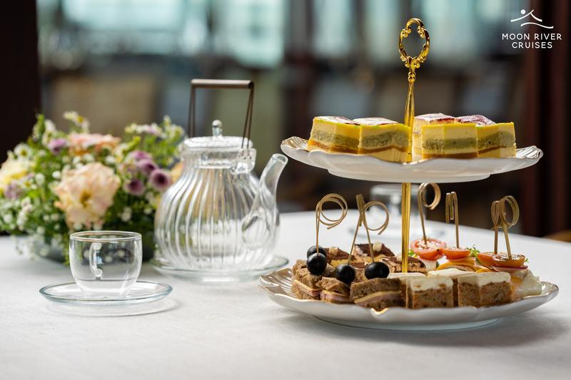
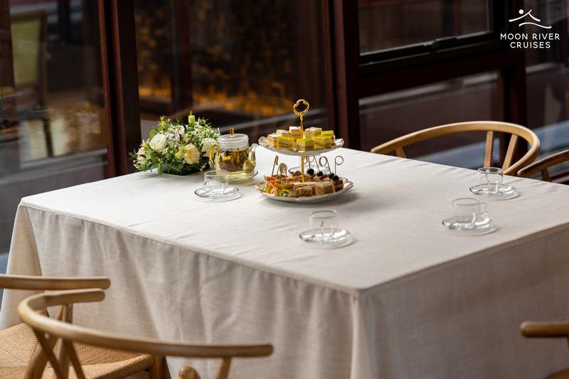
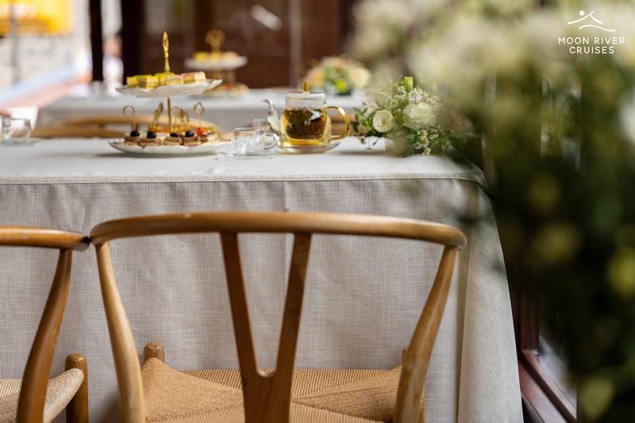
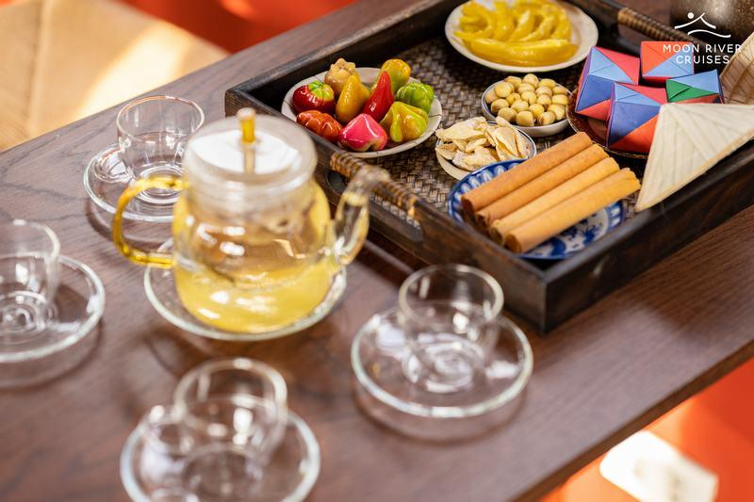
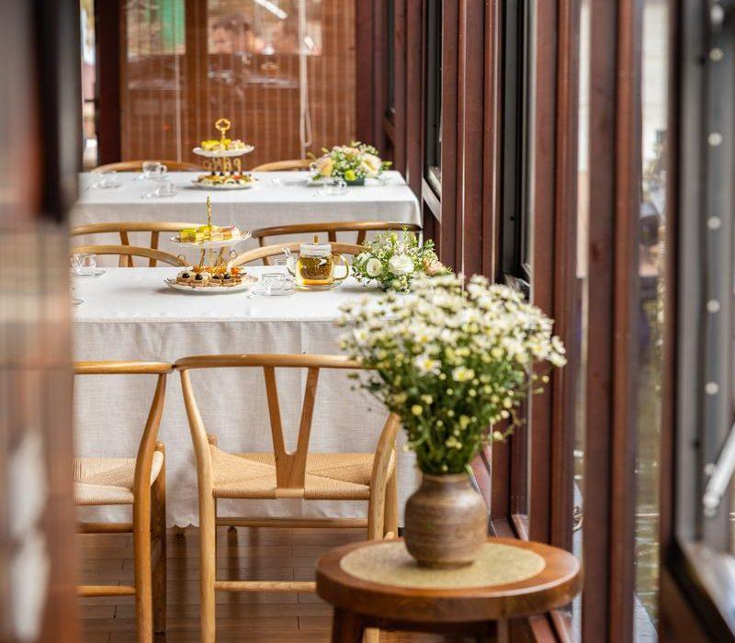
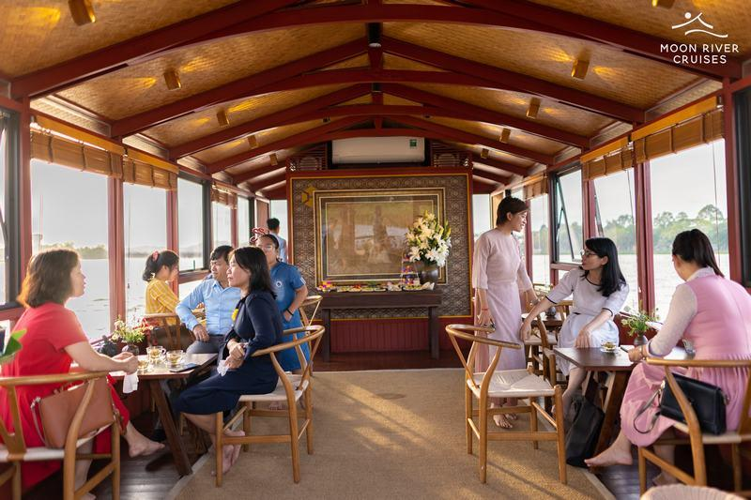
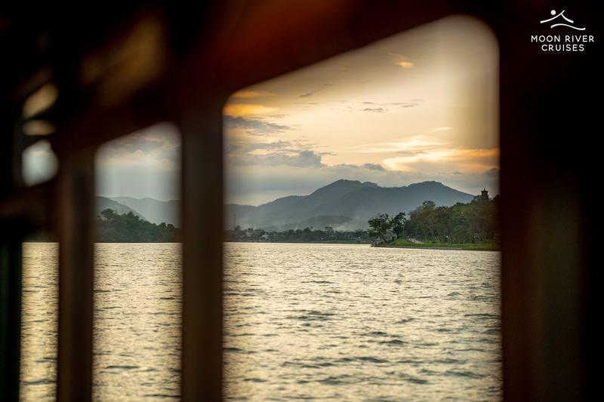
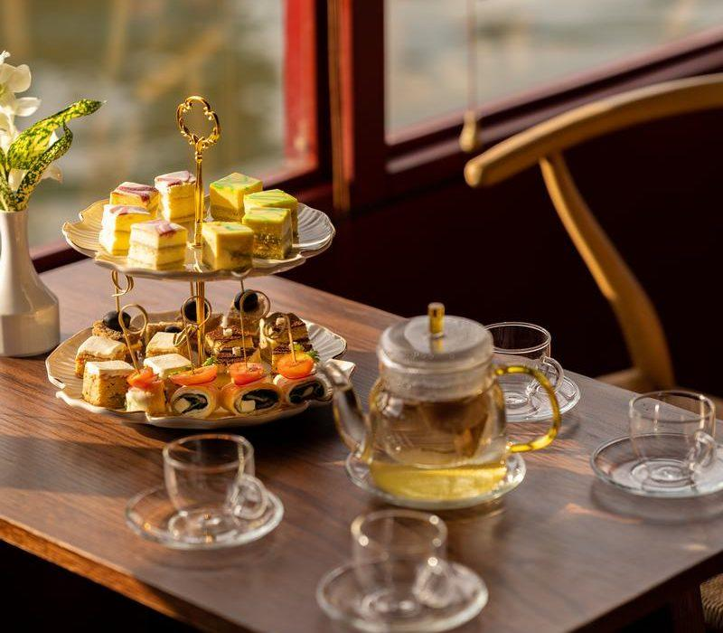
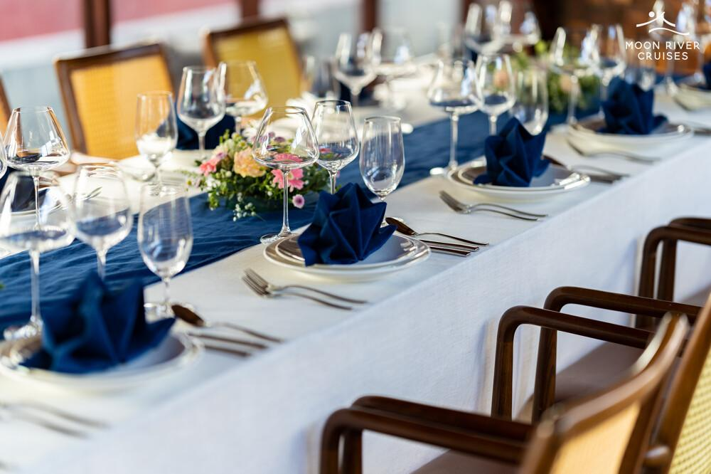
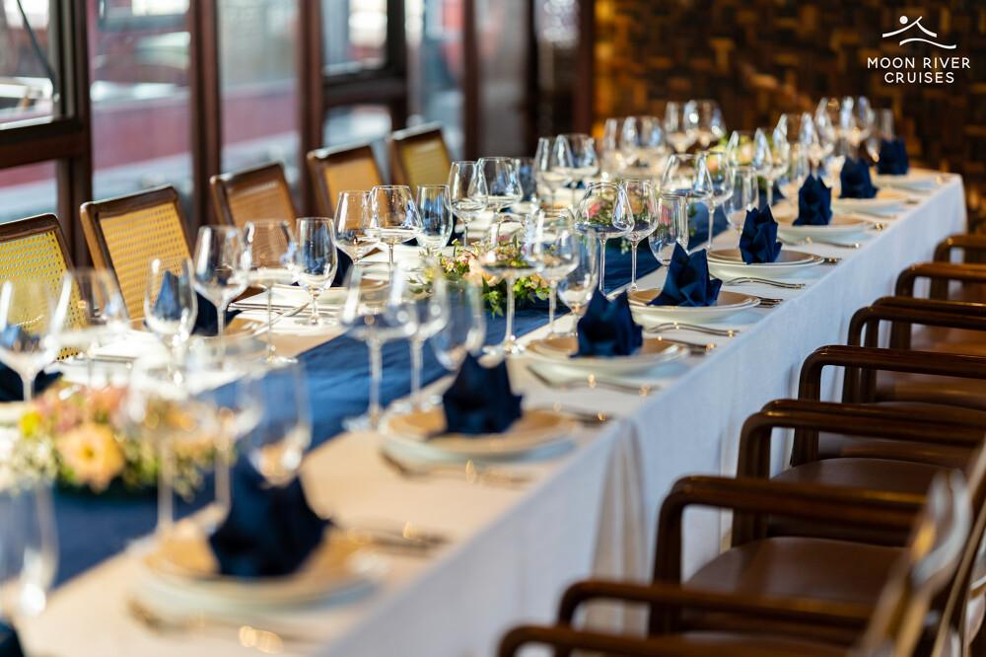

Easia Travel Head Office

Vietnam Head OfficeC/o: ATS Hotel, Suite 326 &327, 33B Pham Ngu Lao Street, Hanoi, VietnamTel: +84 24-39 33 13 62www.easia-travel.com

