LAOS – Muang Ngoi – Visit the Muang Ngoi Viewpoint
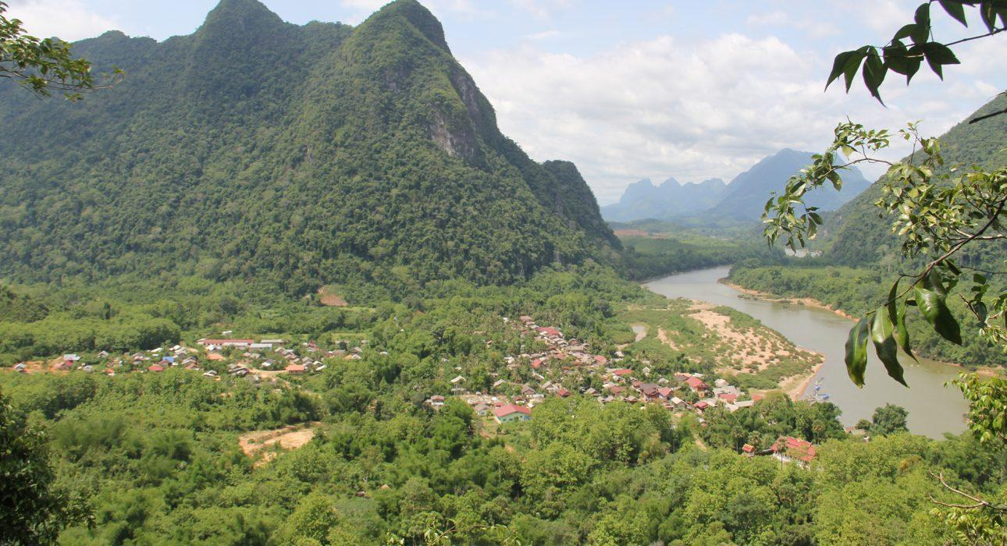

Over View

Theme
Classic

Country - City
Laos - Muang Ngoi

Market segment
Groups, Thematic Leisure

Price Level
$

Level of difficulties
LEVEL 2

Max pax
25

Seasonality
October to May (possible in the rainy season though not recommended)

Arrival city
Muang Ngoi

Departure city
Muang Ngoi

Description

Pha Noy Viewpoint is a popular spot in Muang Ngoi, Laos. Located on a small hilltop (“Pha Noy” means small hill) overlooking the Nam Ou River, the viewpoint offers spectacular views of the lush jungle and winding river. The perfect spot for a morning or afternoon walk, the viewpoint is accessible by a winding path and is surrounded by dense forest and stunning limestone cliffs.2h / 2.3km / +140m – the top can be reached in 40-45 minutes. The trail starts and ends in the town. The trail forks halfway, with a steeper, more adventurous route to the top going to the left and an easier way going to the right.

Can be combined with
Thematic Leisure
- LAOS – Muang Ngoi – Hike to Ban Na Village
- LAOS – Muang Ngoi – Boat Cruise on the Nam Ou River

Selling points

- The views over the town are beautiful and really lets visitors get a feel for where they are.
- It is an easy walk that is accessible to most travelers.
- The route is varied, passing through farmland, coffee plantations, forest, and rocky areas.

Sustainability

Level Of The Excursion
Low - This activity impacts local community, culture and/or environment in a small but meaningful way

The Impact Of This Excursion

Social/cultural Impact
Community welfare and health

Environment Impact
Transportation

Economic Impact
Local individual benefits, Community benefits

Additional Information
This activity benefits the local community through the collection of a small entrance fee. The entrance fee supports the local families who maintain the trails, bridges, and viewpoints.

Time And Transportation

From | To | Km | By | Duration | Road condition
Nong Khiaw | Muang Ngoi | 18 | Boat | 1h15 (upstream) 1h (downstream) | Wet, it’s a river
Muang Ngoi | Hike to Ban Na and back | 10 | Walking | 4-5 hours | Dirt track and trails, sometimes dusty.
Muang Ngoi | Hike to viewpoint and back | 2.3 | Walking | 2 hours | Mountain trail, steep in places.

Photos

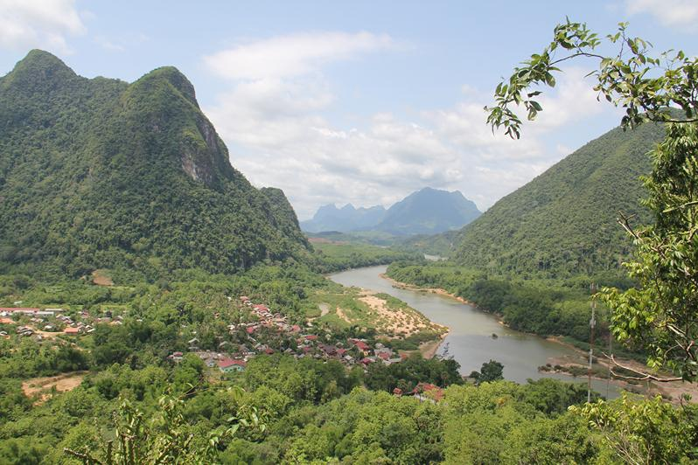
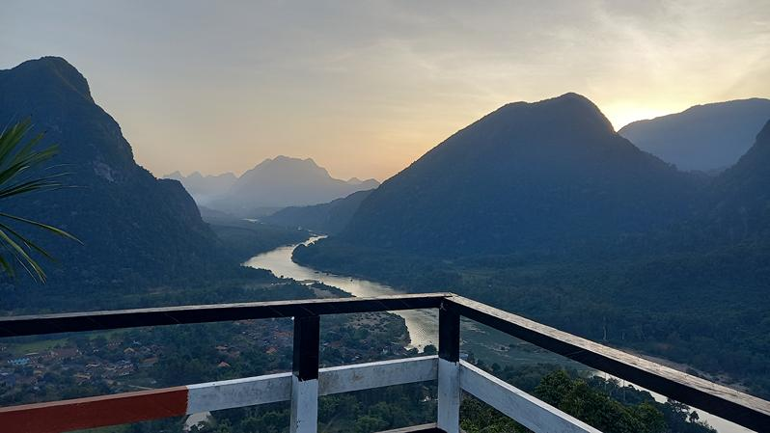
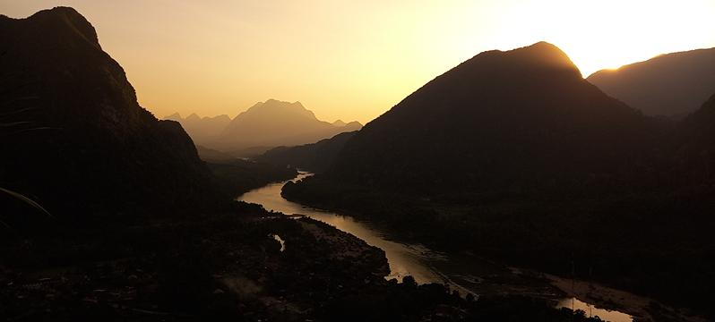
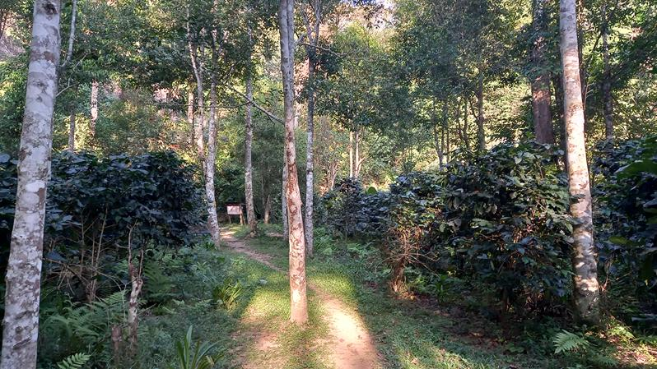
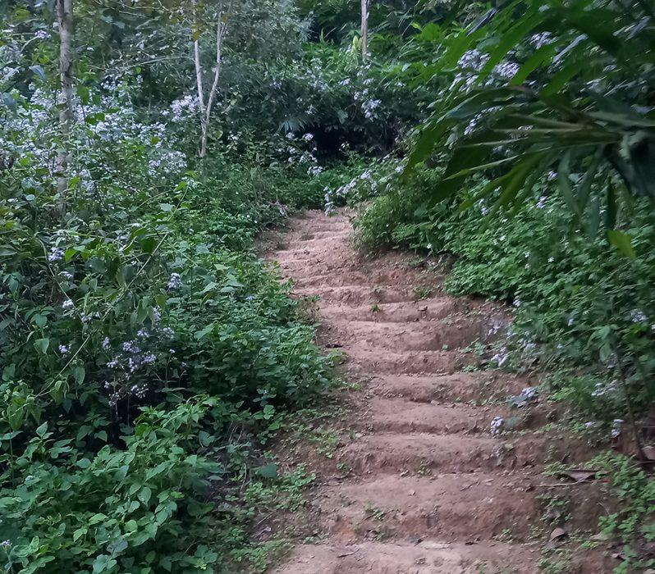
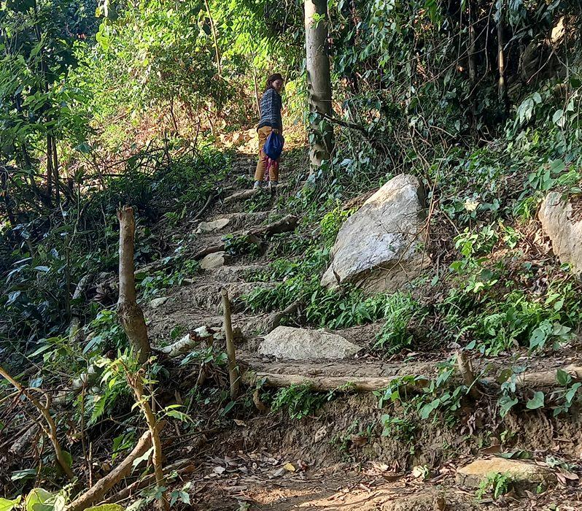
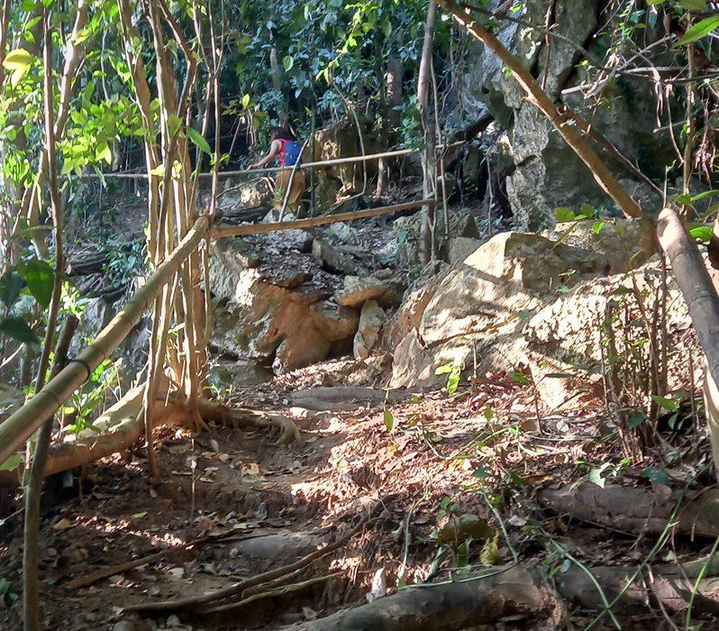

Easia Travel Head Office

Vietnam Head OfficeC/o: ATS Hotel, Suite 326 &327, 33B Pham Ngu Lao Street, Hanoi, VietnamTel: +84 24-39 33 13 62www.easia-travel.com

