THAILAND – Pai – Local Life and Nature Experience at a Karen Village
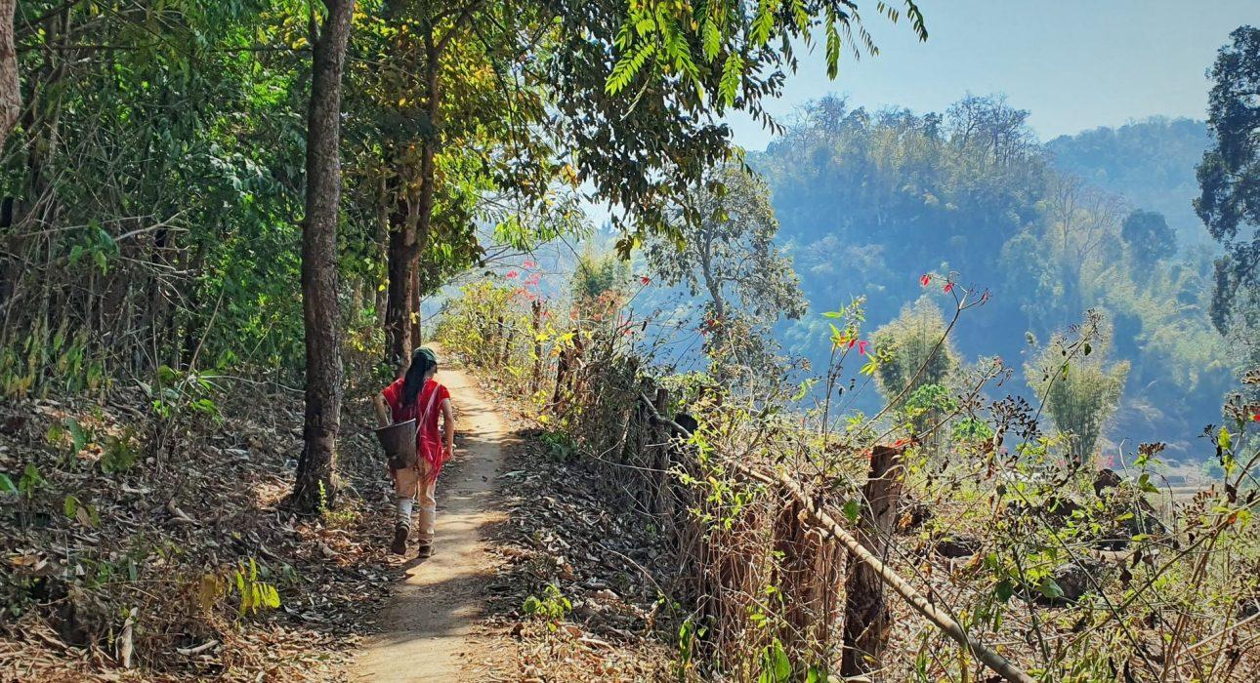

Over View

Theme
Art & Culture, Classic, Family, Sustainable

Country - City
Thailand - Pai

Market segment
Thematic Leisure

Price Level
$$$

Level of difficulties
LEVEL 1

Max pax
8

Seasonality
Possible year round, but not recommended during the hot season (March - April)

Arrival city
Pai

Departure city
Pai

Description

During this visit, guests will venture out to a remote Karen village, located in a scenic valley surrounded by forest and rice paddies. The host, a dynamic Karen woman who was born and raised in the village, will welcome them and show them around the village while explaining about daily life and traditions. There will also be time for a nature hike to enjoy the surroundings, have an adventurous picnic lunch in green surroundings, and learn how the Karen people live in harmony with nature. Back in the village, the secrets of traditional Karen weaving and natural dyeing will be revealed, a skill that has been passed on for generations.

Selling points

- A very scenic village, easy to include in any programs staying overnight in Pai.
- While basic fitness is needed, the program is flexible and can be adapted to the travelers’ needs.
- A passionate and dynamic host to show guests around the village.
- The village is not very well known with the general public.
- Good to combine with Tham Lod cave, which is a must-see in the area.

Sustainability

Level Of The Excursion
Medium – This activity offers tangible positive contributions to the local community, culture and/or environment

The Impact Of This Excursion

Social/cultural Impact
Cultural Conservation, Empowerment and education, Homestays, Involving minorities

Economic Impact
Local individual benefits, Community benefits

Additional Information

Positive impacts:
This activity is led by women and supports the traditional crafts and lifestyle of the community both directly and indirectly through the activities that guests will partake in.

Negative impacts:
No negatives.

Time And Transportation

From | To | Km | By | Duration | Road condition
Pai | Karen Village | 55 | Car | 1 hour 15 minutes | Good, but mountainous. The last part to the village is quite rough
Tham Lod | Karen Village | 7 | Car | 20 minutes | Rough mountainous road
Karen Village | Mae Hong Son | 80 | Car | 2 hours | Good, but mountainousThe first part from the village is quite rough

Photos

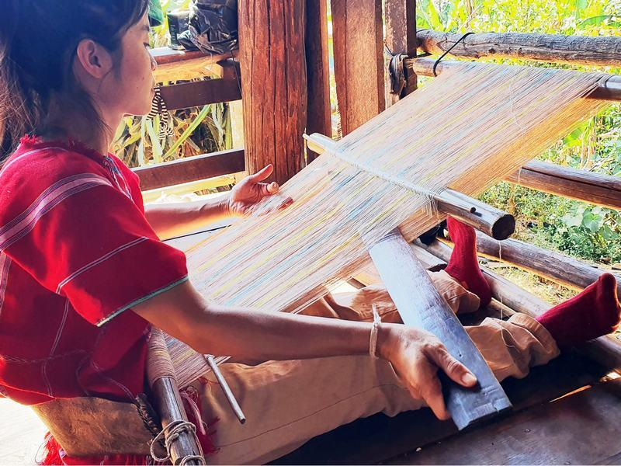
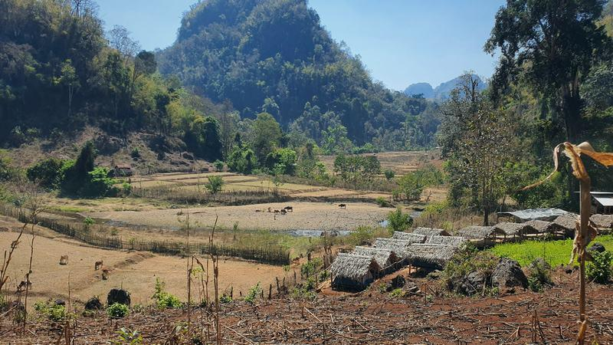
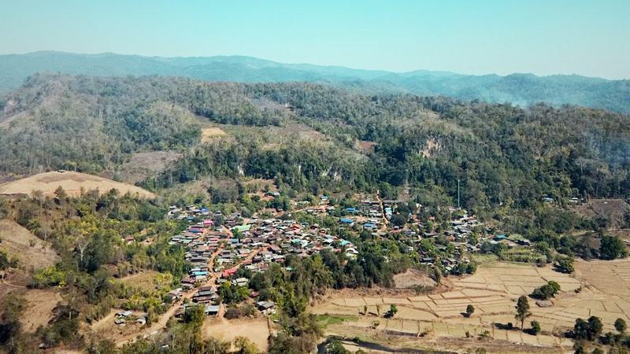
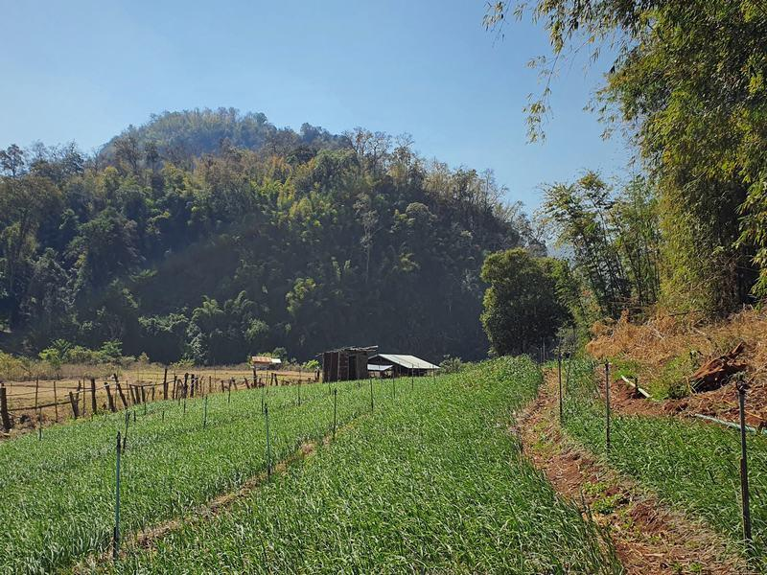
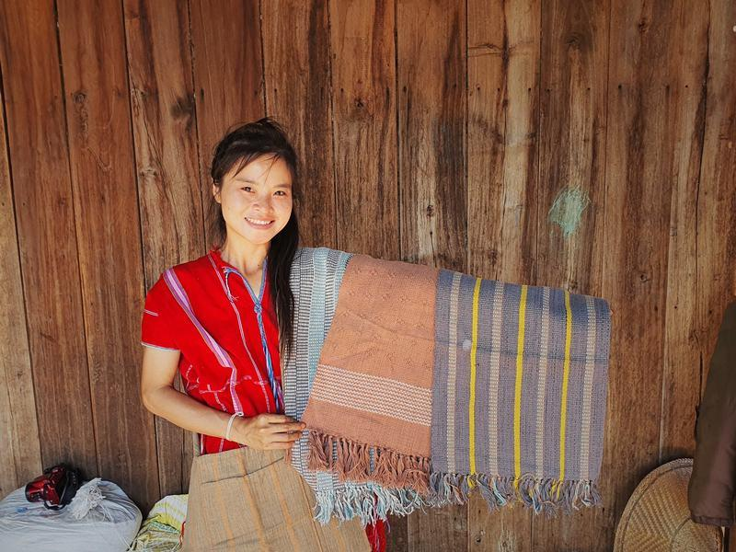
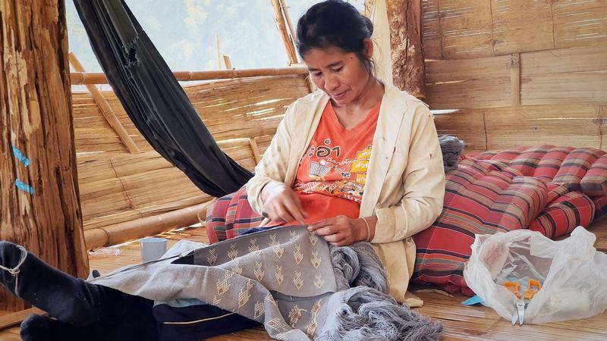
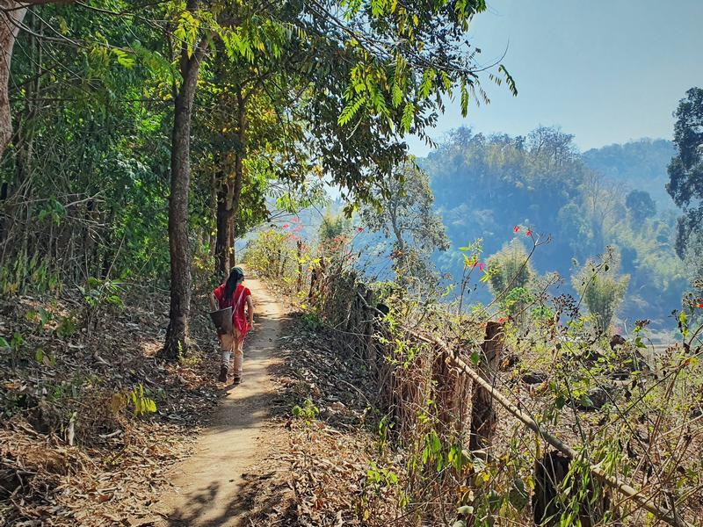
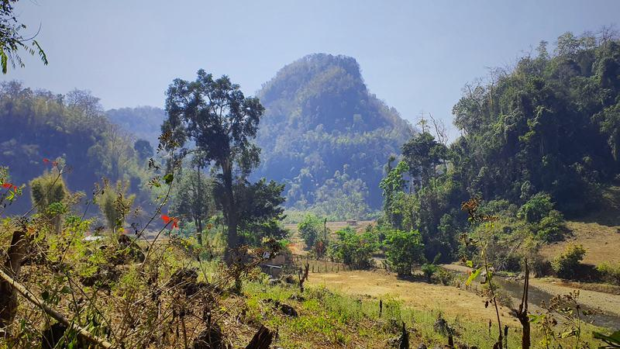

Easia Travel Head Office

Vietnam Head OfficeC/o: ATS Hotel, Suite 326 &3 27, 33B Pham NguLao Street, Hanoi, VietnamTel: +84 24-39 33 13 62www.easia-travel.com

