CAMBODIA – Siem Reap – The Beauty of Tonle Sap Lake on the Easia Boat
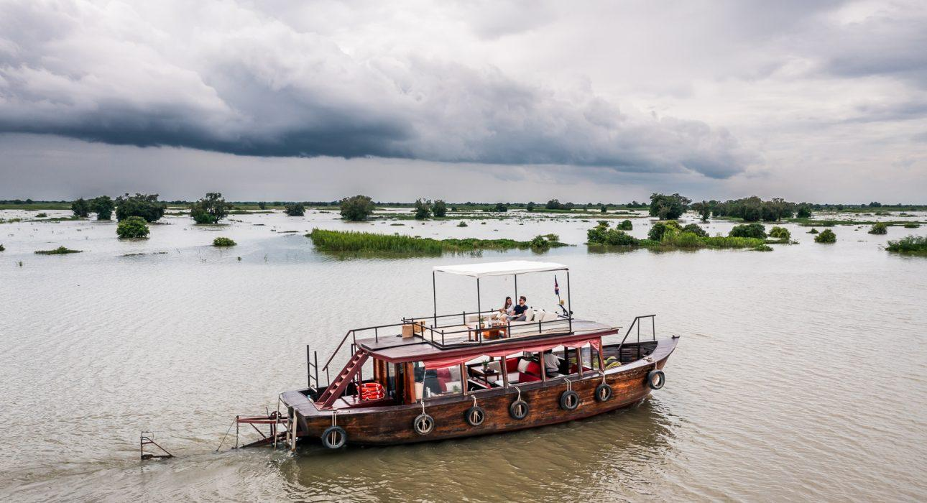

Over View

Theme
Art & Culture, Classic, Cruise & River Cruise, Family, Honeymoon, Sustainable

Country - City
Cambodia - Siem Reap

Price Level
$$$

Level of difficulties
LEVEL 0

Max pax
16pax

Seasonality
July to March

Arrival city
Siem Reap

Departure city
Siem Reap

Description

FEB – MAR – JUL – AUG : Kompong Kleang Cruise Visiting a floating village by boat is the perfect way to discover the daily life of the people who live on or near the great Tonlé Sap Lake, Southeast Asia’s largest freshwater lake. Travelers will be able to witness local fishermen pulling up their nets, children playing on the porches of their floating houses, hawkers traveling on their barges, and much more…Departing from Kompong Kleang, you will board our beautiful boat led by our captain. The wooden ship will meander easily from village to village along the various canals leading up to the Great Lake. Once it reaches the end of the channel, travelers will soon realize the immensity of this lake, where the horizon stretches as far as the eye can see.Tea, coffee, and soft drinks are available on board.During the dry season, a walk to meet the locals is offered before guests set out for the cruise.
FEB – MAR – JUL – AUG: Afternoon cruise with Aperitif – Kompong Kleang Cruise Embark on an adventure this afternoon as you explore the magnificent Tonlé Sap Lake, the largest freshwater lake in Southeast Asia. Upon arrival at the pier, the warm and welcoming boat crew will greet you and guide you to a beautifully crafted wooden boat fully equipped for comfort.Hop on the boat and prepare to be captivated by the sight of local fishermen hauling in their nets, playful children on the stilted houses, and vendors navigating their barges.Sit back, relax, and immerse yourself in the tranquil ambiance of the lake as the attentive boat crew serves you delectable finger foods, snacks, and refreshments, including wine and soft drinks.
SEP – OCT – NOV – DEC – JAN : Mechrey to Prek Toal CruiseGuests embark on a journey to discover the great Tonle Sap Lake, the largest freshwater lake in Southeast Asia, and visit the Prek Toal floating village and an incredible bird sanctuary during this priceless experience.Early morning, departing from Mechrey, travelers will embark and navigate until Prek Toal, one of Tonle Sap Lake’s most authentic floating villages. Tea, coffee, and breakfast boxes are served on board.Start with the visit to the bird Sanctuary, a natural and unique ecosystem of the waterbird breeding colony. The reserve is essential for eight species of bird: the Spot-billed Pelican, Greater Adjutant, Lesser Adjutant, Milky Stork, Painted Stork, Black-headed Ibis, Oriental Darter, and Grey-headed Fish-Eagle. Thousands of commoner waterbirds also breed here, and over 150 species have been recorded.After the visit, you cruise through the village and discover the unique livelihoods of those living on the lake, where everything floats, from the pagoda to the school to the pharmacy!Experience a locally cooked lunch in a floating restaurant managed by a local NGO and create a final memory: a water hyacinth handicraft workshop. A villager will teach you to create a colorful household item from the water hyacinth plant. Finally, you will wave goodbye to this water world and return to the mainland in Mechrey.
SEP – OCT – NOV – DEC – JAN: Sunset CruiseThis private sunset cruise on a beautifully decorated and well-equipped boat lets you experience the great lake in an exceptionally relaxed and exclusive atmosphere. Before sunset, welcome at the pier by the friendly boat crew and start your scenic cruise past floating farms, houses, and local fishing boats out on the Tonle Sap Lake. Have the chance to feast on a selection of nicely assorted and presented finger food, snacks, and imported wine and soft drinks. Out on the lake, the engine stops and floats peacefully to experience the magnificent sunset, take time for a chat, and leave all their cares behind. Return to the pier to start the quick transfer to Siem Reap town.

Selling points

- The best of Tonle Sap Lake on a stylish boat
- Choices of cruises adapted to the seasons & water level of the Lake
- A lot of options to make the experience even more exclusive
- Signature activity from Easia

Sustainability

Level Of The Excursion
Medium – This activity offers tangible positive contributions to the local community, culture and/or environment

The Impact Of This Excursion

Social/cultural Impact
Cultural Conservation

Environment Impact
Transportation

Economic Impact
Local individual benefits, Community benefits

Additional Information
The Easia boat project supports individual local businesses as well as the community.

Time And Transportation

From | To | Km | By | Duration | Road condition
Town | Mechrey | 27 | Car, Bus | 45/50 minutes | Good
Town | Kompong Kleang | 52 | Car, Bus | 1h30 min | Good
Mechrey | Prek Toal |  | Boat | 45min to 1h30 min

Photos

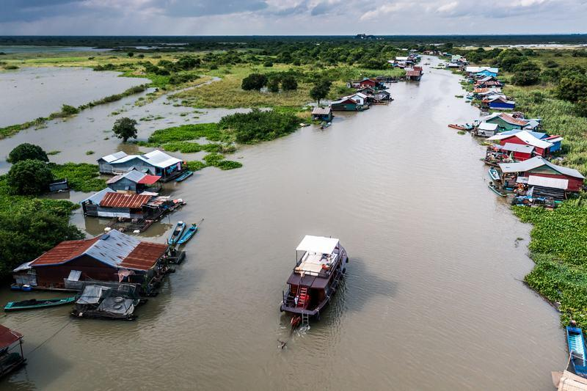
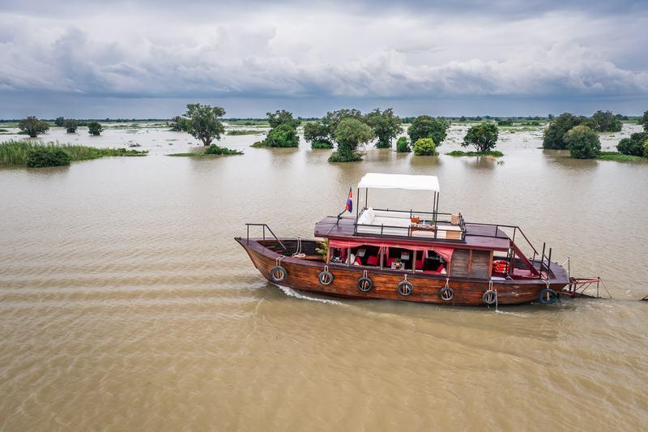
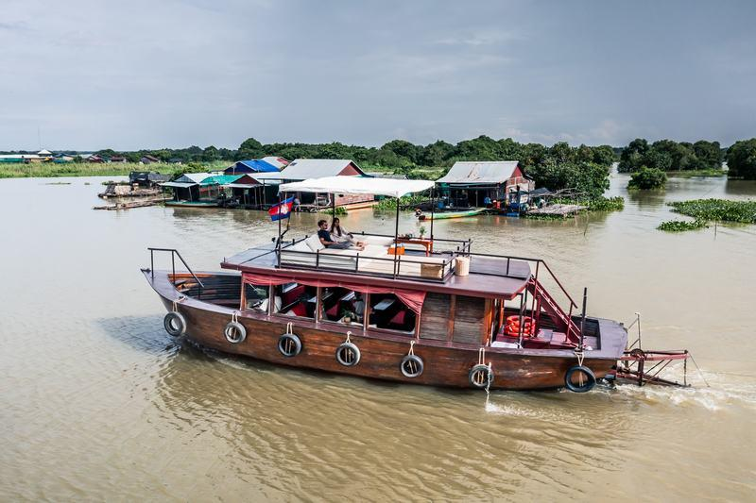
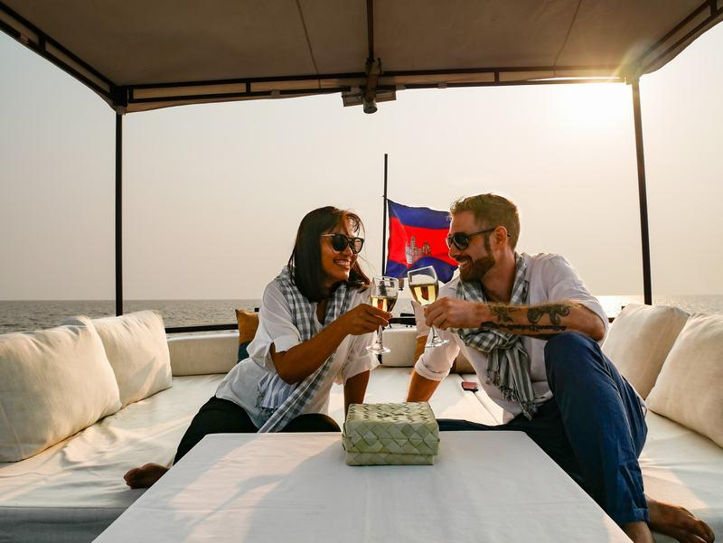
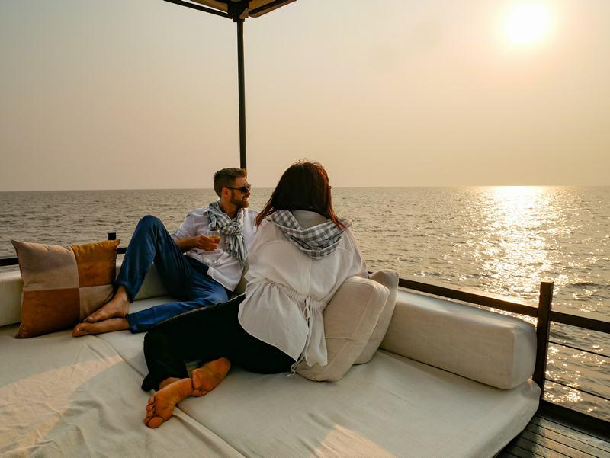
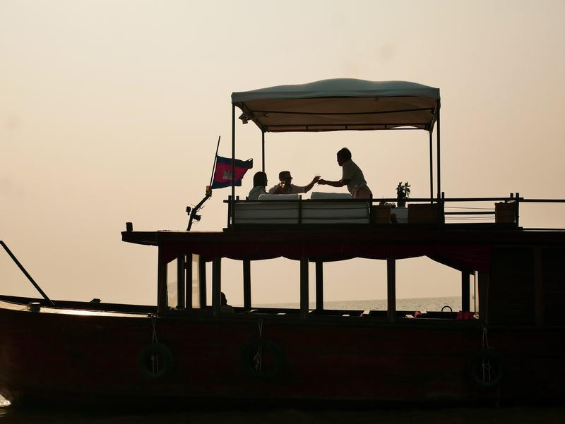
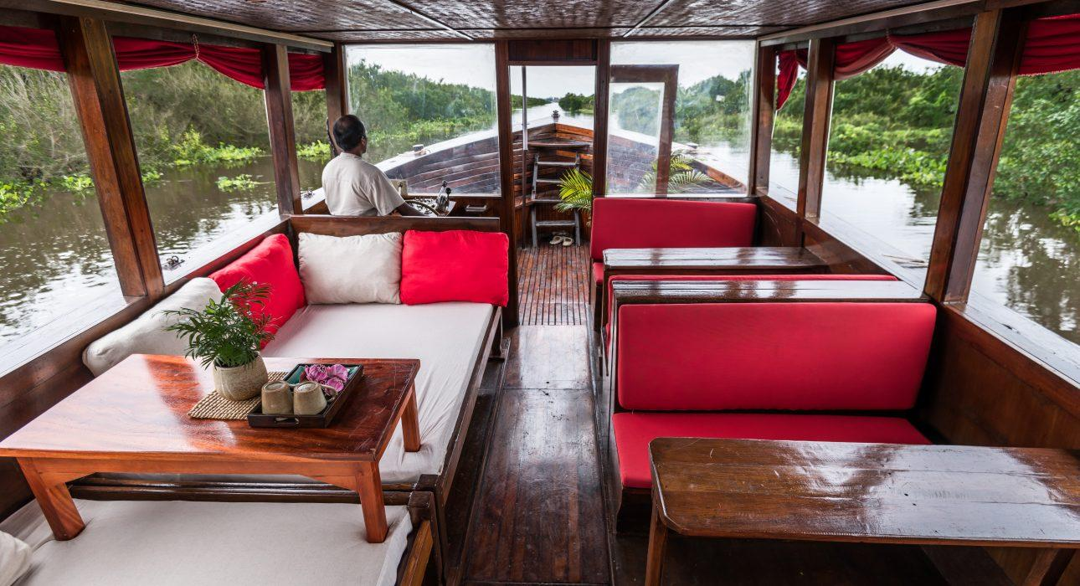
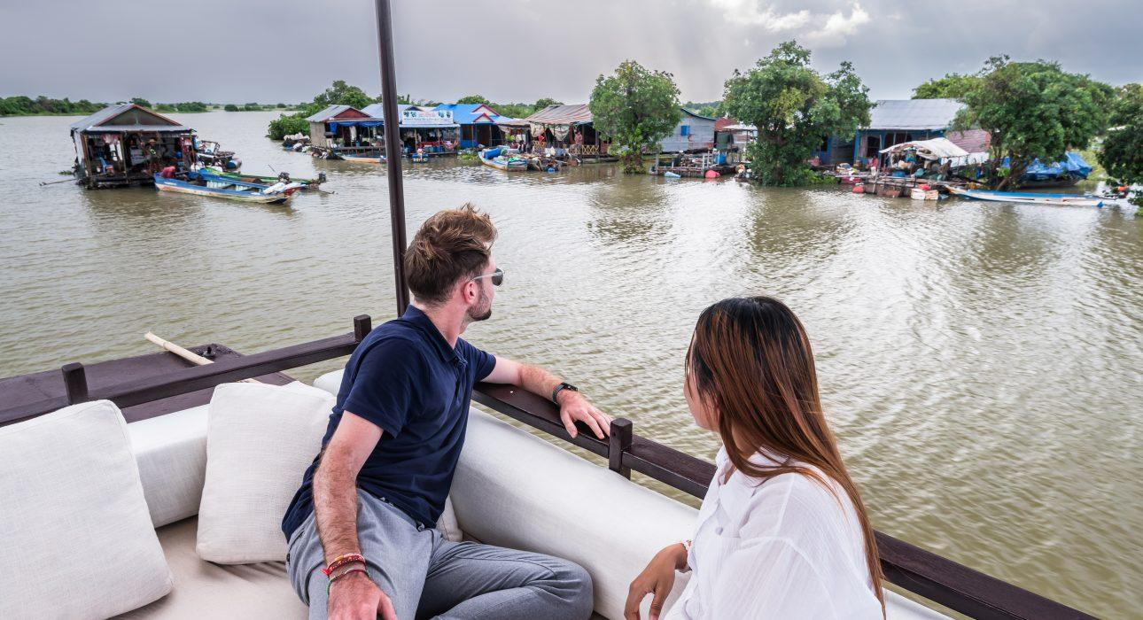
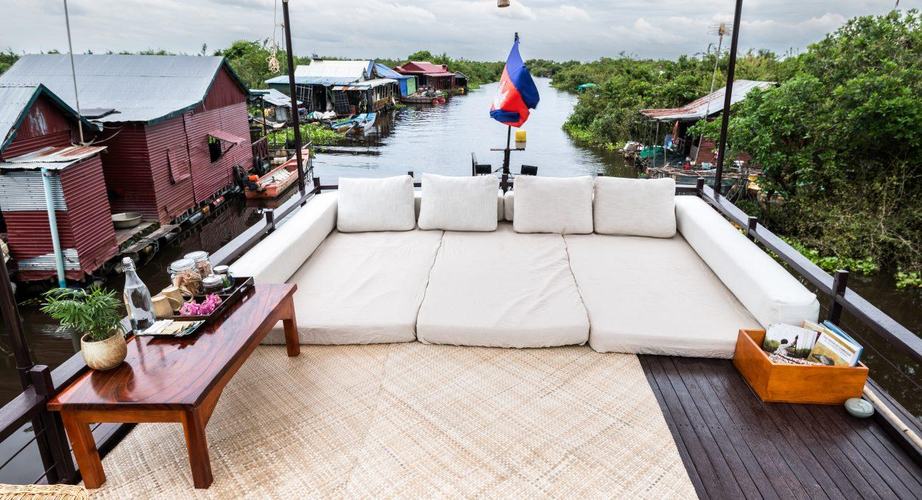
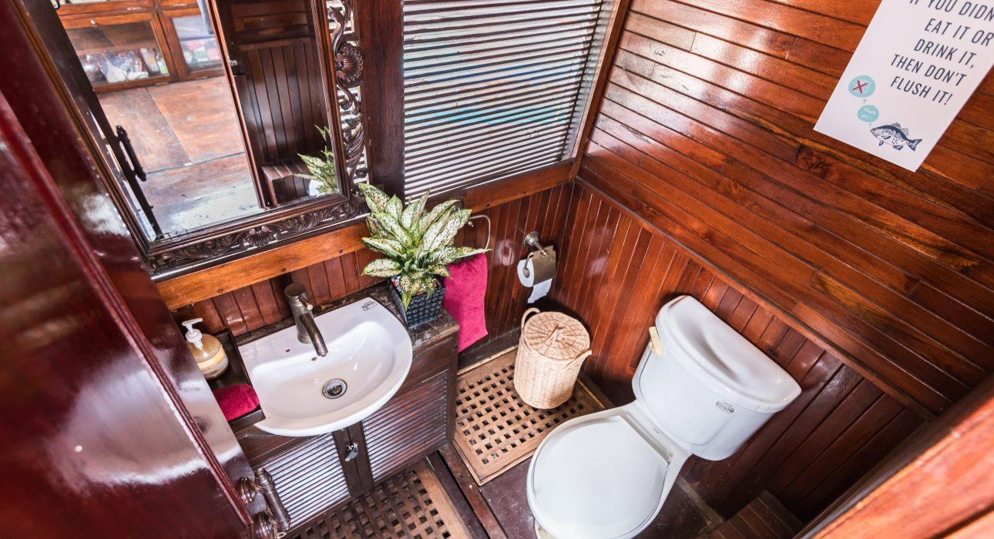
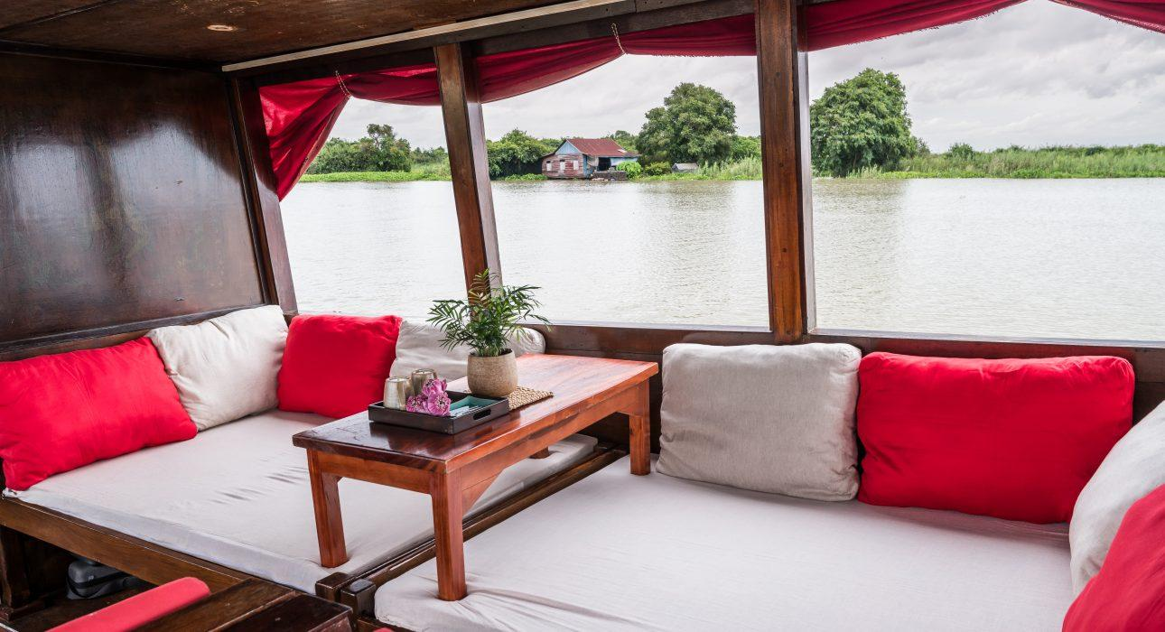
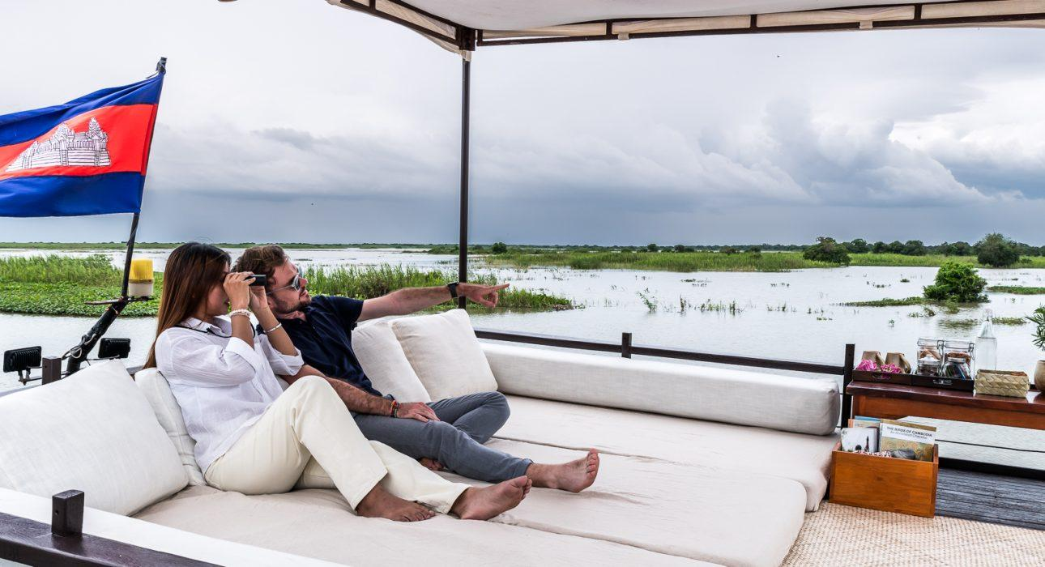

Easia Travel Head Office

