THAILAND – Pai – A Visit to Paem Bok Community and Bamboo Bridge
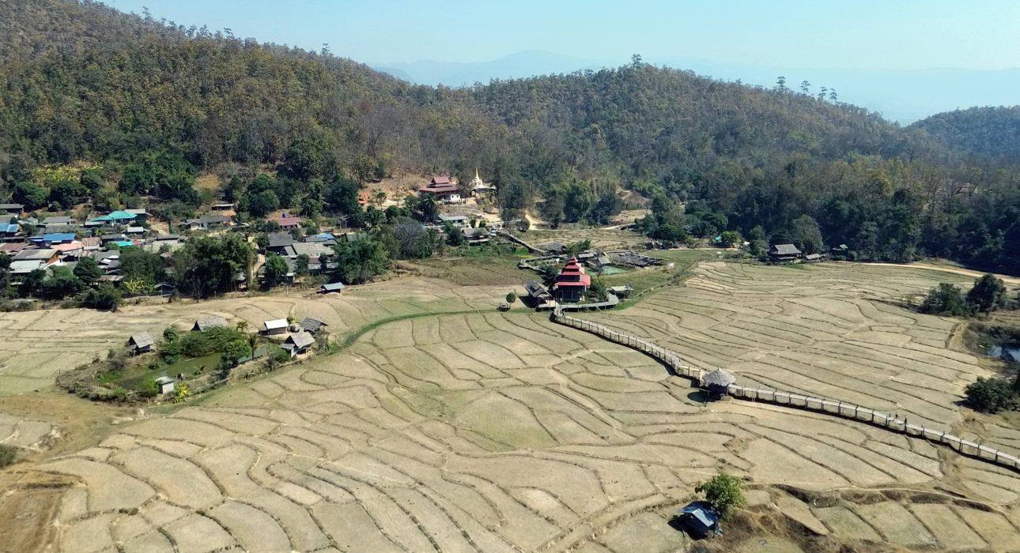

Over View

Theme
Art & Culture, Classic, Family, Sustainable

Country - City
Thailand - Pai

Market segment
Thematic Leisure

Price Level
$$

Level of difficulties
LEVEL 0

Max pax
10

Seasonality
Possibly year round, but not recommended during March-April (hot season)

Arrival city
Pai

Departure city
Chiang Mai

Description

The Kho Ku So bamboo bridge is undoubtedly the main attraction of Paem Bok Village. And while a regular visit to the scenic bridge is excellent in its own right, adding a visit to the neighboring community offers a much more complete and immersive experience. The impressive bridge is a welcome source of extra income for the community, but it doesn’t define their society. During a community-based visit to the village and surrounding fields, guests will get a unique insight into the bridge’s history, the culture of the Shan people, and their livelihoods.

Selling points

- An excellent half-day activity for travelers staying overnight in Pai.
- Adds a more immersive dimension to a regular visit to the bamboo bridge.
- Combines exciting encounters with a famous sight (the Kho Ku So bamboo bridge).
- Community-based, suitable for a wide range of profiles.

Sustainability

Level Of The Excursion
Medium – This activity offers tangible positive contributions to the local community, culture and/or environment

The Impact Of This Excursion

Social/cultural Impact
Cultural Conservation, Empowerment and education, Homestays, Involving minorities, Community welfare and health

Economic Impact
Local individual benefits, Community benefits

Additional Information

Positive impacts:
This activity is community-based and supports the traditional crafts and lifestyle of the community both directly and indirectly through the activities that guests will partake in.

Negative impacts:
No negatives.

Time And Transportation

From | To | Km | By | Duration | Road condition
Pai | Paem Bok community | 10 | Car | 25 minutes | Good, but the last part is mountainous and a bit rough
Chiang Mai | Paem Bok Community | 135 | Car | 3 hours 15 minutes | Good but mountainous, the last part is a bit rough
Paem Bok Community | Paem Bok Waterfall | 2 | Car | 5 minutes | Mountainous and quite rough in some sections

Photos

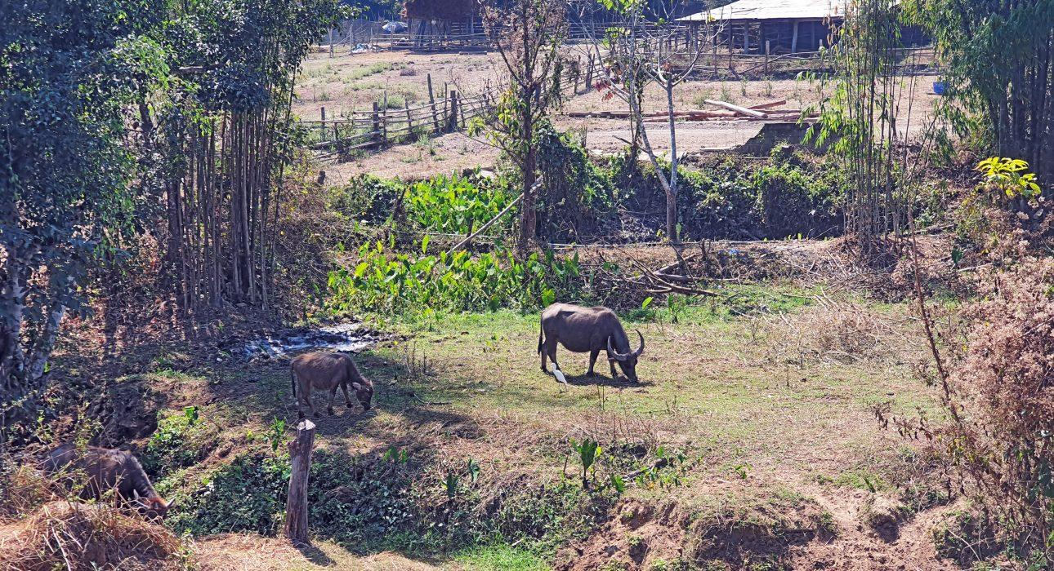
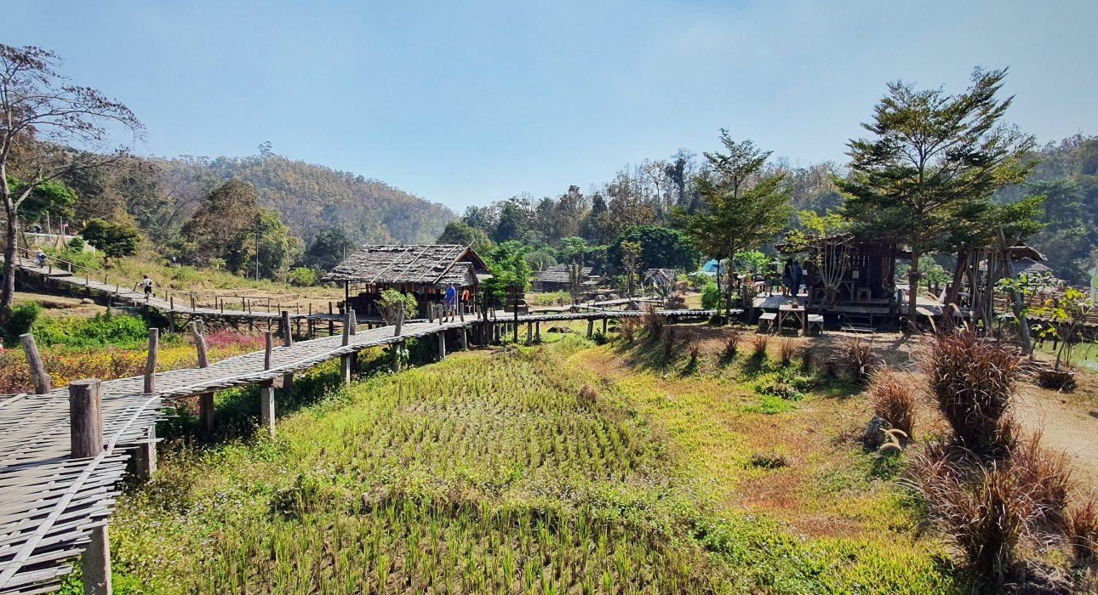
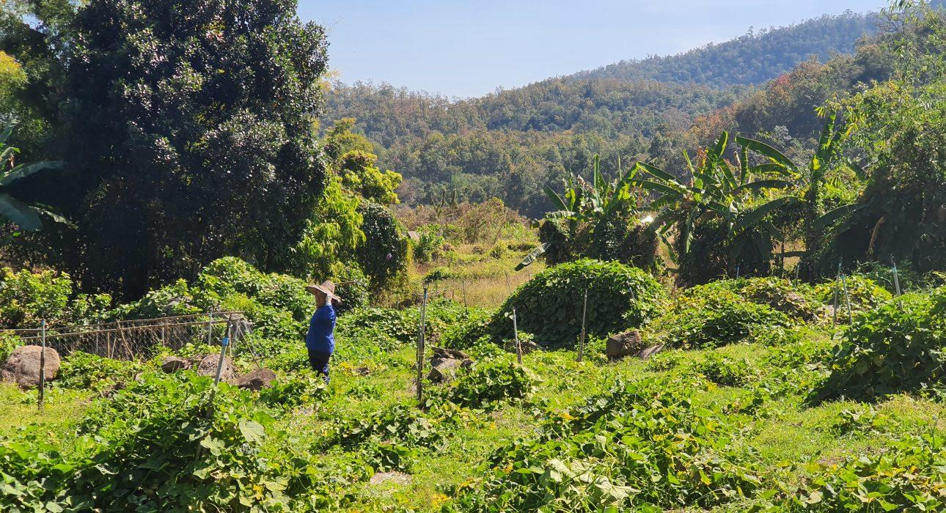
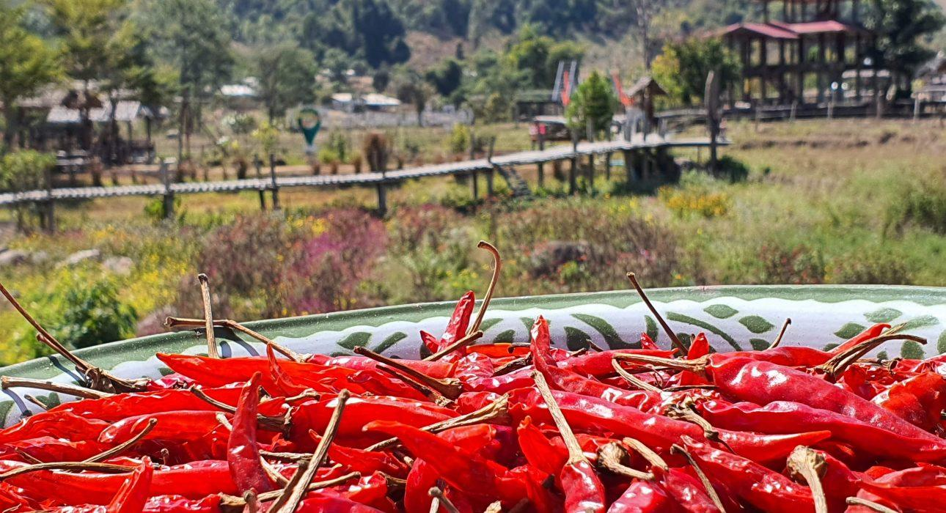
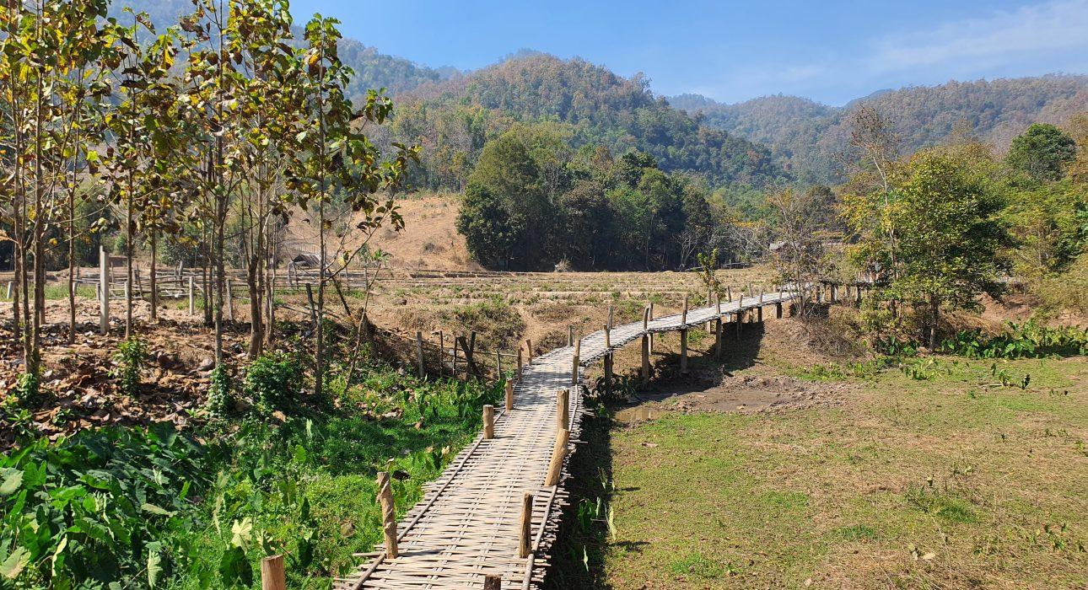

Easia Travel Head Office

Vietnam Head OfficeC/o: ATS Hotel, Suite 326 &3 27, 33B Pham NguLao Street, Hanoi, VietnamTel: +84 24-39 33 13 62www.easia-travel.com

