MYANMAR – Mergui Archipelago – Burma Boating
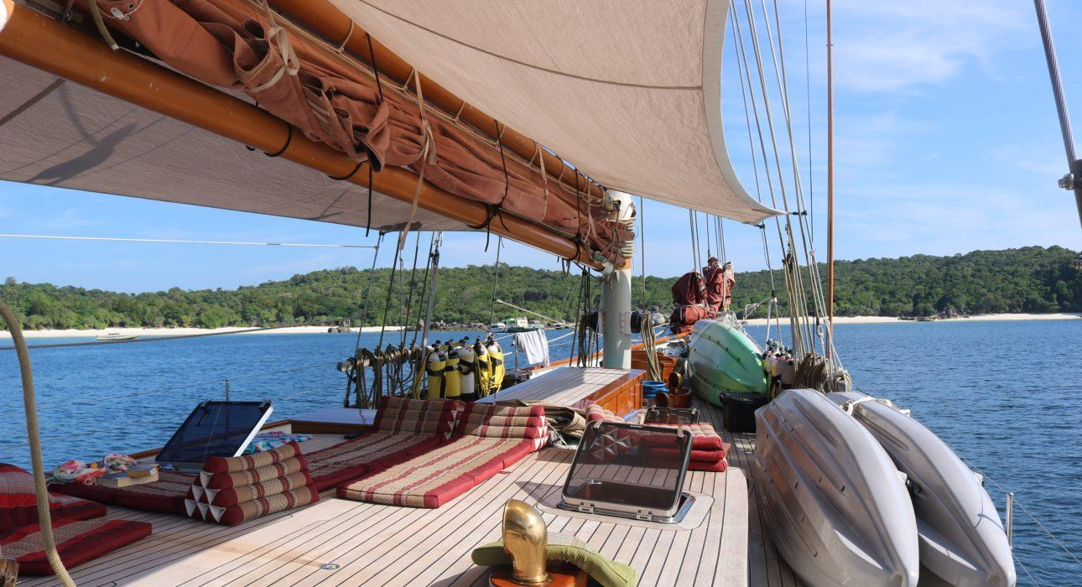

Over View

Theme
Beach Stay, Cruise &amp; River Cruise, Honeymoon

Market segment
Thematic Leisure

Total number of cabins
3 or 4 cabins depending on the yacht

Price Level
$$$$

Description

Burma Boating is one of the rare company to operate cruises in the southern part of the Mergui archipelago. Each one of their yacht is equipped with finest amenities for the most comfortable sailing holiday. The four- or five- night cruise will bring you to remote, uncharted islands, for diverse sea adventures. Each yacht can host between 6 and 8 passengers

Selling points

- One of the only cruise company operating in the Mergui Archipelago
- Mergui Archipelago is the last uncharted archipelago on Earth – still a hidden paradise
- A unique way to discover the archipelago
- A selection of different yachts that can be chartered on demand
- Quality amenities with excellent service on board – the intimacy of the boat gives you the feeling to be surrounded by family
- A perfect addition to a cultural sightseeing program in the rest of the country
- An ideal alternative to a beach stay for guests who have a deeper sense of exploration
- A real feeling a freedom

Cabins

Number of cabins
3 or 4 cabins depending on the yacht

Cabin type and Surface
Each boat has different types of cabin, more or less spacious, with a double bed or bunk beds.Choosing the cabin type:There is no real “best choice”, each boat has its own disposition. Be careful with the location of the room on the cabin plan and avoid rooms that are next to the kitchen/engine/generator (for ex: Master Room in Dallinghoo is located next to the engine – clients were bothered by the noise and smell of gas very often).
- SY Jubilaeum:
  - Ketch
  - Capacity: 6 guests in 3 cabins:
    - 2 TWN: bunkbeds – private bathroom but not en-suite
    - 1 DBL: en-suite bathroom
- SY Lady Mia:
  - Catamaran Lagoon 500
  - Capacity: 8 guests in 4 cabins:
    - 4 double cabins with en-suite
- SY Y Not:
  - Capacity: 6 guests in 3 cabins
    - Master bedroom – double bed with en-suite
    - 2 double room convertible in TWN with en-suite
- SY Dakota:
  - Catamaran Saona 47
  - Capacity: 8 guests in 4 cabins:
    - 4 double cabins with en-suite
- SY Aventure:
  - Ketch
  - Capacity: 6 guests in 3 cabins:
    - 3 double rooms with en-suite
- SY Meta IV:
  - Bermuda Ketch
  - Capacity: 6 guests in 3 cabins:
    - Owner’s suite: DBL bed + SGL bed
    - TWN cabin
    - 2 DBL cabins
    - All en-suite bathrooms
- SY Aprhodite:
  - Superyacht
  - Capacity: 6 guests in 3 cabins
    - Master suite with double bed and en-suite
    - TWN bunkbed room – private bathroom not en-suite
    - Double room – private bathroom not en-suite
- SY Dallinghoo:
  - Schooner
  - Capacity: 8 guests in 4 cabins:
    - Master bedroom – double bed and en-suite
    - 2 DBL cabins – double bed and en-suite
    - 1 TWN bunk beds – en-suite
- SY Orient Pearl:
  - Schooner
  - Capacity: 10 guests in 5 cabins
    - Owner’s suite: king size bed and en-suite
    - 2 king size bed cabins
    - 2 TWN cabins
    - All with en-suite bathrooms
- SY La Numero Uno:
  - Capacity: 10 guests in 5 cabins
    - Owner’s suite: king size bed and en-suite
    - 2 king size bed cabins
    - 2 TWN cabins
    - All with en-suite bathrooms

Cabin configuration

Connecting rooms
No connecting cabin

Extra bed
No extra bed available

King bed
See Cabin types

Queen bed
See Cabin types

Twin beds
See Cabin types

Services & Facilities

Services

Facilities
Air Conditioning, BBQ Facility, Fan, Flat screen TV, Full Board - B/L/D, Terrace

Disabled Facilities
No disable access

Restaurant information

- No restaurant on the boat – only a kitchen. Despite having a dining room inside the boat, meals are mostly taken outside, on the deck as the dining table is crowded with the luggage that do not fit in the cabins.
- The Chef is from Thailand
- Food was European/Asian fusion but not real Myanmar traditional food.
- Continental Breakfast
- Meals taken all together with the other guests (fixed hours agreed from the beginning together)
- BBQ on board

Photos

Boat Photos
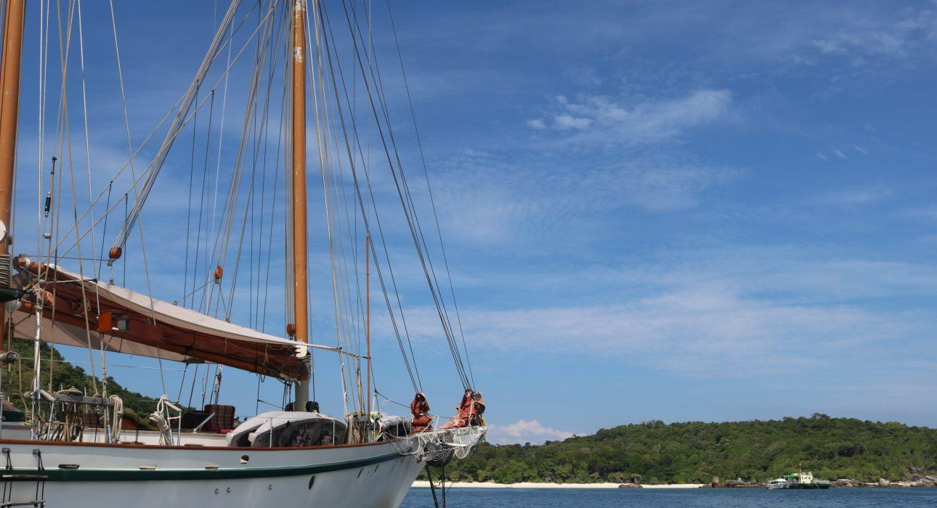
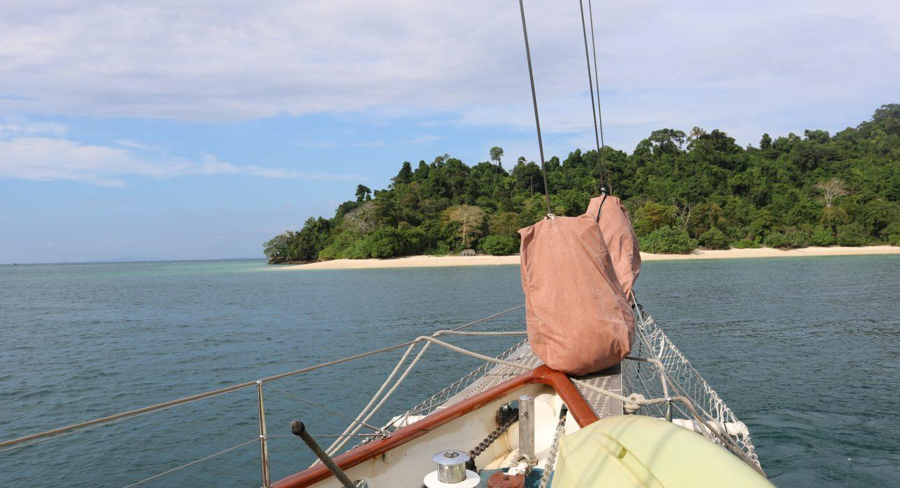
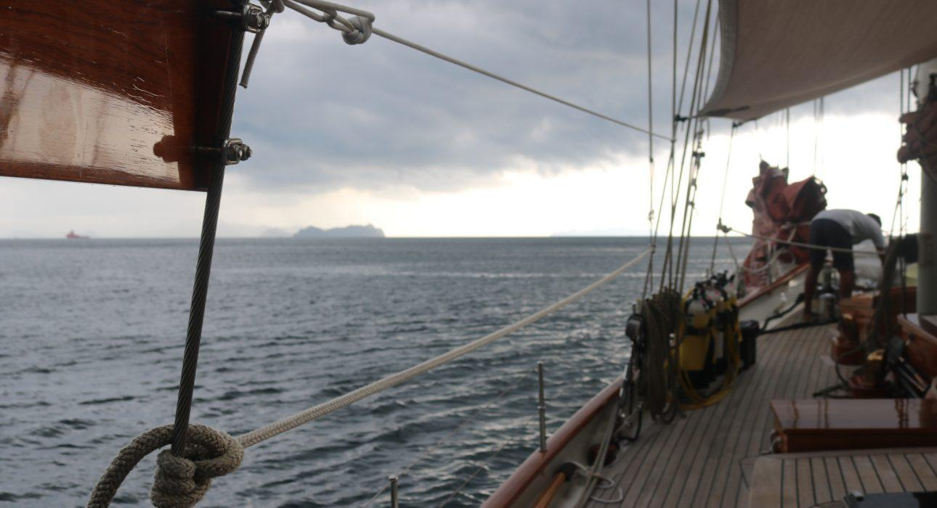
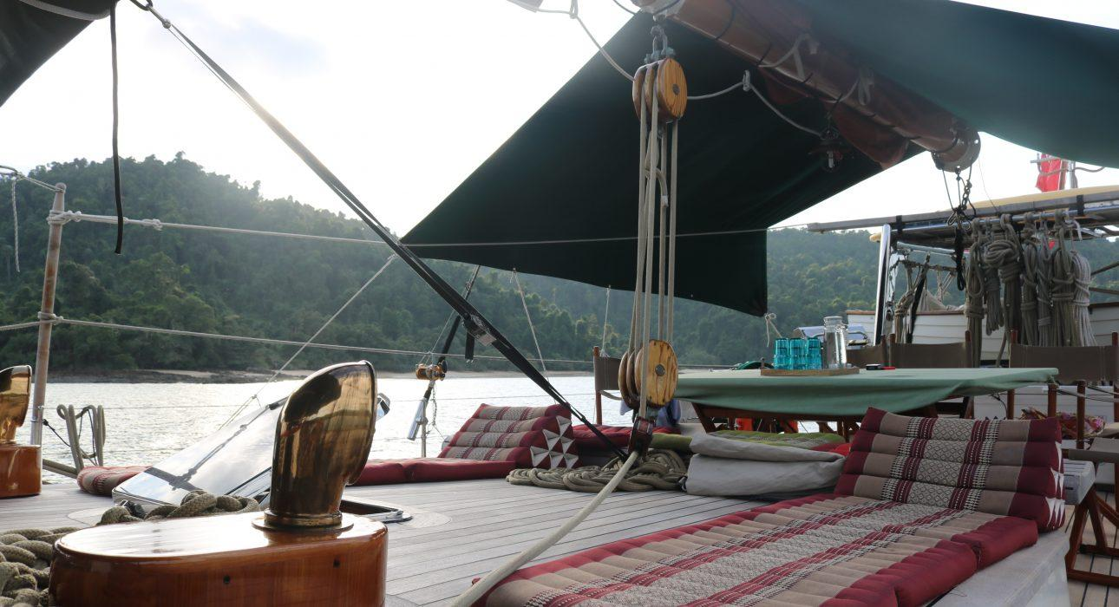
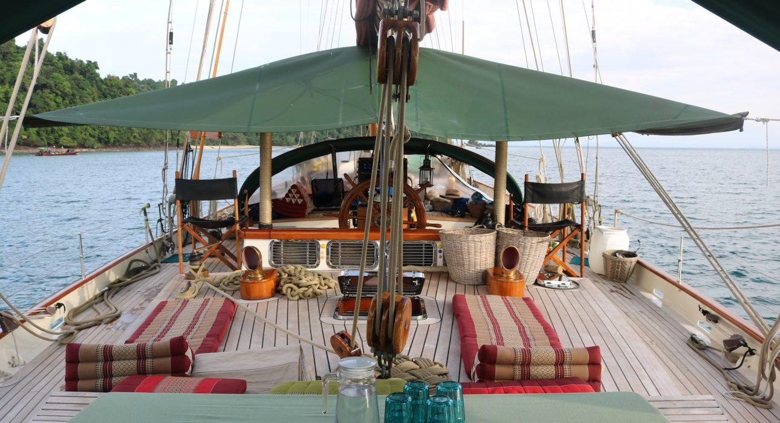
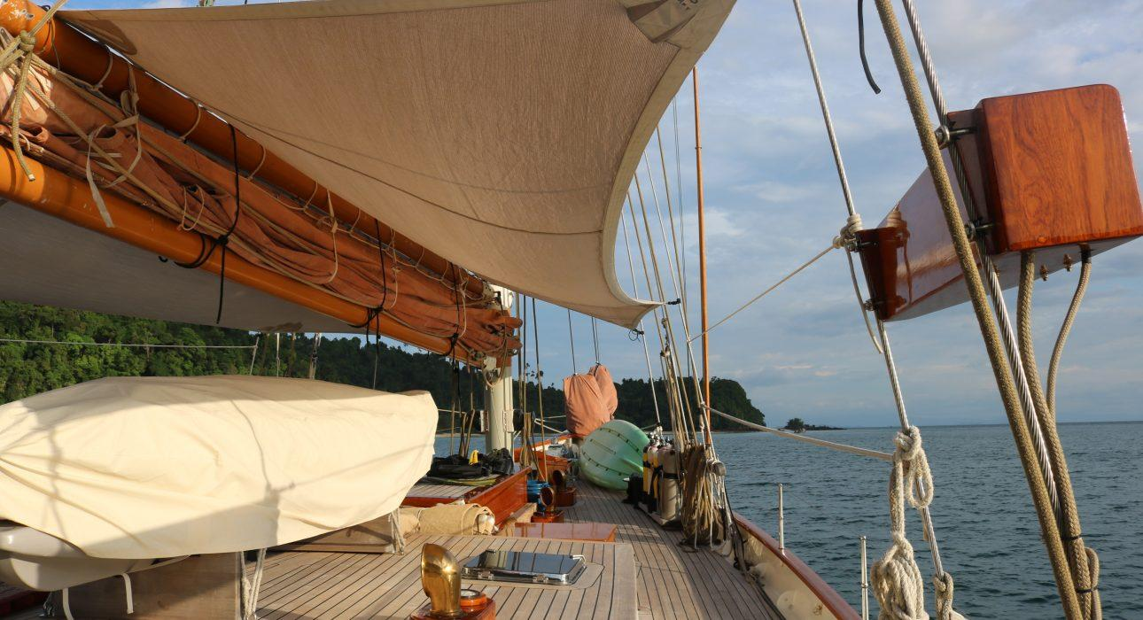
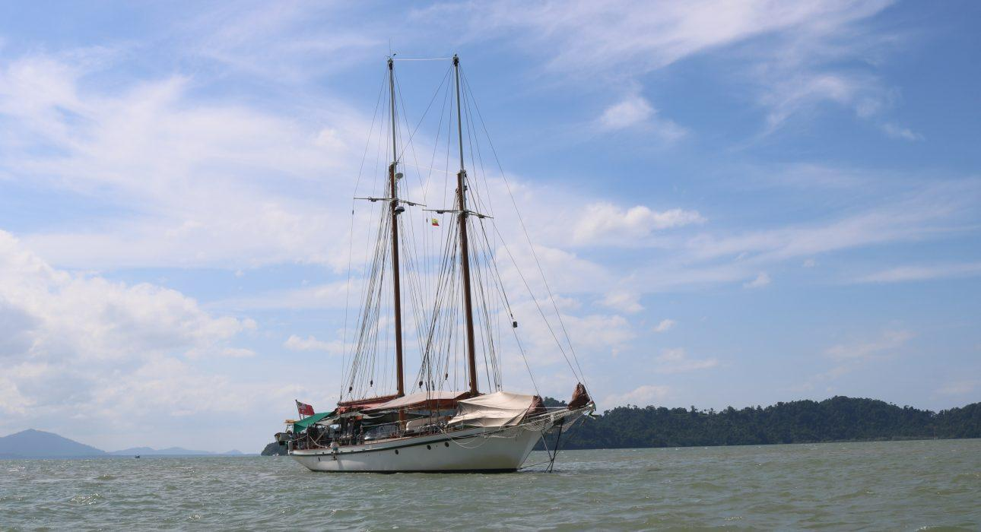

Cabins photos
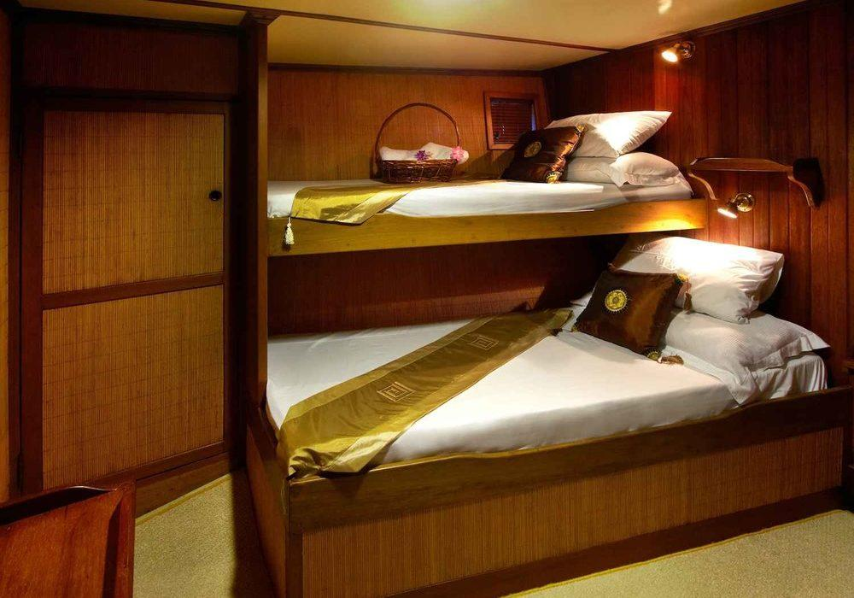
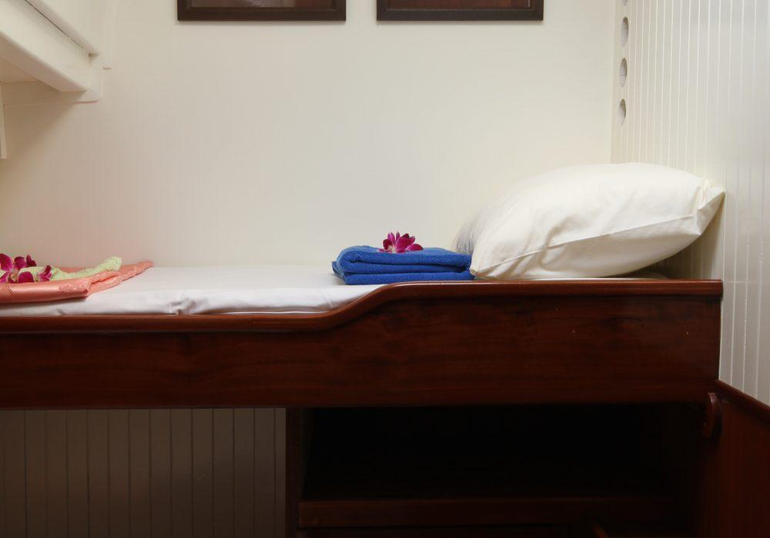
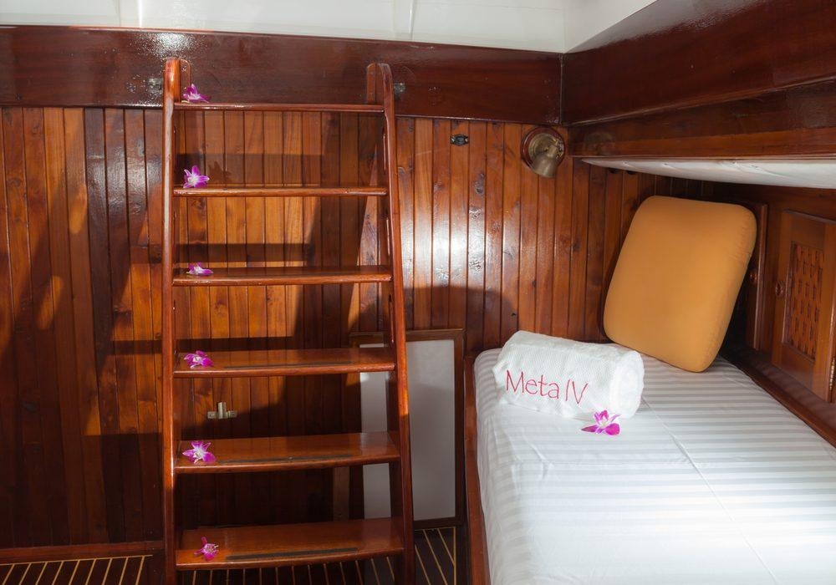
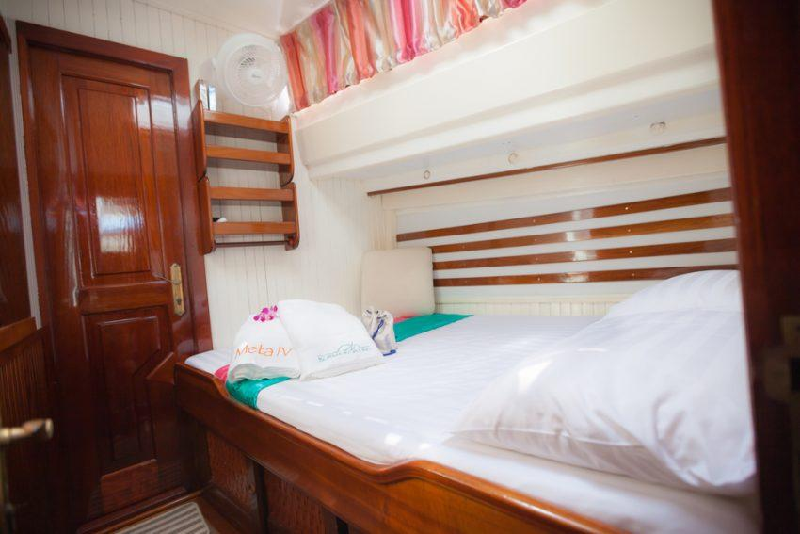
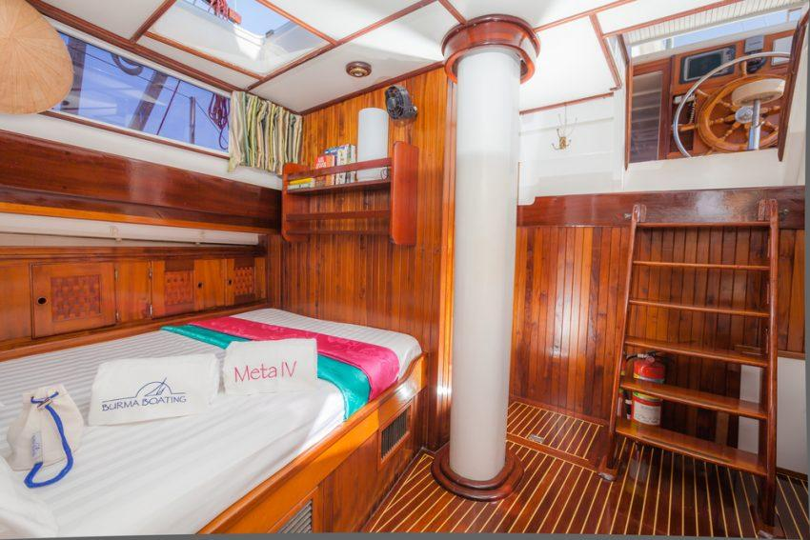
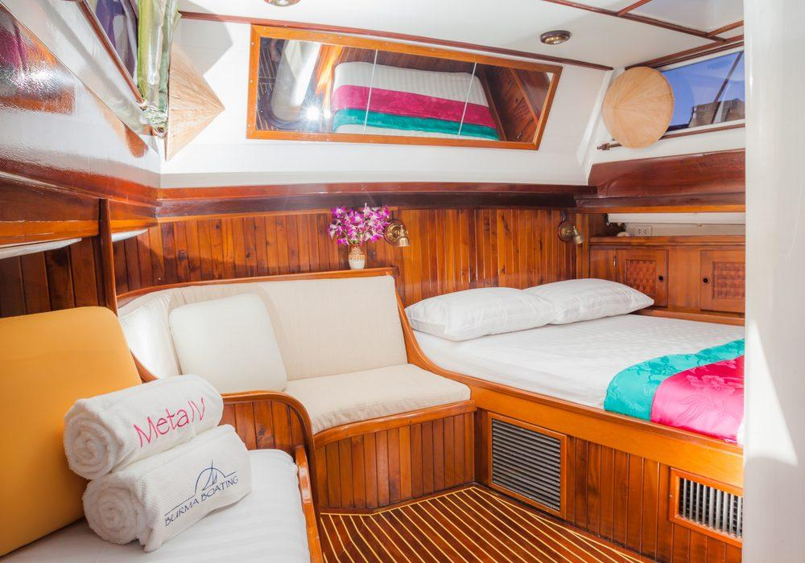

Restaurant photos
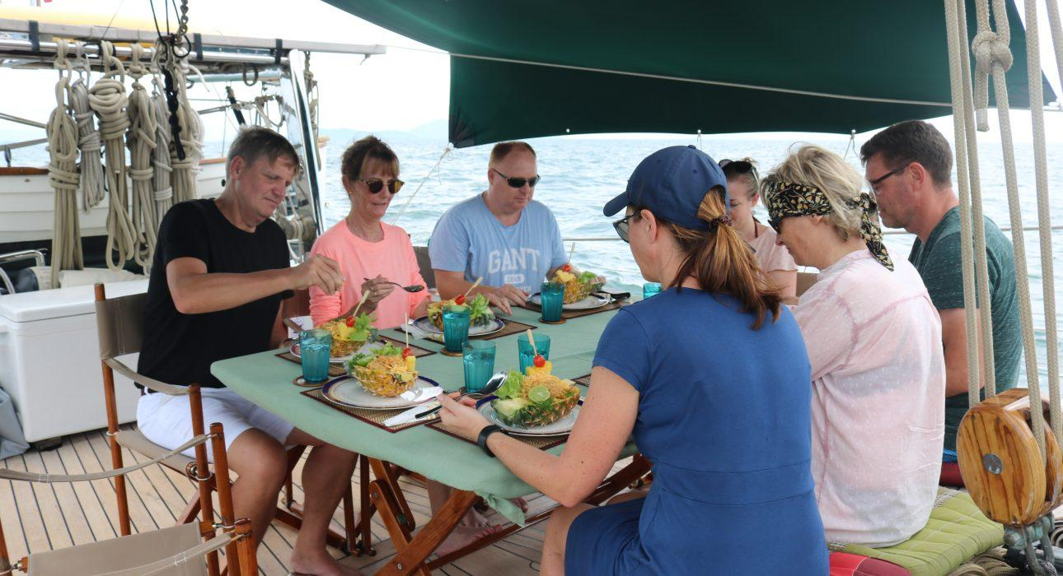
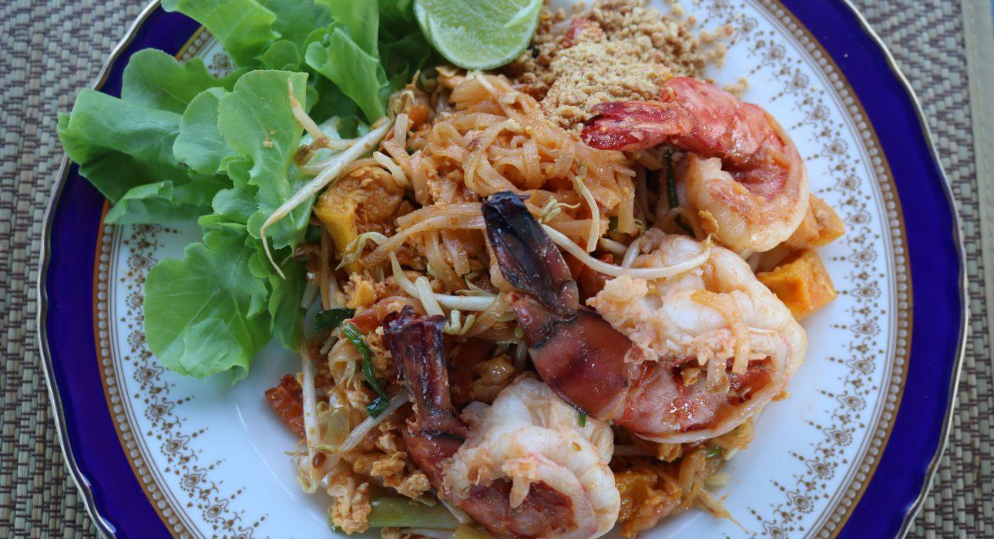
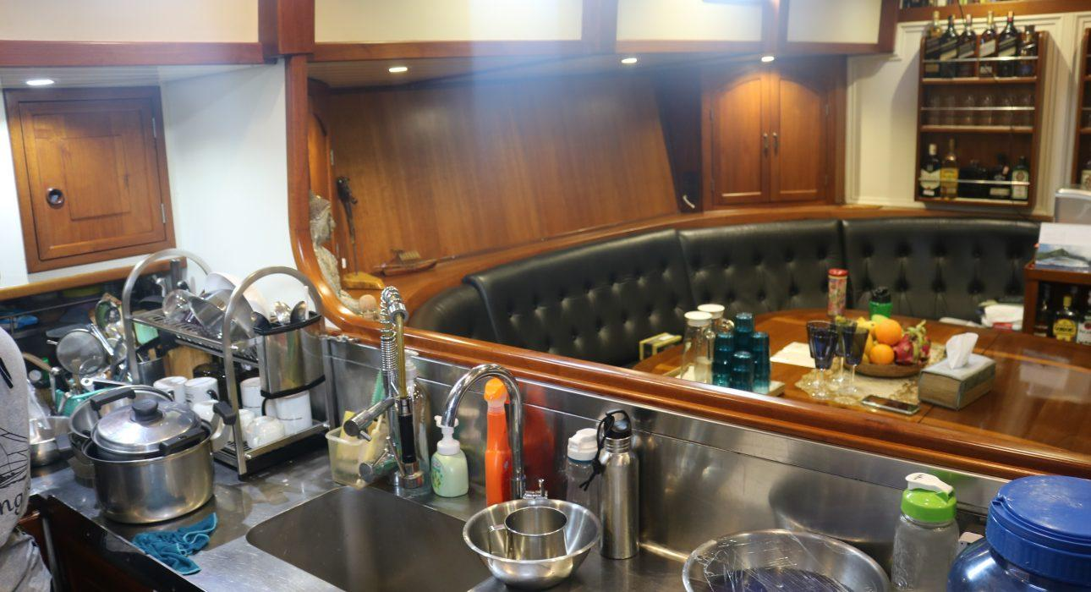

Easia Travel Head Office

Vietnam Head OfficeC/o: ATS Hotel, Suite 326 &327, 33B Pham Ngu Lao Street, Hanoi, VietnamTel: +84 24-39 33 13 62www.easia-travel.com

