LAOS – Upper Mekong – Heritage Line Anouvong
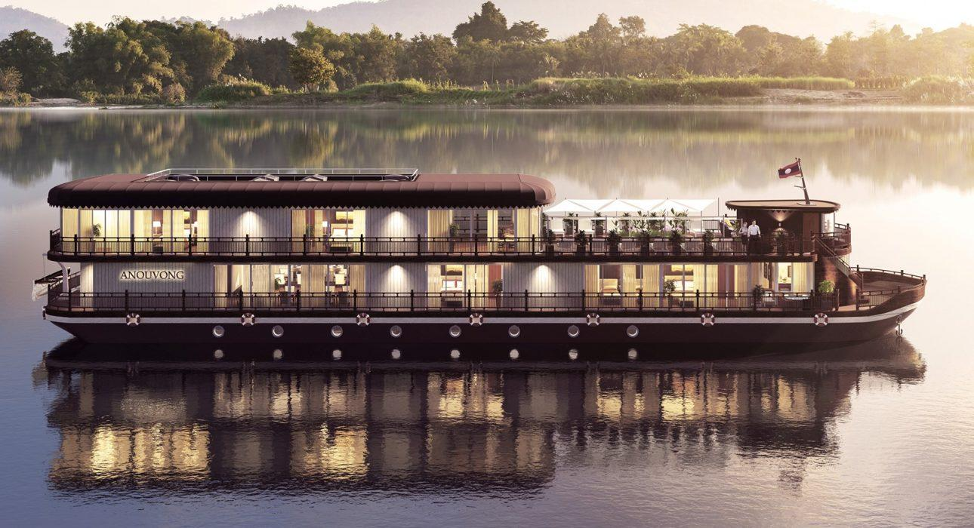

Over View

Theme
Classic, Cruise &amp; River Cruise, Family, Honeymoon, Wellness

Market segment
Thematic Leisure

Total number of cabins
10

Price Level
$$$$

Description

As imposing as the upper Mekong River in Laos, Anouvong enchants as a small boutique luxury ship that seamlessly blends traditional Laotian ambiance and artwork with French-Colonial finesse. Passengers aboard this exclusive vessel discover the most beautiful, remote areas of Laos along the meandering river in utmost luxury.The large staterooms and lavish suites welcome guests with an inventive room layout while emphasizing laid-back coziness. The intimate restaurant, the tucked-away spa, the cozy and light-flooded Café-Bar & Lounge with its adjacent wooden terrace deck have all have a stake in the singular savoir-vivre lifestyle aboard Heritage Line’s latest marvel Anouvong. The ship sails the river on different itineraries between the Thai-Lao border, Luang Prabang and Vientiane (vice versa).Itineraries:
- 3 Nights: Houei Xay – Luang Prabang or Luang Prabang to Houei Xay
- 7 Nights: Houei Xay – Vientiane
- 9 Nights: Vientiane – Houei Xay

Selling points

- Excellent way to explore the main waterway of northern Laos in style and comfort.
- 3 day, 7 day and 9 day downstream and upstream itineraries are possible.
- The most high-end and luxurious cruise boat with cabins on the upper Mekong.
- Itineraries are interesting and have varied activities, including the highlights to ensure that travelers get to experience everything that makes Laos special.
- The cabins are comfortable and have panoramic windows to provide the best views from the room.
- An excellent range of services and amenities are provided for guests to ensure their comfort.

Cabins

Number of cabins
10

Cabin type and Surface
There are a total of 10 cabins on Heritage Line’s Anouvong:
- 4 Deluxe Staterooms – 20m²
  - 3 twin
  - 1 double
- 4 Deluxe Executive Rooms – 20m²
  - 2 twin
  - 2 double
- 2 Signature Suites – 30m²
  - 2 double
A bit more information about each room type:“Anouvong’s Deluxe Staterooms come with floor-to-ceiling windows that open onto a French balcony. French-colonial charms paired with the spirituality of Laos unfold through the immaculate furniture and décor. The separate marble-tiled bathroom is complete with a spacious walk-in shower, vanity and luxury toiletries”
- Comfortable bed (Twin Bed 100 x 200 cm, Double Bed 180 x 200 cm), French balcony, individually controlled air conditioner, cabinet, mini bar, safety box, writing desk and chair, bathroom with vanity, walk-in shower, bathrobe, luxury bathroom toiletries, sandals, sun hat, umbrella, hair dryer, tea and coffee facility, Bluetooth music station with loudspeaker, Wi-Fi, in-house phone, international power sockets, luggage rack.
“The Deluxe Executive Staterooms are designed and equipped equally to the Deluxe Staterooms while offering views from one floor higher, on the terrace deck. These staterooms are also decorated with handpicked Laotian artwork and furniture inspired by the French-colonial epoch”
- Comfortable bed (Twin Bed 100 x 200 cm, Double Bed 180 x 200 cm), French balcony, individually controlled air conditioner, cabinet, mini bar, safety box, writing desk and chair, bathroom with vanity, walk-in shower, bathrobe, luxury bathroom toiletries, sandals, sun hat, umbrella, hair dryer, tea and coffee facility, Bluetooth music station with loudspeaker, Wi-Fi, in-house phone, international power sockets, luggage rack.
“The Signature Suites, large and light-flooded and set at the front of the main deck have their own seating area in addition to a private balcony. the outsized bathroom features a double antique vanity, large walk-in shower, and jacuzzi with fantastic views of the passing scenery. Each of the suites has its own particular design theme composed of Laotian patterns and unique artwork”
- Comfortable bed (Double Bed 200 x 200 cm), private balcony (3 sqm) with chairs and small table, individually controlled air conditioner, separate seating area with table and two chairs, cabinet, mini bar, safety box, writing desk and chair, bathroom with vanity, walk-in shower, bathrobe, luxury bathroom toiletries, sandals, sun hat, umbrella, hair dryer, tea and coffee facility, LCD screen, movie and music system, Bluetooth music station with loudspeaker, Wi-Fi, in-house phone, international power sockets, luggage rack.

Cabin configuration

Services & Facilities

Services

Facilities
Air Conditioning, Bar, coffee and tea making facilities, Full Board - B/L/D, Hair Dryer, Internet, Mini Bar, Safety Box, Shower With Hot Water, Umbrella, Complimentary bottle of water, Complimentary fresh towel, Laundry services

Disabled Facilities
No disable access

Restaurant information

Restaurant on Heritage Line’s Anouvong
- Capacity: 20pax
- Opening hours: scheduled meal times.
- Type of cuisine: Asian and western cuisine.

Photos

Boat Photos
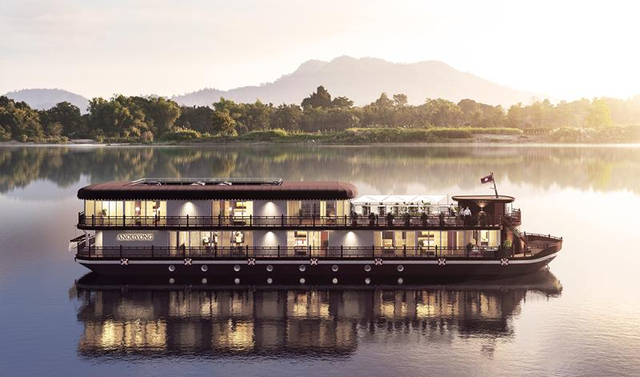
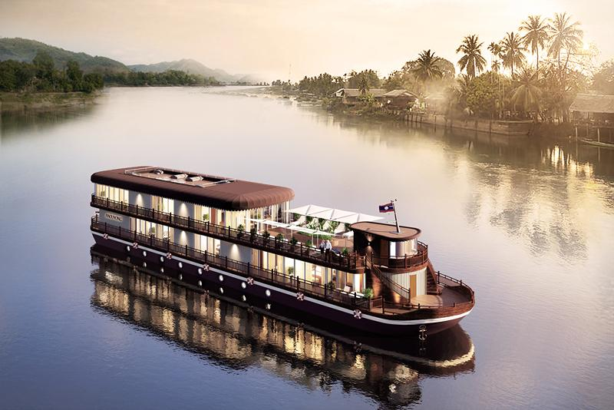

Cabins photos
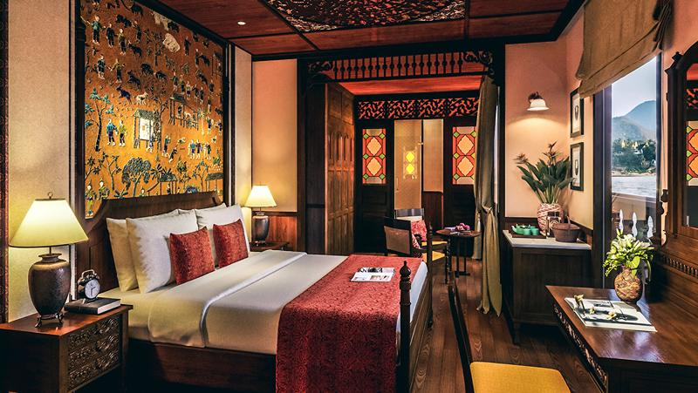
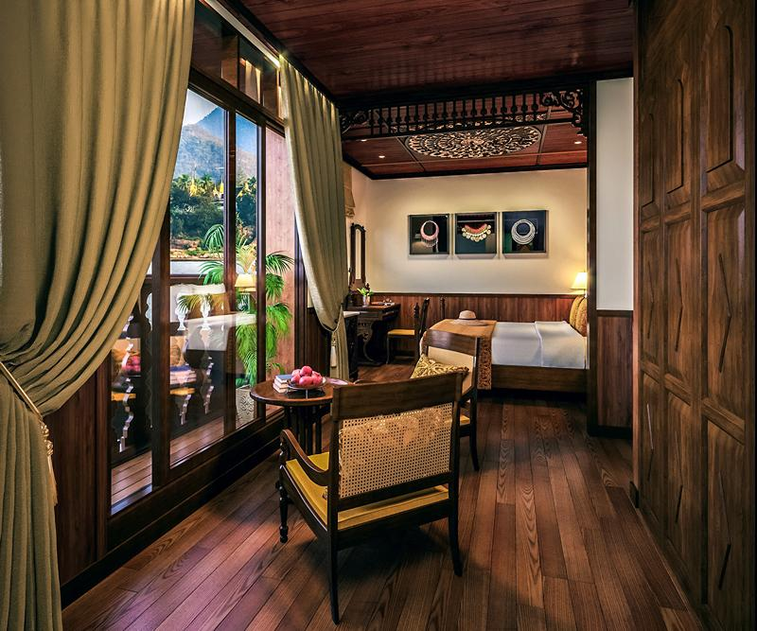
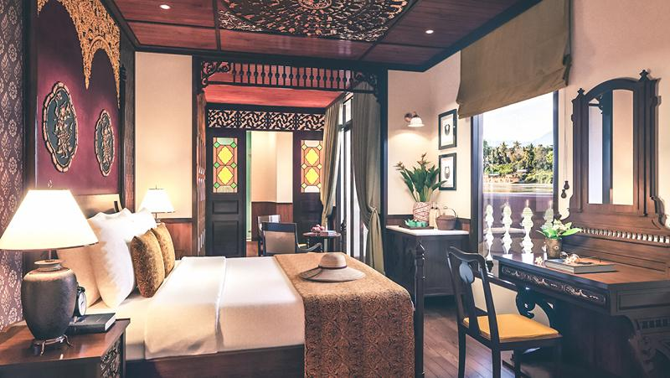
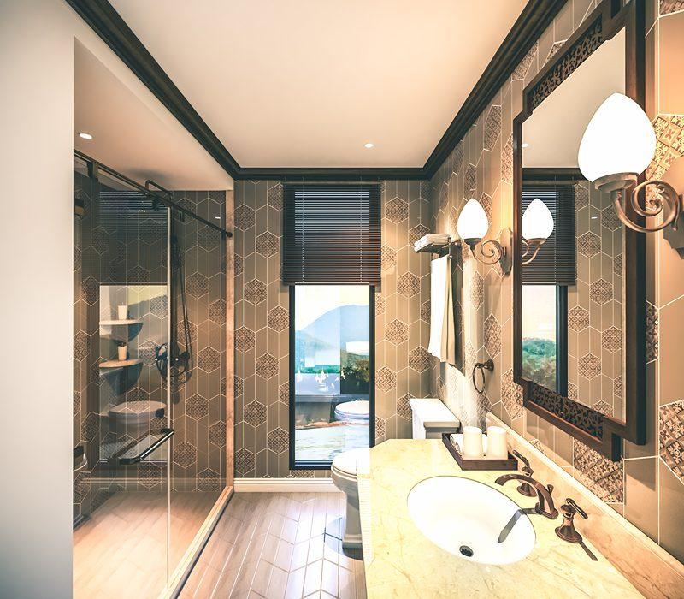
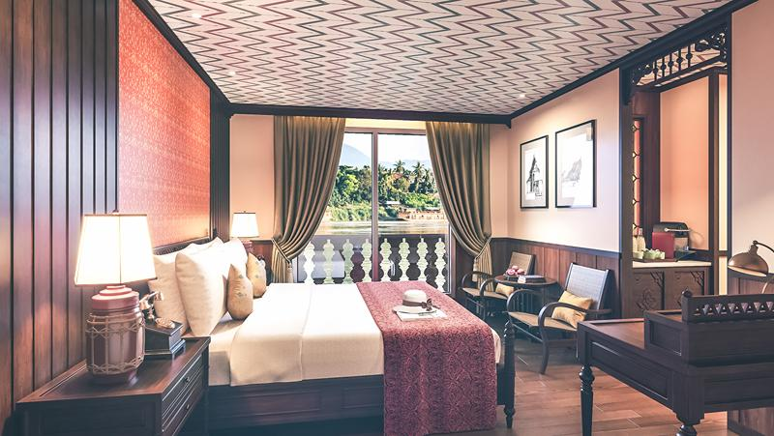
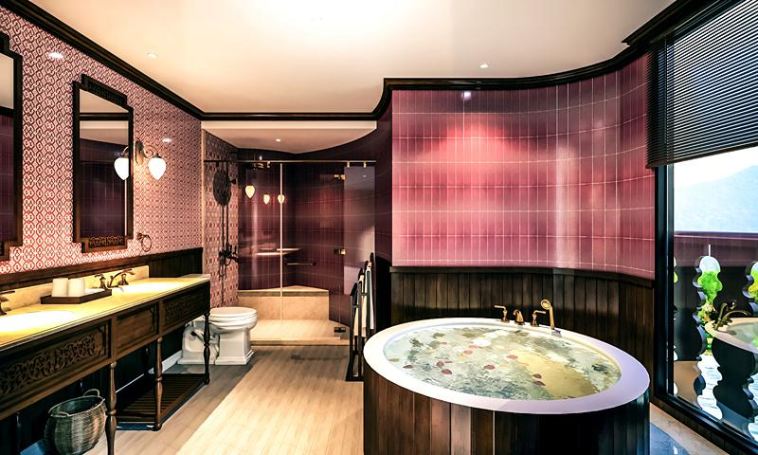

Restaurant photos
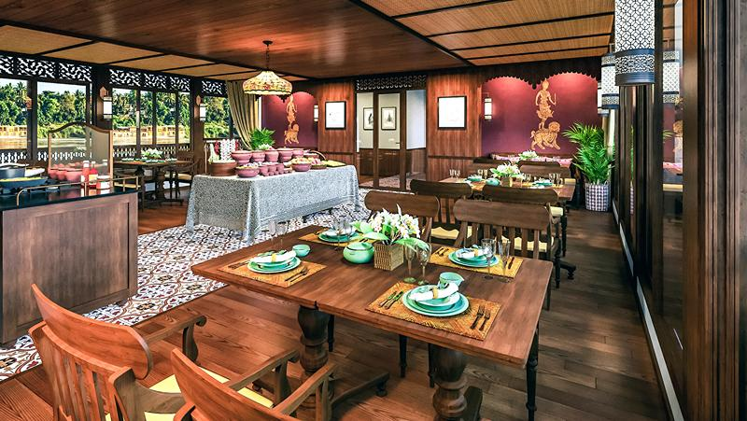

Services & facilities photos
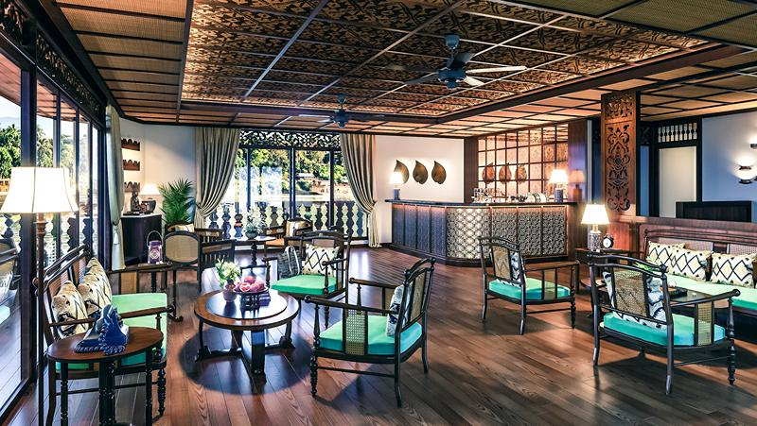
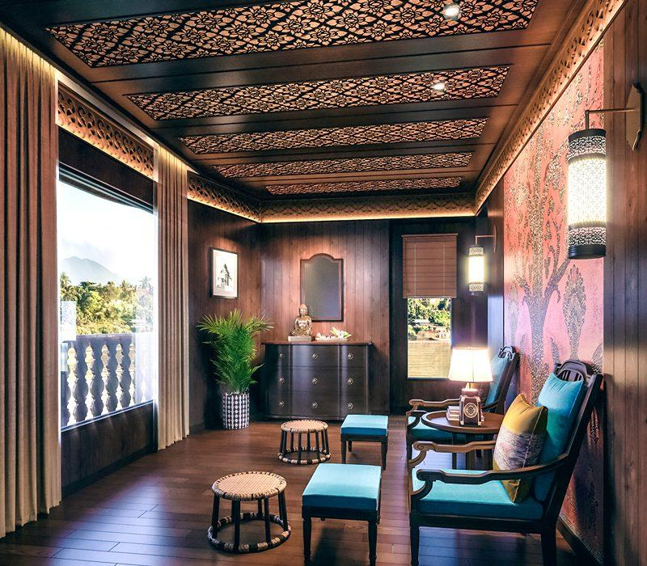
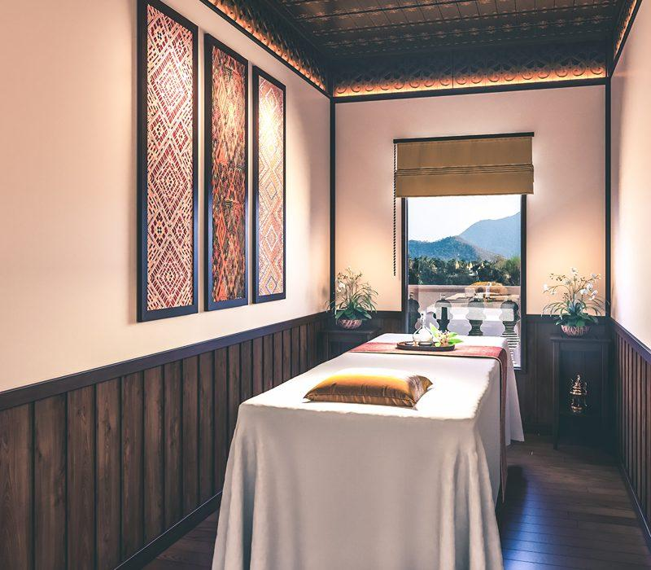

Easia Travel Head Office

Vietnam Head Office4th Floor – ATS hotel,33B Pham Ngu Lao Street,Hoan Kiem District, Hanoi.T: +84 24-39 33 13 62 (ext. 251)

