LAOS – Upper Mekong – Le Grand Cruise
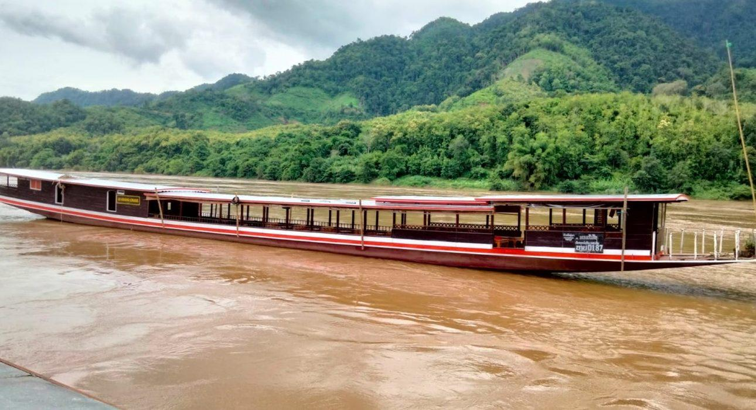

Over View

Theme
Classic, Cruise &amp; River Cruise, Family

Market segment
Groups, Thematic Leisure

Price Level
$$$

Description

A 2-day traditional slow boat cruise is a unique way of venturing deep into northern Laos after entering the country across the Thai-Lao border near the Golden Triangle. It’s a perfect way to explore the exotic scenery of the north in comfort. Cruising down the Mekong provides a relaxing start to a traveler’s journey and helps develop a sense of serenity while being absorbed by the physical pull of the river and its surrounding lush green landscape. Gliding smoothly along the river, travelers will soak up the slow-paced atmosphere while encountering isolated ethnic villages of friendly, smiling locals on the way to Luang Prabang.Le Grand Cruise stops halfway between Houei Xai and Luang Prabang in a small riverside town called Pakbeng. Accommodation is included at Le Grand Pakbeng, a hilltop resort with stunning mountain and river views and one of the most beautiful sunsets in all of northern Laos.Made of teak and rosewood and tastefully decorated, the 35-m Le Grand Cruise boat can carry up to 40 travelers at a time. The boat offers professional and high quality services, space for walking, clean toilets, and a range of pleasurable delights such as magazines, books, tea and coffee. Also, to complement the cruise experience, there is a sundeck, a bar area, and a different lunch provided everyday.Itineraries:
- 2 Days / 1 Night (cruise + hotel) : Houei Xay – Luang Prabang / Luang Prabang to Houei Xay
- 1 Day (cruise only) : Houei Xai to Pakbeng / Pakbeng to Houei Xay / Pakbeng to Luang Prabang / Luang Prabang to Pakbeng

Selling points

- Excellent way to explore the main waterway of northern Laos in style and comfort.
- Upstream, downstream, and even half-cruises are possible (should guests want to stop/start in Pakbeng)
- The only join-in package on the market offering a combined cruise and hotel.
- High-quality professional service.

Cabins

Cabin configuration

Services & Facilities

Services

Facilities

Disabled Facilities
No disable access

Restaurant information

Le Grand Cruise Cuisine
- Type of cuisine: Lao, buffet style.
- Capacity: 40 pax
- Opening hours: Variable, depends on the day’s itinerary.

Photos

Boat Photos
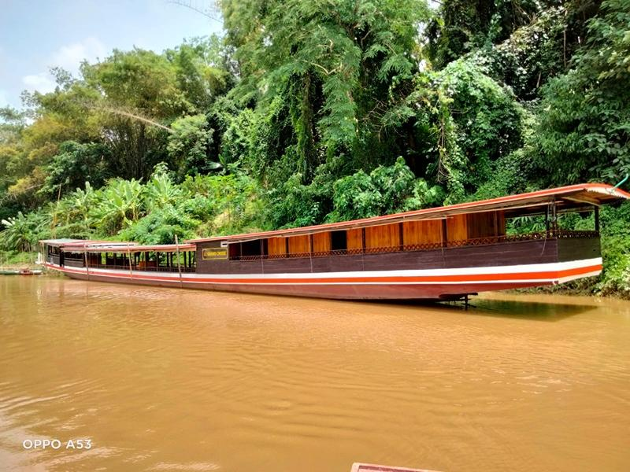
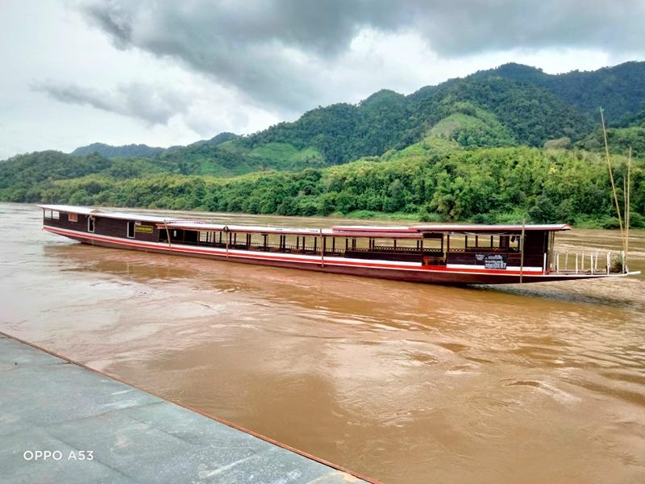
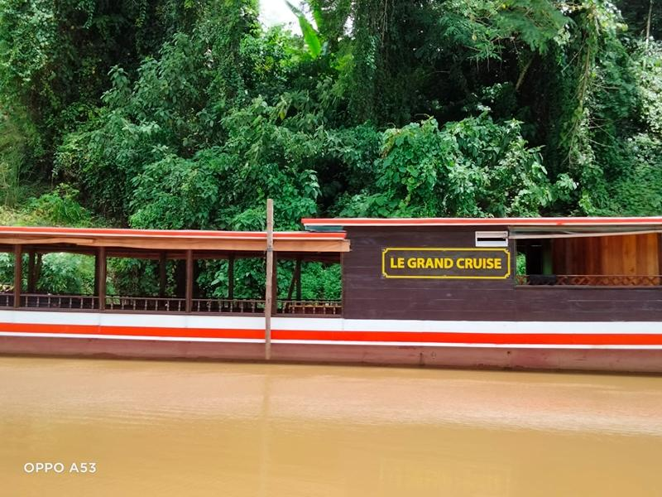
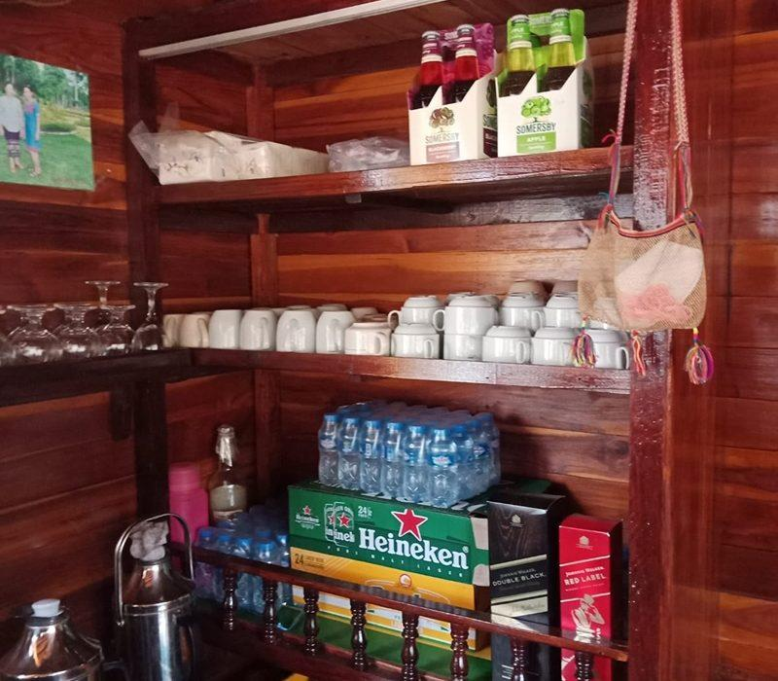
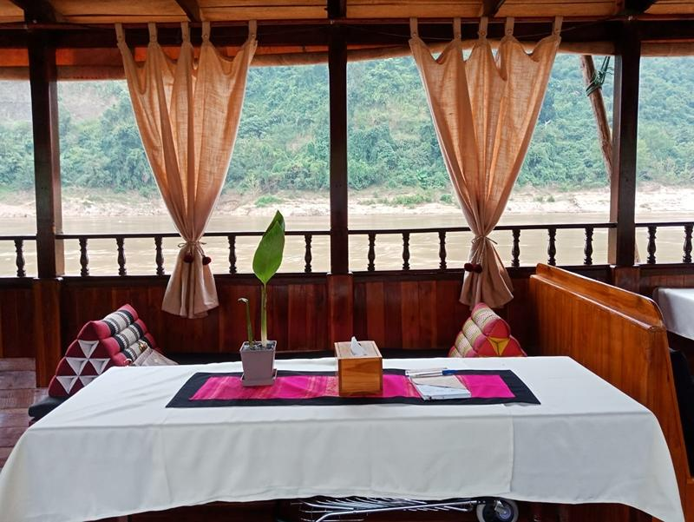
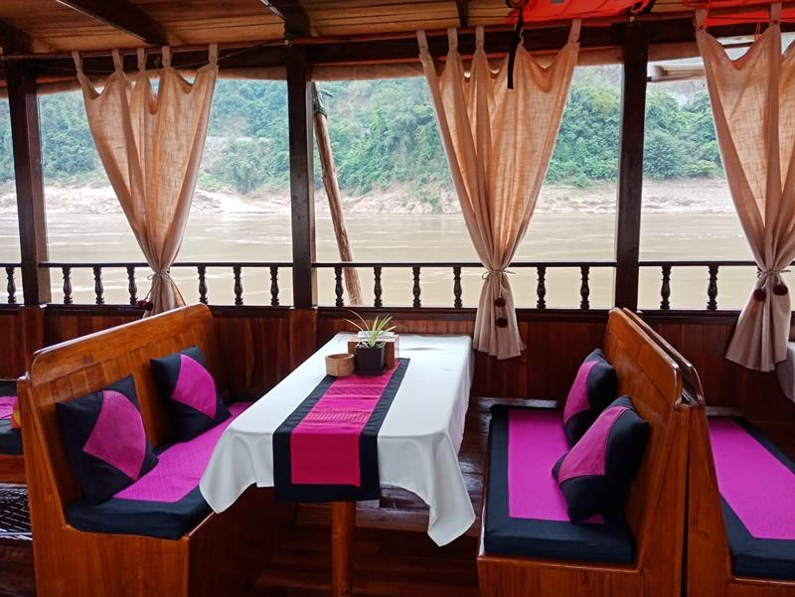
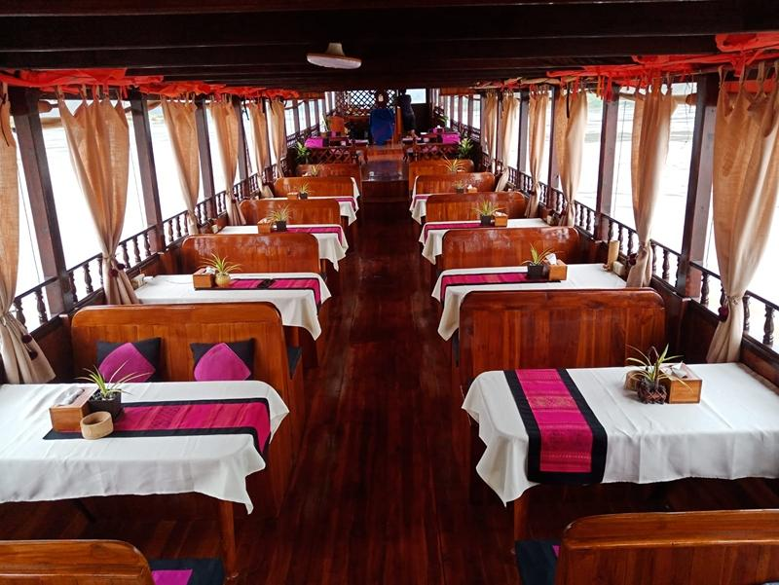
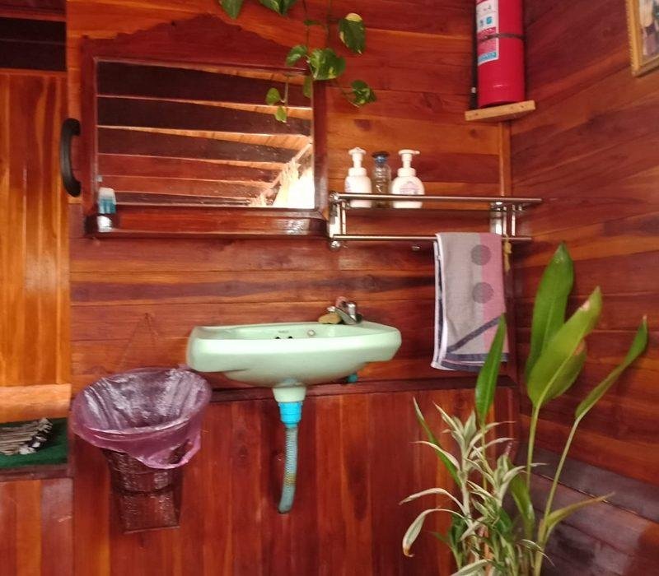
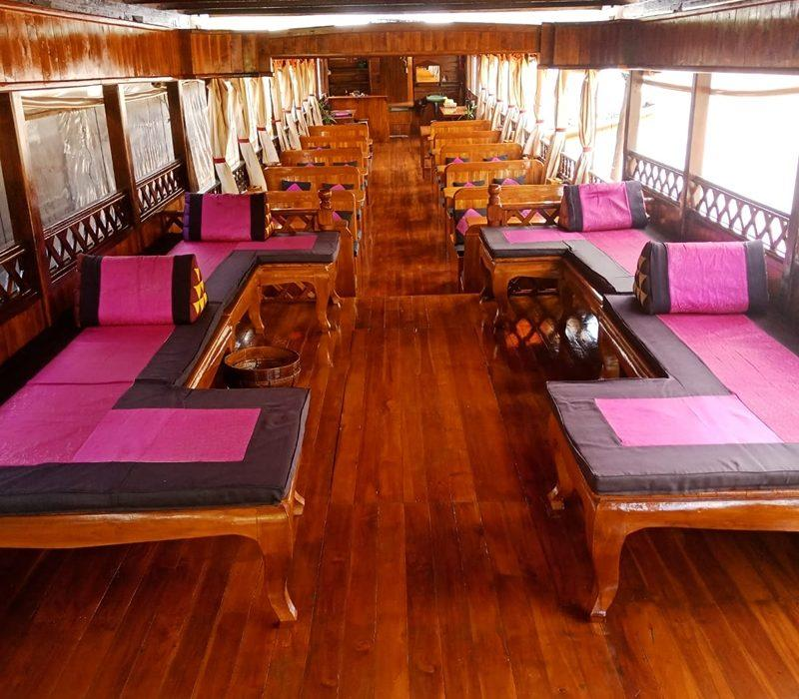

Restaurant photos
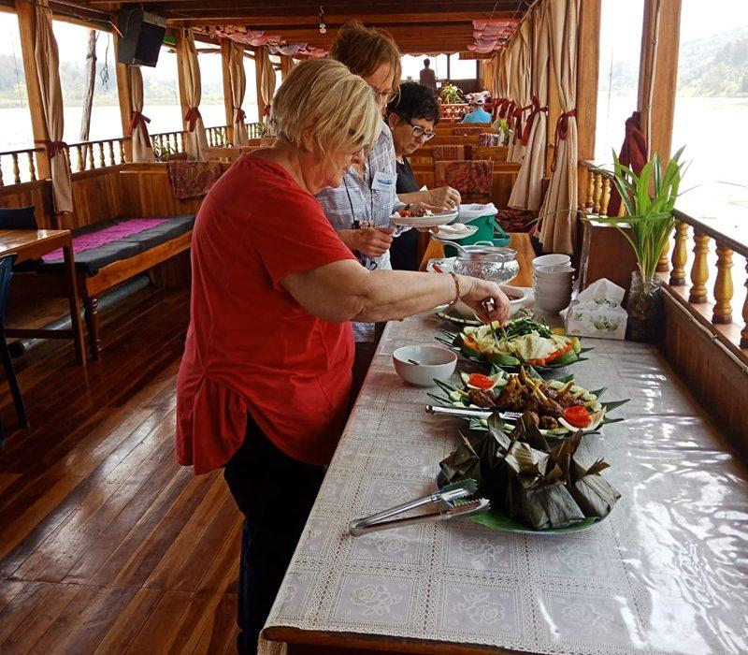
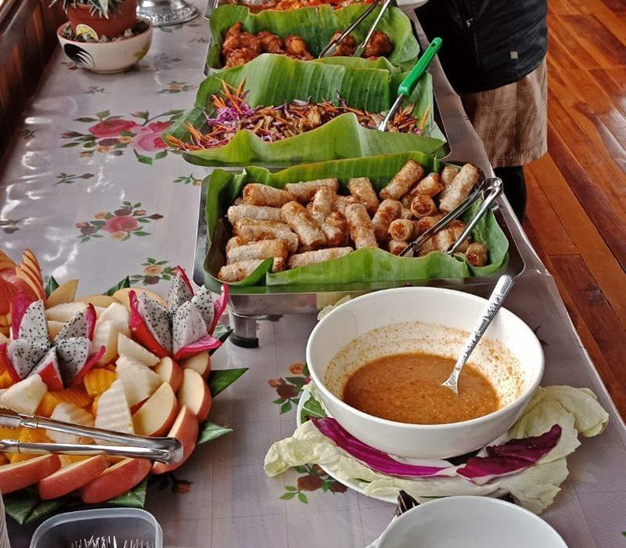

Easia Travel Head Office

Vietnam Head Office4th Floor – ATS hotel,33B Pham Ngu Lao Street,Hoan Kiem District, Hanoi.T: +84 24-39 33 13 62 (ext. 251)

