CAMBODIA – Sihanoukville – Song Saa Private Island
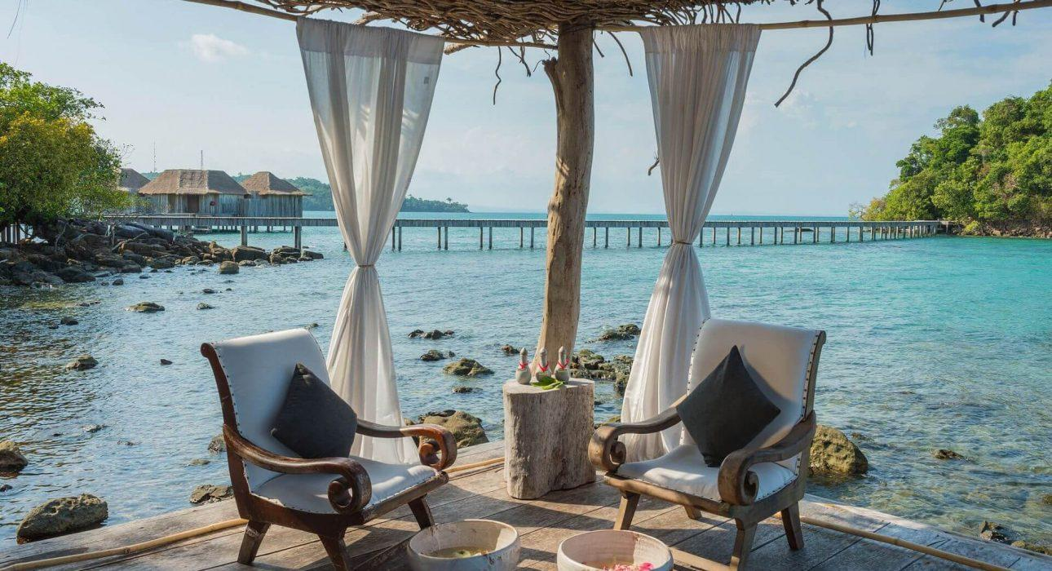

Over View

Theme
Beach Stay, Honeymoon, Wellness

Country - City
Cambodia - Sihanoukville

Market segment
Thematic Leisure

Official category
5*

Easia category
Deluxe

Total number of rooms
27

Price level
$$$$

Traveller made amenities
Song Saa Private Island is a Traveller Made Hotel Partner.

Description

The Song Saa Private island spans the two pristine islands of Koh Ouen and Koh Bong, known locally as Song Saa – Khmer for ‘The Sweethearts’. The chunky island of Koh Rong wraps Song Saa in an encircling arm, protecting it from the winds and seas of the Gulf of Thailand. This, they thought, would be the perfect spot to build Cambodia’s first luxury private island resort. Apart from Melita’s strong background in design, they had no experience in building a resort in a remote, third-world location. Yet because they came at it from the oblique angle of people who love great design and who love Cambodia and have made it their home – even to the extent of adopting a Cambodian child – this is a resort that doesn’t feel formulaic.The resort features twenty seven (22 one bedrooms and 5 two bedrooms) luxury over water, jungle and ocean view villas built with sustainable materials and with the deepest respect for the natural environment. About a third of Song Saa’s villas are overwater bungalows. Another seven are on dry land, overlooking the sea. The rest are scattered among the rain forest that caps the tiny island and they’re all huge and brilliantly designed to make the most of the natural surroundings. The style is silk cocoon with rustic edges.Each villa offers a spacious bedroom, living area, en-suite bathroom, sun deck and a private swimming pool. The resort has a swimming pool, a small private beach, a lounge bar restaurant…The Vista Restaurant & Lounge sits on stilts above the ocean, with a sofa’d deck for cocktails and open-air tables for meals under the stars. The guests in good hands: executive chef Joel Wilkinson has worked in some of the world’s top resorts and has been private chef to the Rod Stewart, Kevin Spacy and Hugh Jackman to name a few. A pizza and a cold beer at the beachside Driftwood Bar, or order from the room service menu, which offers a variety of Western food and rustic Cambodian fare, delivered to the villa in traditional baskets.The wellness retreats at Song Saa fall into three comprehensive categories: ‘Refresh’, ‘Rejuvenate’, and ‘Revive’. Each retreat is linked to its own unique spa menu: refresh with ‘Stillness’, rejuvenate with ‘Blessing’, and revive with ‘Healing’. Inspired by the Buddhist principle of ‘metta bhavana’ (loving kindness), each spa menu has been mindfully curated and embraces traditional and modern treatments from east and west. Executed by a team of local and international practitioners who combine traditional Khmer techniques with modern western practices, the therapies are top-notch.Families are welcome here and children of all ages are catered for. There’s a range of 1- and 2-bedroom villas to choose from and the beach has warm, shallow waters that are safe for little ones.

Selling points

- Song Saa is the first luxury hotel on the Cambodian coast.
- Ideal for honeymooners, but surprisingly family-friendly too.
- The Khmer cuisine and treatments are a unique touch.
- This is one resort with serious eco cred.

Time & Transportation

From | To | Km | By | Duration | Road condition
Phnom Penh | Sihanoukville | 235 km | Car; Mini bus; Bus | 3h – 4h | Good
Siem Reap | Sihanoukville | 541 km | Plane | 1h | Good
Sihanoukville | Song Saa Island | 24 km | Speed boat | 30 min – 45 min (depending on the weather) | Good

Rooms

Easia's recommend room type
Jungle Villa (one bedroom)Number: 9Size: 135 m²Design: Mix of modern and traditionalJungle Villas are perched amongst the rainforest canopy, at the top of the hill looking out over the ocean with the choice of sunrise or sunset views. Each villa offers a spacious bedroom (king size bed), living area, en-suite bathroom, sun deck and a private swimming pool. The one bedroom villas have outdoor showers. The room features air conditioning, safety deposit box, IDD telephone, cable/satellite TV and DVD player, sound system and Wi-Fi broadband, mini bar, tea/coffee making facilities, bathrobe, slippers and hairdryer.Note
- There is sunrise and sunset side, but the sunset would be the best.
- The villas located on sunrise side might result in clients being woken up in the early morning (5am) because of the sunlight.
- The villas are up a steep hill. Therefore, it might not be a good choice for the older clients even though the hotel is equipped with small golf cart to go up and down.
- No twin bed available (only king size bed)
- Mini bar (as well pure water, sparkling water, house wines…) included in the price of the room and restocked daily
Jungle Villa (two bedrooms)Number: 2Size: 300 m²Design: Mix of modern and traditionalJungle Villas are perched amongst the rainforest canopy, at the top of the hill looking out over the ocean with the choice of sunrise or sunset views. Each two bedroom villa offers spacious bedrooms (king size bed), living area, kitchen and dining area, en-suite bathroom, sun deck and a private swimming pool. The room features air conditioning, safety deposit box, IDD telephone, cable/satellite TV and DVD player, internet wireless, mini bar, tea/coffee making facilities, bathrobe, slippers and hairdryer. The two bedroom villas feature a butler service.Note
- There is sunrise and sunset side, but the sunset would be the best.
- The villas located on sunrise side might wake up the clients in the early morning (5am) because of the sunlight.
- The villas are up a steep hill. Therefore, it might not be a good choice for the older clients even though the hotel is equipped with small golf cart to go up and down.
- No twin room available – both rooms are equipped with king size bed
- Mini bar (as well pure water, sparkling water, house wines…) included in the price of the room and restocked daily
Overwater Villa (one bedroom)Number: 6Size: 136 m²Design: Mix of modern and traditionalSituated over the water, the Overwater Villas offer direct access to the ocean from the private sundeck and also the possibility to watch the sunset from the pool. Ideal for those seeking space and privacy without foregoing intimacy. Each villa offers a spacious bedroom (king size bed), living area with comfortable sofas and a glass table for looking at the marine life, en-suite bathroom, sun deck and a private swimming pool. The one bedroom villas have outdoor showers. The room features air conditioning, safety deposit box, IDD telephone, cable/satellite TV and DVD player, sound system and Wi-Fi broadband, mini bar, tea/coffee making facilities, bathrobe, slippers and hairdryer.Note
- If the clients have the budget for it, we should take these villas as they are all sunset facing.
- Only the Overwater Villas have direct access to the sea.
- No twin room available (only king size bed).
- Mini bar (as well pure water, sparkling water, house wines…) included in the price of the room and restocked daily.
Overwater Villa (two bedrooms)Number: 2Size: 309 m²Design: Mix of modern and traditionalSituated over the water, the Overwater Villas offer direct access to the ocean from the private sundeck and also the possibility to watch the sunset from the pool. Ideal for those seeking space and privacy without foregoing intimacy. Each two bedroom villa offers spacious bedrooms (king size bed), living area with comfortable sofas and a glass table for looking at the marine life, en-suite bathroom, sun deck and a private swimming pool. The room features air conditioning, safety deposit box, IDD telephone, cable/satellite TV and DVD player, internet wireless, mini bar, tea/coffee making facilities, bathrobe, slippers and hairdryer.Note
- If the clients have the budget for it, we should take these villas as they are all sunset facing.
- Only the Overwater Villas have direct access to the sea.
- No twin room available – both rooms are equipped with king size bed.
- Mini bar (as well pure water, sparkling water, house wines…) included in the price of the room and restocked daily.
Ocean View Villa (one bedroom)Number: 7Size: 200 m²Design: Mix of modern and traditionalOn the ocean front, the Ocean View Villas offer spectacular sunrise views from the privacy of your own beach (no direct access to the ocean), with an overwater Sala for private dining. Each villa offers a spacious bedroom (king size bed), living area, en-suite bathroom, sun deck and a private swimming pool. The one bedroom villas have outdoor showers. The room features air conditioning, safety deposit box, IDD telephone, cable/satellite TV and DVD player, sound system and Wi-Fi broadband, mini bar, tea/coffee making facilities, bathrobe, slippers and hairdryer.Note
- NEW NAME for this category of room (old name was Beach Villa) in order to avoid any confusion as these villas have no direct access to the Ocean.
- All the Ocean View Villas are in a row next to each other. A bamboo wall between each, therefore, it is not very private.
- All the Villas are on the sunrise side so the clients might be woken up in the early morning (5am) because of the sunlight.
- No twin room available (only king size bed).
- Mini bar (as well pure water, sparkling water, house wines…) included in the price of the room and restocked daily.
Royal Villa (two bedrooms)Number: 1Size: 309 m²Design: Mix of modern and traditionalOver the water with direct access to the ocean, amid the seclusion this is the most exclusive villa of Song Saa Private Island. Views are across the ocean with perfect sunsets as well as north over the open ocean. The Royal Villa offers two spacious bedrooms (king size bed), living area, kitchen and dining area, en-suite bathroom, sun deck and a private swimming pool. The room features air conditioning, safety deposit box, IDD telephone, cable/satellite TV and DVD player, internet wireless, mini bar, tea/coffee making, bathrobe, slippers and hairdryer. The Royal Villa features a butler service.Note
- Sunset view for the Royal Villa.
- Have direct access to the sea from the terrace.
- No twin room available (only king size bed).
- Mini bar (as well pure water, sparkling water, house wines…) included in the price of the room and restocked daily.

Services & Facilities

Services
24 hour reception, 24h security service, Catering (beach, river, cave, other), Children Activities, Concierge service, Currency exchange, Diving, Kayaking, Laundry service, Massage, Private event, partying, Room Service, Spa, Swimming Pool, Wi-fi Free

Facilities
Air Conditioning, Bar, Cable, satelite, Fitness centre, Flat screen TV, Gift Shop, Internet, Massage room, Outdoor swimming pool, Private Beach, Private Pool, Restaurant, Terrace

Restaurant information

Driftwood BarCapacities: 20 paxType of food: International, KhmerOpening hours: 6:30 AM – 11:00 PMSituated on the main beach of the resort, the Driftwood Bar is the ideal place to stop by at any time of the day to enjoy a drink after a dive on the private reef of the resort or for a light lunch, for a spectacular sunset or for a private or BBQ dinner.Vista Restaurant and Overwater Cocktail LoungeCapacities: 70 paxType of food: Asian, Khmer, InternationalOpening hours: 6:30 AM – 11:00 PMVista Restaurant and Lounge offers a contemporary Cambodian cuisine with a 360-degree sea view with sunrise and sunset over the Gulf of Thailand. At the resort’s heart is a world-class restaurant and lounge, spectacularly positioned just off the island’s shoreline and surrounded by sea. Dining promises a culinary adventure using unique flavours of the Khmer cuisine, locally grown produce and seafood sourced from Cambodia’s growing community of sustainable fishers.Poolside DiningCapacities: 20 paxType of food: International, KhmerOpening hours: 7:30 AM – 11:00 PMTables are set up beside the pool, facing out to sea with all the elements provided for a unique and romantic dinner for two. Guest will have the opportunity to taste a traditional Khmer meal while dangling their feet in the water.

Photos

Hotel Photos
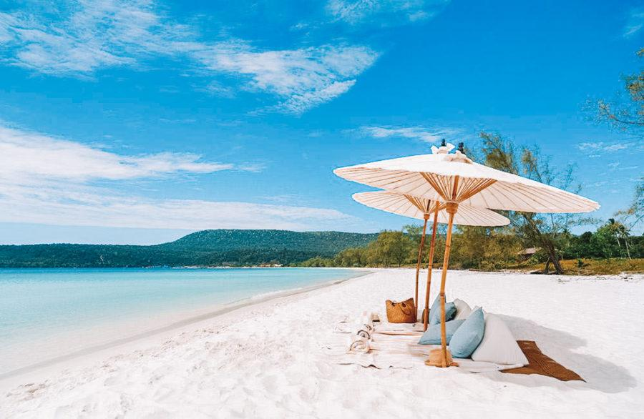
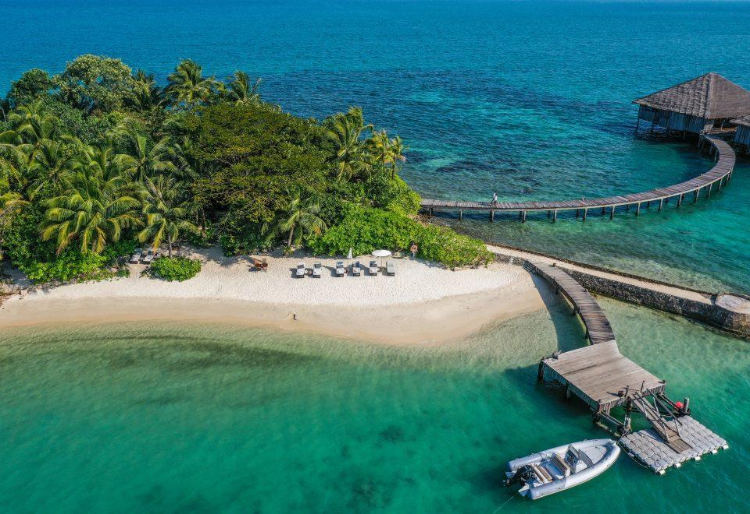
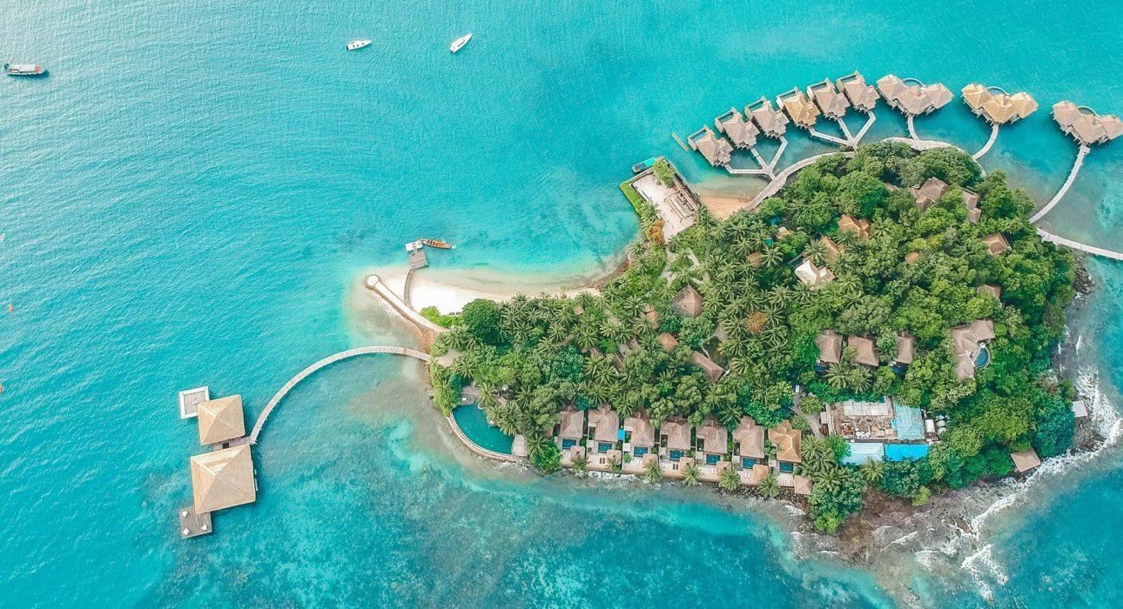
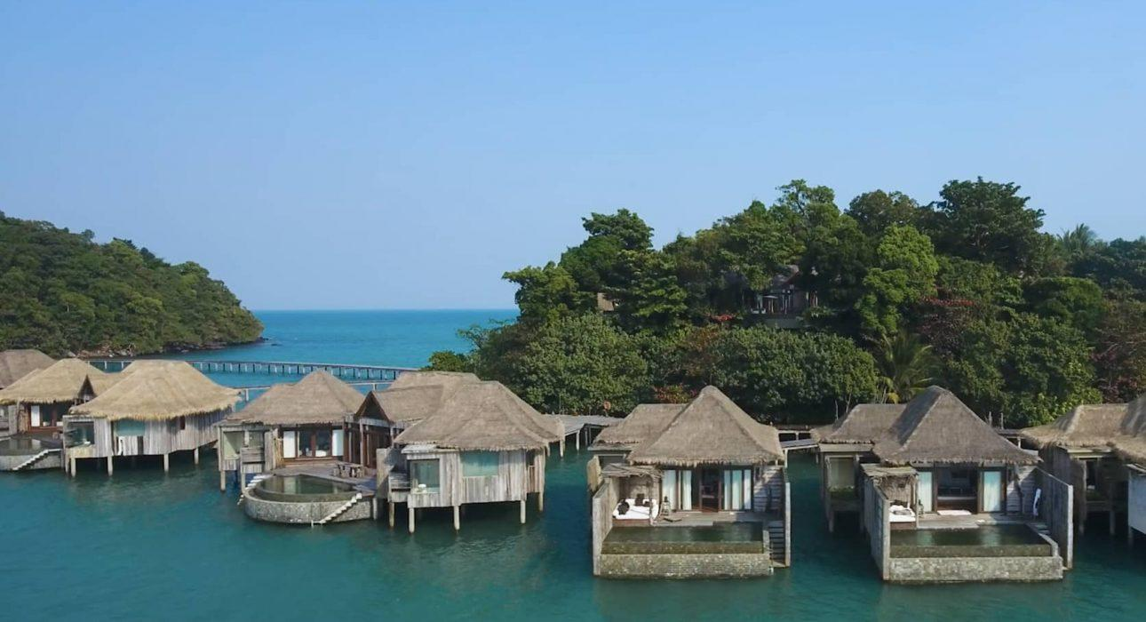

Rooms photos
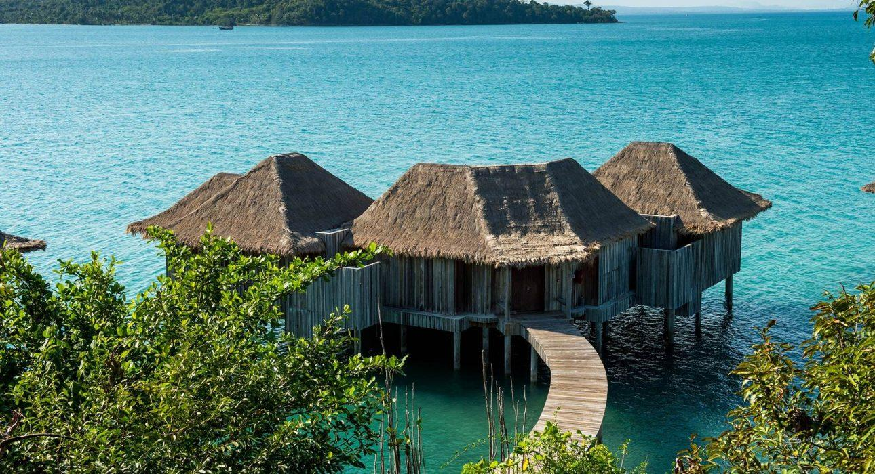
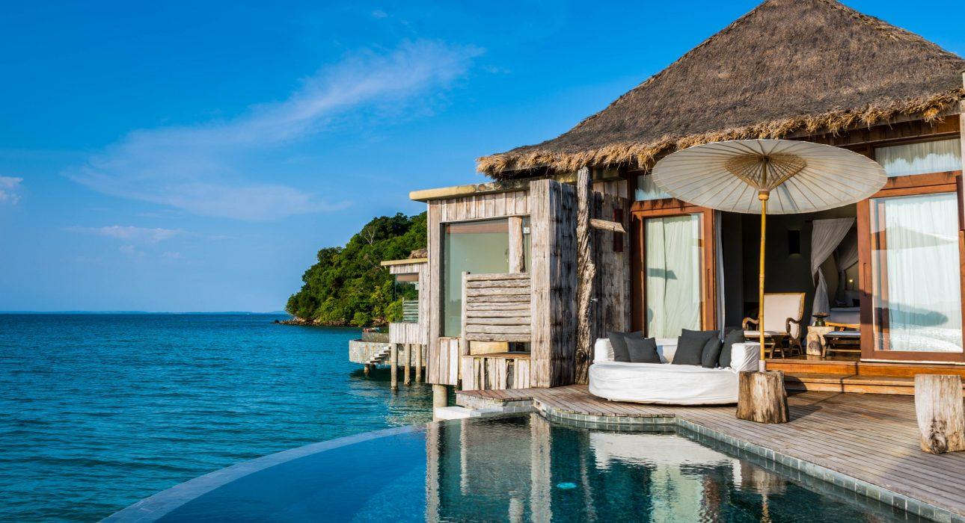
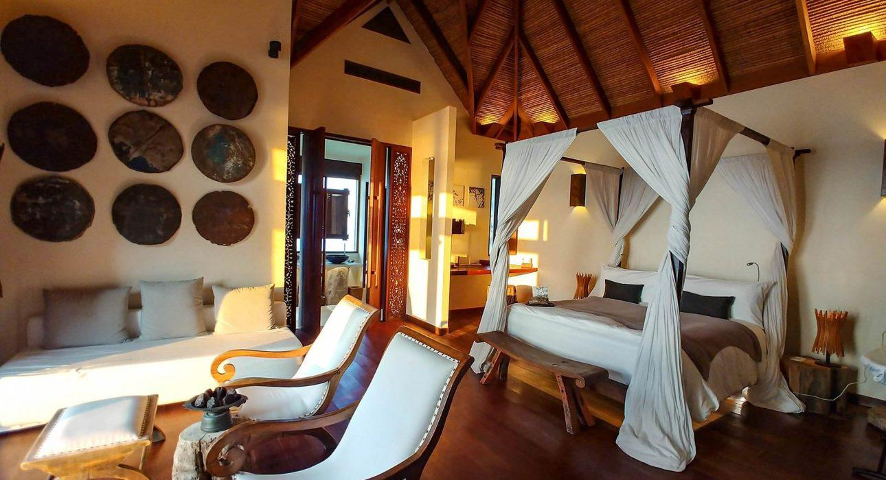
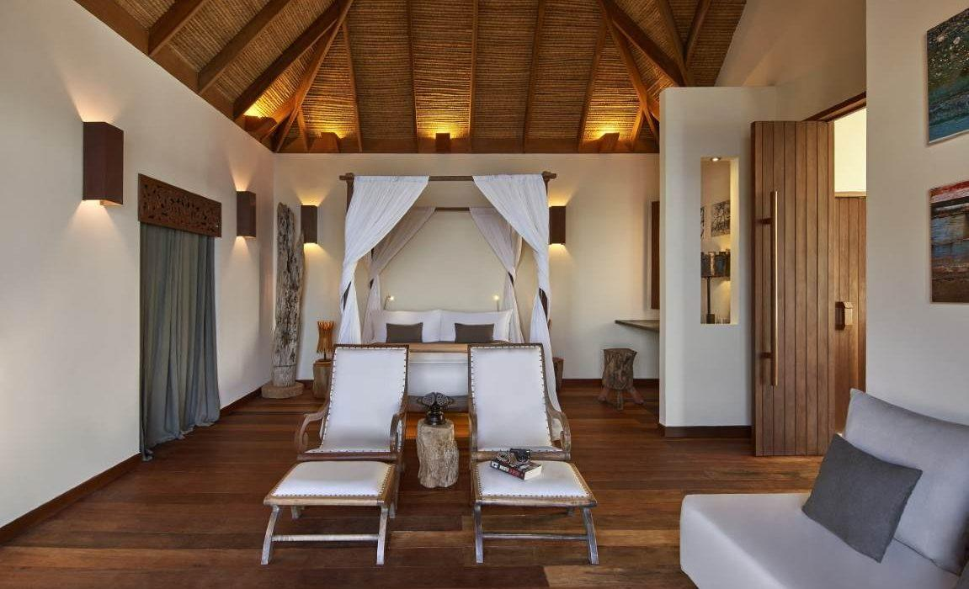
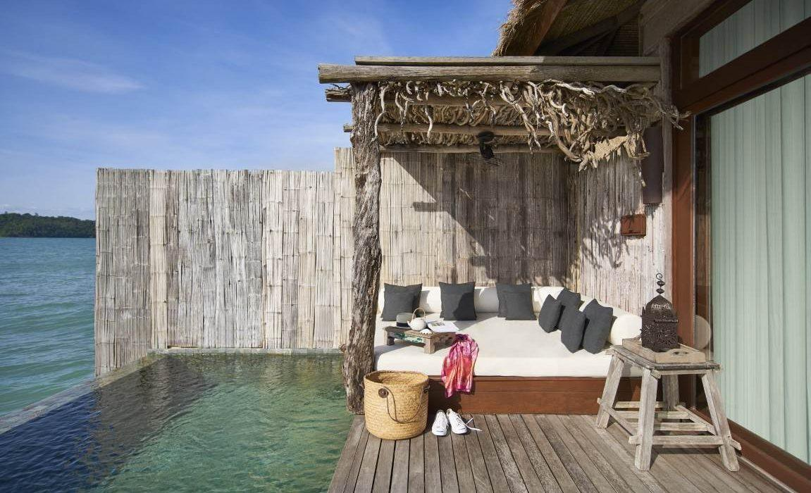
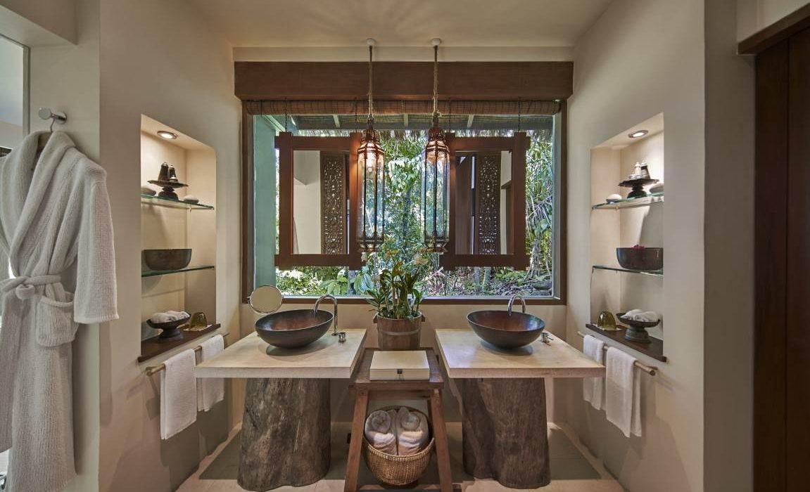
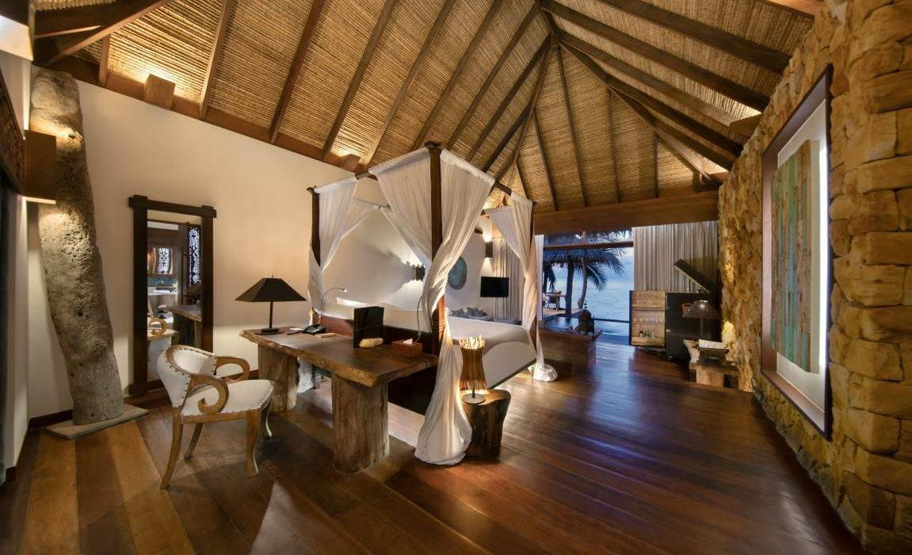

Restaurant photos
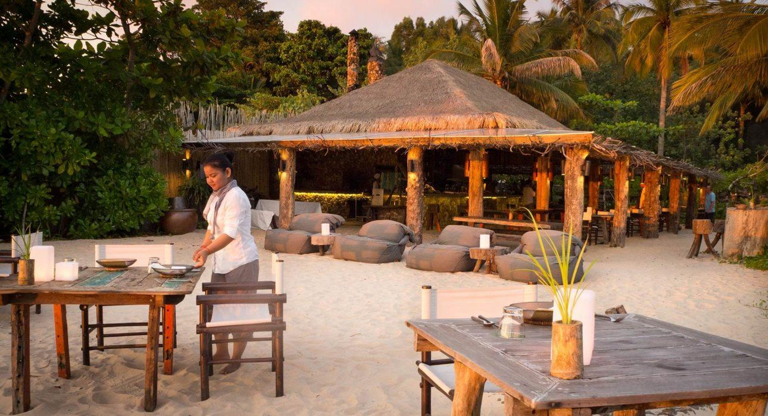
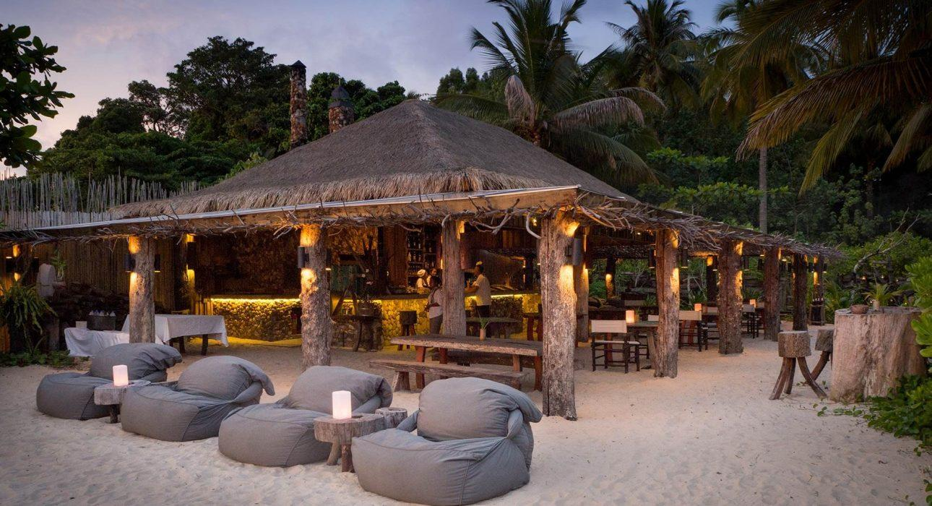
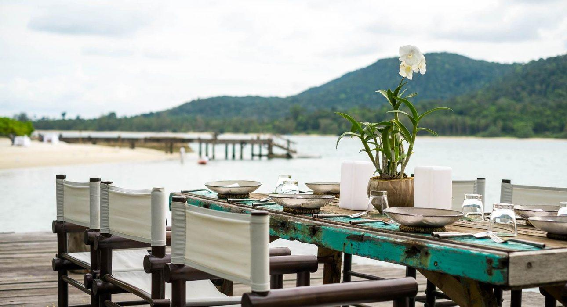
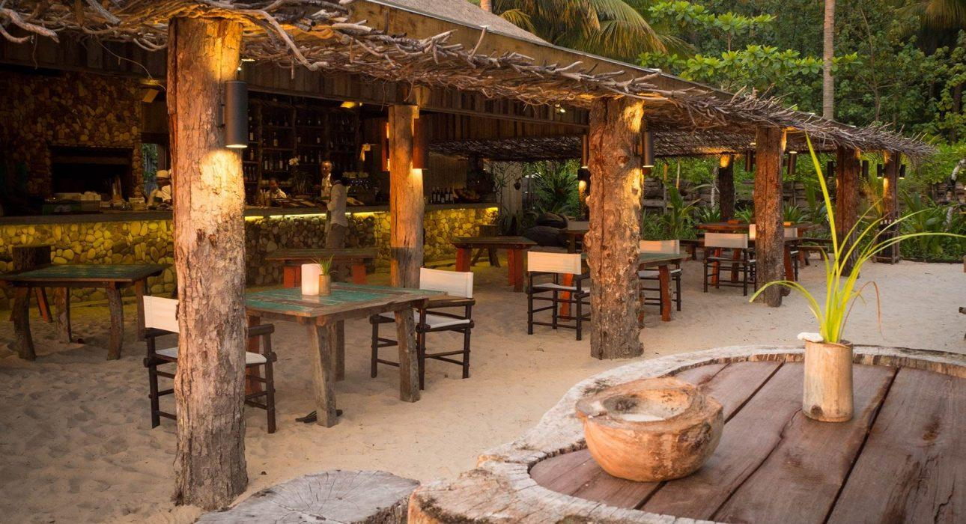
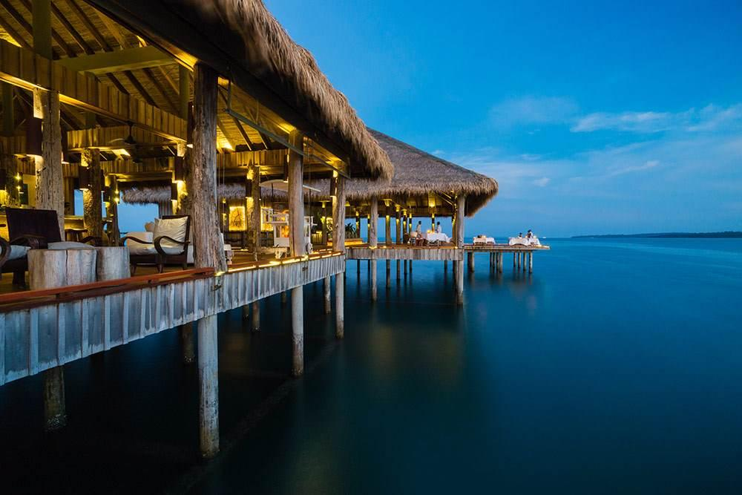
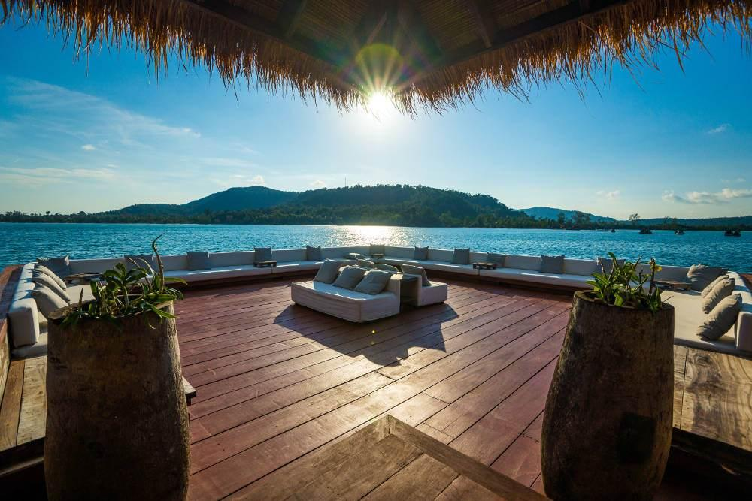
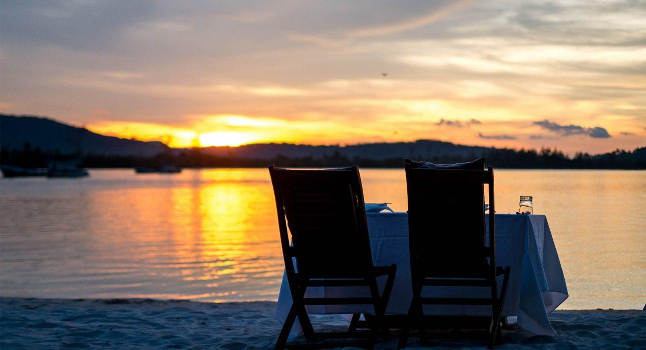

Services & facilities photos
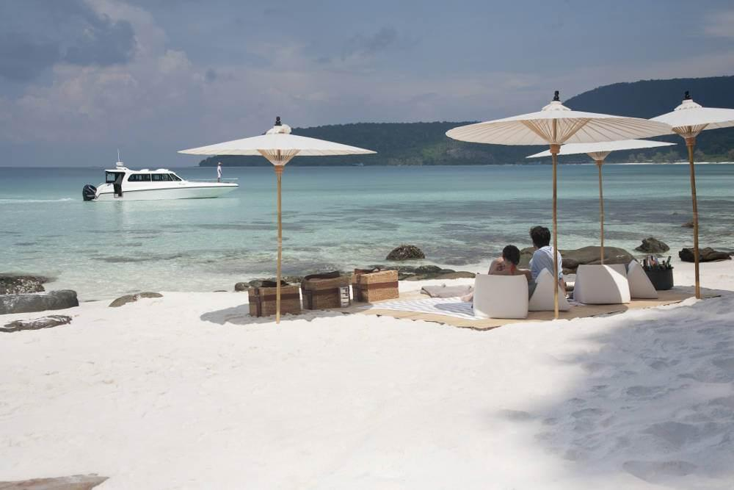
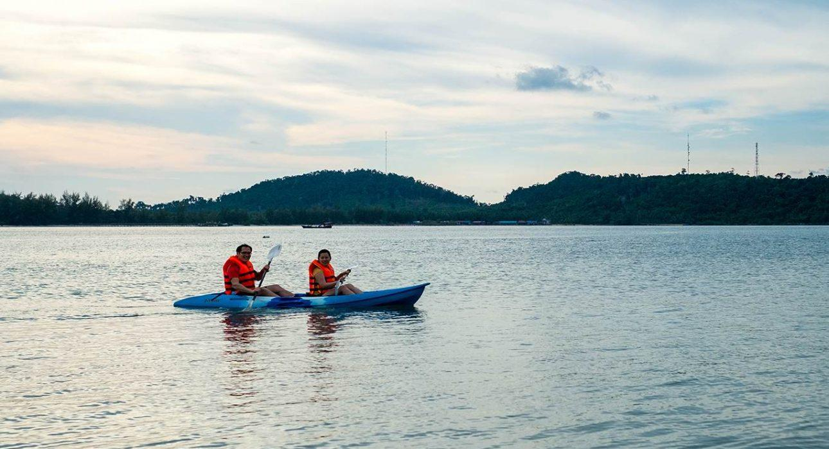
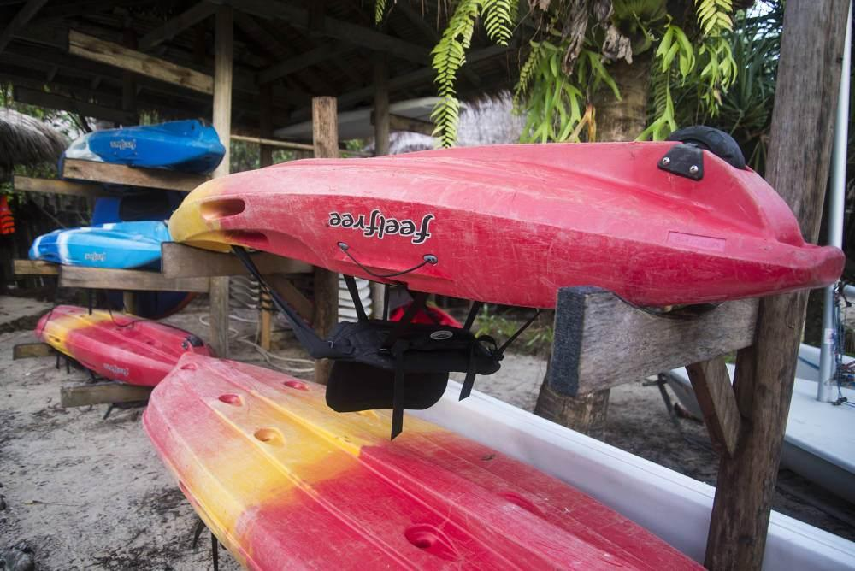
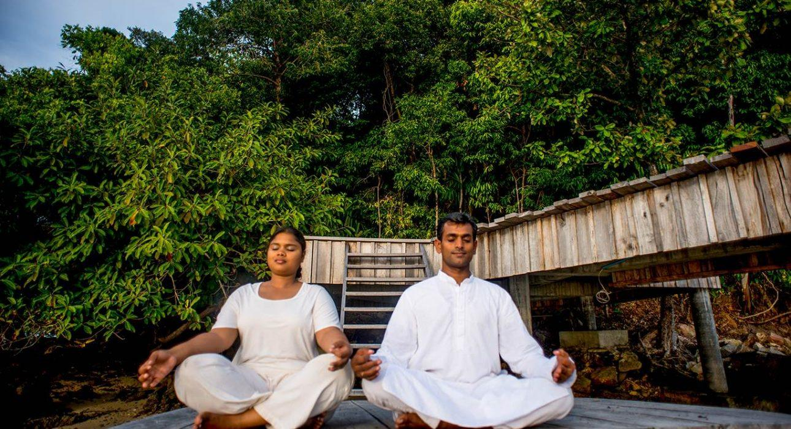
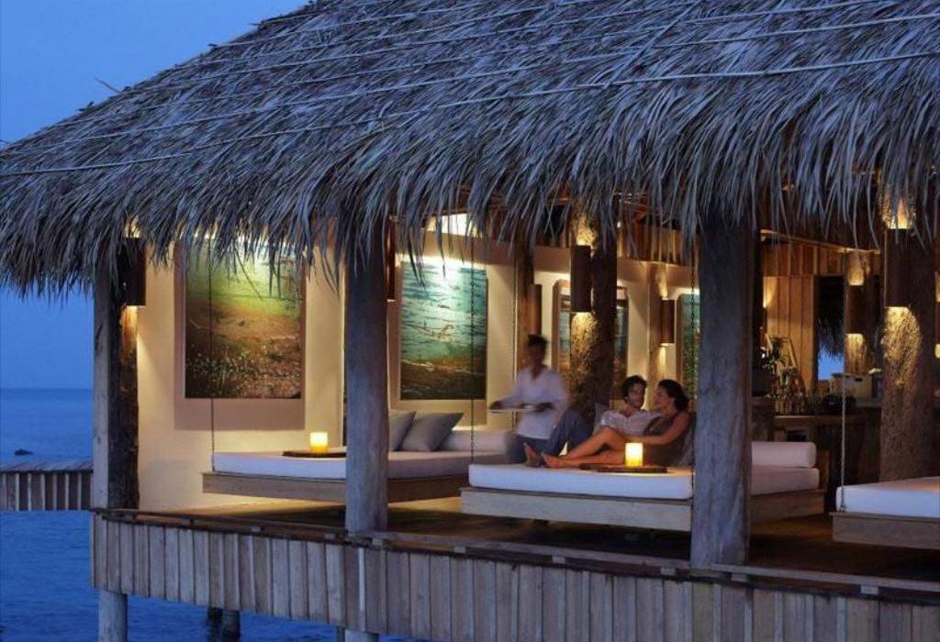
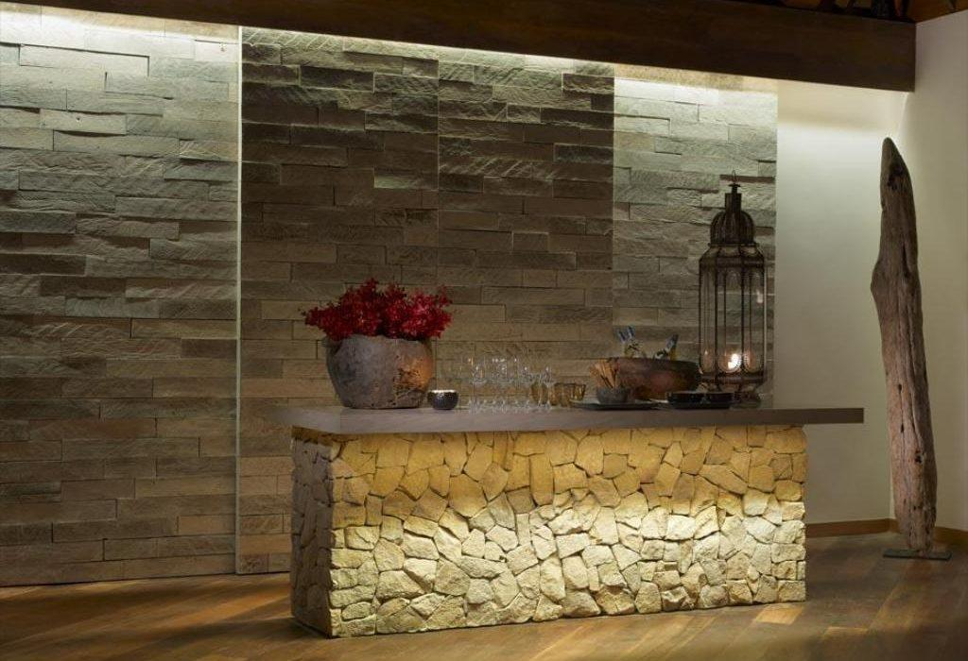

Easia Travel Head Office

Siem Reap BranchCharming City, No. R32 – R34, Road Rolouse, Trorpeangses Village, Sangkat Koukchork, Siem Reap Province – CambodiaTel: (855-63) 76 14 58Fax: (855-63) 76 14 58

