CAMBODIA – Siem Reap – Lotus Blanc Hotel & Resort
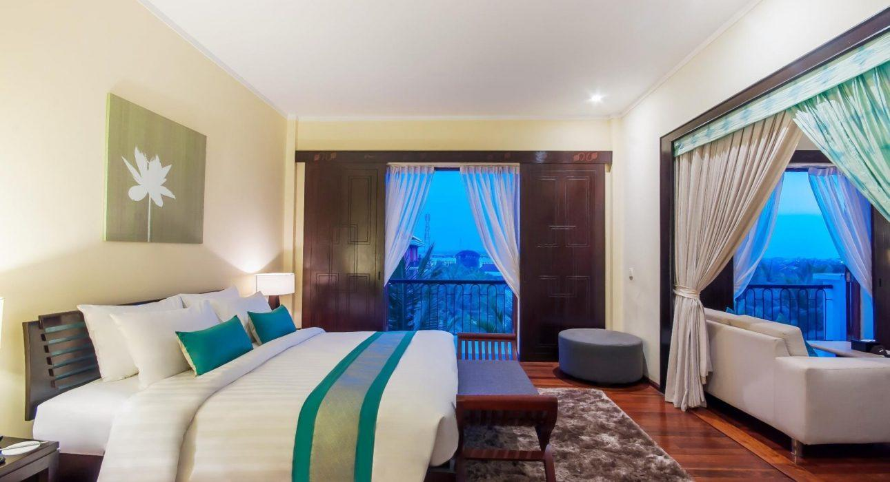

Over View

Theme
Classic

Country - City
Cambodia - Siem Reap

Market segment
Groups, Thematic Leisure

Official category
5*

Easia category
Superior

Total number of rooms
177

Price level
$$$

Description

Lotus Blanc Resort is a French-designed hotel known for its romance, purity, and harmonious atmosphere. Thanks to its tropical lush greeneries, it is a real escape from the city.The Lotus Blanc Resort is an elegant hotel that offers rooms and suites with an elegant French style in a cozy environment. Each of these rooms and suites has a private balcony; most overlook the coconut trees and swimming pool.The Hotel also proposes twoHotelaurants: Le Blanc offers Western and Khmer cuisine and has an open kitchen, which allows the Chef to demonstrate his cooking talents to the guests. The restaurant is open for breakfast, lunch, and dinner. The second option is a fine dining restaurant, classy, and warm Damnak Lounge.Guests can also enjoy the Spa with traditional Khmer massages, the swimming pool, and the hotel’s two bars: the Lemon Hotel’se Coco bar and the fitness center.

Selling points

- An holistic and harmonious style and design
- Fresh and greenery atmosphere- lush tropical garden
- The hotel welcomes and hosts guests inspired by the Khmer culture

Sustainability

Supplier Actions
Protection of Environment

Time & Transportation

From | To | Km | By | Duration | Road condition
Lotus Blanc Resort | Angkor Temples | 6.6km | Car/tuk tuk | 15 min | Good
Lotus Blanc Resort | Siem Reap City center | 2.4km | Car/tuk tuk | 7 min | Good
Lotus Blanc Resort | Siem Reap International Airport | 53.2km | Car | 1hr13 min | Good

Rooms

Easia's recommend room type
Total Room: 177Lotus Hotel & Resort has 2 building:Lotus Blanc Resort (old building)- total: 84 rooms
- Landmark Room -17 TWN (40 square)
- Landmark Room – 35 DBL (40 square)
- Lotus Suite Room – 9 rooms (80 square)
- Privilege Floor – 23 rooms (40 square)
Connecting room: NoExtra bed: able to add one extra bed in Landmark Room. The rest noLotus Blanc Hotel (New building) – Total: 93 rooms
- Deluxe Room TWN – 60 Rooms (32 square)
- Deluxe Room DBL – 31 Rooms (32 square)
- Double Suite – 2 Rooms (75 square)
Connecting room: NoExtra bed: able to add one extra bed in Landmark Room. The rest no

Room configuration

Extra bed
1.2m x 2m

King bed
1.8m x 2m

Twin beds
1.2m x 2m

Services & Facilities

Services
24 hour reception, 24h security service, Buffet Breakfast, Concierge service, Cooking Lesson, Credit Card payment, Currency exchange, Doctor on call, Dry Cleaning, In-Room Dining, Iron, Laundry service, Luggage Storage, Massage, Room Service, Spa, Swimming Pool, Tour desk, Wake-up service, Welcome fruits in room upon arrival, Wi-fi Free

Facilities
Air Conditioning, Bar, Cable, satelite, coffee and tea making facilities, Elevator, Fan, Fitness centre, Flat screen TV, Garden, Hair Dryer, Internet, Massage room, Meeting room, Mini Bar, Outdoor swimming pool, Restaurant, Safety Box, Steam/Sauna

Restaurant information

Le Blanc RestaurantCapacity: 80 pax indoor + 40 pax outdoorOpening hours: breakfast: 6:00 – 10:00 am, lunch: 12:00 – 3:00 pmType of Cuisine: InternationalGet authentic Khmer cuisines and variety of Western flavors where this hotel restaurant, Le Blanc, features an open kitchen that allows chefs to showcase their culinary skills with the state of an art. With both indoor and outdoor settings.Damnak Lounge Fine DiningCapacity: 80 pax indoorOpening hours: breakfast: 6:00 am – 12:00 pm, dinner: 6 – 11 pmType of Cuisine: Modern KhmerIf you appreciate the finest dining experiences in Siem Reap, look for nowhere but here at Damnak Lounge. Relax in our luxurious, air conditioned dining room or in the warm, open air terrace.The Damnak Lounge is among Siem Reap’s finest, classiest restaurants, serving chef’s tailor-made menu of sumptuous modern Khmer cuisine.Lemon BarOpening hours: 8:00 am – 11:00 pmLocated next to Lobby Lounge and Le Blanc, this bar offers a trendy and cheerful setting serving all-day. Here you can sample our chef recommended cakes and signature cocktails or select the menu’s outstanding wine and champagne available for your every need.Coco BarOpening hours: 8:00 am – 11:00 pmThis is the hotel poolside bar distinctively offering from a romantic candle light dinner by the pool to a perfect cool and cheerful poolside party. The surrounding coconut trees provide a great feeling of chilling inside this beautiful Siem Reap hotel when you’re tired of going to a crowded downtown.

Photos

Hotel Photos
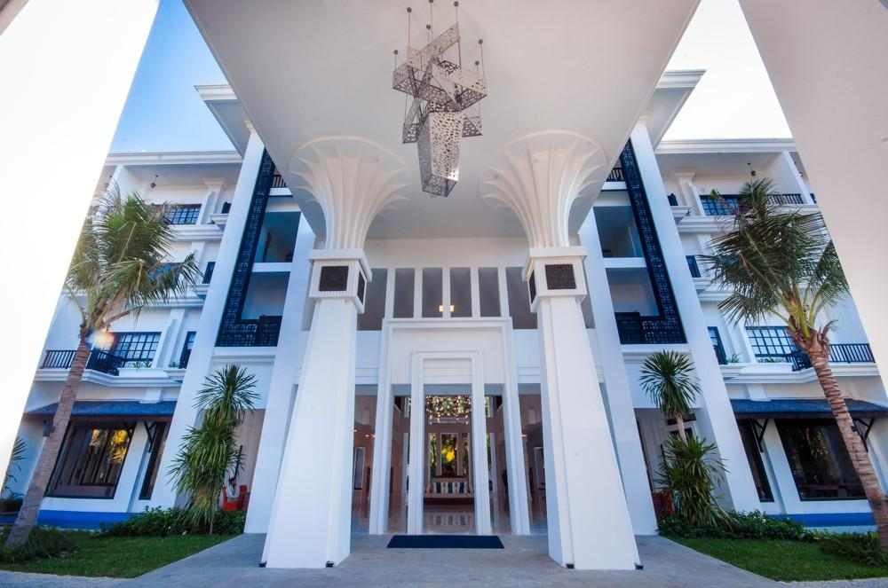
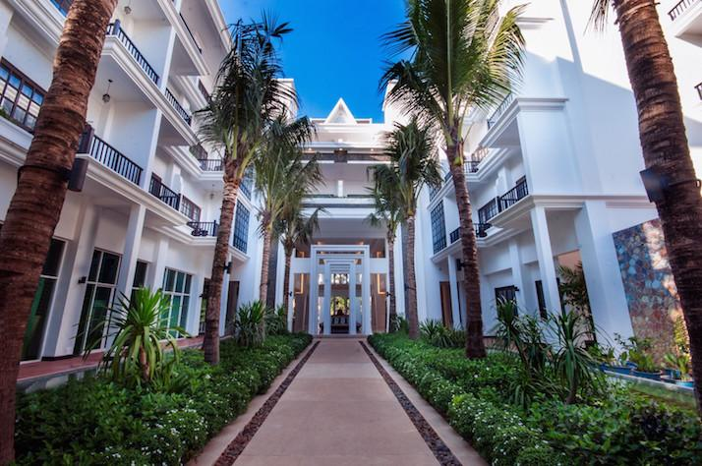
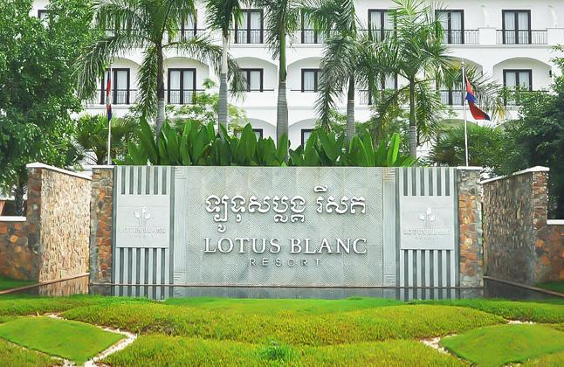
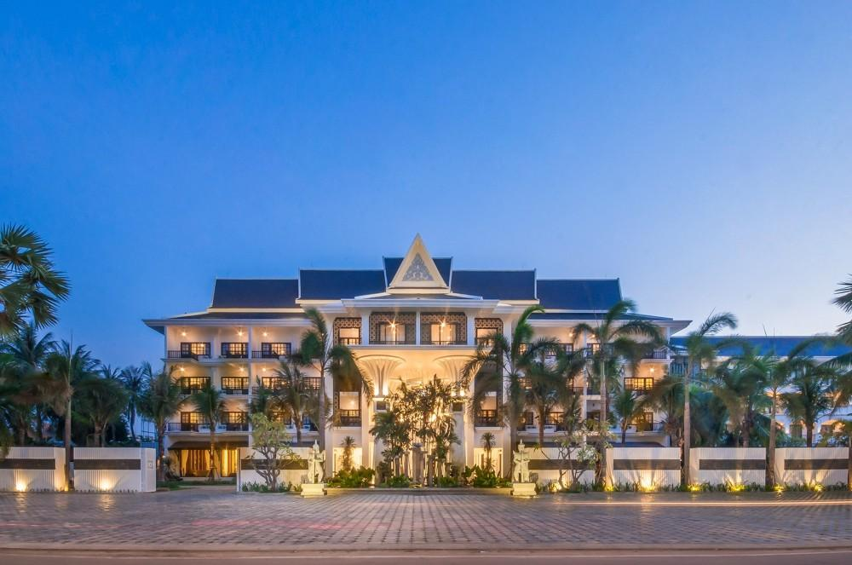

Rooms photos
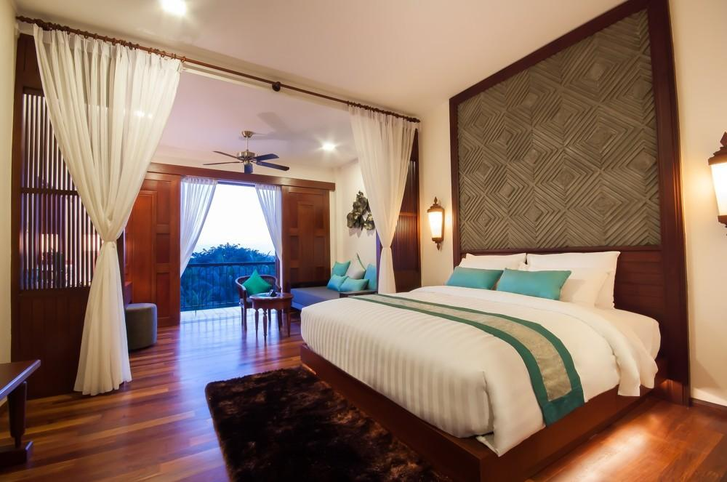
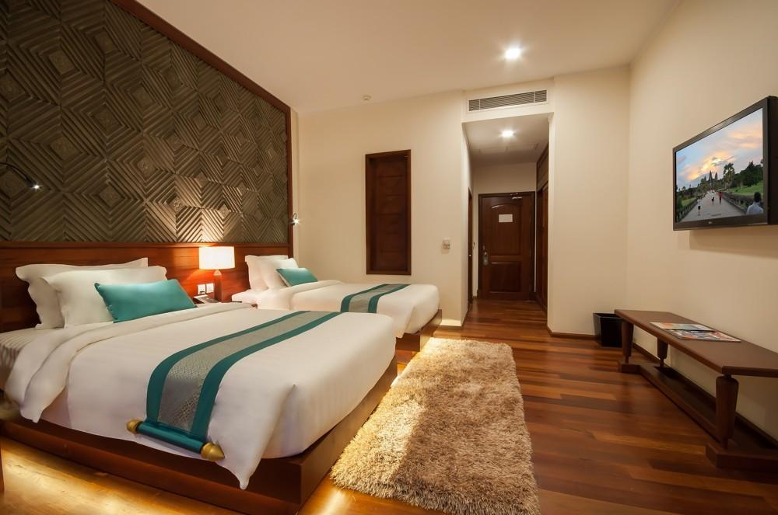
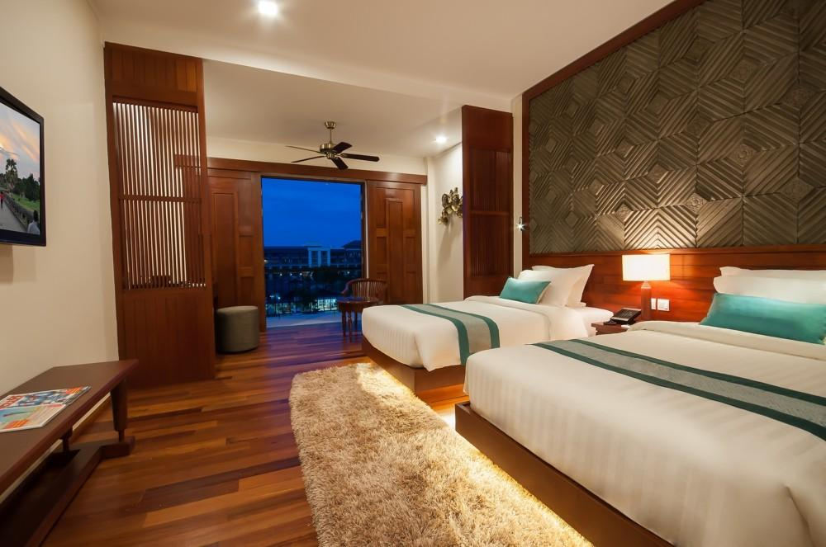
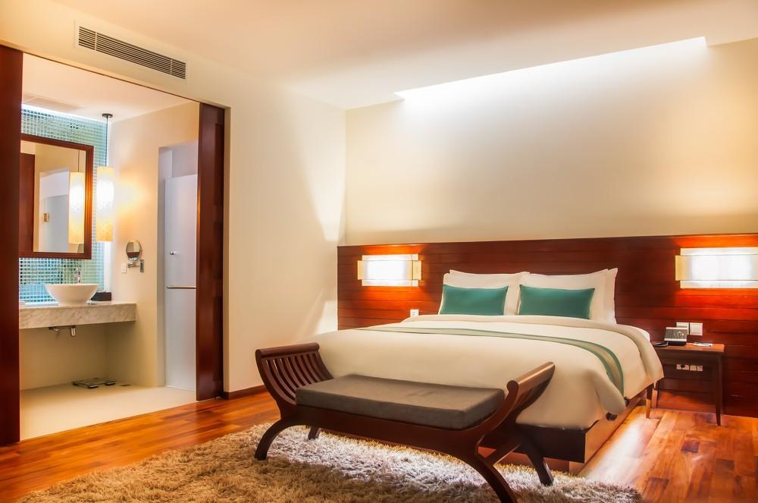
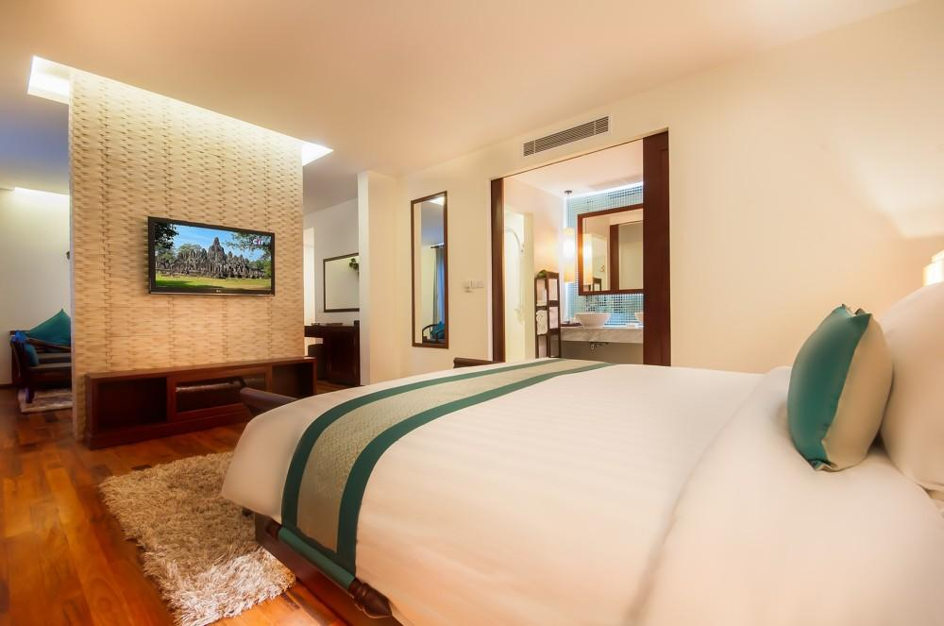
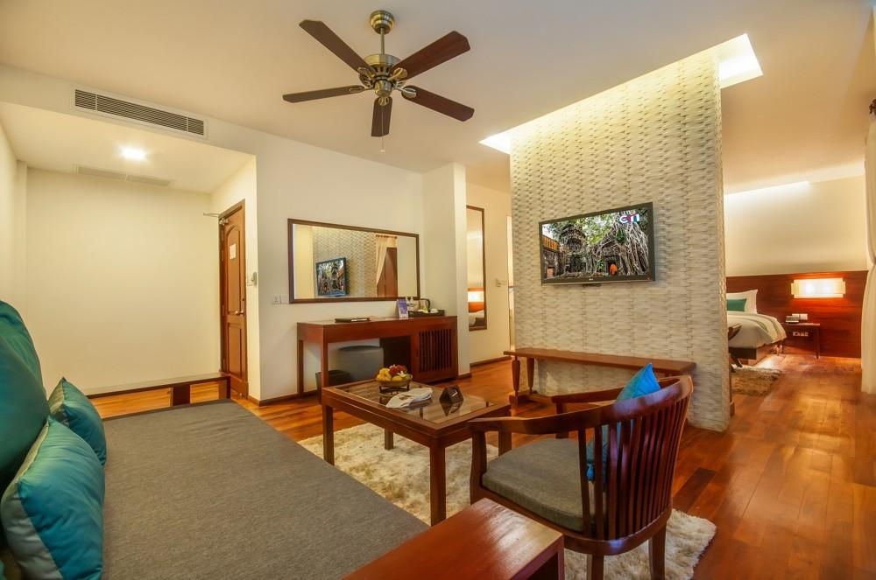
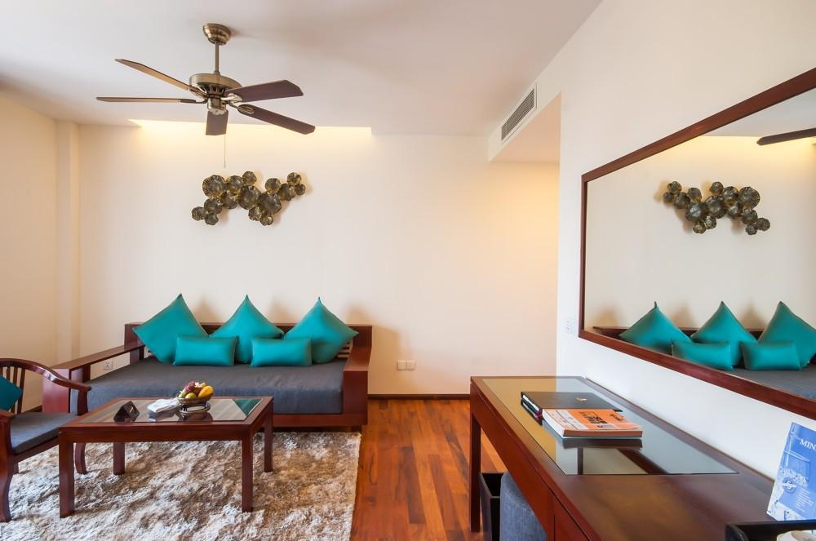
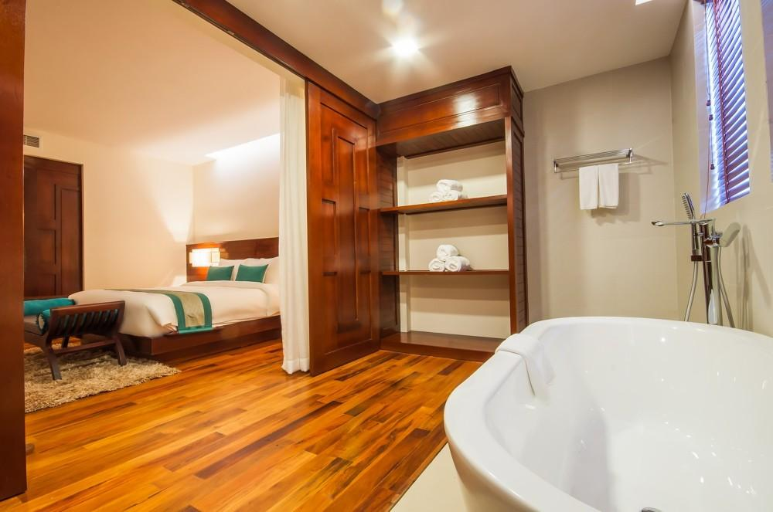
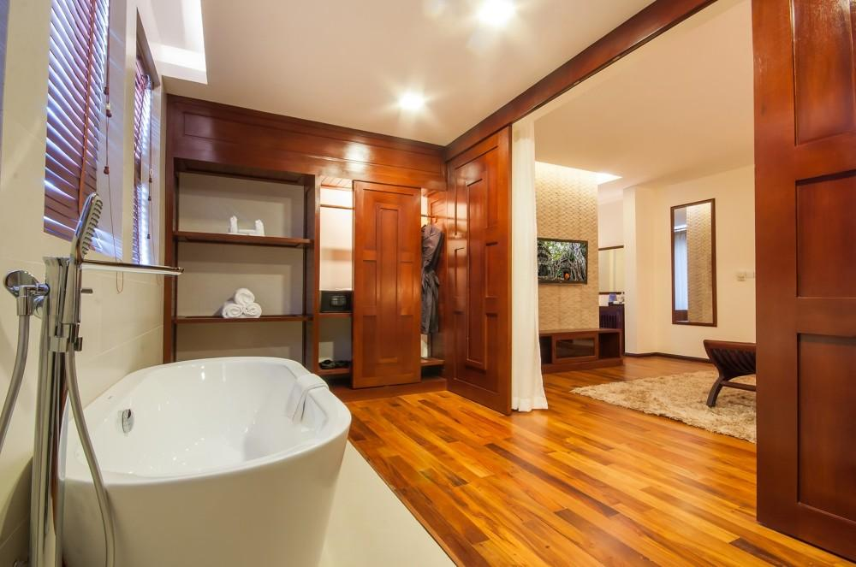
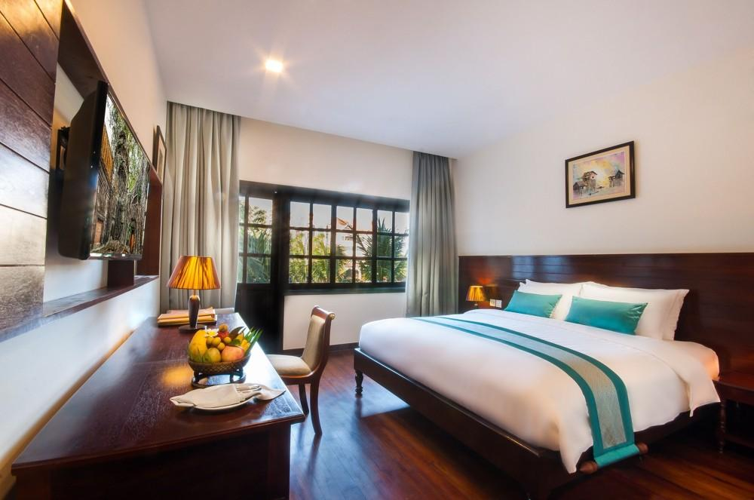
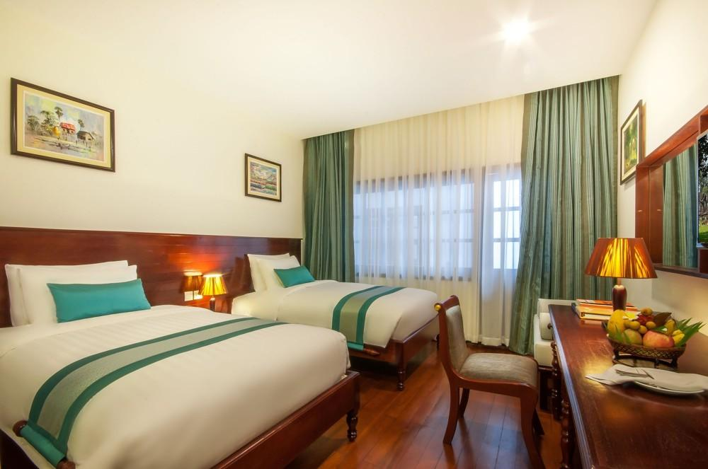
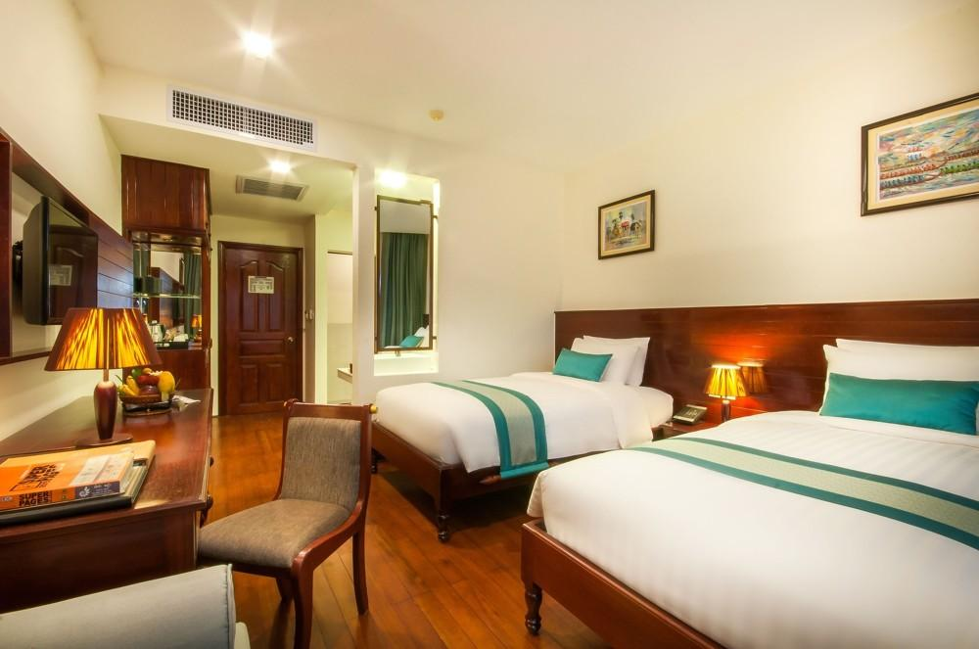
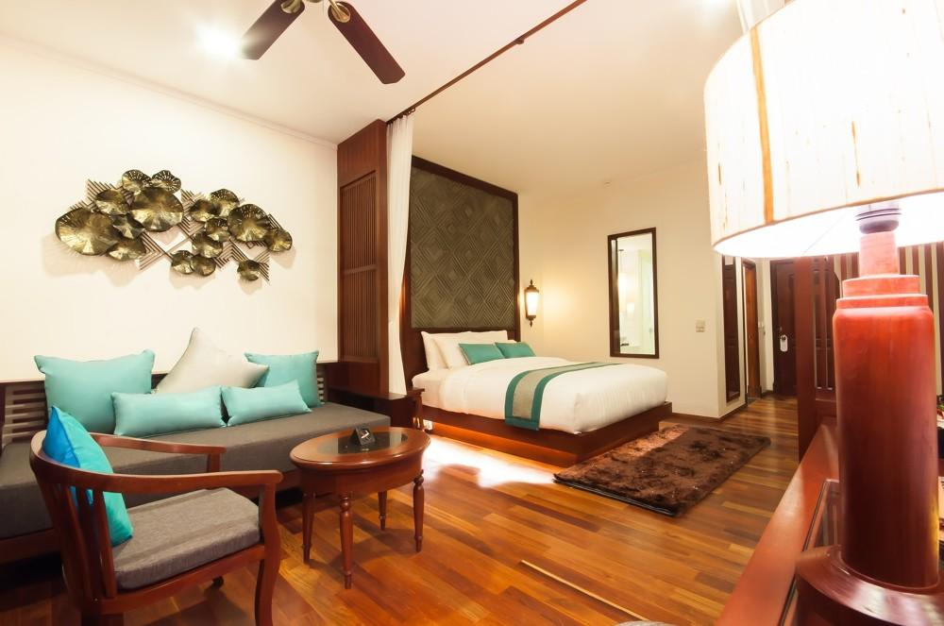
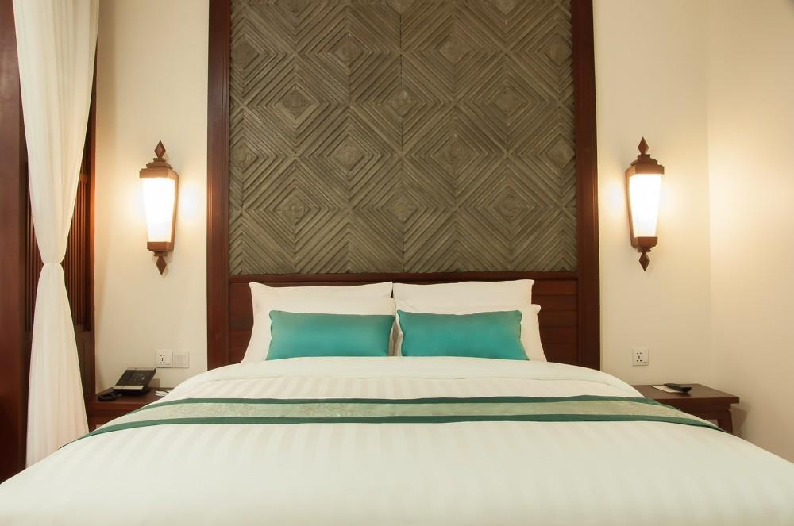

Restaurant photos
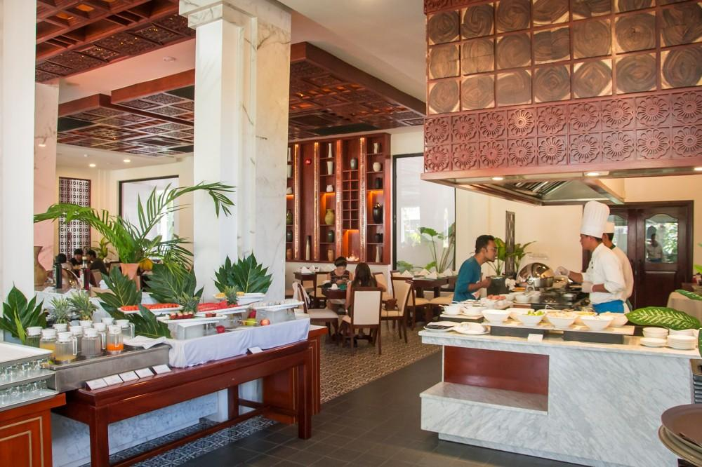
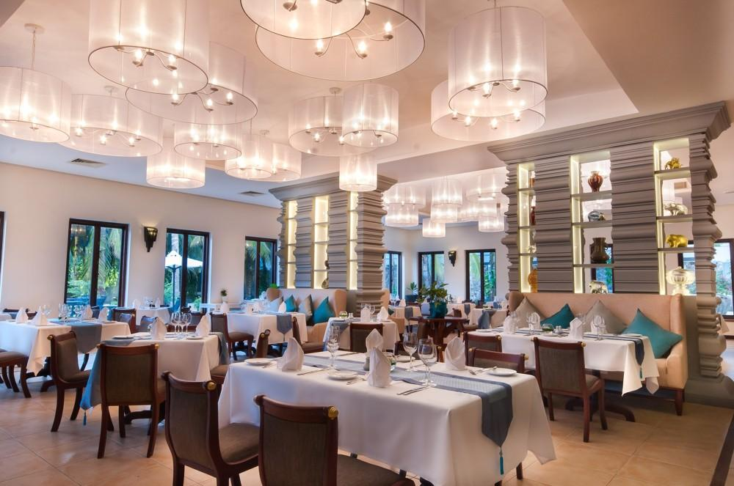
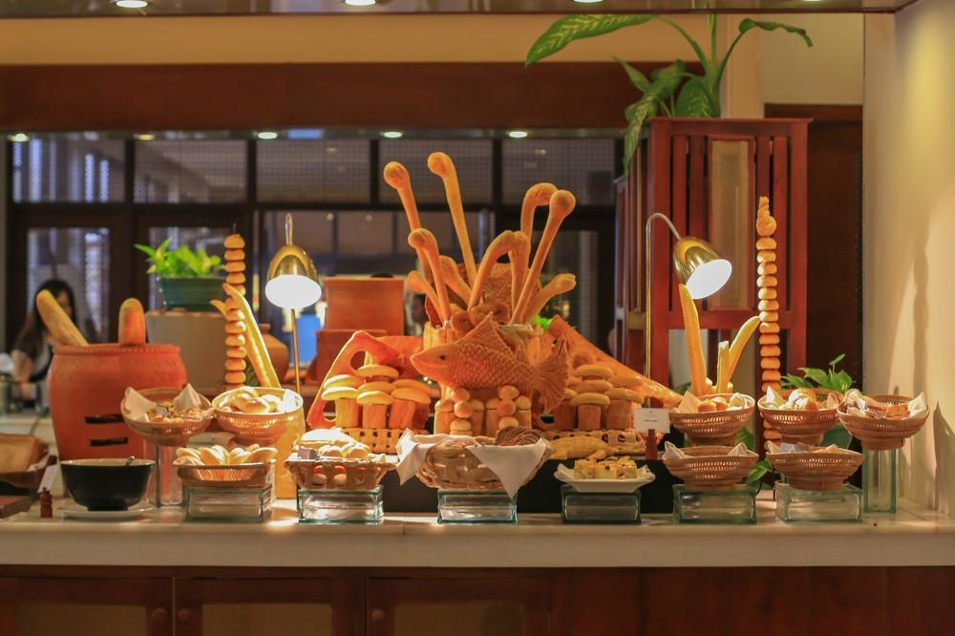
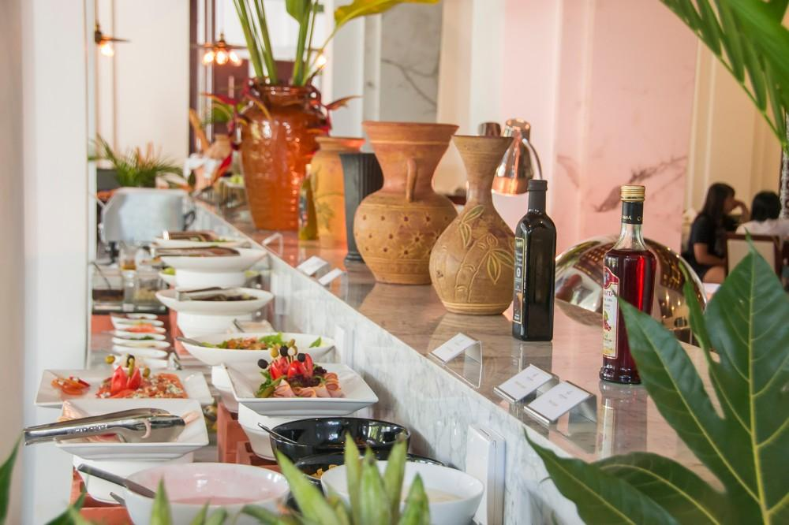
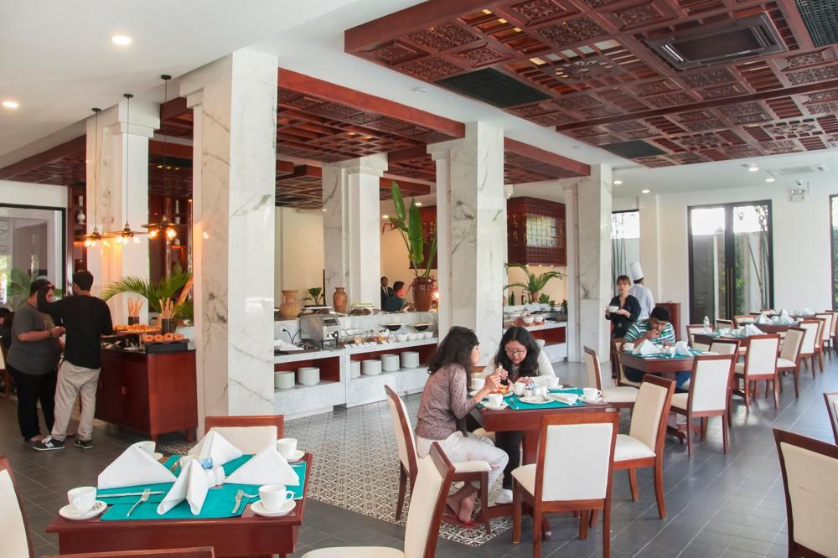
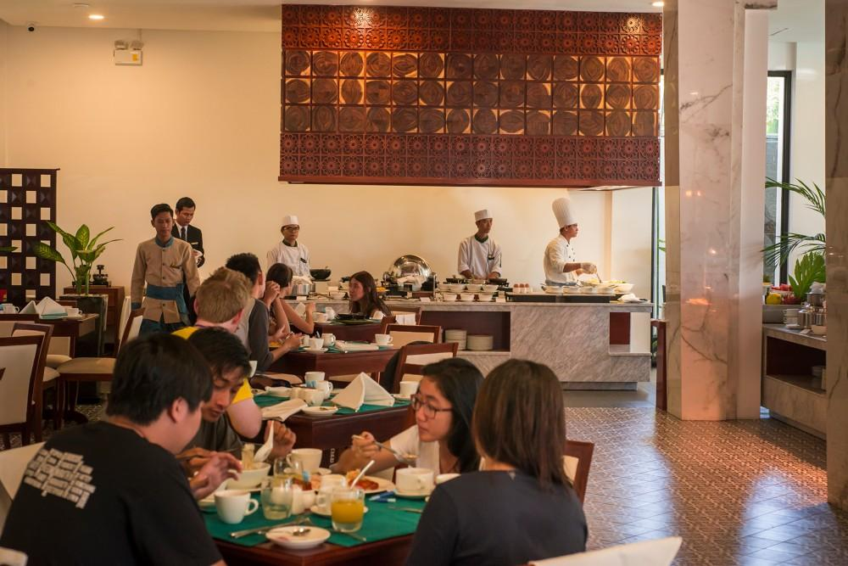
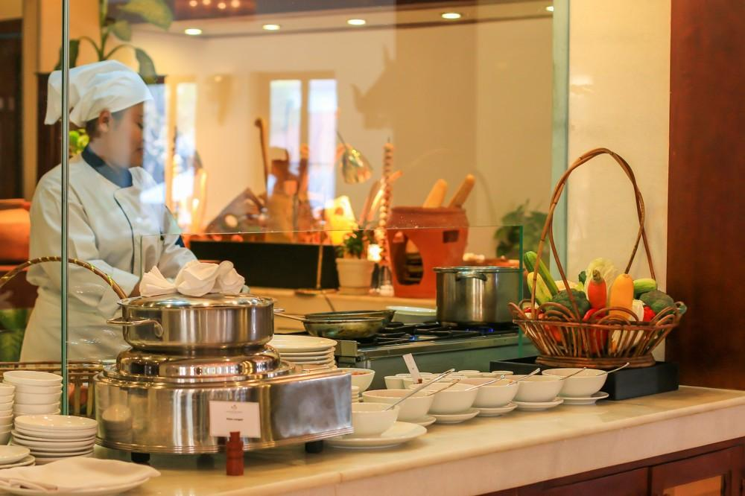

Business facilities photos
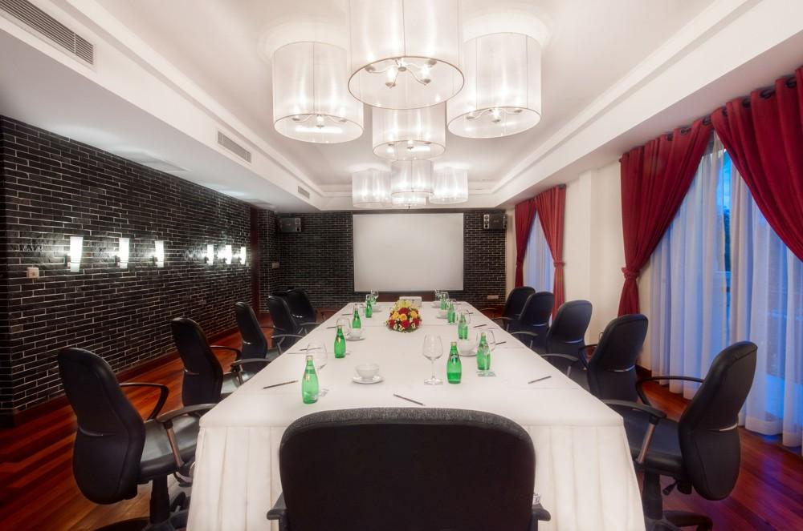
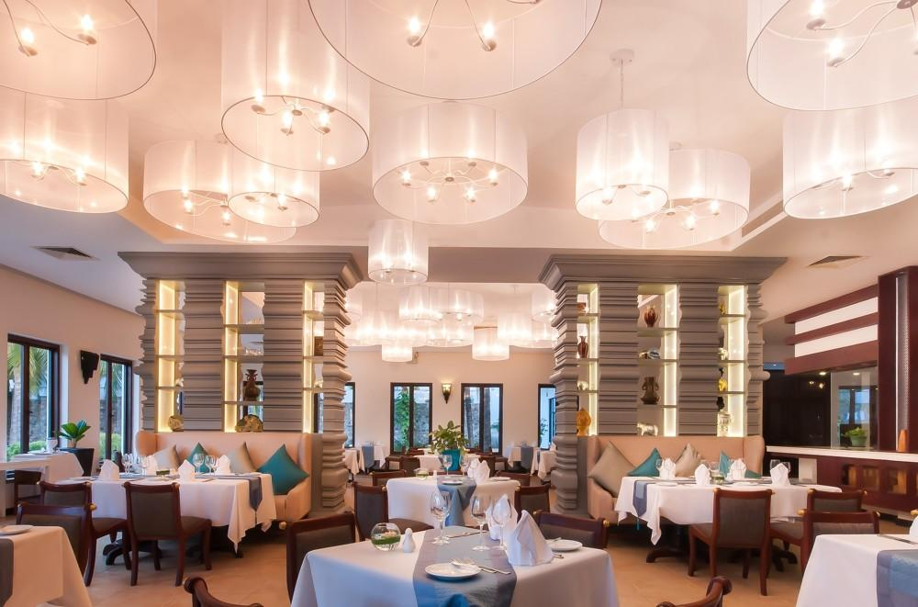
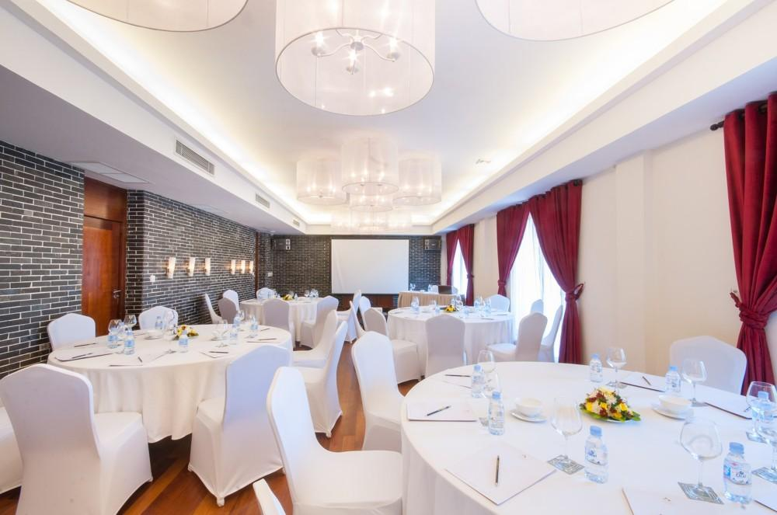
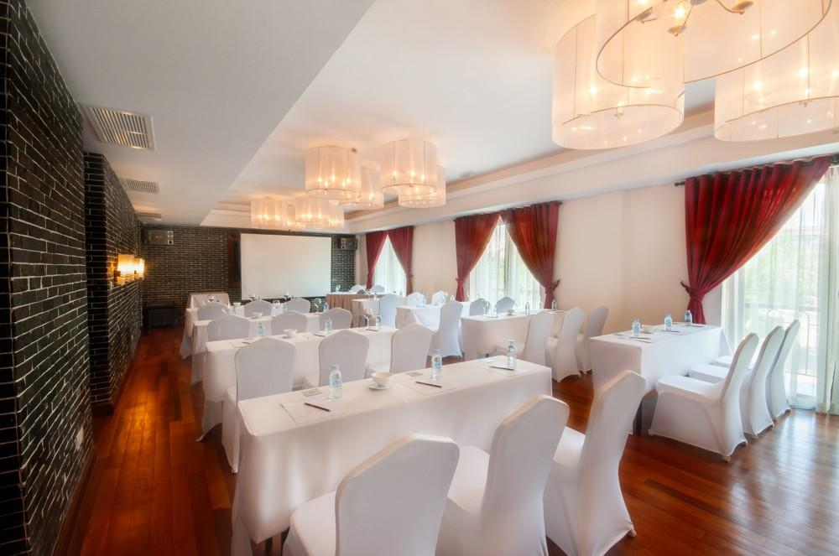

Services & facilities photos
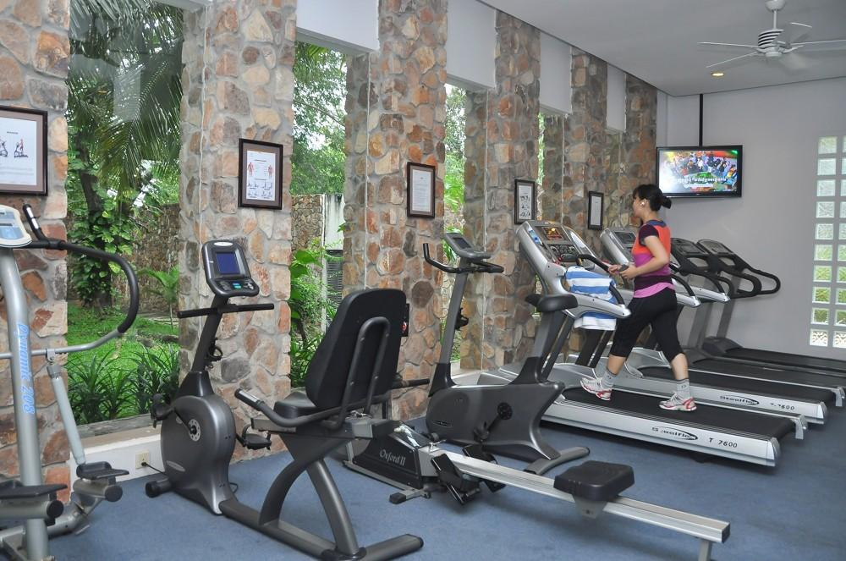
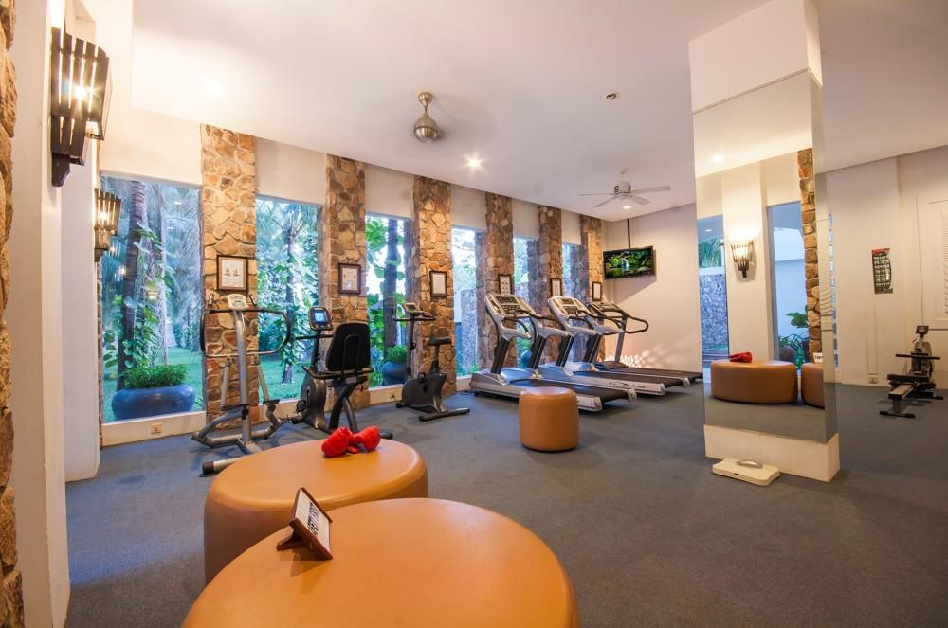
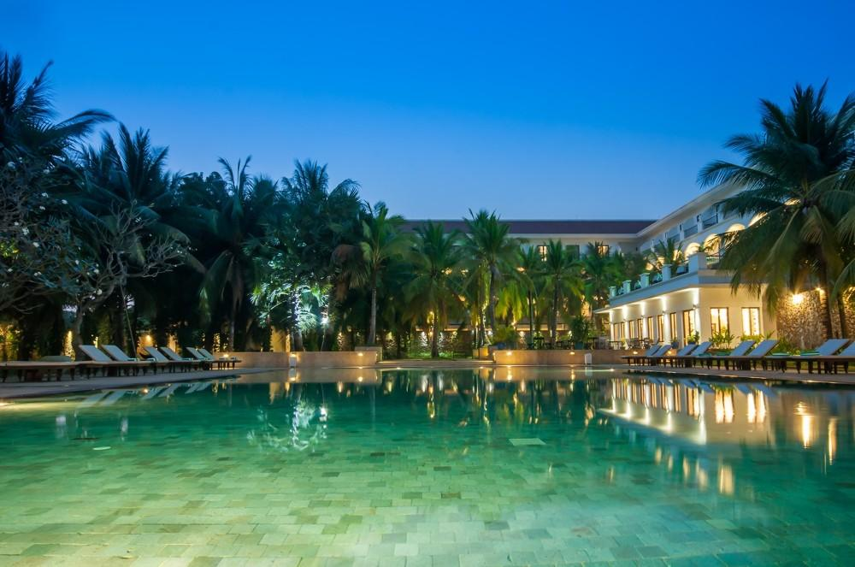
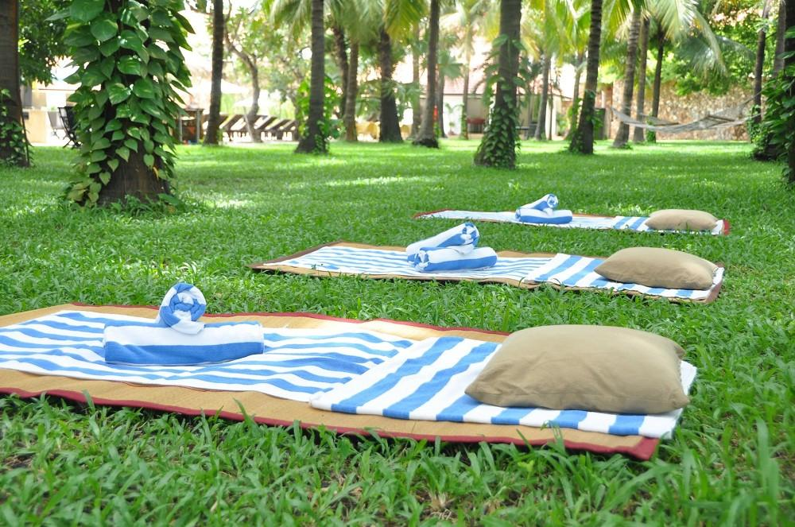
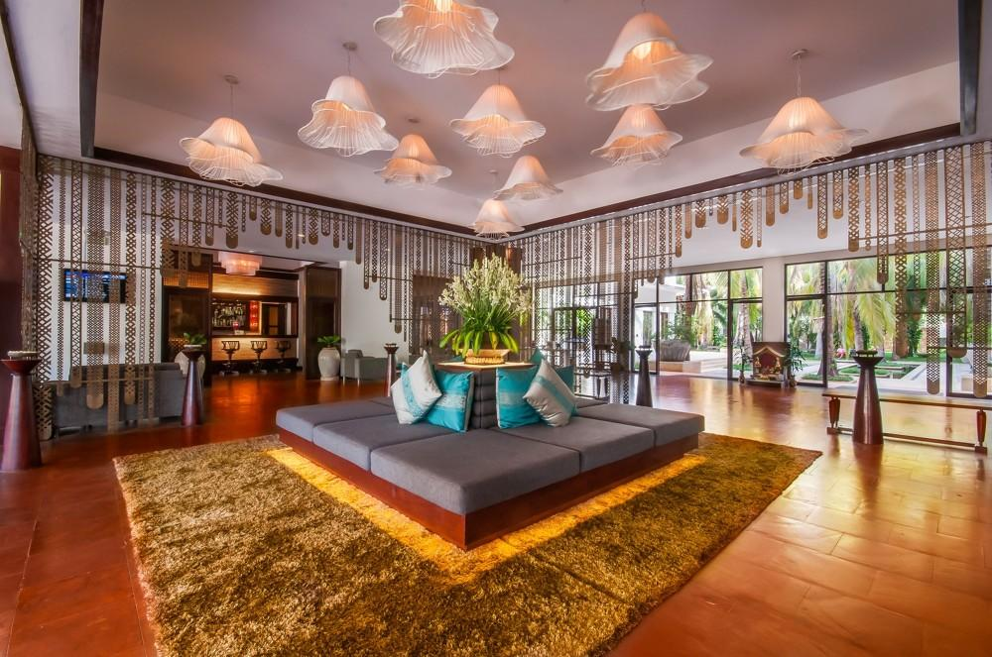
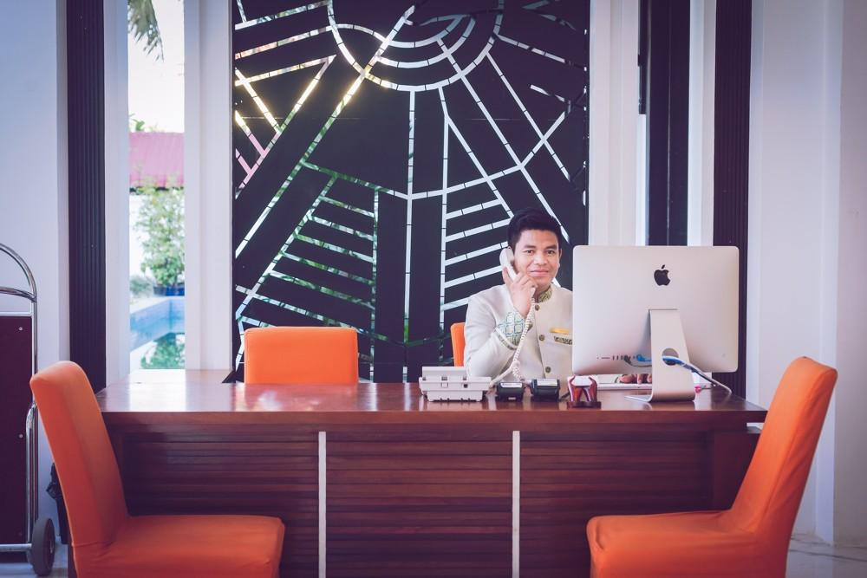

Easia Travel Head Office

Siem Reap BranchCharming City, No. R32 – R34, Road Rolouse, Trorpeangses Village, Sangkat Koukchork, Siem Reap Province – CambodiaTel: (855-63) 76 14 58Fax: (855-63) 76 14 58

