CAMBODIA – Siem Reap – Shinta Mani Shack (former Shinta Mani Resort)
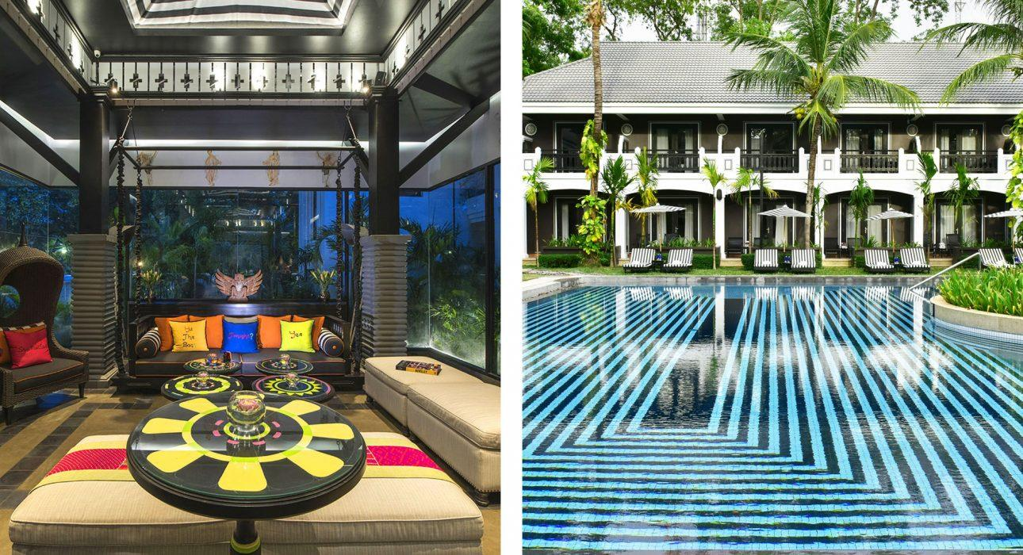

Over View

Theme
Classic, Honeymoon

Country - City
Cambodia - Siem Reap

Market segment
Groups, Thematic Leisure

Official category
4*

Easia category
First Class

Total number of rooms
66

Price level
$$$

Description

The Shinta Mani Shack is a newly renovated Bensley‐designed boutique property centrally located in the leafy French Quarter between The Royal Gardens and the Old Market Area.
Each of the courtyard-style resort’s 62 rooms & 1 junior suite enjoy first floor balcony views or direct access to the stunning swimming pool and flourishing tropical gardens. Public spaces include an all-day dining café/restaurant, conference & meeting facilities as well as complimentary wifi throughout. The Spa, Bensley’s Bar and Kroya Restaurant which are located directly opposite the Resort at the Shinta Mani Angkor are open to guests for their enjoyment. The Shinta Mani Spa, offering 1 spa suite and 3 double treatment rooms is a haven of refuge where the body is restored to exuberant well-being, good health and wholeness. Shinta Mani strongly supports responsible tourism and community outreach through the Shinta Mani Foundation which is located at the nearby Shinta Mani Angkor. The Foundation provides free hospitality training to the less fortunate members of Siem Reap community.

Selling points

- Shinta Mani Shack offers a unique design very spacious and nice common areas in a quiet neighborhood, still very close to the city center.
- The decor is modern with art touches and a very specific architecture.
“This is the former Day Inn Resort that has been lightly refurbished in a Shinta Mani style. But this property is one level below the Club. It would be a low 4**** and a top 3***. The architecture of the building is very nice. This product is a perfect choice for low 4****. This could be also a good choice for low budget incentive that want to privatize a hotel with a nice atmosphere in the center of Siem Reap.”Philippe Richard

Time & Transportation

From | To | Km | By | Duration | Road condition
Shinta Mani Resort | Old Market | 1 kilometer | On foot | 10 minutes | Good
Shinta Mani Resort | Angkor Wat | 6 kilometers | Car | 15 minutes | Good

Rooms

Easia's recommend room type
Pool View RoomNumber: 38Size: 40 m²Design: ModernPool View Rooms are located on the first floor of the courtyard style resort and all have balcony views over the swimming pool and tropical gardens. Rooms enjoy “a Bensley twist” including mirrored feature wall, custom designed iron bed and hand crafted light fittings. Accommodation is available in either King or Twin‐share and both include a wall mounted LCD TV/sound bar, Bluetooth and complimentary wireless internet access. Rooms feature artwork exclusively created for Shinta Mani by Bensley Design Studios, Bangkok.Poolside Garden RoomNumber: 24Size: 44 m²Design: ModernPoolside Garden Rooms are located within footsteps of the swimming pool and tropical surrounds. Rooms enjoy “a Bensley twist” including mirrored feature wall, custom designed iron bed and hand crafted light fittings. Accommodation is available in either King or Twin‐share and both include a wall mounted LCD TV/sound bar, Bluetooth and complimentary wireless internet access. Rooms feature artwork exclusively created for Shinta Mani by Bensley Design Studios, Bangkok.Junior SuiteNumber: 2Size: 78 m²Design: ModernThe Junior Suite is located on the first floor of the Resort with balcony views of the swimming pool and tropical gardens. The suite with separate sleeping and living room enjoys a retro feel including mirrored feature wall, custom‐designed iron King bed and hand crafted light fittings. The suite comes with a separate shower, toilet and bath. Facilities include a wall mounted LCD TV/sound bar, Bluetooth and complimentary wireless internet access. The Suite also features artwork exclusively created for Shinta Mani by Bensley Design Studios, Bangkok.Executive SuiteNumber: 2Size: 94 m²Design: ModernThe Executive Suites are located on the second floor of Shinta Mani Shack with balcony views of the urban streetscape. The suites have separate living/sleeping areas whilst the oversized bathrooms have his and her vanity units and a separate shower stall with rain shower. Rooms enjoy “a Bensley twist” including mirrored feature wall, custom designed iron bed and hand crafted light fittings. Accommodations also include a wall mounted LCD TV/soundbar, blue tooth and complimentary wireless internet access. Rooms feature artwork exclusively created for Shinta Mani by Bensley Design Studios, Bangkok

Services & Facilities

Services
24 hour reception, 24h security service, Afternoon Tea, Buffet Breakfast, Car rental, Concierge service, Cooking Lesson, Laundry service, Massage, Private event, partying, Spa, Swimming Pool, Wi-fi Free

Facilities
Air Conditioning, Bar, Business centre, Cable, satelite, coffee and tea making facilities, Family Room, Flat screen TV, Garden, Hair Dryer, In-Room safe, Internet, Massage room, Meeting room, Mini Bar, Outdoor swimming pool, Restaurant, Steam/Sauna, Terrace

Business facilities details
Room Name | Size | CAPACITY
Classroom | Theater | Ballroom | U shape | Board room | Banquet
Blackboard | 47 m² | 20 pax | 30 pax | N/A | 14 pax | 14 pax | 20 pax

Restaurant information

BaitongCapacities: 108 pax; 68 indoor and 40 outdoorType of food: International & KhmerOpening hours: Breakfast Buffet: 6 – 10:30 amA La Carte Lunch: 11:30 am – 2:30 pmAfternoon Tea: 2:30 – 4:30 pmA La Carte Dinner: 6 – 10:30 pmBaitong offers all day dining. Guests may choose from International comfort food as well as Khmer street food. Enjoy indoor and outdoor seating in this cool green space. Known for scrumptious burgers, sandwiches and salads.KroyaCapacities: 72 pax; 38 indoor and 34 outdoorType of food: Khmer and InternationalOpening hours: Breakfast: 6 – 10:30 amA La Carte Lunch: 11:30 am – 2:30 pmA La Carte Dinner: 6 – 10:30 pmKroya Restaurant menu blends international as well as local product, combining fresh ingredients, native herbs and spices to create innovative, palette pleasing flavours. Kroya offers air-conditioned comfort or outdoor swing terrace.
Bensley’s BarType of food: Selection of tapasOpening hours: 11 am – 10:30 pmThe cool grey hued bar offers a laid back environment for post temple tour drinks and discussions. The Shinta Mani Angkor Bensley Bar is an airy venue, located on the Club’s second floor overlooking the inner courtyard.Note: Happy Hours: 5 – 7 pmPool BarType of food: Light food snacksOpening hours: 11 am – 8 pmRefresh at the Shinta Mani Shack’s large pool and tropical garden while enjoying our signature Icy Green Ginger cocktail or perhaps try a thirst quenching fruit smoothie. Drinks and light snacks are served throughout the day.

Photos

Hotel Photos
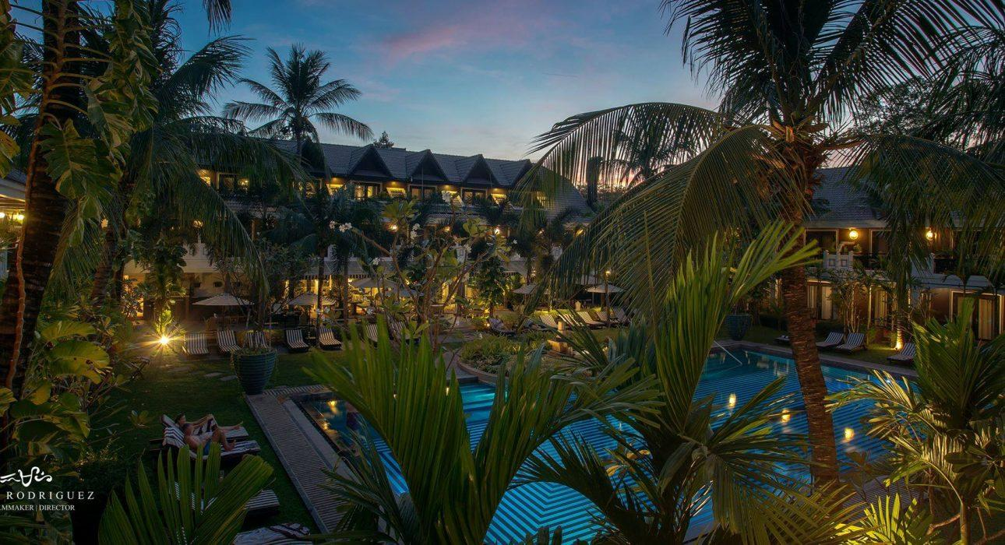
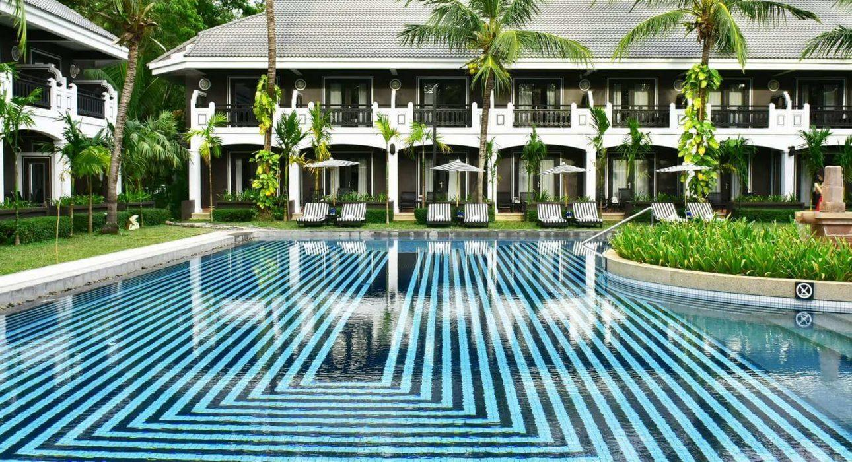
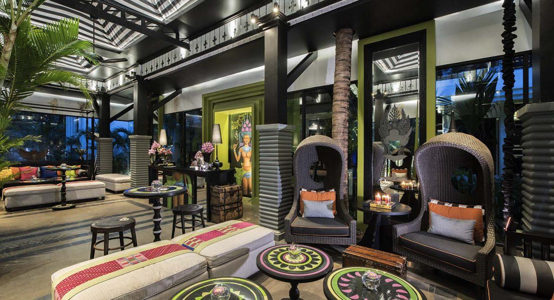
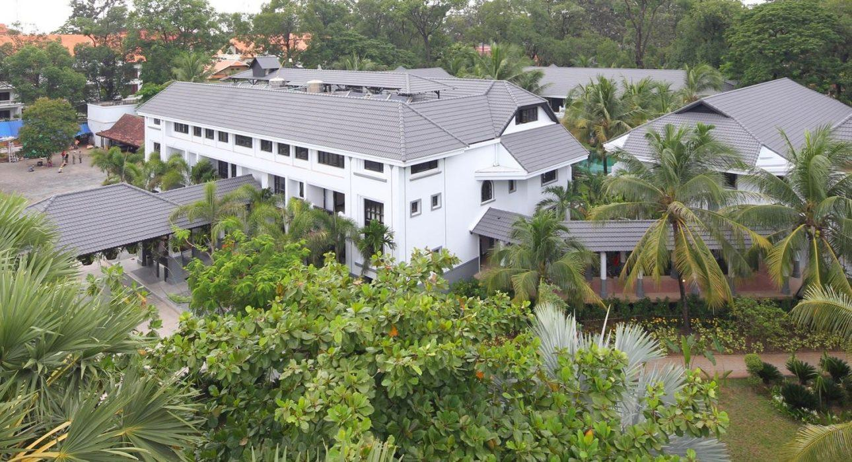

Rooms photos
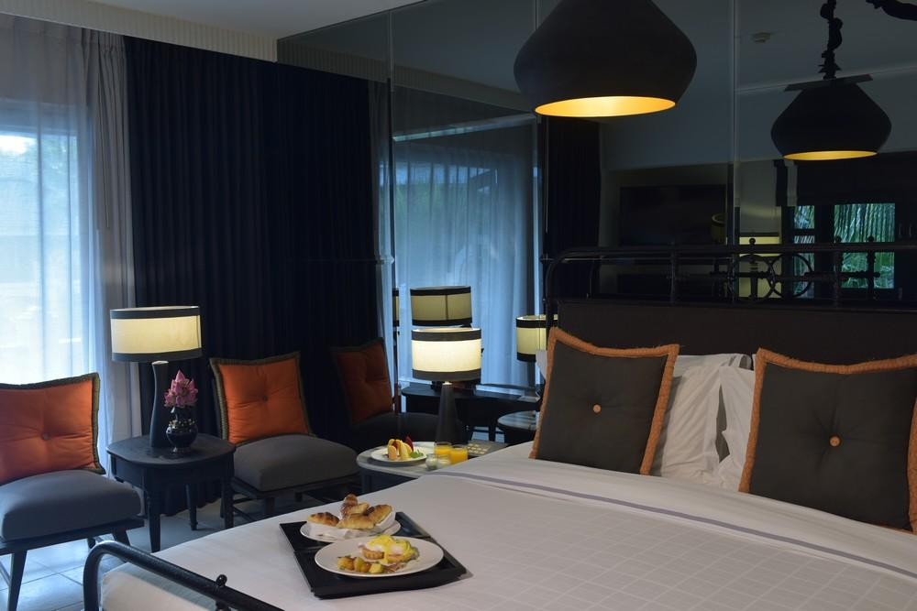
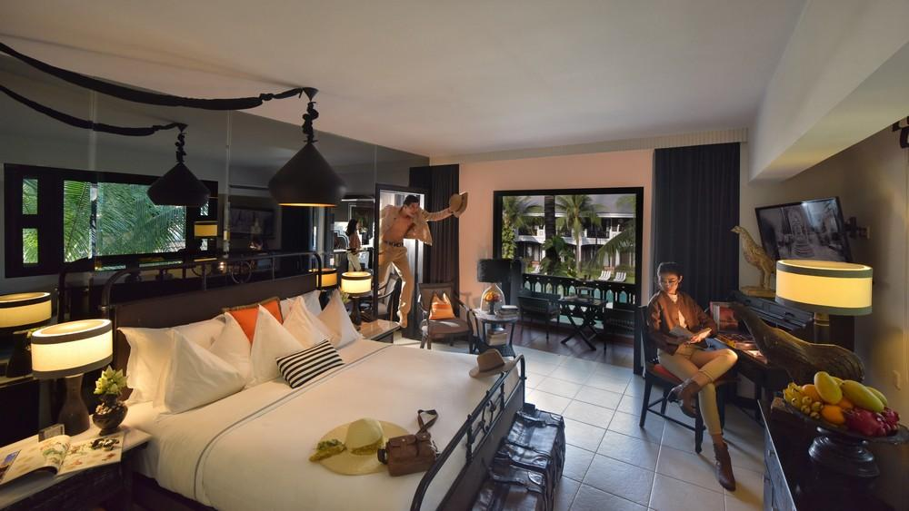
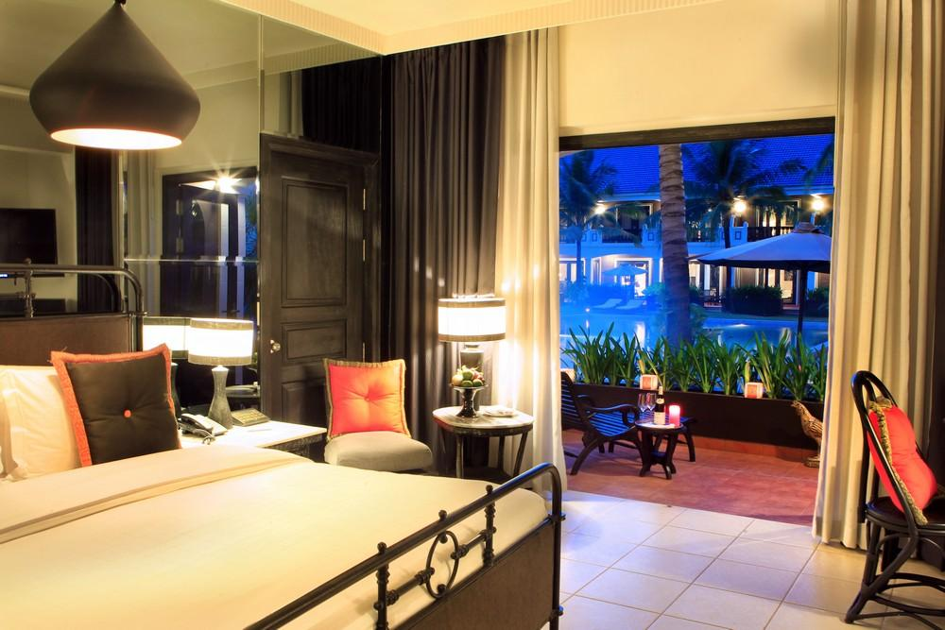
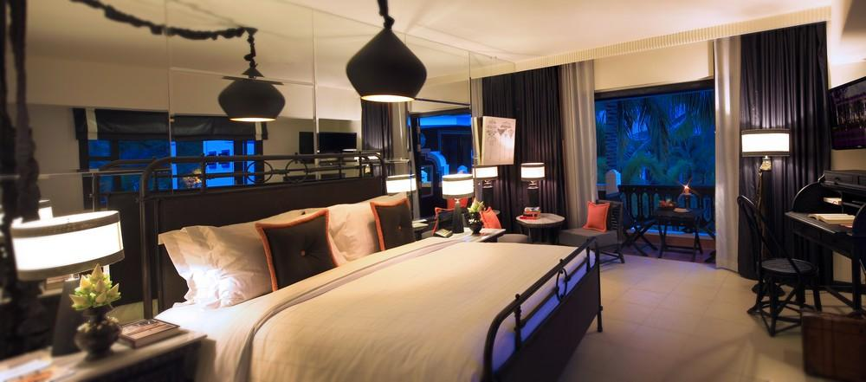
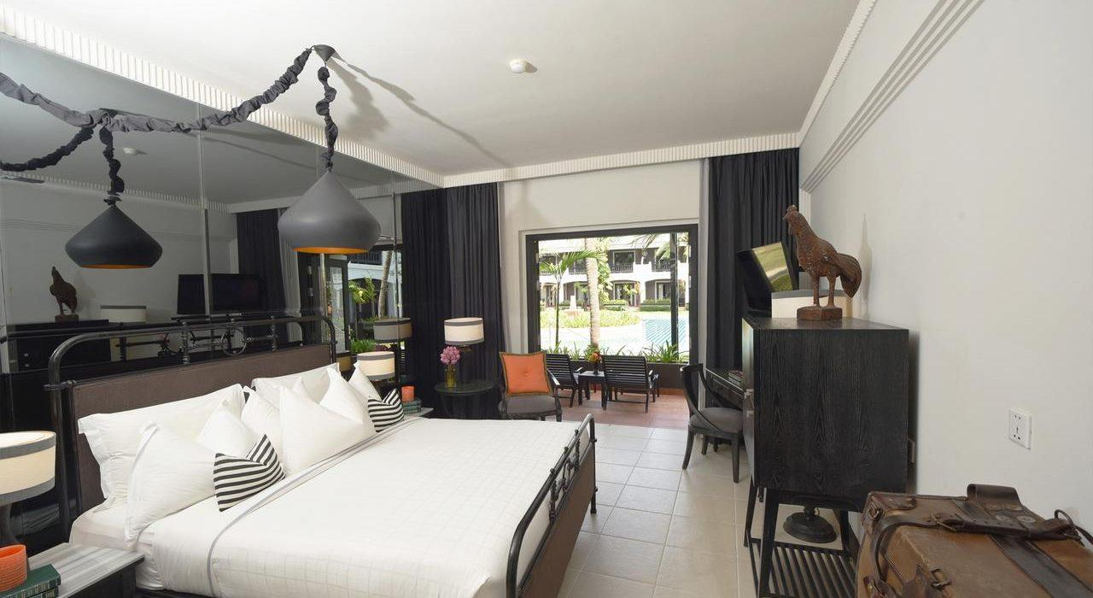
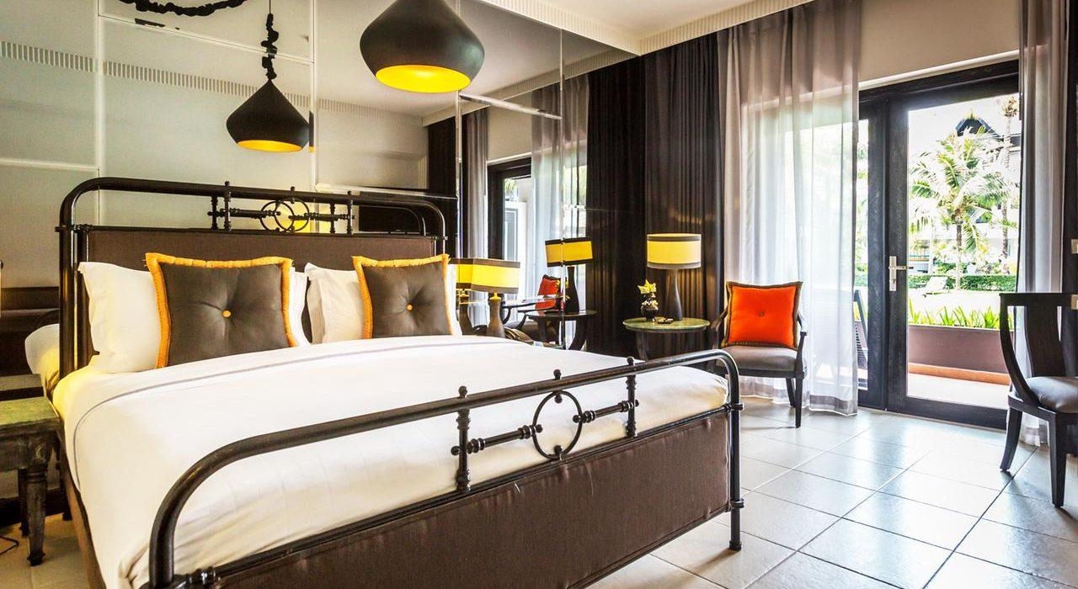
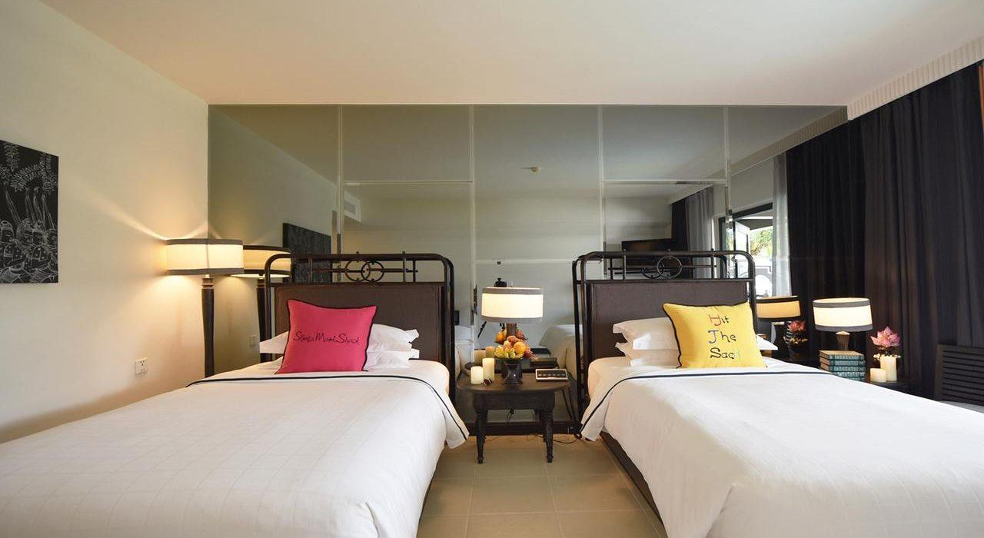
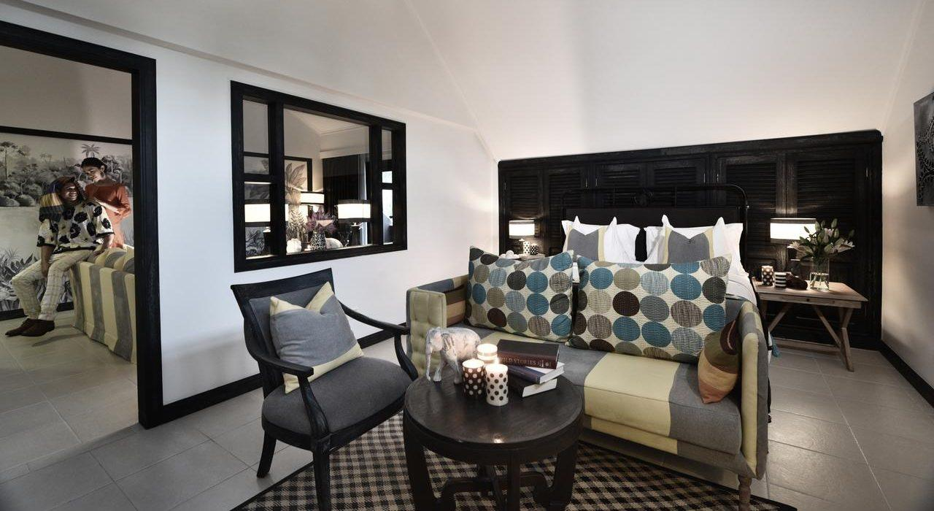
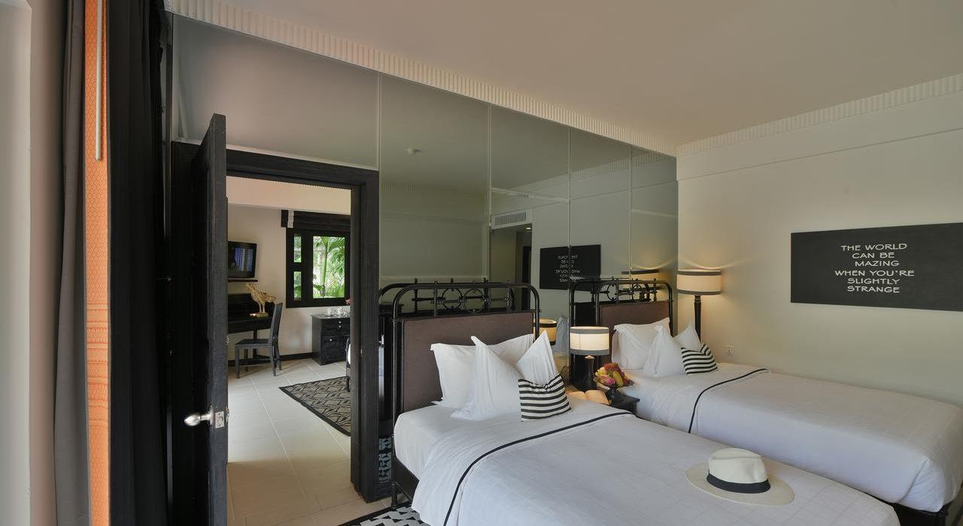
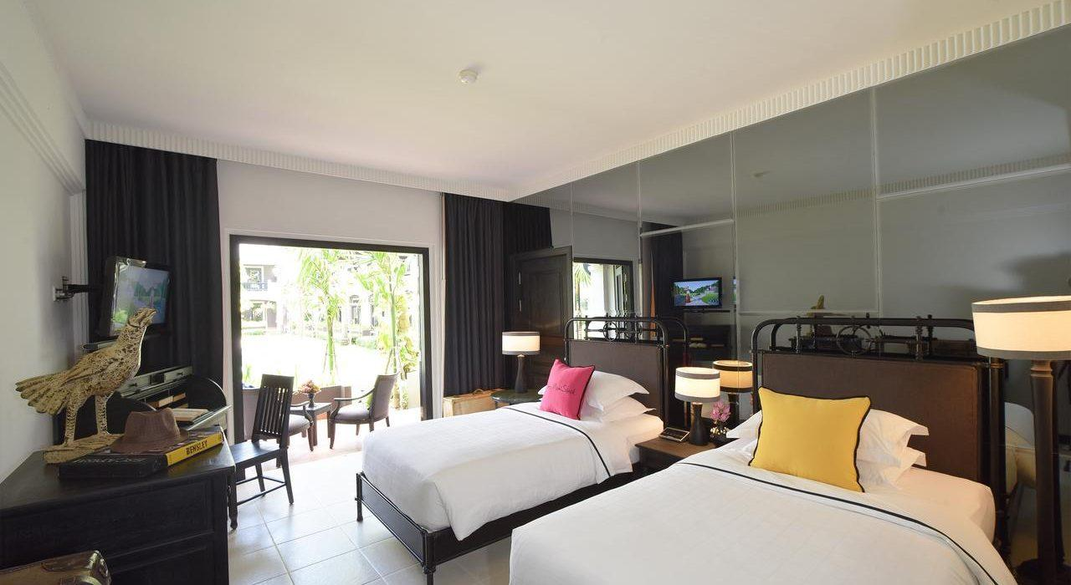
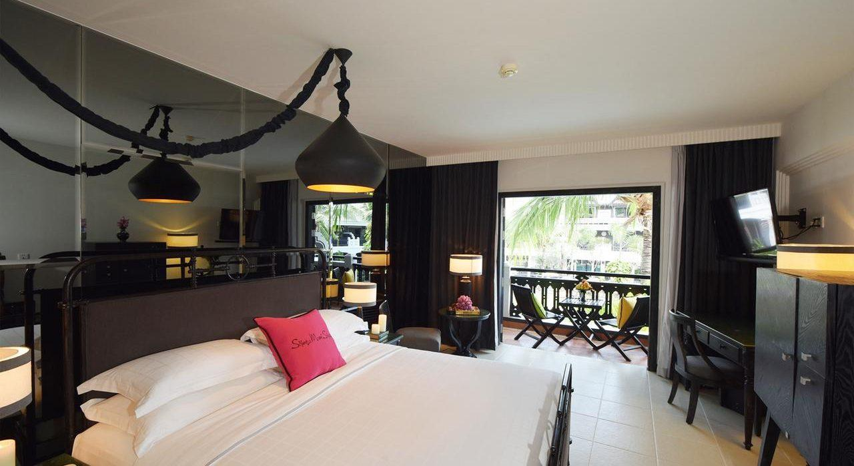
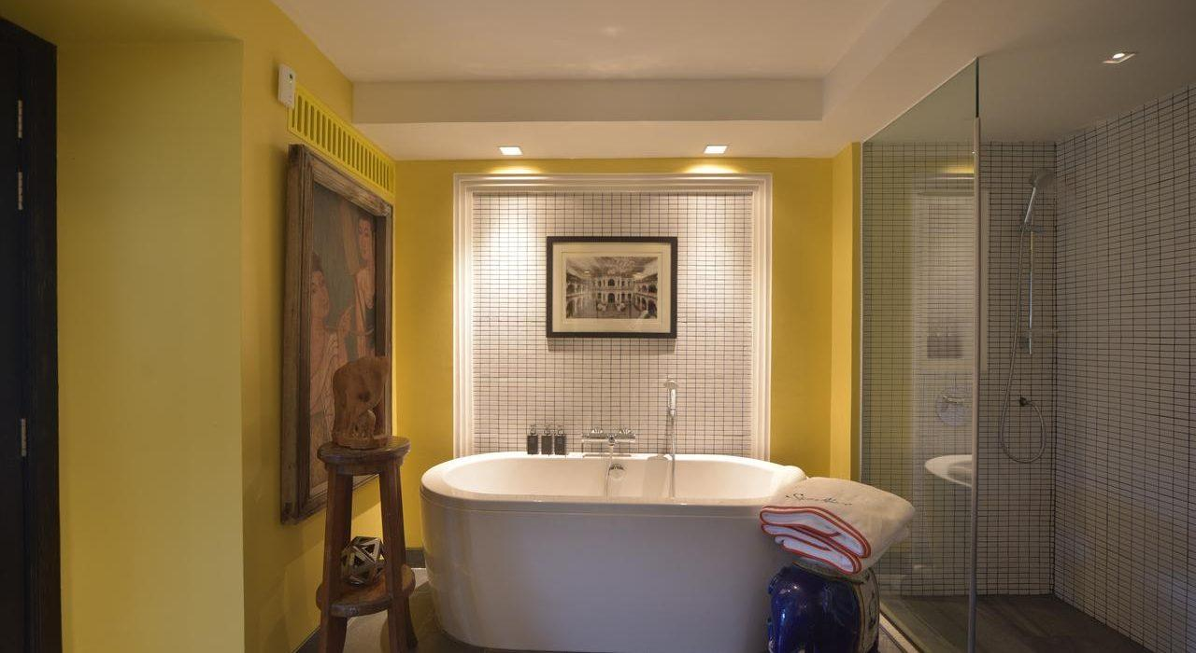

Restaurant photos
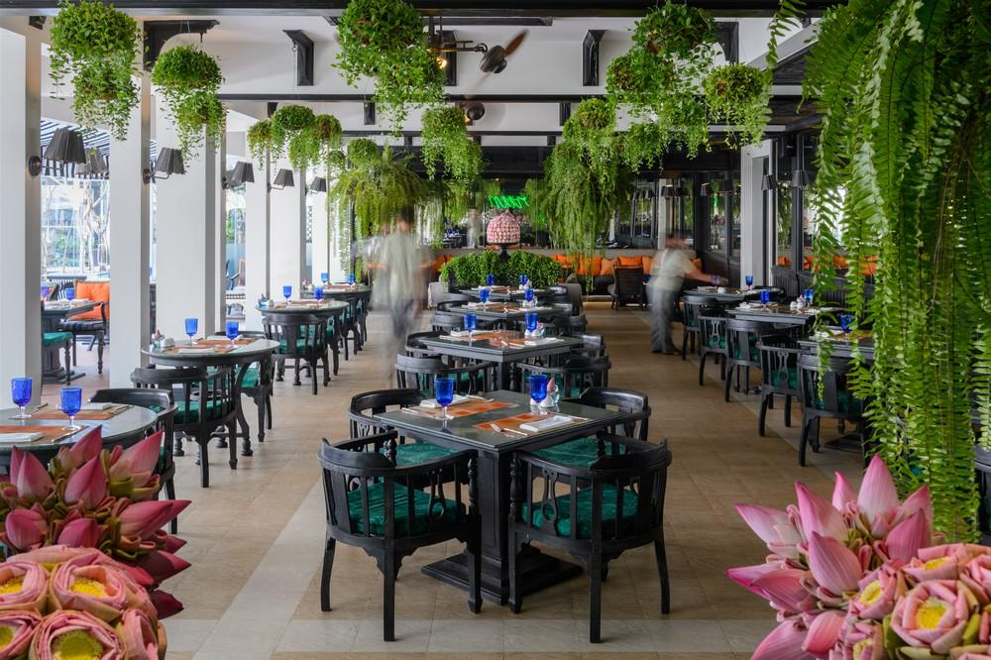
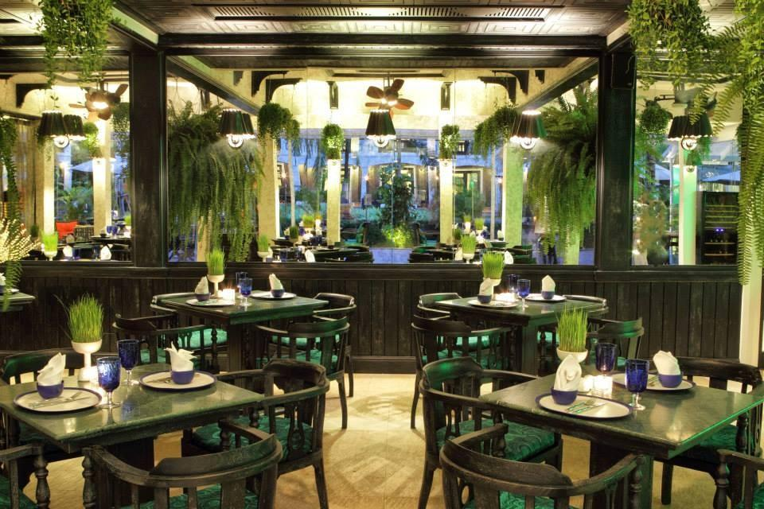
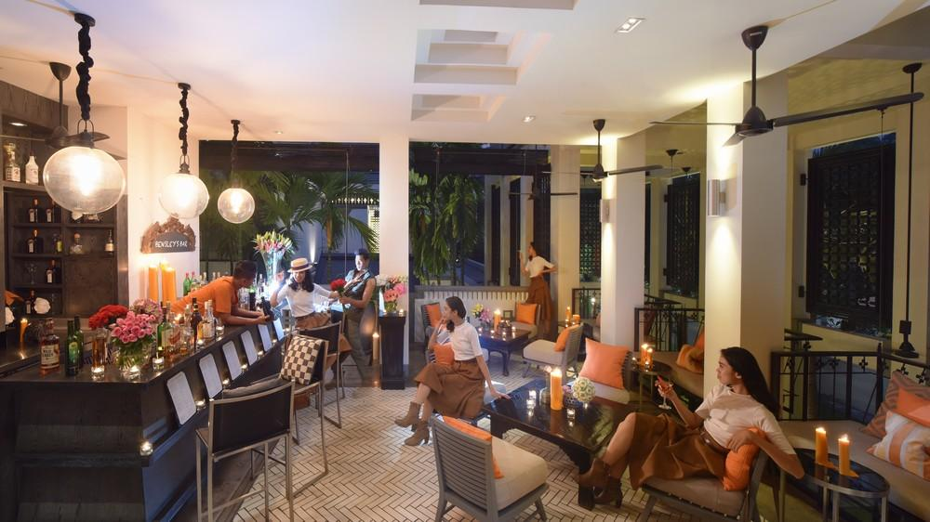
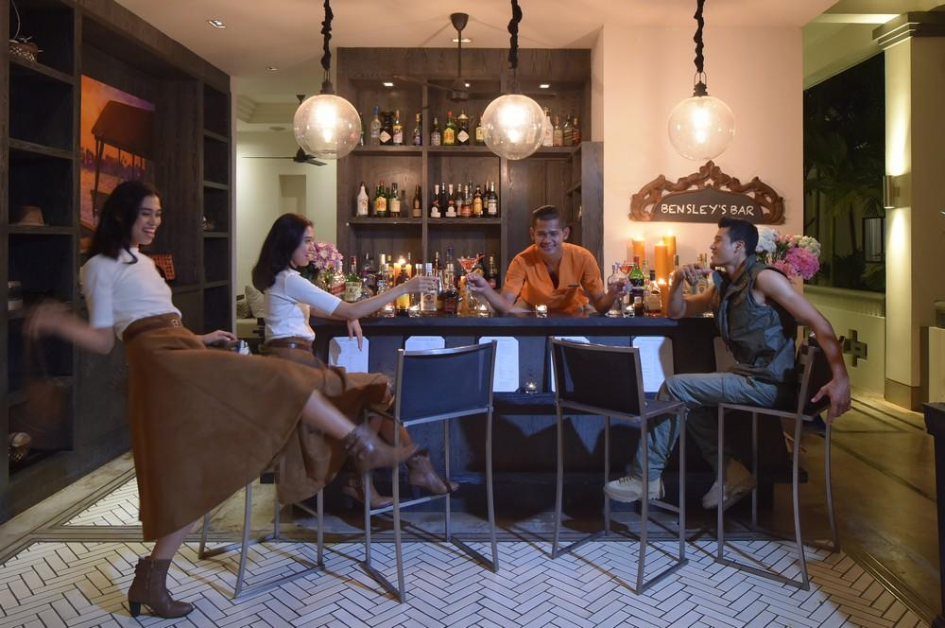
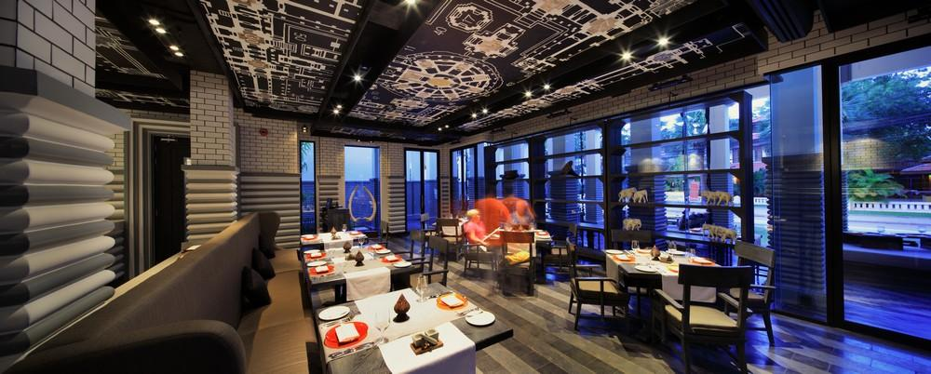
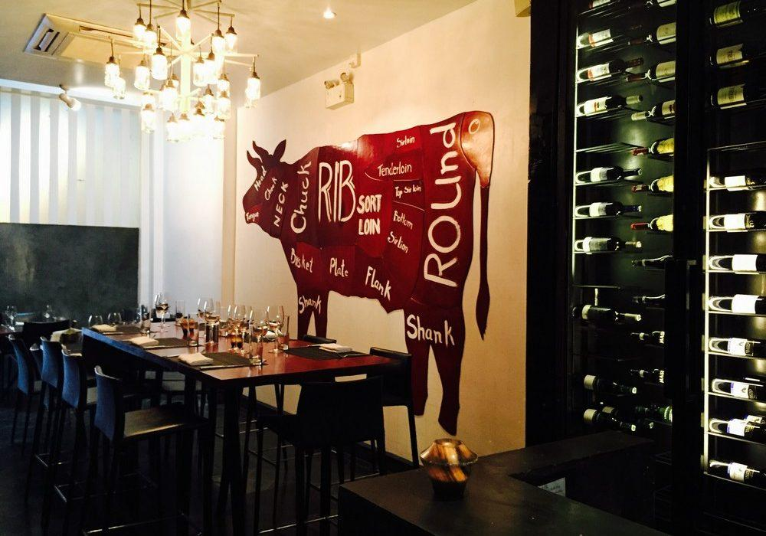
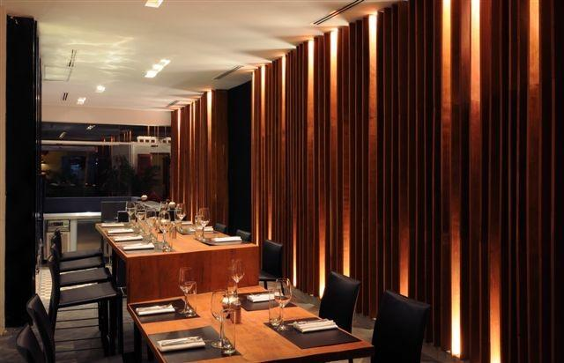

Services & facilities photos
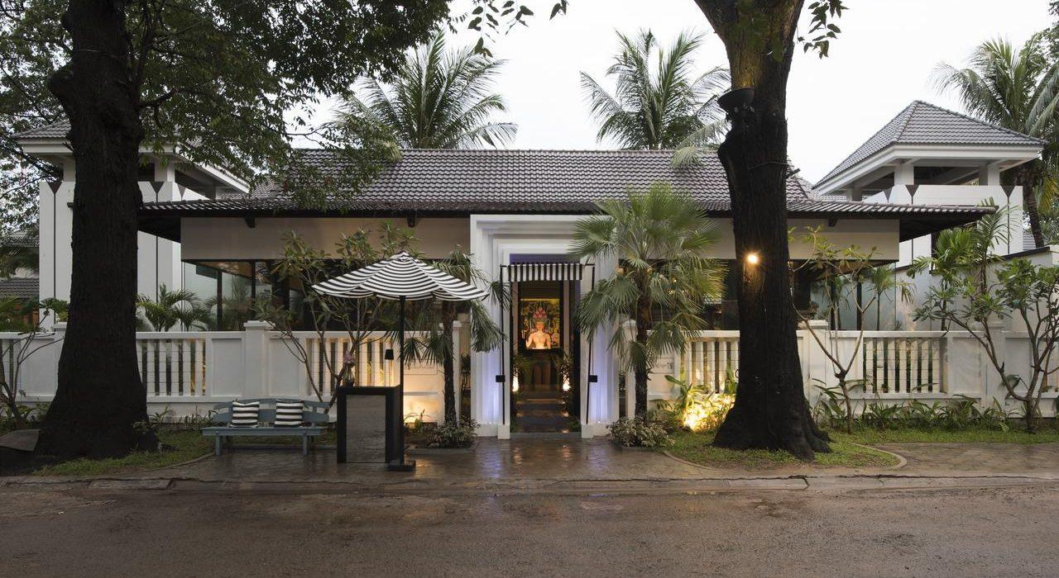
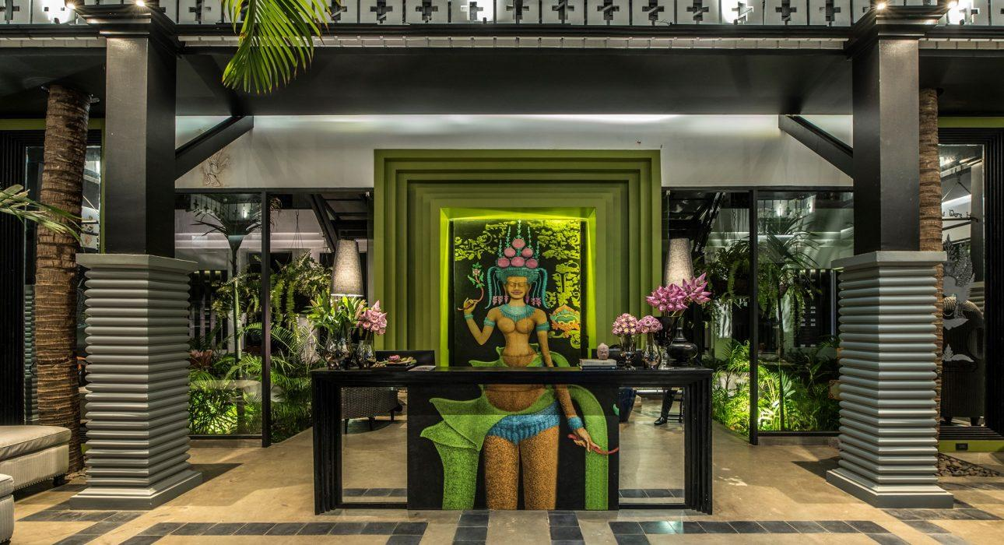
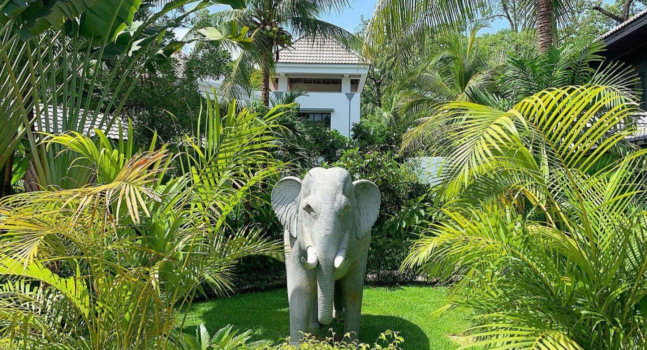
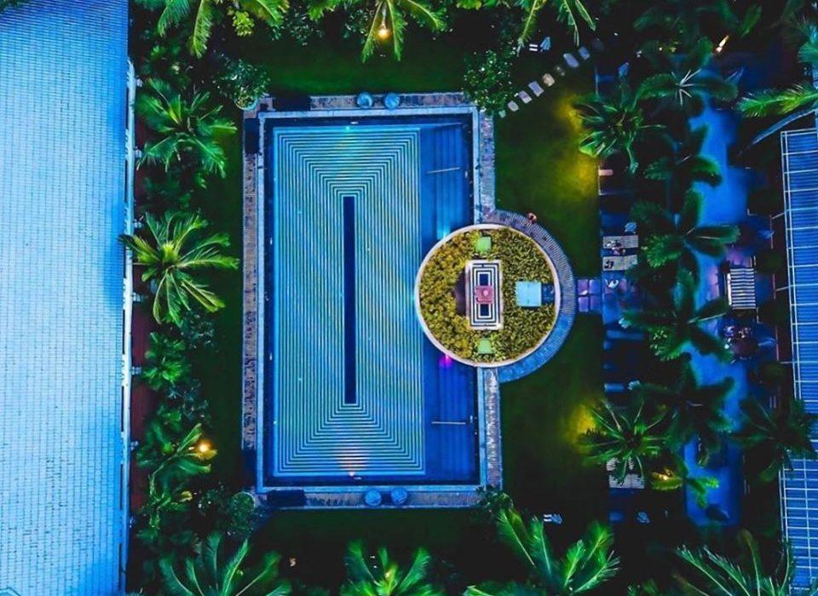
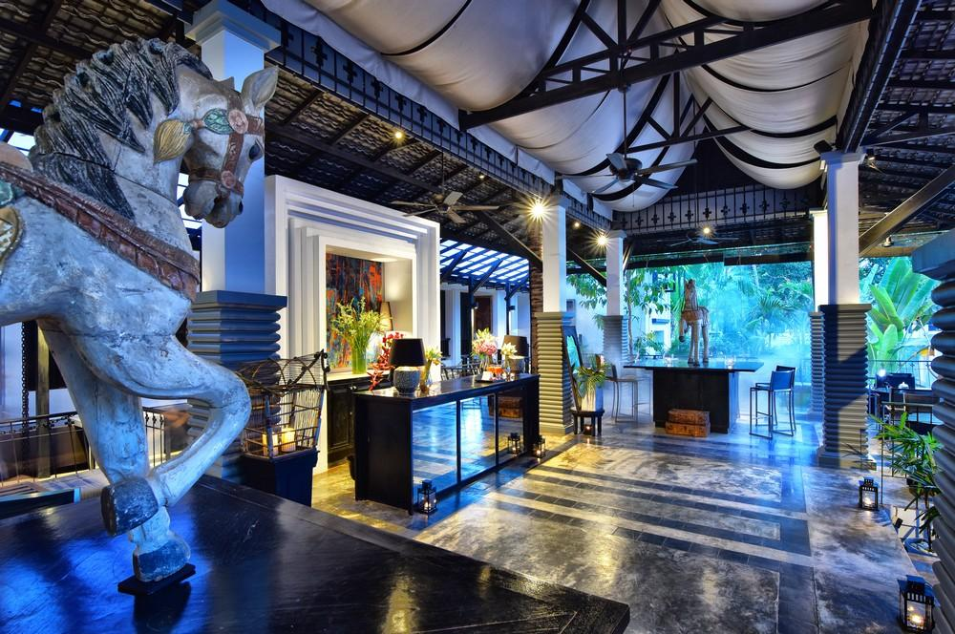
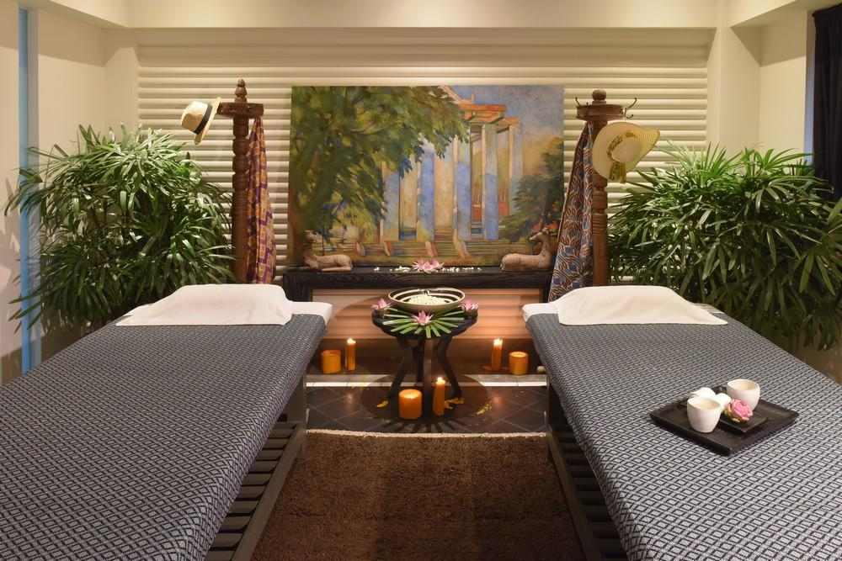
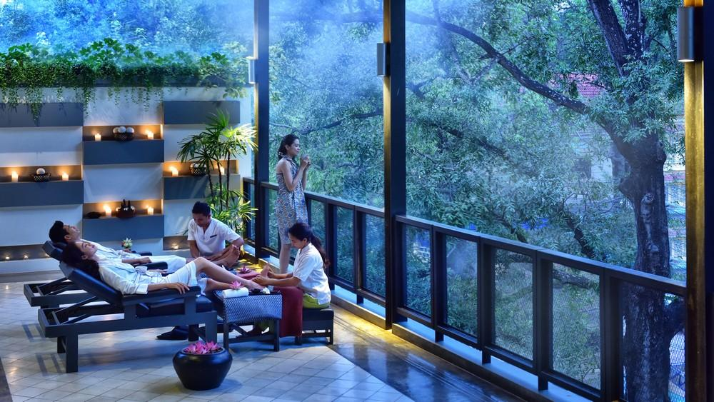

Easia Travel Head Office

Siem Reap BranchCharming City, No. R32 – R34, Road Rolouse, Trorpeangses Village, Sangkat Koukchork, Siem Reap Province – CambodiaTel: (855-63) 76 14 58Fax: (855-63) 76 14 58

