CAMBODIA – Siem Reap – Heritage Suites Hotel
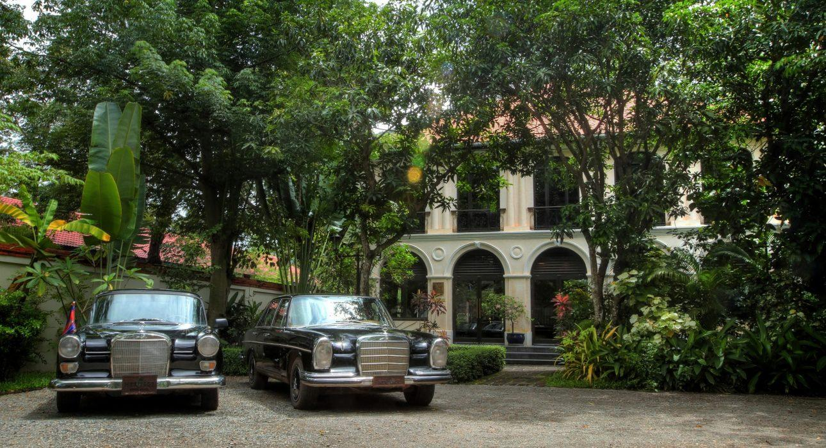

Over View

Theme
Honeymoon

Country - City
Cambodia - Siem Reap

Market segment
Groups, Thematic Leisure

Official category
5*

Easia category
Deluxe

Total number of rooms
26

Price level
$$$$

Description

Heritage Suites Hotel is a sophisticated boutique retreat which features intimate rooms and newly refurbished suites nestled amidst lush tropical gardens. It is located in a quiet area which enables its guests to relax while being close enough to town if they wish to enjoy it.Guests are welcomed in an ancient colonial house with golden whitewashed walls and immediately taken in by its authenticity and charm. This Boutique Hotel redefines luxury with stunning architecture, personalized and attentive service, a host of culinary delights and comfortable, stylish rooms.The hotel features a nice pool with a bar where private events can be held, an in-house spa and a high-qulity restaurant which provides a refined blend of Khmer, Asian and Western dishes, and a Spa provided by Bodia Spa. They regularly have events such as a Jazz night every thursday.

Selling points

- They create a sense of unique experience for guests, starting from the airport where the guest is picked-up in a vintage car to the personalized service they provide in a beautiful setting.
- The hotel is small and can be privatized for high-end groups.
- The design is very unique compared to other boutique hotels and the restaurant is one of the best in town.

Time & Transportation

From | To | Km | By | Duration | Road condition
Heritage Suites Hotel | Angkor Wat Temple | 6 | Car;Tuk Tuk | 15 mn | Good
Heritage Suites Hotel | Old Market (Town) | 2 | Car;Tuk tuk | 5 mn | Good
Siem Reap International Airport | Heritage Suites Hotel | 7 | Car;Tuk tuk | 15 mn | Good

Rooms

Easia's recommend room type
DeluxeNumber: 6Size: 35m²Design: ClassicThe Deluxe rooms are located on the first floor of the building situated on the walkway to the pool. Designed for maximum comfort, spacious and with natural light, all the deluxe rooms offer centralized air-conditioning, phone, internet wifi, safety deposit box, complimentary water, mini bar… Bathroom and toilet are separated. TV is available upon request.NoteI would not recommend this room category for our clients because it’s small and there is nothing charming about it.For the same price as this room we can get a nice charming superior room at Victoria Angkor Resort & Spa.Bungalow SuitesNumber: 17Size: 75m²Design: Traditional Khmer styleLocated in a lush garden at the back of the pool, the Bungalow Suites are uniquely decorated and furnished in a blend of Asian and art decor themes. Featuring a king-size bed, this category of room offers the possibility to set up an extra bed for kids or a third adult. The suite offers a private garden and is equipped with an open air shower. All suites offer centralized air-conditioning, internet wifi, phone, safety deposit box, complimentary water, tea and coffee making, mini bar. The bathroom is equipped with an oversized roll-top bathtub, separate shower, separate toilet and a private steam bath (the only hotel in Siem Reap to offer this). TV is available upon request.NoteRecommend for couples holidays. We have used this room type the most.Executive SuitesNumber: 2Size: 105m²Design: Traditional Khmer styleLocated in the lush garden at the back of the pool, the Executive Suites have the same design and amenities as the Bungalow Suites, the only difference is the size and the outside Jacuzzi in the private garden. Featuring a king-size bed, it is possible to set up an extra bed for kids or for a third adult. All suites offer centralized air-conditioning, internet wifi, phone, safety deposit box, complimentary water, tea and coffee making, mini bar. The bathroom is equipped with an oversized roll-top bathtub, separate shower, separate toilet and a private steam bath (the only hotel in Siem Reap to offer this).TV is available upon request.NoteThis room is very comfortable for a family, or couple who need a big room.Royal SuiteNumber: 1Size: 160m²Design: Traditional Khmer styleThe Royal Suite is called Red Poppy and is decorated in a unique contemporary Cambodian style. The suite offers an expansive living space set up with 2 king-size beds and is the perfect suite for a family. All amenities are the same as in the Executive Suites. The suite offers a private garden with an outdoor Jacuzzi and is equipped with a centralized air-conditioning, internet wifi, phone, safety deposit box, complimentary water, tea and coffee making, mini bar. The bathroom is equipped with an oversized roll-top bathtub, separate shower, separate toilet and a private steam bath (the only hotel in Siem Reap to offer this).TV is available upon request.NoteVery comfortable for a family or couple who need a big room.

Services & Facilities

Services
Catering (beach, river, cave, other), Currency exchange, Laundry service, Luxury car rental, Picnic boxes, Spa, Room service

Facilities
Air Conditioning, Gift Shop, Internet, Outdoor swimming pool, Terrace

Restaurant information

The Lantern RestaurantCapacities: 40 paxType of food: International, Asian, KhmerOpening hours: 6:00 – 10:30 AM (Breakfast) 11:00 AM – 3:00 PM (Lunch) 6:00 : 11:00 PM (Diner)Traditional Khmer cuisine, Asian dishes and Western delicacies can be enjoyed inside the colonial house or outdoors by the pool.NoteOur guests can also enjoy breakfast, lunch or dinner at the poolside if they request.Friendly staff.

Photos

Hotel Photos
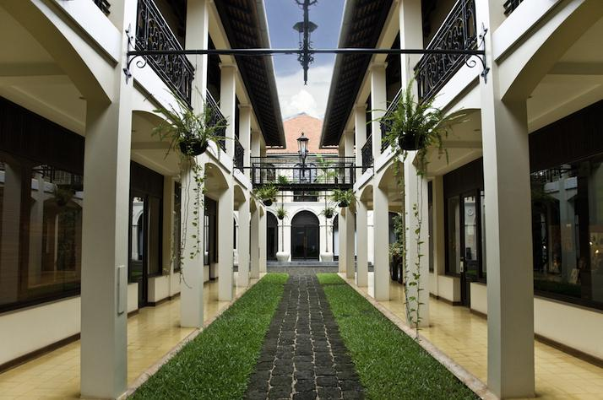
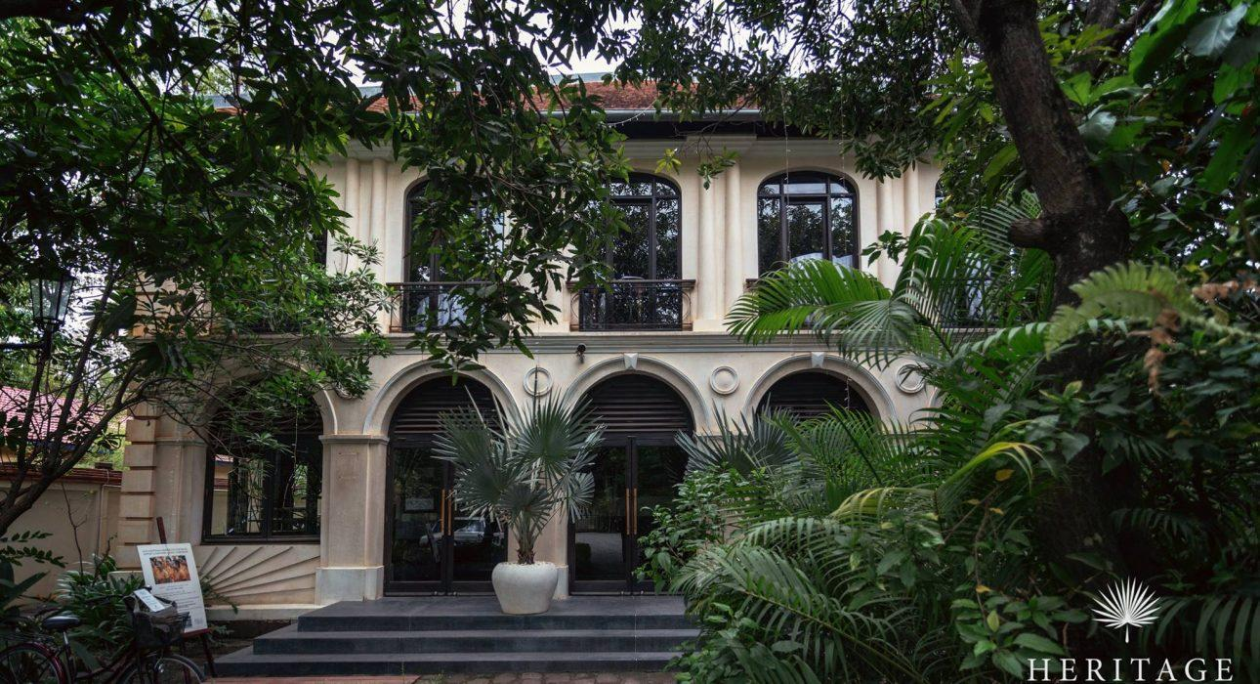
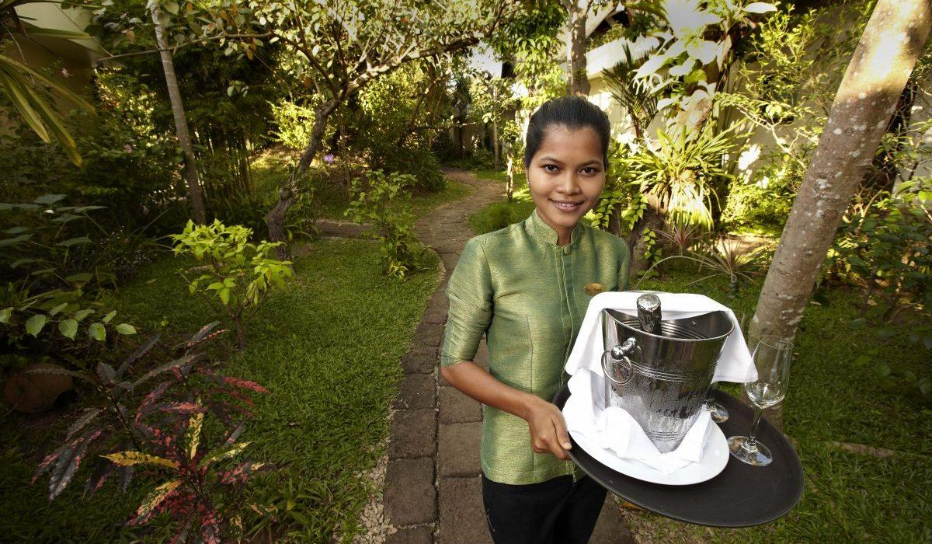

Rooms photos
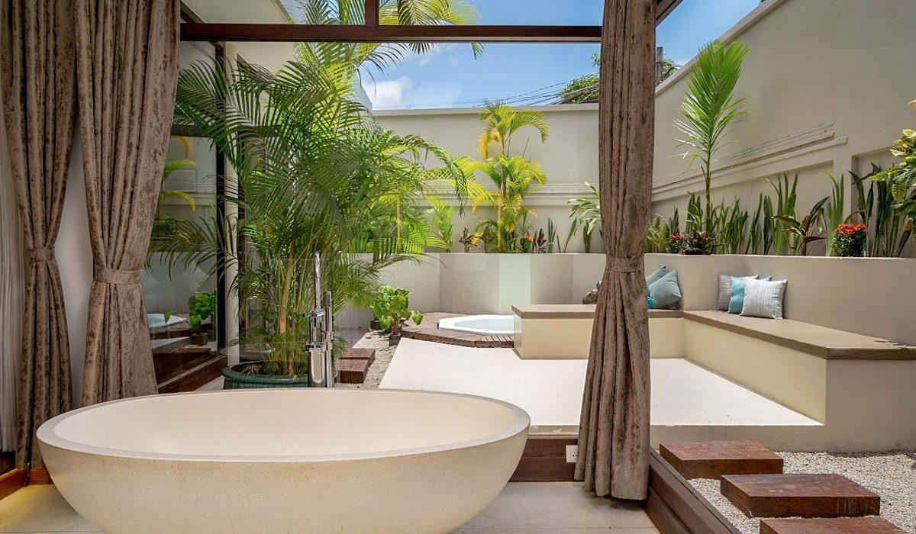
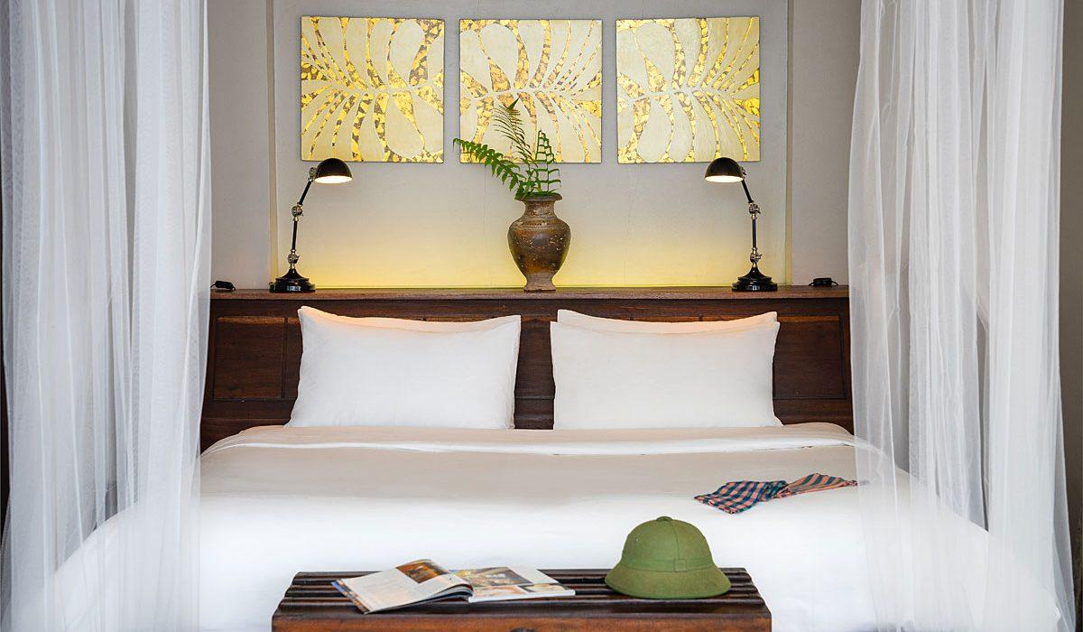
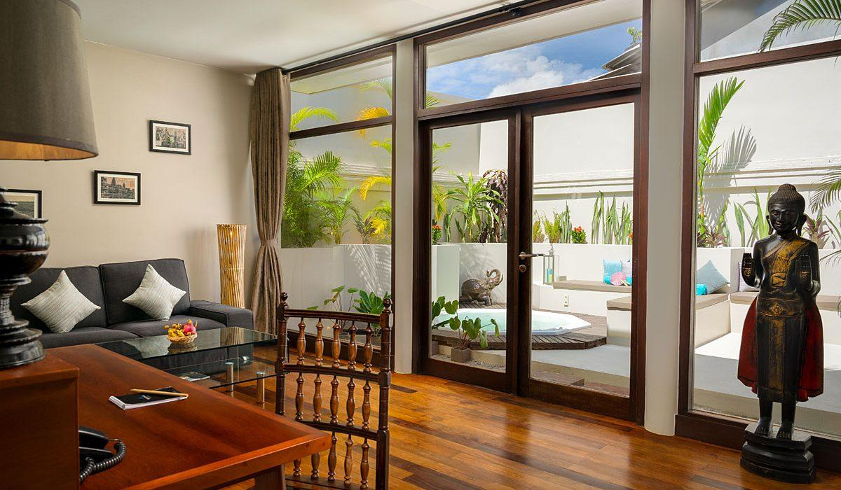
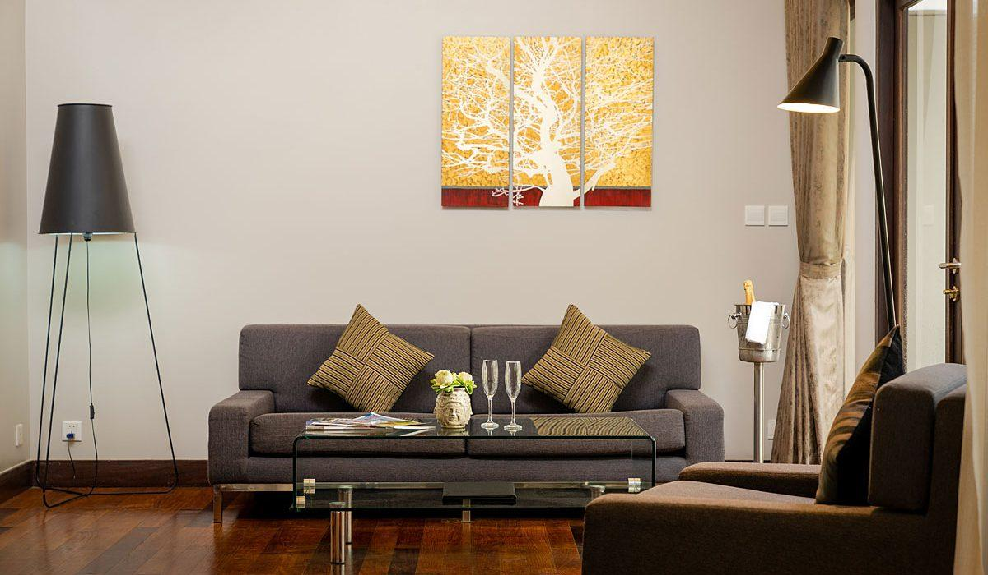
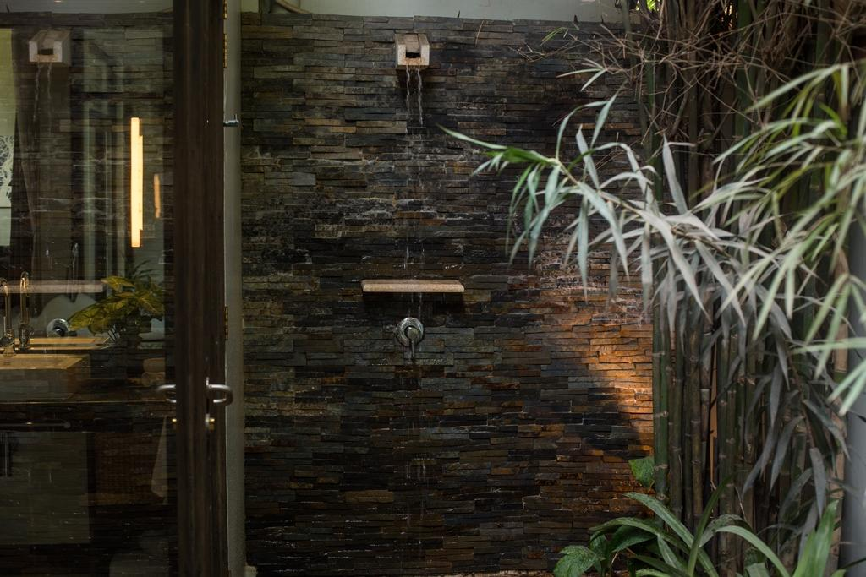
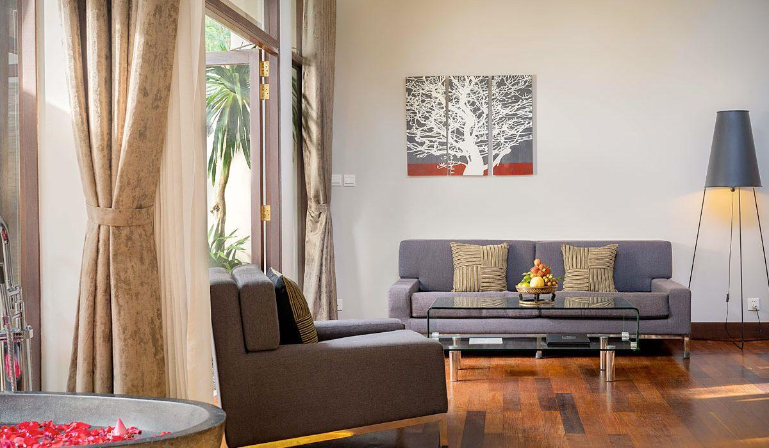
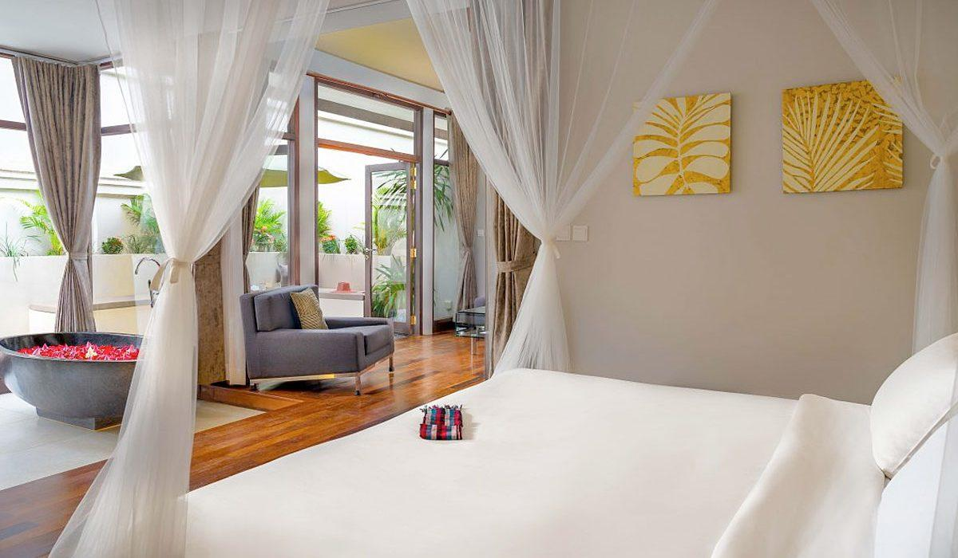
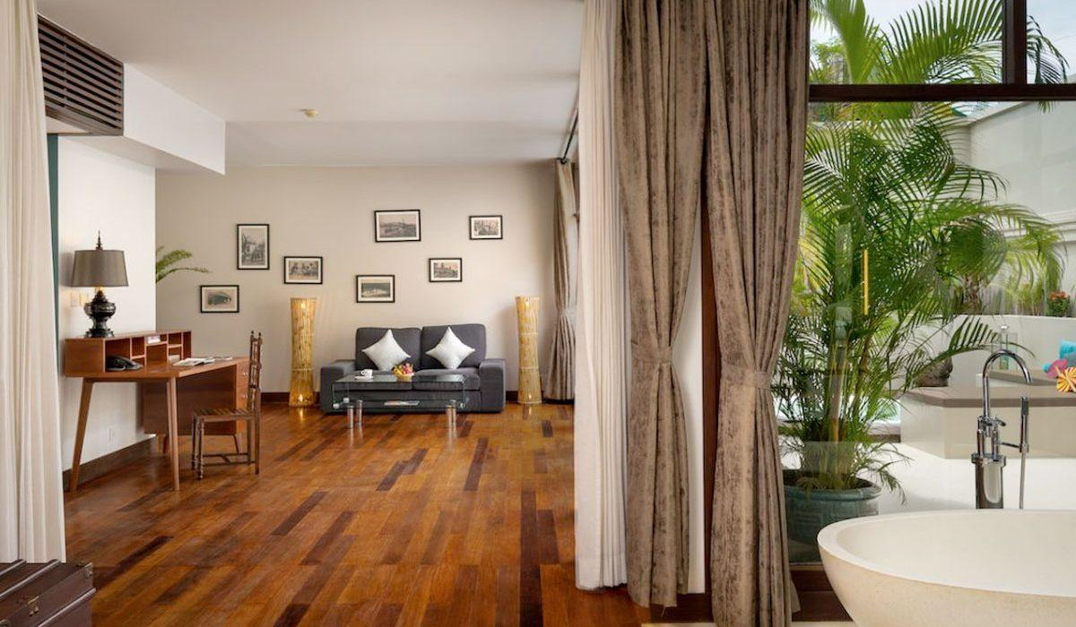
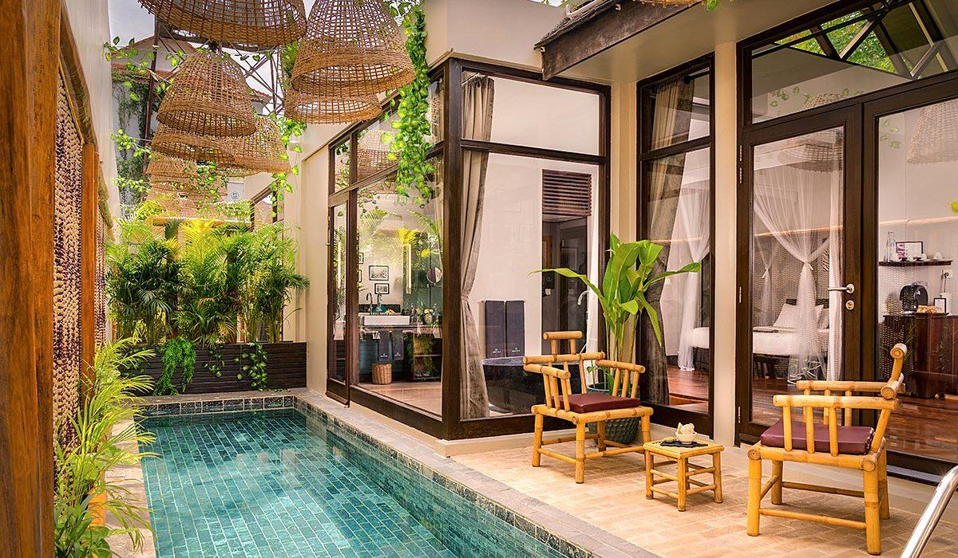
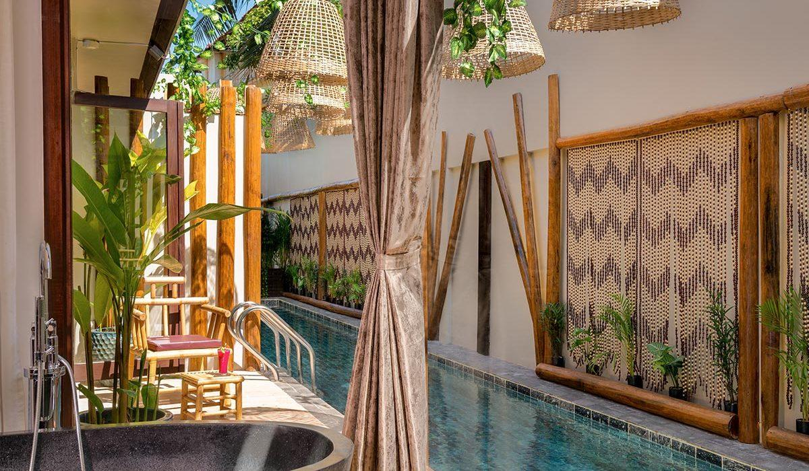
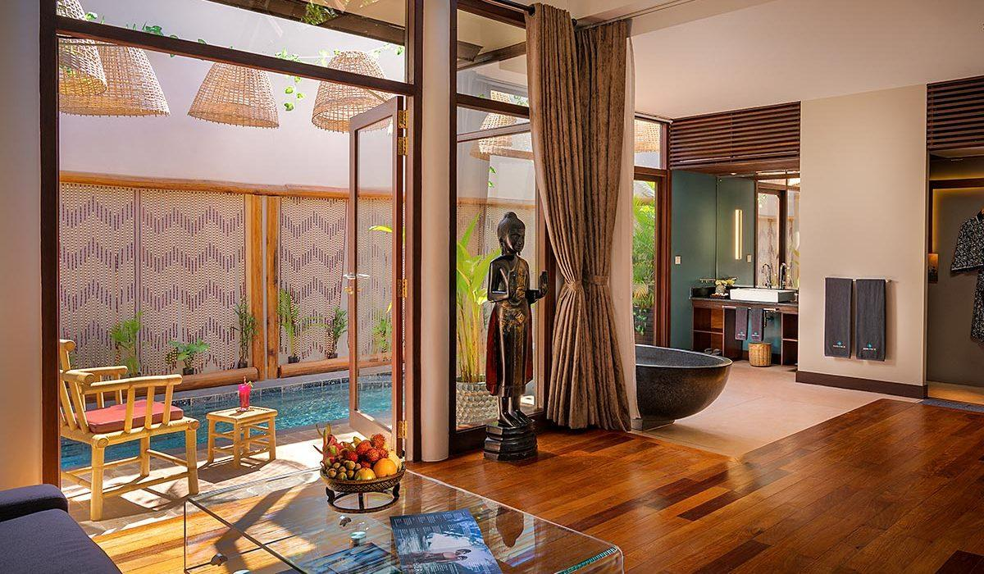
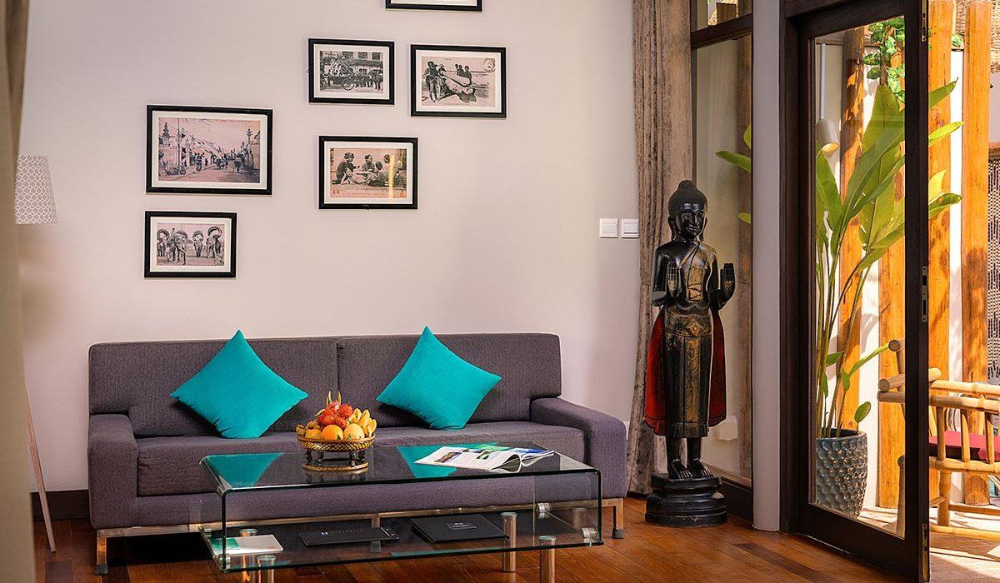
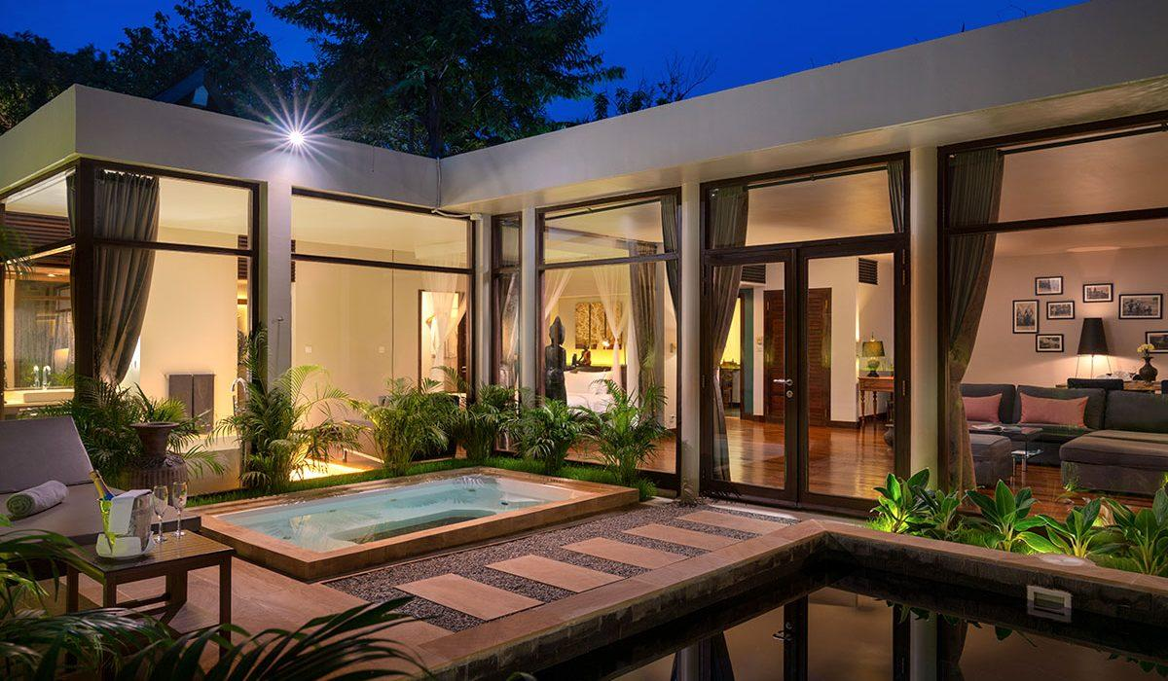
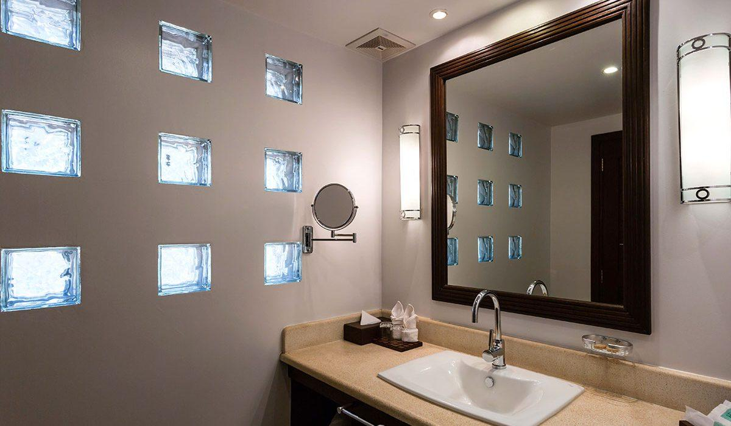

Restaurant photos
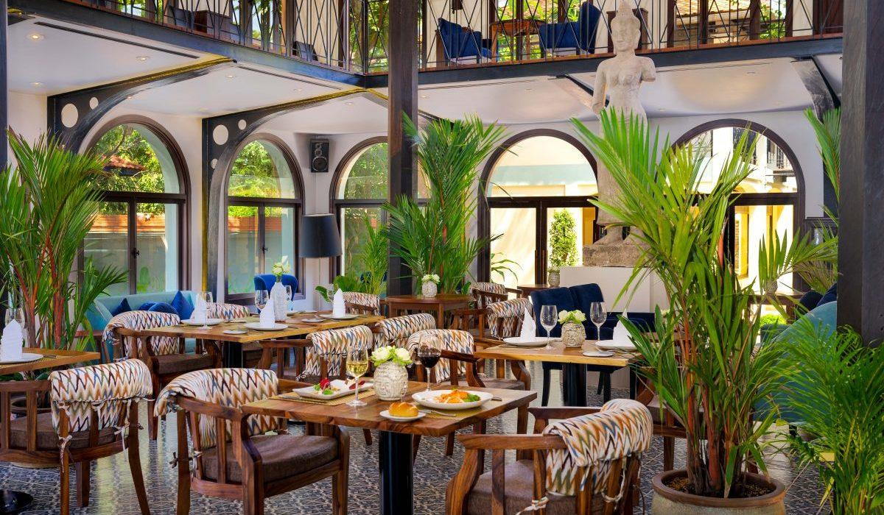
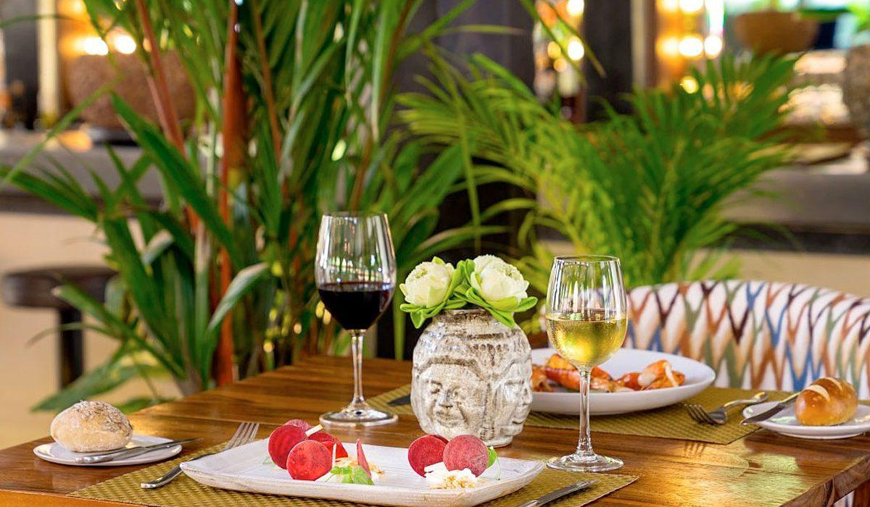
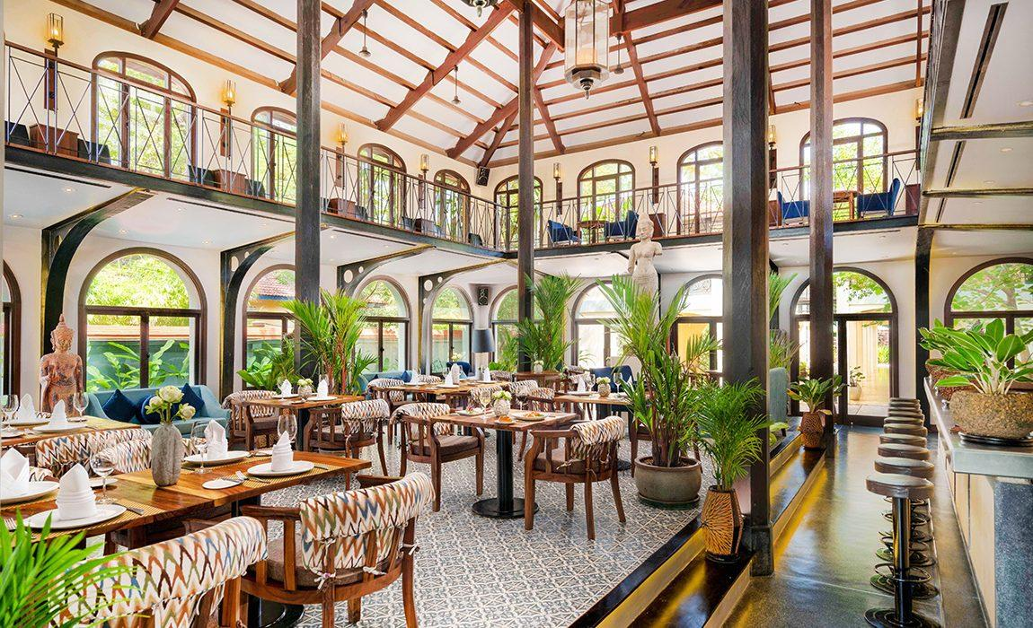
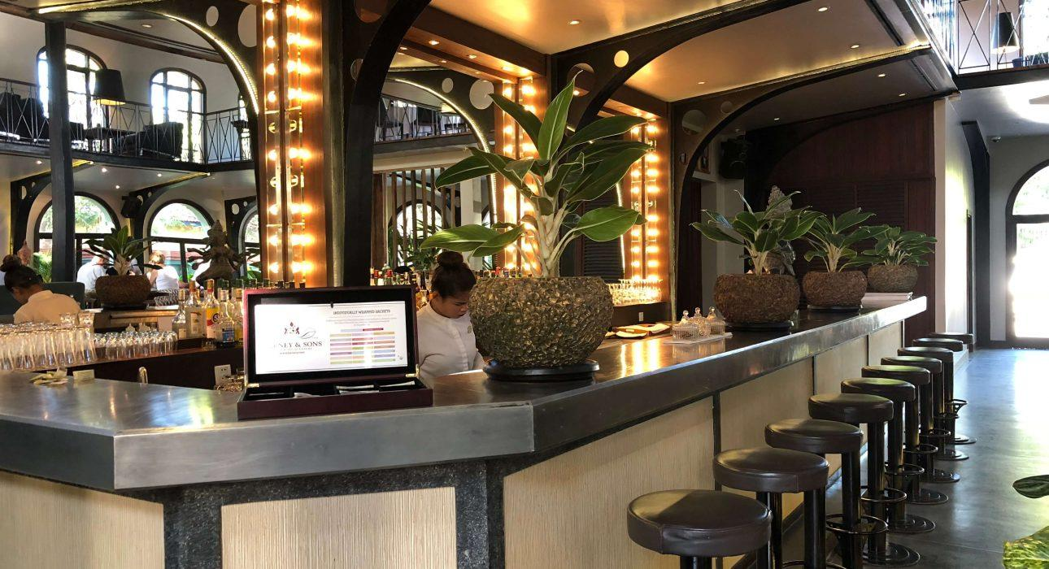
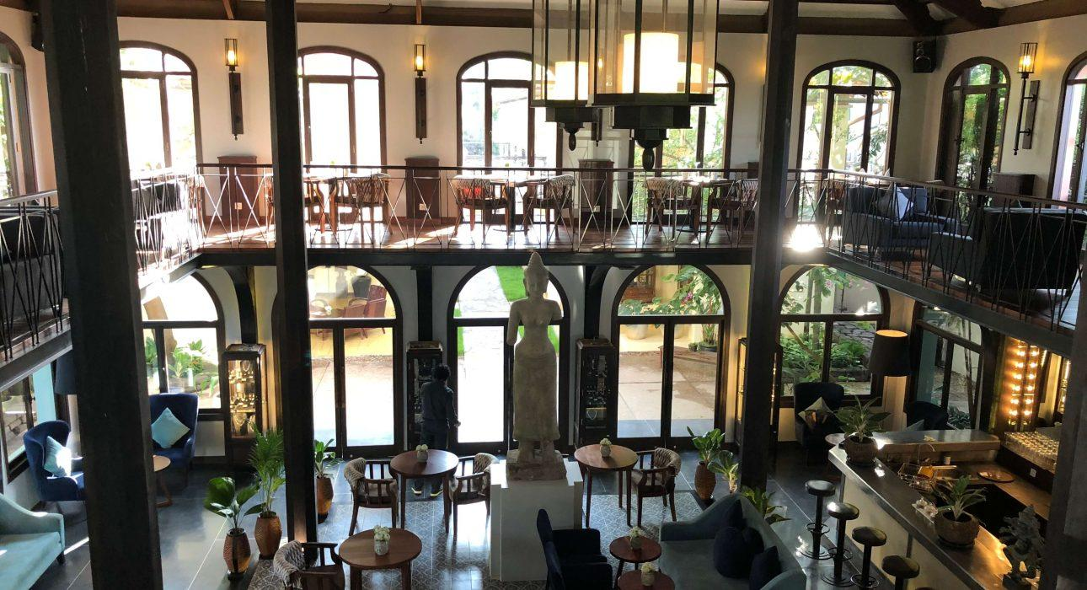
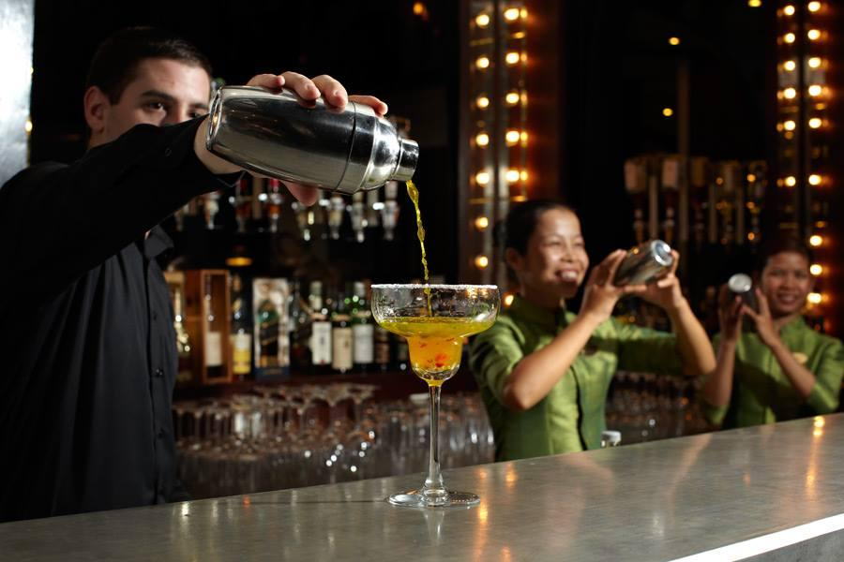
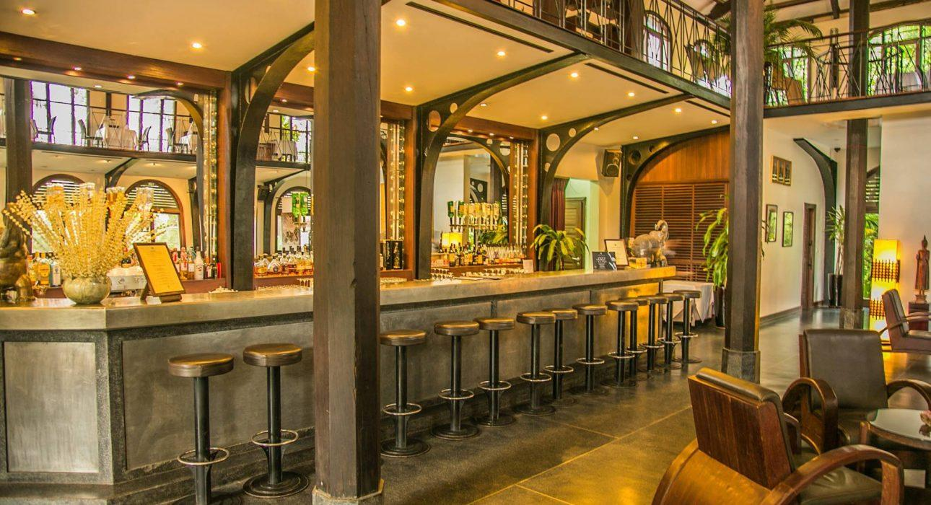

Services & facilities photos
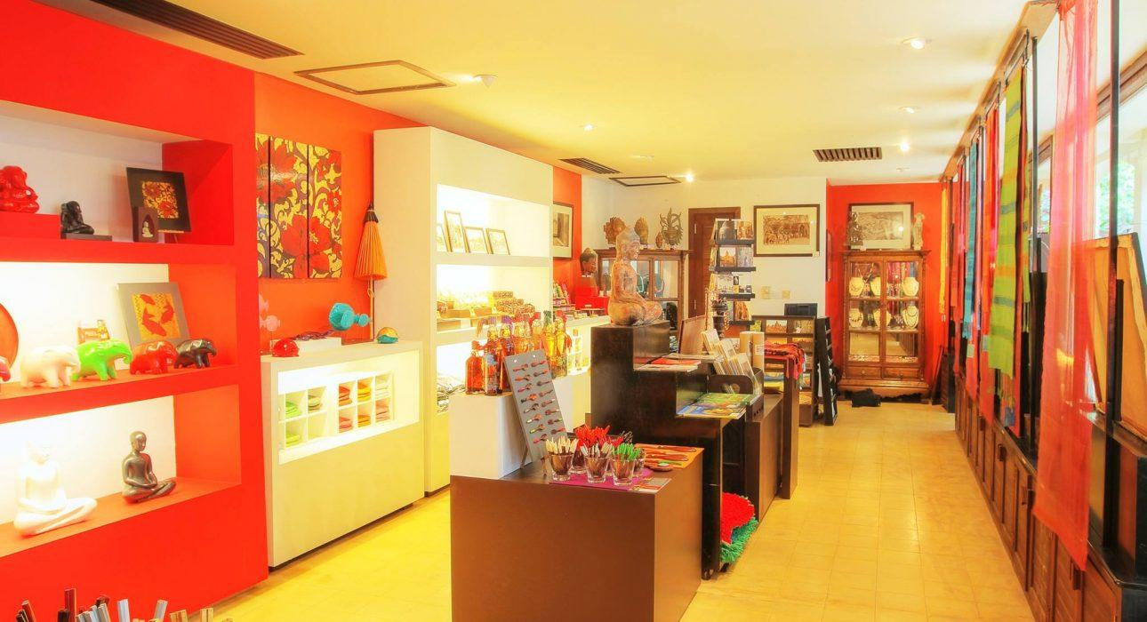
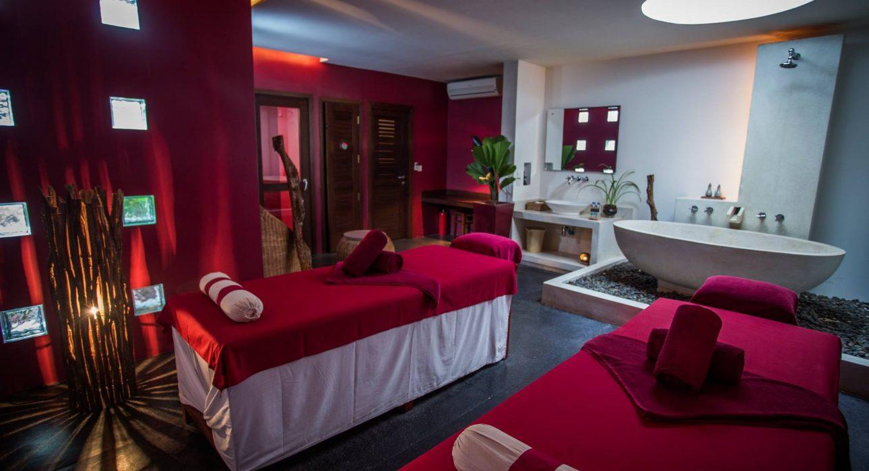
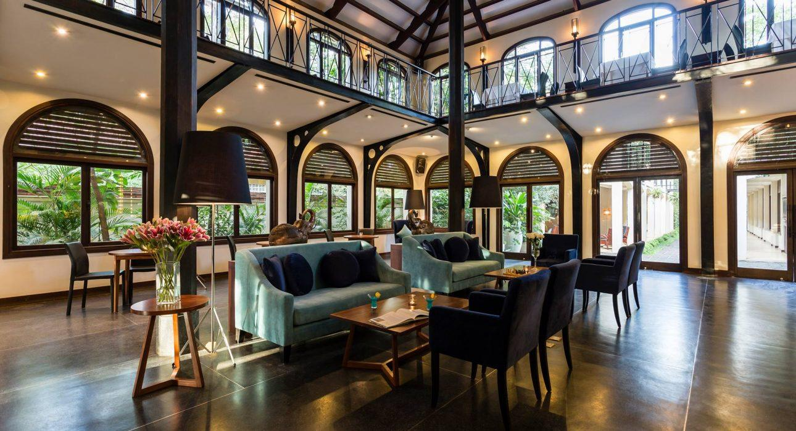
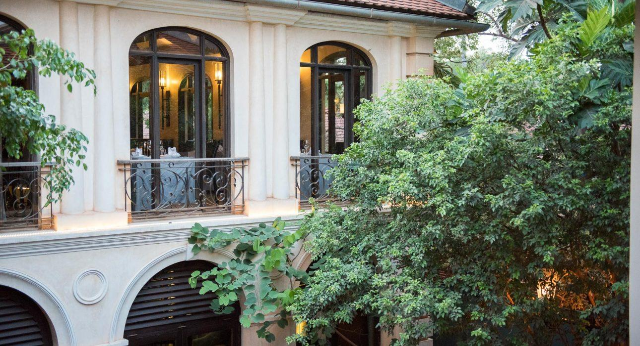
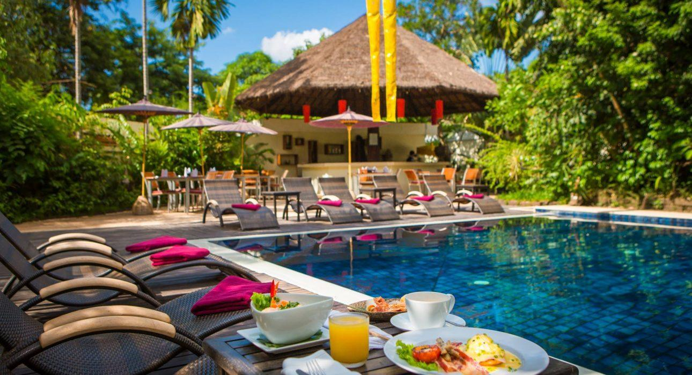

Easia Travel Head Office

Siem Reap BranchCharming City, No. R32 – R34, Road Rolouse, Trorpeangses Village, Sangkat Koukchork, Siem Reap Province – CambodiaTel: (855-63) 76 14 58Fax: (855-63) 76 14 58

