CAMBODIA – Siem Reap – Shinta Mani Angkor (Former Shinta Mani Club)
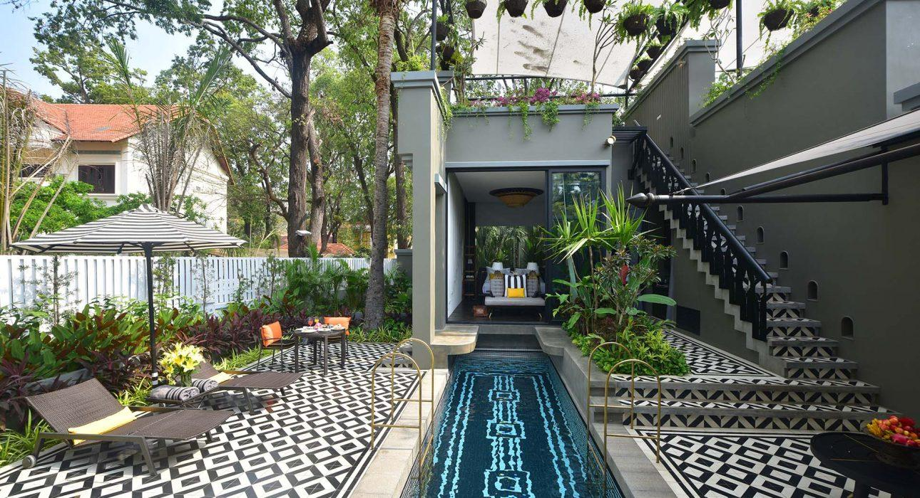

Over View

Theme
Honeymoon

Country - City
Cambodia - Siem Reap

Market segment
Thematic Leisure

Official category
5*

Easia category
First Class

Total number of rooms
39

Price level
$$$$

Description

Shinta Mani Angkor is the perfect place to relax and unwind after a busy day. It is located in a quiet area, but just a few minutes from the city center.
The rooms are beautifully designed with modern furniture. The decor is great for people who love art, as the hotel has an original and unique decorative style. The swimming pool is surrounded by nice looking buildings, and that makes it a very intimate place.
The hotel has a very well-trained staff which provides the guests with excellent service. The Spa is awarded as one of the best in Southeast Asia, and the Shinta Mani is proud to support the less fortunate in the local community – especially through the education and development of young adults. Your stay will help to achieve their goal of creating a lasting and positive impact and to ensuring a bright future for Cambodian people. A percentage of your daily room rate will contribute to support the Shinta Mani Foundation activities.

Selling points

- A perfect city-center hotel for couples and guests looking for a private experience.
- A contemporary, boutique hotel with style and charm.
- The property sits in a fantastic location, just 10-15 minutes from the airport and the magnificent Angkor Wat.
- The hotel has an impressive community service foundation, so the guest stay really benefits the local community.

Time & Transportation

From | To | Km | By | Duration | Road Condition
Shinta Mani Angkor | Old Market | 1km | Foot | 10 mins | Good
Shinta Mani Angkor | Angkor Wat | 6 km | Car | 15 mins | Good

Rooms

Easia's recommend room type
SuperiorNumber: 15Size: 36m²Design: ModernNote: There is no balcony in these rooms.Superior Poolside RoomNumber: 3Size: 40m²Design: ModernNote: These rooms have private balcony. We recommend this one.Deluxe RoomNumber: 19Size: 45m²Design: ModernDeluxe Living RoomNumber: 2Size: 42m²Design: ModernNote: No balcony.

Services & Facilities

Services
24 hour reception, 24h security service, Airport Shuttle, Airport transfer, Buffet Breakfast, Concierge service, Cooking Lesson, In-Room Dining, Laundry service, Massage, Porter, Spa, Swimming Pool, Tour desk, Wake-up service, Wi-fi Free

Facilities
Air Conditioning, Bar, Cable, satelite, coffee and tea making facilities, Courtyard, Family Room, Fitness centre, Flat screen TV, Garden, Hair Dryer, In-Room safe, Internet, Mini Bar, Outdoor swimming pool, Restaurant

Business facilities details
Room Name | Size | CAPACITY
Classroom | Theater | Ballroom | U shape | Board room | Banquet
Blackboard Room | N/A | 24 persons | 40 persons | 24 persons | 19 persons | 20 persons | 40 persons

Restaurant information

Kroya Restaurant
- Capacities: 72 persons
- Type of food: Fusion, Khmer
- Opening hours: 6:00 – 23:00
- Capacity: 38 indoor and 34 outdoor

Photos

Hotel Photos
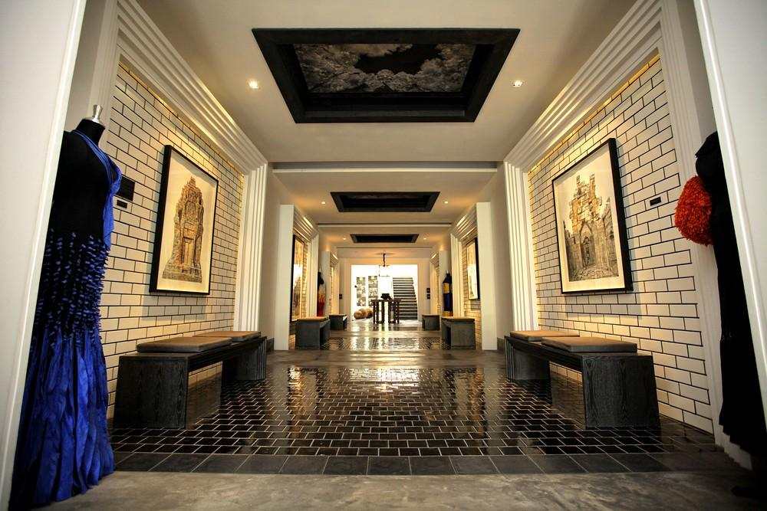
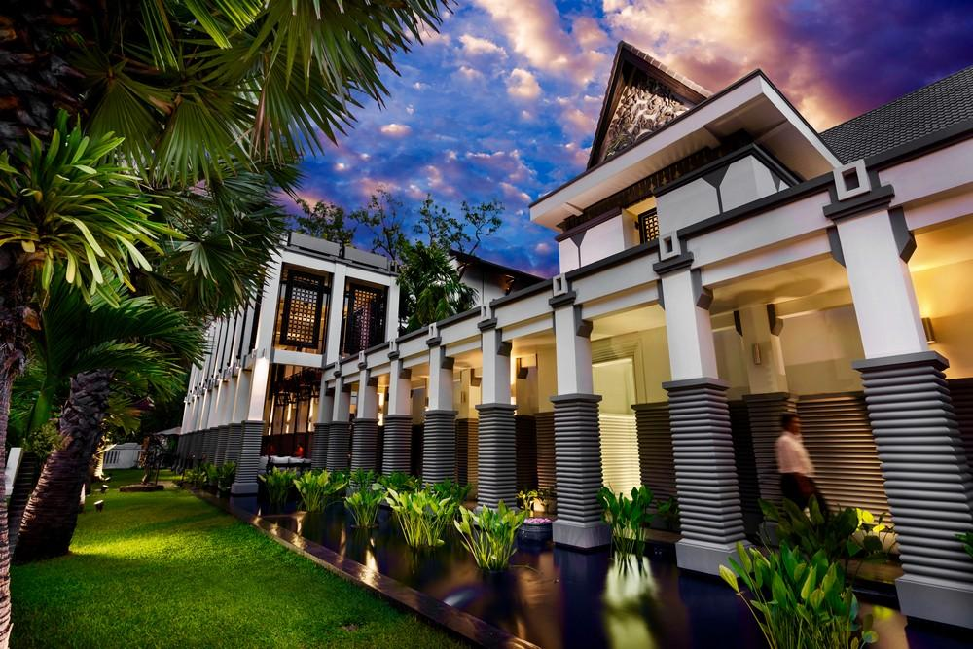
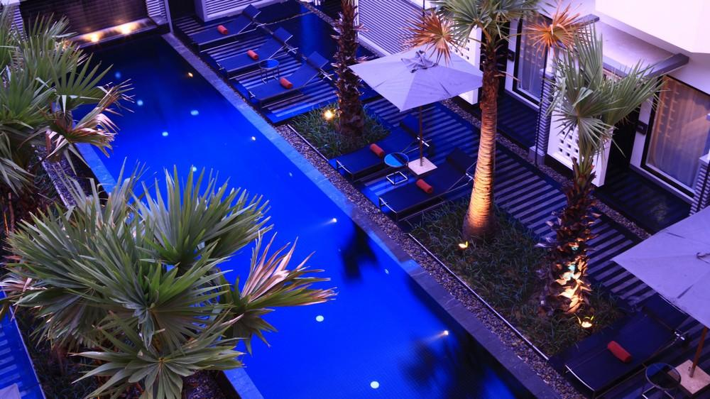
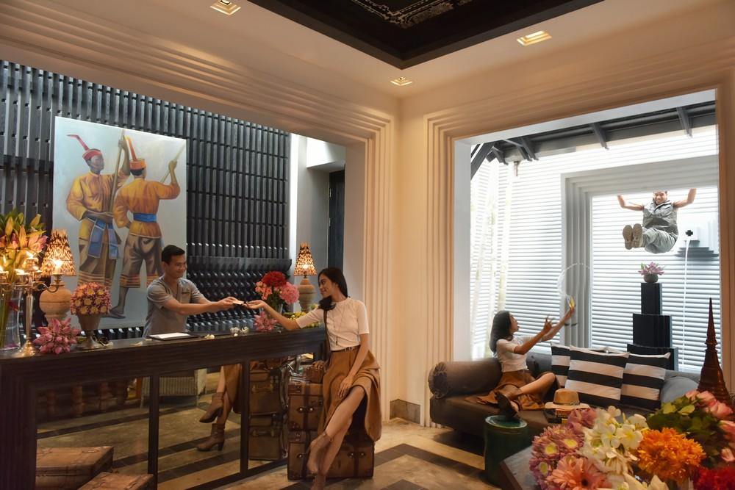

Rooms photos
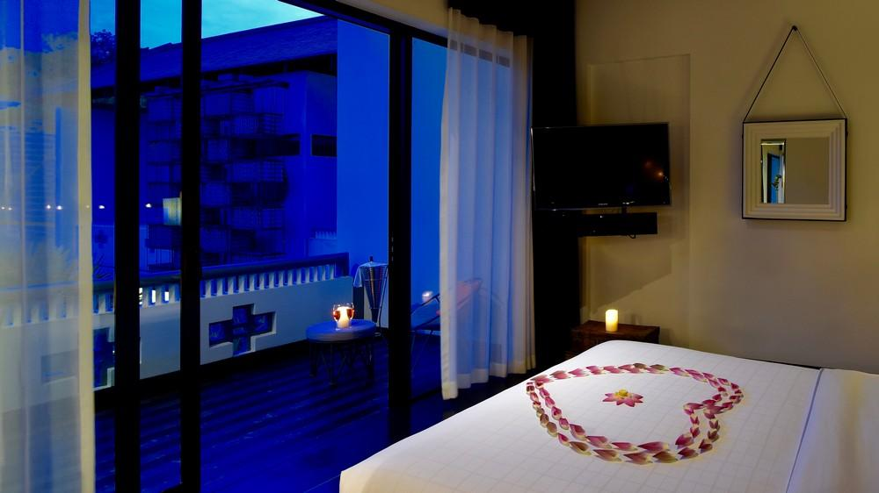
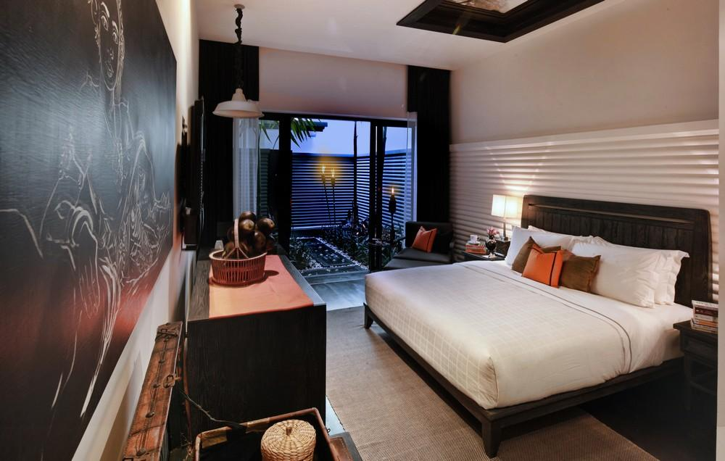
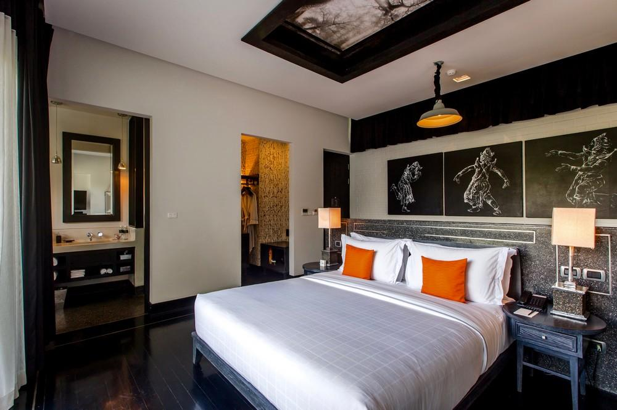
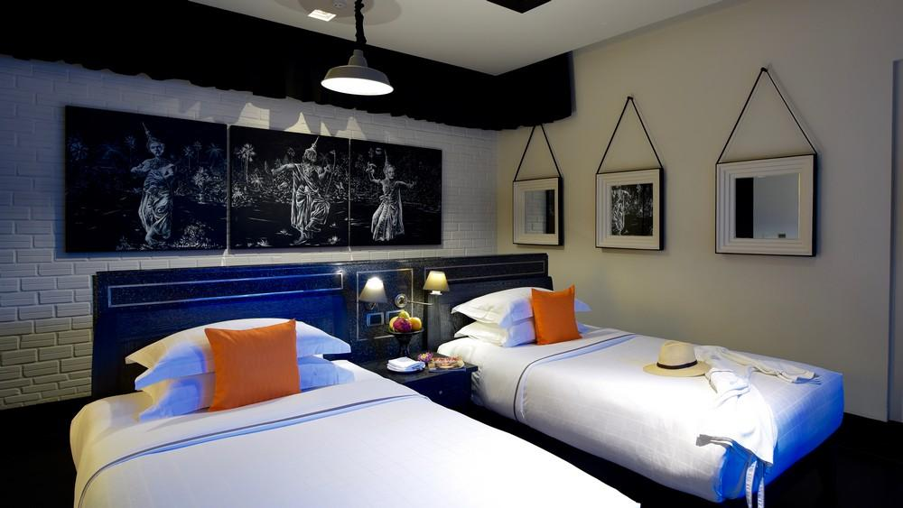
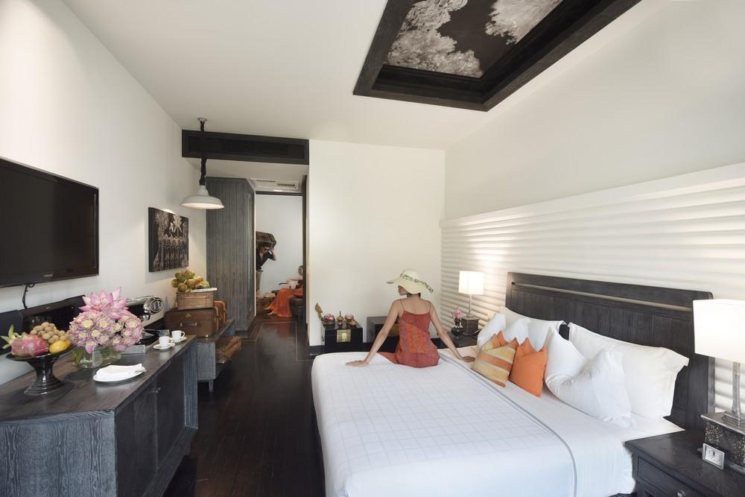
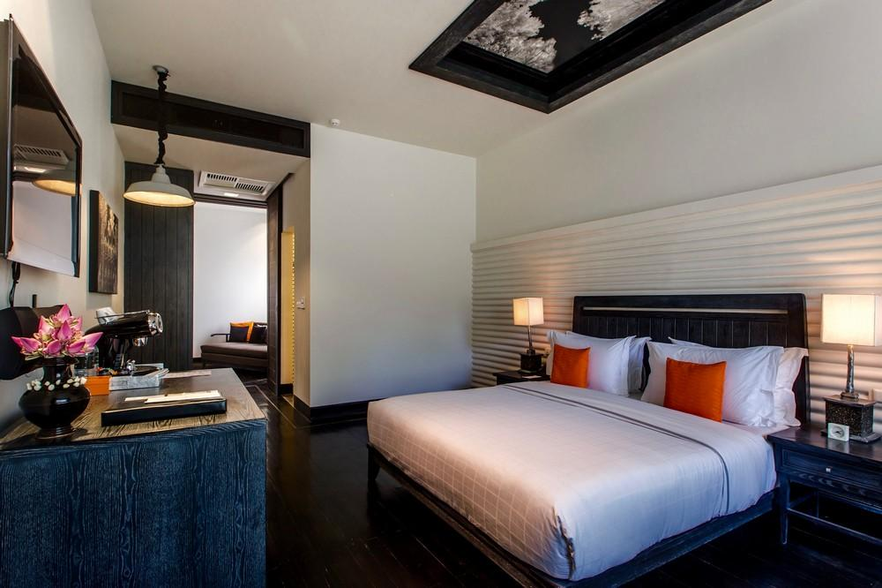
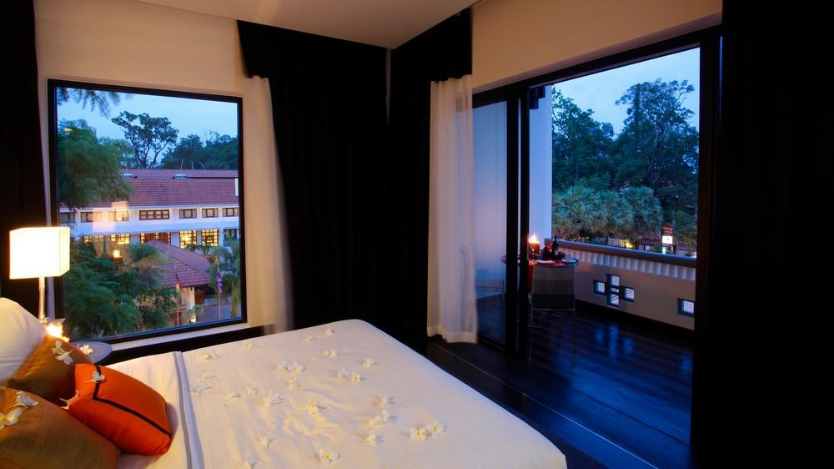

Restaurant photos
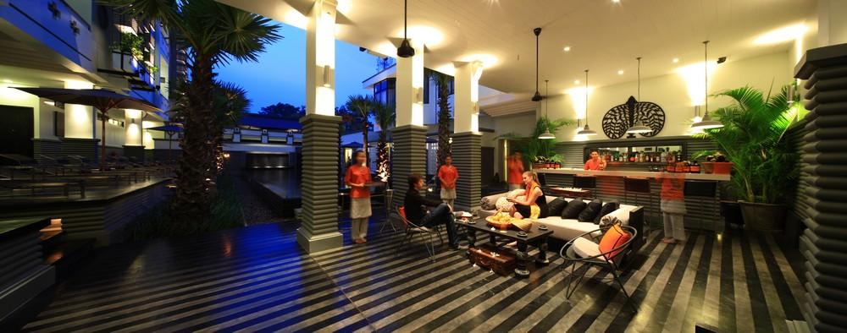
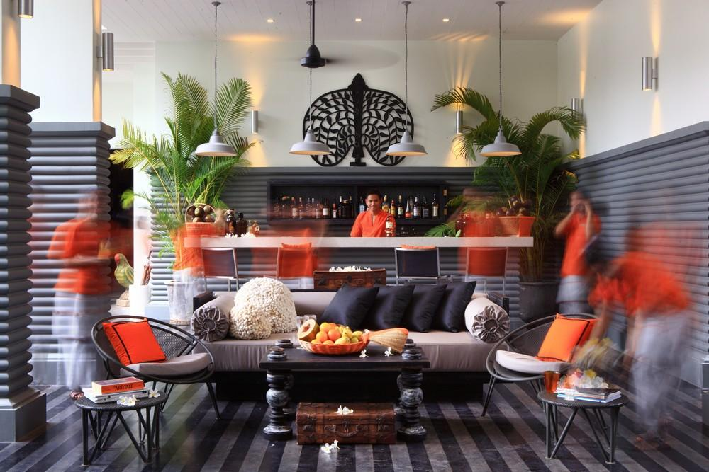
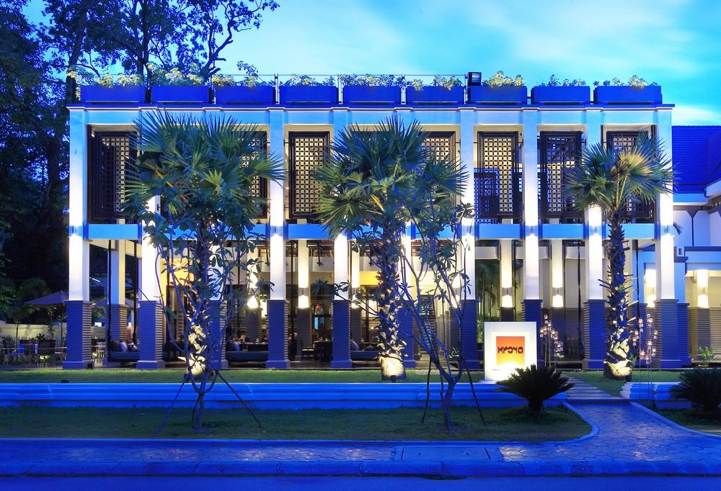
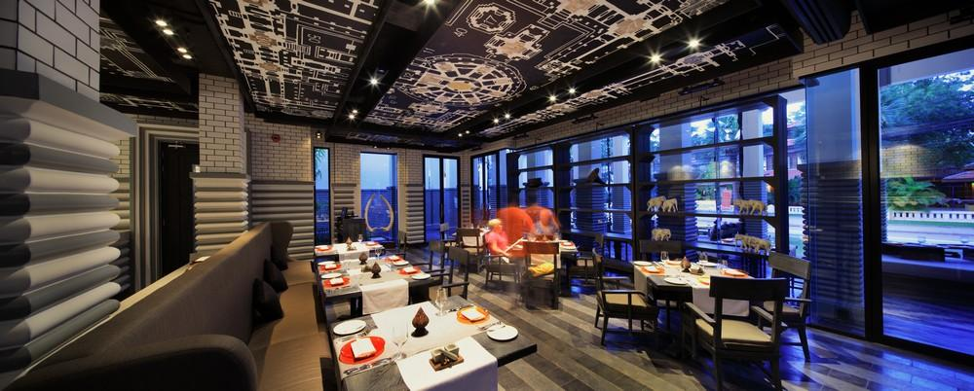
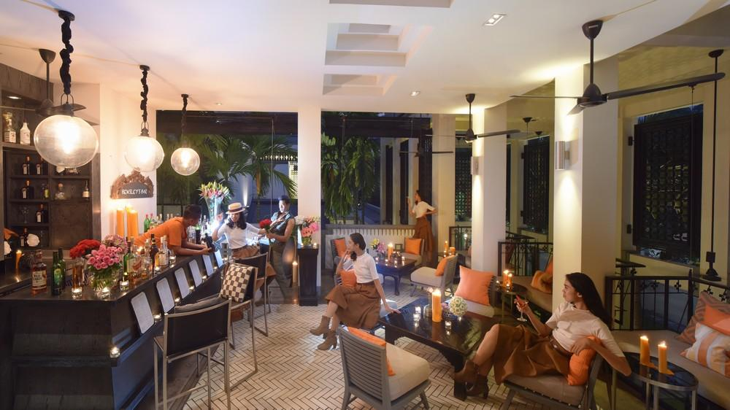
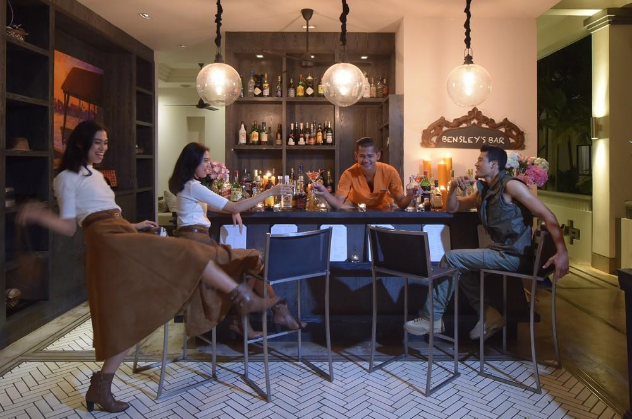
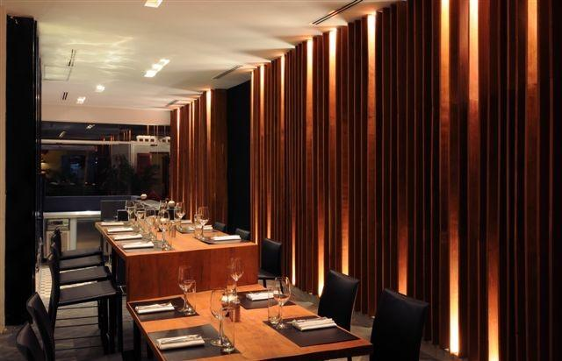
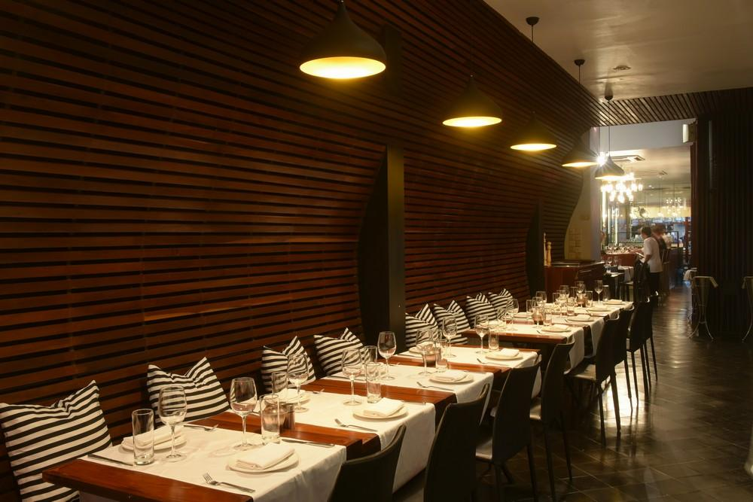

Services & facilities photos
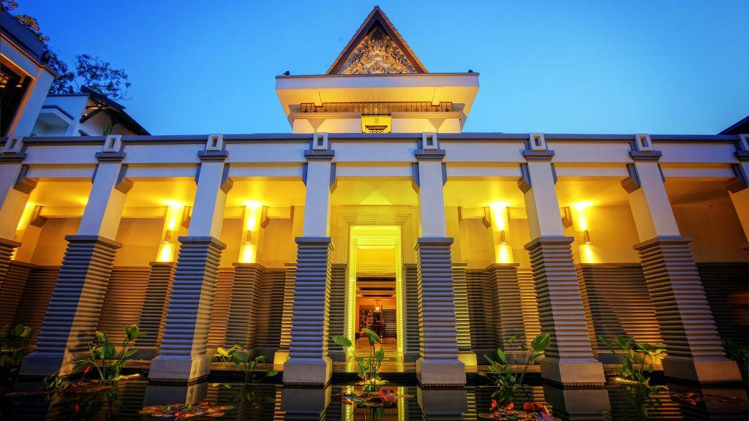
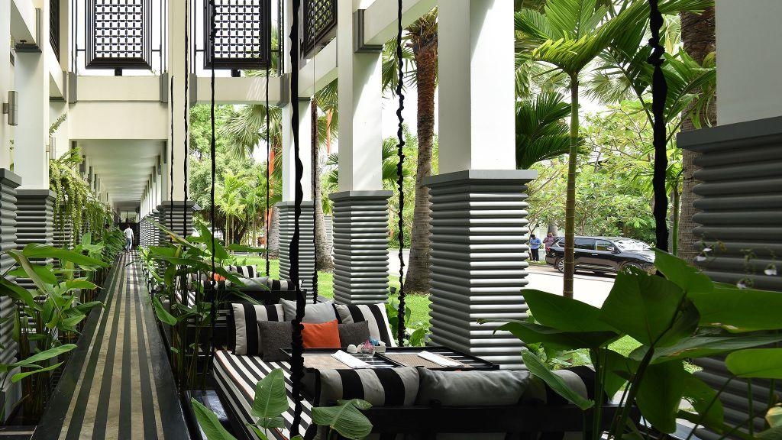
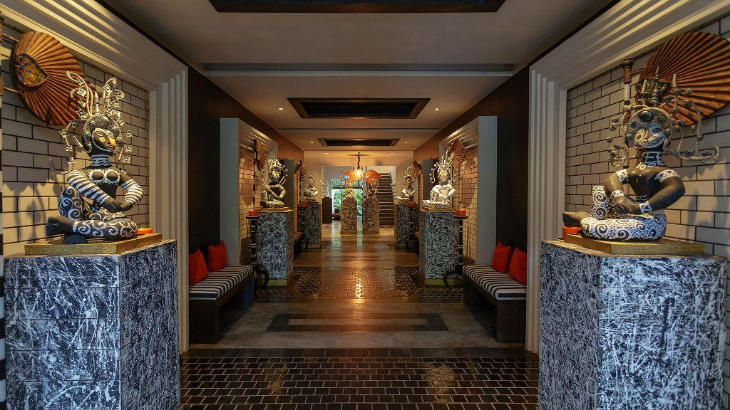
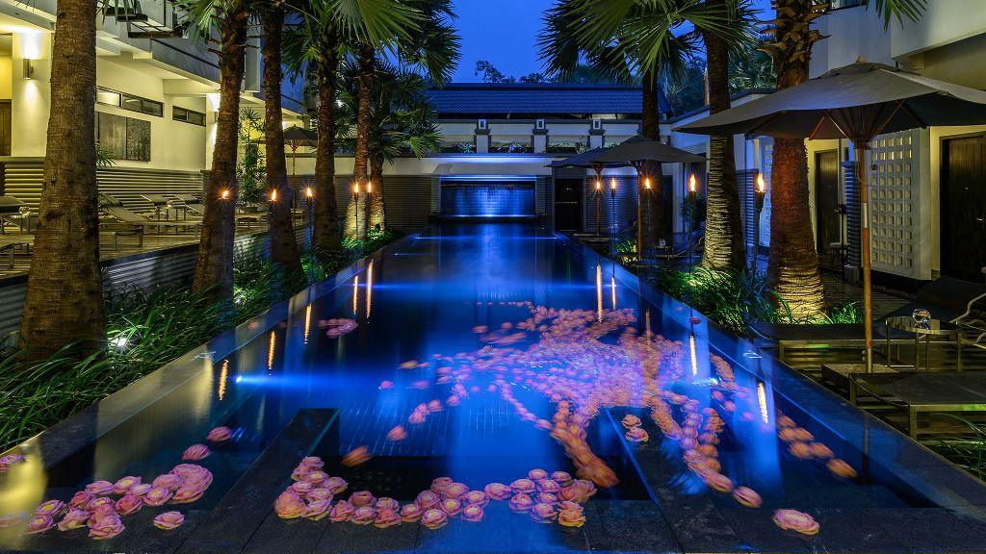
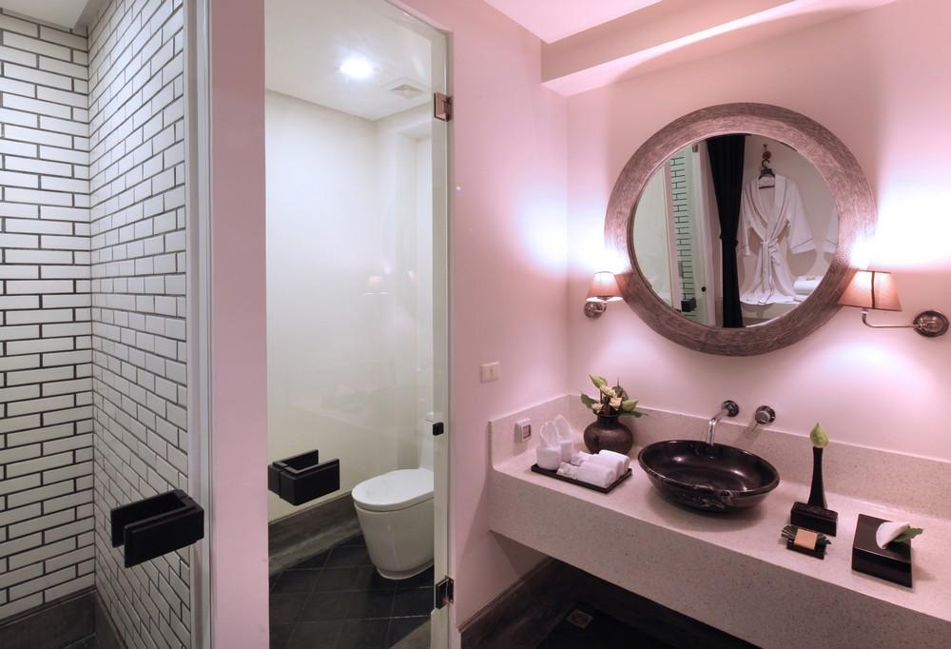
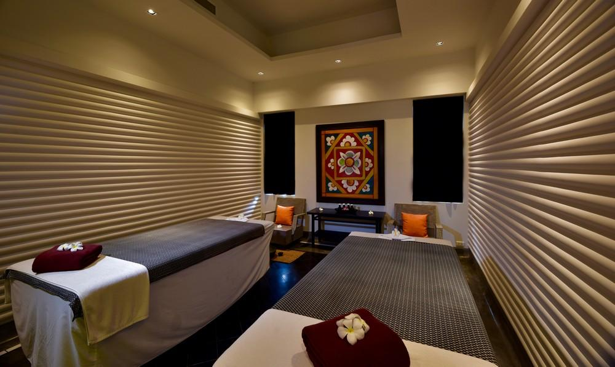

Easia Travel Head Office

Siem Reap BranchCharming City, No. R32 – R34, Road Rolouse, Trorpeangses Village, Sangkat Koukchork, Siem Reap Province – CambodiaTel: (855-63) 76 14 58Fax: (855-63) 76 14 58

