VIETNAM – Hoi An – Palm Garden Resort
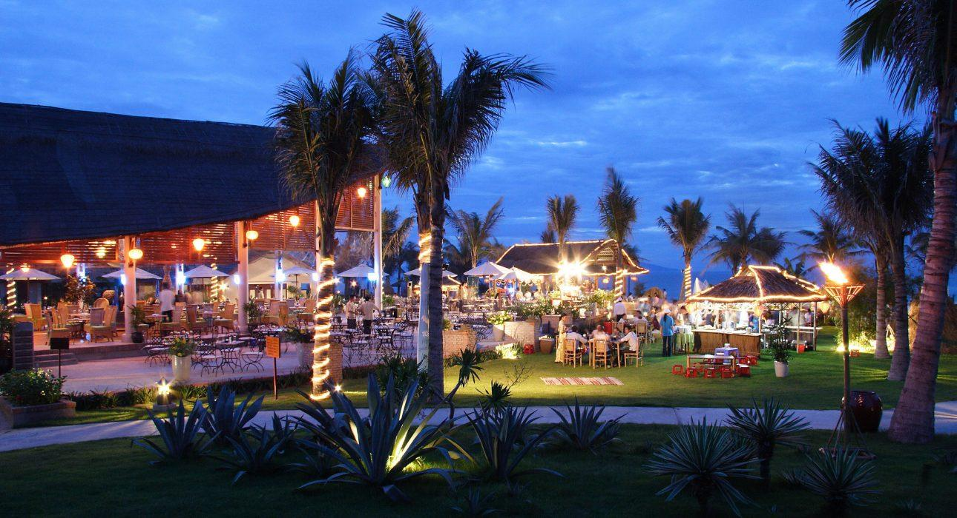

Over View

Theme
Beach Stay, Classic, Sustainable

Country - City
Vietnam - Hoi An

Market segment
Groups, Thematic Leisure

Official category
5*

Easia category
Deluxe

Total number of rooms
216

Price level
$$

Description

Ideally situated on a 5-hectare tropical garden, this beach hotel features more than 400 palm trees, as well as complexes of bungalows and suites nestled among the idyllic, seaside greenery. The resort has been beautified with several species of palm and coconut trees, and is furnished with beautiful Vietnamese silk, wood, and ceramic wares. Your guests can let tensions ease away at the spa, work out at the fitness center, partake in a range of exciting water sports, and sample a range of delicious dishes at one of the resort’s many of restaurants and bars.The simple yet elegant rooms are set among the gardens in three-story blocks, topped with terracotta tiles, and have garden or sea views. Superior and Deluxe Rooms are similar, but the latter are more spacious. For extra space and a superior location, guests can upgrade to a Deluxe Sea-view Room, which is just a few steps from the beach. Spacious and luxurious Suites and Bungalows are available, as well. Pathways connect all rooms and buildings to the beach, central pool, spa, and the resort’s three restaurants.Guests will feast on an expansive breakfast buffet and enjoy traditional Vietnamese cuisine, as well as international dishes at the Terrace Café, which overlooks the gardens. The Colibri Beach Restaurant has sea views and hosts both themed dinners and delicious seafood buffets.

Selling points

- The Palm Garden Resort has one of the most beautiful gardens and swimming pools out of all the resorts in Hoi An.
- The resort has an elegant, simple decor and nice landscapes.
- The staff is welcoming, warm, and professional

Sustainability

Supplier Actions
Protection of Environment, Support local communities, Animal Welfare, Respect social policy &amp; human rights, Water refill stations

Time & Transportation

FROM | TO | DISTANCE (KM) | BY | DURATION | ROAD CONDITION
Hotel | Hoi An Ancient Town | 5.5 kilometers | Car | 15 minutes | Good
Hotel | Da Nang International Airport | 27.5 kilometers | Car | 30 minutes | Good

Rooms

Easia's recommend room type
- Room type:
+ SuiteJunior Suite: 3Palm Garden Suite: 2+ Deluxe: 123 (109 Garden View, 14 Sea View)+ Bungalow: 20 (6 Garden Pool View, 14 Beachfront)+ Superior: 68 (68 Garden View, 6 Sea View)
- Surface area:
+ SuiteJunior Suite: 64m²Palm Garden Suite: 104m²+ Deluxe: 48 – 51m²+ Bungalow: 58m²+ Superior: 40m²

Services & Facilities

Services
24/7 nursing &amp;amp; medical services, Airport transfer, Bicycle Rental, Buffet Breakfast, Children Activities, Concierge service, In-Room Dining, Laundry service, Massage, Private event, partying, Spa, Wake-up service, Welcome fruits in room upon arrival, Steam

Facilities
Air Conditioning, Bar, Bicycle, Business centre, Cable, satelite, Fitness centre, Flat screen TV, Free private parking, Garden, Gift Shop, In-Room safe, Jacuzzi, Massage room, Meeting room, Outdoor swimming pool, Private Beach, Steam/Sauna, Terrace

Business facilities details
ROOM NAME | SIZE (WxLxH) | CLASSROOM | THEATER | U SHAPE | BANQUET
Orchid | 6 meters x 12 meters x 3 meters | 24 m² | 30 m² | 22 m² | 20 m²
Palm Court | 21 meters x 33 meters x 6 meters | 350 m² | 500 m² | 100 m² | 400 m²
Lotus | 12 meters x 19.5 meters x 4 meters | 72 m² | 160 m² | 36 m² | 80 m²
Jasmine | 3.6 meters x 12.3 meters x 3 meters | n/a | n/a | n/a | 20 m²

Restaurant information

Terrace Restaurant
- Capacity: 240 persons
- Opening Hours: 6:30 – 22:30
- Type of cuisine: Western, Asian, Vietnamese, and Fusion
Colibri Beach Restaurant
- Capacity: 250 persons
- Opening Hours: 10:00 – 22.00
- Type of cuisine: cocktails, long drinks, barbecued seafood, Vietnamese, and Western cuisine (Italian specialties).
- Note: It’s an open-air restaurant, designed in the shape of a boat with traditional adornments, and is located just on the beach.
Contino Bar
- Capacity: 80 persons
- Opening Hours: 17:00 – 24:00
- Note: A live band plays relaxing music from 20:00 to 23:00.

Photos

Rooms photos
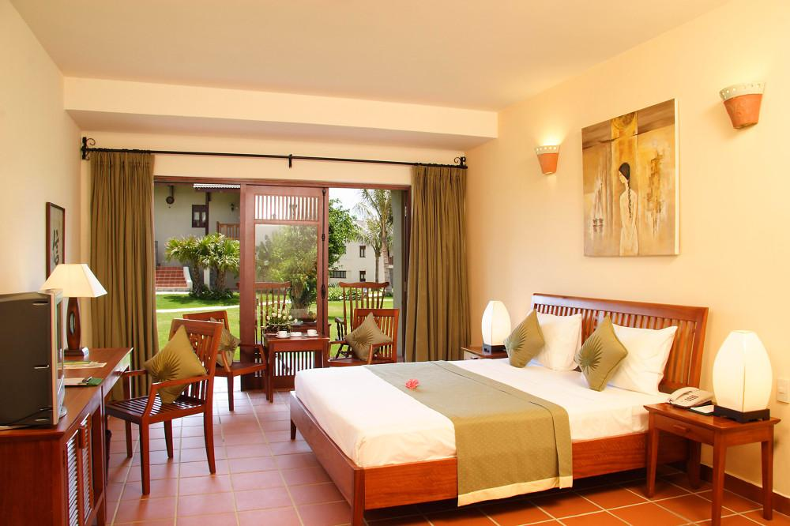
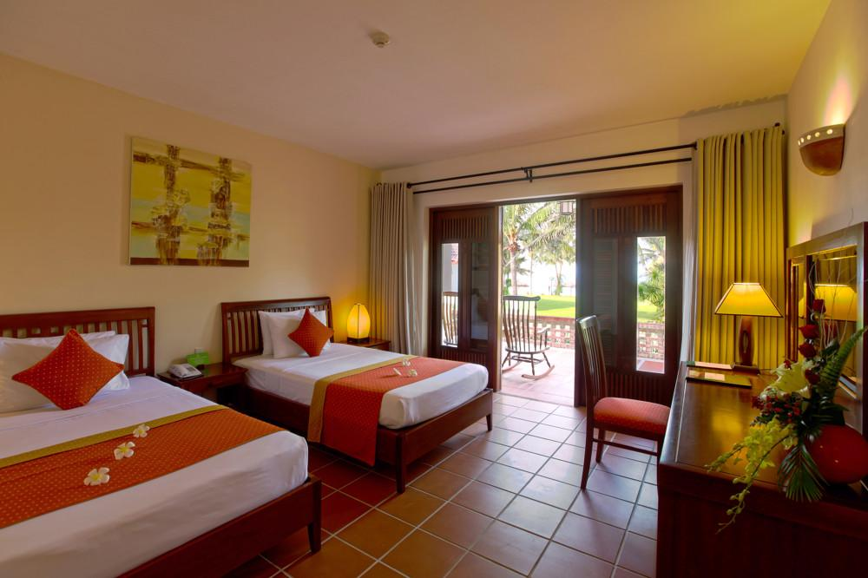
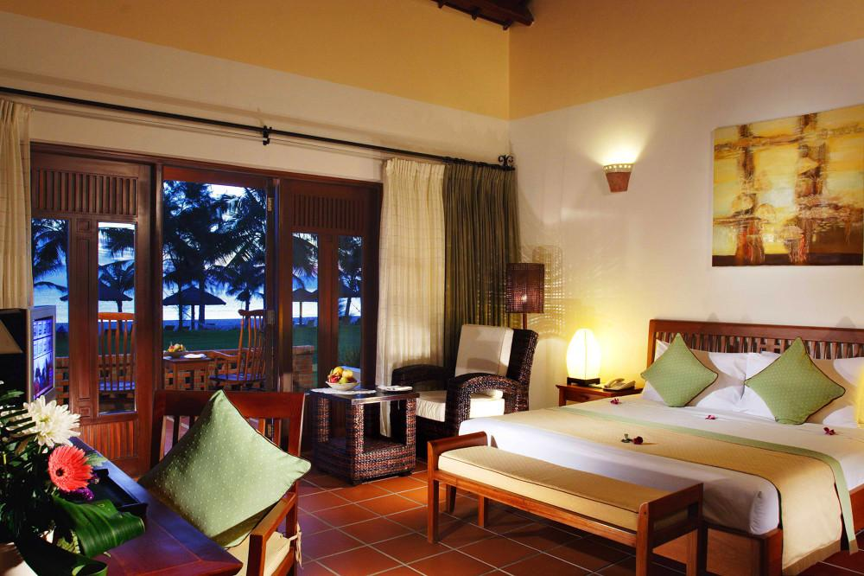
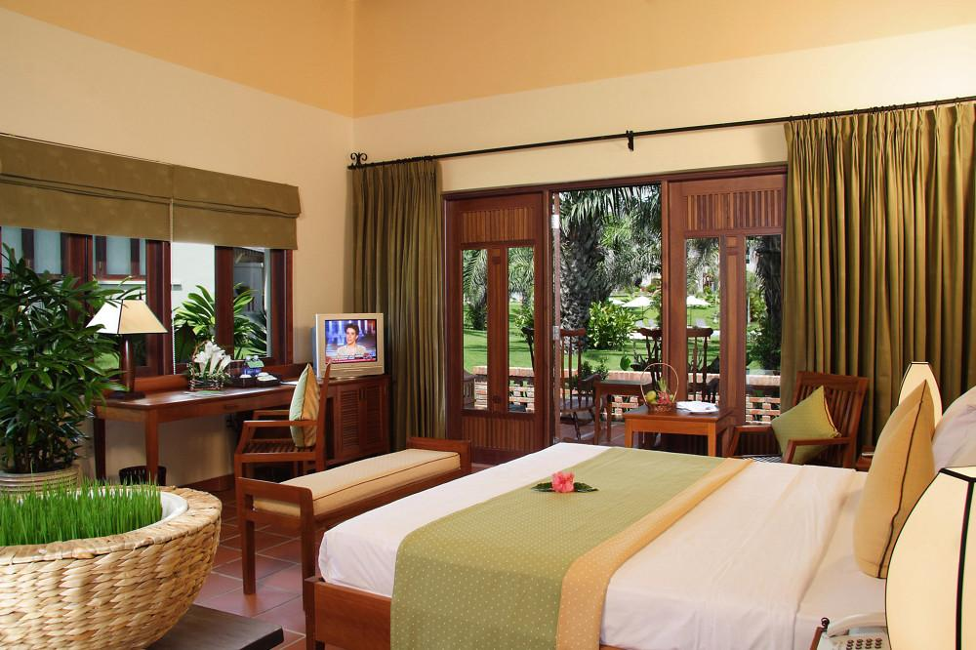
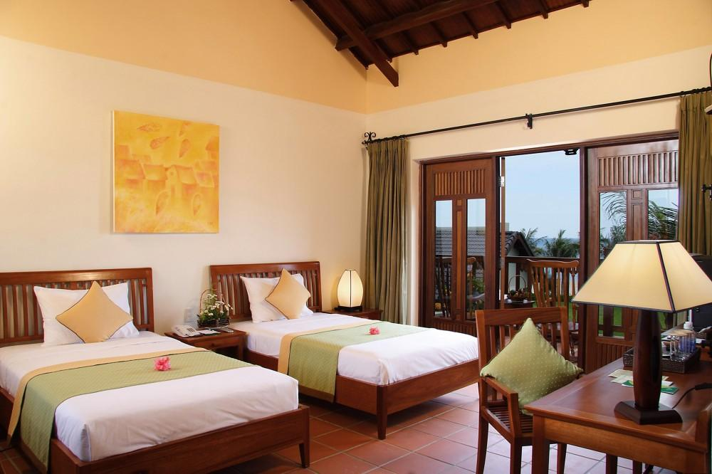
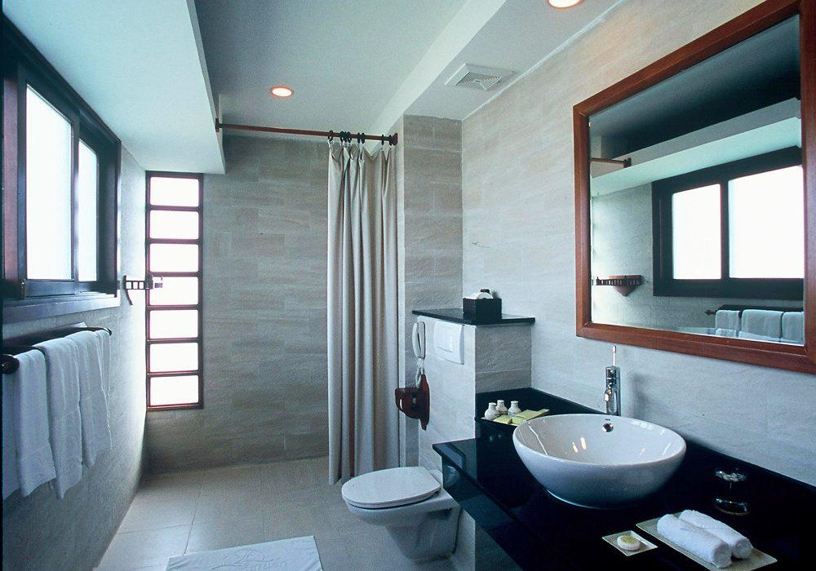
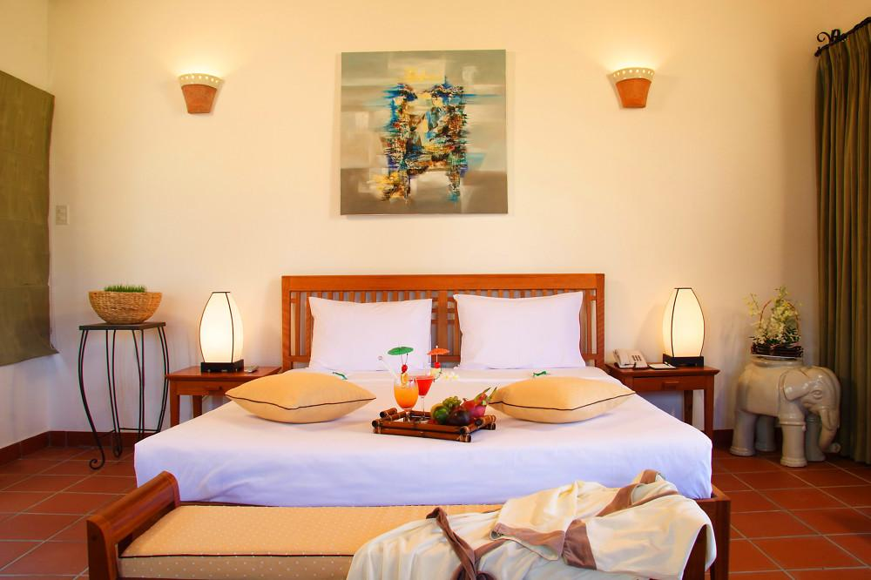
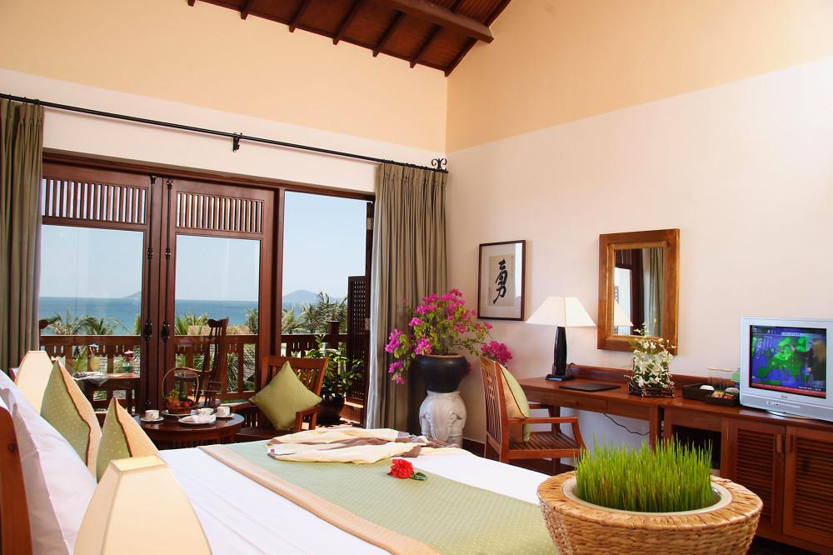

Restaurant photos
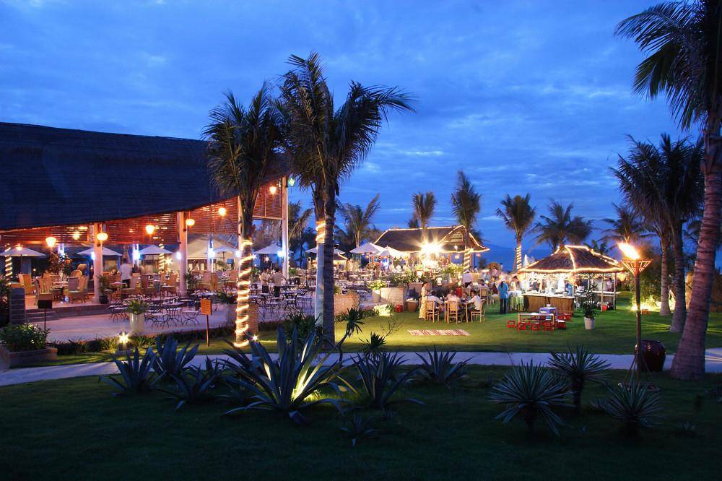
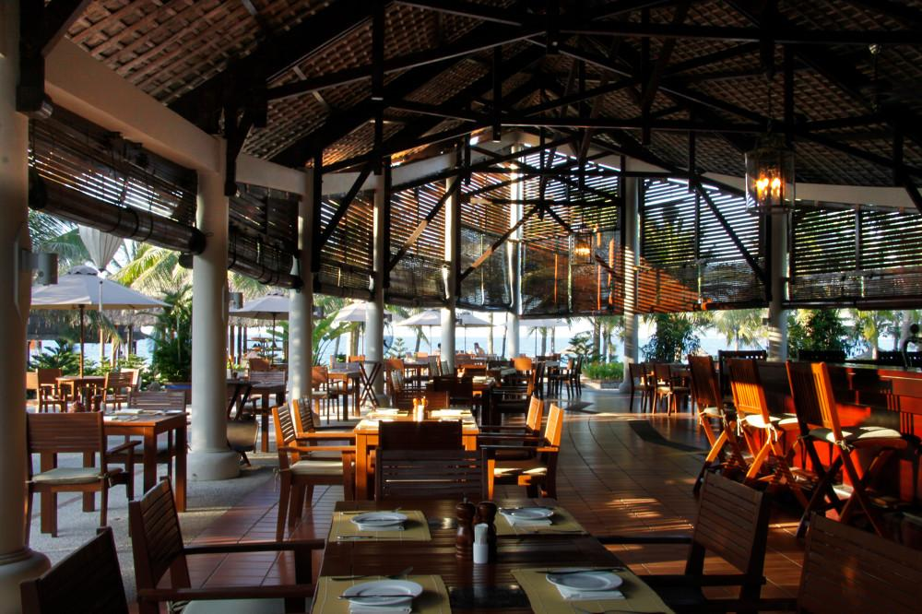
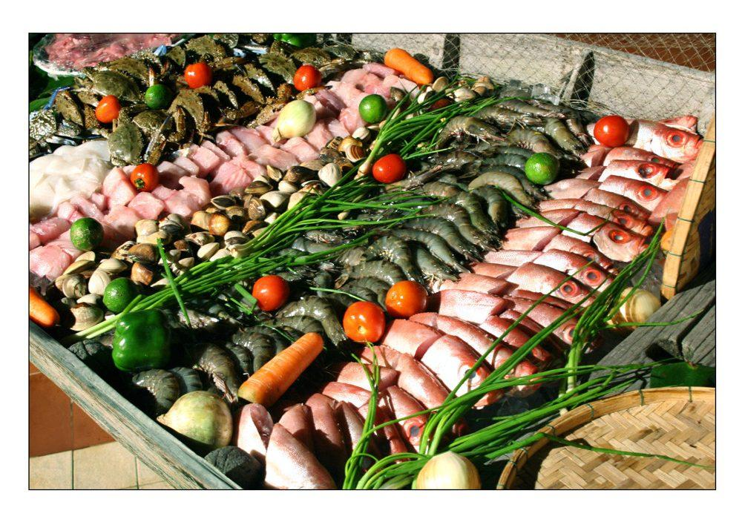
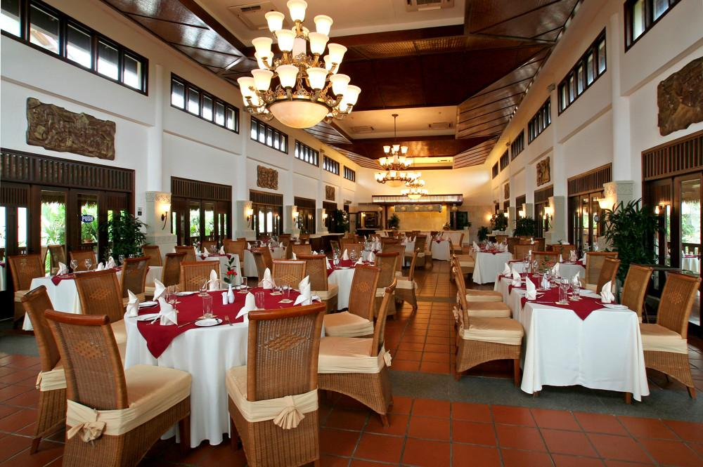

Business facilities photos
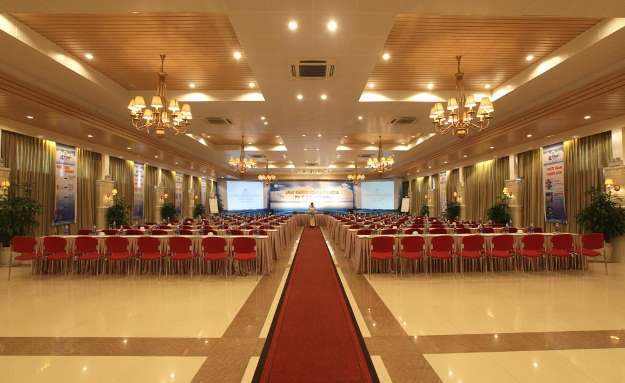
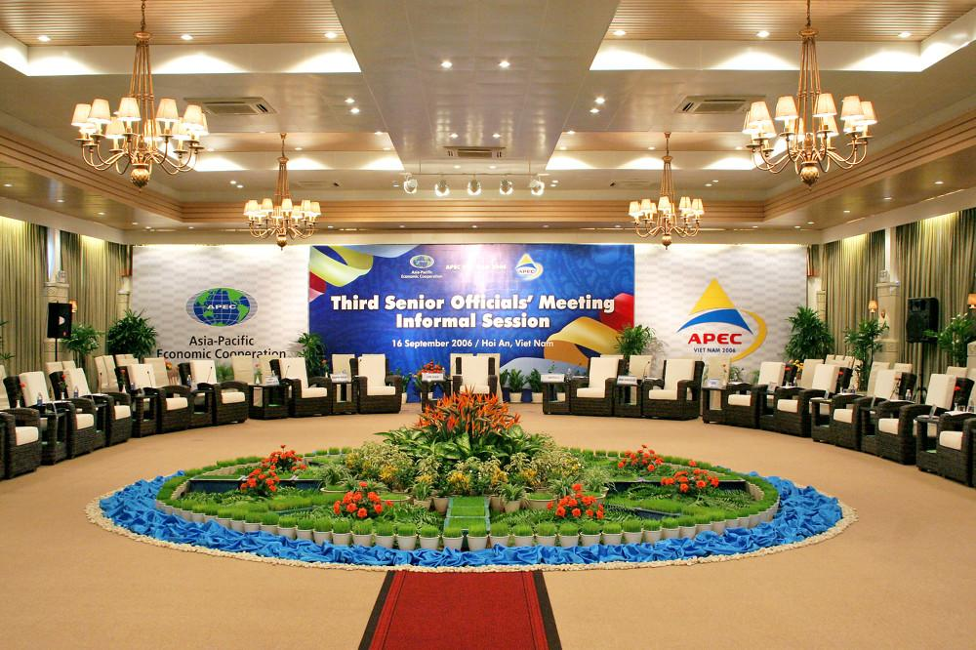
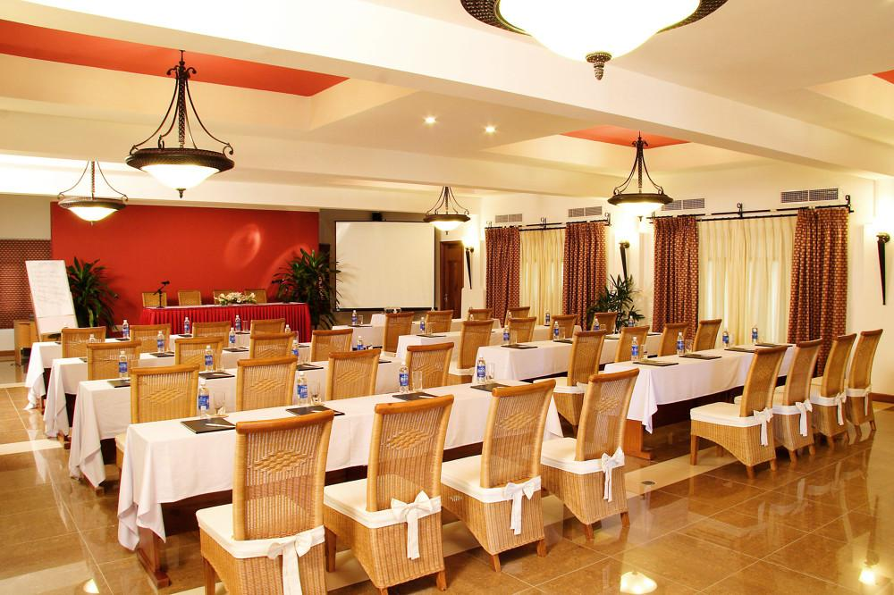

Services & facilities photos
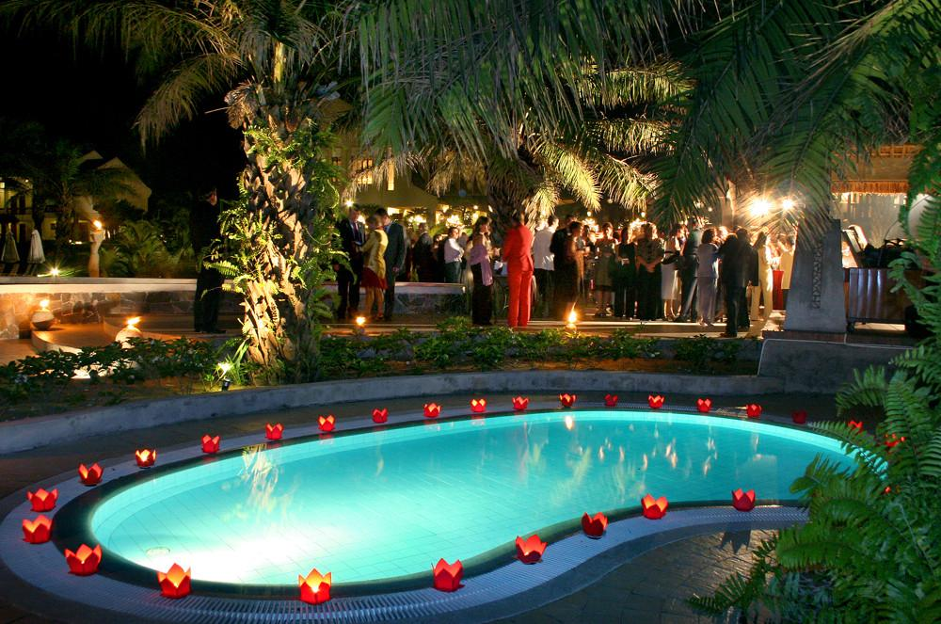
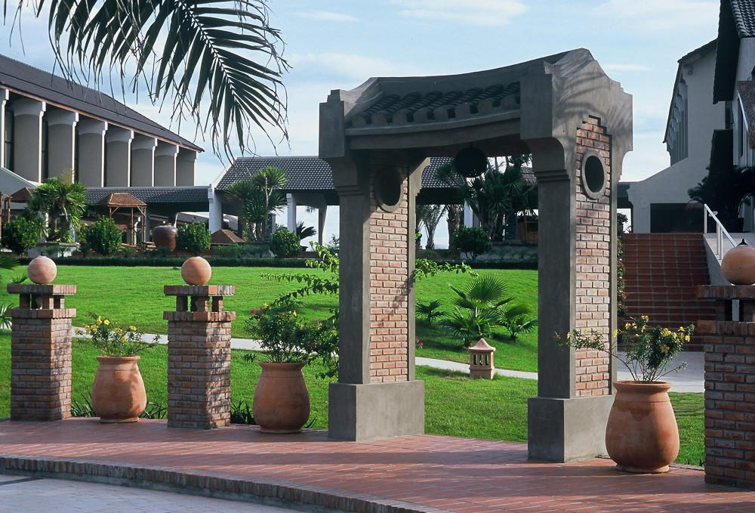
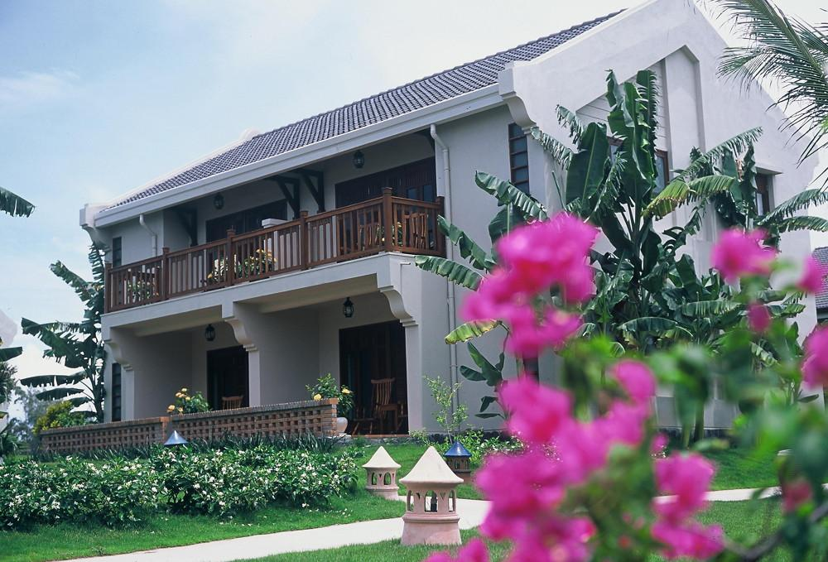
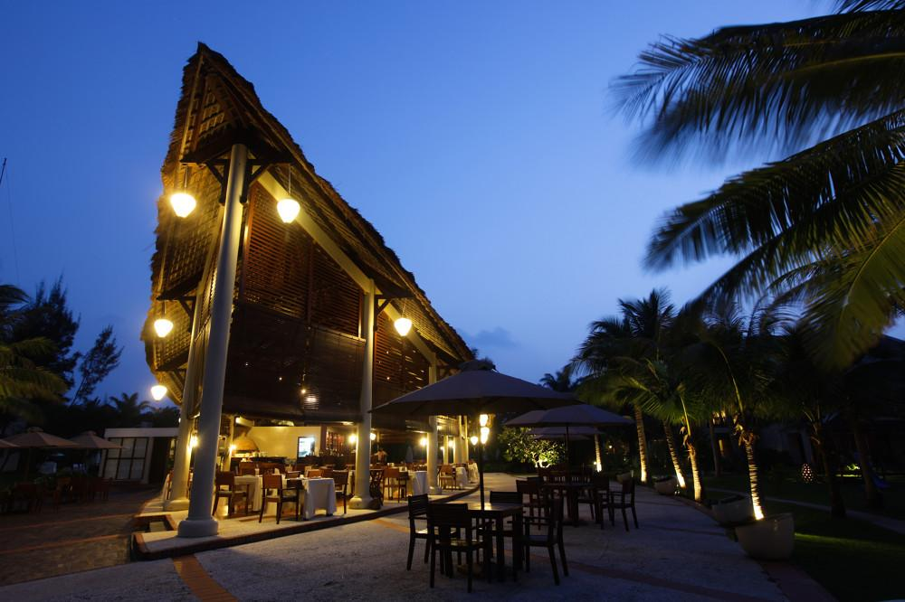
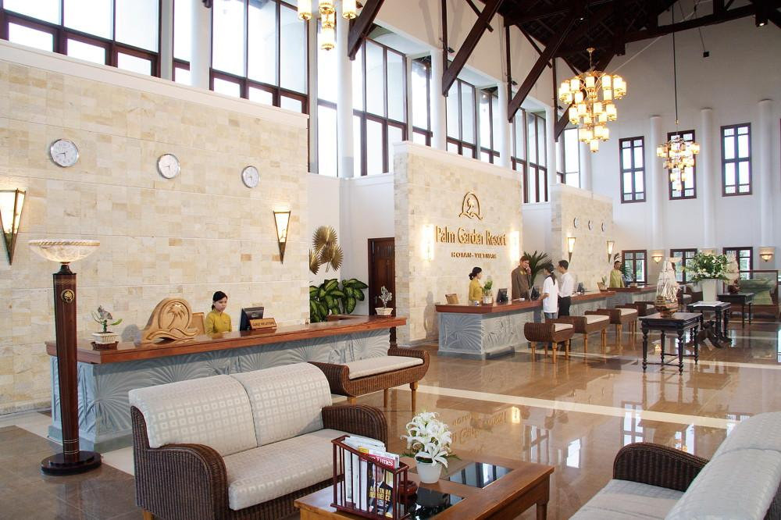
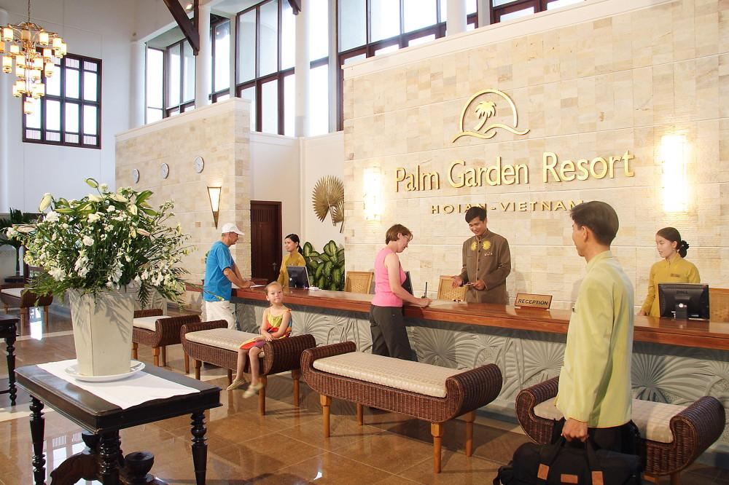

Easia Travel Head Office

Vietnam Head OfficeC/o: ATS Hotel, Suite 326 &327, 33B Pham Ngu Lao Street, Hanoi, VietnamTel: +84 24-39 33 13 62www.easia-travel.com

