VIETNAM – Hue – Banyan Tree Lang Co
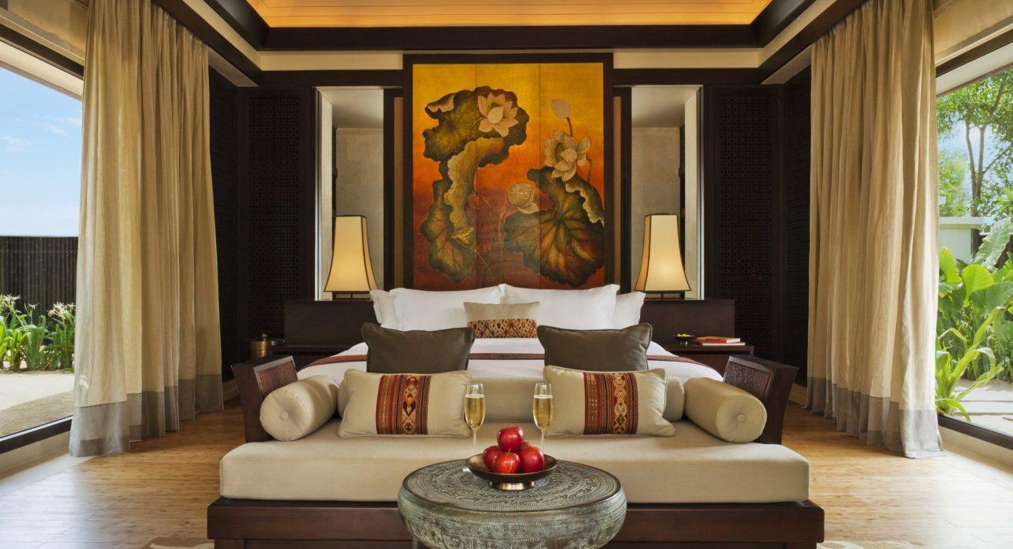

Over View

Theme
Beach Stay, Classic, Honeymoon, Sustainable

Country - City
Vietnam - Hue

Market segment
Groups, Thematic Leisure

Official category
5*

Easia category
Deluxe

Total number of rooms
64

Price level
$$$$

Description

The Banyan Tree Lang Co is a collection of 64 villas on the central coast of Vietnam, right between the UNESCO World Heritage Sites of Huế and Hoi An. Open courtyards, pottery and traditional Vietnamese fabrics feature throughout the resort. All the spacious villas come with a private pool and free WiFi. Guests are entitled to round trip airport transfer service.Surrounded by white sand beaches and magnificent mountains, the air-conditioned villas are decorated with elegant paintings and eco-friendly materials like bamboo. Villas come with a flat-screen TV, minibar and seating area. En suite bathrooms have a bathtub.Daily buffet breakfast is served at The Water Court, while Saffron Restaurant specialize in Thai fusion cuisine. Italian and Mediterranean meals and drinks can be enjoyed at the beach-front Azura Restaurant.There is an award-winning world-class spa on site, with private treatment pavilions located alongside a tranquil lagoon, guests can relax with a full-body massage. The resort also has a well-equipped gym, free bicycle rentals and a business center.The Laguna Lang Co Golf Club, an 18-hole, par-71 championship course designed by Sir Nick Faldo, delivers a golfing experience that can be enjoyed by skilled and novice players alike. The club is vastly unique in the region and the distinction of the course lies in its variation. Starting in a rice-paddy environment, the course has been cleverly routed alongside woodlands at the base of a stunning mountain range, through sand and waste areas, to the ocean side and back to the clubhouse, with magnificent views of the whole exotic, bucolic landscape.

Selling points

- Located on the perfect crescent beach, the resort offers privacy and a rare difference, Banyan Tree Lang Co is the most luxurious accents in the complex.
- Perfect for who loves enchantingly remote and romantic retreat.
- The Destination Dining concept allows you to eat anywhere at the resort; the butler-served beach banquet is a highlight
- Comprehensive amenities, including an 18-hole golf course designed by Sir Nick Faldo, a water sports center with a marine lab, a gym with a yoga pavilion and a holistic spa

Sustainability

Supplier Actions
Protection of Environment, Support local communities, Animal Welfare, Facilities for people with reduced mobility (PRM), Respect social policy &amp; human rights, Water refill stations

Certifications
Achieved the Gold EarthCheck Certificate in 2019, 2020Banyan Tree Lang Co proudly received the CSR Award by AusCham in March 2019Laguna Golf Lang Co is awarded as one of the “Top 10 World’s Most Eco-Friendly Golf Courses” by Golfscape in November 2019

Time & Transportation

From | To | Distance (km) | By | Duration | Road condition
Airport | Hotel | 60 | Shuttle bus | 1 hour | good
Hotel | Airport | Shuttle bus | good
Hotel | Hoi An | 120 | Shuttle bus | 2 hours | good
Hoi An | Hotel | Shuttle bus | good
Hotel | Hue | 60 | Shuttle bus | 1 hours | good
Hue | Hotel | Shuttle bus | good
Hotel | Da Nang | 60 | Shuttle bus | 2 hours | good
Da Nang | Hotel | Shuttle bus | good
Hotel | LC town | 20 | Shuttle bus | 30 minutes | good
LC town | Hotel | Shuttle bus | good

Rooms

Easia's recommend room type
- Lagoon Pool Villa:
  - 131sqm
  - View Lagoon
  - Capacity: 2
- Beach Pool Villa
  - 124 sqm
  - Ocean View
  - Capacity 2
- One Bedroom Sea-view Hill Pool Villa:
  - 152 sqm
  - Ocean View
  - Capacity: 2
- Two Bedroom Seaview Hill Pool Villa 237 sqm
  - 237 sqm
  - Ocean View
  - Capacity: 4
- Three Bedroom Seaview Hill Pool Villa: 260 sqm
  - 260 sqm
  - Ocean View
  - Capacity: 4

Room configuration

Connecting rooms
No

Extra bed
roll-away with size 1m * 2m

King bed
2m * 2m

Queen bed
No

Twin beds
1.1m * 2m. It is Hollywood twin.

Services & Facilities

Services
24 hour reception, 24/7 nursing &amp;amp; medical services, Airport transfer, Buffet Breakfast, Complimentary bottle of water, Complimentary fresh towel, Concierge service, Credit Card payment, Currency exchange, Golf, Laundry service, Massage, Spa, Tai Chi Class, Wi-fi Free, Room service, Baby sitting, Kindergarten, Inroom meals

Facilities
Air Conditioning, Bicycle, Business centre, Family Room, Fitness centre, Free private parking, Gift Shop, Indoor swimming pool, Newspapers and magazine, Outdoor swimming pool, Private Beach

Business facilities details
ROOM NAME | SIZE | CLASSROOM | THEATER | U SHAPE | BOARDROOM | BANQUET
BT board room | 5m x 5m | N/A | N/A | N/A | Yes – existing 12 pax | N/A
Banyan Tree 1 | 10mL x 4mW | N/A | N/A | N/A | Yes – existing 18 pax | N/A
Banyan Tree 2 | 13Ml x 5Mw | N/A | N/A | N/A | Yes – existing 22 pax | N/A
Wedding Chapel | As request | Yes 15 pax | Yes 25 pax | 12pax | 14pax | Yes 2 round table of 10
Beach | As request | As request | As request | As request | As request | As request

Restaurant information

- The water court
  - Capacity: 142 pax
  - Opening Hours: Breakfast 7.00 – 10.30 and Dinner 18.00 – 23.00
  - Type of Cuisine: Breakfast buffet and Dinner: Vietnamese food
- Saffron
  - Capacity: 88 pax
  - Opening Hours: Dinner 18.00 – 23.00
  - Type of Cuisine: Thai food
  - Note: Closed on Wed & Thu
- Azura
  - Capacity: 79 pax
  - Opening Hours: Lunch 11.00 – 18.00
  - Type of Cuisine: Italian food
  - Note: Seedlings dinner on Wed, Thu & Fri 18.00 – 21.00
- Thu Quan
  - Capacity: 45 pax
  - Opening Hours: 14.00 – 24.00
  - Type of Cuisine: Snack & Drinks
  - Note: Seedlings dinner on Wed, Thu & Fri 18.00 – 21.00

Photos

Hotel Photos
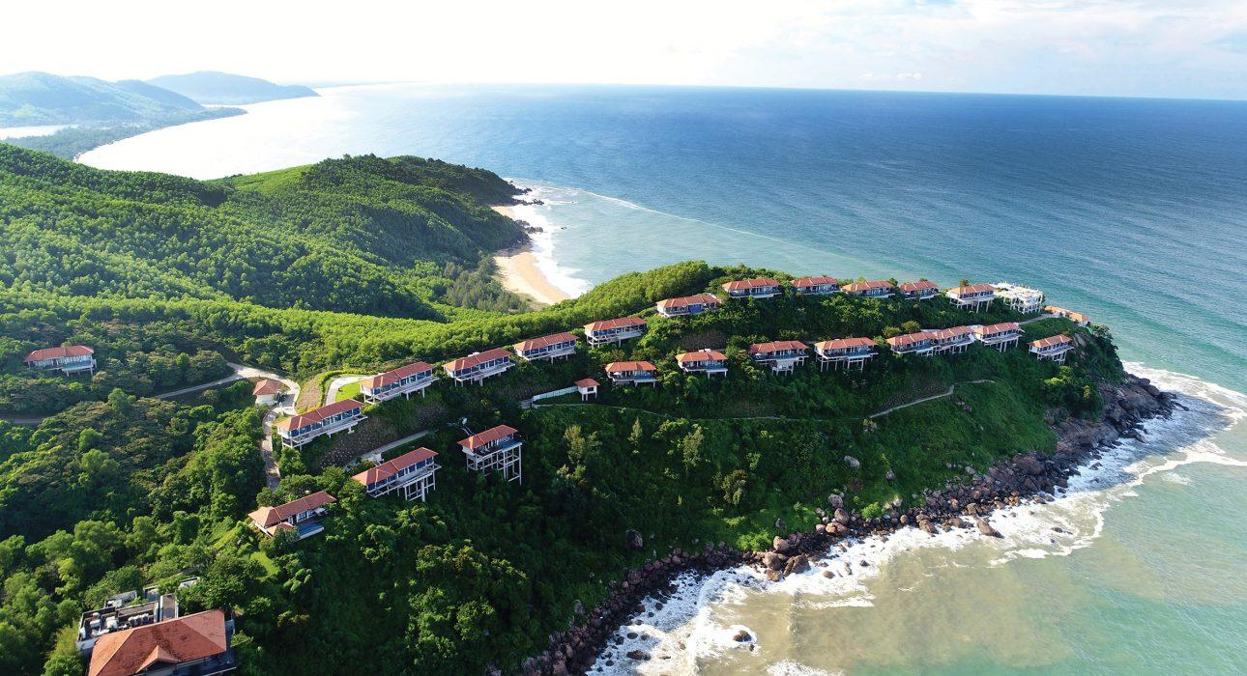
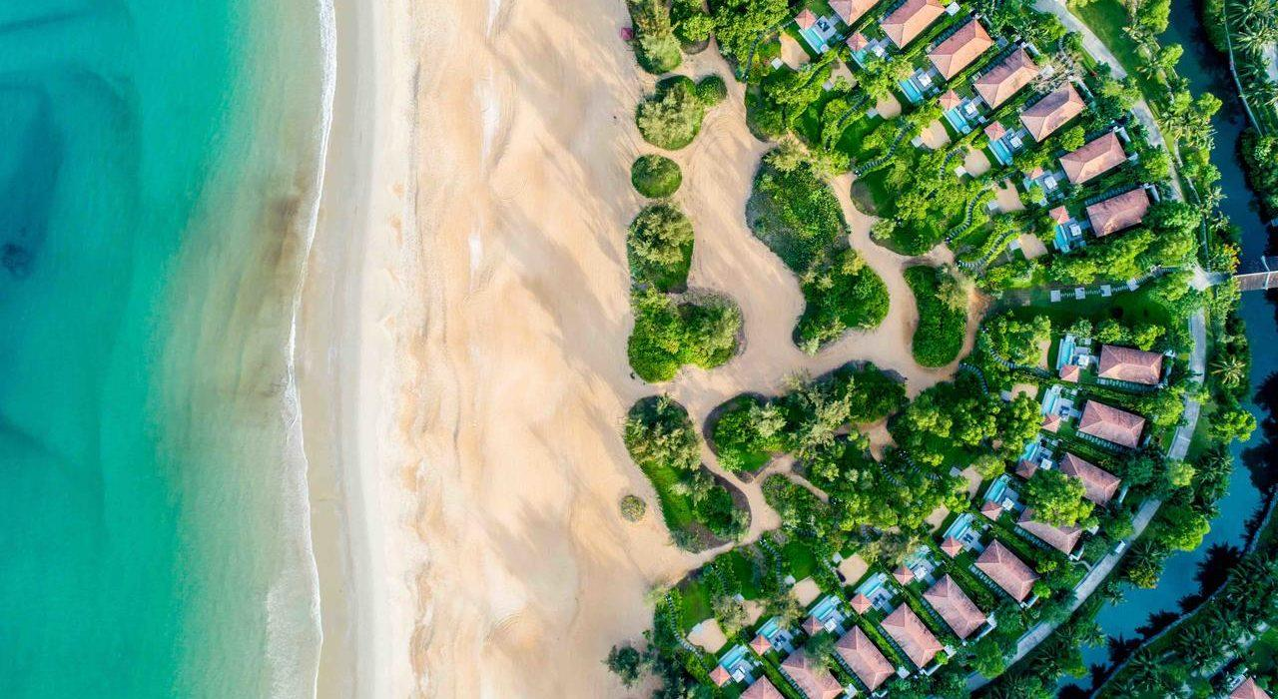
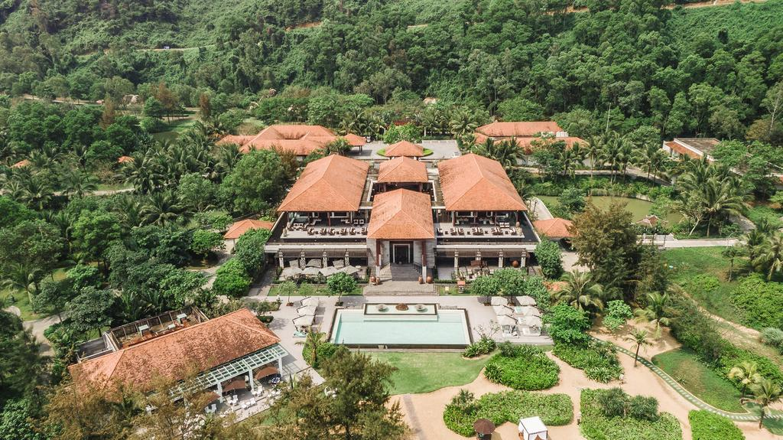
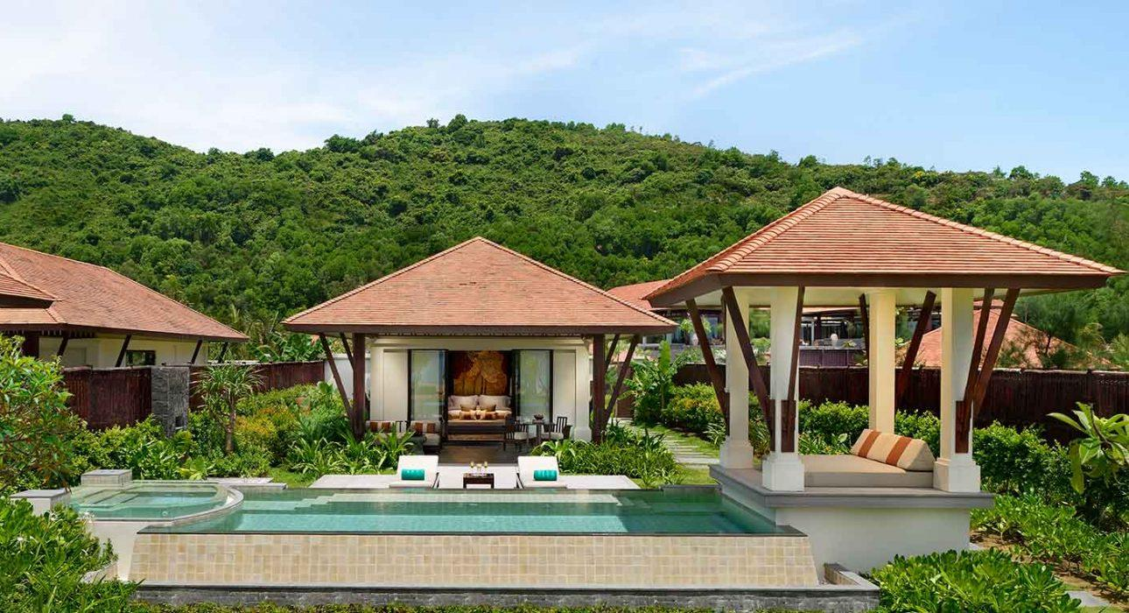
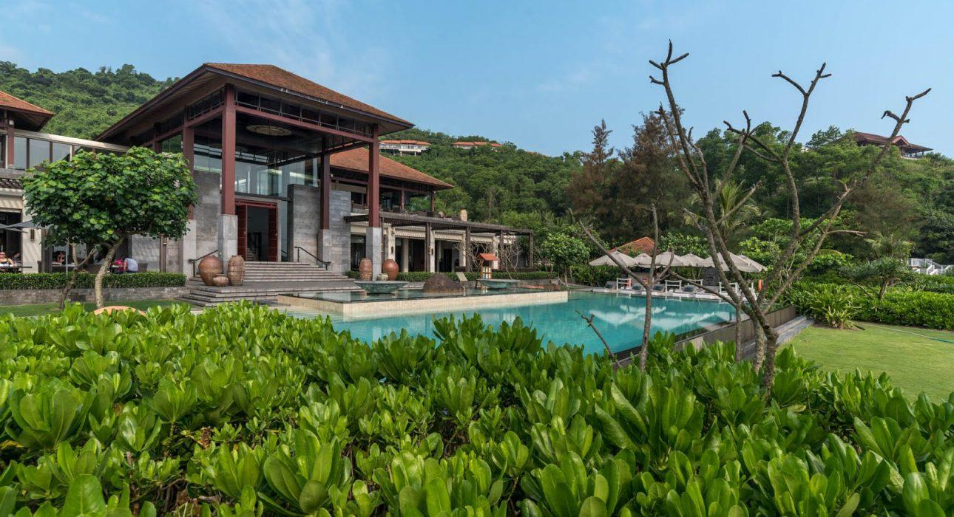

Rooms photos
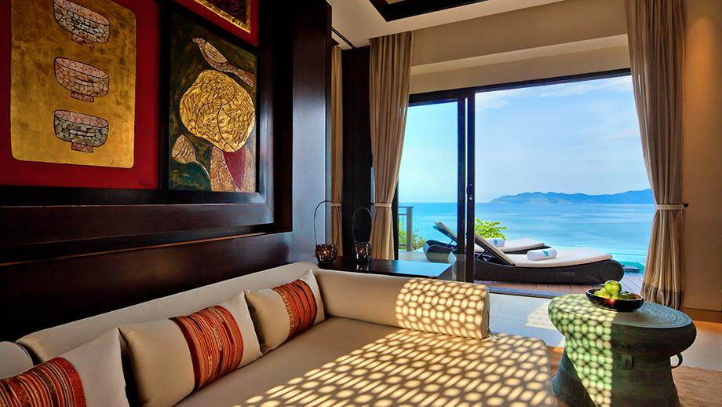
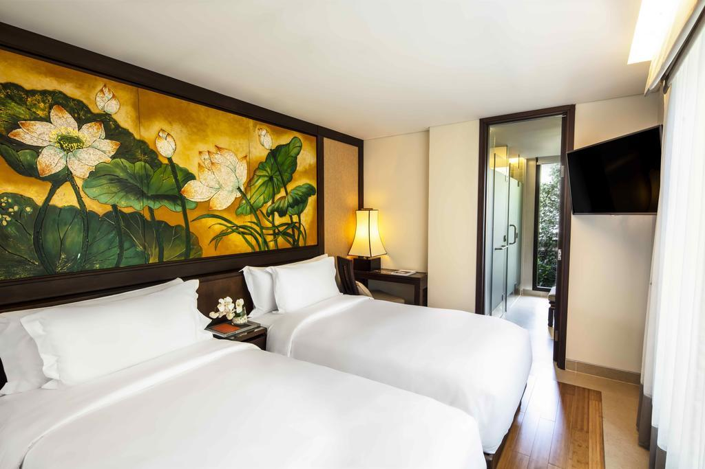
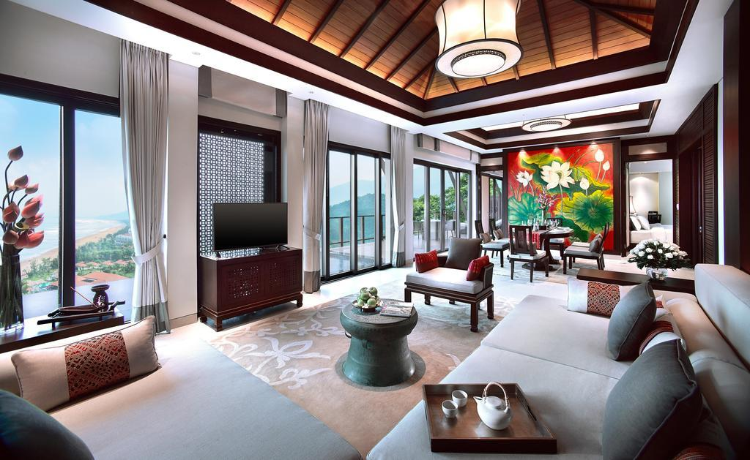
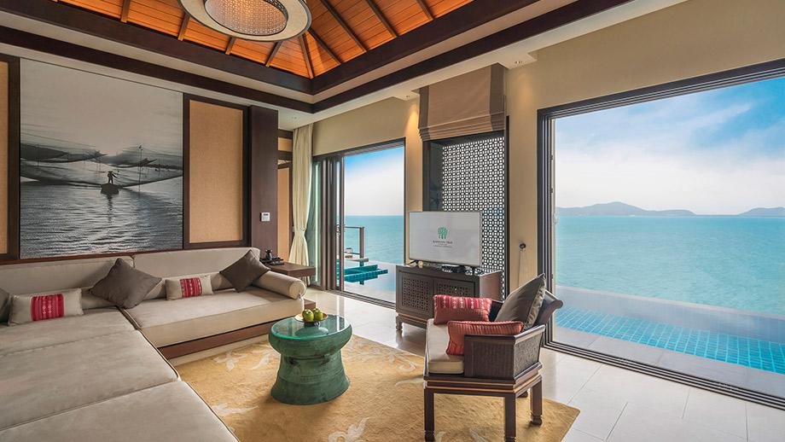
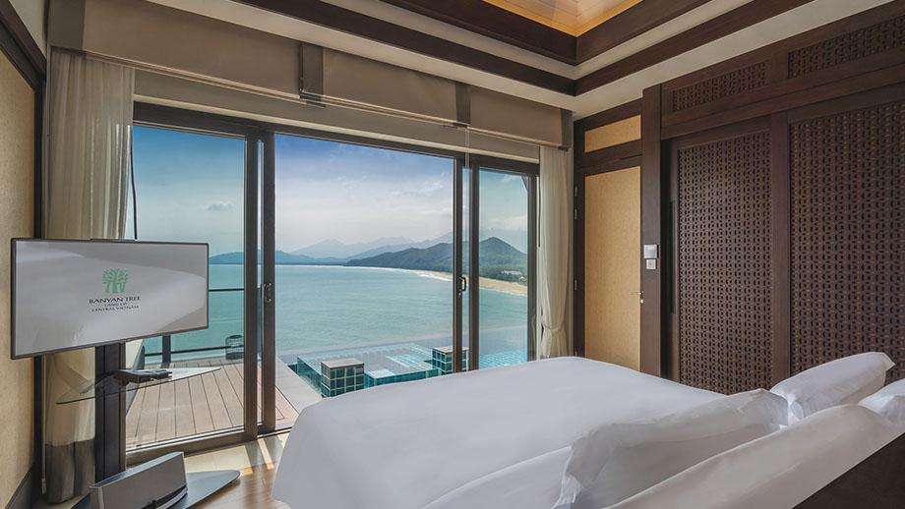
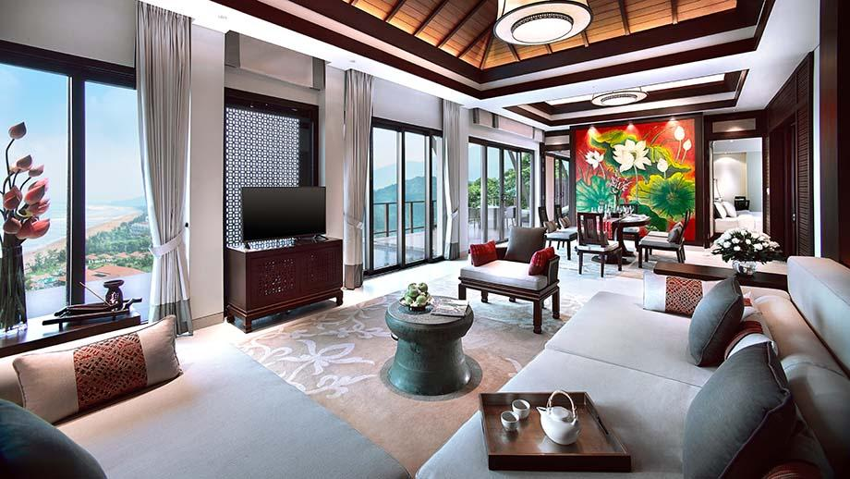
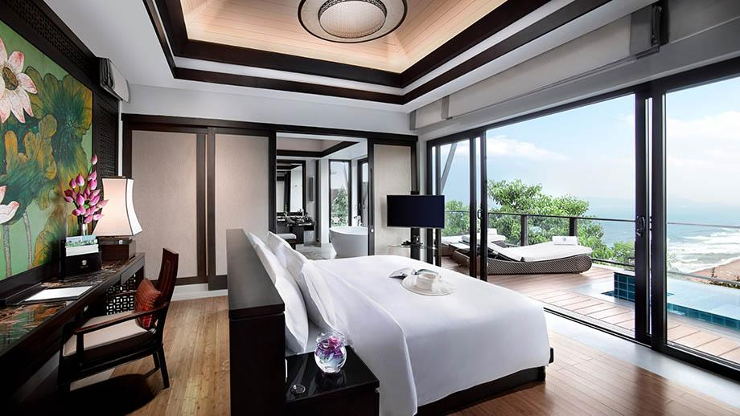
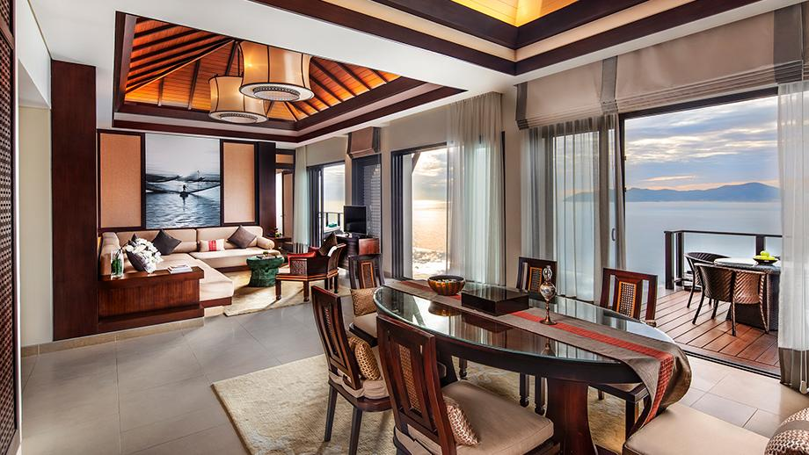
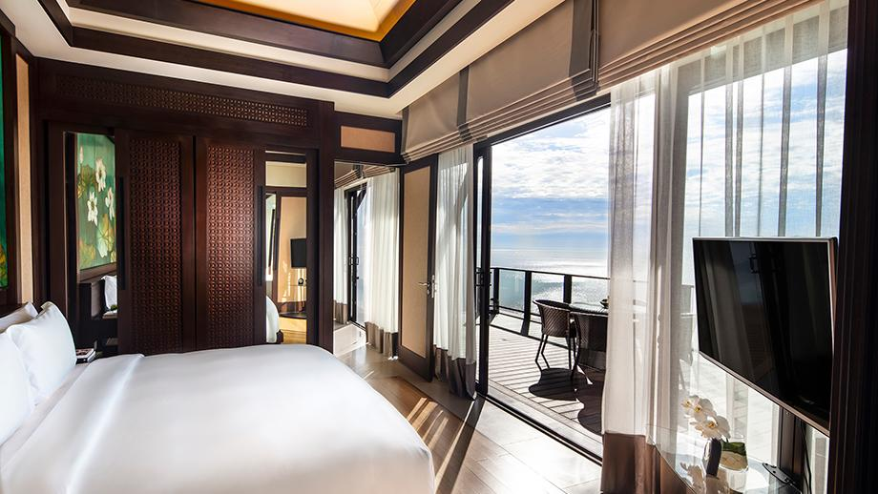
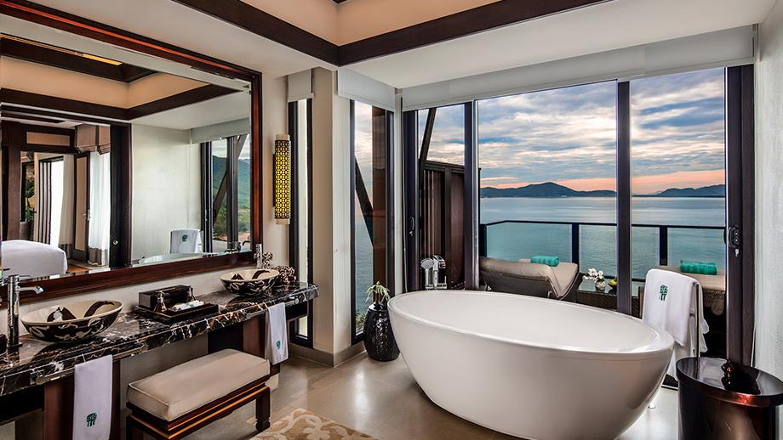
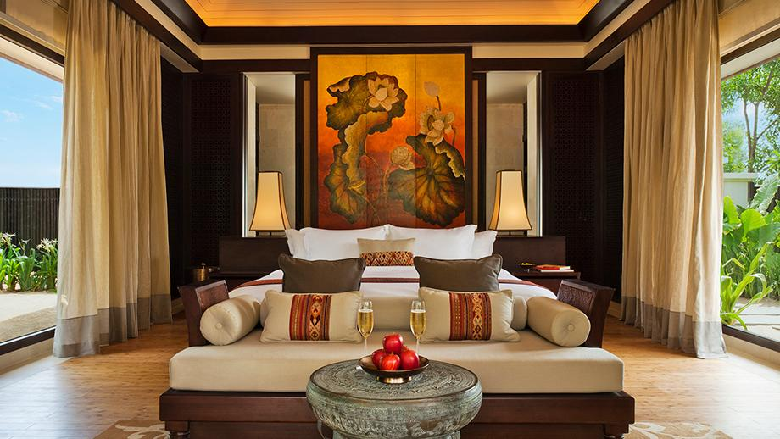
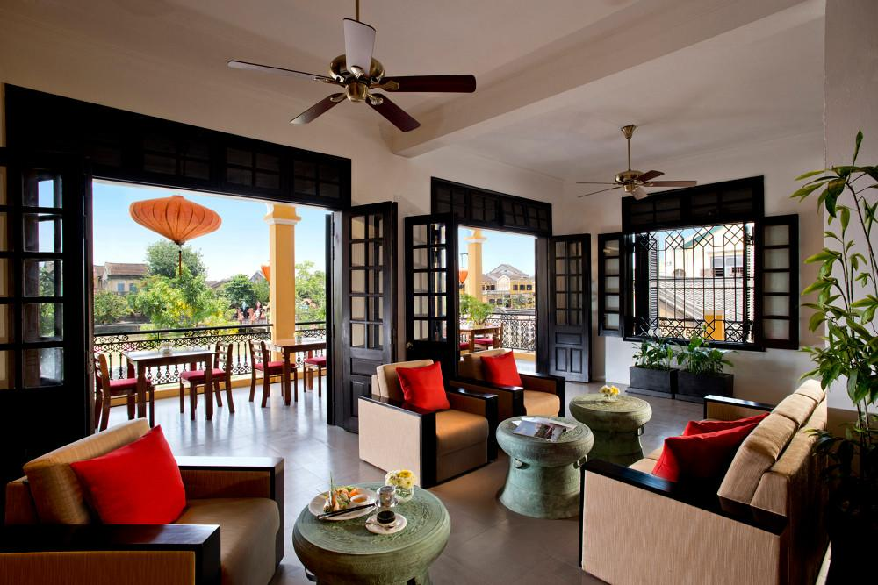

Restaurant photos
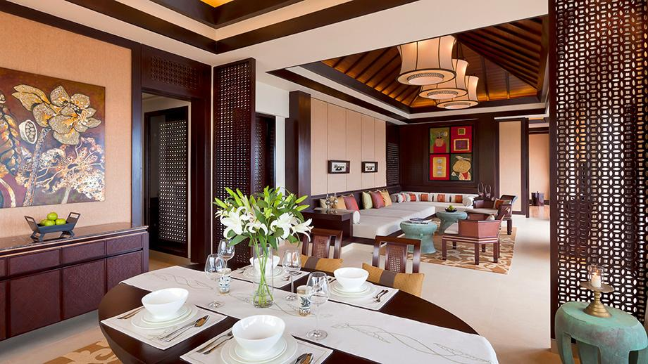
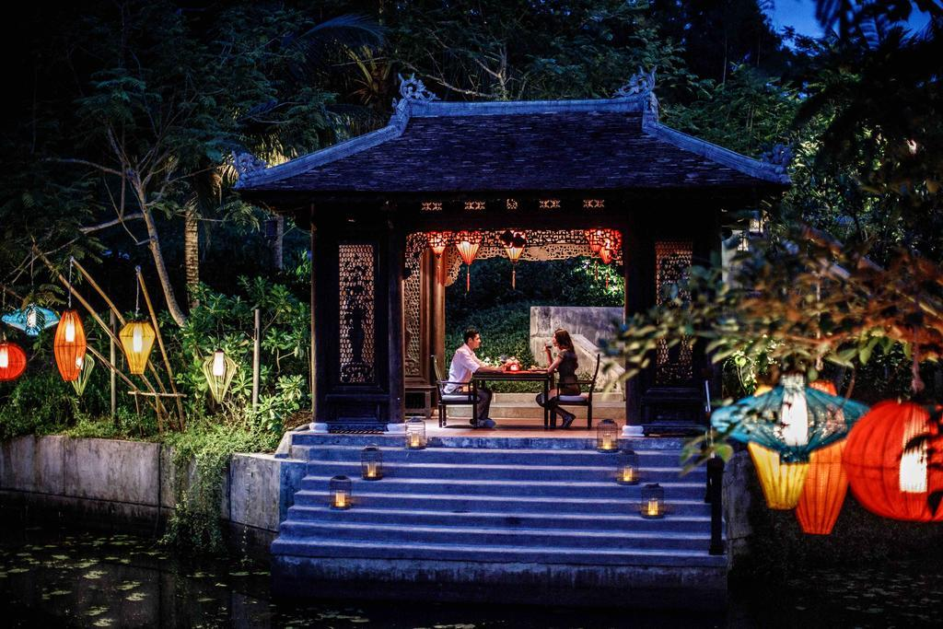
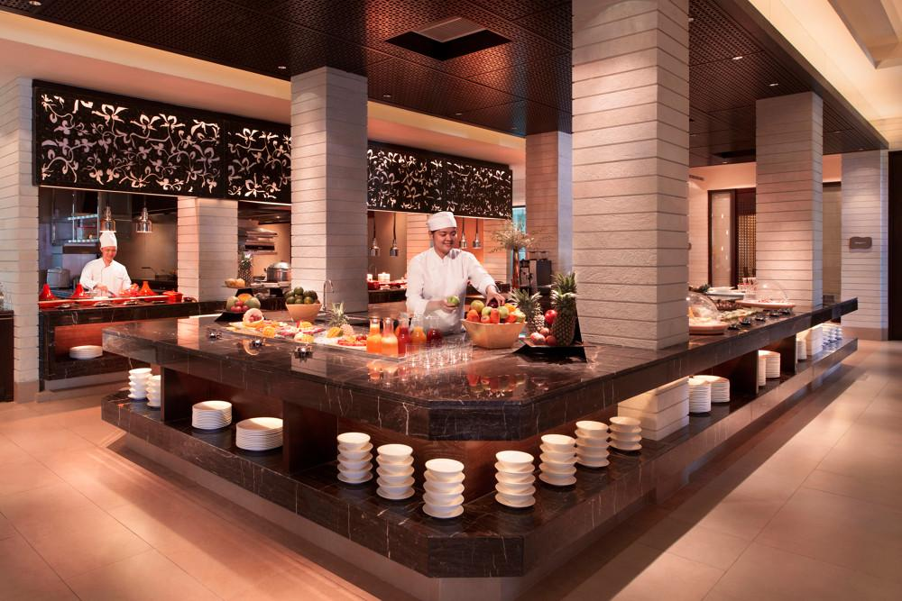
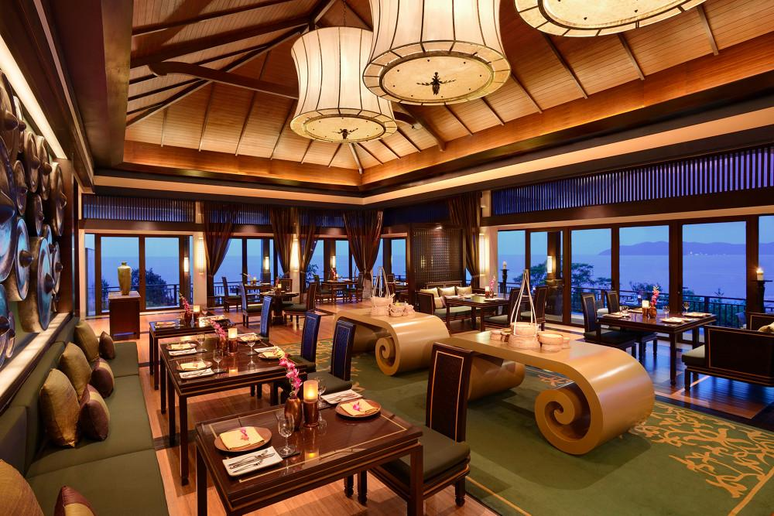
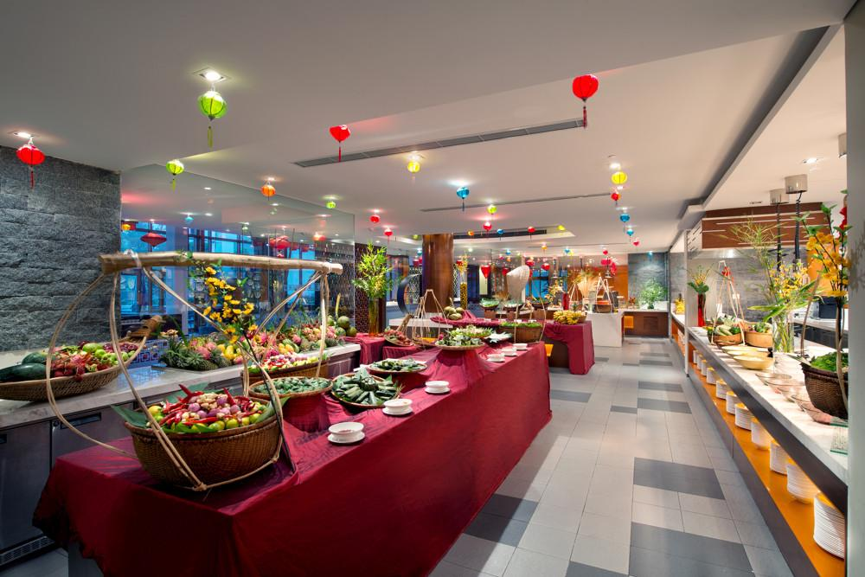
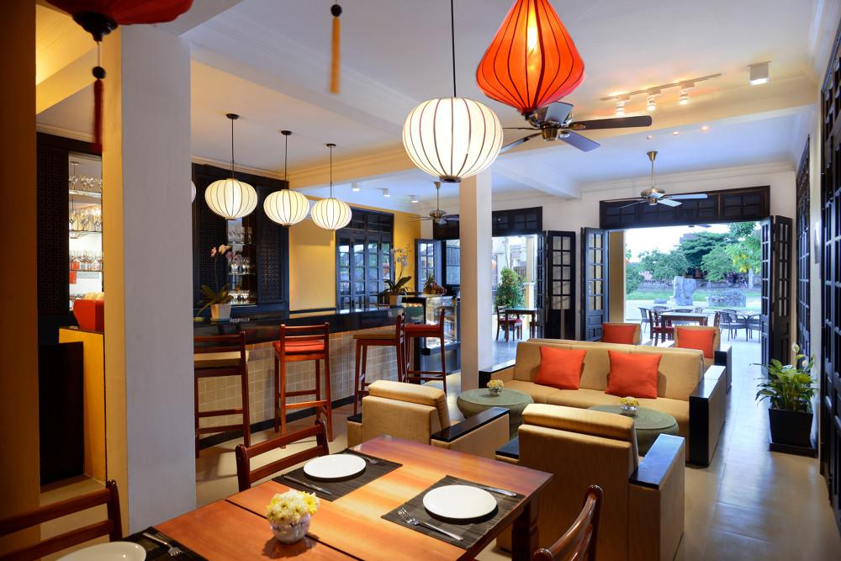
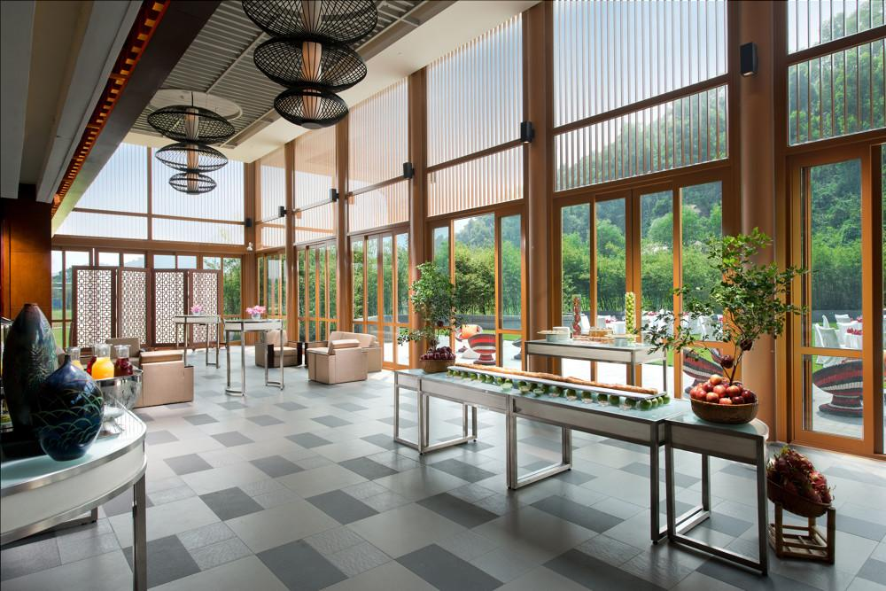

Services & facilities photos
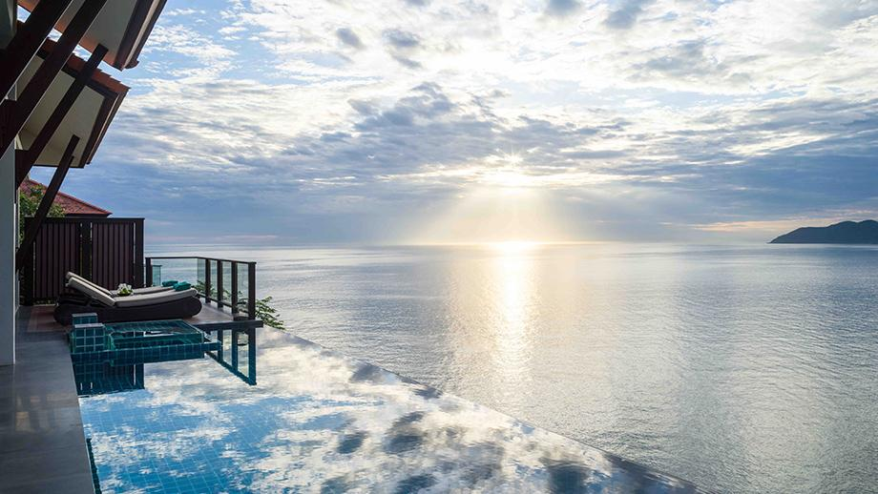
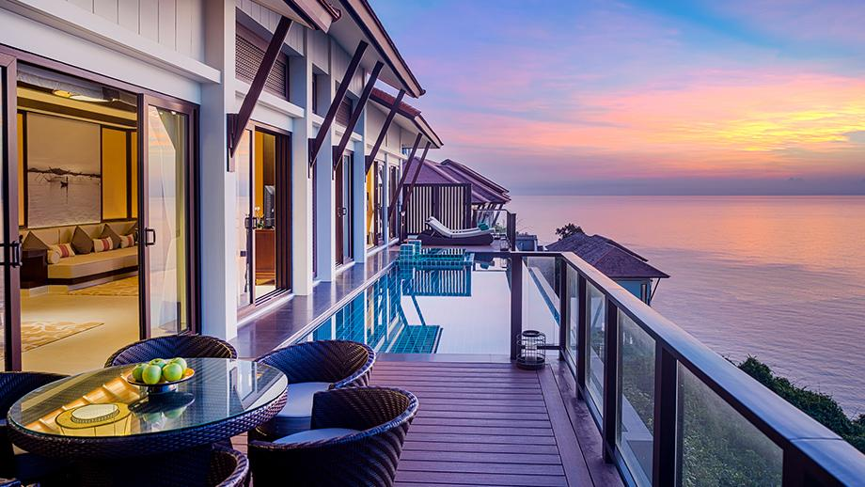
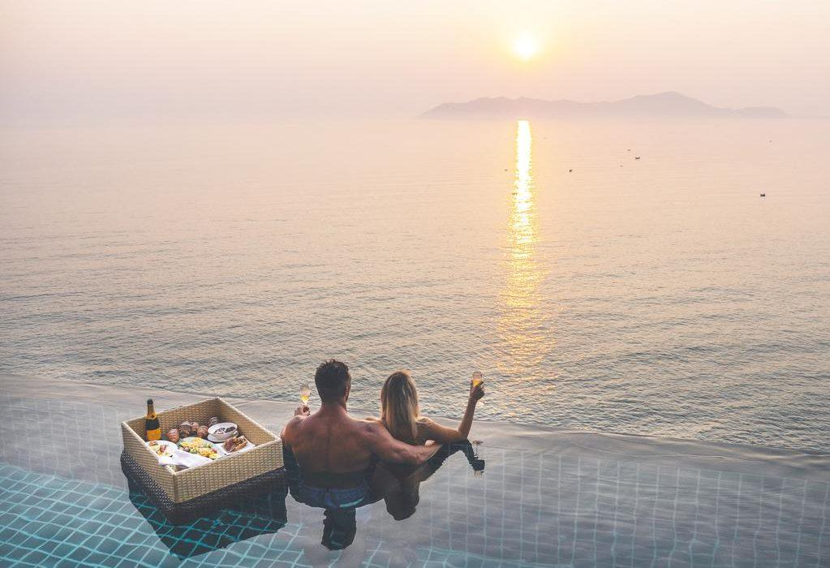
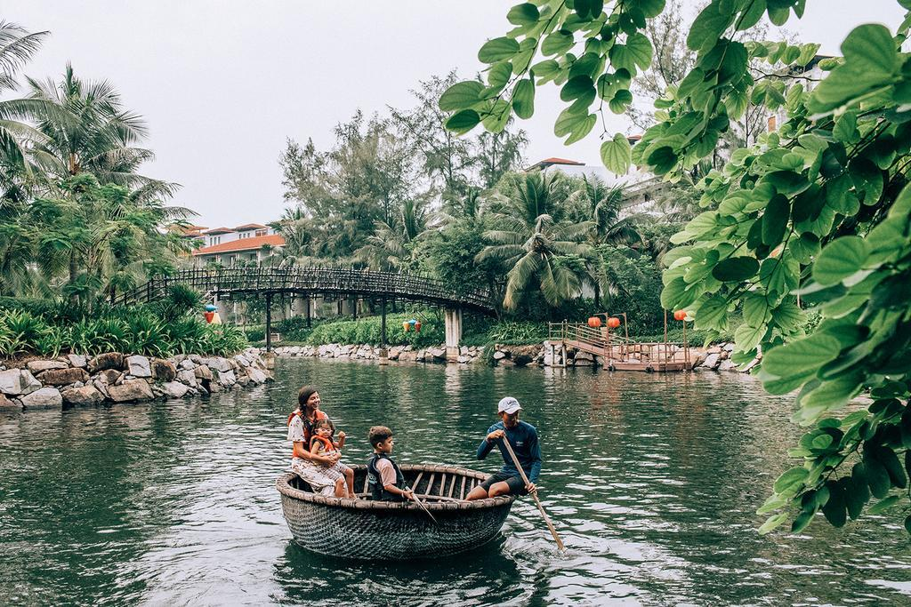
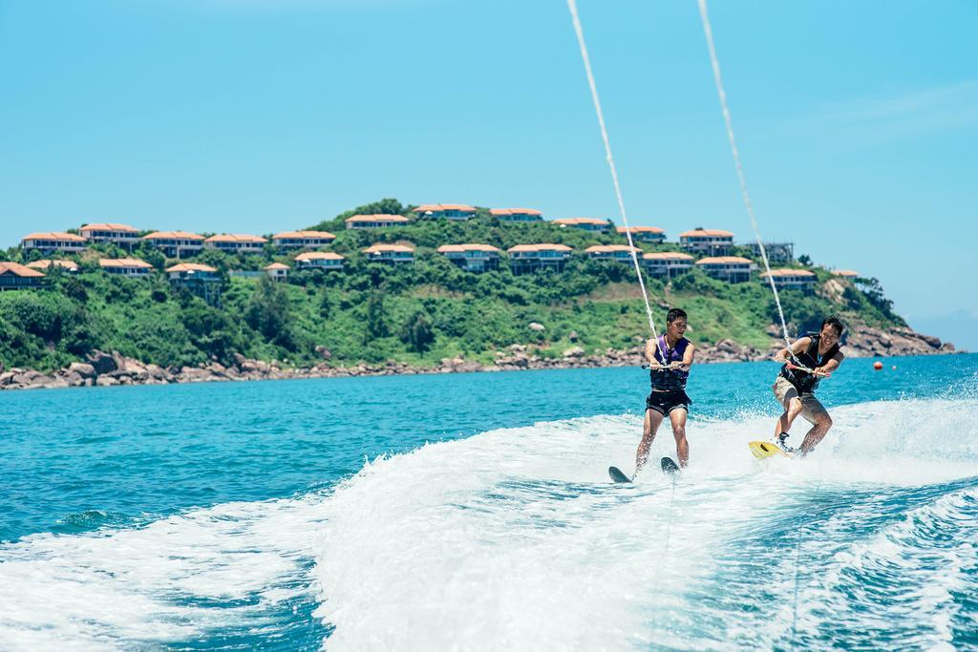
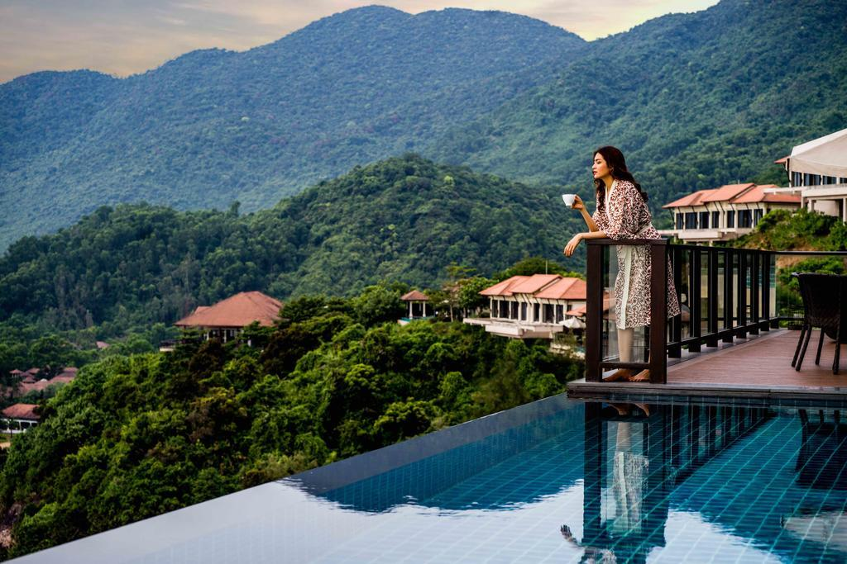
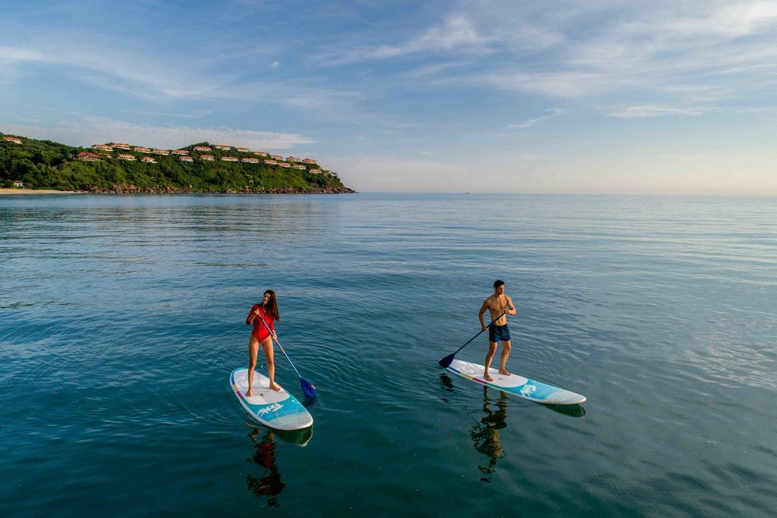
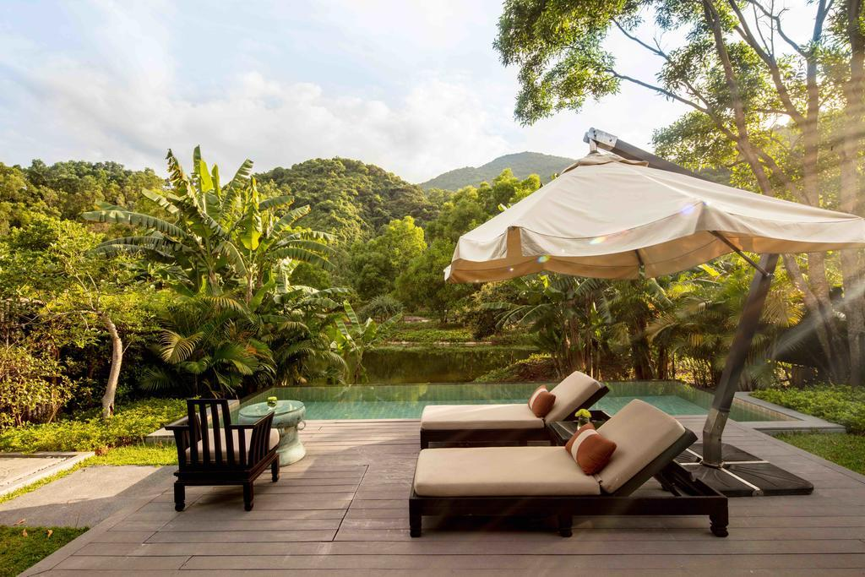
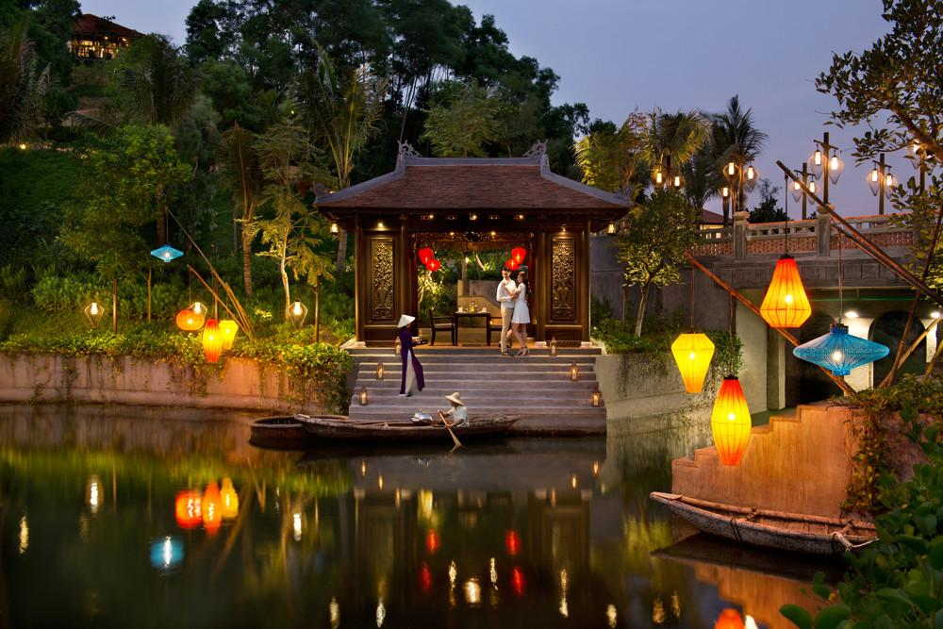
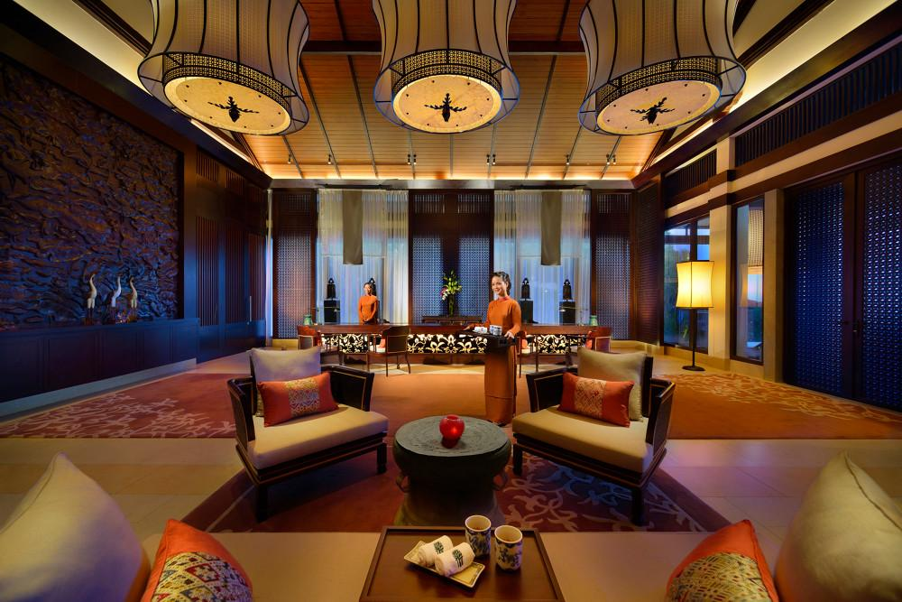
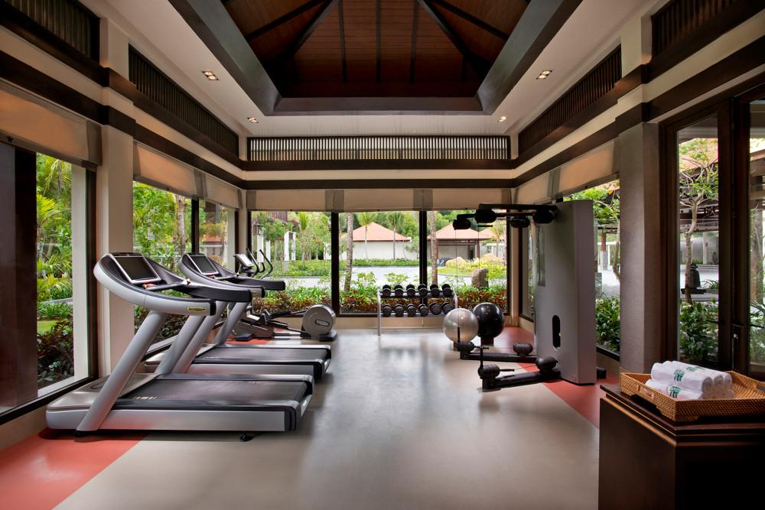
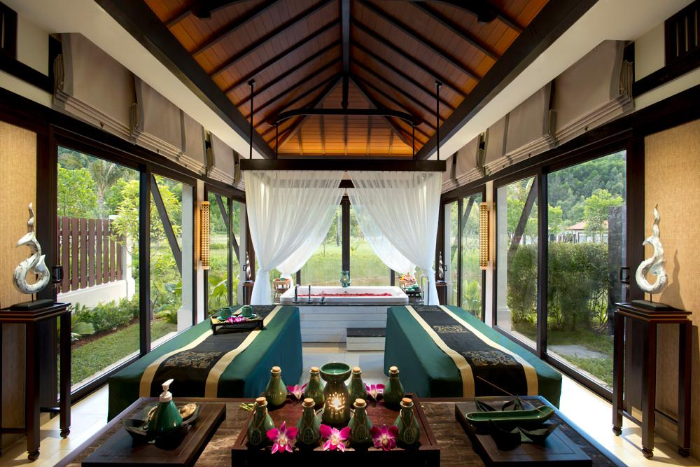
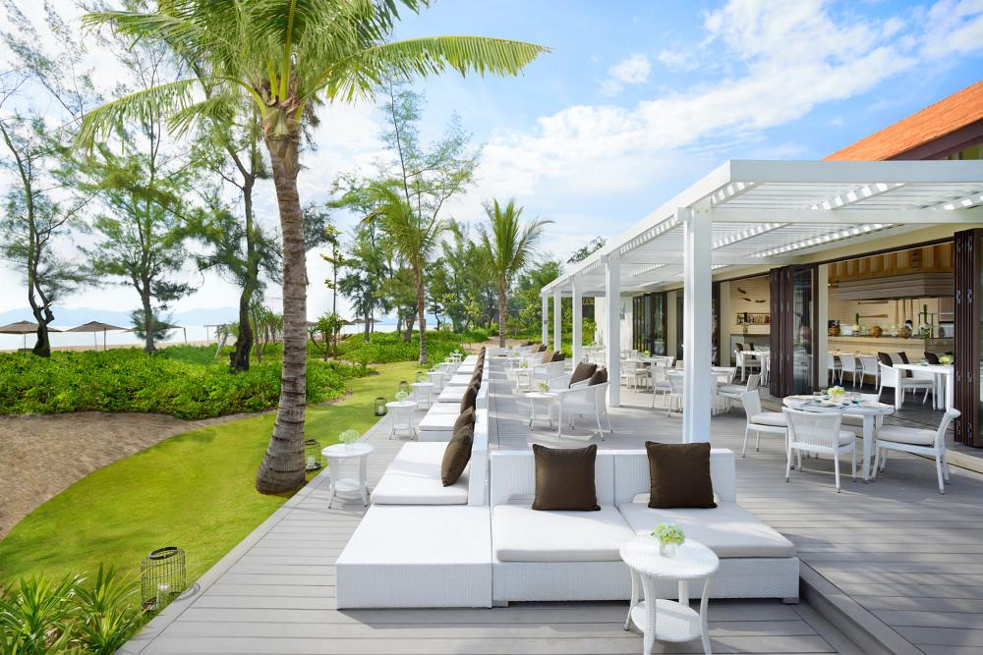
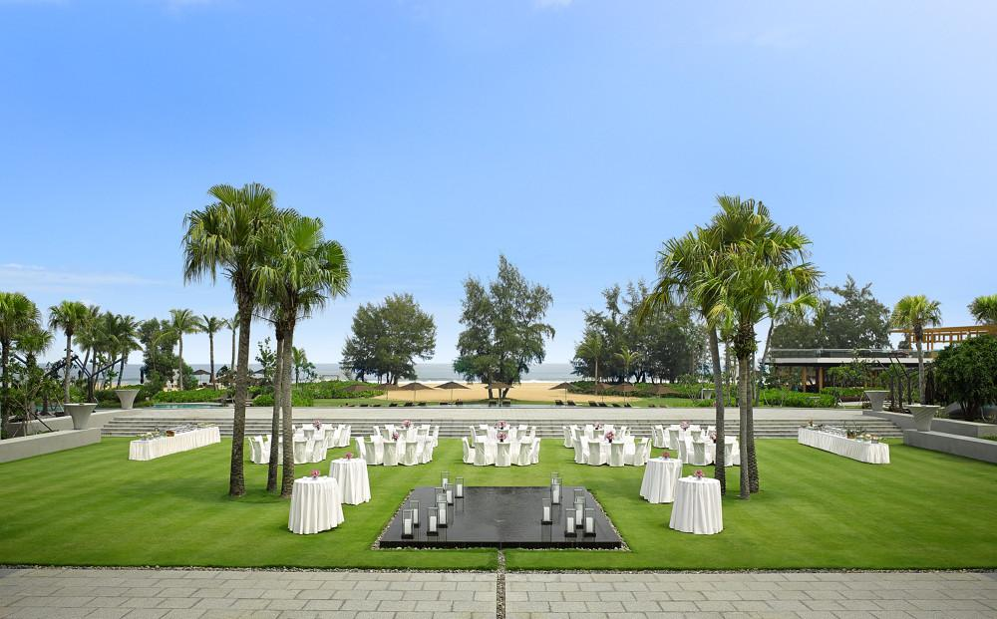
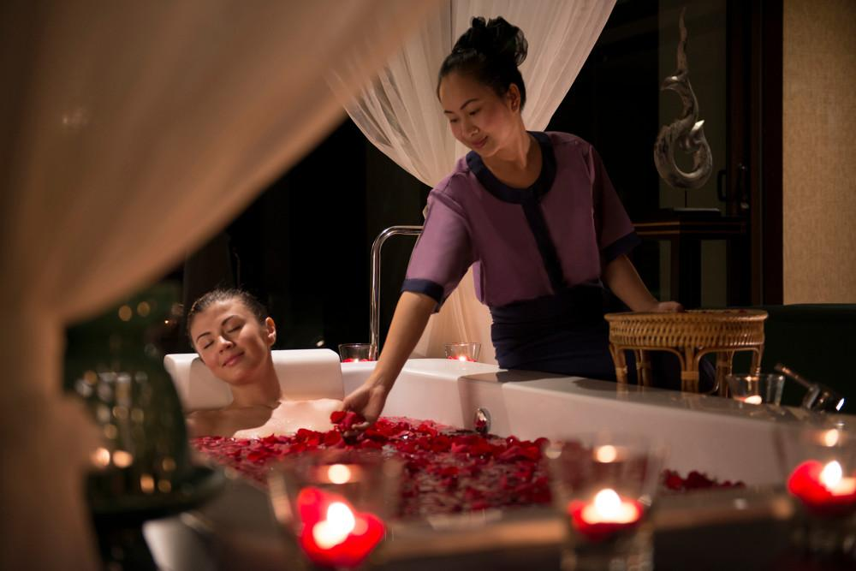

Easia Travel Head Office

Vietnam Head OfficeC/o: ATS Hotel, Suite 326 &327, 33B Pham Ngu Lao Street, Hanoi, VietnamTel: +84 24-39 33 13 62www.easia-travel.com

