CAMBODIA – Koh Kong – Shinta Mani Wild Tented Camp
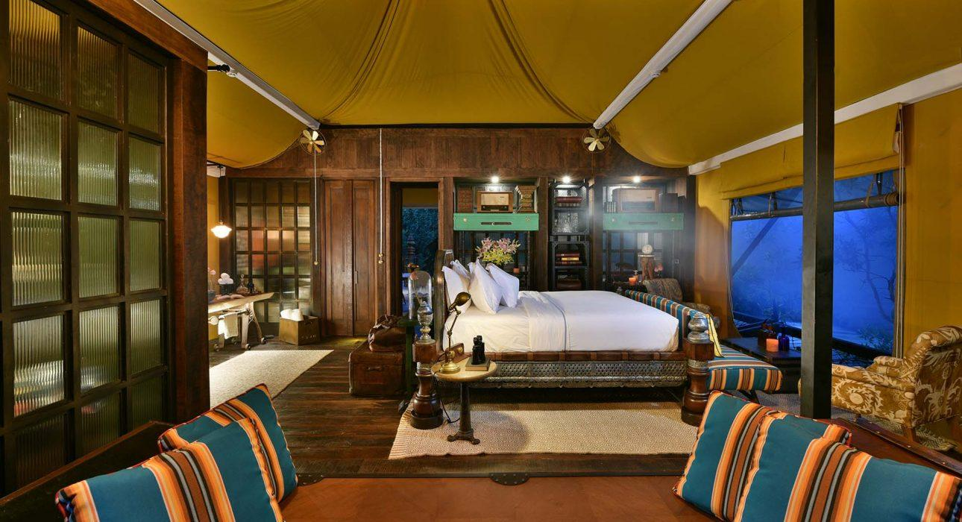

Over View

Theme
Honeymoon, Wellness

Country - City
Cambodia - Koh Kong

Official category
Tented Camp

Easia category
Luxury

Total number of rooms
15 tents

Price level
$$$$

Description

The Shinta Mani Wild – Bensley Collection is not only a great addition to Cambodia’s illustrious Shinta Mani hotel collection, but also contributes to the protection of 400 acres of wilderness in southwest Cambodia.The Shinta Mani Wild is located on the border of the three national parks – Kirirom, Bokor and Cardamom – which highlight one of Cambodia’s wildest, most remote areas. The fully-equipped camp has a plethora of nature and wildlife-focused activities available for guests to enjoy.Owned and designed by the famous Bill Bensley, the Shinta Mani Wild is a radical new concept for a luxury camp experience in Cambodia, with a combination of world-class design, top-notch services, and sustainability through the conservation of the surrounding flora and fauna.

Selling points

- a WOW and exclusive concept for a secluded yet luxury tented camp experience
- A unique combination of world-class design and top-notch services in the middle of a beautiful preserved area
- Due to the rich and lush environment, Shinta Mani Wild focuses on preserving its surrounding environment while making it an immersive experience for guests

Time & Transportation

From | To | Km | By | Duration | Road condition
Shinta Mani Wild | Phnom Penh | 179 kilometers | Car | 4 hours | Road under renovation and experience busy timings
Shinta Mani Wild | Sihanoukville | 167 kilometers | Car | 2hr 30min | Good

Rooms

Easia's recommend room type
- Wild Tent – 10 tents (100 m²) – Located in the compel intimacy rain-forest of the property, they are ideal for those who does not like to hear the water flow of the river
- Waterfall Tents – 4 tents (100 m²) – Located at the edge of the river, the tent face the river and the Cardamom Mountains while being in the complete intimacy of the rain- forest
- 2 Bedroom tents – 1 tent (141 m²) – Located near the headquarter, they are the only set of tent close by each other while being on the edge of the river. Ideal for family or friends stay-cation.

Room configuration

Connecting rooms
1

King bed
15

Services & Facilities

Services
24 hour reception, 24h security service, Afternoon Tea, Butler Service, In-Room Dining, Iron, Laundry service, Massage, Mobile phone, Porter, Private event, partying, Room Service, Spa, Swimming Pool, Wi-fi Free

Facilities
Air Conditioning, Bar, Business centre, Cable, satelite, coffee and tea making facilities, Fan, Flat screen TV, Full Board - B/L/D, In-Room safe, Internet, Jacuzzi, Library, Massage room, Mini Bar, Newspapers and magazine, Outdoor swimming pool, Private Pool, Restaurant, Safety Box, Terrace, TV Room, Safe

Restaurant information

Waterfall Restaurant:Cuisine: Khmer, WesternCapacity: 32 personsOperation hours: 6:00 – 24:00

Photos

Hotel Photos
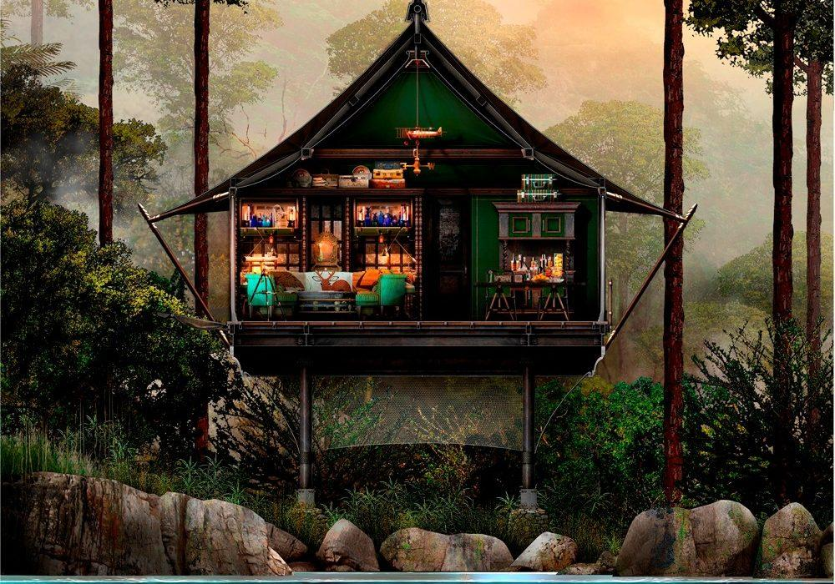
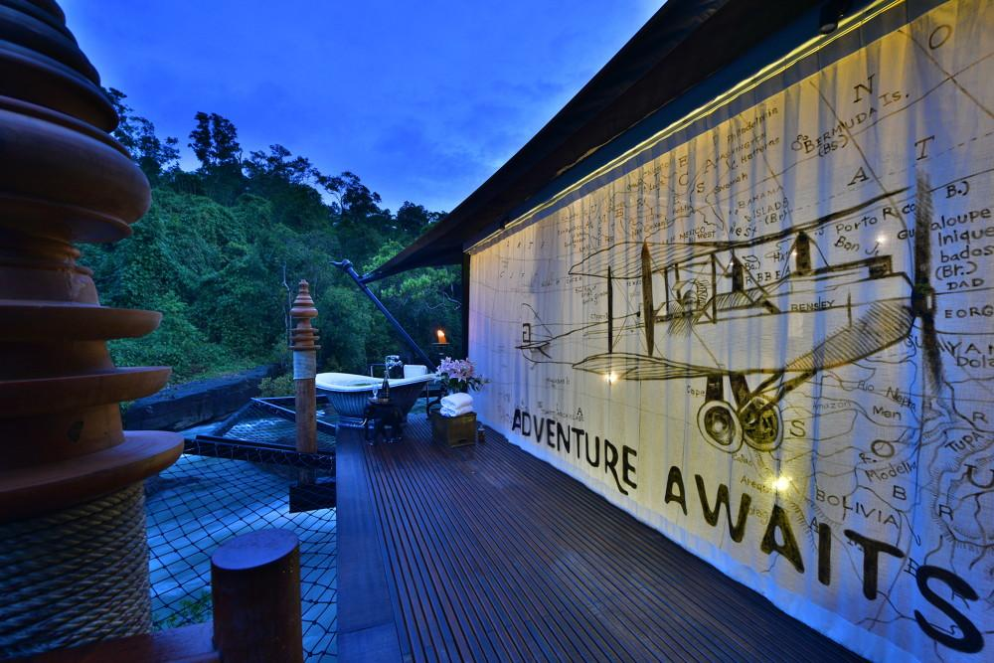

Rooms photos
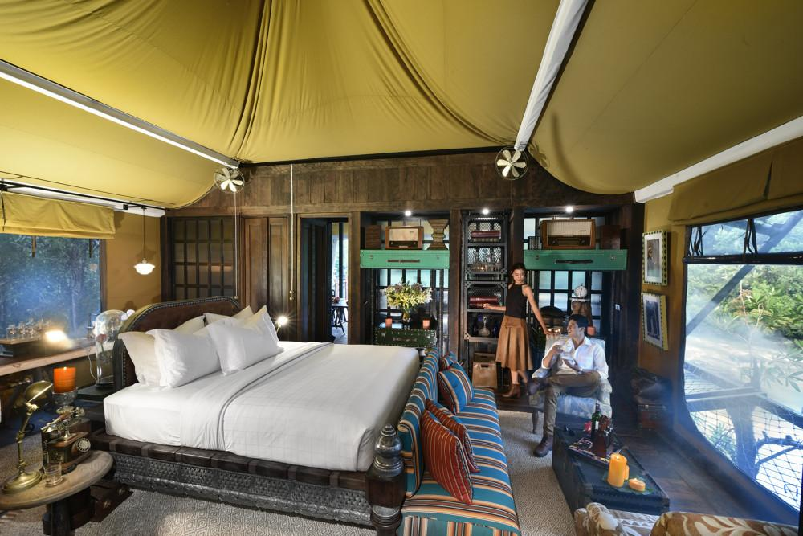
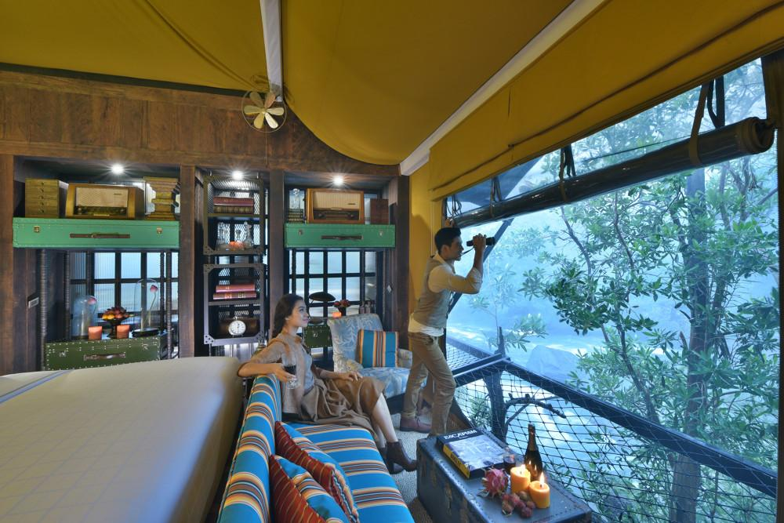
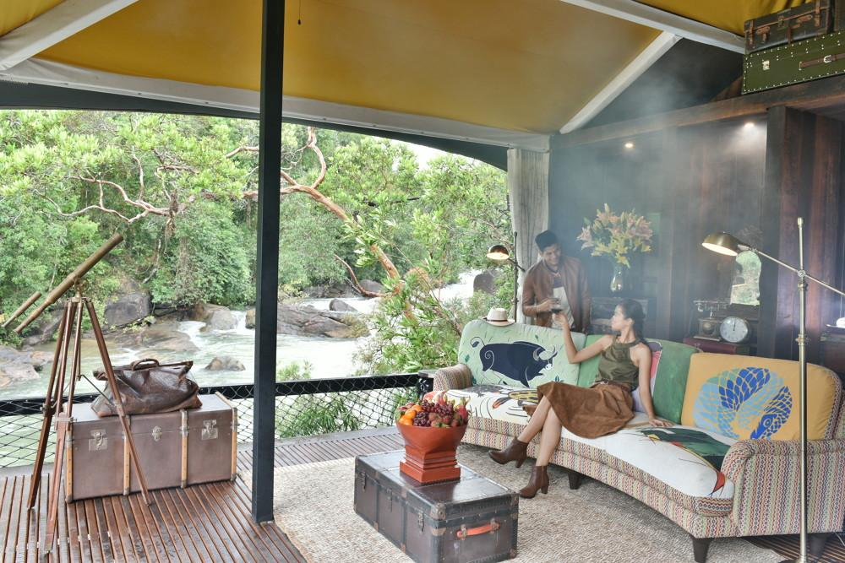
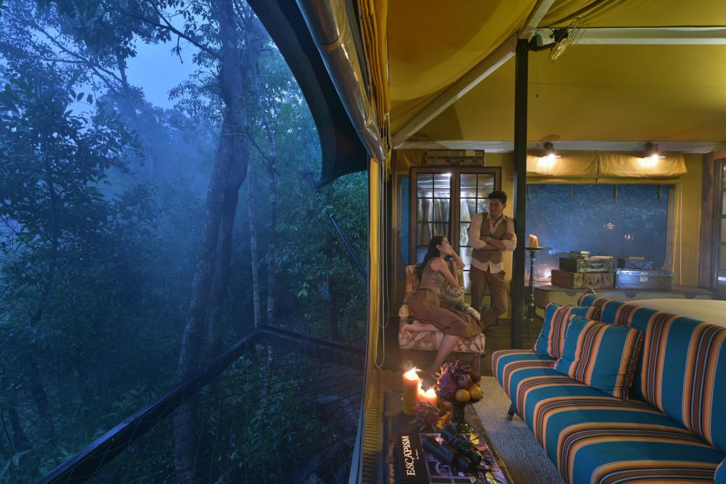
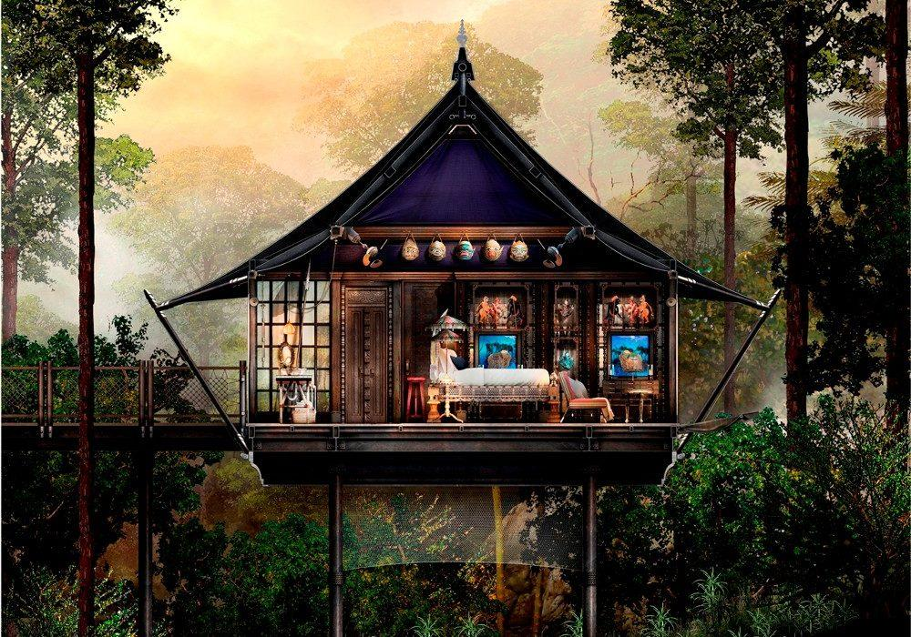
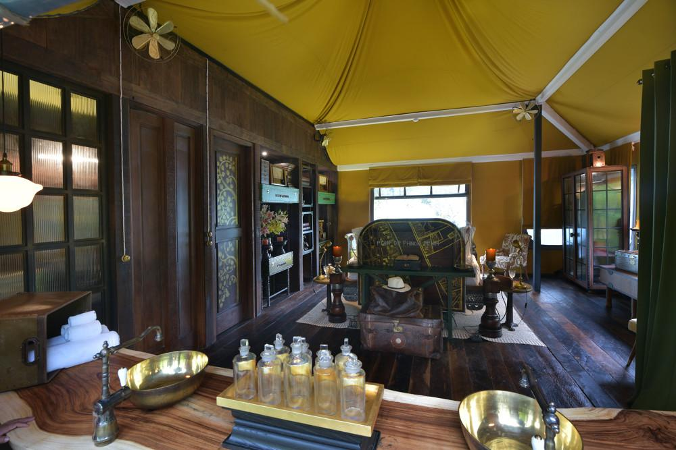
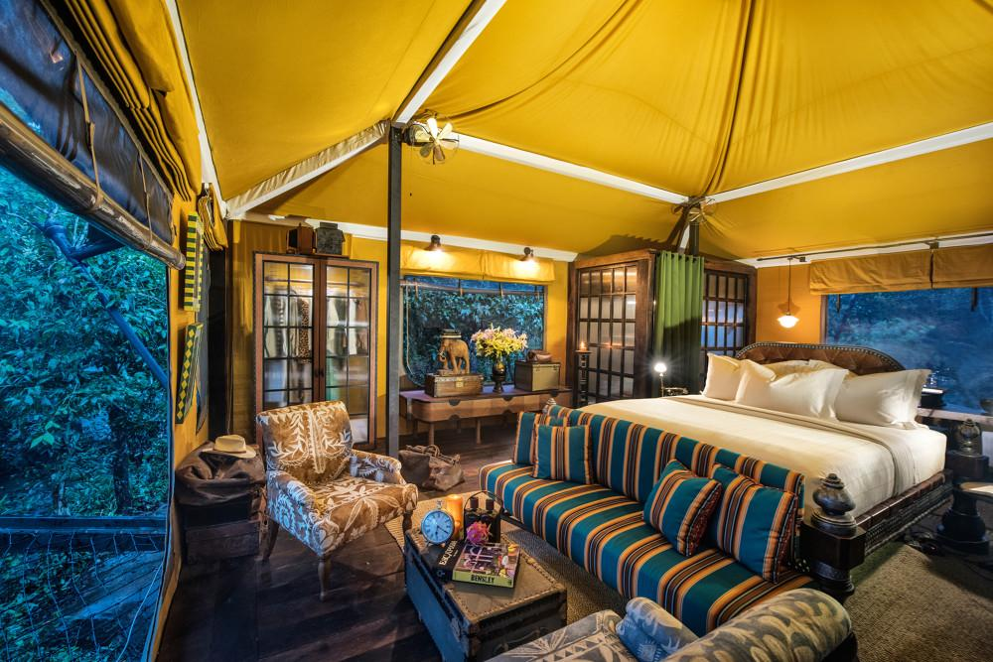
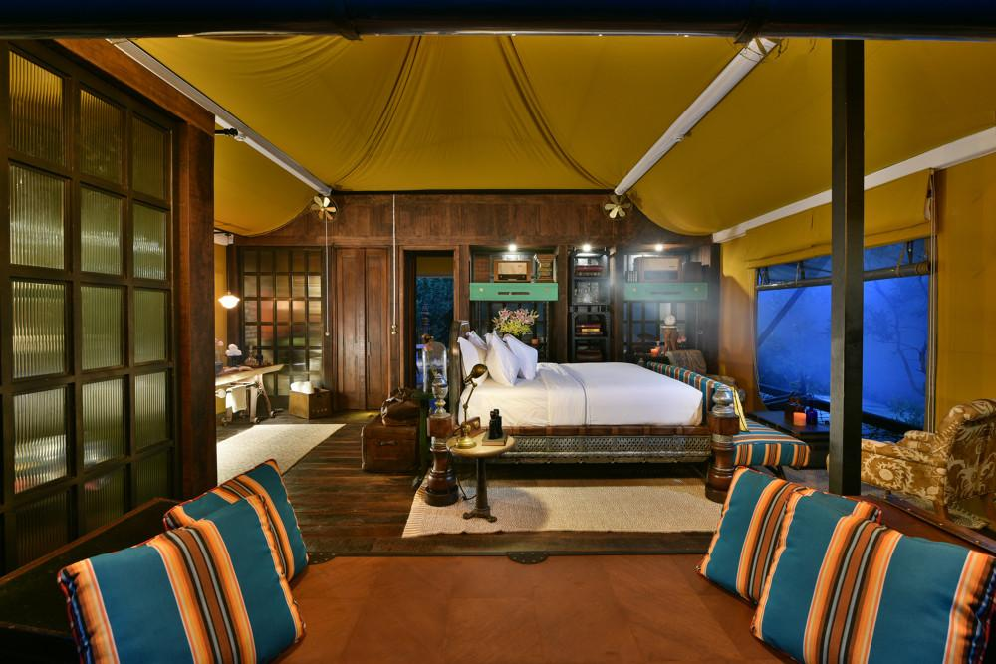
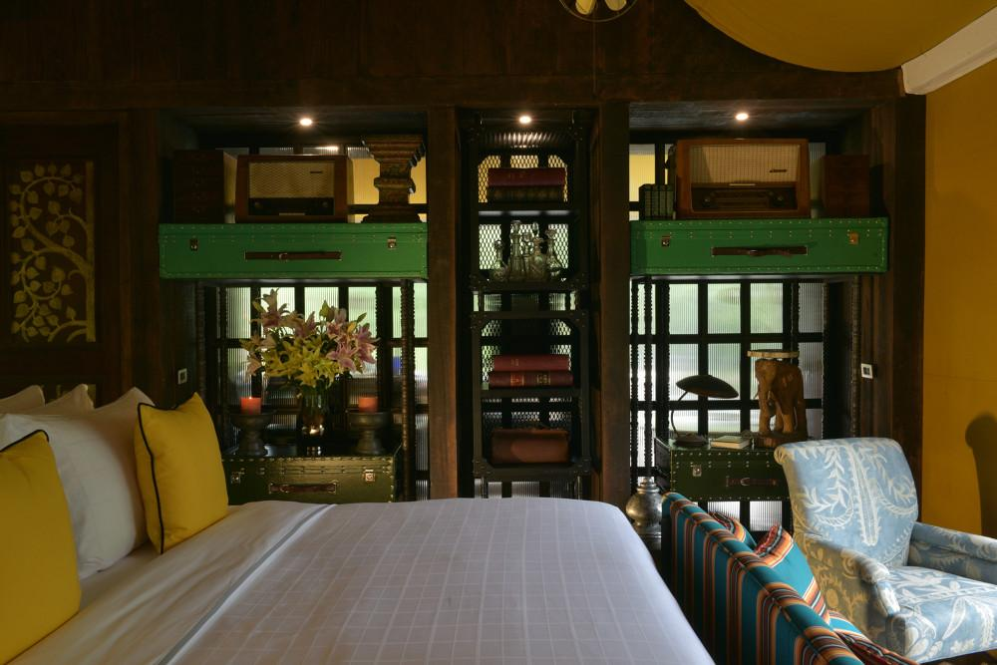
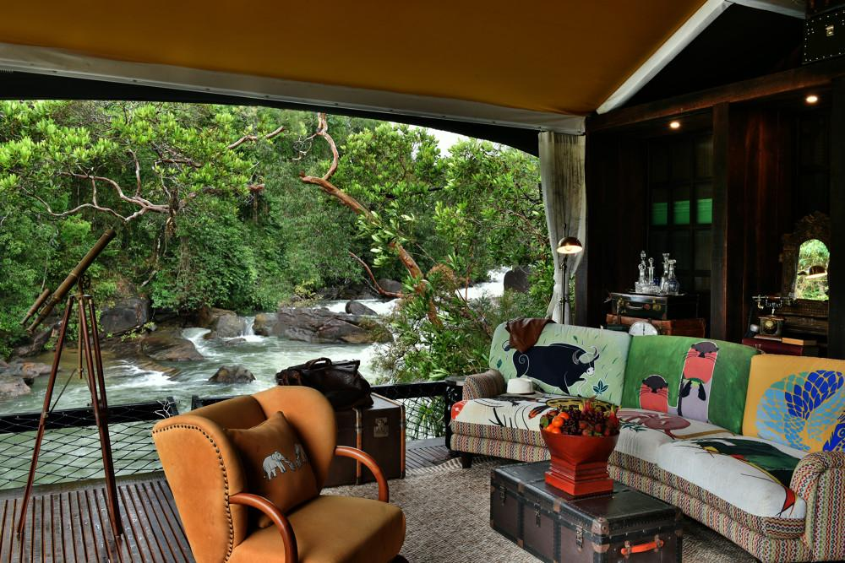

Services & facilities photos
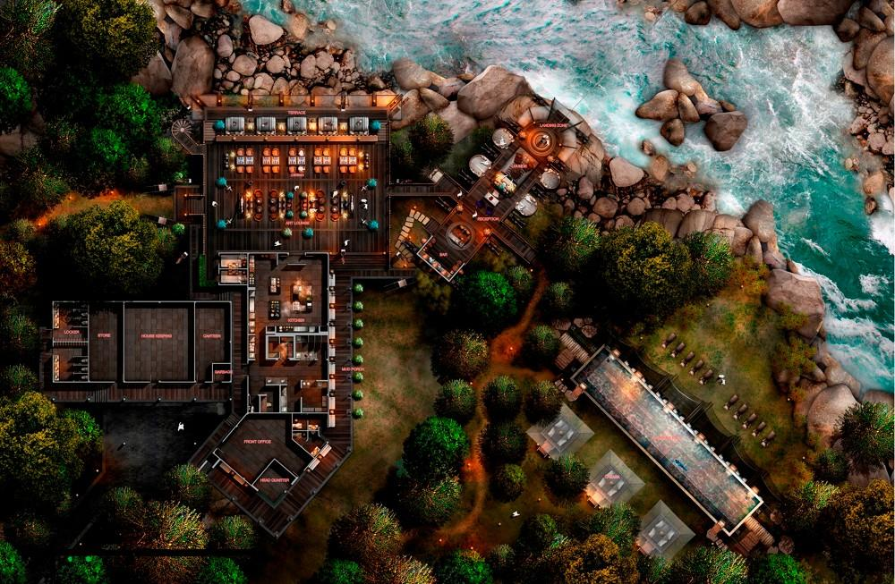

Easia Travel Head Office

Siem Reap BranchCharming City, No. R32 – R34, Road Rolouse, Trorpeangses Village, Sangkat Koukchork, Siem Reap Province – CambodiaTel: (855-63) 76 14 58Fax: (855-63) 76 14 58

