LAOS – Pakbeng – Le Grand Pakbeng
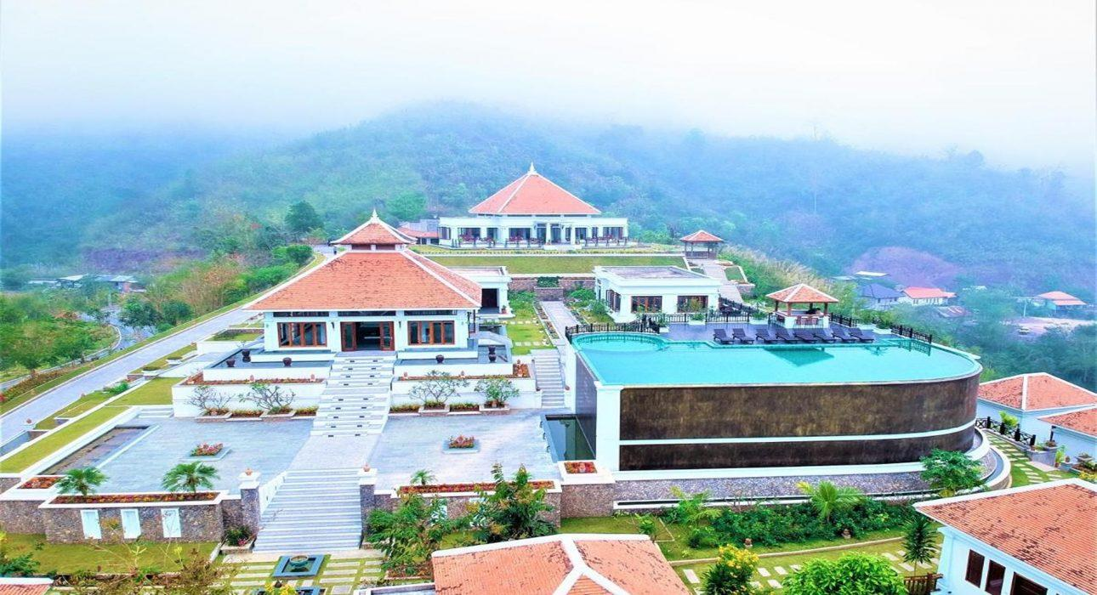

Over View

Theme
Classic, Honeymoon

Country - City
Laos - Pakbeng

Market segment
Groups, Thematic Leisure

Official category
4*

Easia category
First Class

Total number of rooms
45

Price level
$$$

Description

Halfway between Houei Xai and Luang Prabang, high above the mighty Mekong River valley and surrounded by the verdant jungle of northern Laos, sits the amazing Le Grand Pakbeng Resort. Perched around the hilltop are 45 self-contained villas and suites with private terraces and high-end facilities all of which provide a luxurious place to unwind and relax while enjoying the jaw-dropping views of the Mekong River and the surrounding mountains. This luxury resort guarantees a memorable stay with a highly personalized service combined with all-inclusive experiences, pampering treatment, and exquisite gourmet dining.

Selling points

- Amazing location high above the river provides stunning views.
- A variety of luxurious rooms with excellent facilities and amenities.
- High-quality and professional service.
- An incredible infinity pool on top of the hill – an incredible place to watch the sunset.
- Gourmet dining in a unique setting.

Sustainability

Supplier Actions
Protection of Environment

Certifications
Travel life

Time & Transportation

From | To | Km | By | Duration | Road condition
Le Grand Pakbeng | Oudomxai Airport | 170 km | Minivan | 3 h | Good
Le Grand Pakbeng | Public Boat Pier | 1.4 km | Car | 5 min | Good

Rooms

Easia's recommend room type
Room type:
- 4 Mountain Villas – 35m²
  - 2 Double; 2 Twin
- 33 Mekong Villas – 35m²
  - 13 Double; 20 Twin
- 7 Signature Villas – 37m²
  - 7 Double
- 1 State Room – 42m²
  - 1 Double

Room configuration

Connecting rooms
No

Extra bed
Yes-1,20m x 2m

King bed
2m x 2m

Twin beds
Yes-1,60m x 2m

Services & Facilities

Services
24 hour reception, 24h security service, Buffet Breakfast, Catering (beach, river, cave, other), Complimentary bottle of water, Complimentary fresh towel, Concierge service, Cooking Lesson, Credit Card payment, Currency exchange, Laundry service, Luggage Storage, Picnic boxes, Room Service, Swimming Pool, Tour desk, Wi-fi Free

Facilities
Air Conditioning, Bar, Business centre, coffee and tea making facilities, Conference hall, Fan, Garden, Internet, Mini Bar, Outdoor swimming pool, Restaurant, Shower With Hot Water, Terrace, Umbrella

Disabled Facilities
No disable access

Restaurant information

Indochine Restaurant
- Capacity: 90 pax
- Type of food: Asian, Western, Lao
- Opening hours: 06:00 – 24:00
Bistro Lounge
- Capacity: 30 pax
- Offers: Drinks, Wine, Cigars
- Opening hours: 11:00 – 24:00

Photos

Hotel Photos
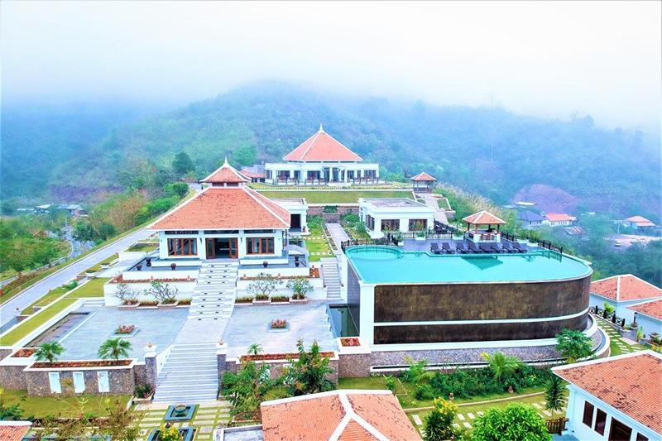
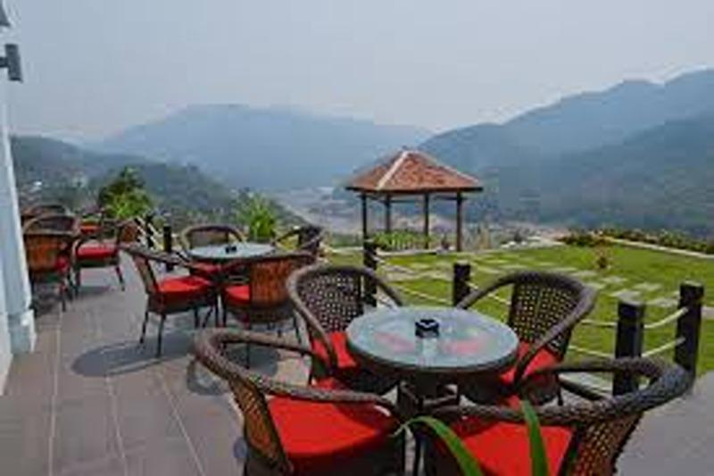
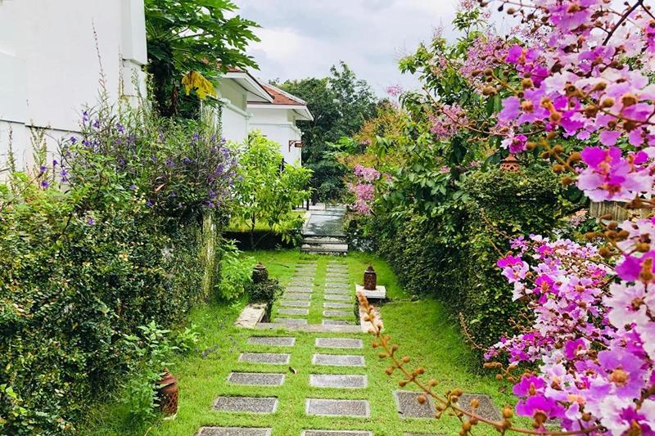
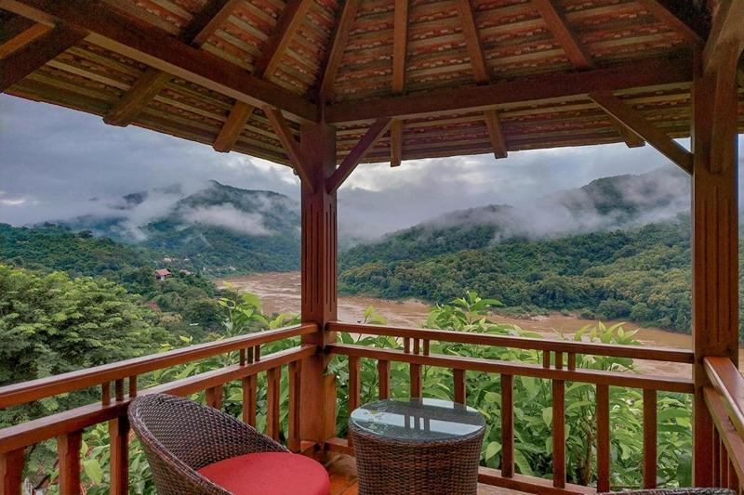
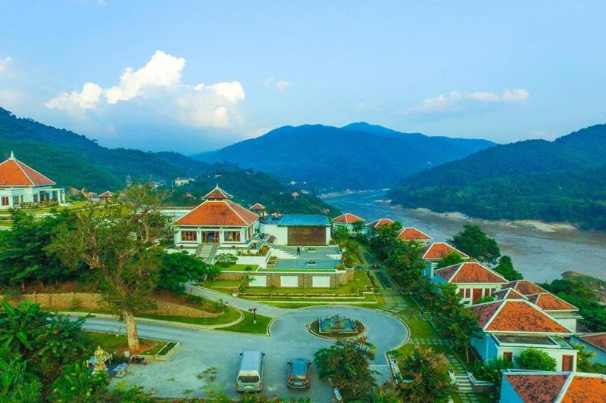
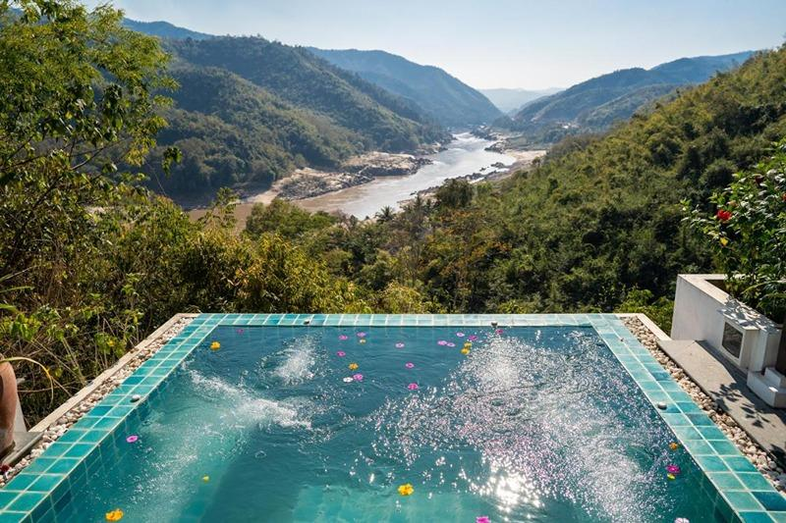

Rooms photos
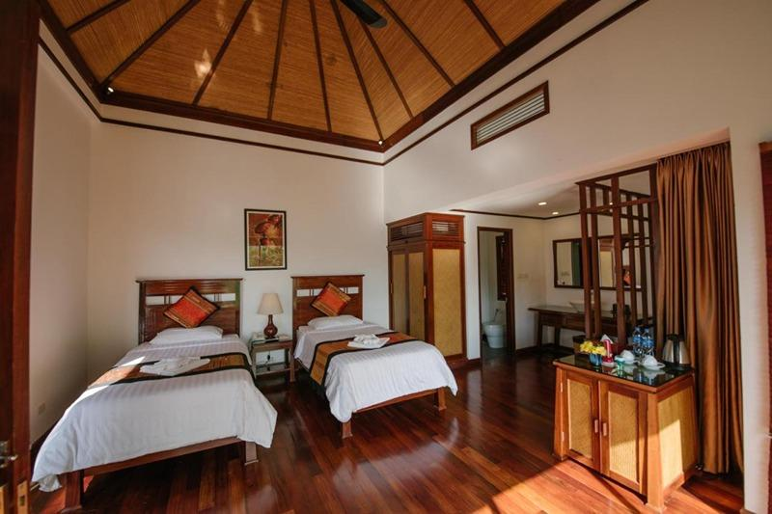
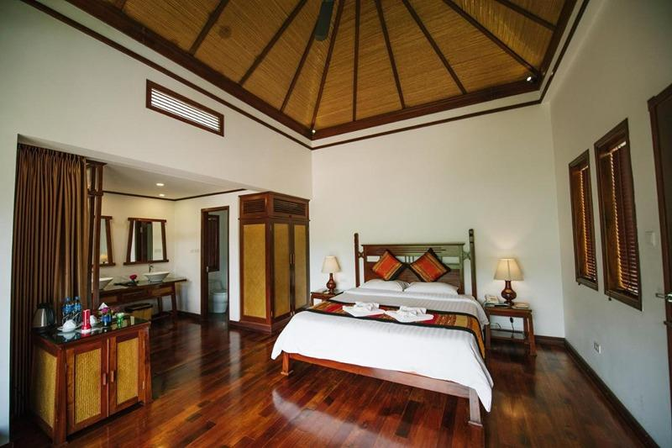
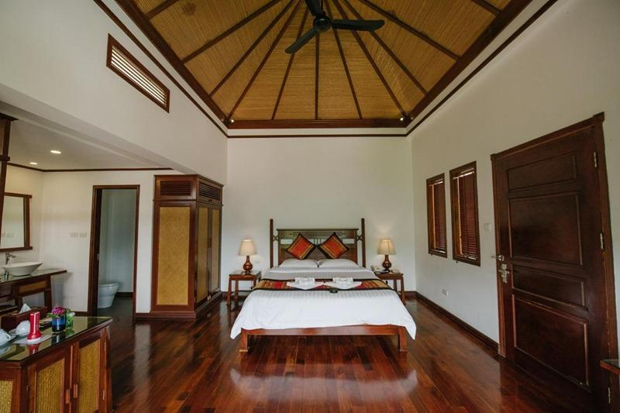
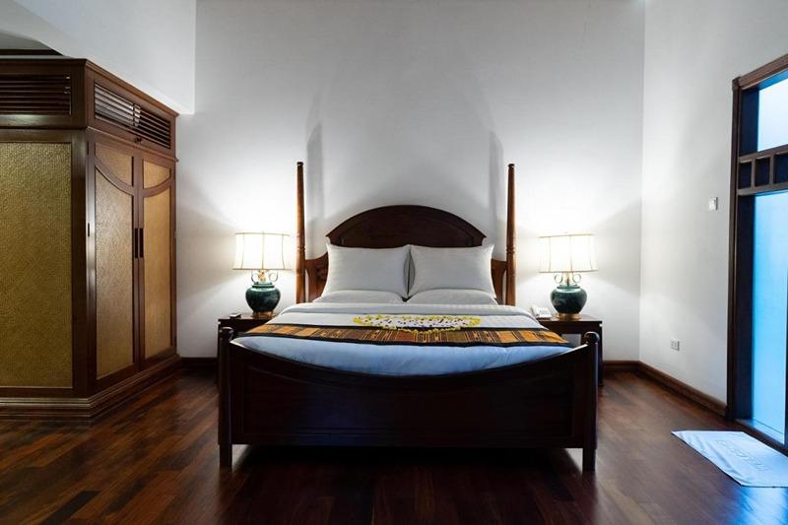

Restaurant photos

Services & facilities photos
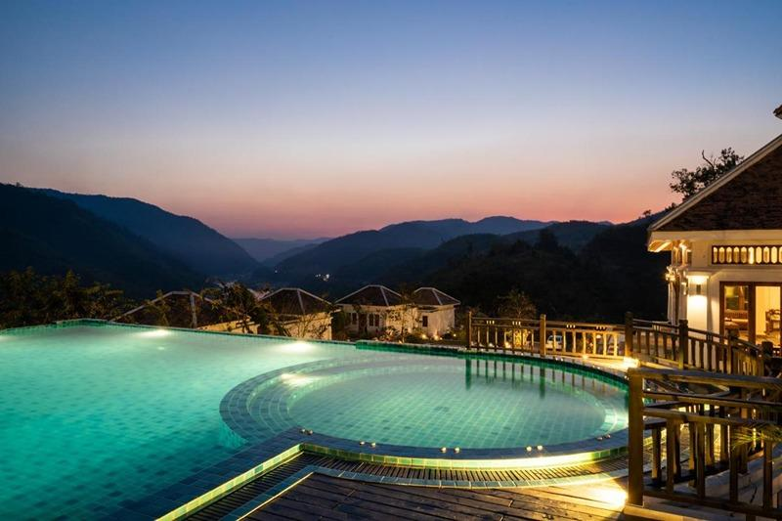
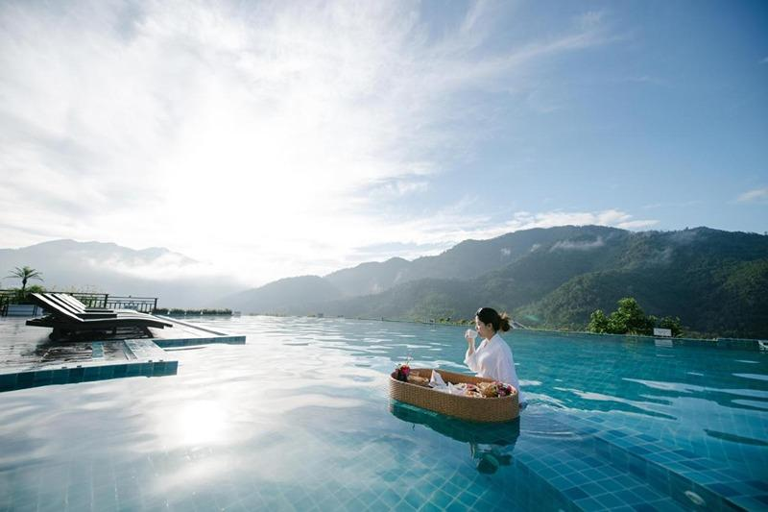
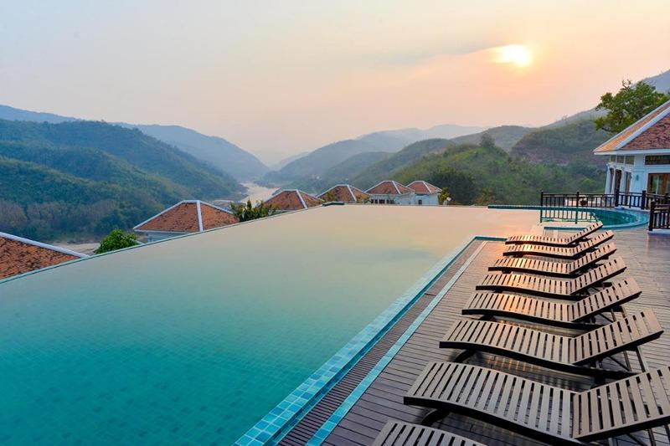

Easia Travel Head Office

Vietnam Head Office4th Floor – ATS hotel, 33B Pham Ngu Lao Street, Hoan Kiem District, Hanoi.T: +84 24-39 33 13 62 (ext. 251)

