VIETNAM – Hoi An – Hoian Rosemary Boutique Hotel
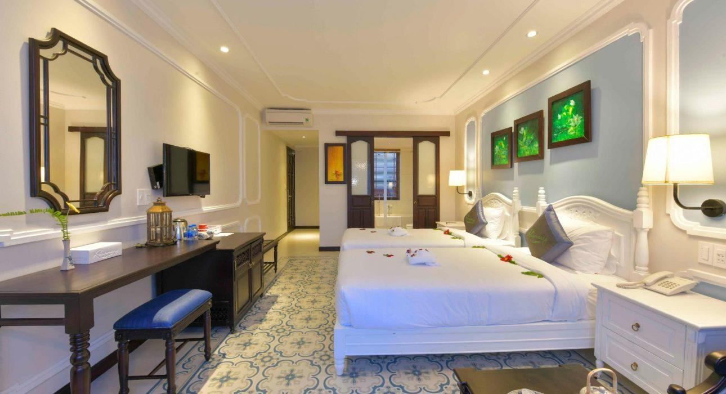

Over View

Theme
Family, Honeymoon

Country - City
Vietnam - Hoi An

Market segment
Groups

Official category
4*

Easia category
Superior

Total number of rooms
91

Price level
$$

Description

Situated at a walkable distance to Hoi An Ancient Town and Cua Dai Beach, Hoi An Rosemary Boutique Hotel is a great hotel with a variety of services to make travelers enjoyable.Hoi An Rosemary Boutique Hotel is a 4-star hotel with 91 modern and spacious rooms. The hotel offers plenty of public facilities such as: swimming pool, restaurant, conference room, gym, spa… that will meet the need of traveler during their stay. In addition, there are many tours to visit the scenic, traditional village or the experience of shopping, cooking Hoi An traditional dish… which travelers can book for themselves. Besides of modern facilities and friendly staff service, customers can also enjoy variety of cuisines from Vietnamese cuisine to Western cuisine.

Selling points

- Competitive price
- Near the center

Time & Transportation

FROM | TO | DISTANCE (KM) | BY | DURATION | ROAD CONDITION
Hotel | Hoi An Town | 01km | Shuttle bus | 05minutes | Good
Hotel | An Bang Beach | 4km | Shuttle bus | 15 minutes | Good

Rooms

Easia's recommend room type
- Room type:
Rosemary Deluxe: 49 rooms = 35 m2TPL Deluxe: DBL/TWIN +extrabed= 10 rooms = 45m2Rosemary Suite: 05 rooms = 45m2Family Quadruple:15 rooms= 50m2Family 02 bed suite: 06 rooms = 75m2

Room configuration

Connecting rooms
They don’t have connecting room.

Extra bed
They have extra bed, it’s fixed bed.

Queen bed
1,8 x 2 m

Twin beds
1m1 x 2 m.

Services & Facilities

Services
24 hour reception, 24/7 nursing &amp;amp; medical services, 24h security service, Airport transfer, Catering (beach, river, cave, other), Complimentary fresh towel, Credit Card payment, Massage, Room Service

Facilities
Air Conditioning, Bar, Bicycle, Business centre, Cable, satelite, Conference hall, Elevator, Family Room, Fitness centre, Flat screen TV, Free private parking, Outdoor swimming pool, Private Beach, Steam/Sauna, Terrace, TV Room, Umbrella

Business facilities details
ROOM NAME | SIZE | CLASSROOM | THEATER | U SHAPE | BOARDROOM | BANQUET
MEETING ROOM |  | 40 | 60 | 32 | 40 | 40

Restaurant information

Rosemary Restaurant
- Capacity: 120 seats.
- Opening Hours: 6h30 am – 22:00 pm
- Type of Cuisine: Vietnam and western dishes.

Photos

Hotel Photos
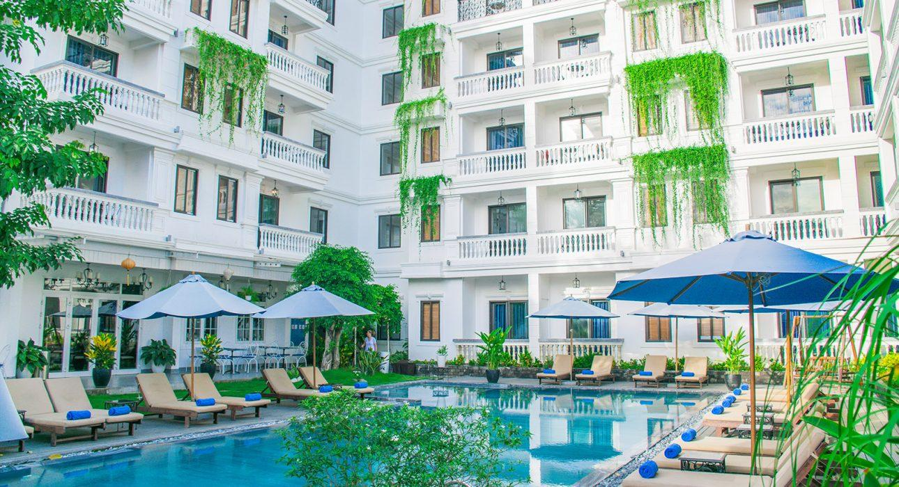

Rooms photos
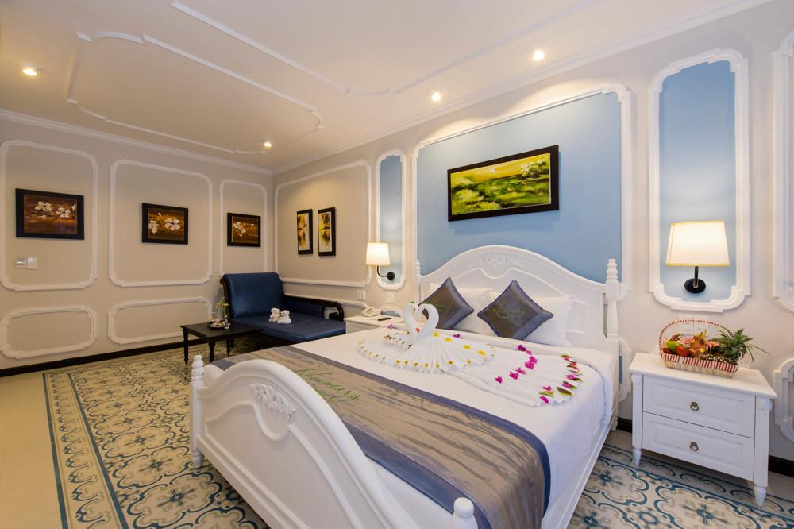
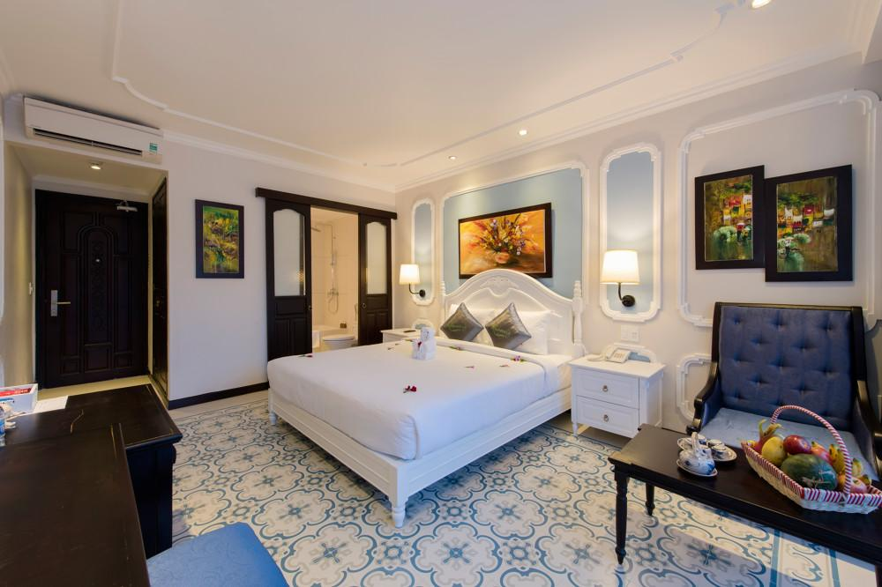
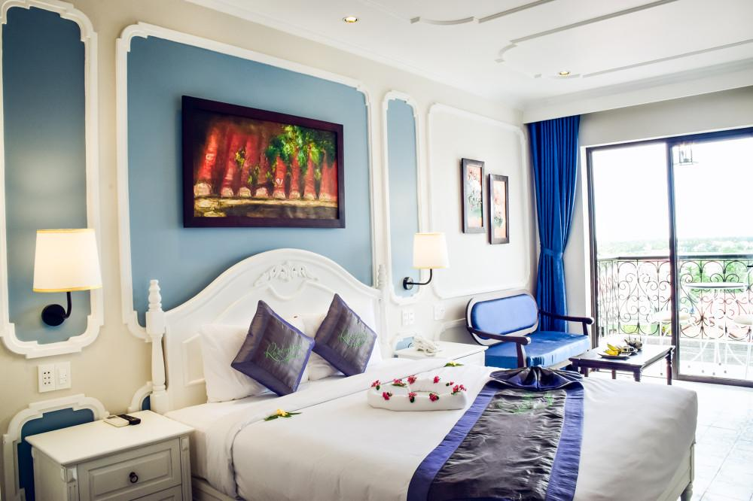
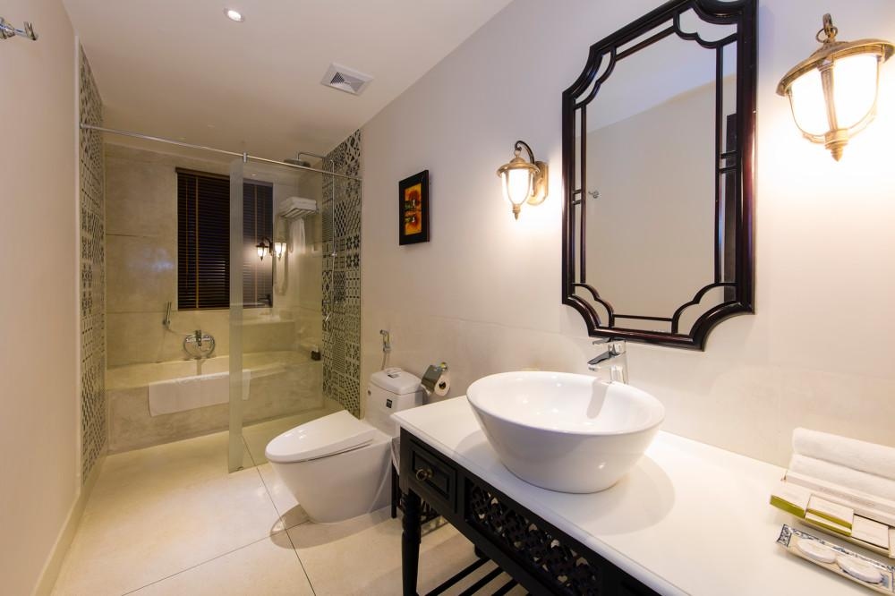
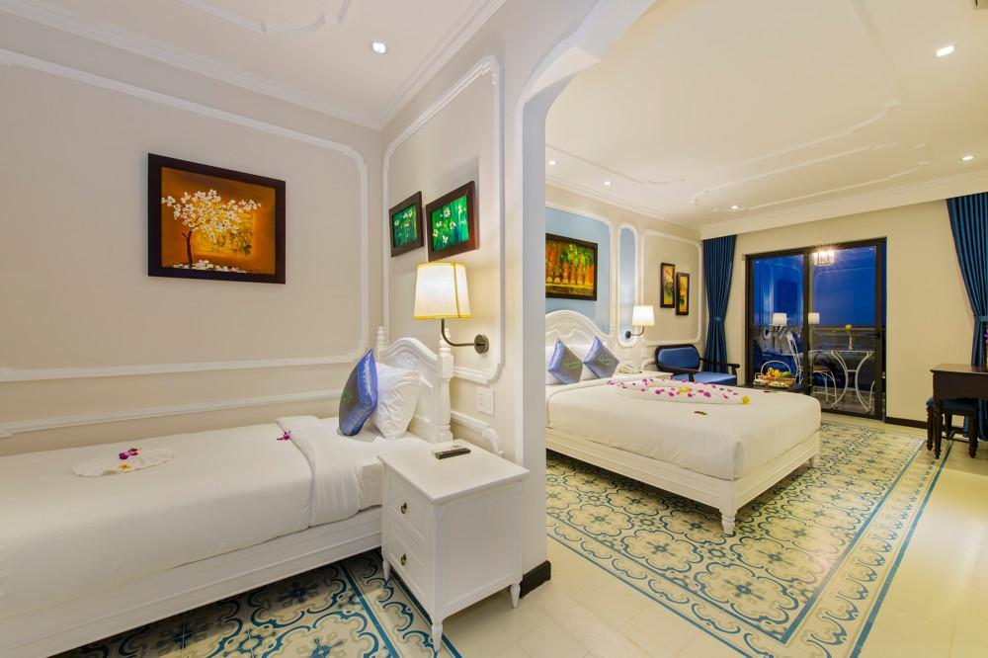
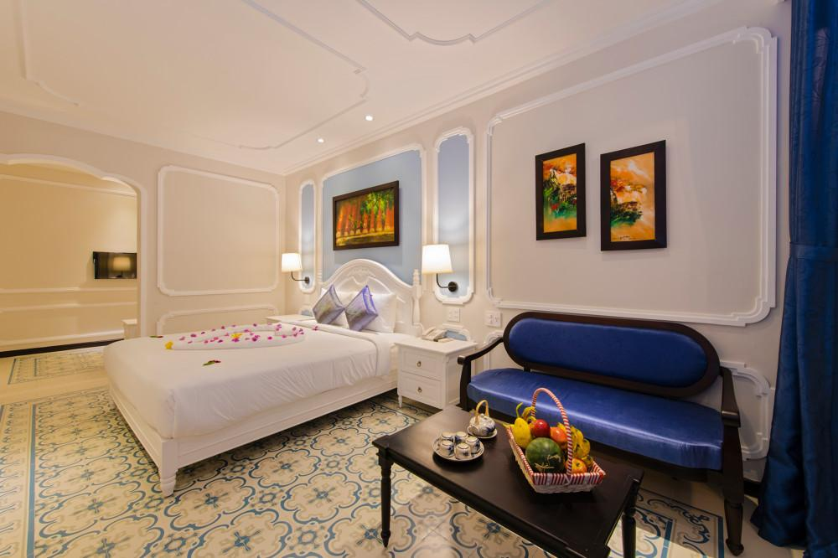
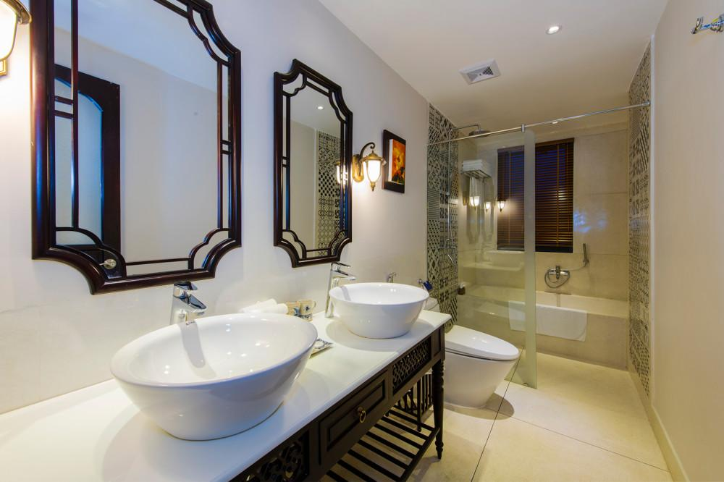
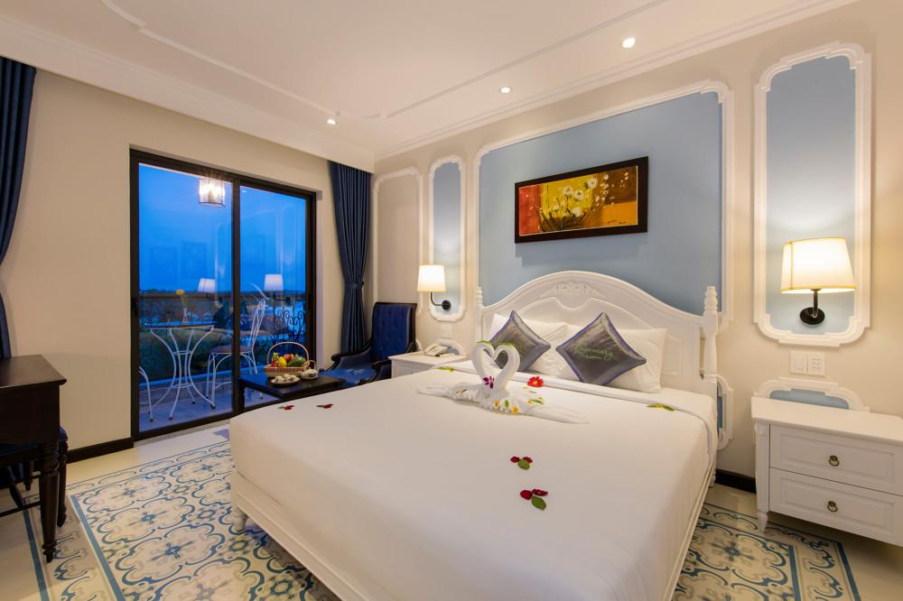
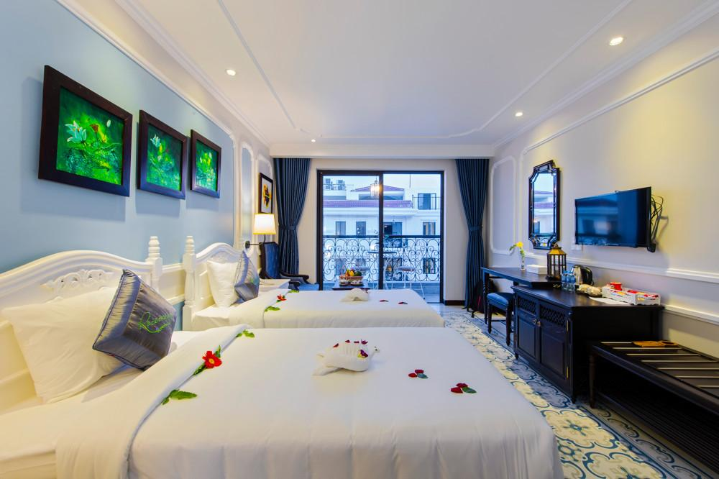
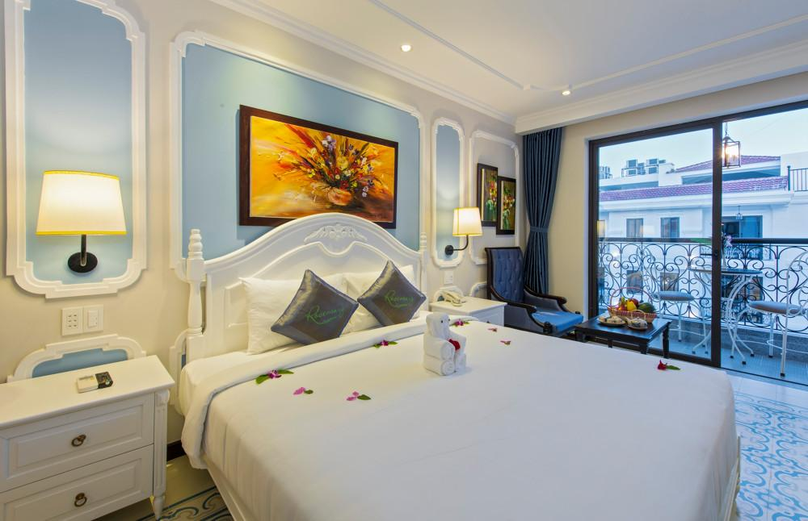
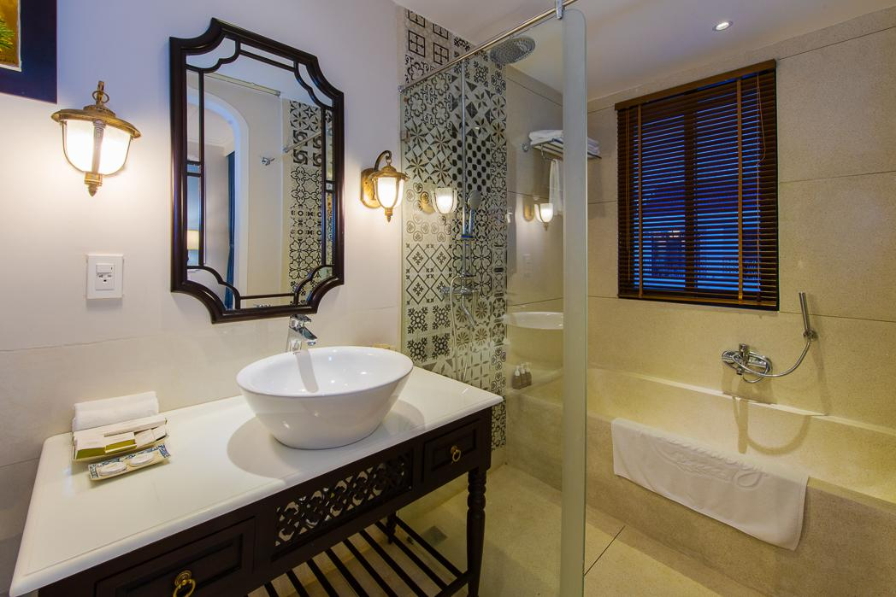
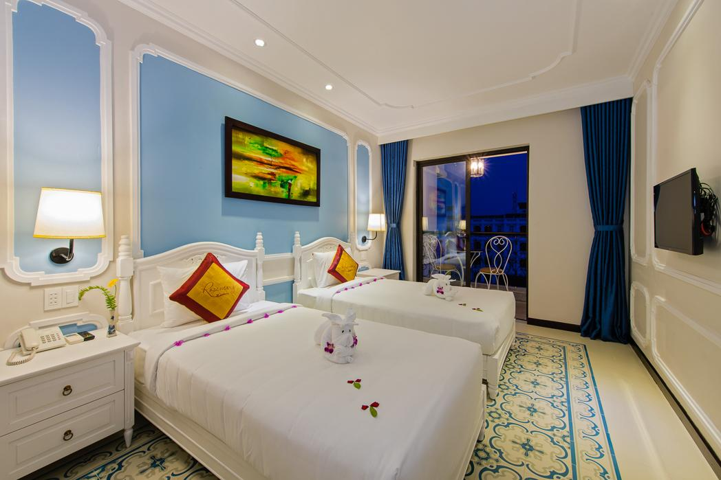
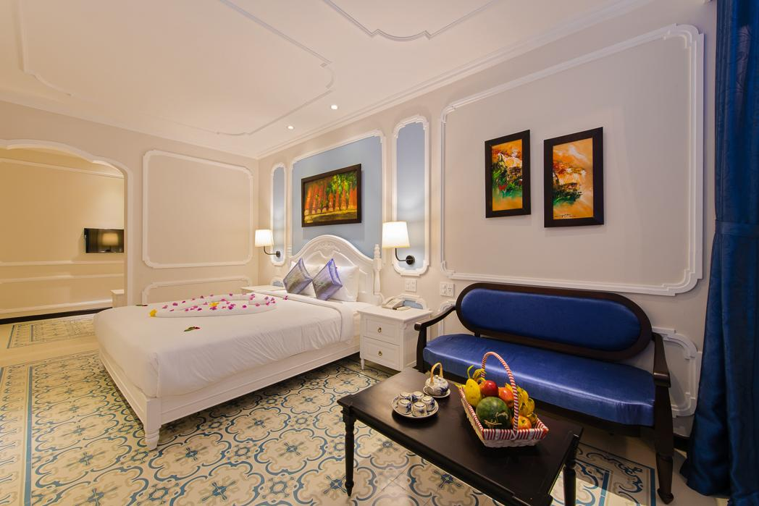

Restaurant photos
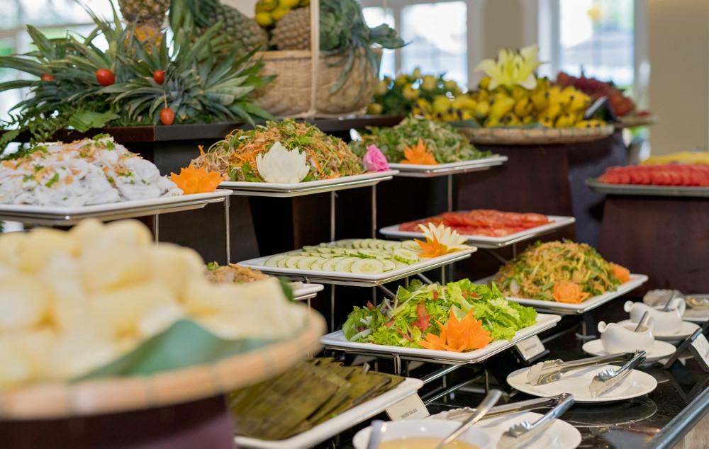
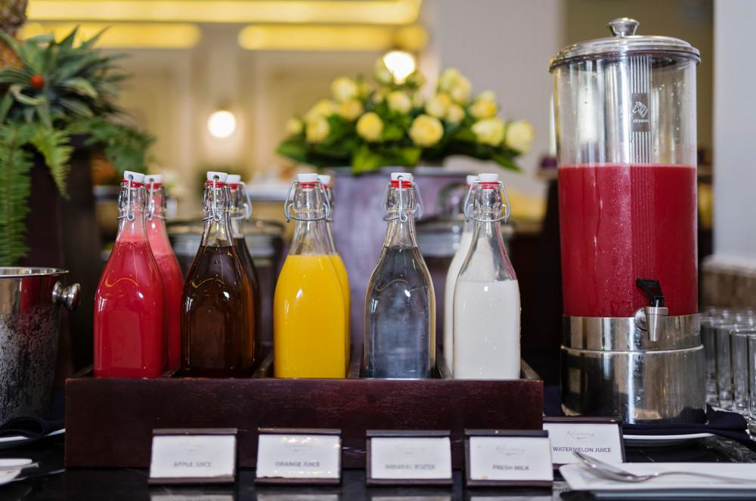

Business facilities photos
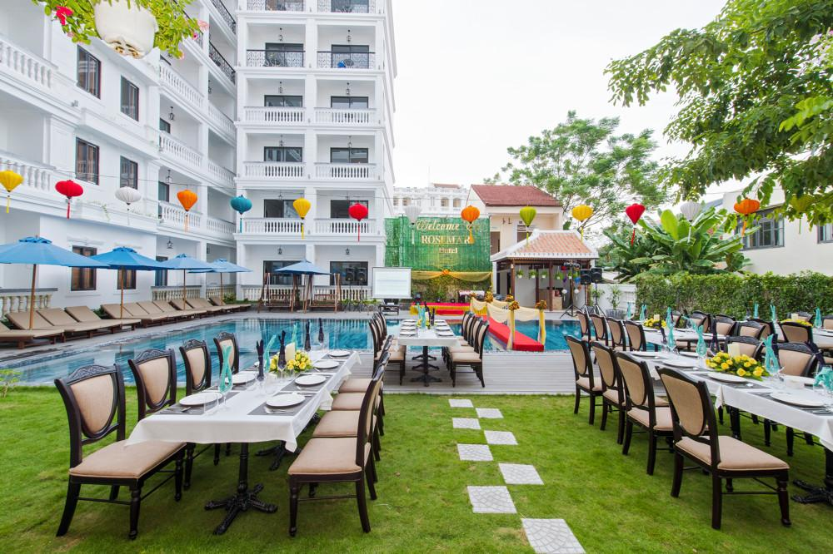
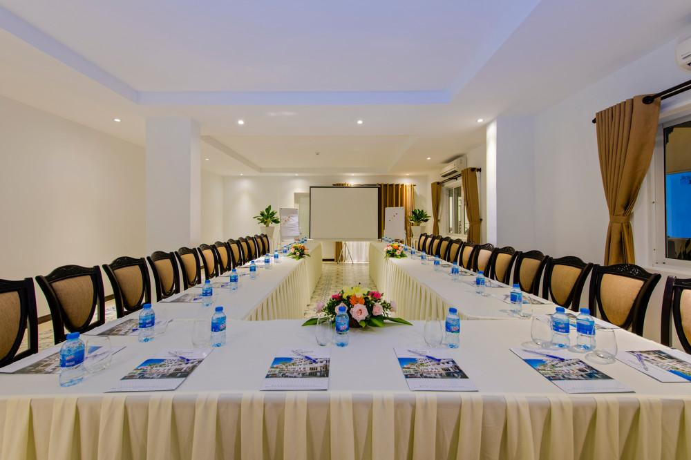

Services & facilities photos

Easia Travel Head Office

Vietnam Head OfficeC/o: ATS Hotel, Suite 326 &327, 33B Pham Ngu Lao Street, Hanoi, VietnamTel: +84 24-39 33 13 62www.easia-travel.com

