THAILAND – Phuket – Beyond Patong
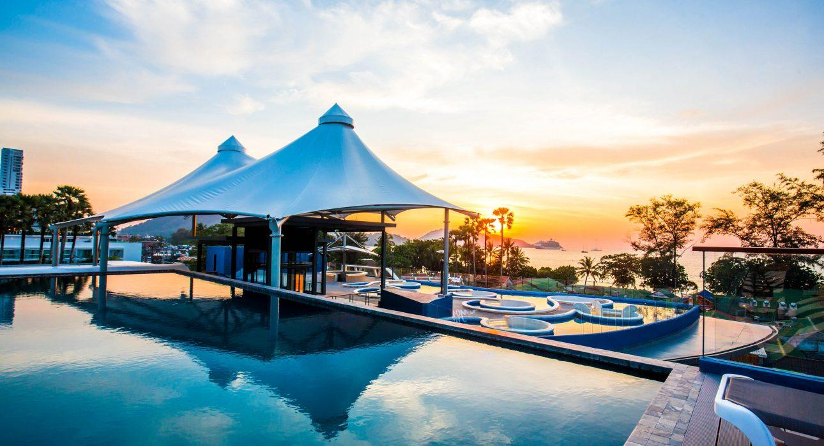

Over View

Theme
Classic, Honeymoon

Country - City
Thailand - Phuket

Market segment
Groups, Thematic Leisure

Official category
4*

Easia category
First Class

Total number of rooms
161

Price level
$$$

Traveller made amenities
No

Description

Beyond Patong is a newly-build hotel in Patong, arguably Phuket’s finest beach area, and features a highly distinctive design – a “Deep Blue Sea” theme – that takes its inspiration from wave shapes and marine life. The architectural and interior design is at the heart of the hotel concept, forming an attraction in and of itself for visitors. Beyond Patong stands to be a new landmark in Patong, a hotel in which guests can relax completely with family and friends, and which will be an integral part of their Phuket holiday experience.

Selling points

- Convenience location in Patong beach
- Modern and comfortable rooms
- Local brand ” Beyond ” is quite well known in European market

Time & Transportation

FROM | TO | KM | DURATION | BY | ROAD CONDITION
Hotel | Phuket International Airport | 30 | 1 hour | Car | Good
Hotel | Phuket Old Town | 15 | 30 minutes | Car | Good
Hotel | Big Buddha | 25 | 50 minutes | Car | Good

Rooms

Easia's recommend room type
- Premier Deluxe A (33 sqm.)
- Premier Deluxe B – Enclosed Bathroom (33 sqm.)
- Beyond Deluxe (38-40 sqm.)
- Beyond Room (30 sqm.)

Room configuration

Connecting rooms
No

Extra bed
Yes

King bed
Yes

Queen bed
Yes

Twin beds
Yes

Services & Facilities

Services
24 hour reception, 24h security service, Airport transfer, Buffet Breakfast, Complimentary bottle of water, Complimentary fresh towel, Concierge service, Credit Card payment, Currency exchange, Dry Cleaning, Laundry service, Porter, Room Service, Spa, Swimming Pool, Wake-up service

Facilities
Air Conditioning, Bar, Cable, satelite, coffee and tea making facilities, Elevator, Family Room, Fitness centre, Flat screen TV, Free private parking, Hair Dryer, In-Room safe, Internet, Massage room, Meeting room, Mini Bar, Outdoor swimming pool, Restaurant, Safety Box, satellite LCD TV, Shower With Hot Water, Umbrella

Restaurant information

- Beyond Seafood
  - Open from breakfast until late in the evening, Beyond Seafood offers diners a choice of indoor and outdoor seating, and in addition to the main restaurant area, features four distinct and special areas for dining in style.

- Beyond Sky bar
  - On the rooftop, with cooling ocean breezes and glorious views of the shimmering blue horizon, Beyond Sky bar is where you sit back and relax with one of the exciting cocktails whipped up by the mixologist.

Photos

Hotel Photos
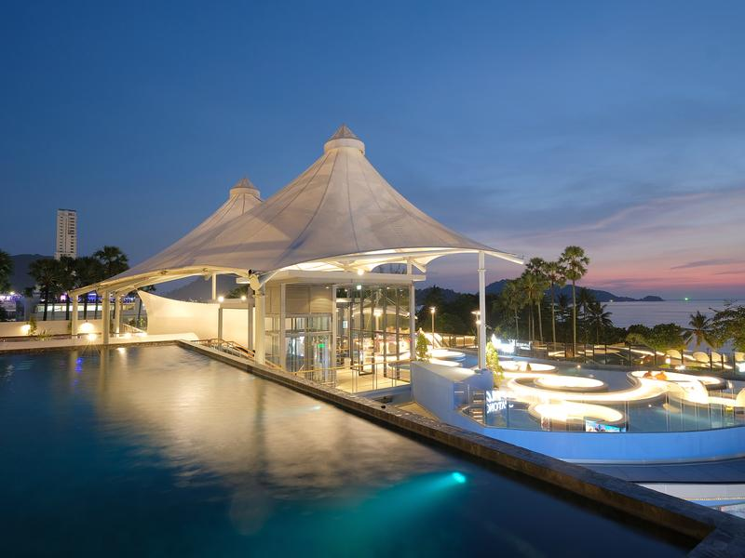
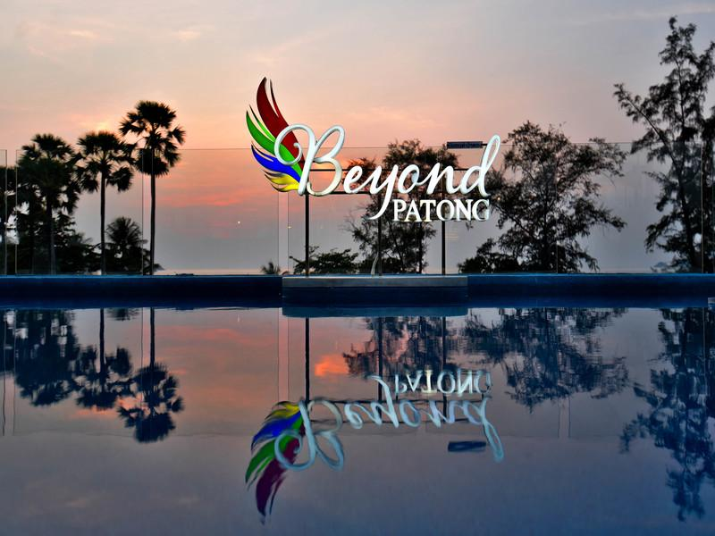

Rooms photos
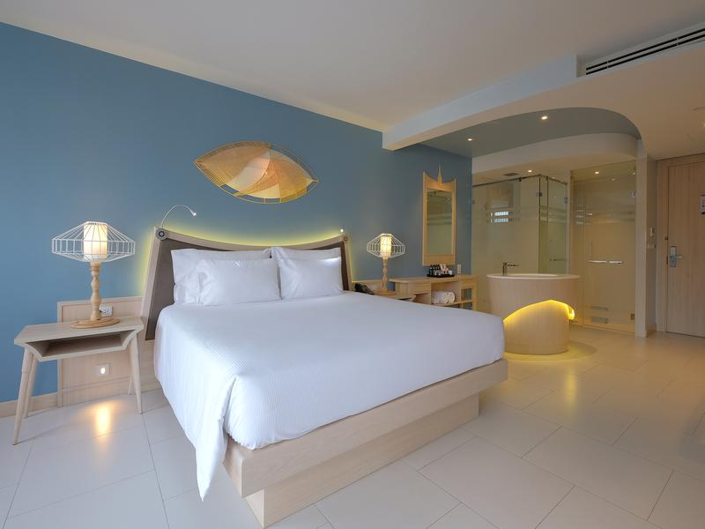
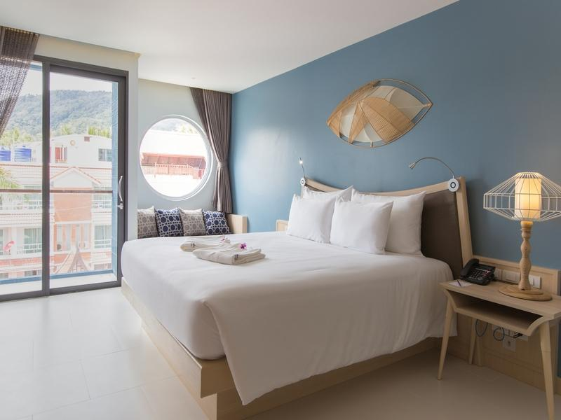
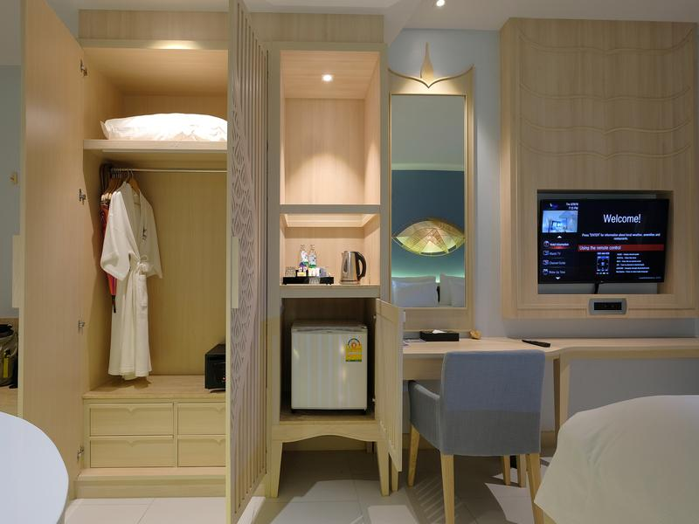
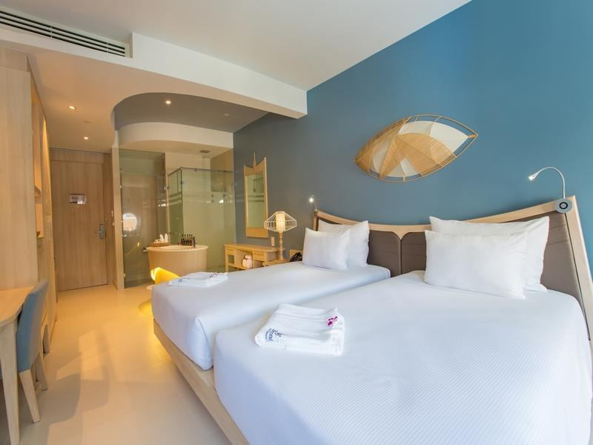

Restaurant photos
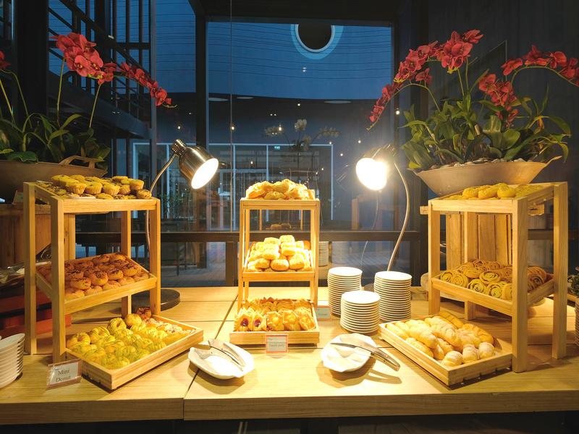
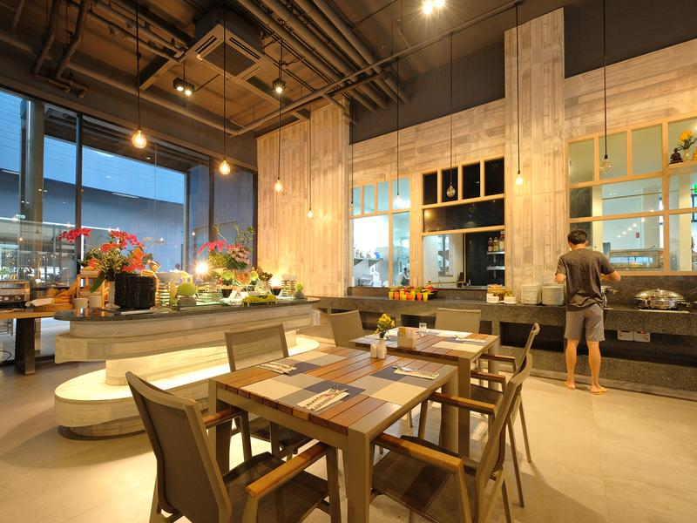
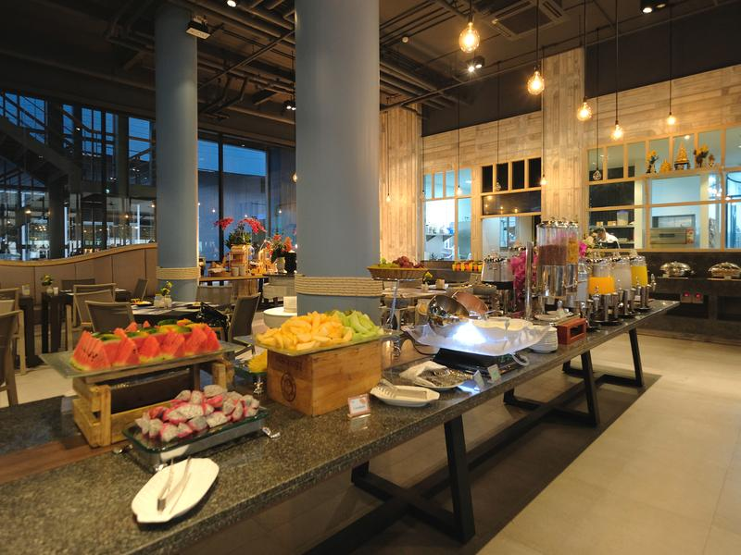
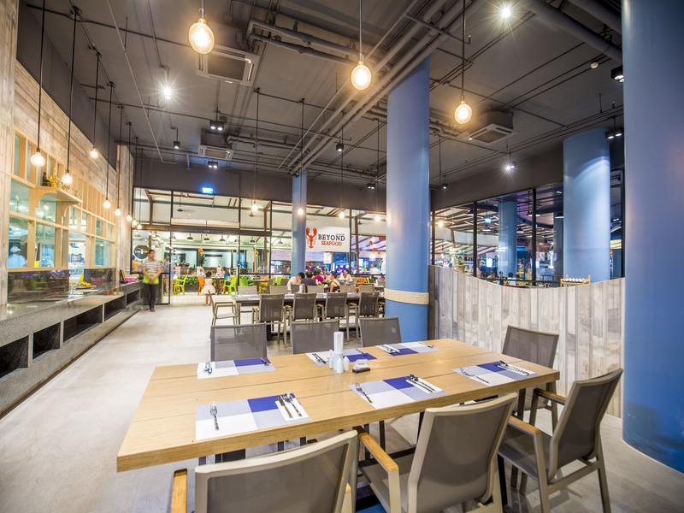

Business facilities photos
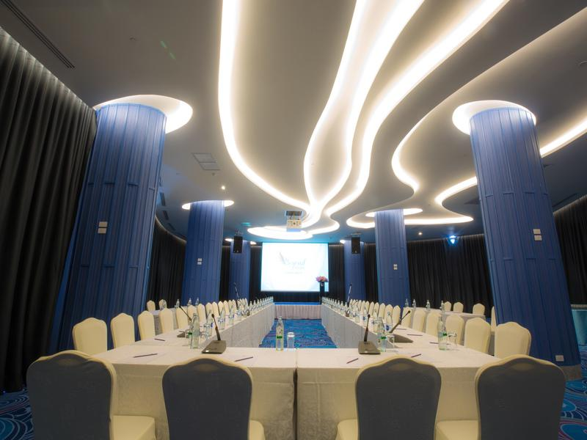
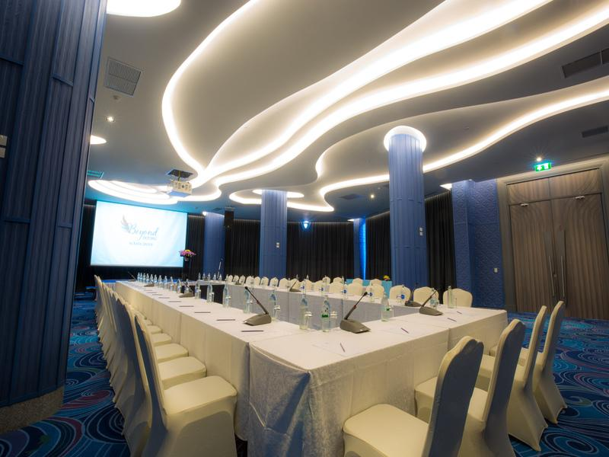
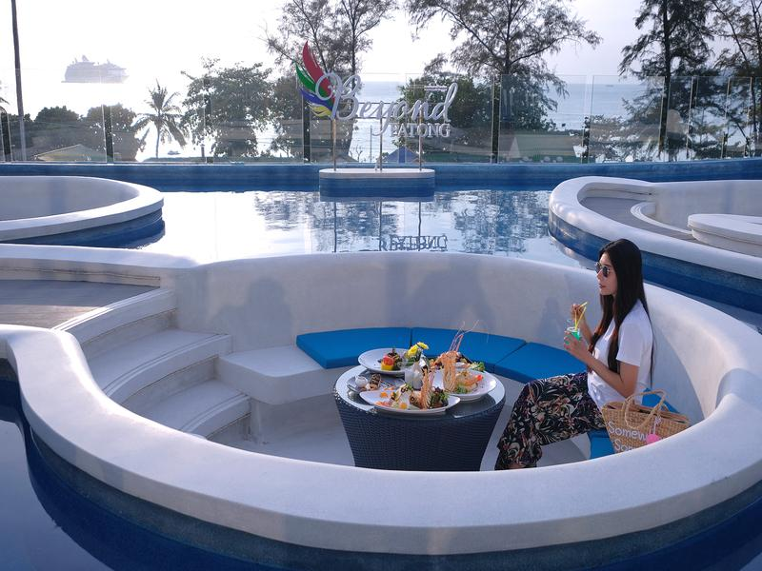

Services & facilities photos
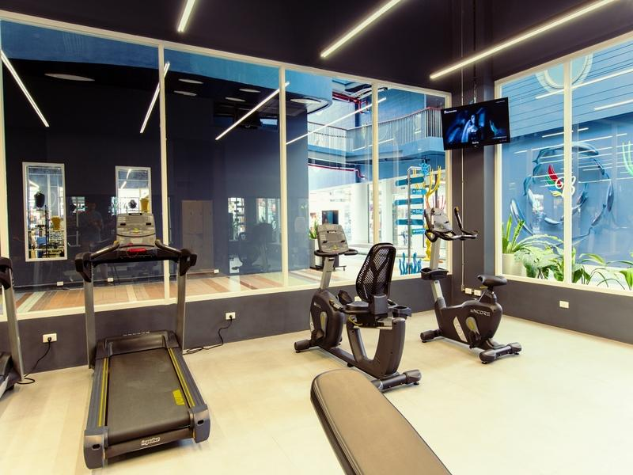
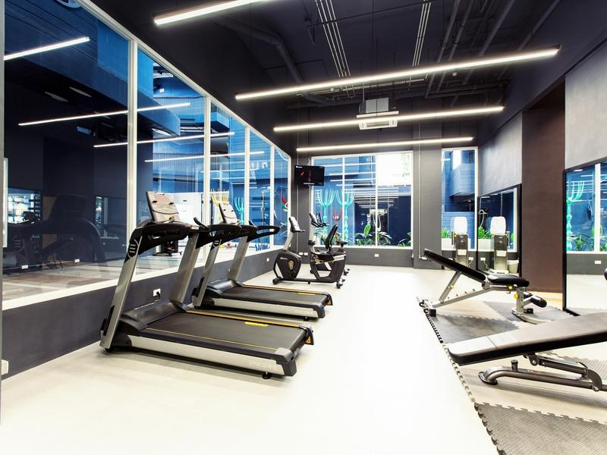
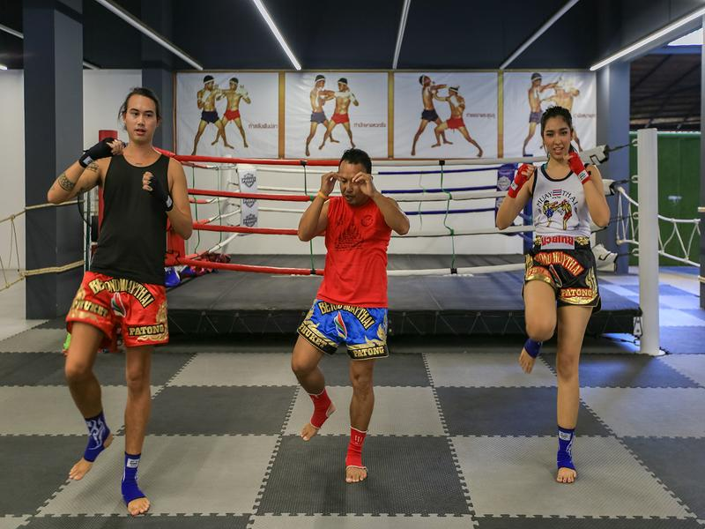
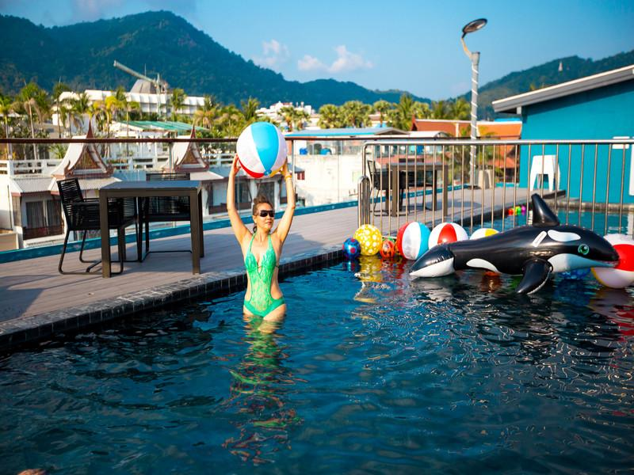
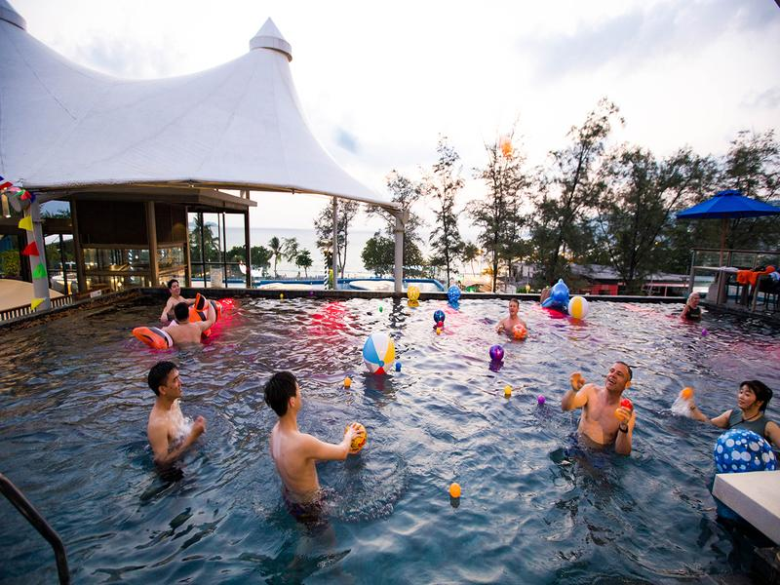
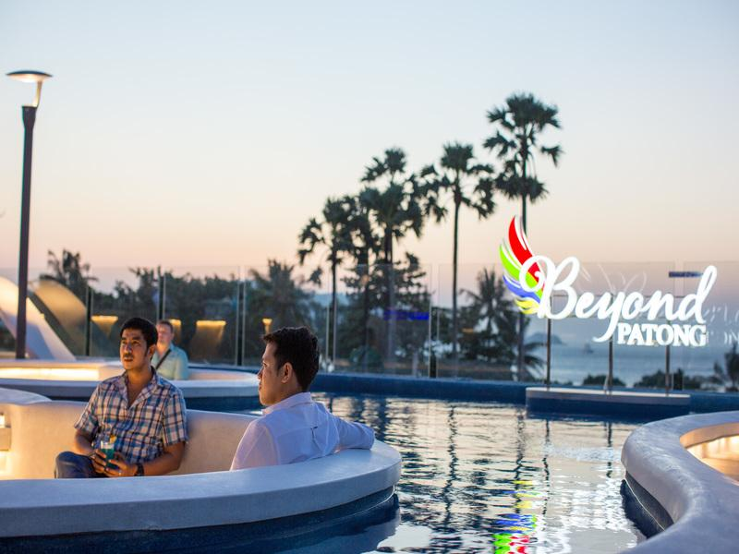

Easia Travel Head Office

