CAMBODIA – Koh Rong – Tamu Koh Rong
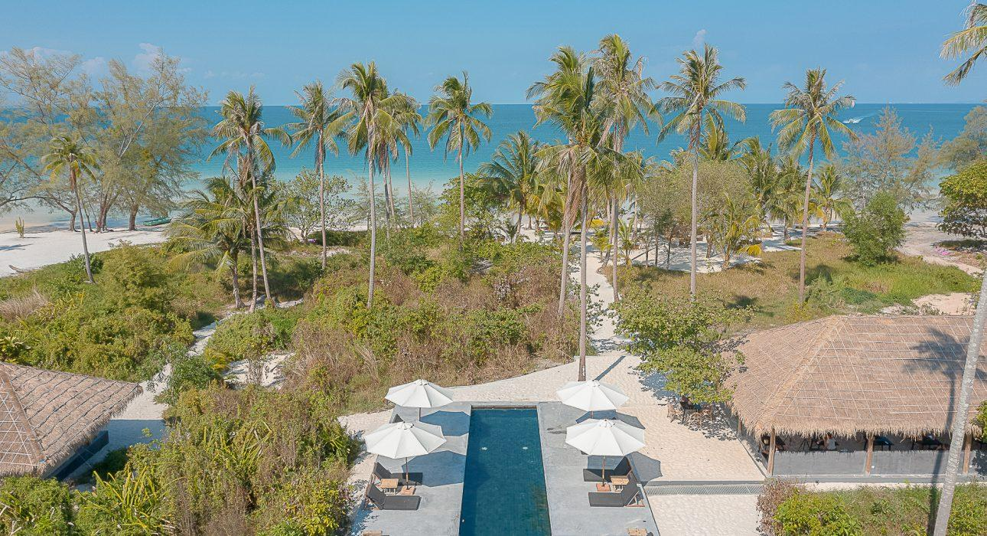

Over View

Theme
Beach Stay, Family, Honeymoon, Sustainable

Country - City
Cambodia - Koh Rong

Market segment
Thematic Leisure

Official category
4*

Easia category
Ecolodge, Tented Camp, First Class

Total number of rooms
15

Price level
$$$$

Description

Tamu Koh Rong is designed to experiment the escapism and adventure recreation that offer luxurious air-conditioned tents, while enjoying the ease and the advantages of a luxury hotel on a remaining wild part of the island.Featuring a swimming pool, a restaurant and a white sand beach shadowed by coconut trees, Tamu Koh Rong is ideal to experience the beauty of Cambodian islands.

Selling points

- Tamu, the barefoot chic spirit hotel is coming on the wild island of Koh Rong with the new concept of Glamping
- All room direct access to private beach
- Guest can sleep in a tent with all the comfort and amenities of a luxury room.
- Pagoda bay is perfect to enjoy snorkeling and to bath into the shallow pristine clear water.

Time & Transportation

From | To | Duration
Sihanoukville(Port gate 1) | Koh Rong Pier (Pagoda Beach) | . By private speed boat 30 min

Rooms

Easia's recommend room type
- Seafront Deluxe Tent (Have 3 Tents, 35 m²)
- Sea View Deluxe Tents (Have 3 Tents, 35 m²)
- Garden Deluxe Tents (Have 4 Tents, 35 m²)
- Jungle Rooms (Have 5 rooms, 35 m²)

Services & Facilities

Services
24h security service, Afternoon Tea, Airport Shuttle, Airport transfer, Babysitting, Boat rental, Boat Transfer from/to, Buffet Breakfast, Butler Service, Car rental, Children Activities, Complimentary bottle of water, Concierge service, Credit Card payment, Diving, Doctor on call, Dry Cleaning, E-bike rental service, Fishing, Golf, In-Room Dining, Iron, Kayaking, Laundry service, Luggage Storage, Mobile phone, Other: Private Jetty, Postal Service, Private event, partying, Room Service, Services for children, Snorkeling, Spa, Special entertaining programs for groups, Tennis, Visiting local villages, Wake-up service, Wi-fi Free

Facilities
Air Conditioning, Bar, Fan, Garden, Hair Dryer, In-Room safe, Internet, Library, Outdoor swimming pool, Private Beach, Restaurant, Safety Box, satellite LCD TV, Terrace, Umbrella

Restaurant information

Restaurant Name | Tamu Koh Rong Restaurant
Capacities | 25 pax
Type of food | Western, Asian, Cambodian, Seafood
Opening hours | Breakfast 7:00 AM to 10:30 AMLunch 11:00 AM to 5:00 PMDinner 6:00 PM to 9:30 PM

Photos

Hotel Photos
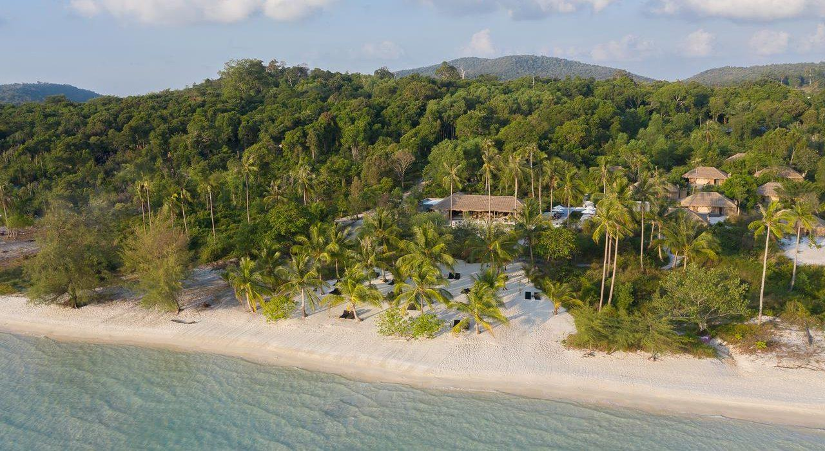
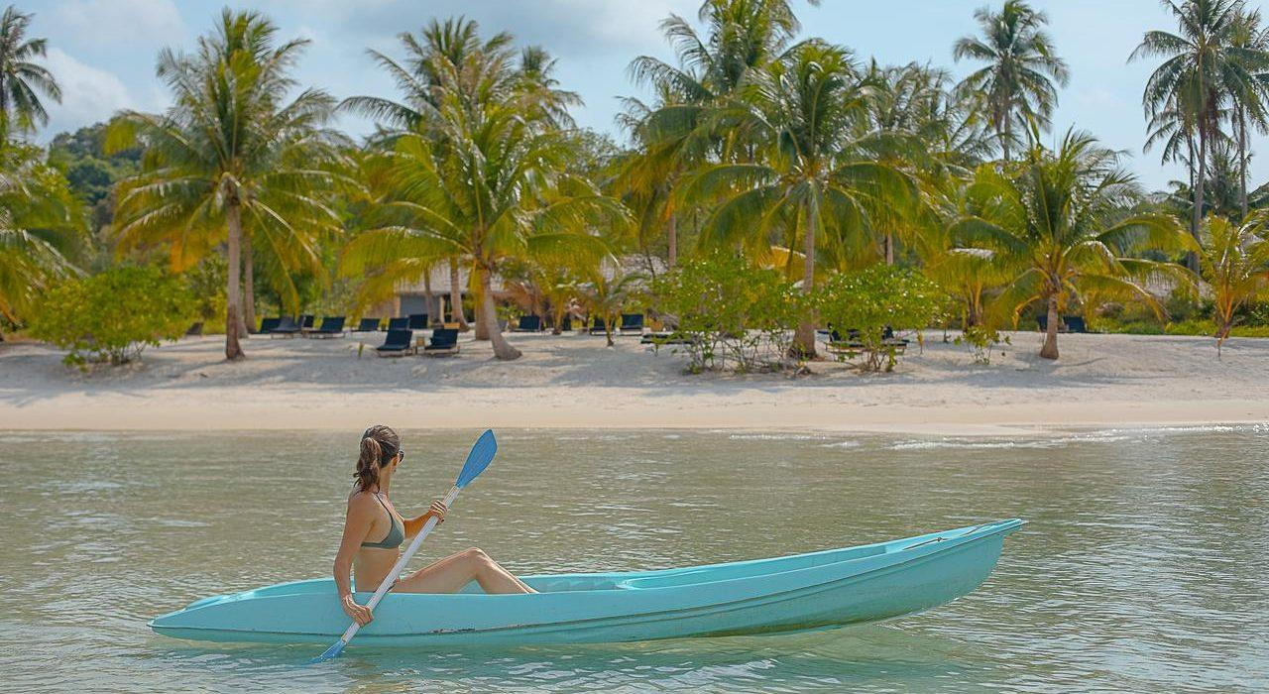
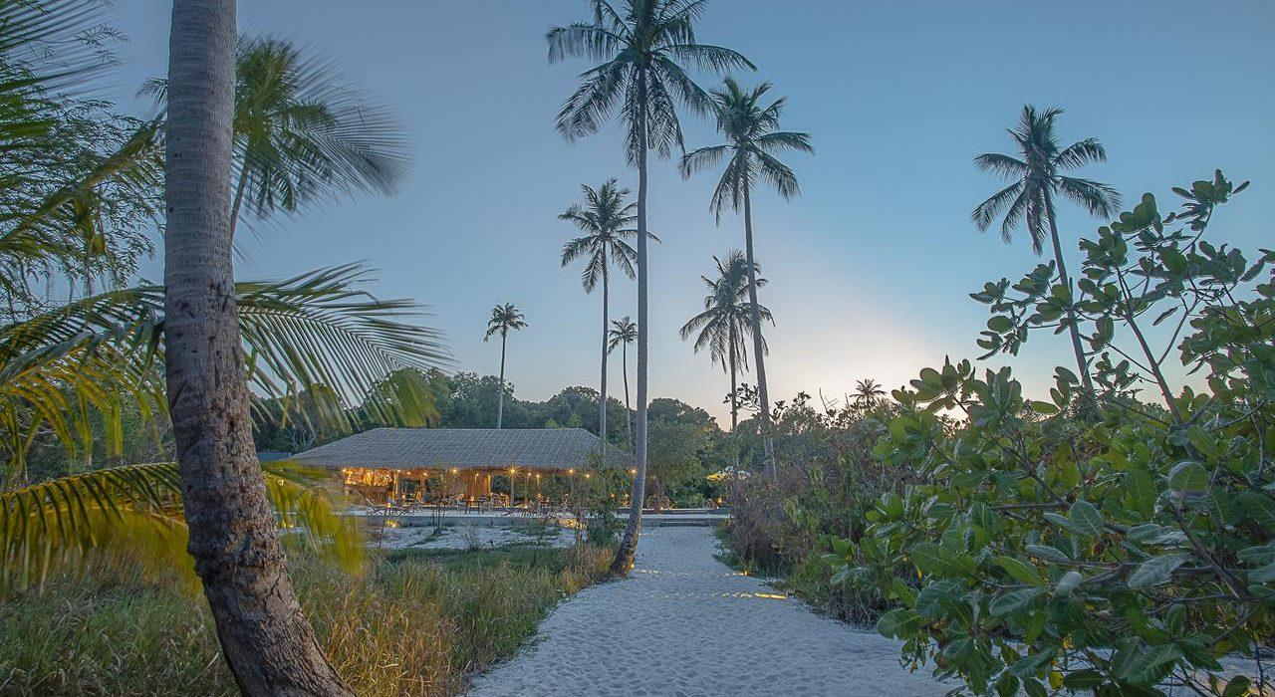
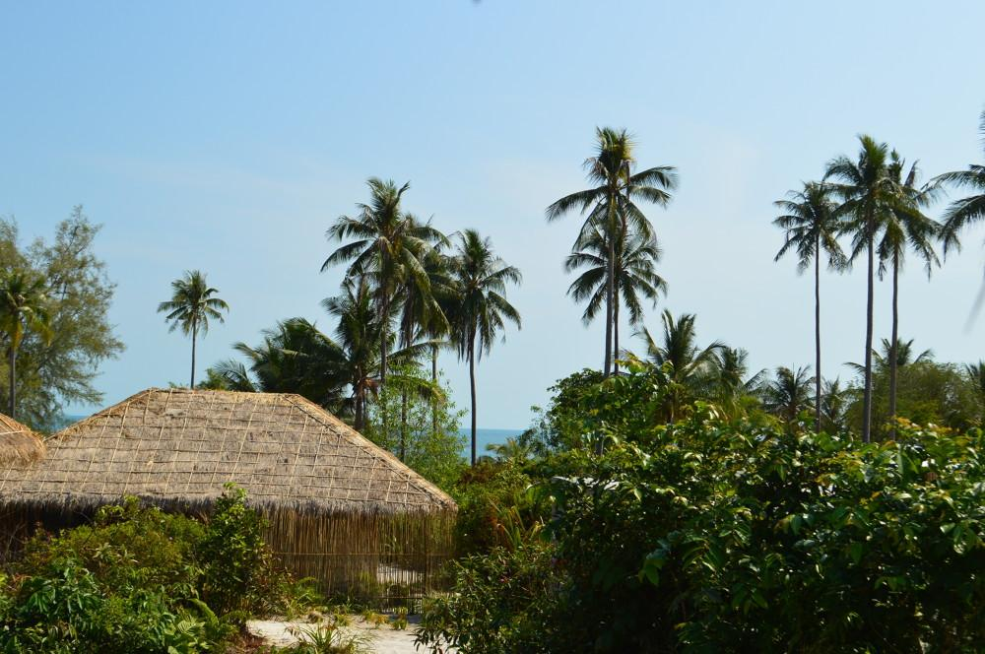
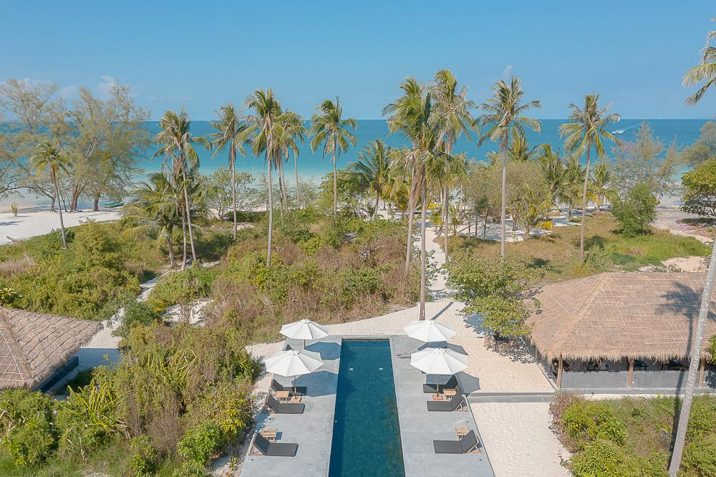

Rooms photos
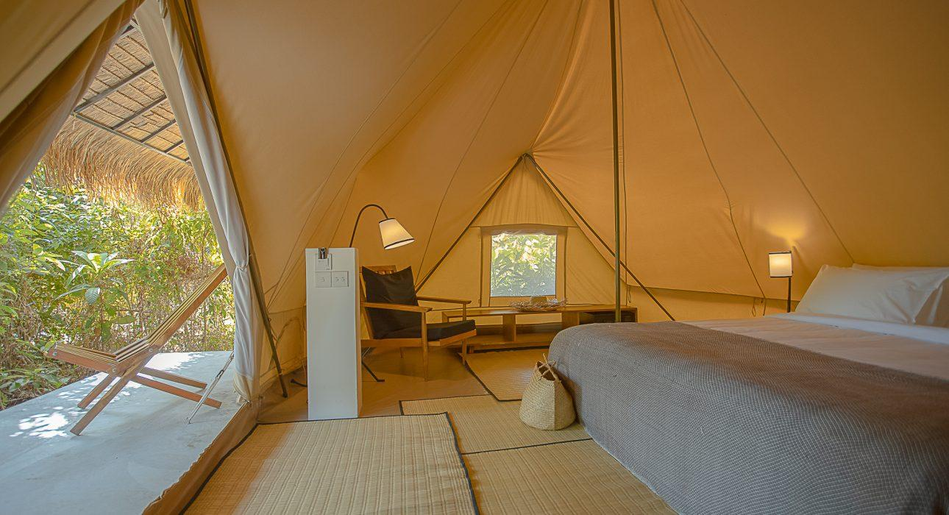
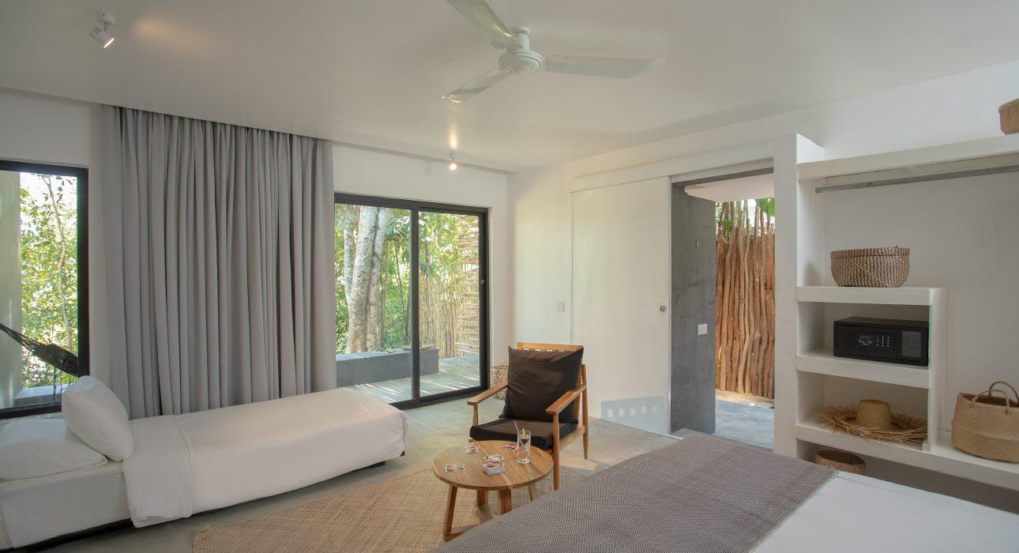
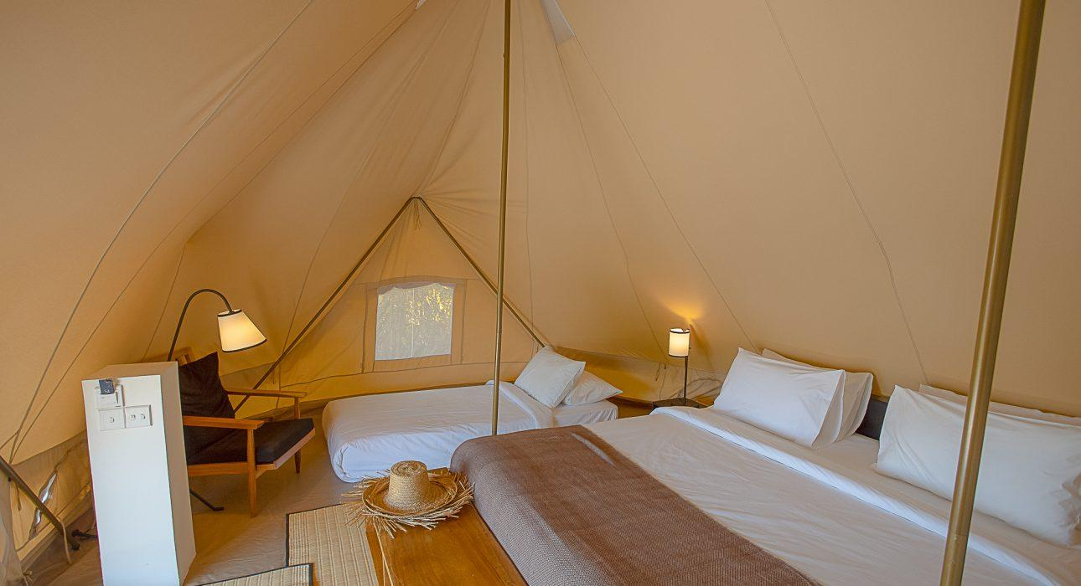
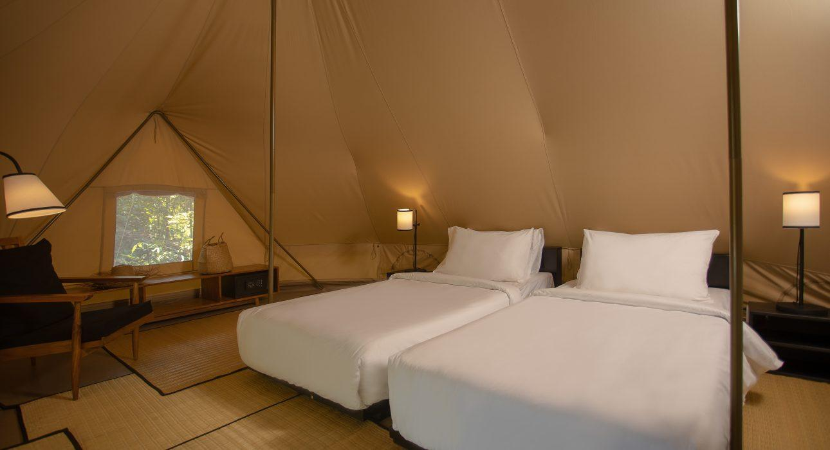

Restaurant photos
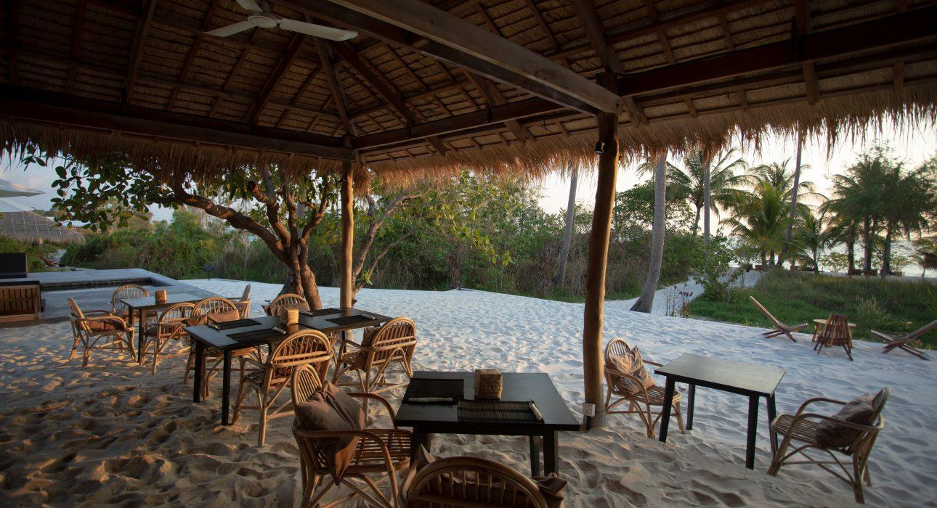
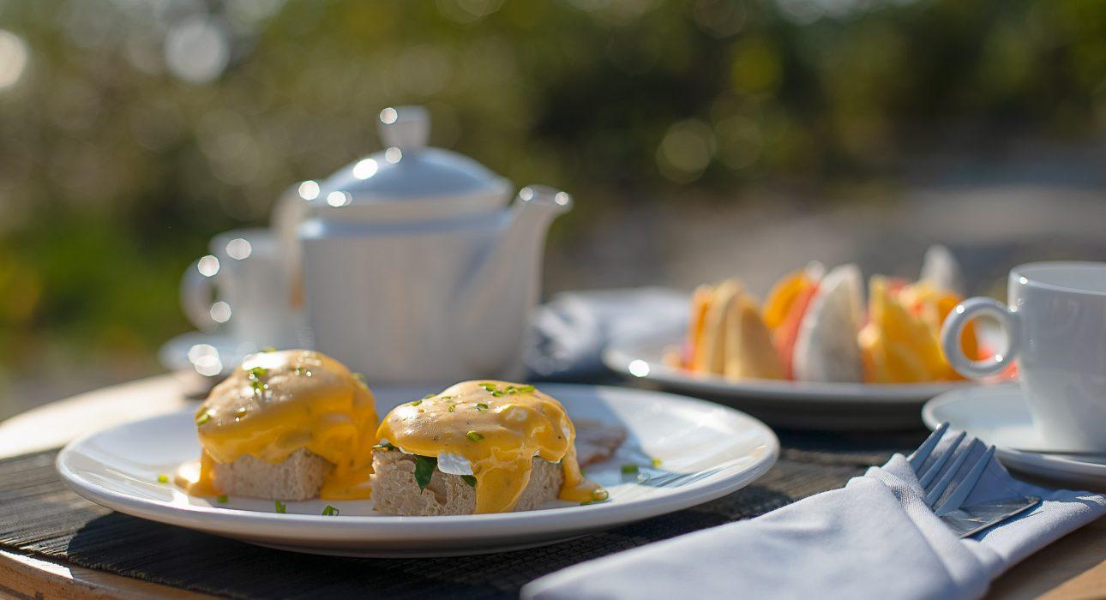
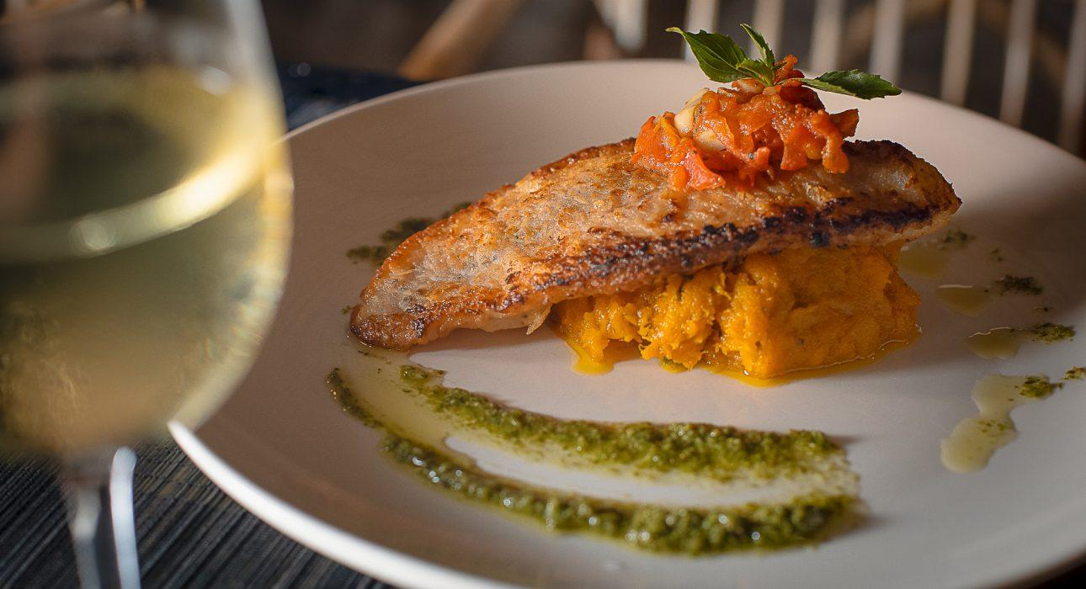
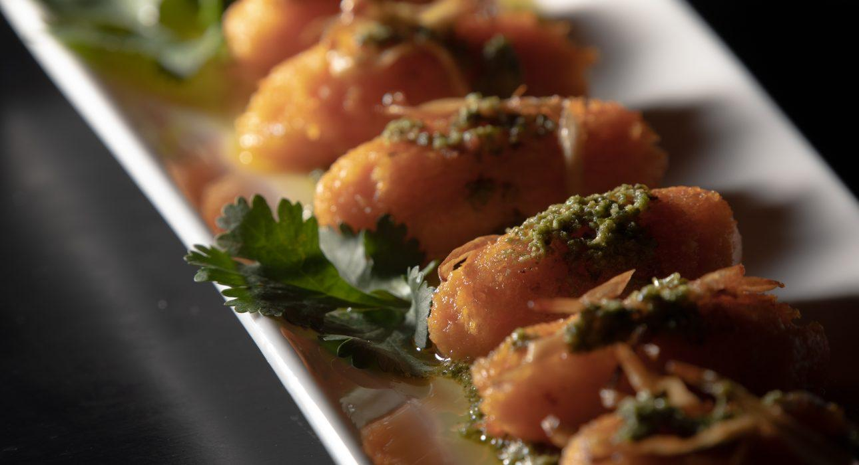
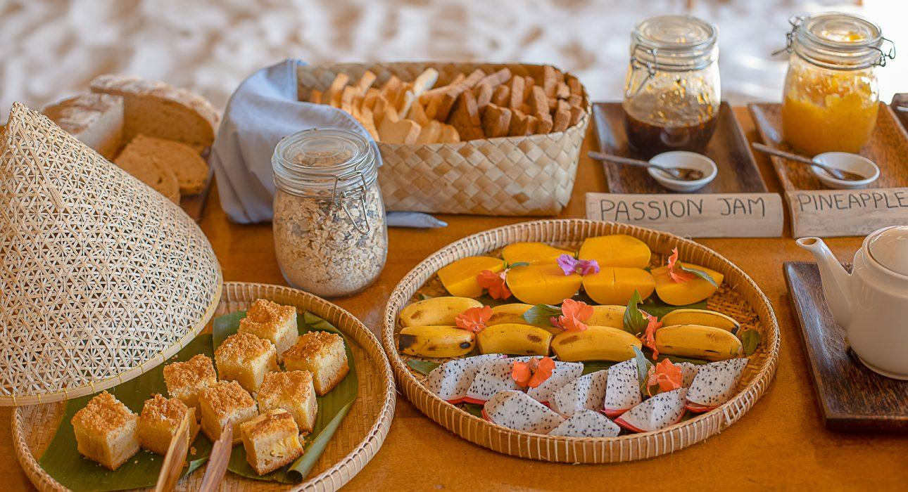

Easia Travel Head Office

Siem Reap BranchCharming City, No. R32 – R34, Road Rolouse, Trorpeangses Village, Sangkat Koukchork, Siem ReapTel: (855-63) 76 14 58Fax: (855-63) 76 14 58www.easia-travel.com

