CAMBODIA – Koh Kong – Cardamom Tented Camp
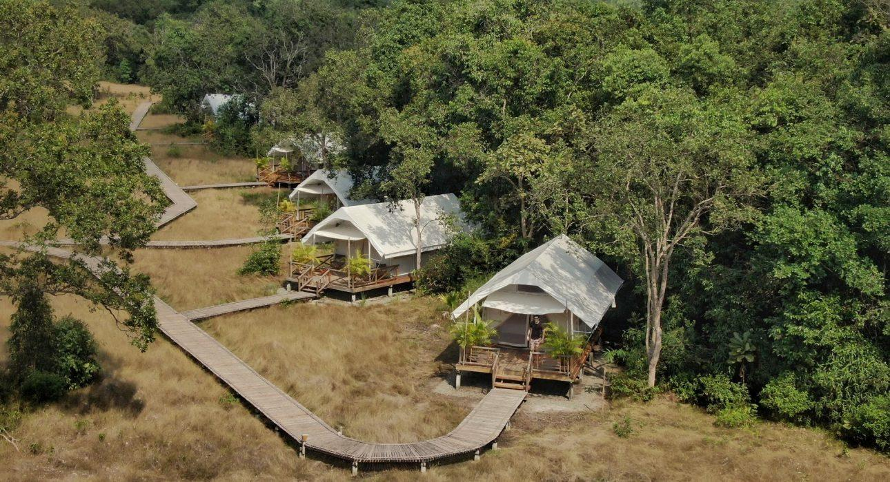

Over View

Theme
Sustainable

Country - City
Cambodia - Koh Kong

Market segment
Thematic Leisure

Official category
Ecolodge

Easia category
Tented Camp, First Class

Total number of rooms
9 tents (4 TWNs+ 5 DBLs)

Price level
$$$$

Description

An eco-friendly tented camp safari style within a nice and peaceful location along Preak Tachan river and last biggest rain-forest in Cardamom region. Relax and emerge yourself with real nature atmosphere in an eco-friendly tented camp that great experiences.Cardamom Tented Camp is located in Trapeang Rung village, Trapeang Rung district -Koh Kong province along Butom Sakor river. with that great location between river and biggest rain-forest make this luxurious safari-style tented camp one of the best place for relax and experience with real nature and wildlife

Selling points

- An eco-friendly safari tented camp style with well set up in middle of nature
- A nice peaceful location along the river and surrounding by the last biggest rain-forest
- An immersion experience supporting the protection of the local environment and the Wildlife Alliance,

Sustainability

Supplier Actions
Protection of Environment, Support local communities, Animal Welfare

Time & Transportation

How to get to Cardamom Tented Camp:
- First: guest from Phnom Penh or from Sihanouville or from other destination need to reach the Cardamom Tented boat pier.
- Then, guest will take around 30 minutes on boat trip from Cardamom Tented boat pier to Cardamom Tented Camp land.
From | To | By | Km | Duration | Road Condition
Phnom Penh | Cardamom tented boat pier | Minivan | 223 | 5 hours | Good, until road national 6
Thai border Cham Yeam/Trat | Cardamom tented boat pier | Minivan | 70 | 1 hour and 30mn | Good
Sihanoukville airport / Pier | Cardamom tented boat pier | Minivan | 150 | 2 hours 30 mm | Good
Cardamom tented boat pier | Cardamom tented Camp | Boat | 10 | 45-60 minutes
Note: The regulation boat usually leaves around 2PM and usually not later than 15 min. However, there is an additional charge of 20 USD per boat for fuel cost to arrange another boat outside the schedule. -It is private boat

Rooms

Easia's recommend room type
The eco-camp is equipped with nine comfortable safari-style tents. The setup of all 9 tents are the same. The canvas tents are 32.6m². In tent amenities include Twin, Double or Triple beds; standing fans; bamboo and rattan furniture; bathroom facilities with hot water, rain showers, and locally-sourced soaps and shampoos; and spacious patios with sun chairs.
- Canvas-tented room set up on a 0.5m raised platform and balcony deck (12.6m²)
- Bed types: Twin, Double or Triple beds
- Top quality bedding with a luxurious mattress
- Bedside and window fans
- Sun-protected terrace / seating area
- En suite private bathroom (6.7m²) with hot water and rain shower
- Locally-sourced environmentally-friendly soaps and shampoos by Kambio Nature
- Ambient lighting and flashlight
- 24-hour security on site
- 24-hour electricity supply
- Daily housekeeping

Room configuration

Connecting rooms
No connecting room

Extra bed
No

Queen bed
5 DBLs

Twin beds
4 TWNs

Services & Facilities

Services
24 hour reception, 24h security service, Boat Transfer from/to, Doctor on call, Kayaking, Laundry service, Mobile phone, Other: Private Jetty, Wi-fi Free

Facilities
Bar, coffee and tea making facilities, Fan, In-Room safe, Internet, Library, Restaurant, Shower With Hot Water, Smoking Area, Terrace, Umbrella

Disabled Facilities
No disable access

Restaurant information

Restaurant Name | Riverbank Restaurant
Capacities | 18 pax
Type of food | International, Khmer
Operation hour | Breakfast: 7:00 – 10:00 AMLunch: 12:00 PM – 2:30 PMDinner: 6:00 – 9:00 PM

Photos

Hotel Photos
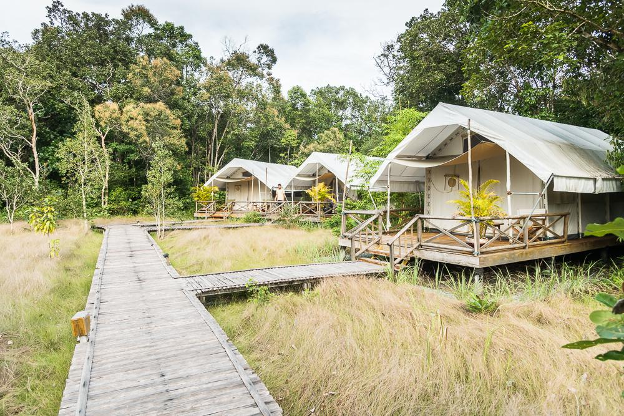
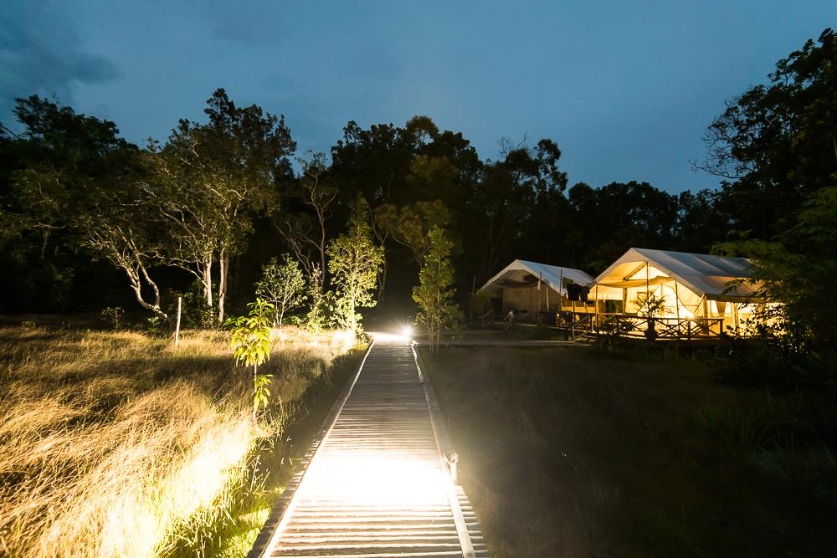
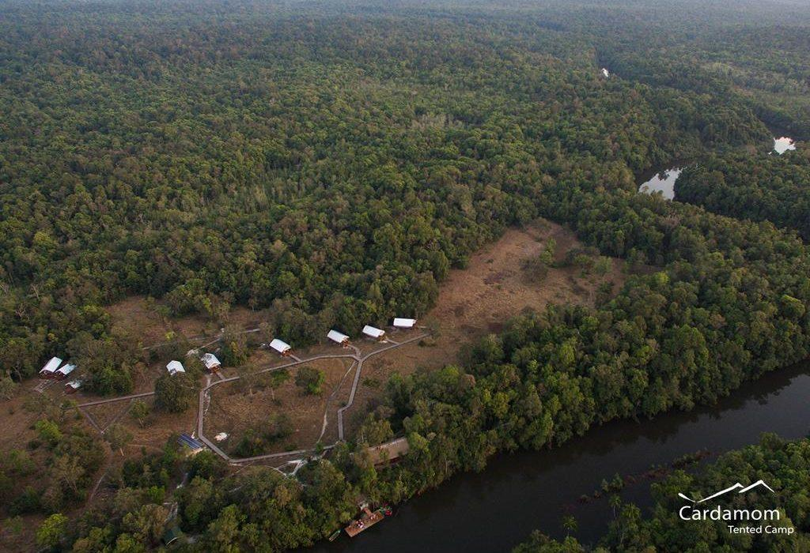
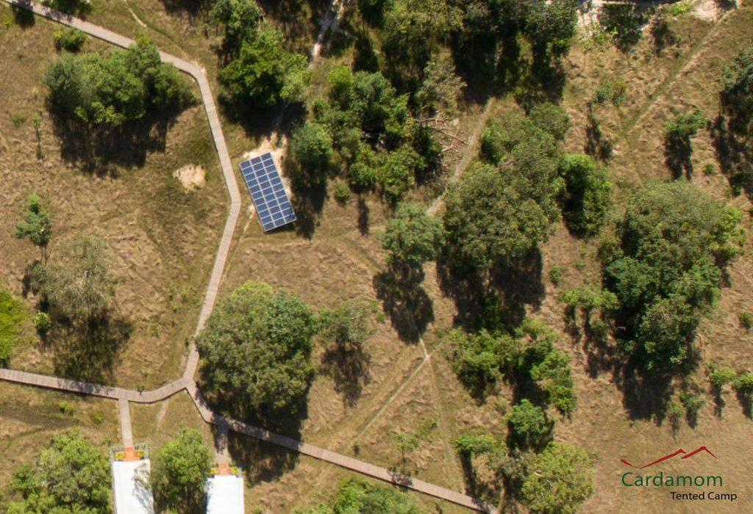
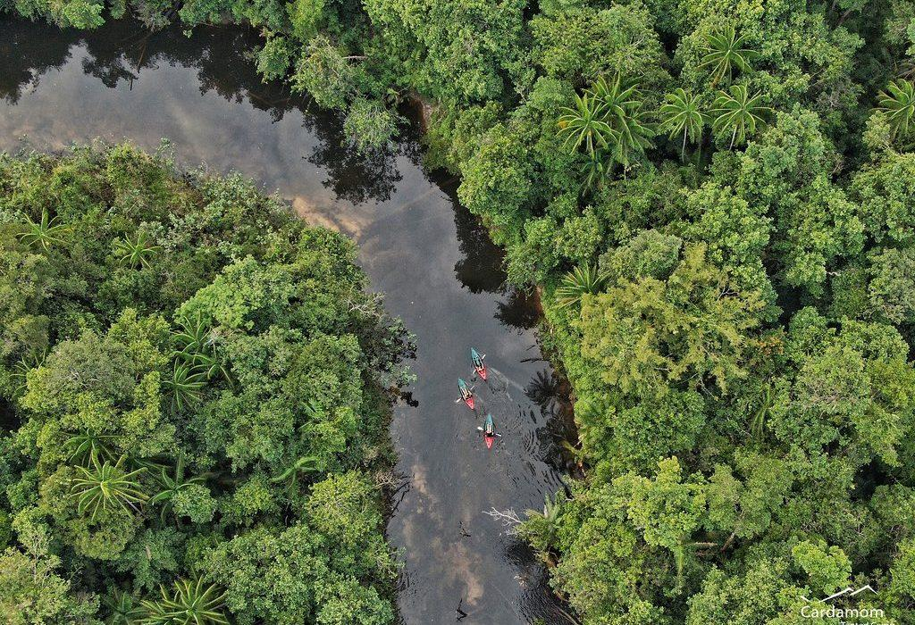
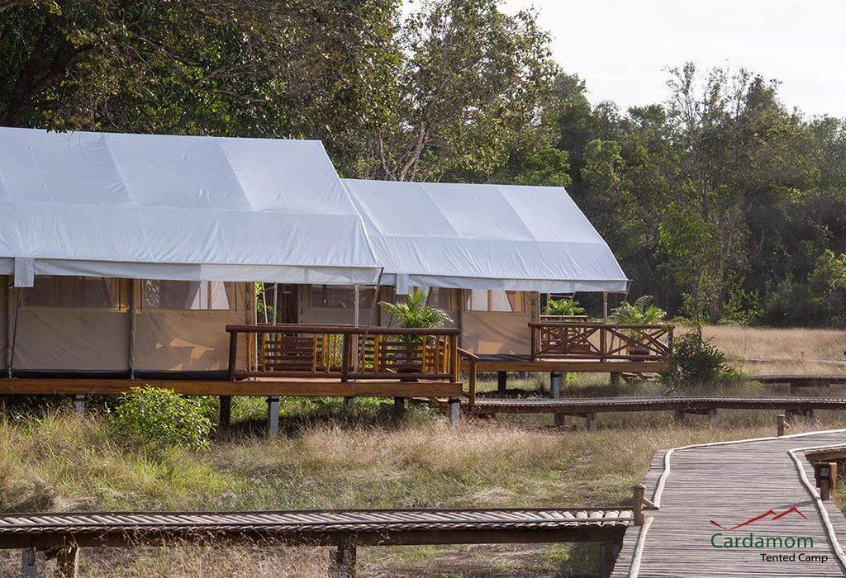
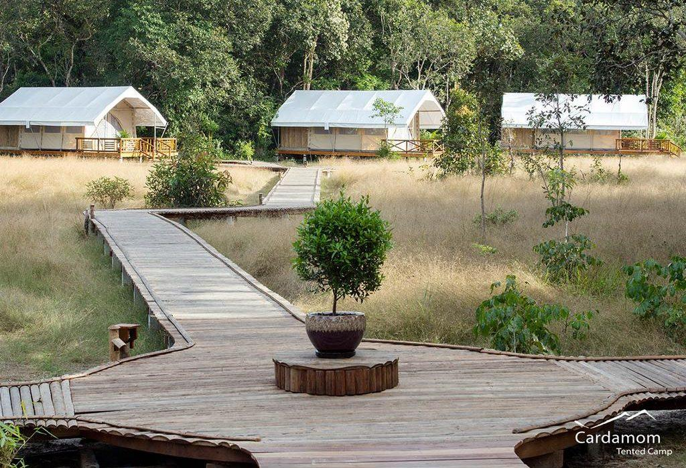

Rooms photos
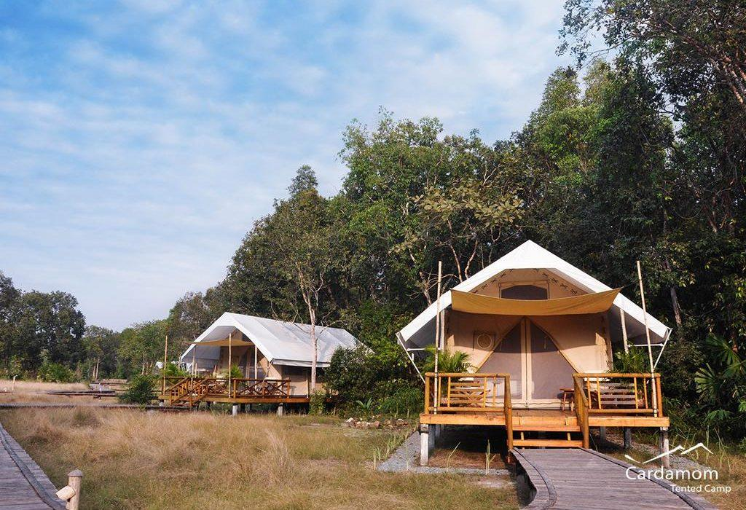
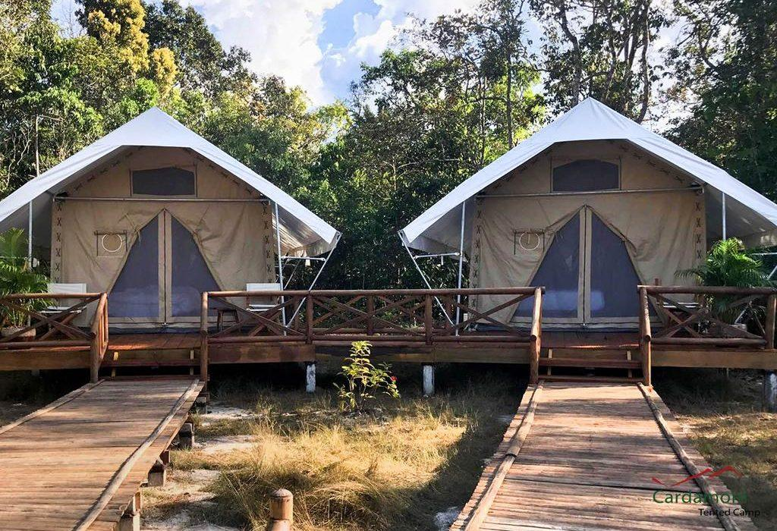
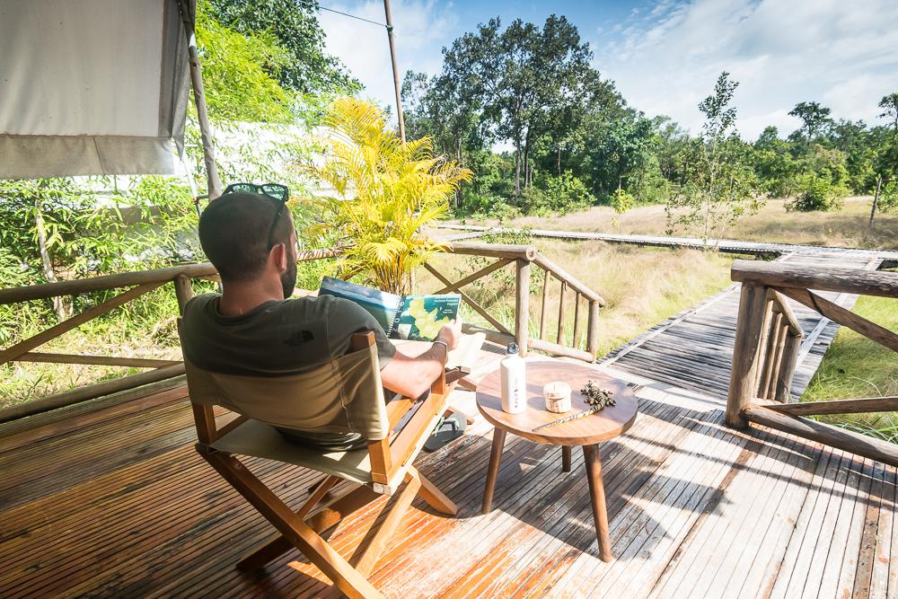
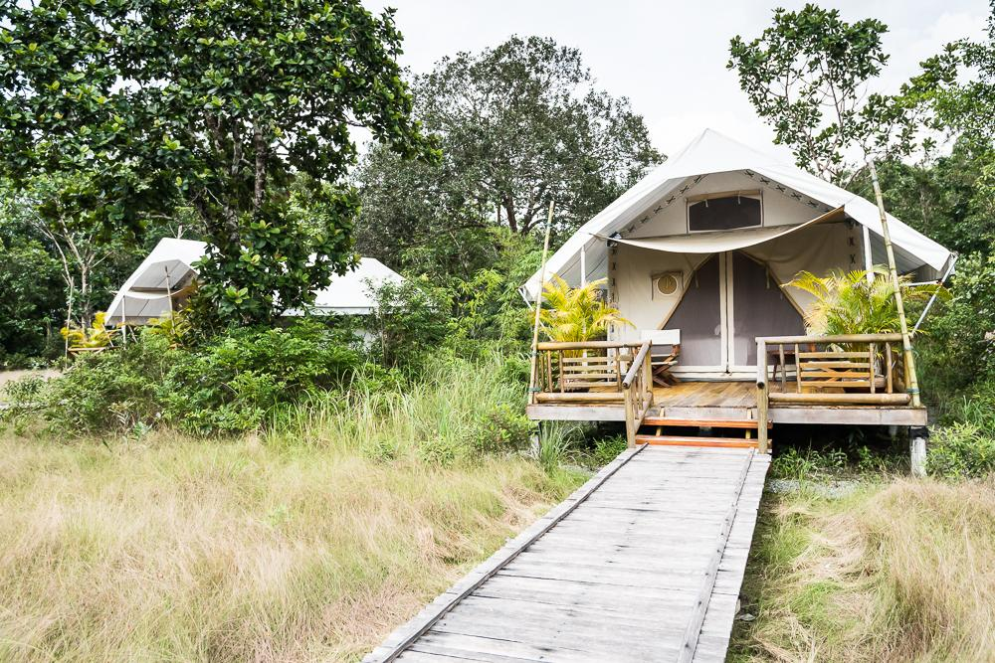
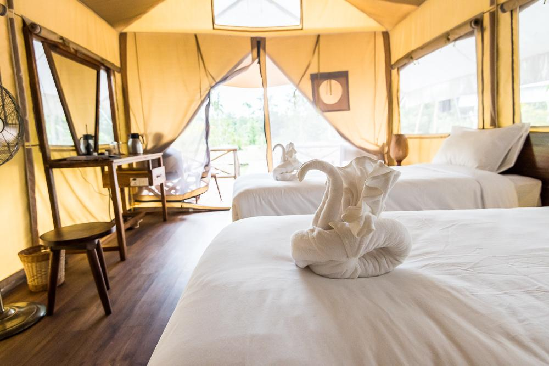
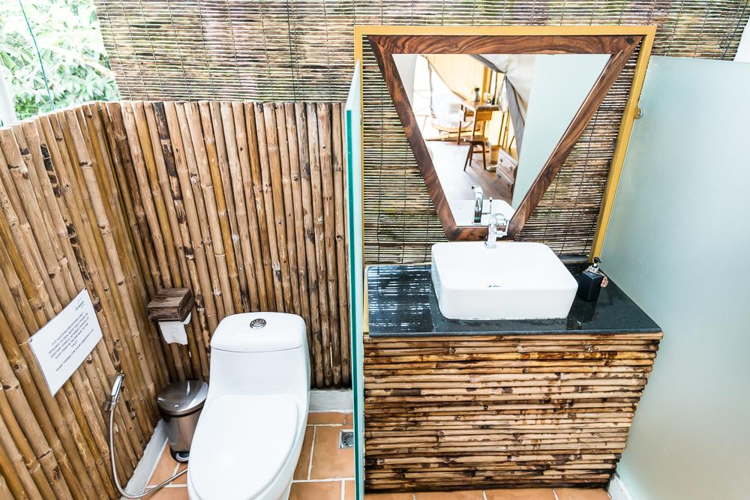
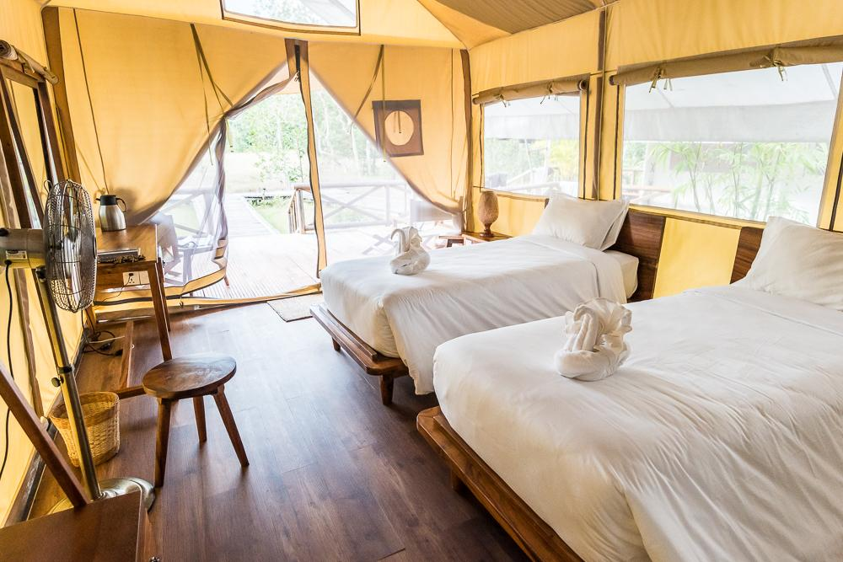
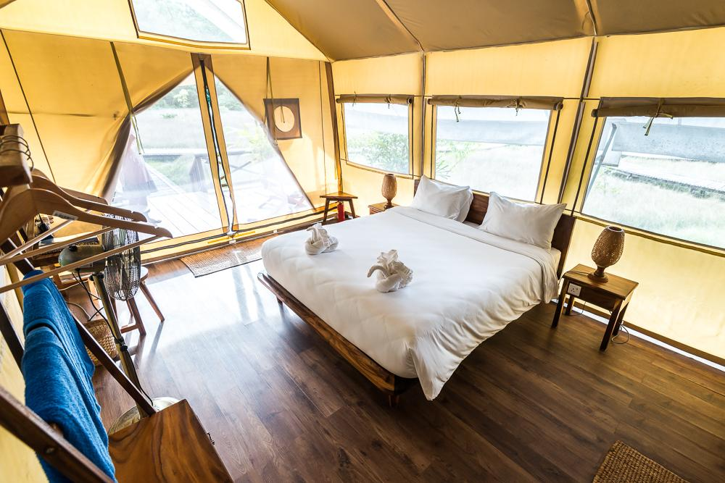
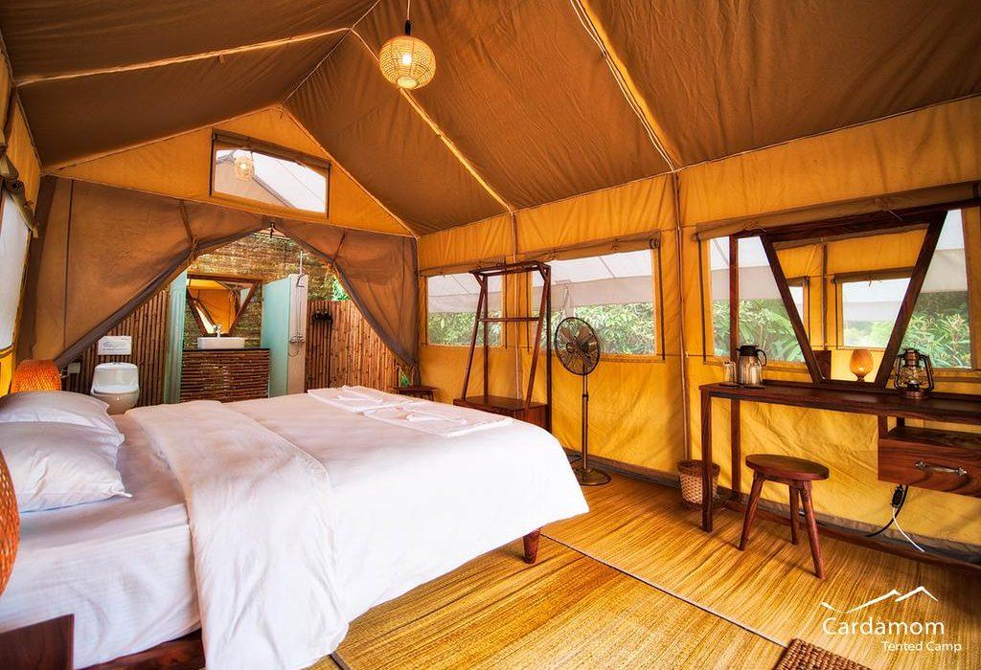
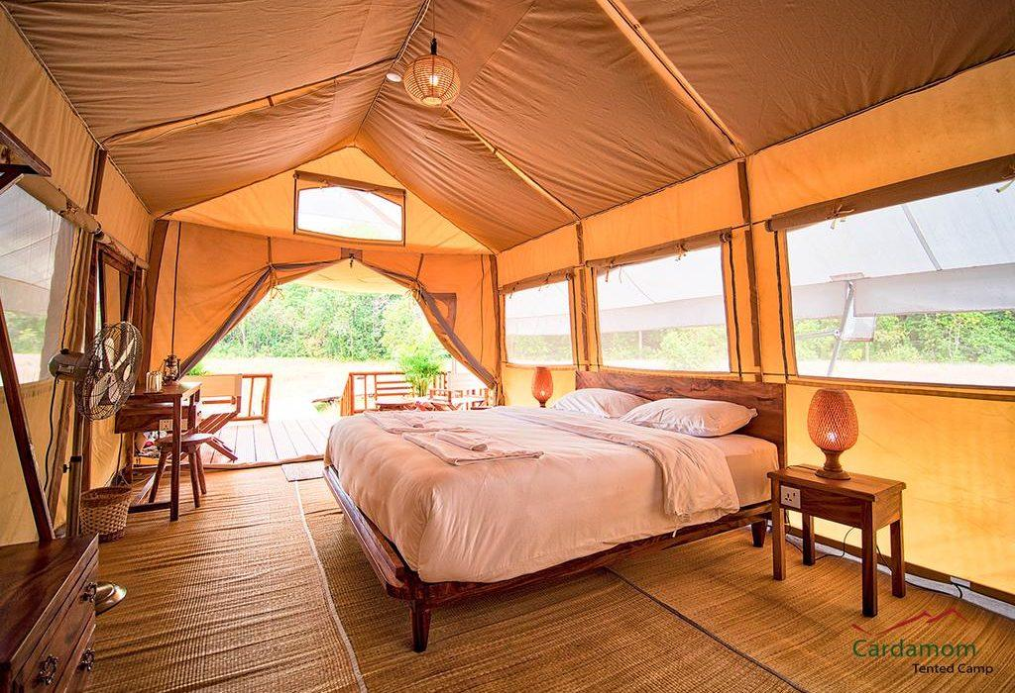
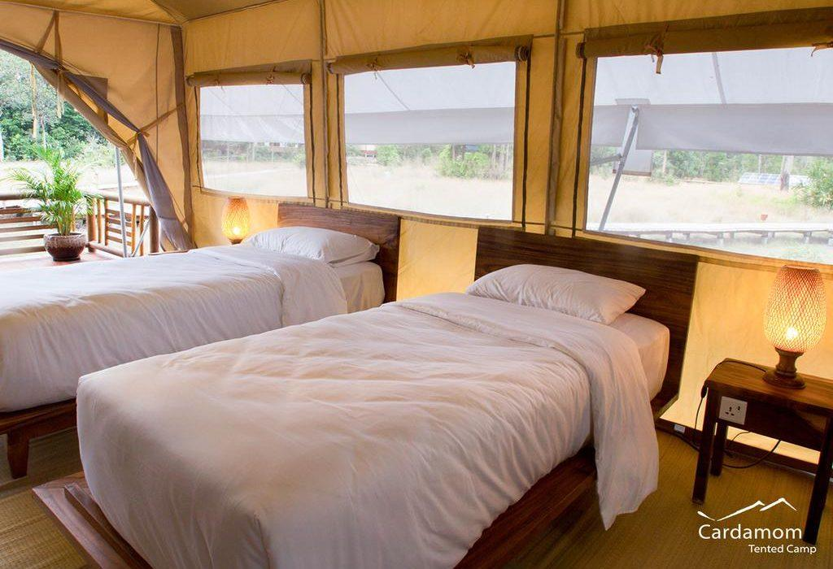
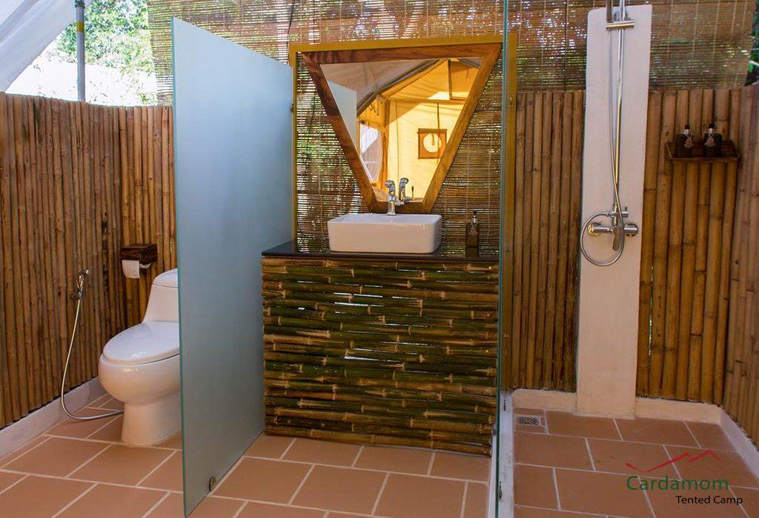
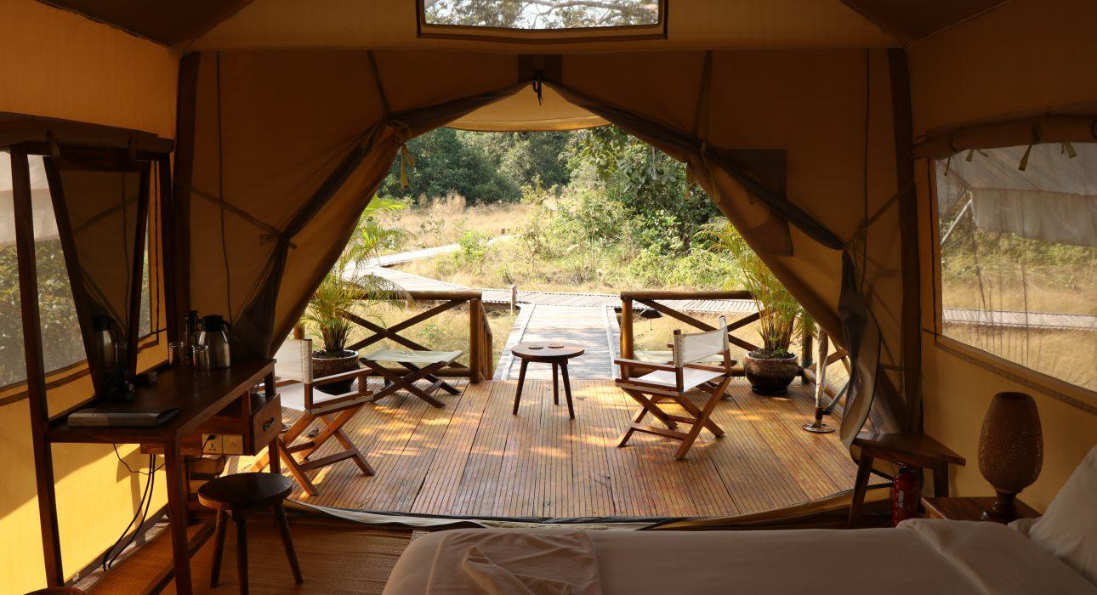

Restaurant photos
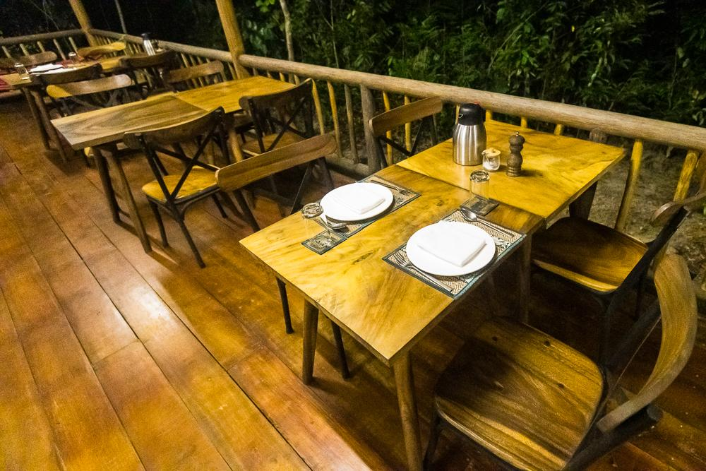
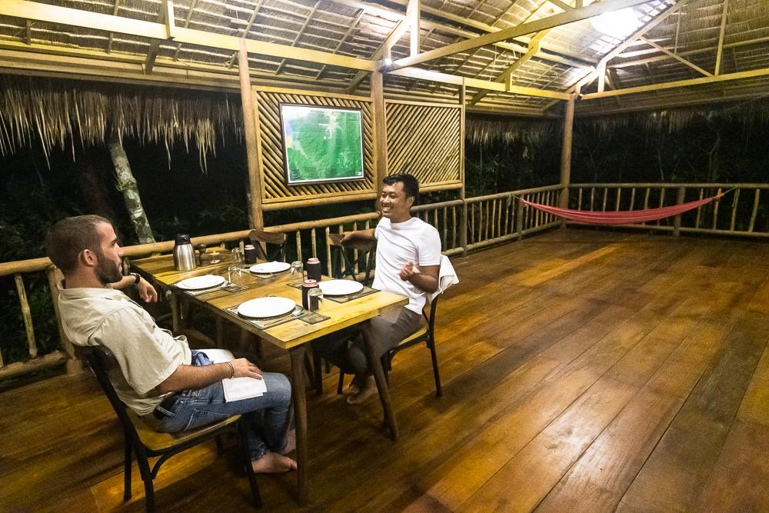
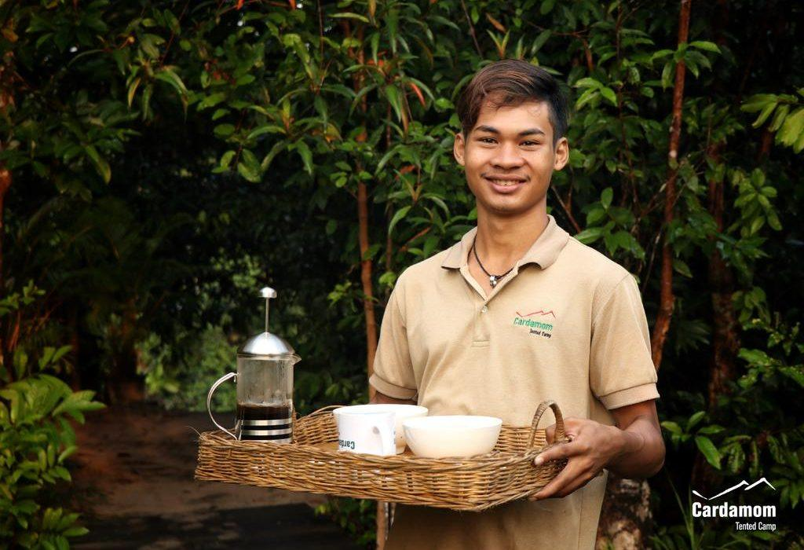
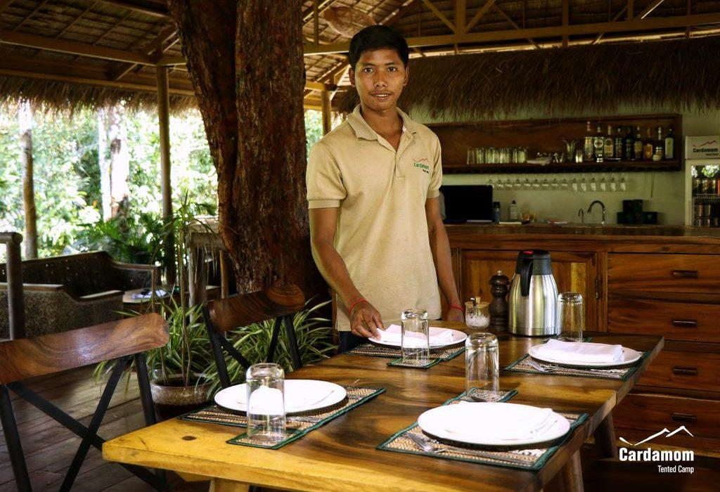
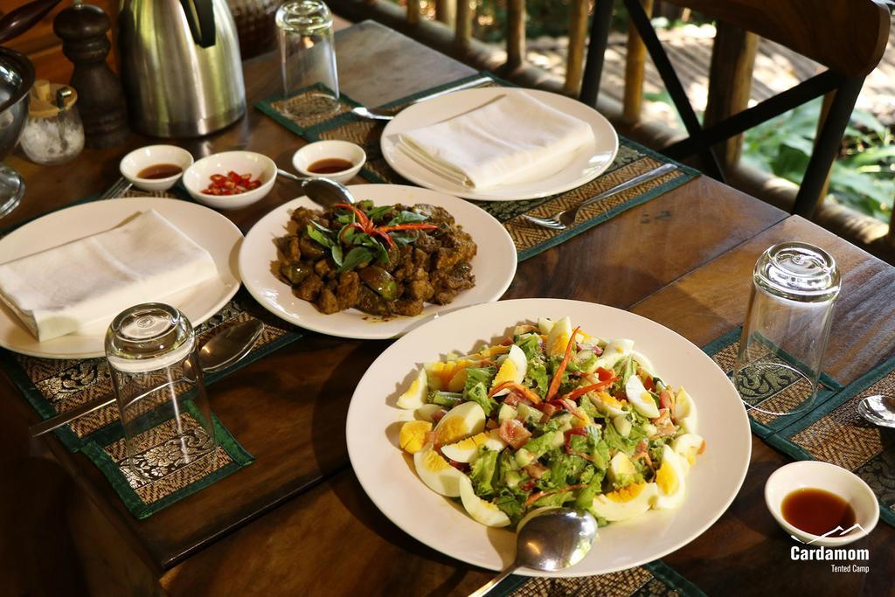

Services & facilities photos
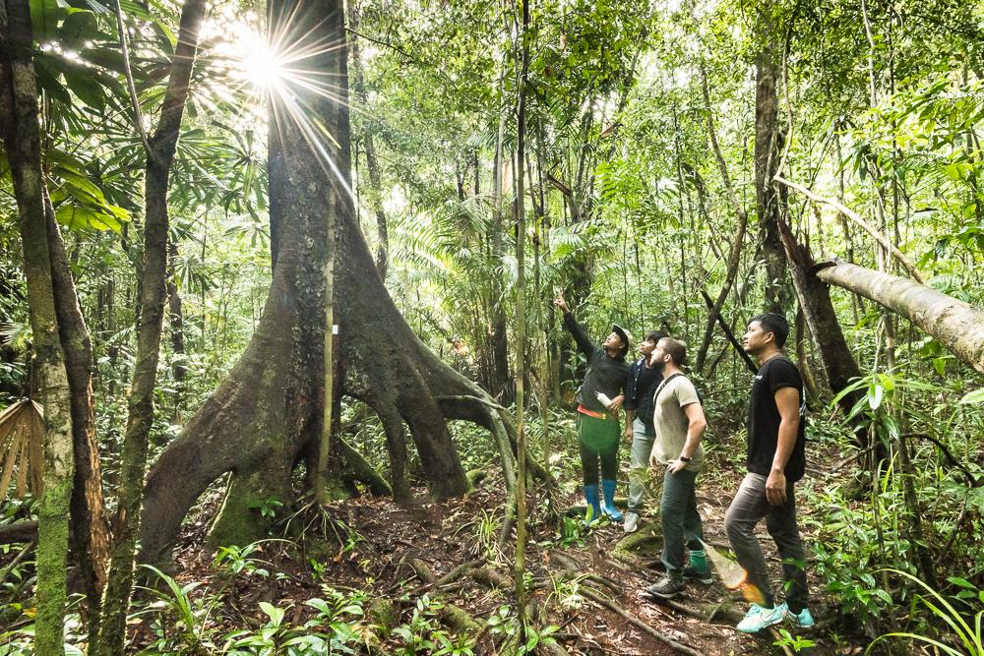
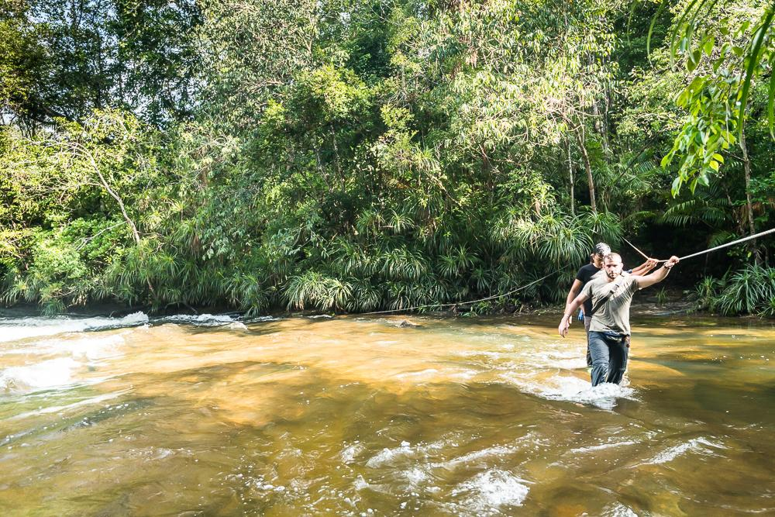
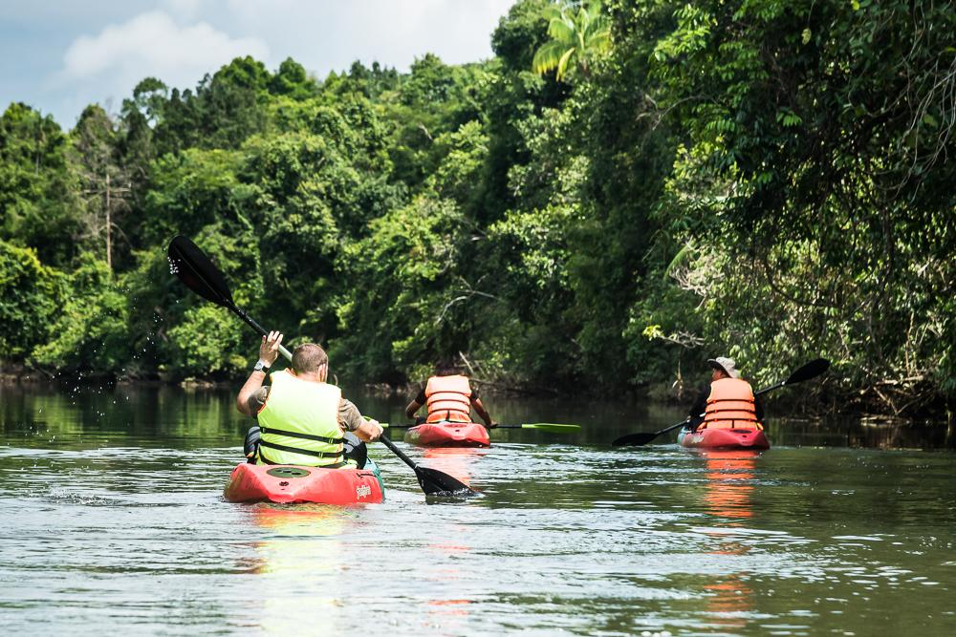
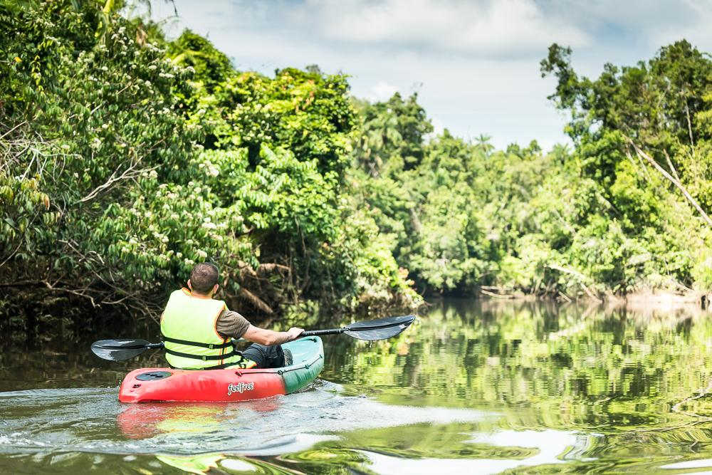
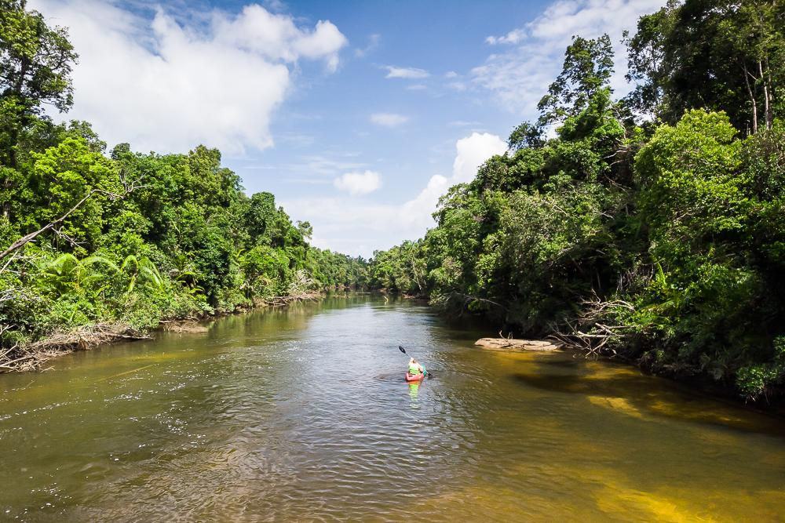
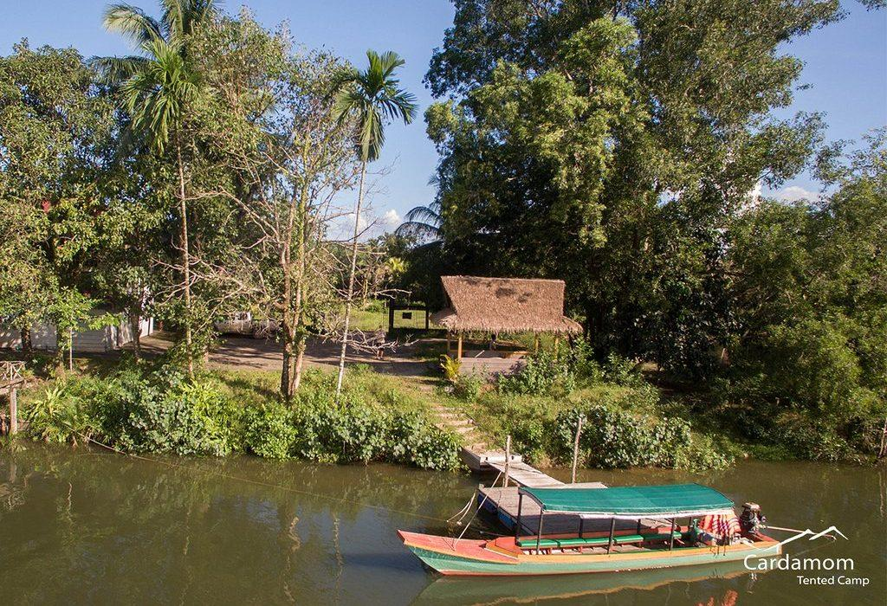
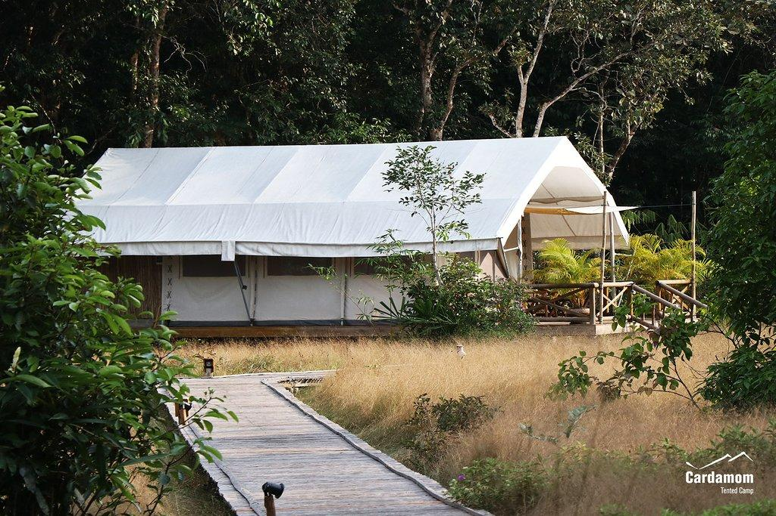
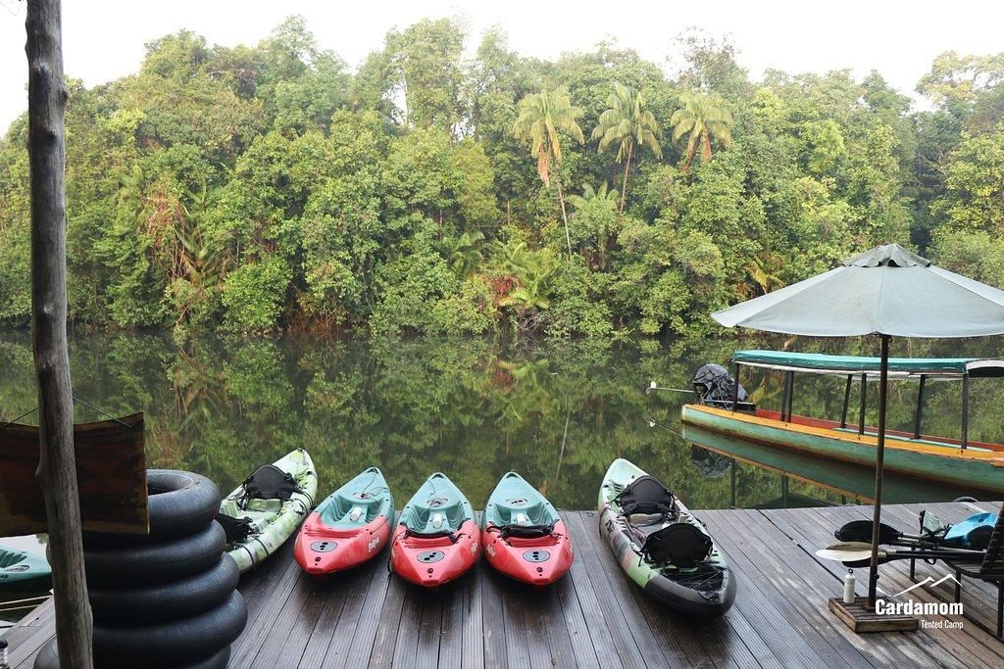
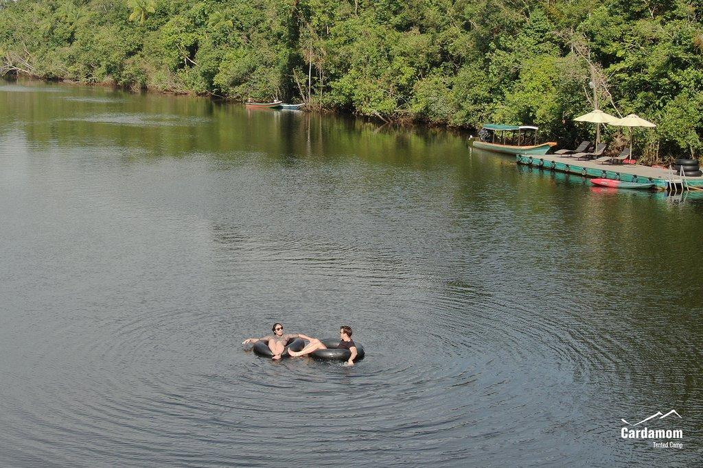
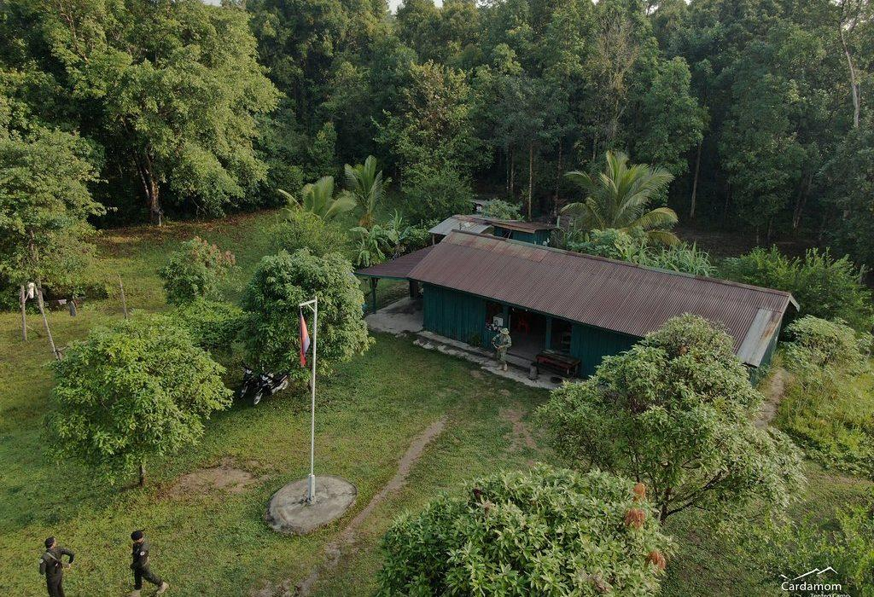
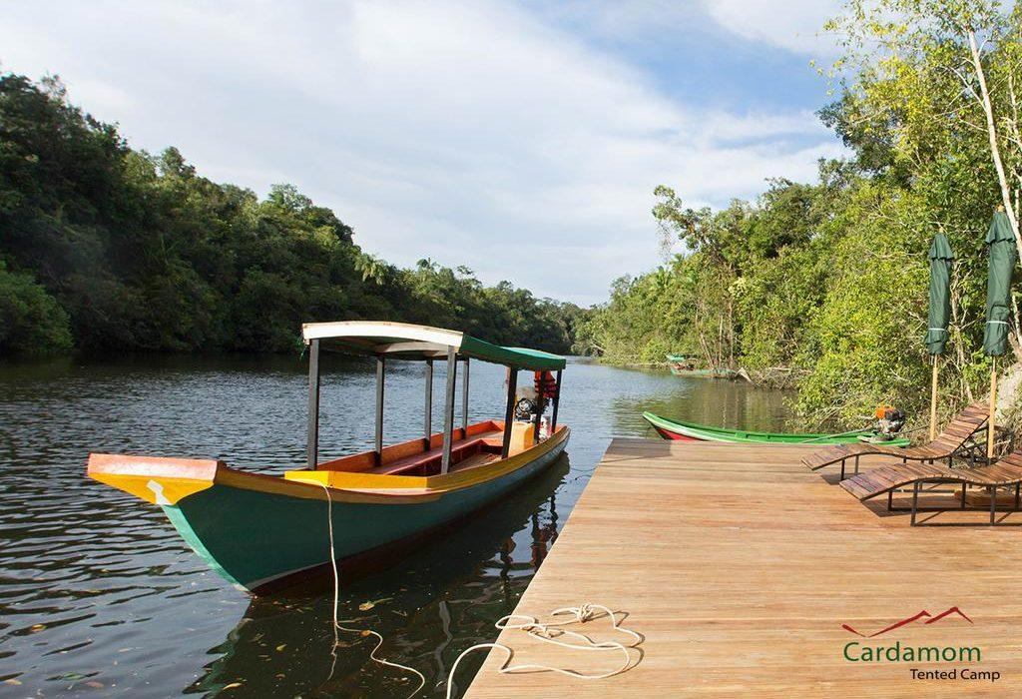
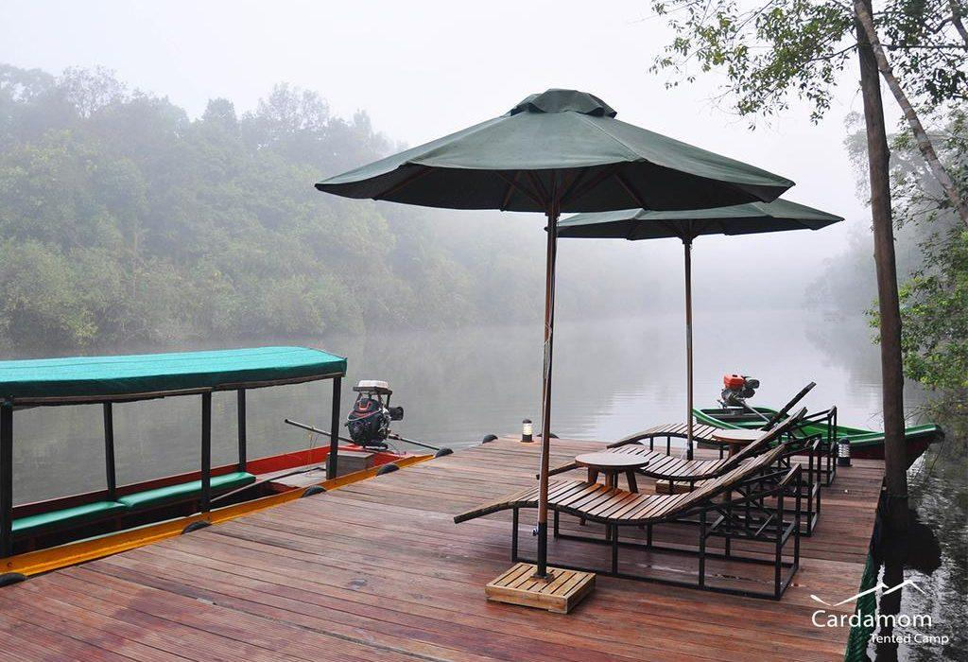

Easia Travel Head Office

Siem Reap BranchCharming City, No. R32 – R34, Road Rolouse, Trorpeangses Village, Sangkat Koukchork, Siem Reap Province – CambodiaTel: (855-63) 76 14 58Fax: (855-63) 76 14 58

