VIETNAM – Can Tho – Can Tho Ecolodge
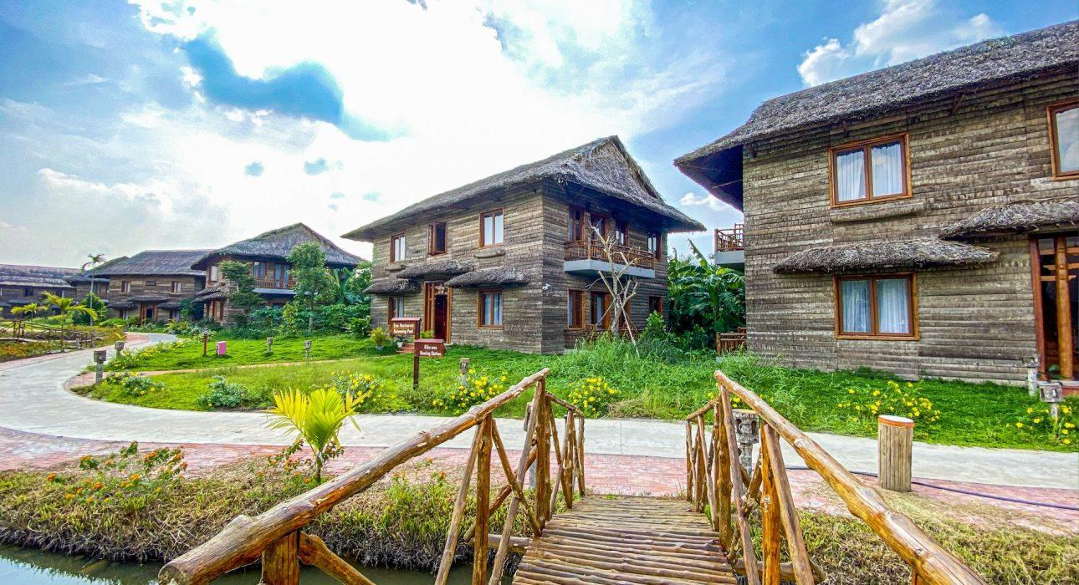

Over View

Theme
Classic, Family, Honeymoon, Sustainable

Country - City
Vietnam - Mekong Delta - Can Tho

Market segment
Groups, Thematic Leisure

Official category
Ecolodge

Easia category
Ecolodge, First Class

Total number of rooms
48

Price level
$$

Description

Located away 10km from the central of Can Tho city, Can Tho Ecolodge is home of 12 thatched cottages including 48 rooms. It spread over 2.7 tropical hectares on the banks of the Ba Láng River. All rooms represent the powerful call of nature across renewable building materials and 4-star amenities. These offer a panoramic balcony and natural wooden bathtub, each delivered in a symphony of local bamboo, palm leaf, and red brick.The Hotel’s restaurant and bar offer dining and socializing options, while a spa, swimming pool, and jacuzzi pool provide opportunities to melt into a tropical paradise.Can Tho Ecolodge features free bicycles, an outdoor swimming pool, a garden and bar in Can Tho. Among the facilities of this property are a restaurant, a 24-hour front desk and room service, along with free WiFi. The rooms are equipped with a balcony with a garden view. All guest rooms at the resort are equipped with a seating area. Each room is equipped with a private bathroom with a bath, a hair dryer, free toiletries, air conditioner.

Selling points

- Eco-friendly lodge concept, no competitor with a similar concept in Can Tho.
- Only 10 minutes by boat to Cai Rang floating market
- Spacious rooms
- Big outdoor swimming pool

Sustainability

Supplier Actions
Protection of Environment, Support local communities, Restrict plastic use, Respect social policy & human rights, Water refill station

Other Notes
Review Factsheet: 27 July 2023 by Hoang Oanh and Hong Ngoc

Time & Transportation

FROM | TO | DISTANCE (KM) | BY | DURATION | ROAD CONDITION
Can Tho Ecolodge | Ninh Kieu Pier | 10 km | Car | 20 Min | Good
Can Tho Ecolodge | Airport | 17 km | Car | 30-40 Min | Good
Can Tho Ecolodge | Cái Răng floating market | 2km | Boat | 10 Min | Good

Rooms

Easia's recommend room type
Room configuration:
- Junior Deluxe: (08 Double rooms) 38m2
  - The rooms offer panoramic garden views over the glittering waters of the canal from a private balcony. The room’s handmade furnishings, including a king-sized bed, are complemented by charming decorative elements that reflect the region’s rich culture.
- Deluxe: (16 Doubles + 14 Twins + 10 Triple ) 56m²
  - The rooms are a picture of paradise located on the banks of the Ba Lang River. These 56m2 offerings are flooded with light streaming through large windows, which open onto an inviting balcony and the lush tropical gardens of the ecolodge spanning outwards. Attractive timber furnishings are dotted around a large double bed or two twin beds, while a free-standing bathtub made of jackfruit tree wood highlights a gorgeous en suite bathroom.

Room configuration

Connecting rooms
Yes, 4 pairs of rooms ( Deluxe rooms - DBL connecting TWN)

Extra bed
4 beds ( Rollaway bed 1m x 2m )

King bed
2m x 2m

Twin beds
1.4m x2.2m

Services & Facilities

Services
24 hour reception, 24h security service, Airport transfer, Bicycle Rental, Buffet Breakfast, Car rental, Chef- Prepared meals and cooking lession, Cooking Lesson, Credit Card payment, Currency exchange, Cycling, In-house English speaking tour guide, Iron, Laundry service, Luggage Storage, Massage, Spa, Swimming Pool, Tour desk, Wake-up service, Wi-fi Free

Facilities
Air Conditioning, Bar, Bicycle, Buggy, coffee and tea making facilities, Family Room, Fan, Hair Dryer, In-Room safe, Internet, Mini Bar, Outdoor swimming pool, Restaurant, Safety Box, Smoking Area, Umbrella

Disabled Facilities
No disable access

Business facilities details
ROOM NAME | SIZE | CLASSROOM | THEATER | U SHAPE | BOARDROOM | BANQUET
Conference Room | 65m2 | 40 pax | 60 pax | 30 pax | N/A | N/A

Restaurant information

Mekong Restaurant
- Capacity: 200 pax
- Opening Hours: 06h30 – 22h00
- Type of Cuisine: Vietnamese and Western
- Note: on the 2nd floor and has view to the pool

Photos

Hotel Photos
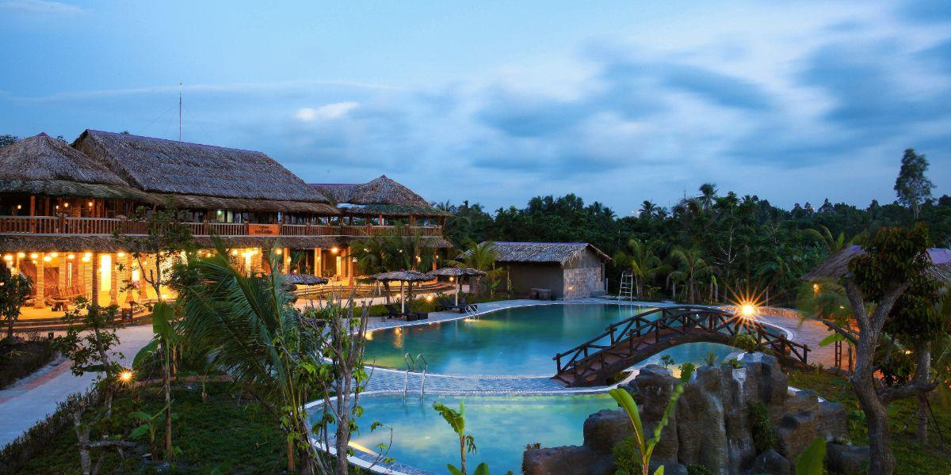
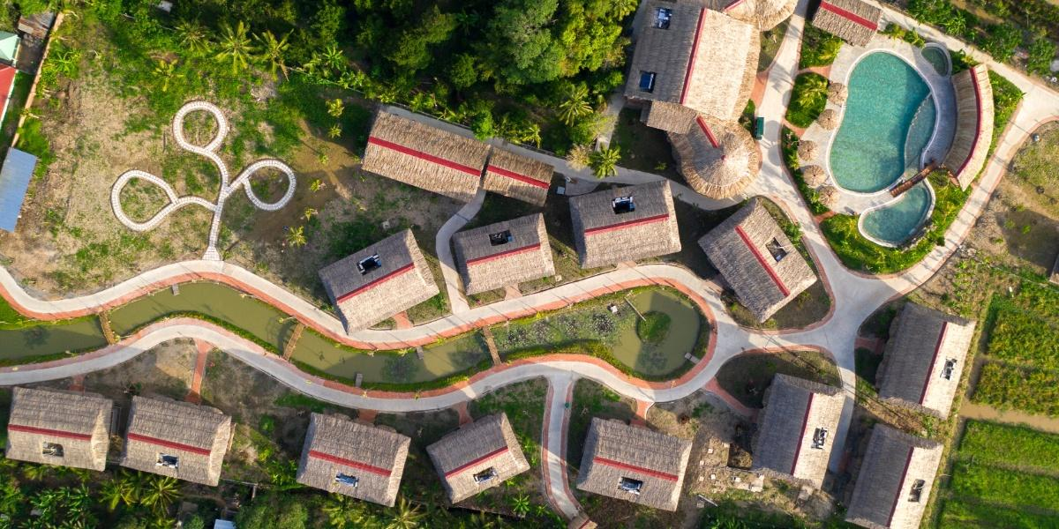
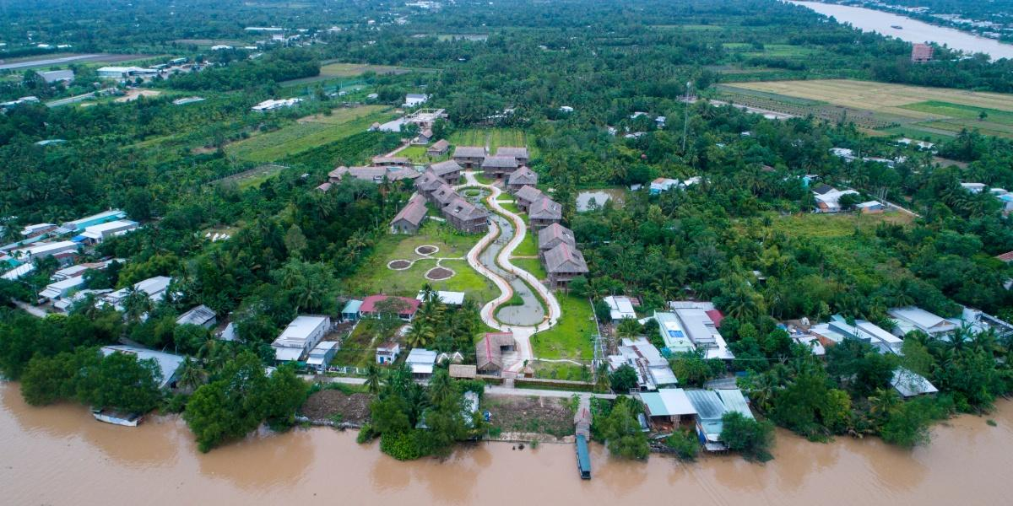
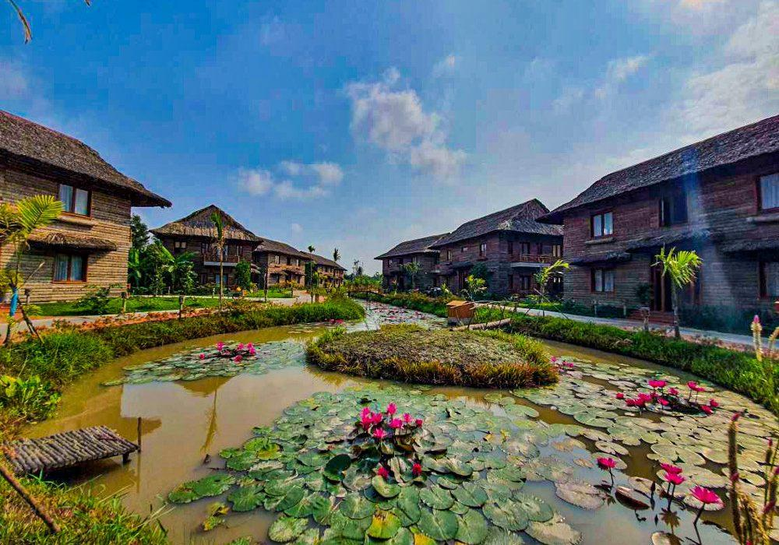
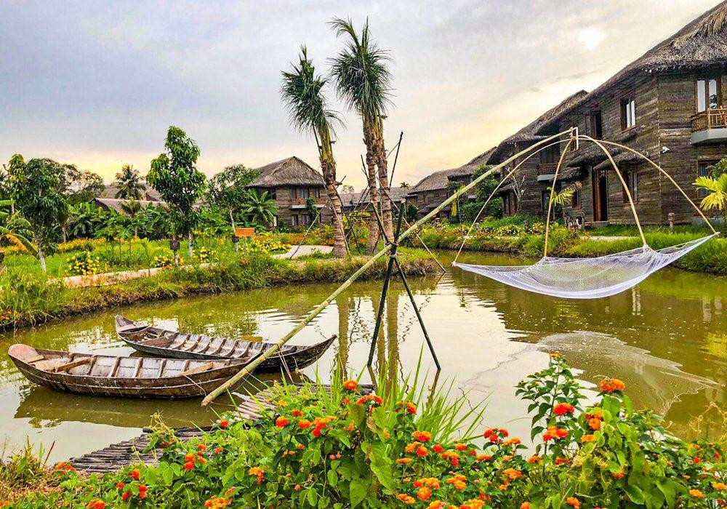
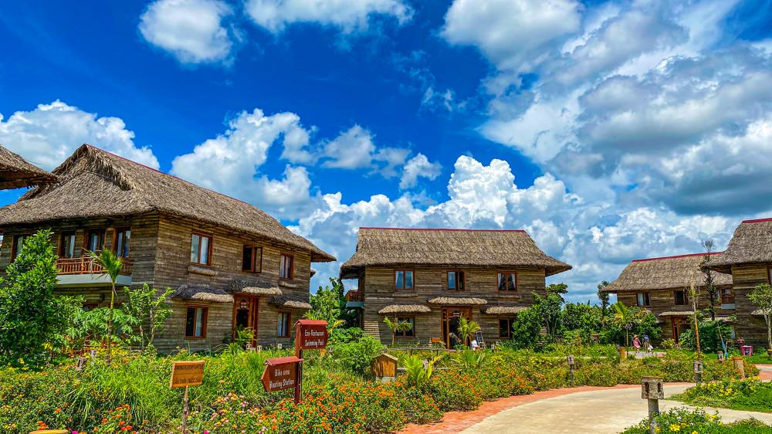

Rooms photos
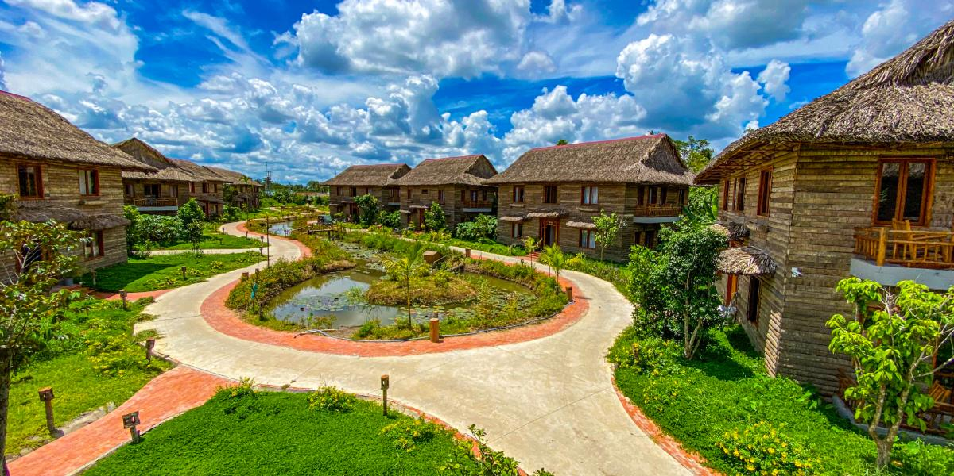
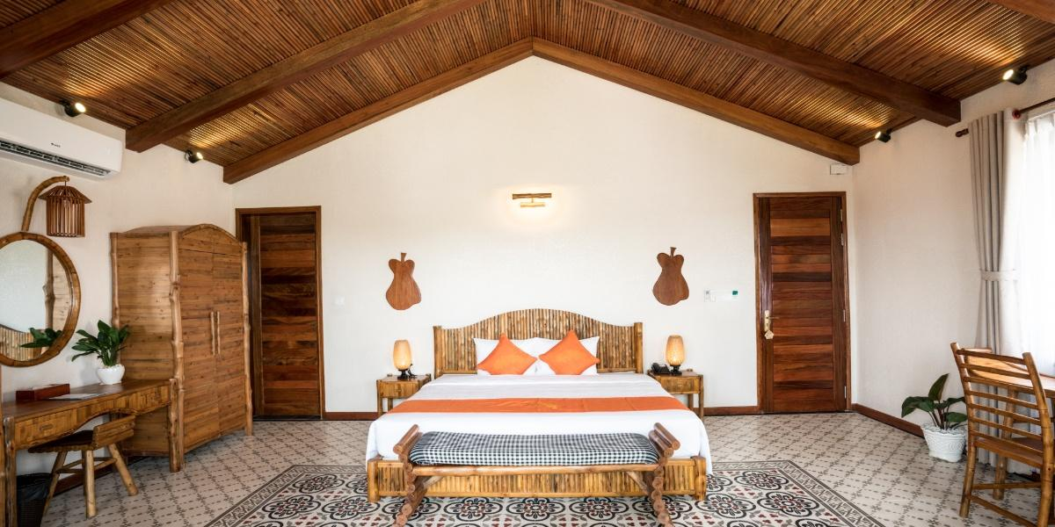
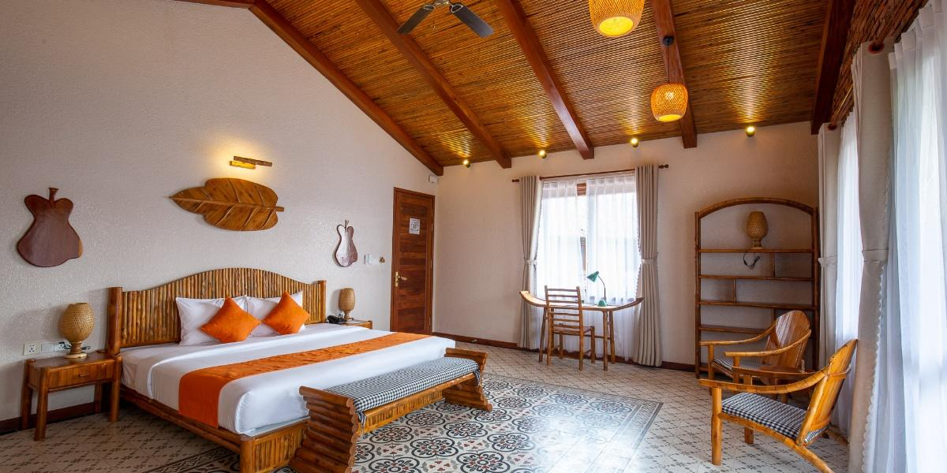
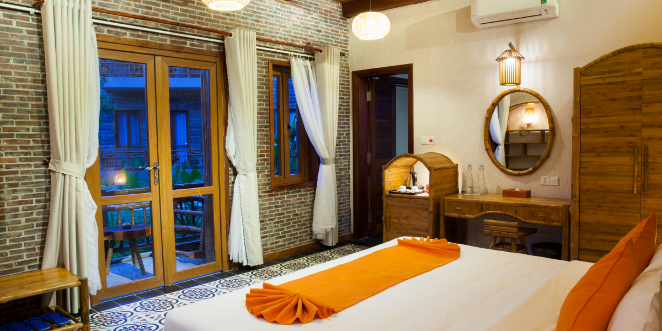
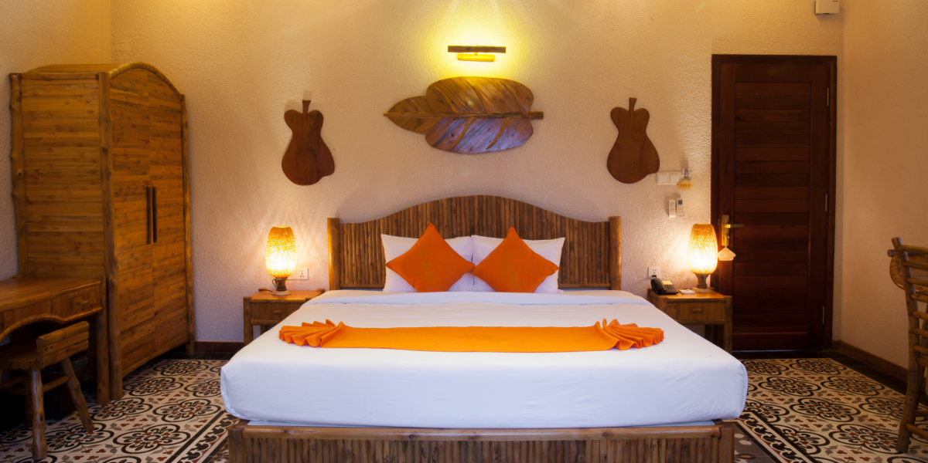
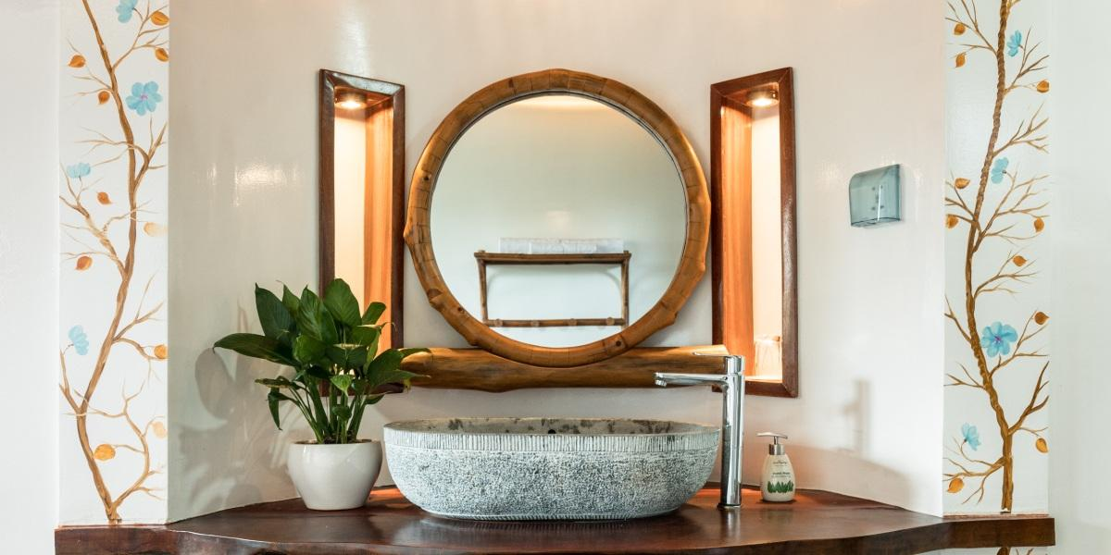
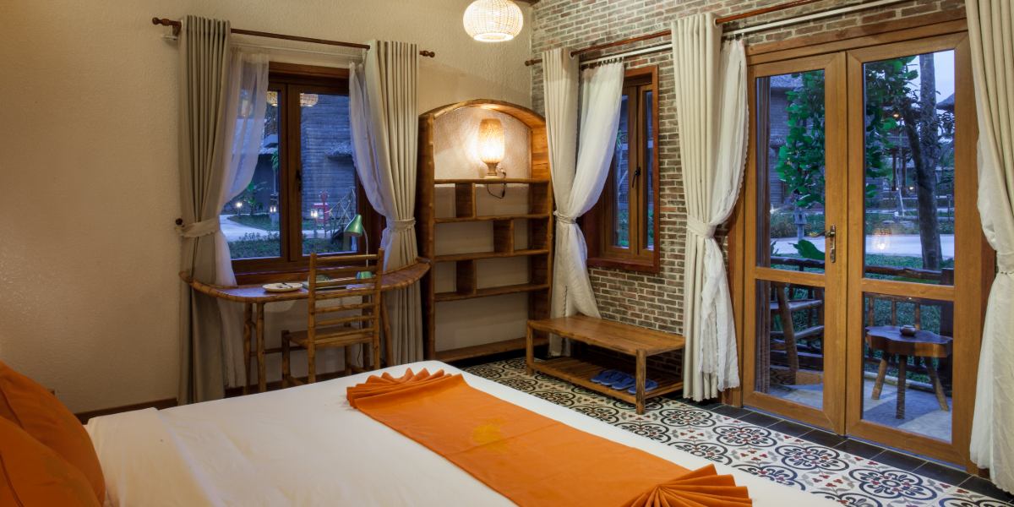
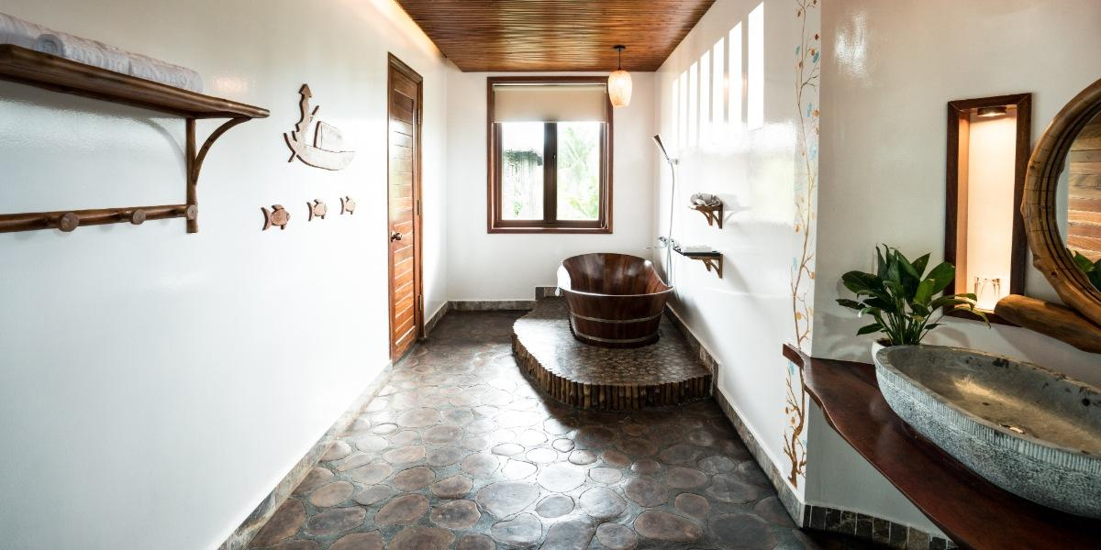
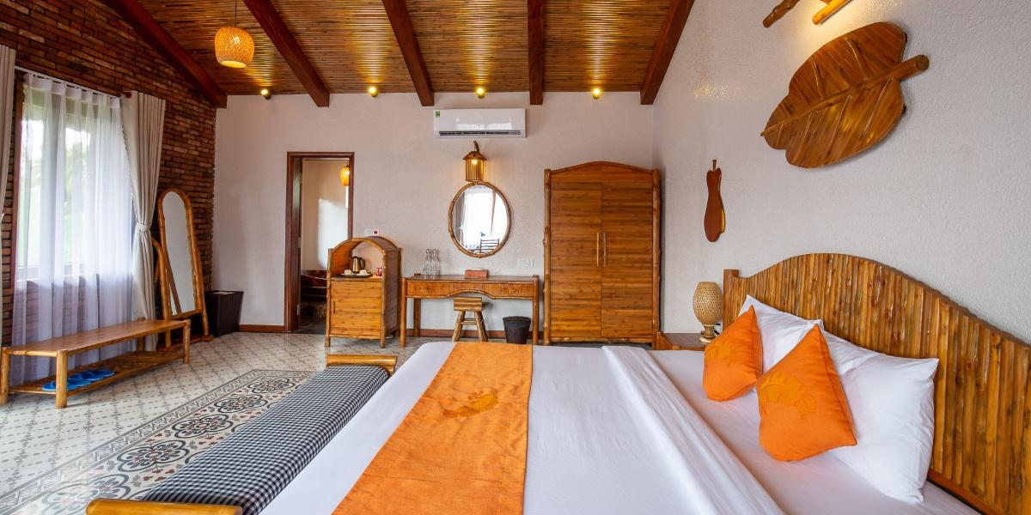
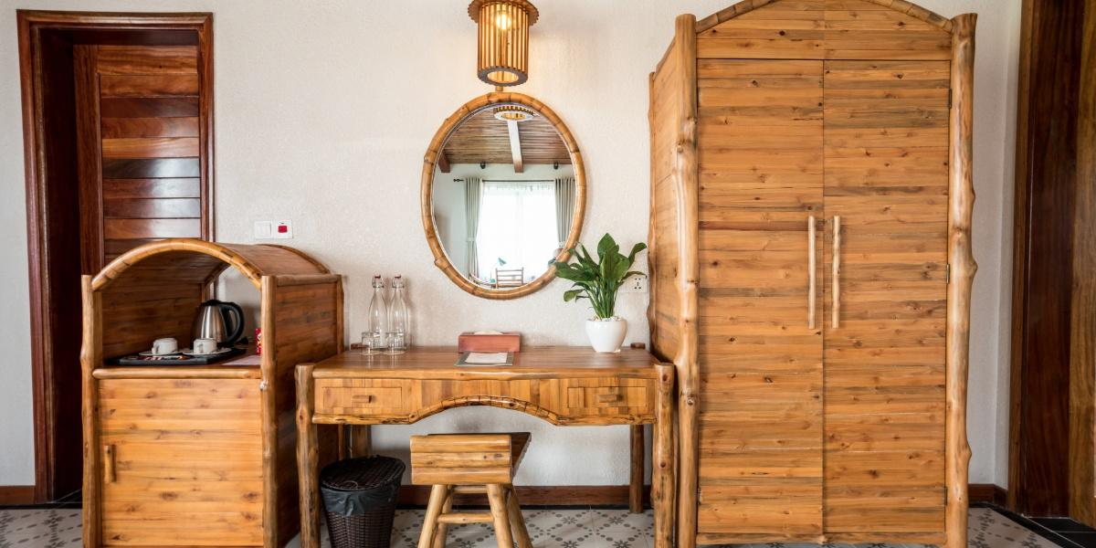
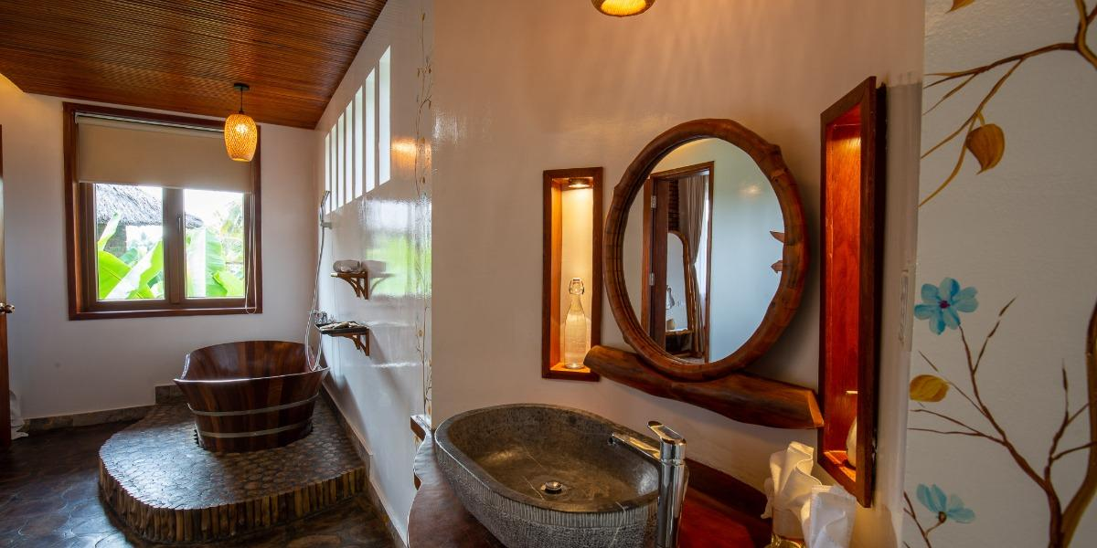
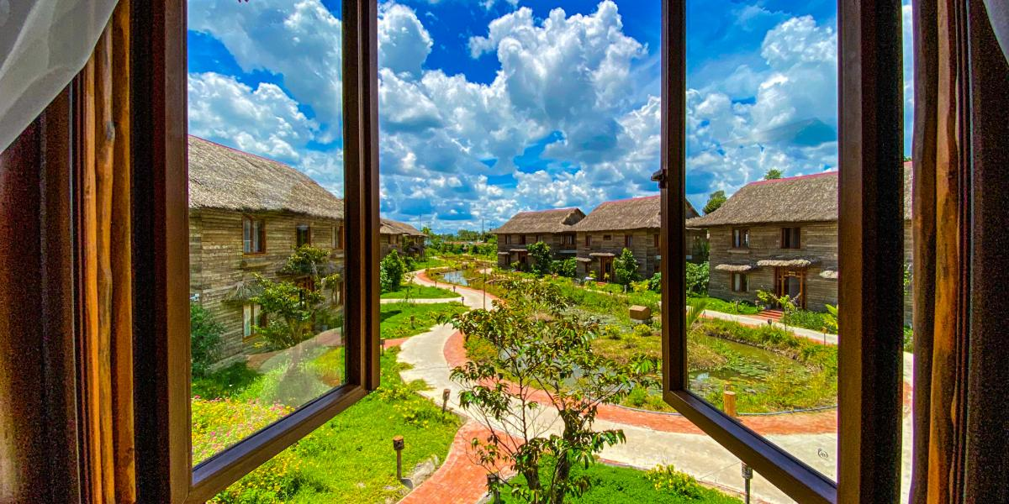
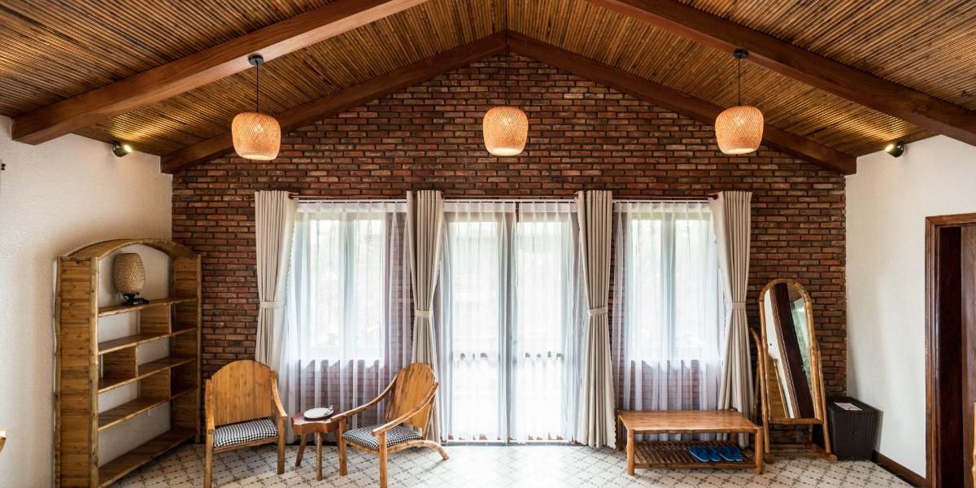

Restaurant photos
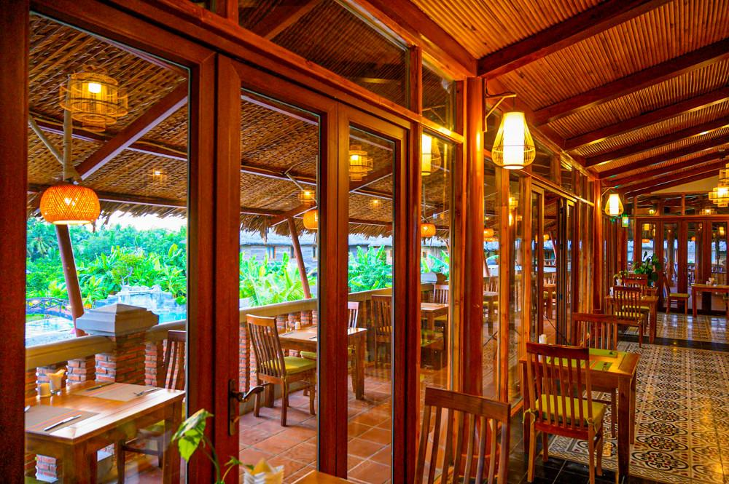
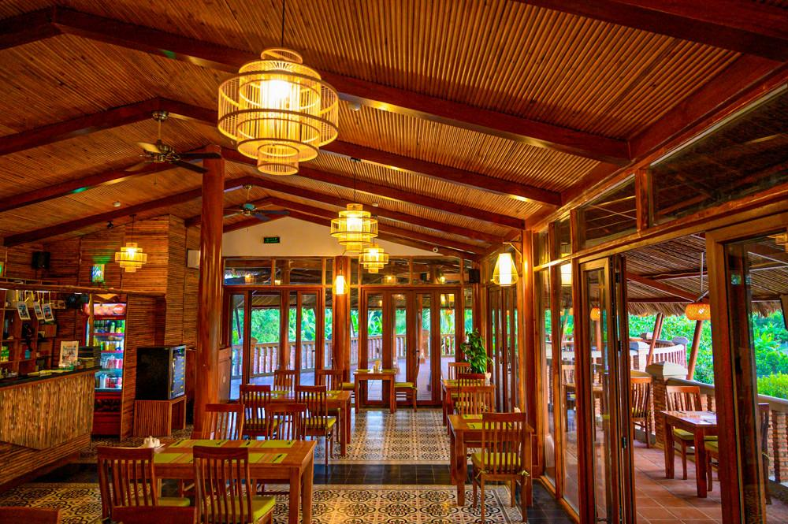
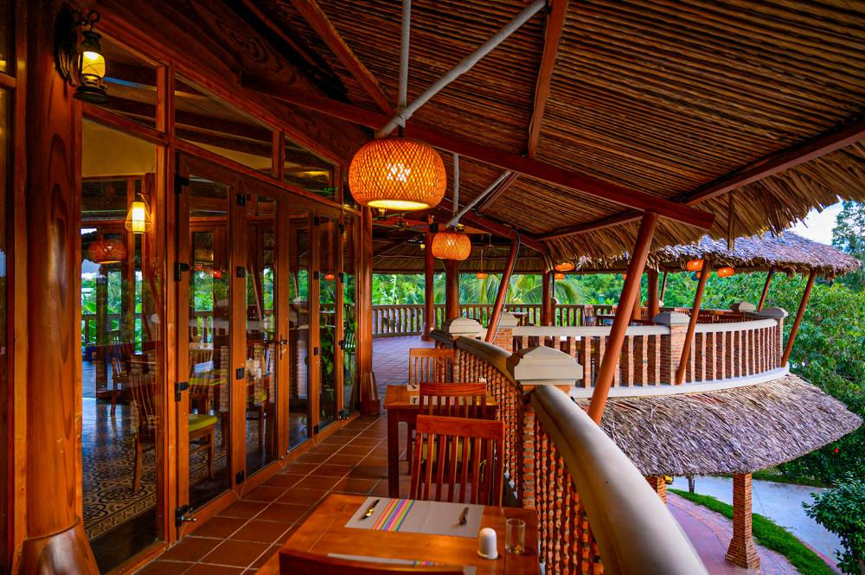
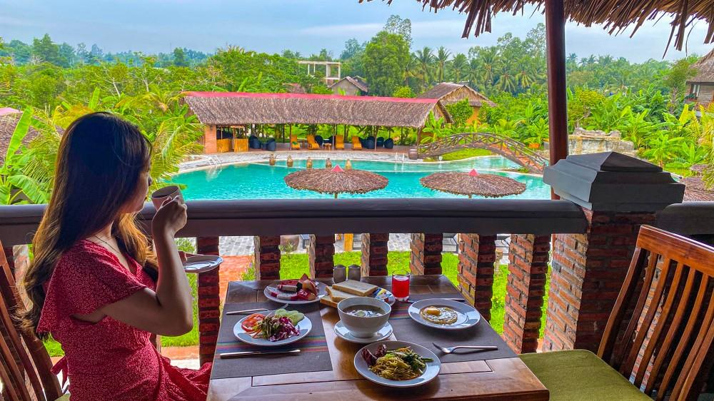
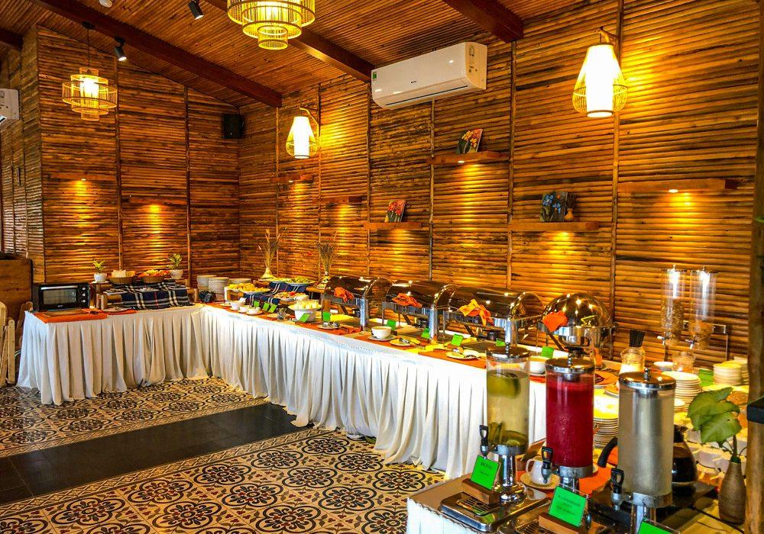
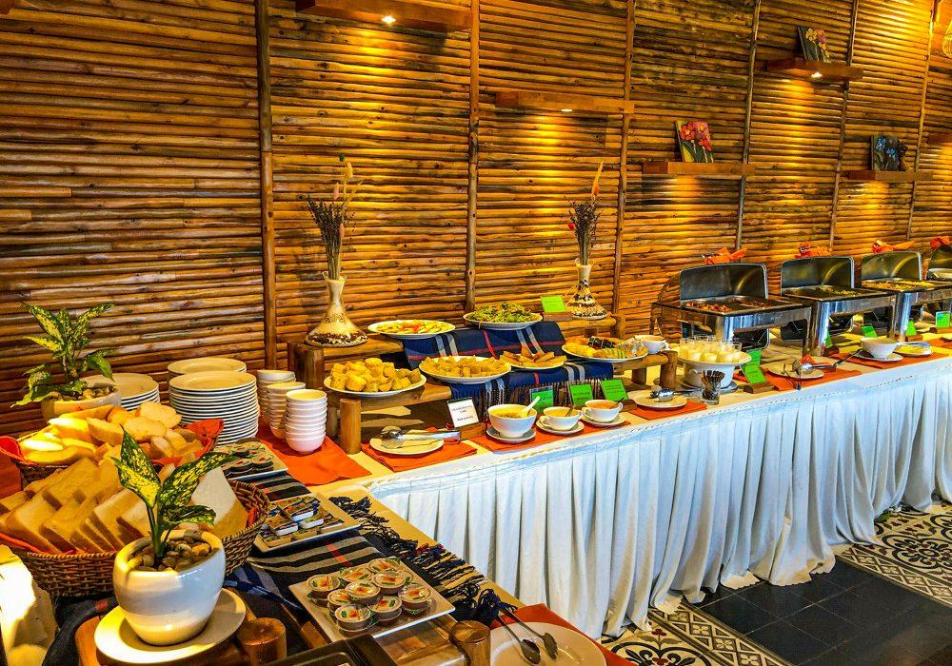
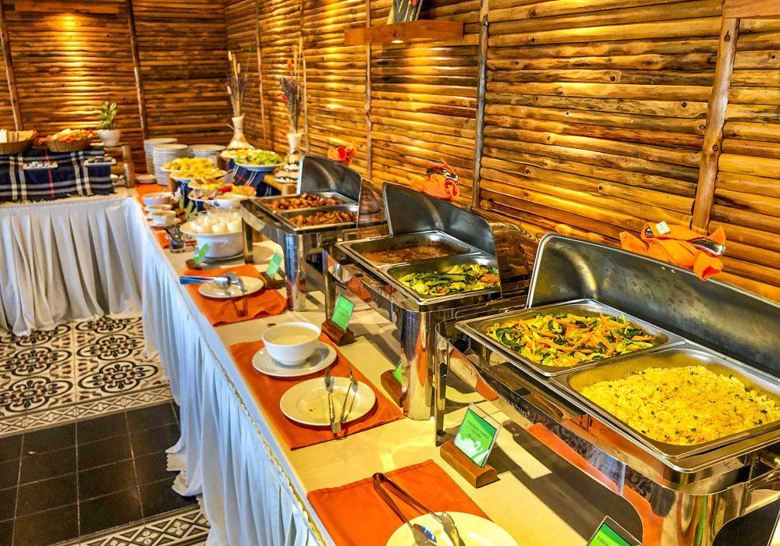

Services & facilities photos
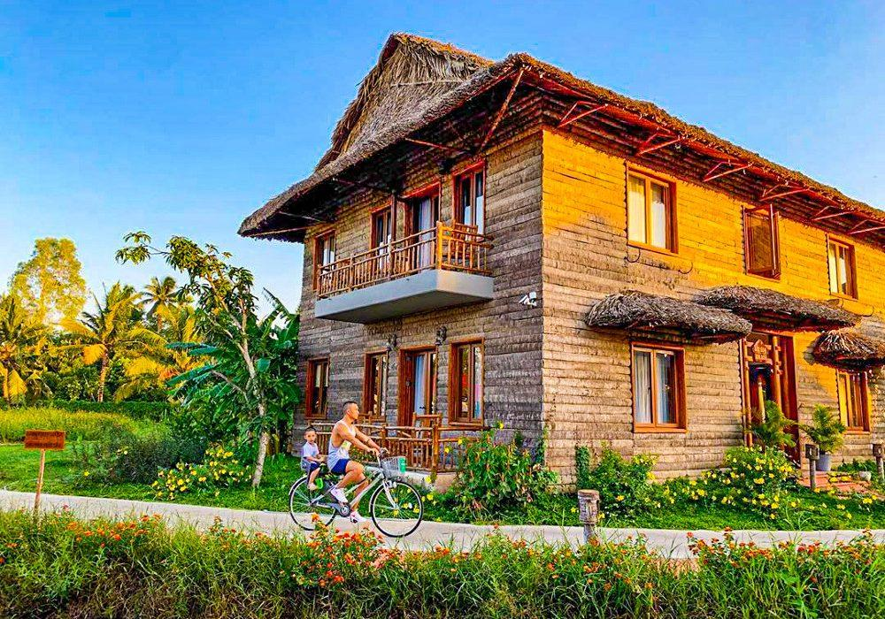
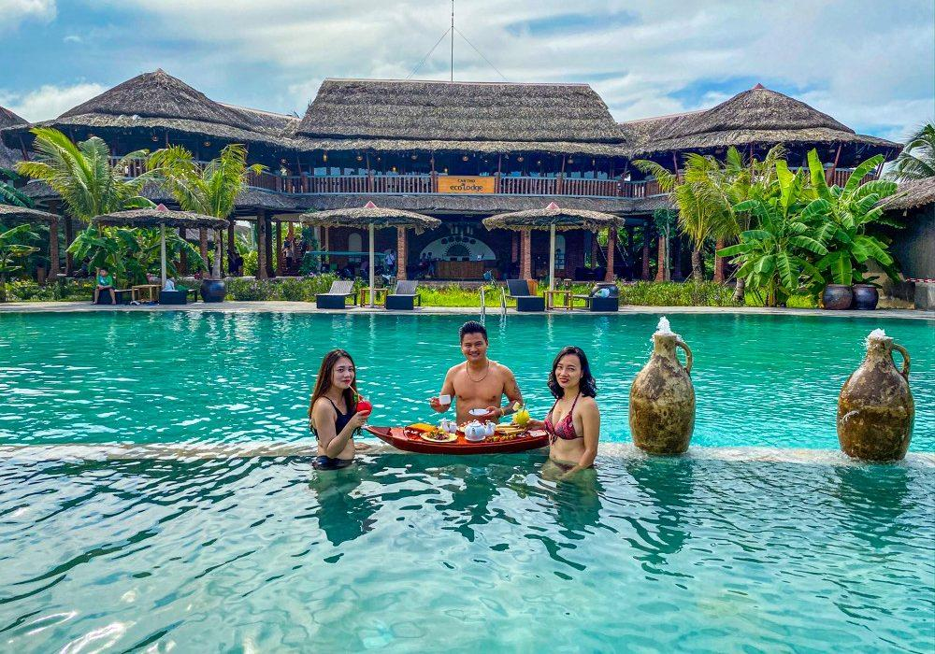
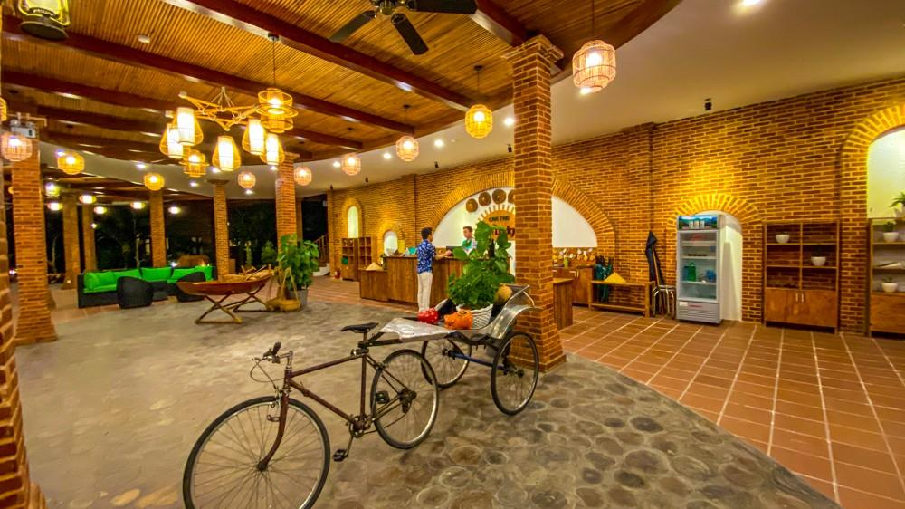
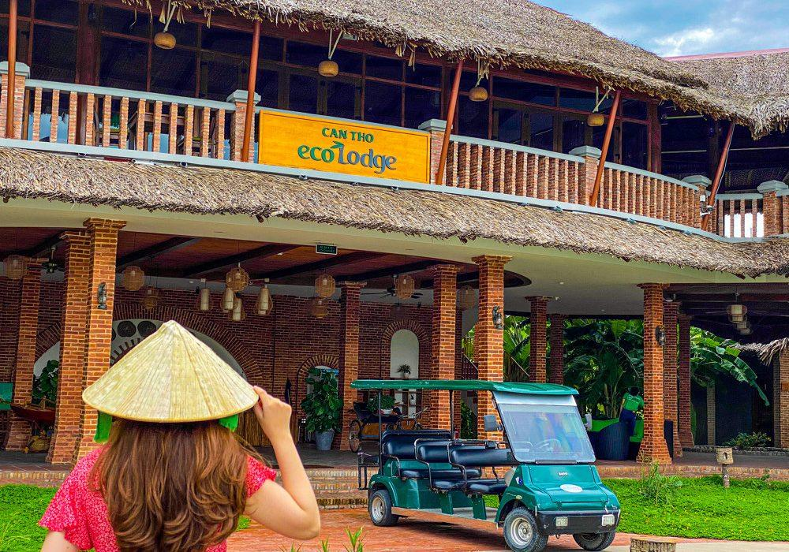
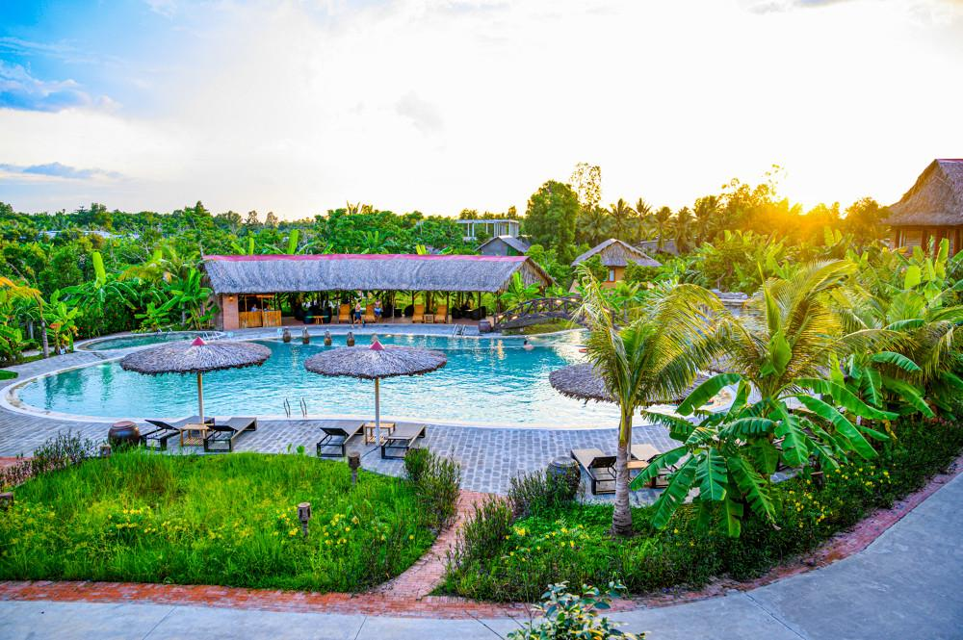
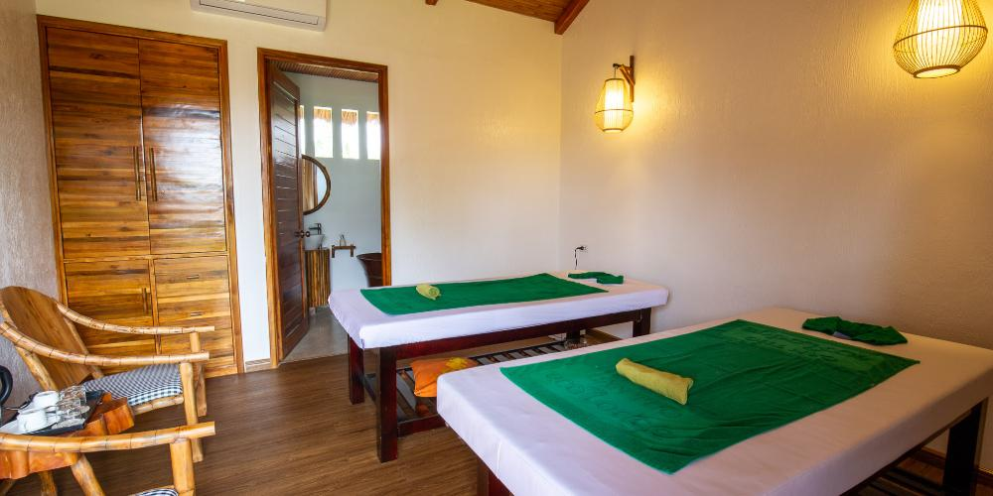

Easia Travel Head Office

