VIETNAM – Ho Chi Minh City – The Reverie Saigon
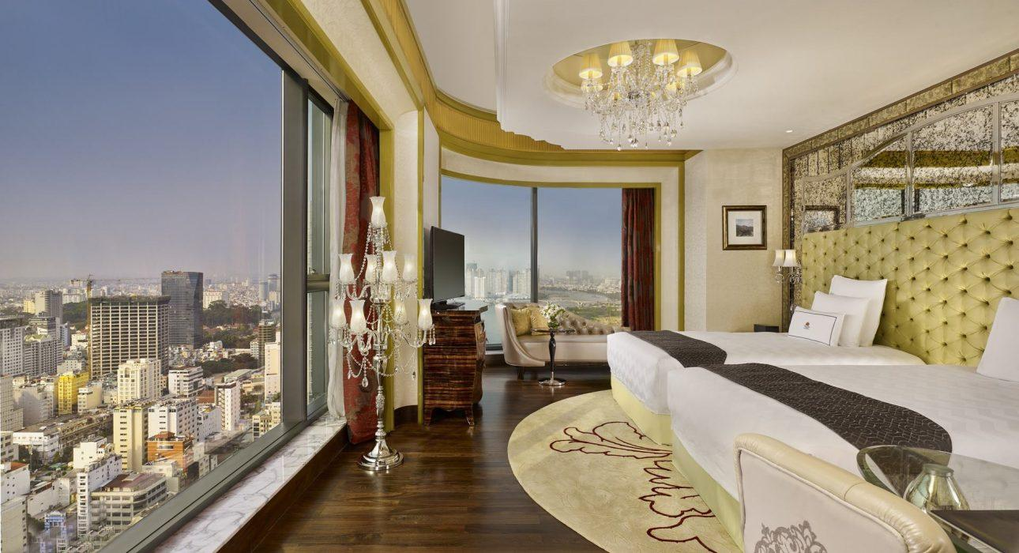

Over View

Theme
Art &amp; Culture, Classic, Family, Gastronomy, Honeymoon, Sustainable

Country - City
Vietnam - Ho Chi Minh City

Market segment
Groups, Thematic Leisure

Official category
5*

Easia category
Luxury

Total number of rooms
286

Price level
$$$$

Description

The Reverie Saigon has debuted as the most spectacularly extravagant hotel in Vietnam and as the one and only member property of The Leading Hotels of the World in all of Vietnam.Taking pride in place on the topmost floors of the landmark Times Square Building in prestigious District 1, The Reverie hotel presents world-class hospitality with its impeccable service and its unique celebration of Haute Italian design and inimitable luxury.Furnished in the hotel’s fanciful, electric style, all of The Reverie Saigon’s 286 guestrooms pay homage to the Italian passion for exquisite décor, artistry, and craftsmanship. Ranging in size from 43 to 313 square meters, all 12 categories of hotel accommodations offer some of the most spacious rooms and suites in the city.In addition, 89 full-service residential-style suites offer luxury living in a more residential style, accompanied by access to the hotel’s services and amenities.

Selling points

- Located right at the city’s heart tight on Nguyen Hue Blvd and Dong Khoi streets, the most prestigious address in HCMC.
- One of the highest hotels in Ho Chi Minh City, with sweeping city or river views from every guest room.
- Starting at 43m2, the Reverie Saigon features the city’s most spacious entry-level hotel room.
- Luxury amenities Chopard in standard rooms, Hermes in Suites room, and Aqua di Parma in 2 largest Suites
- Offer complimentary minibar in all room types.
- Various cuisine of food and drink restaurants and bar: French, Italian, Chinese, casual bar

Sustainability

Supplier Actions
Protection of Environment, Support local communities, Respect social policy & human rights, Facilities for people with reduced mobility (PRM)

Certifications
ISO 14001:2015 & ISO 50001:2011

Time & Transportation

FROM | TO | DISTANCE (KM) | BY | DURATION | ROAD CONDITION
Tan Son Nhat International Airport (SGN) | Hotel | 8km | Car | 40 minutes
Hotel | Independence Palace | 1,3km | Car | 5 minutes
Hotel | War Museum | 3km | Car | 15 minutes

Rooms

Easia's recommend room type
Room Type | Number of room
DBL | TWIN | Total
Deluxe | 134 | 33 | 167
Grand Deluxe | 27 | 12 | 39
Panorama Deluxe | 18 | N/A | 18
Junior Suite | 18 | N/A | 18
Romance Suite | 13 | N/A | 13
Executive Suite | 13 | N/A | 13
Panorama Suite | 12 | N/A | 12
Designer Suite | 4 | N/A | 4
The Reverie Suite | 1 | N/A | 1
The Sai Gon Suite | 1 | N/A | 1
Description:DeluxeBright and airy, the Deluxe Room defines a decidedly glamorous take on urban chic with its sophisticated, classical décor in a rich palette of earthy tones and shimmering platinum offset by custom finishes. Each comes with a spectacular backdrop of city or river views.Grand DeluxeGreat for business or weekend getaways, the Grand Deluxe Room is evocative of a romantic age of travel, with its distinctive decorative accents such as silk headboards, a sculptural standing chandelier, and a plush leather chaise longue.Panorama DeluxeFor those who prefer more space to work and play, the Panorama Deluxe Room presents an ultra-glamorous living space with covetable, wrap-around windows and an ambiance oozing la dolce vita.Junior SuitePresenting one of the most en-vogue stay experiences in Saigon, the distinctive and stylish Junior Suite is reminiscent of a chic, private Italian salon with its magnificent furnishings and smoldering design accents.Romance SuiteThe Reverie Romance Suite represents the quintessence of Italian luxury with its uniquely appointed living and, ultimately, the seductive sleeping area that subtly tributes to the art of romance.Executive SuiteWell-suited for entertaining or relaxing while enjoying the chic and sophisticated abode, the suite features a spacious dining and living space and an entirely separate master bedroom.Panorama SuiteThe Panorama Suite is perfect for the modern jet setter seeking a statement space to impress or relax in style.Designer SuiteThe generous, residential-style space seamlessly combines beautiful furnishings with grand design statements

Room configuration

Connecting rooms
No - Only Adjoining Rooms, 13 Pairs

Extra bed
Yes , Rollaway bed: 0.95m x 1.95m

King bed
2m x 2m (except for Grand Deluxe King 1m8 x 2m)

Twin beds
1m4 x 2m

Services & Facilities

Services
24 hour reception, Afternoon Tea, Airport transfer, Buffet Breakfast, Caving, Concierge service, Credit Card payment, Currency exchange, In-Room Dining, Iron, Laundry service, Luxury car rental, Room Service, Spa, Swimming Pool, Wake-up service, Wi-fi Free

Facilities
Air Conditioning, Bar, Business centre, Cable, satelite, Cigar club, Coffee Machine Facilities, Coffee Shop, Conference hall, Disabled Facility, Elevator, Fitness centre, Flat screen TV, Gift Shop, Hair Dryer, In-Room safe, Internet, Meeting room, Mini Bar, Outdoor swimming pool, Restaurant, Safety Box, satellite LCD TV, Shower With Hot Water, Umbrella

Disabled Facilities
Elevator

Business facilities details
 | Venue Name | sqm | Classroom | Theatre | U-shape | Boardroom | Hollow Square | Round Table(1.86m) | Cocktail
The Royal Pavilion Level 4 | Amber Room | 156 | 80 | 160 | 40 | 42 | 42 | 80 | 150
Jade Room | 91.3 | 48 | 80 | 21 | 28 | 28 | 60 | 90
Pre-function | 72.8 |  |  |  |  |  | 60 | 70
Amber + Jade + Pre-function | 348.6 | 120 | 300 |  |  |  | 240 | 300
La Scala Ballroom &San Carlo Room Level 5 | Pre-function | 454.2 |  |  |  |  |  |  | 300
La Scala Ballroom A | 345 | 189 | 240 | 48 | 56 | 56 | 160 | 200
La Scala Ballroom B | 272.5 | 126 | 200 | 40 | 50 | 50 | 120 | 150
La Scala Ballroom A + B | 617 | 315 | 600 | 120 | 140 | 140 | 350 | 550
La Scala Ballroom Corridor | 195 |  |  |  |  |  | 120 | 100
San Carlo Room | 130 | 72 | 105 | 30 | 36 | 36 | 60 | 100
La Scala Ballroom A + B + Corridor | 812 | 430 | 700 |  |  |  | 450 | 700
Boardrooms & Conference Rooms Level 8 | Conference Room 1 | 47.88 | 27 | 40 | 15 | 18 | 18 | 30 | 50
Conference Room 2 | 54.7 | 30 | 50 | 18 | 21 | 21 | 30 | 50
Conference Room 1 + 2 | 102 | 56 | 90 | 27 | 30 | 30 | 60 | 80
Conference Room 3 | 66.88 | 45 | 65 | 21 | 24 | 24 | 40 | 60
Conference Room 4 | 72.25 | 45 | 70 | 24 | 27 | 27 | 40 | 60
Conference Room 5 | 66.3 | 36 | 50 | 15 | 18 | 18 | 30 | 60
Conference Room 4 + 5 | 138.25 | 60 | 100 | 35 | 38 | 38 | 80 | 100
Boardroom 1 | 22 |  |  |  | 10
Boardroom 2 | 20.6 |  |  |  | 8
Boardroom 3 | 40 |  |  |  | 24
Designer Lounge | 99 |  |  |  |  |  |  | 60
The Reverie Lounge Level 38 & 39 | e Reverie Lounge | 197 |  |  |  |  |  |  | 60
Executive Meeting Room | 35.5 |  |  |  | 12

Restaurant information

Name: CAFÉ CARDINAL (6th floor)
- Capacity: 100 pax
- Opening Hours: 06:00 -23:00
- Type of Cuisine: Continental during the day & contemporary French in the evening
Name: R & J (B1 Level )
- Capacity: 74 pax in the restaurant & 48 pax in the lounge
- Opening Hours:
RESTAURANT: 6:00 pm – 10:00 pmLOUNGE: 5:00 pm-midnight
- Type of Cuisine: Italian foods
Name: The Royal Pavilion (4th floor)
- Capacity: 200 pax | 9 private dining rooms
- Opening Hours: 11:00 -22:00
- Type of Cuisine: Chinese
Name: The Long @Times Square (Street Level)
- Capacity: 180 seated | 300 standing
- Opening Hours: 10:00 -midnight
- Type of Cuisine: Asian & Western
Name: The Reverie Boutique (2nd floor)
- Capacity: 30
- Opening Hours: 7:00 am – 7:30 pm daily
- Type of Cuisine: it’s croissants and Vietnamese coffee in the morning, a gourmet sandwich or salad at noon, or pastries, smoothies, and ice cream all day long

Photos

Hotel Photos
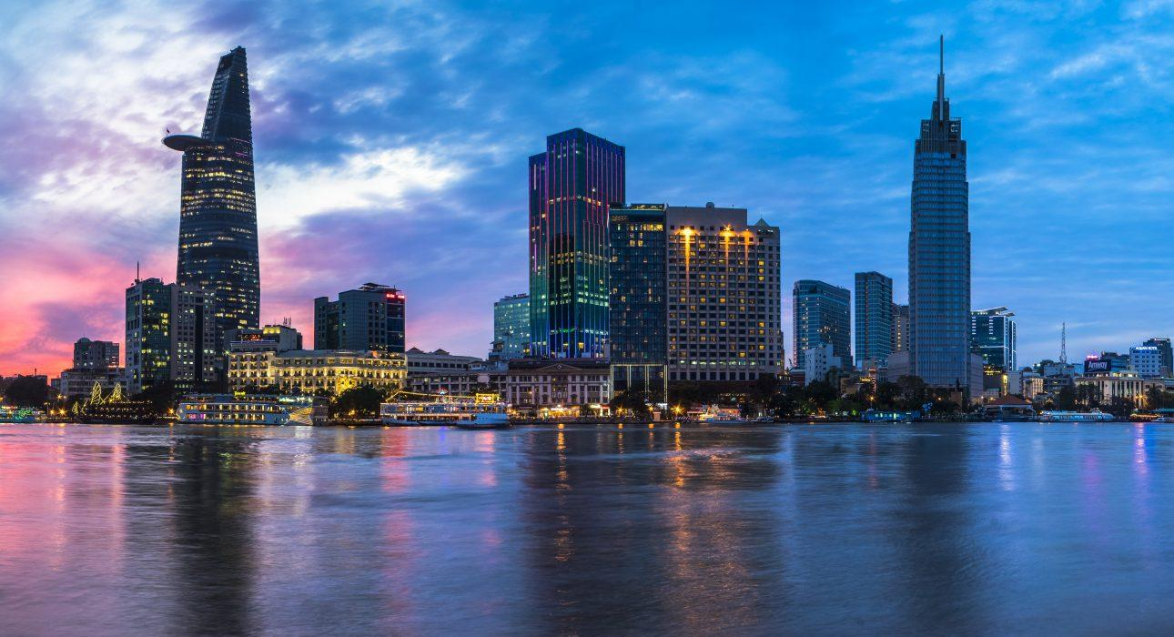
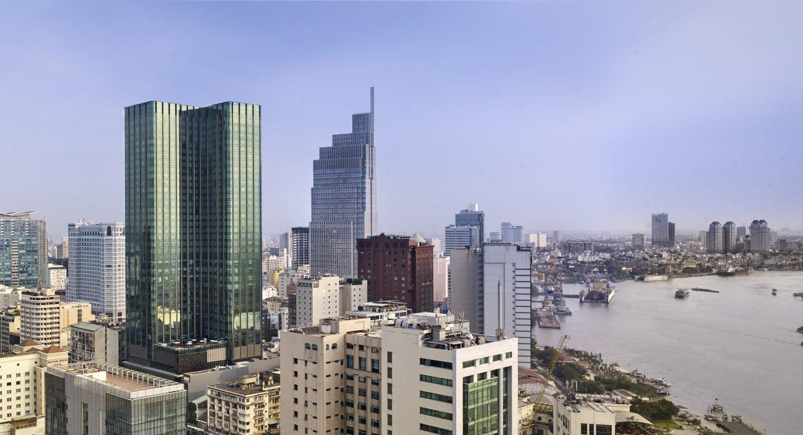
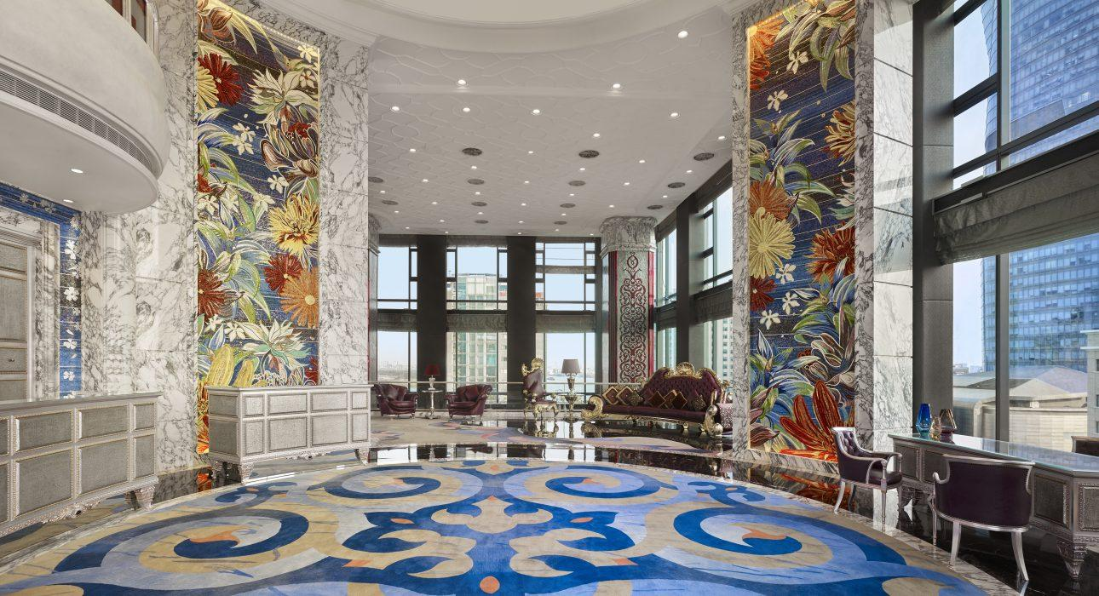
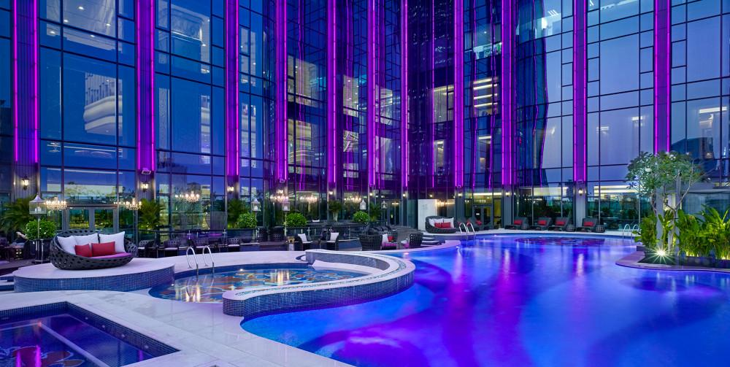

Rooms photos
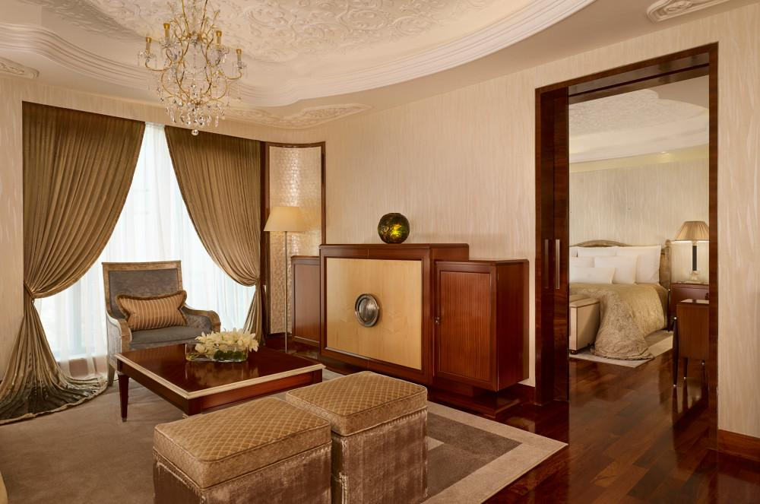
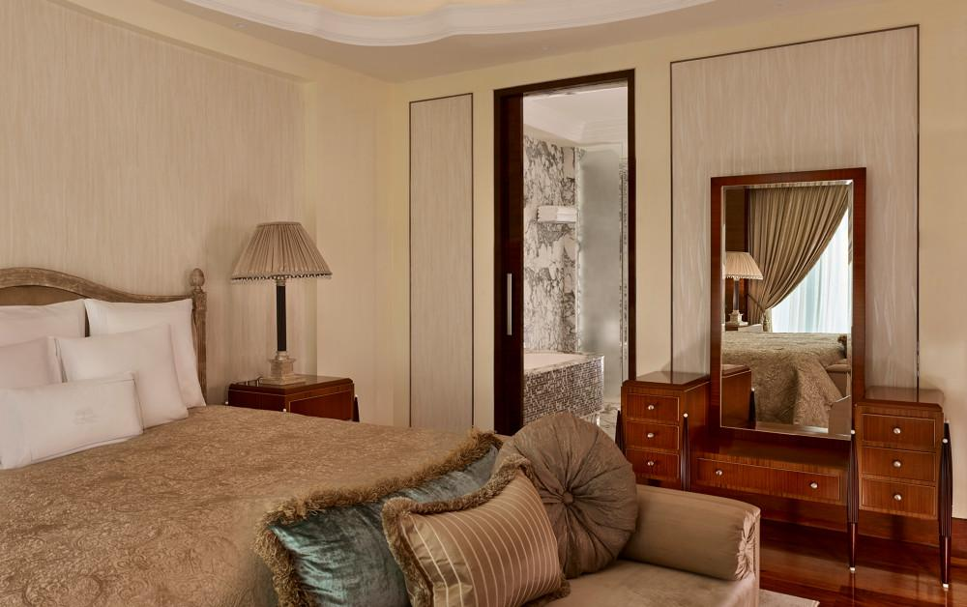
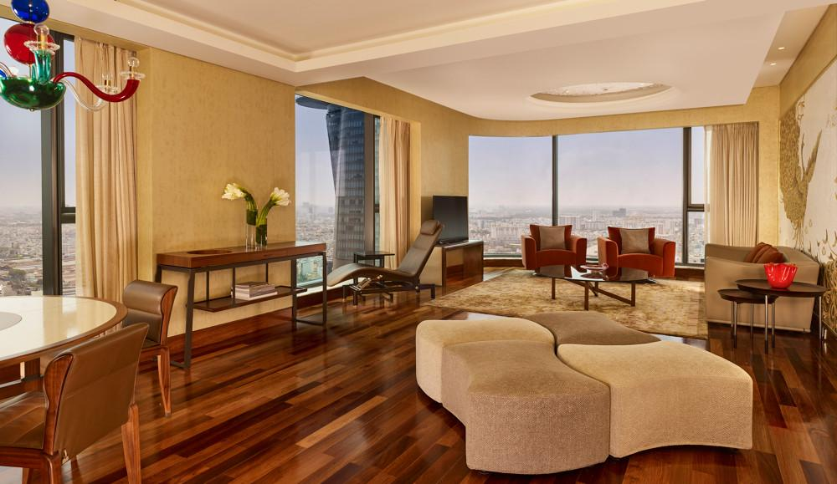
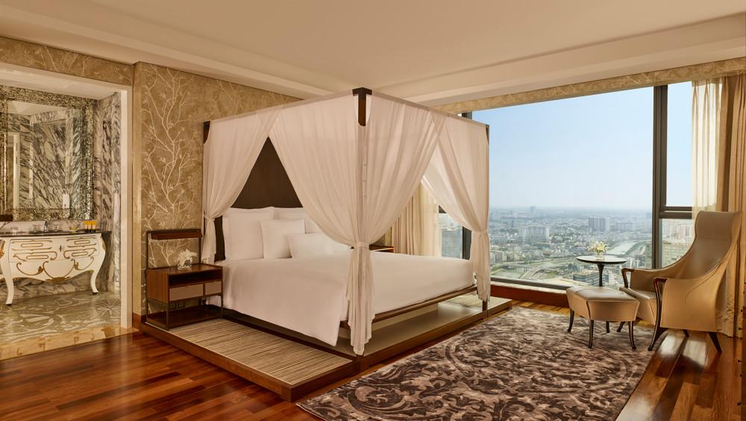
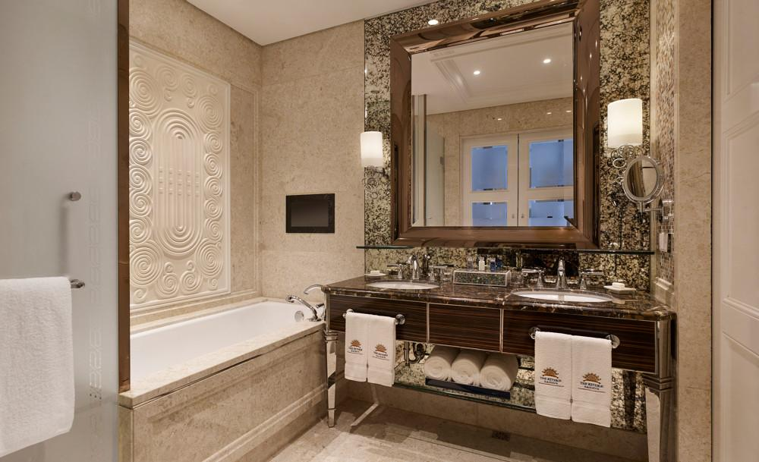
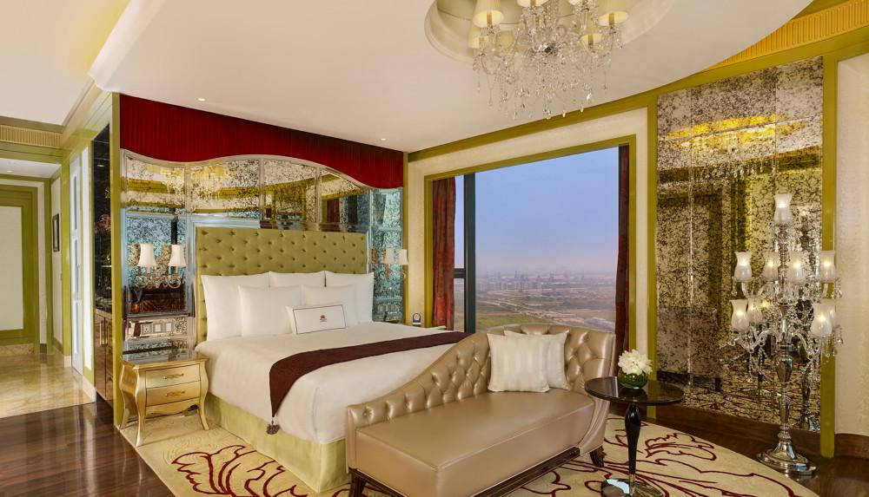
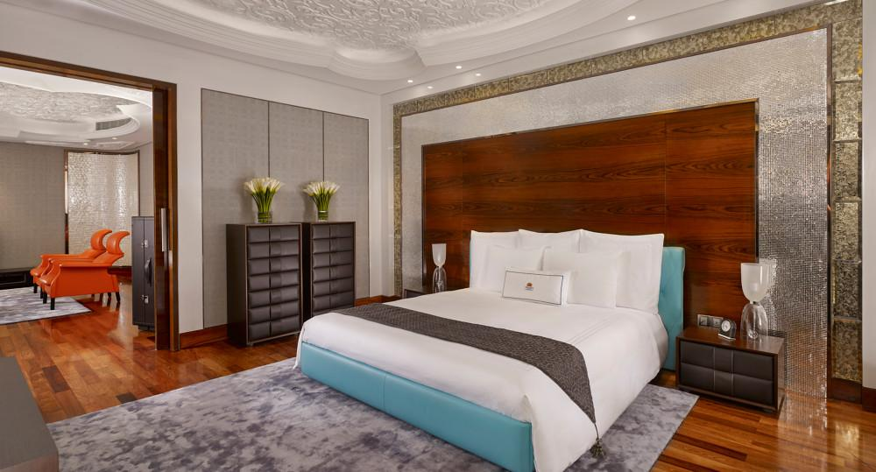
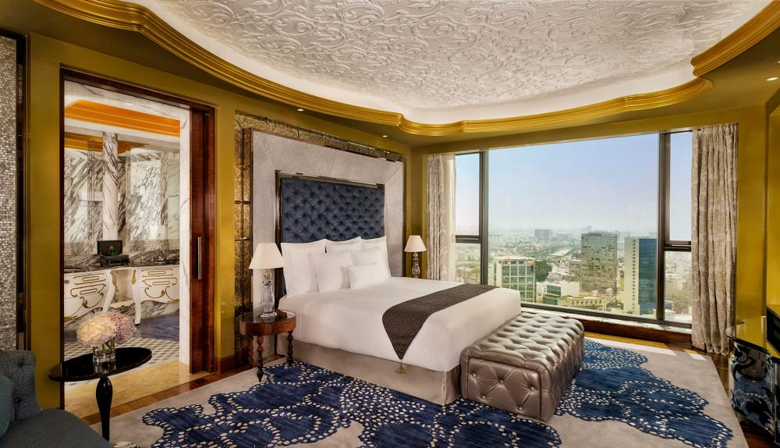
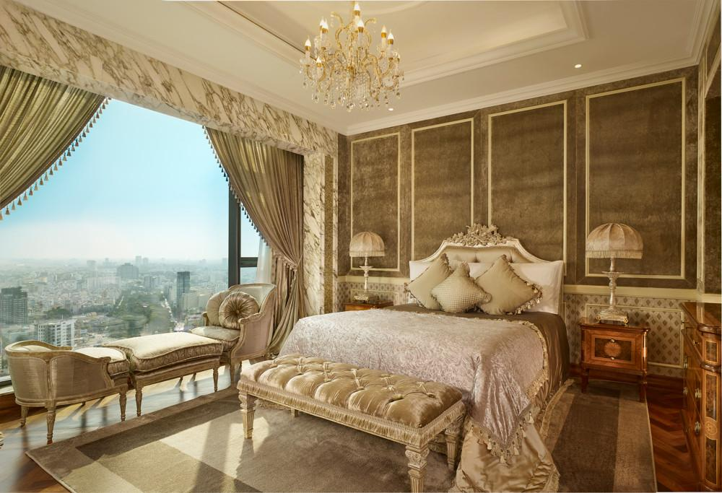
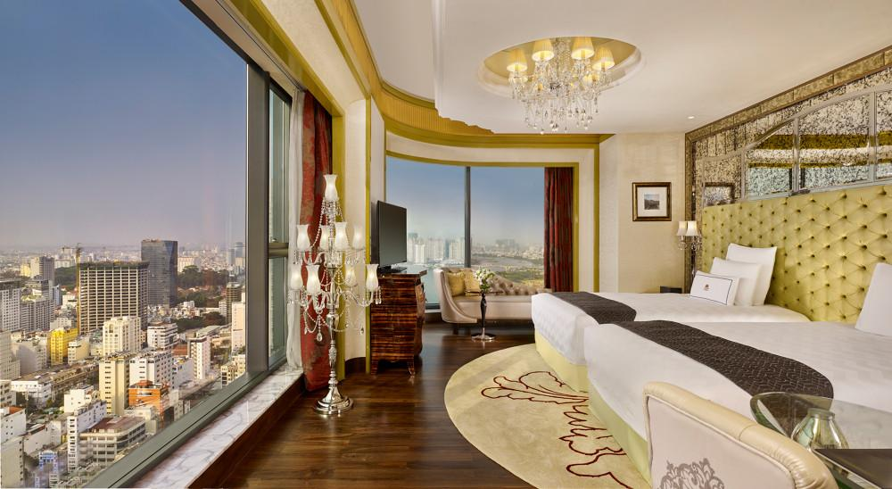
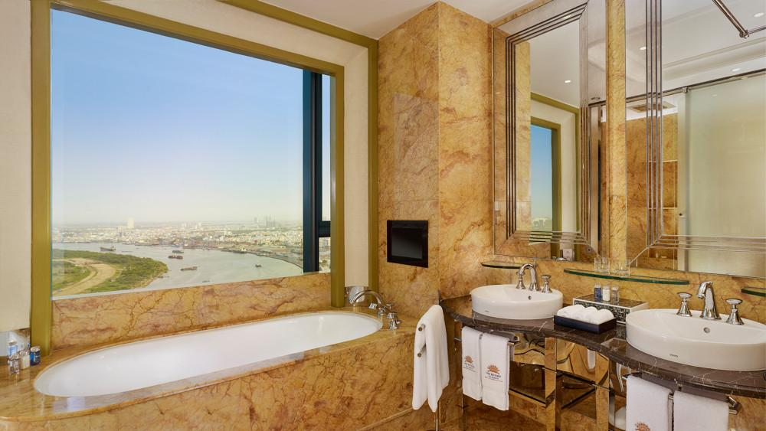
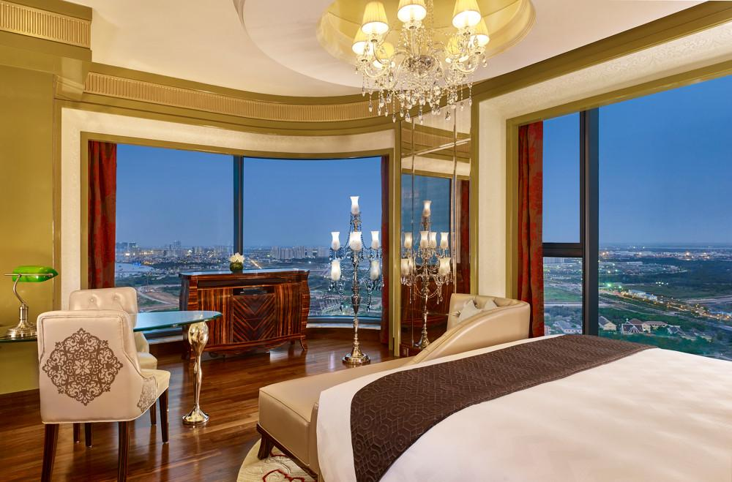

Restaurant photos
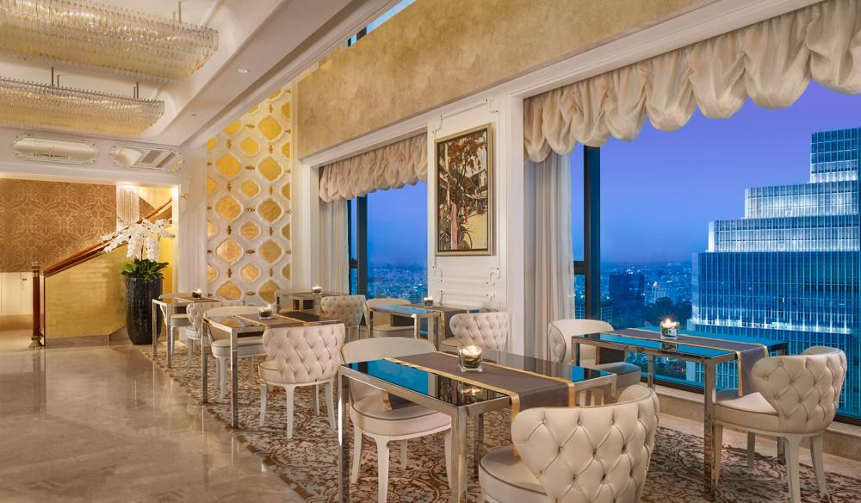
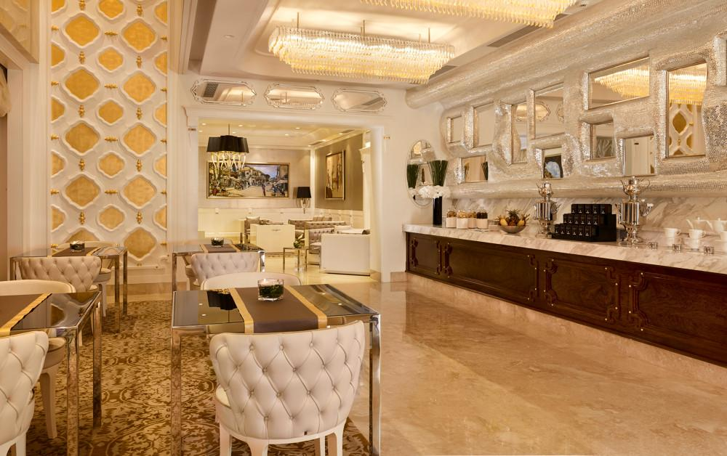
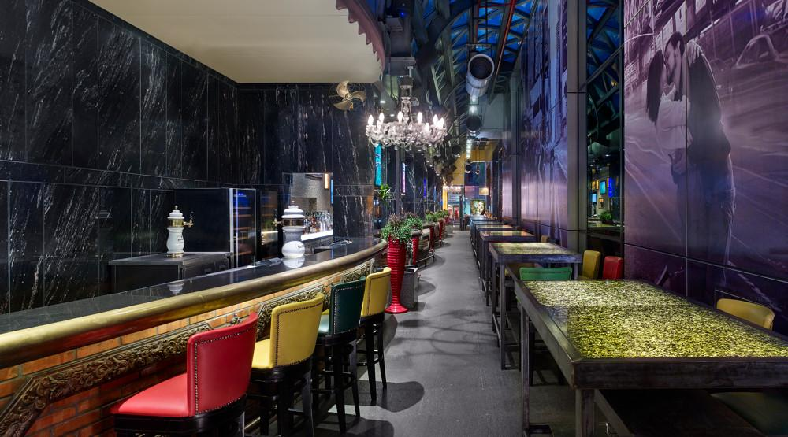
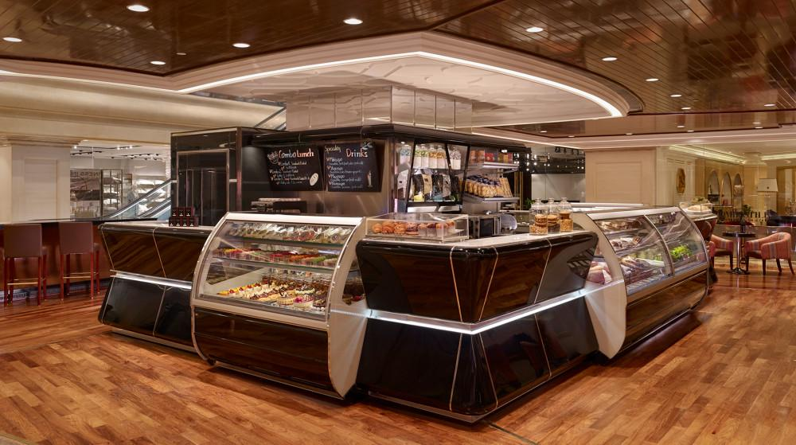
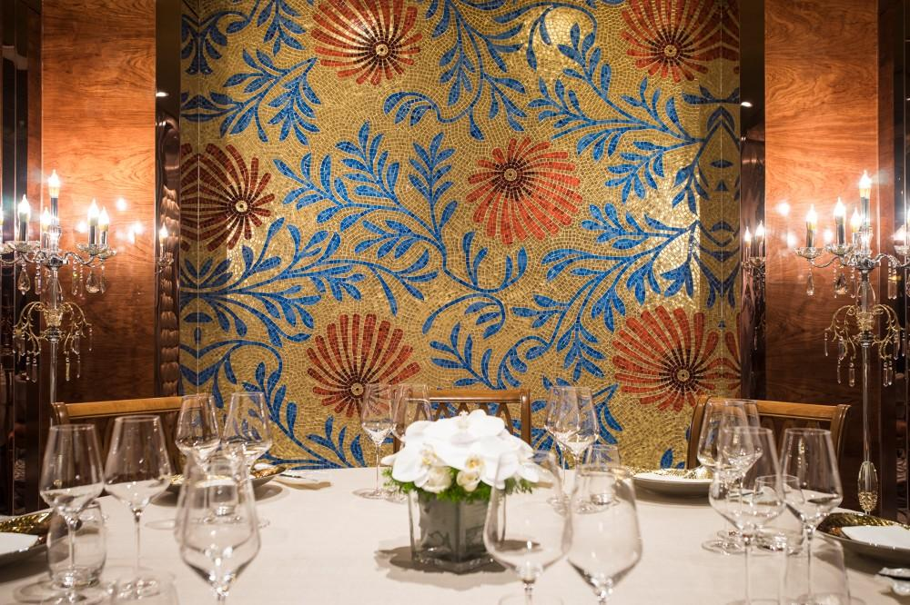
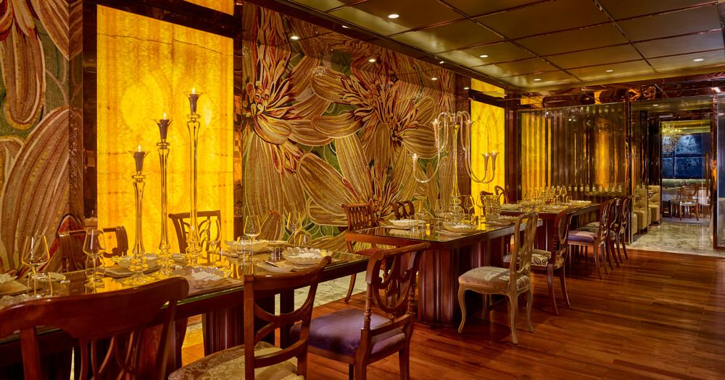
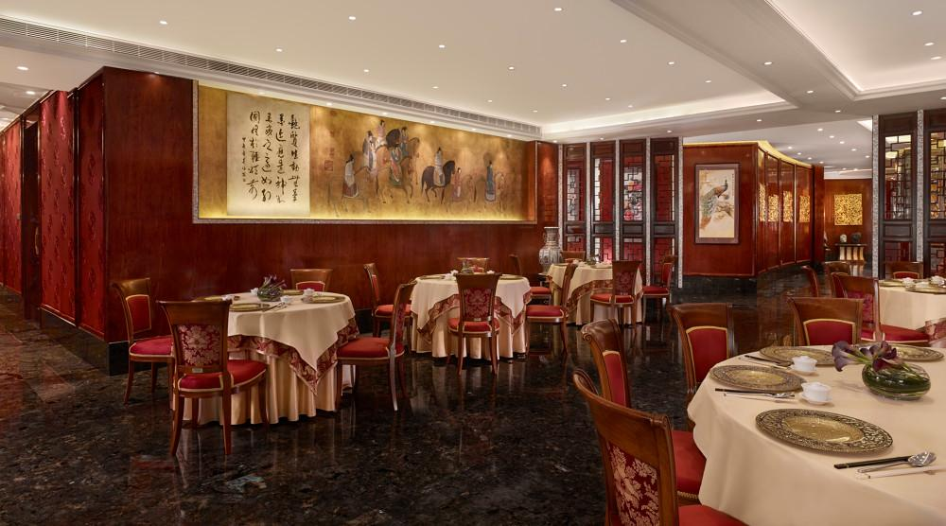

Services & facilities photos
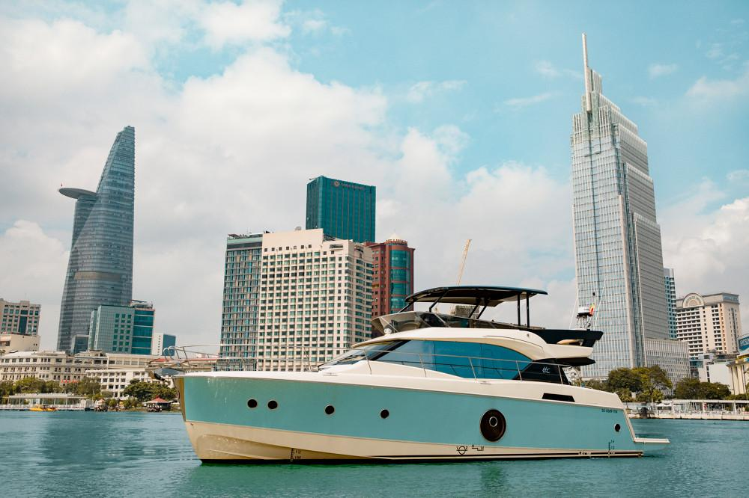
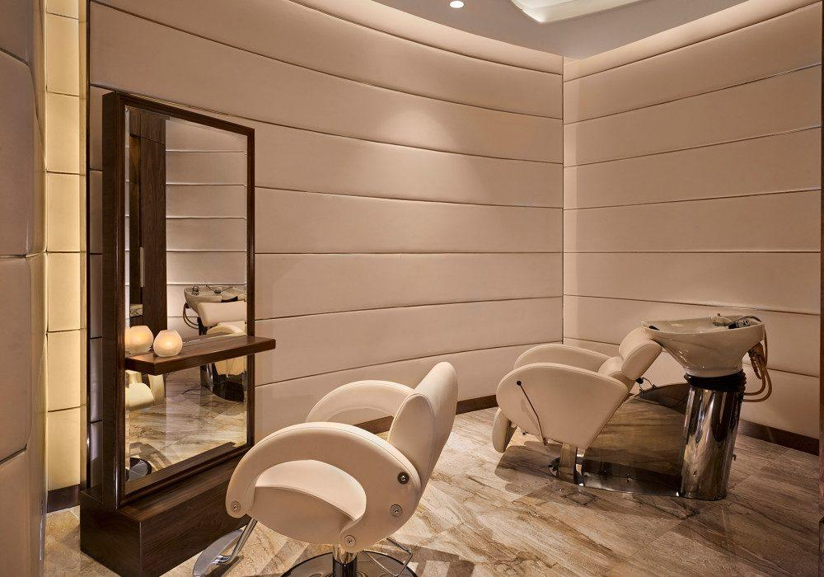
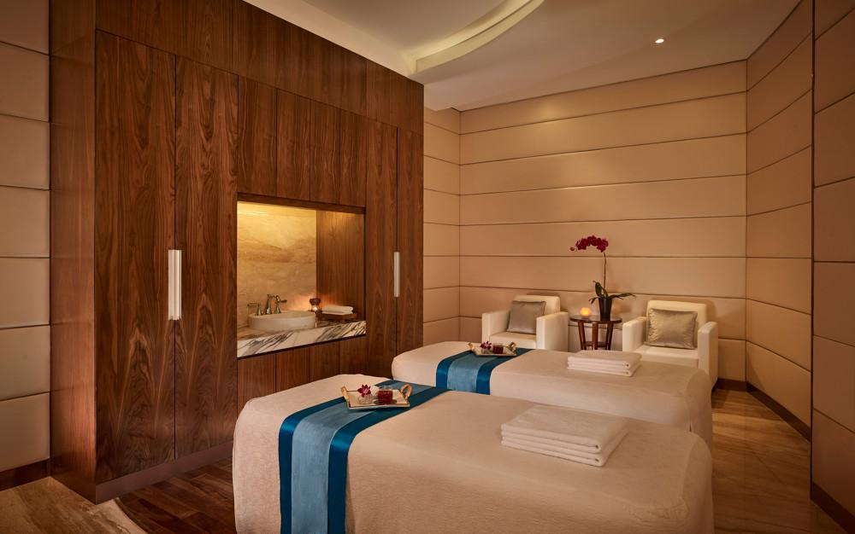
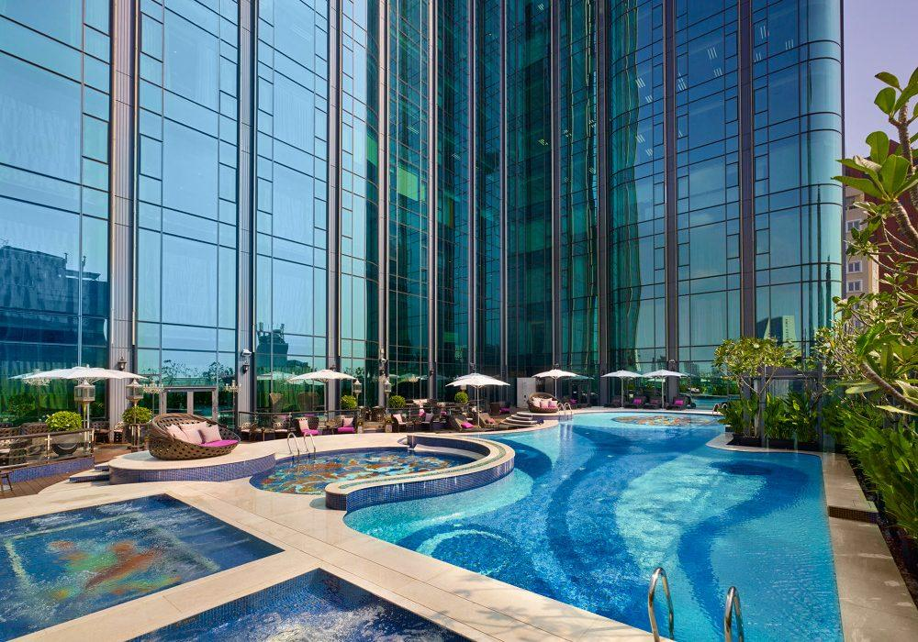
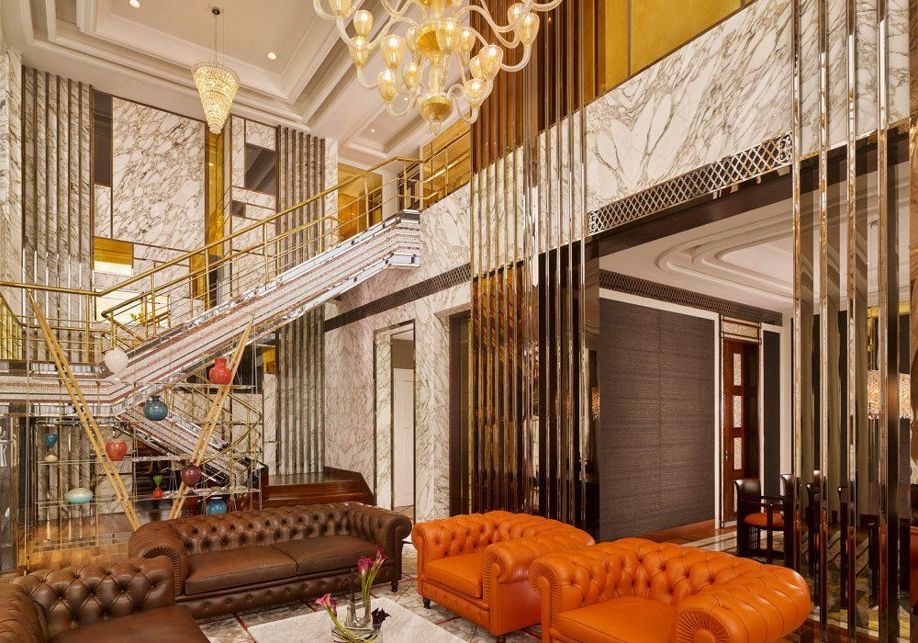
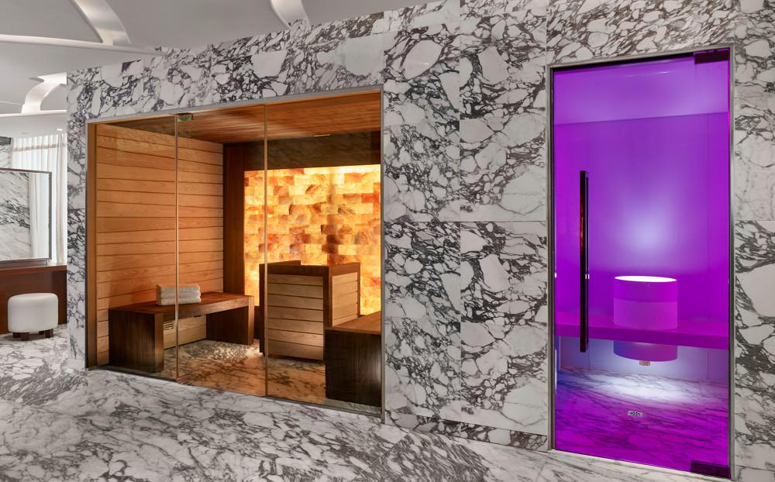

Easia Travel Head Office

