VIETNAM – Ho Chi Minh – Sofitel Saigon Plaza
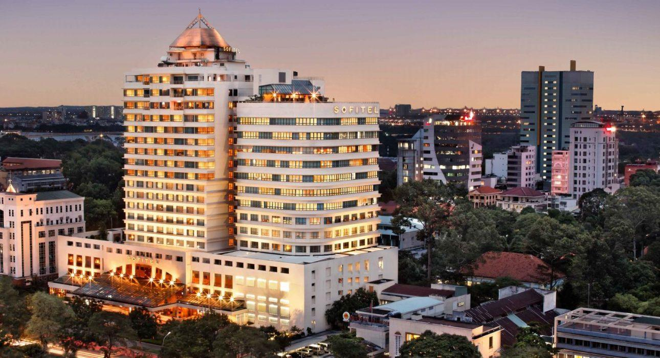

Over View

Theme
Classic, Family, Honeymoon, Sustainable

Country - City
Vietnam - Ho Chi Minh City

Market segment
Groups, Thematic Leisure

Official category
5*

Easia category
Deluxe

Total number of rooms
286

Price level
$$$$

Description

Welcome to 5-star luxury and heartfelt service at Sofitel Saigon Plaza. Chic contemporary design and pure French style artfully blend to engender an atmosphere of refined elegance. From the soaring columns, marble floors, and towering ceilings of the lobby to the sumptuous comfort and inspired décor of rooms and suites, warmth and joie de vivre embrace you.Gentle tones, polished hardwood floors, and stylishly designed space make the Sofitel room a tranquil cocoon above the frantic hum of Ho Chi Minh City. All 286 rooms & suites are free high – speed wifi and luxury bathroom amenities equipped. Fine white linens and a choice of pillows on your kingsize or twin Sofitel MyBed promise you a night of blissful repose.Discover classic Provençal cuisine, tantalizing flavors from around Asia and the world, lovingly crafted cocktails, and exceptional wines through our five outlets and 24-hour in-room dining menu. Relax and absorb panoramic Saigon views from the rooftop pool terrace. Take advantage of Sofitel Fit gym and luxuriate in a treatment at the Natural Rendez Vous.The stately ballroom, the Diamond Hall, is a magnifique setting for wedding receptions, banquets, or congresses. Seven polished meeting rooms offer state-of-the-art seminar, conference, or social event facilities.Sofitel Saigon Plaza is located in a quiet enclave on prestigious, tree-lined Le Duan Boulevard in the business, cultural, and shopping heart of Ho Chi Minh City. The French, British, and U.S. consulates are mere steps from the hotel. Storied Saigon attractions such as Notre Dame Cathedral, the Zoo and Botanical Gardens, and Independence Palace are all just a short walk away.

Selling points

- It is managed by Accor – A famous international hotel management brand for the European market.
- Perfect location, Sofitel Saigon Plaza is located in a quiet enclave on prestigious, tree-lined Le Duan Boulevard in the business, cultural, and shopping heart of Ho Chi Minh City. The French, British, and U.S. consulates are some steps from the hotel. Storied Saigon attractions such as Notre Dame Cathedral, the Zoo and Botanical Gardens, and Independence Palace are all just a short walk away.
- Suitable for FIT, leisure groups, and incentive groups.

Sustainability

Supplier Actions
Protection of Environment, Support local communities, Child Protection, Respect social policy &amp; human rights, Facilities for people with reduced mobility (PRM)

Other Notes
Hotel was built in 1998Construction update : 2017

Time & Transportation

FROM | TO | DISTANCE (KM) | BY | DURATION | ROAD CONDITION
Hotel | Tan Son Nhat Airport | 8 kilometers | Car | 30 minutes | Good
Hotel | Notre Dame Cathedral | 550 meters | Walking | 7 minutes | Good
Hotel | Ben Thanh Market | 2,1 kilometers | Car | 10 minutes | Good
Hotel | Opera House | 1,3km | Car | 7 minutes | Good

Rooms

Easia's recommend room type
Total: 286 rooms from Superior to Luxury Club & 11 suites from Prestige to Presidential Suite.Room Type: All rooms have Panoramic windows.
Room name | Area (m2) | Number of each room category | Number of DBL | Number of TWN | Room Features
Superior | 30 | 177 | 133 | 44 | + Located on the 4th – 12th floors
Superior Club | 30 | 40 | 36 | 4 | + Located on the 16th – 17th floors+ Your Superior Room provides little privileges like evening cocktails at the Club Millésime.
Luxury | 30 | 40 | 24 | 16 | + Located on the 14th – 15th floors
Luxury Club | 30 | 12 | 12 | 0 | + Located on the 18th floor+ You can join us at the Club Millésime for breakfast, evening cocktails, and breathtaking Saigon views.
Prestige Suite | 68 | 16 | 16 | NA | + Located on the 19th – 20th floors+ Master bedroom & living room+ Your Prestige Suite gives you access to the Club Millésime, with privileges including private check-in and check-out, breakfast, and evening cocktails.
Impérial Suite | 231 | 01 | 02 | NA | + Located on the 20th floor+ 2 bedrooms & living room+ A private elevator carries you to the 20th floor+ The Club Millésime welcomes Presidential Suite guests with private check-in and check-out, club breakfast, and evening cocktails.

Room configuration

Connecting rooms
Yes - 09 pairs of connecting for Superior room, 02 pairs of connecting for Luxury room, 02 pairs of connecting for Club Superior room, 02 pairs of connecting for Club Luxury room

Extra bed
Yes - 1m x 2m - (rollaway bed)

King bed
1m8 x 2m

Twin beds
1m2 x 2m

Services & Facilities

Services
24 hour reception, Afternoon Tea, Airport transfer, Babysitting, Buffet Breakfast, Car rental, Catering (beach, river, cave, other), Chef- Prepared meals and cooking lession, Concierge service, Credit Card payment, Currency exchange, Dry Cleaning, Handicap Accessible, In-Room Dining, Iron, Laundry service, Luxury car rental, Porter, Postal Service, Private event, partying, Room Service, Spa, Swimming Pool, Wake-up service, Wheelchair, Wi-fi Free, Yoga Retreat

Facilities
Air Conditioning, Bar, BBQ Facility, Business centre, Cable, satelite, Children Pool, Club Lounge/ Executive Lounge, coffee and tea making facilities, Conference hall, Disabled Facility, Elevator, Family Room, Fitness centre, Flat screen TV, Free shutter bus, Full Board - B/L/D, Gift Shop, In-Room safe, Internet, Massage room, Meeting room, Mini Bar, Newspapers and magazine, Outdoor swimming pool, Private Dining Room, Restaurant, Safety Box, satellite LCD TV, Smoking Area, Steam/Sauna, TV Room, Umbrella

Disabled Facilities
Outside access, Restaurants, Swimming pool, Elevator

Business facilities details
ROOM NAME | SIZE | CLASSROOM | THEATER | U SHAPE | BOARDROOM
Diamond A | 280 sqm | 136 | 190 | 45 | 40
Diamond B | 120 sqm | 68 | 110 | 30 | 25
Diamond A + B | 400 sqm | 250 | 380 | 108 | 110
Emerald | 86 sqm | 40 | 65 | 27 | 30
Ruby | 37 sqm | 18 | 36 | 15 | 12
Emerald + Ruby | 123 sqm | 60 | 90 |  | 42
Jade | 44.6 sqm | 24 | 47 | 15 | 10
Saphire | 27sqm |  |  |  | 8
Topaz | 29sqm |  |  |  | 10
Turquoise | 27sqm |  |  |  | 10
Aquamarine | 27sqm |  |  |  | 12

Restaurant information

Name: Mezz Restaurant
- Capacity: 200 pax
- Opening Hours: 06:00 – 22:30
- Type of Cuisine: International
- Note: nonsmoking area
Name: LE17 BISTRO
- Capacity: 70 pax
- Opening Hours: 11:30 – 14:00 and 17:00 – 22:30
- Type of Cuisine: Western
- Note: Private function can be arranged on request; nonsmoking area

Photos

Hotel Photos
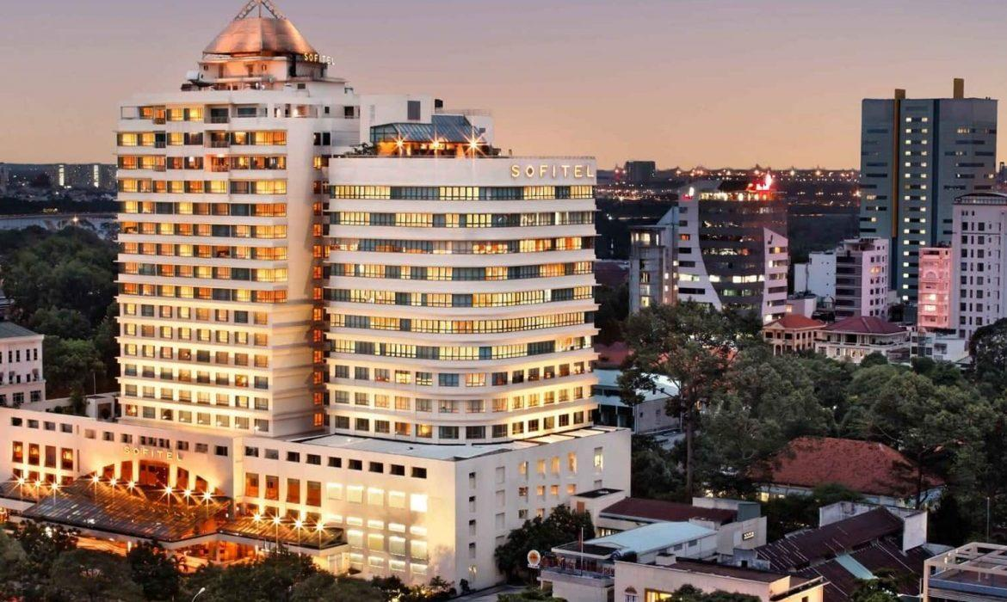
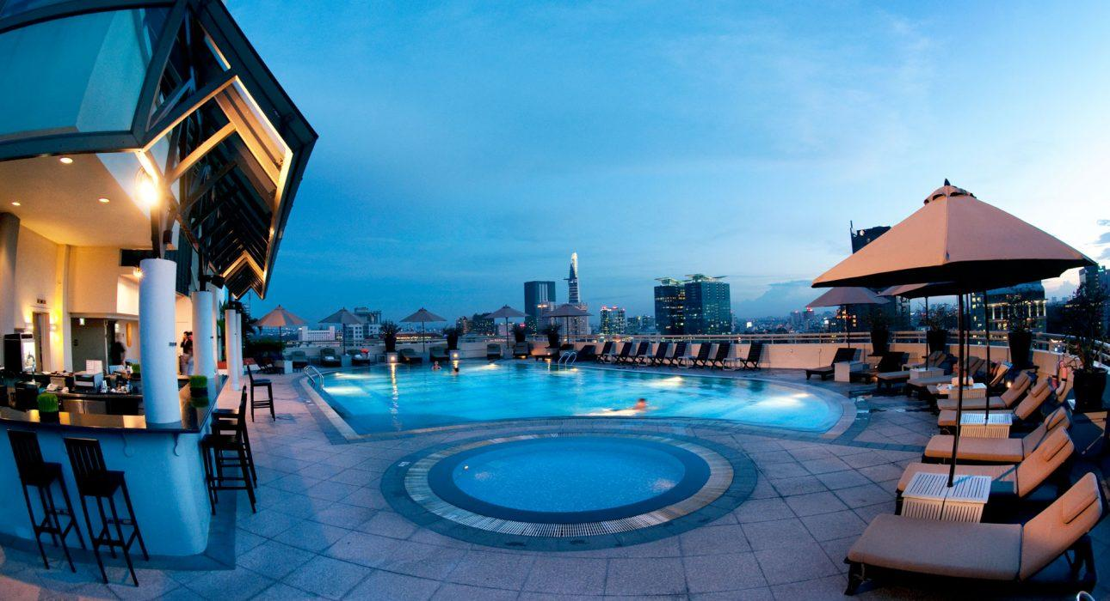

Rooms photos
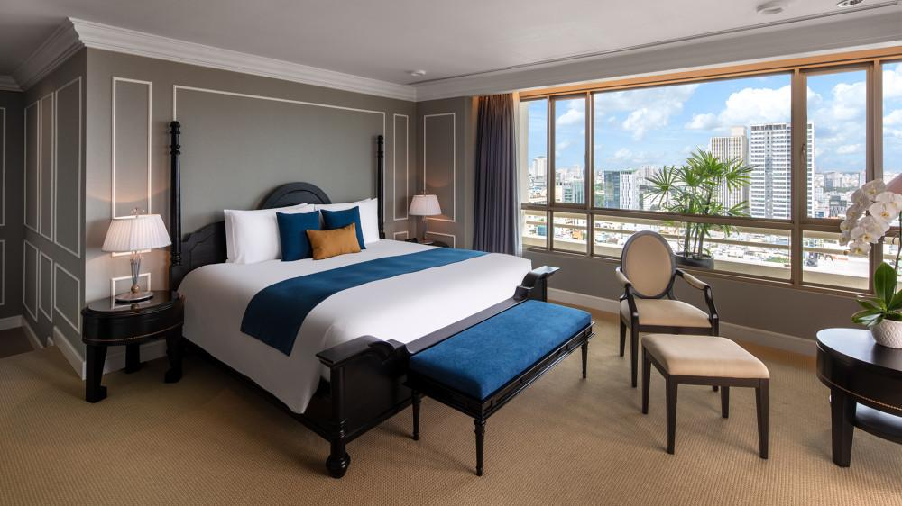
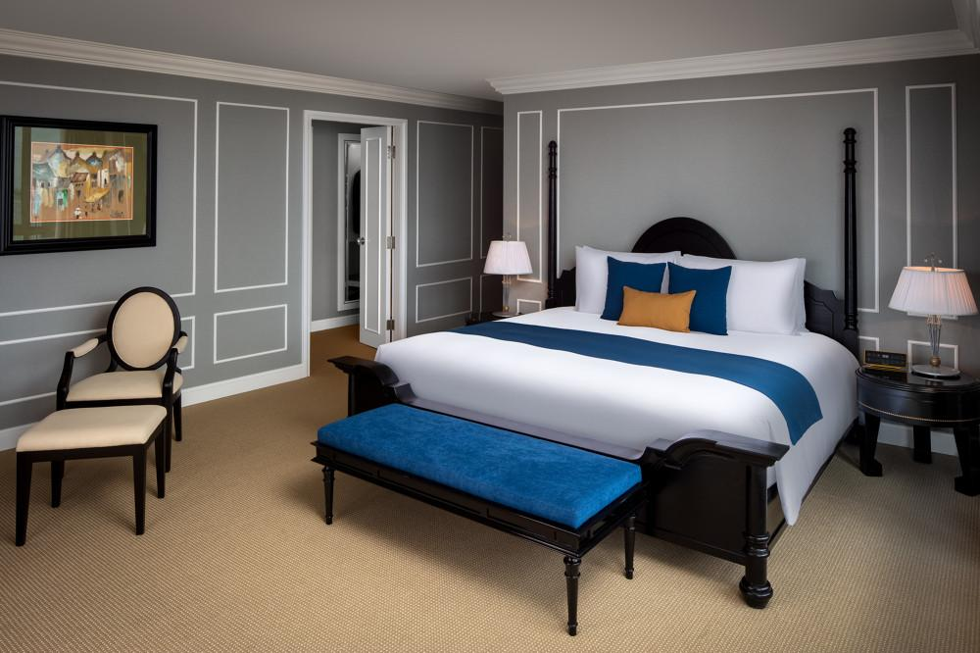
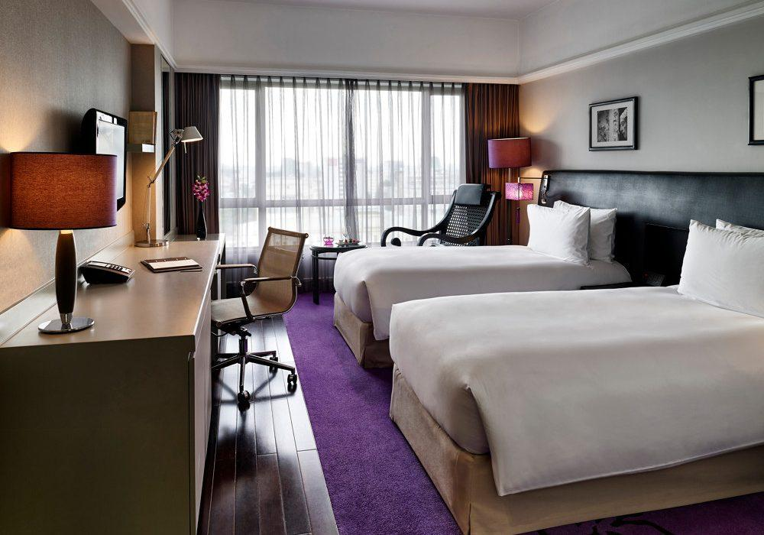
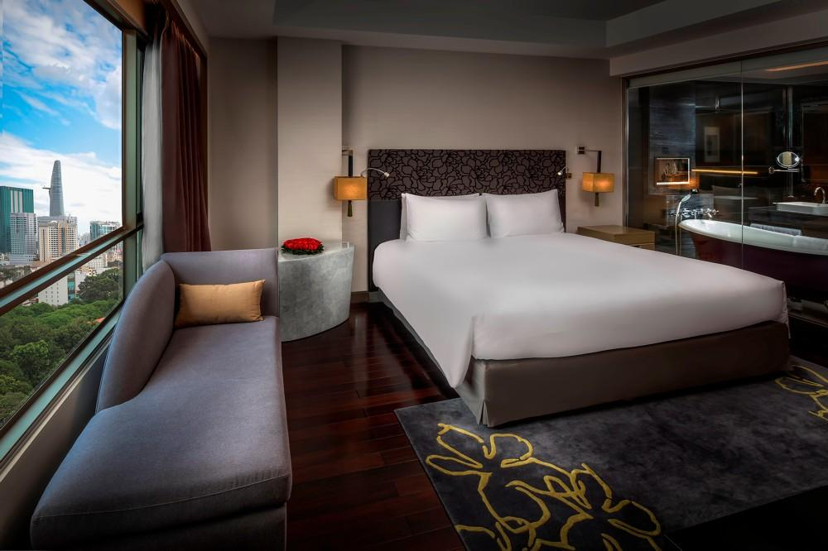
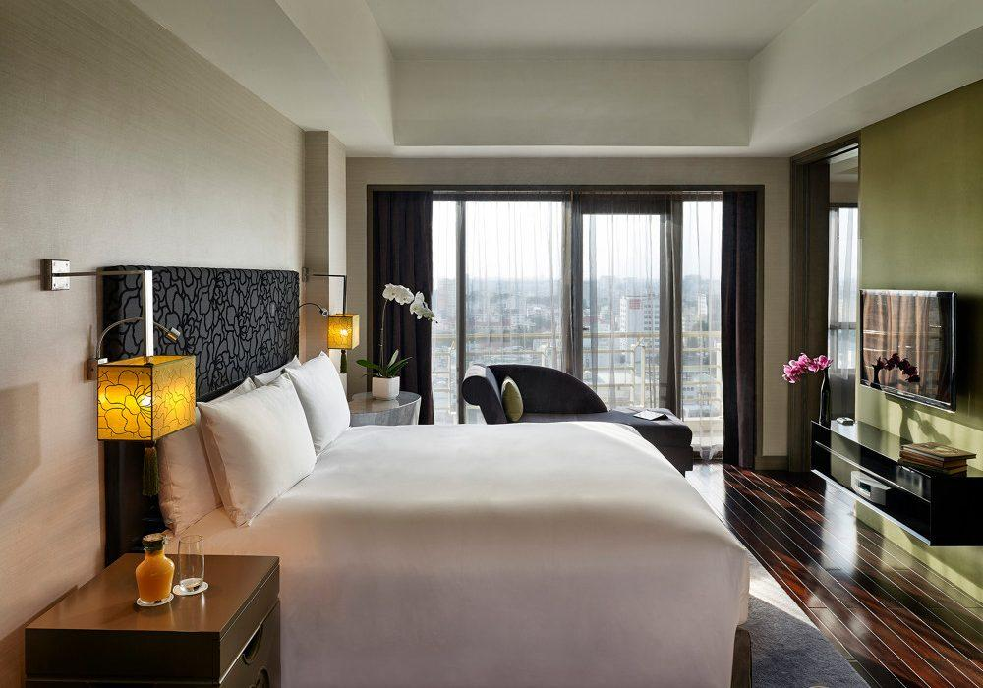
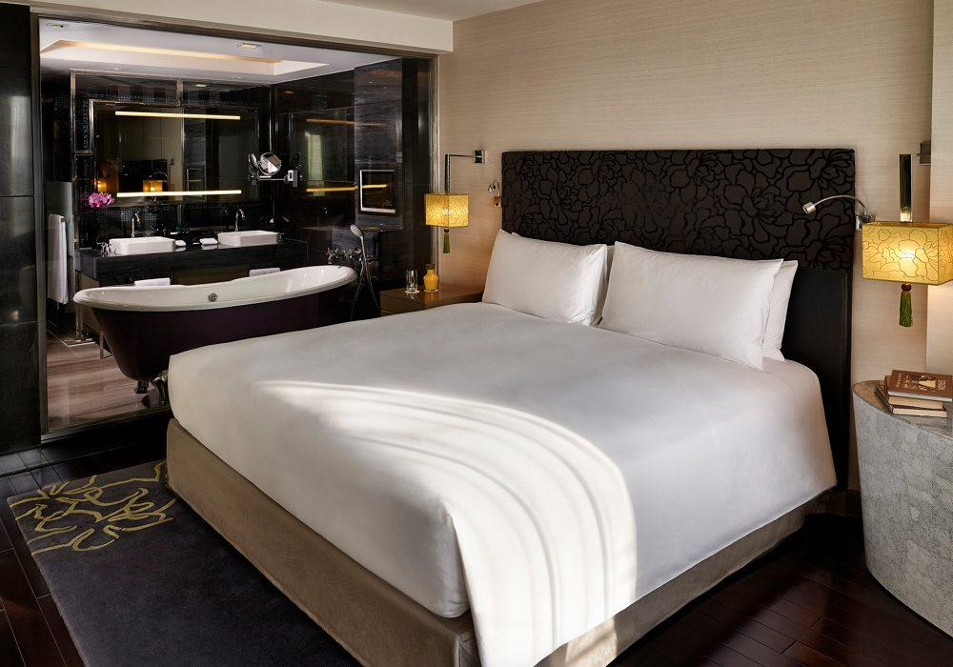
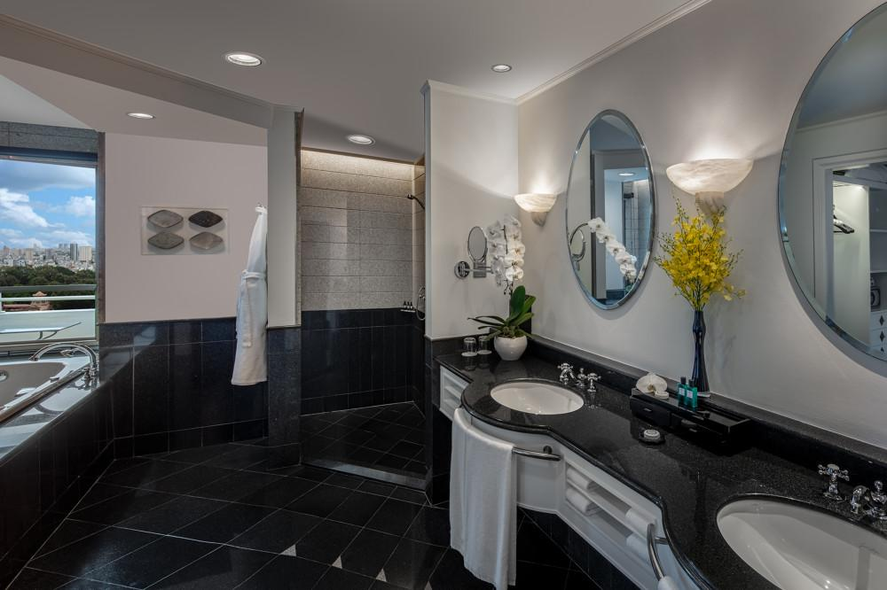

Restaurant photos
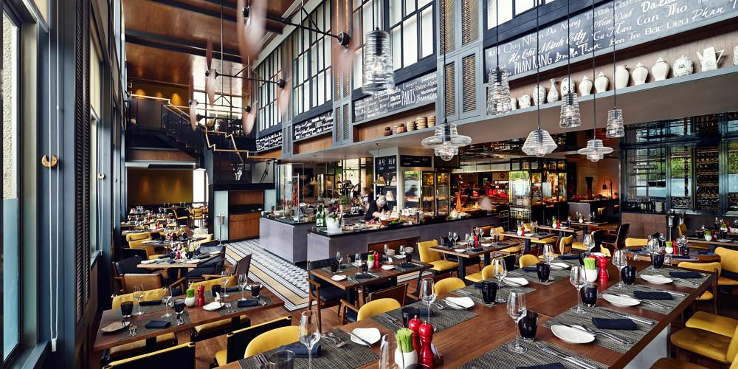
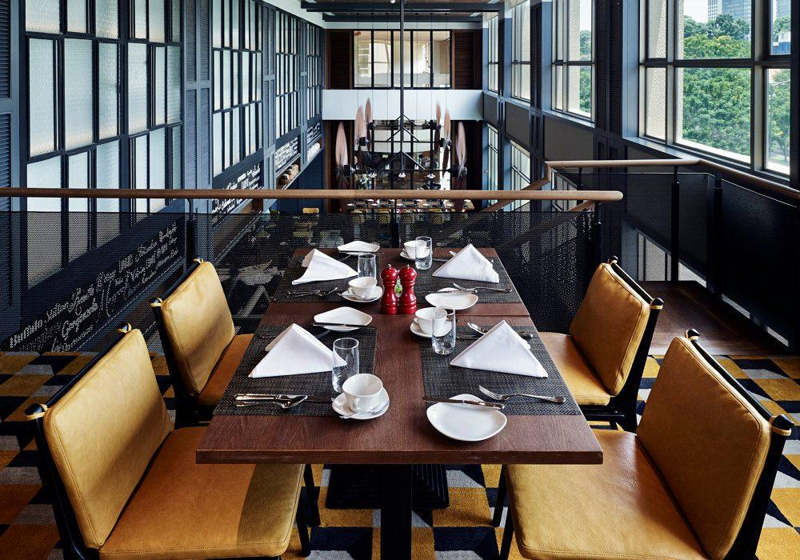
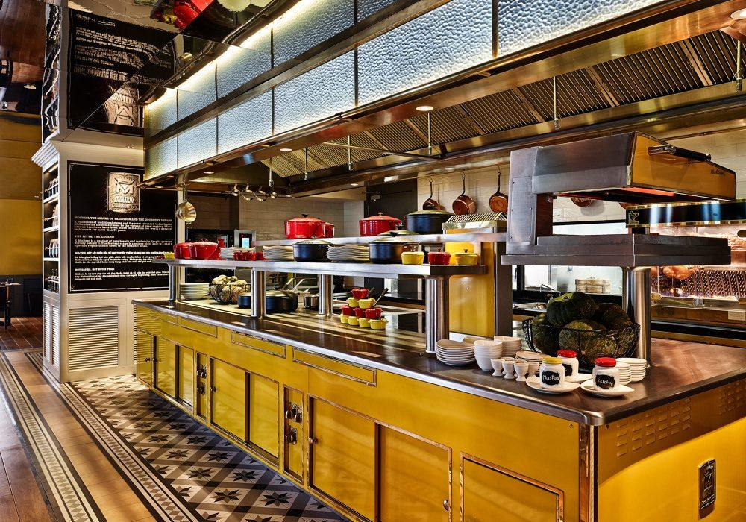
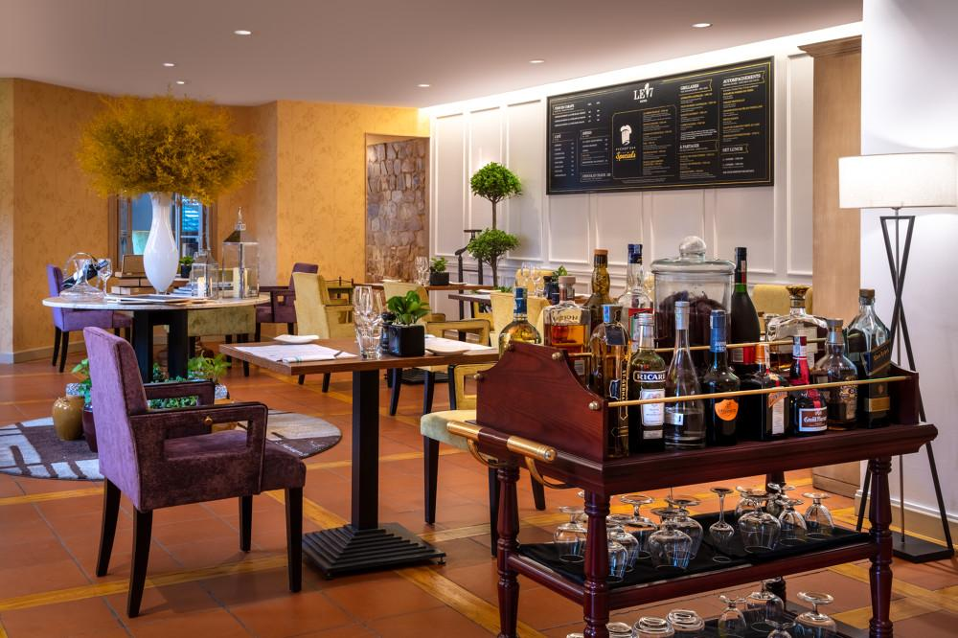
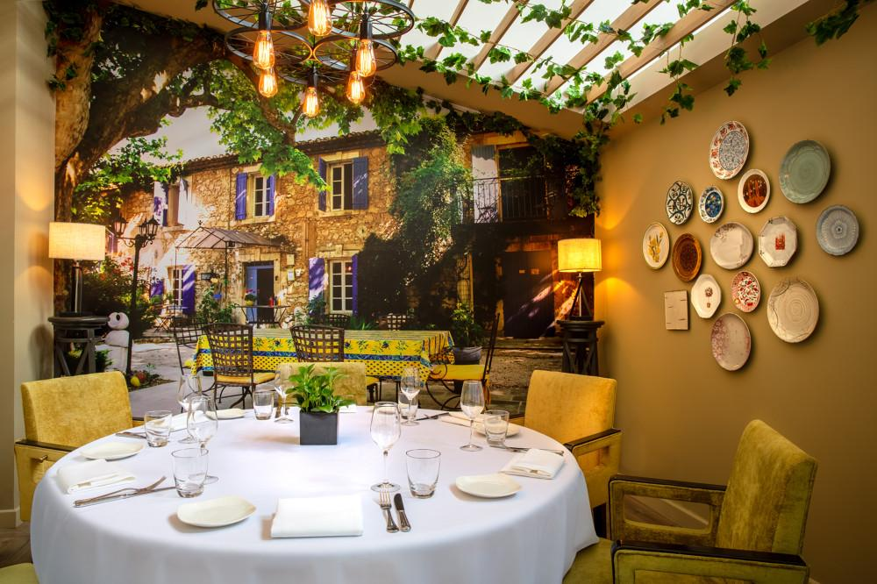
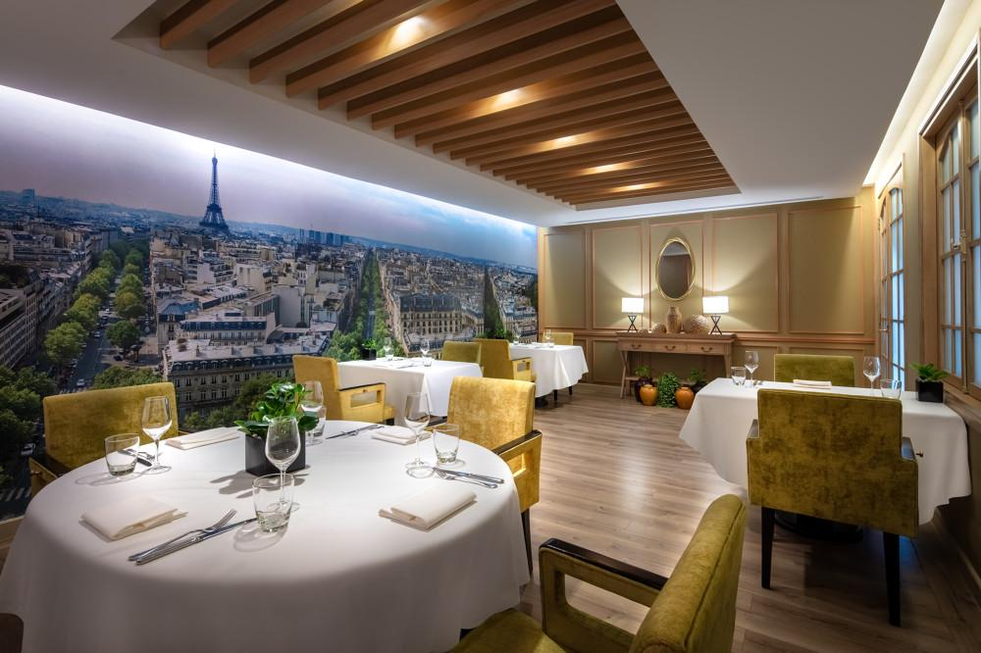
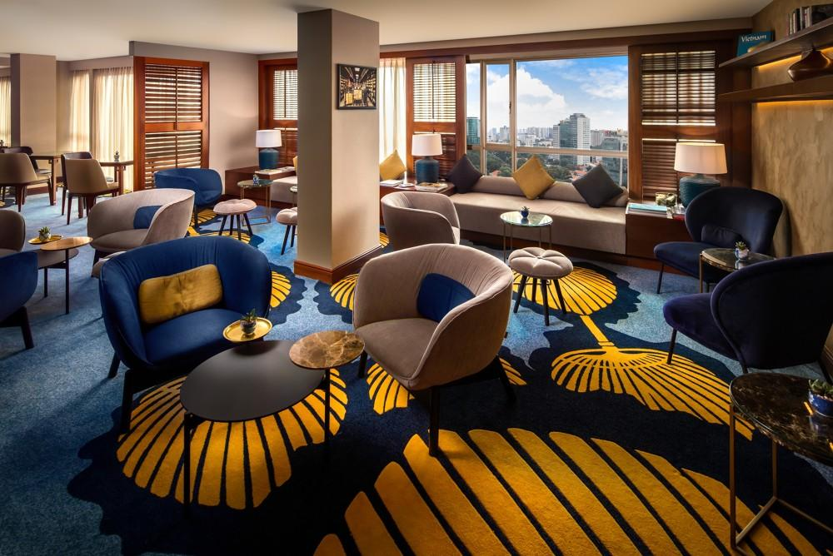

Business facilities photos
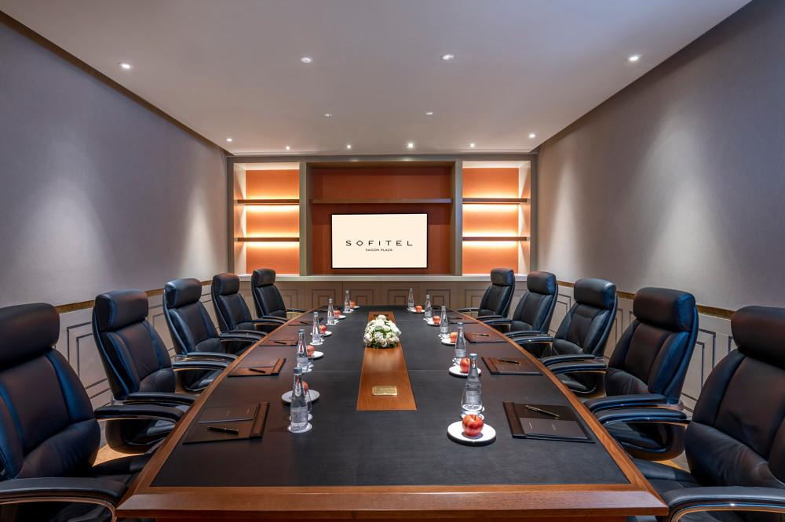
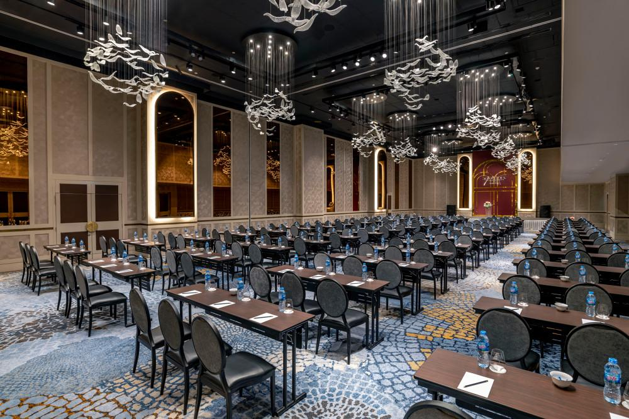
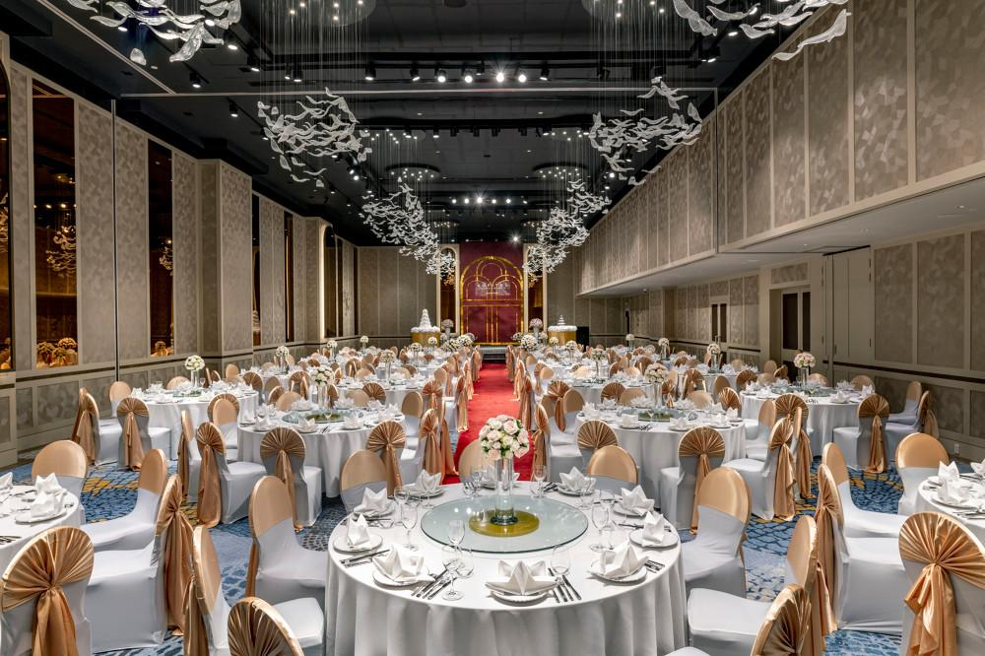
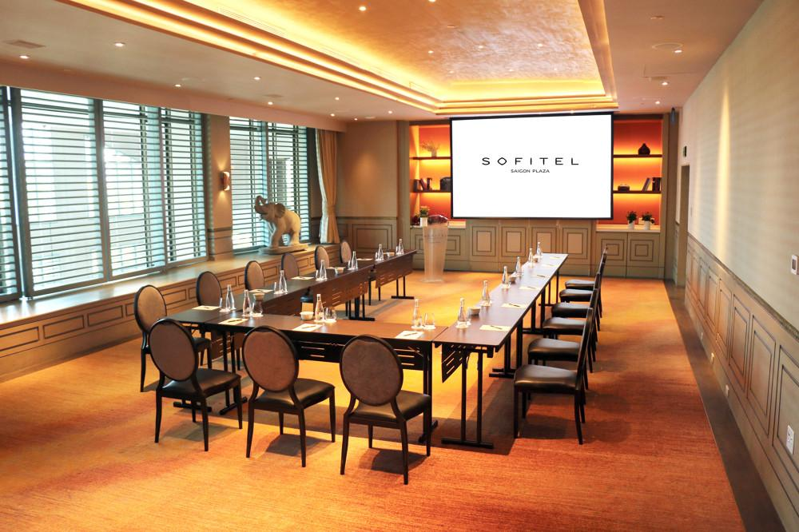
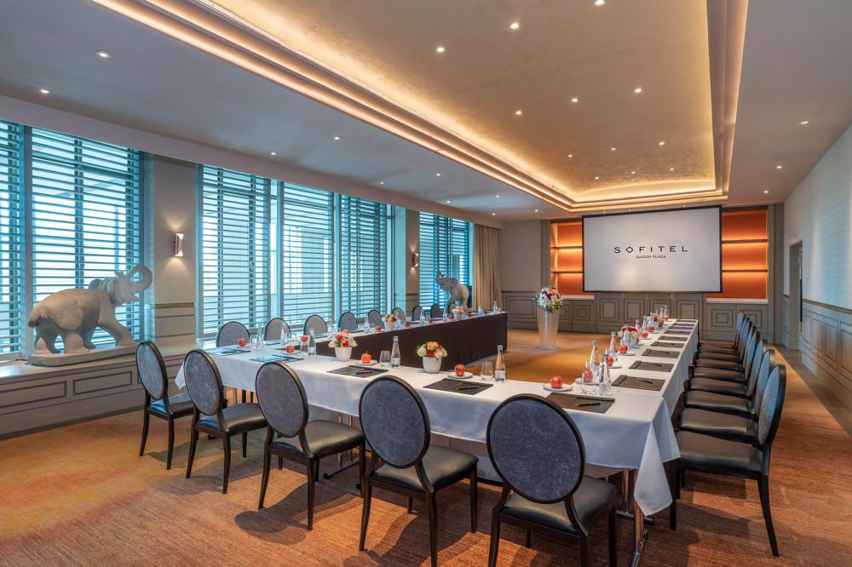
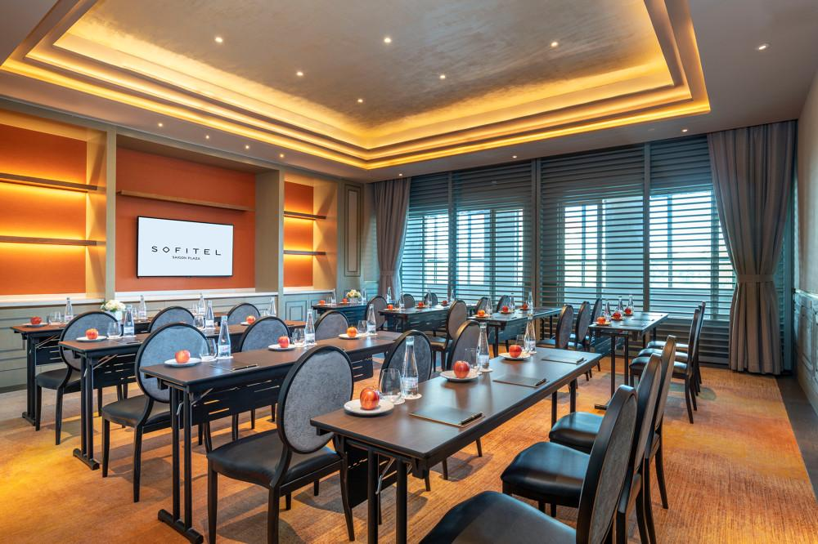
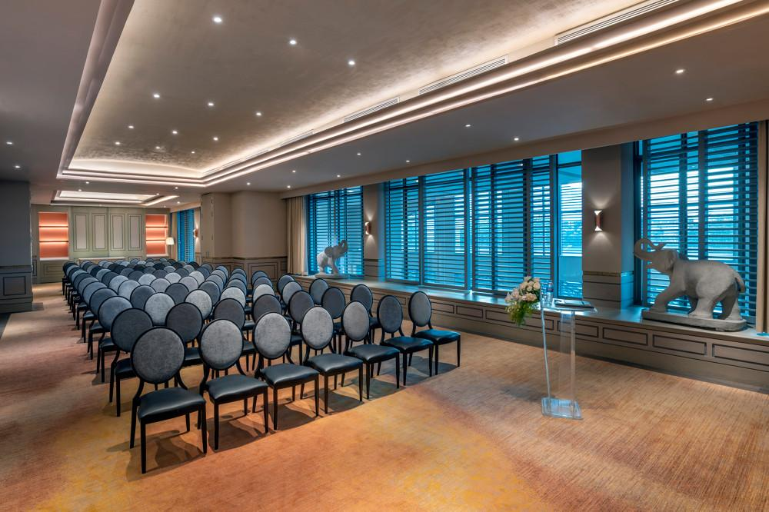

Services & facilities photos
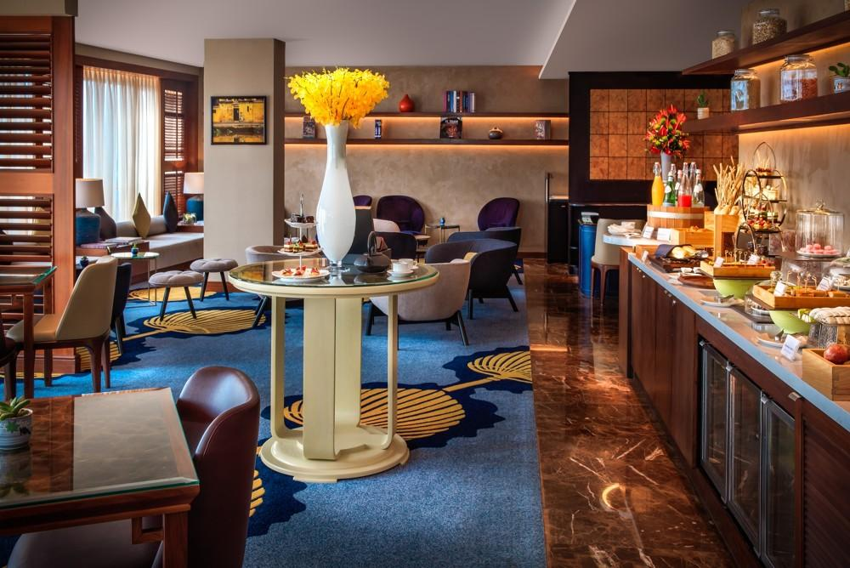
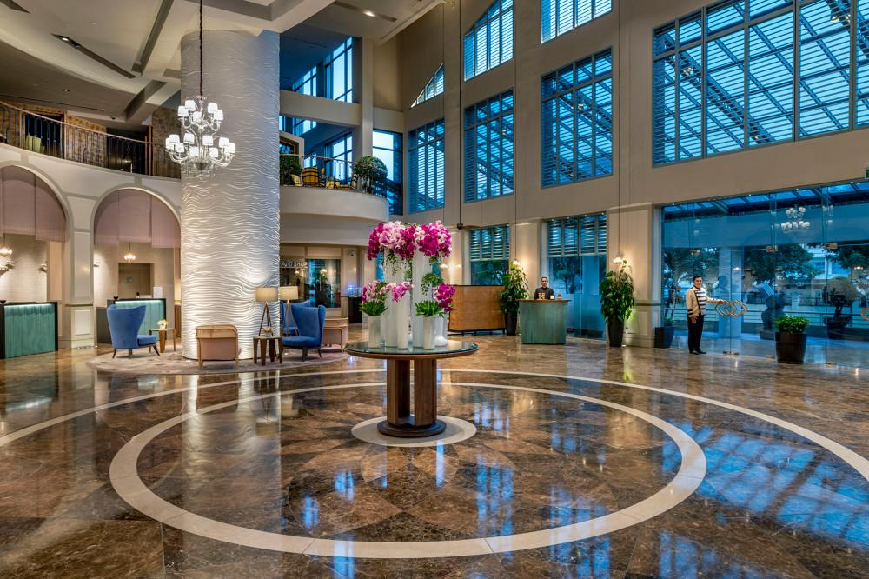
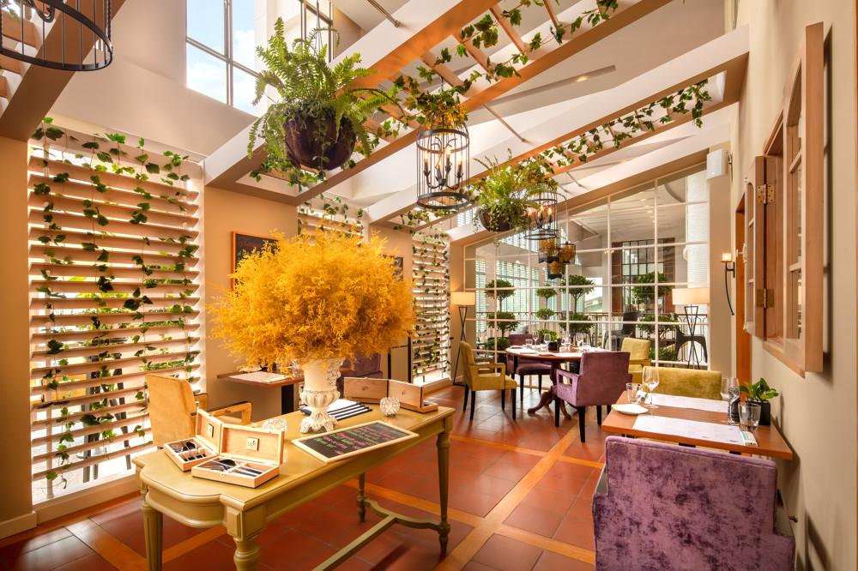
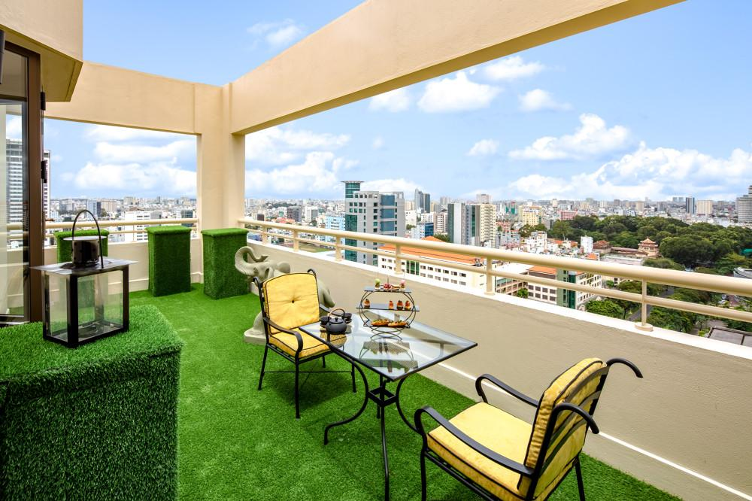
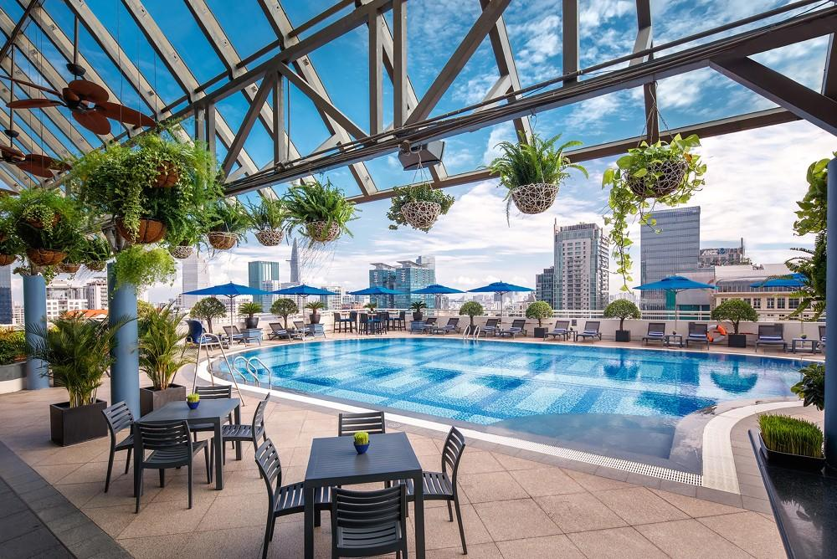
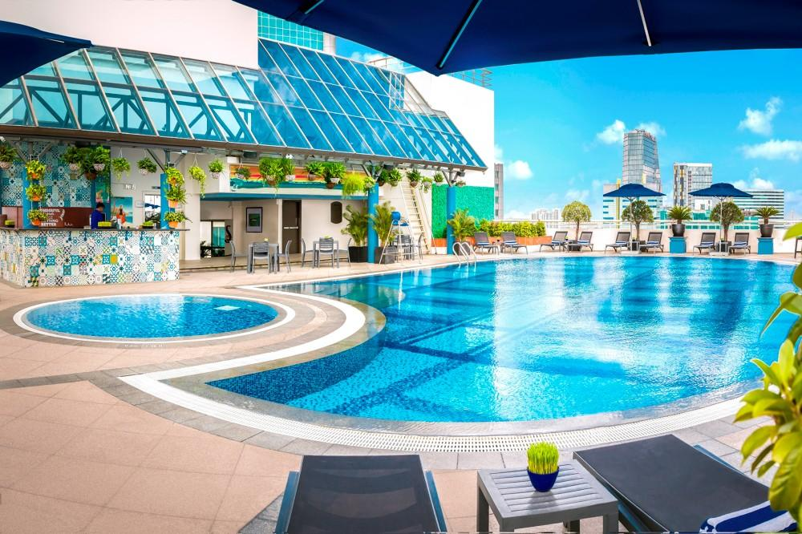
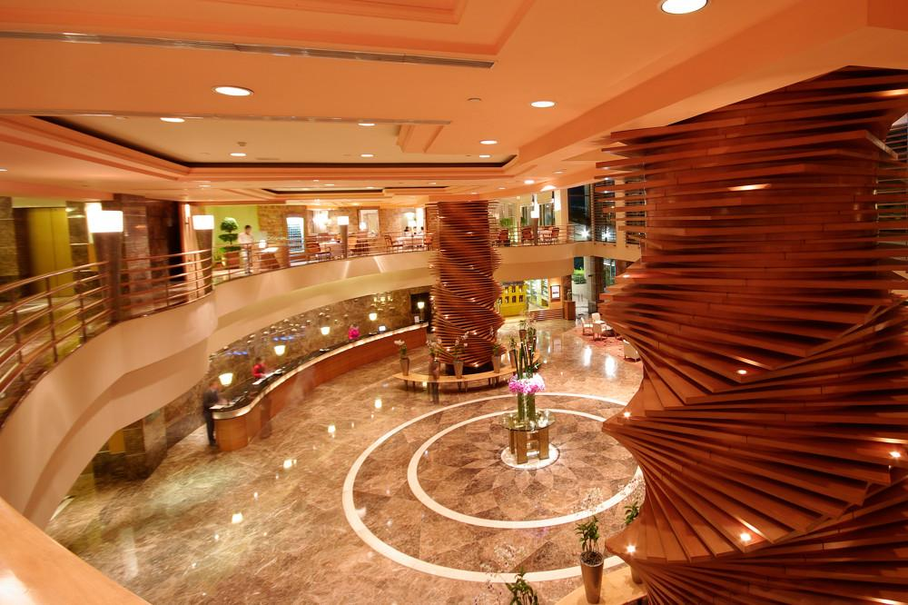

Easia Travel Head Office

