CAMBODIA – Koh Rong Sanloem – La Passion by Achariyak
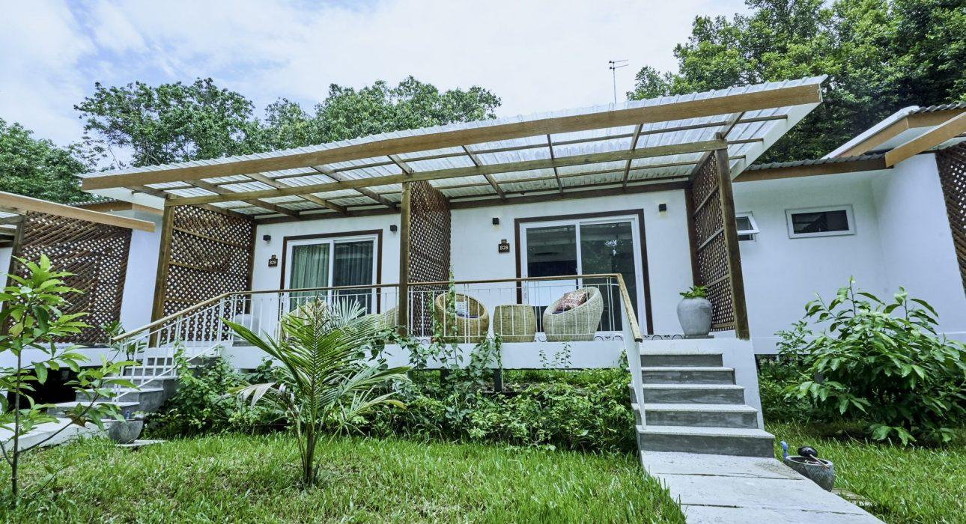

Over View

Theme
Beach Stay, Classic, Family, Honeymoon

Country - City
Cambodia - Koh Rong Sanloem

Market segment
Groups, Thematic Leisure

Official category
4*

Easia category
First Class

Total number of rooms
57

Price level
$$$

Description

La Passion Resort basks in an unprecedented seclusion on the shores of a 3,600- acre nature preserve in Koh Rong Sanloem.It is the beautiful combination of old-world charm, ambiance, contemporary decor, and a fabulous rooftop pool.The resort enjoys one of the most picturesque views in coastal Cambodia and hosts 78 villas and suites. The rooms are spacious, light, and bright with an electric blend of traditional and modern decore.The villas are set amidst lush vegetation and each villa has personal touches, private terraces, and various choices of the garden, rainforest, mountain, or sea view. There are options to suit all travel group sizes including connecting rooms, suites with lounge rooms, and multi-bedroom configurations plus 16 with their own pools.All villas and the complex facilities have been built in full respect of nature, using eco-friendly materials and in a manner designed to have the least possible impact on the local natural environment.

Selling points

- Organizing by Achariyak Hospitality – a premier hospitality management, acquisition, and development company.
- Newly built eco-friendly beachfront resort with complete facilities & services
- Sustainably designed with an eclectic blend of traditional and contemporary décor

Time & Transportation

- 60 minutes by hotel boat to the property

Rooms

Easia's recommend room type
Standard Room
- Unit : 26 rooms (King 10 + Twin 16)
- Size : 35sqm
Superior Room
- Unit : 12 rooms (King 11 + Twin 01)
- Size : 35sqm
Deluxe Room
- Unit : 04 rooms (King 04)
- Size : 40sqm
Executive Room with Pool
- Unit : 10 rooms (King 10)
- Size : 45sqm
Two-Bedroom Villa with Pool
- Unit : 5 rooms (King 5)
- Size : 85 sqm

Room configuration

Extra bed
1m x 2m (Rolling Bed)

Services & Facilities

Services
24 hour reception, 24h security service, Afternoon Tea, Bicycle Rental, Boat rental, Boat Transfer from/to, Buffet Breakfast, Car rental, Catering (beach, river, cave, other), Chef- Prepared meals and cooking lession, Children Activities, Children Swimming Pool, Complimentary bottle of water, Complimentary fresh towel, Concierge service, Cooking Lesson, Credit Card payment, Cycling, Diving, Fishing, In-Room Dining, Iron, Kayaking, Live Music, Luggage Storage, Massage, Other: Private Jetty, Picnic boxes, Private event, partying, Room Service, Snorkeling, Spa, Special entertaining programs for groups, Swimming Pool, Tour desk, Traditional show, Wake-up service, Welcome fruits in room upon arrival, Wi-fi Free, Yoga Retreat

Facilities
Air Conditioning, Bar, BBQ Facility, Bicycle, Bond fire, Buggy, Business centre, Children Pool, Coffee Machine Facilities, Coffee Shop, Conference hall, Courtyard, Family Room, Fan, Fitness centre, Flat screen TV, Full Board - B/L/D, Garden, Hair Dryer, In-Room safe, Internet, Massage room, Meeting room, Mountain bikes, Outdoor swimming pool, Private Dining Room, Private Pool, Restaurant, Safety Box, Shower With Hot Water, Smoking Area, Steam/Sauna, Terrace, Umbrella

Restaurant information

The Fisherman restaurantCapacity: 120pax
- Breakfast: 06:30 -10:00
- Lunch: 11:00 – 14:00
- Snack: 14:30 – 17:00
- Dinner: 17:30 – 22:00
Jongkran – dinner only Capacity: 36paxDinner: 18:30 – 22:00

Photos

Rooms photos
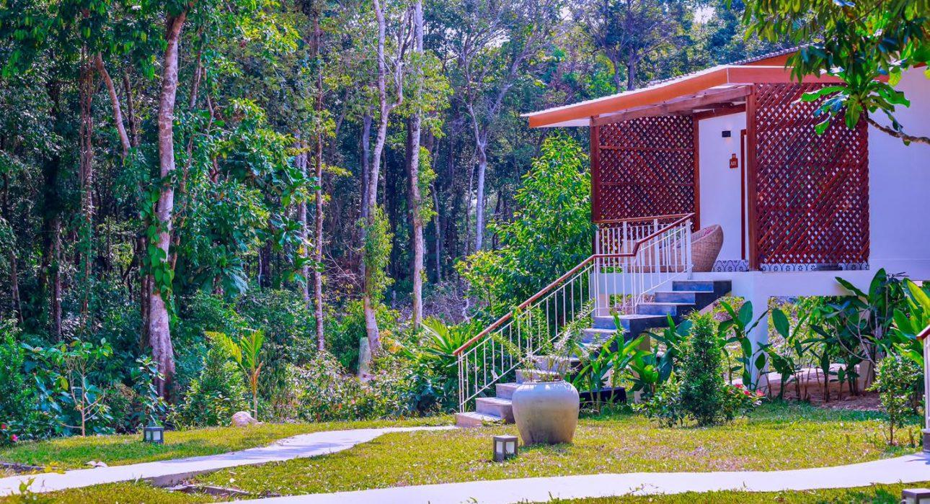
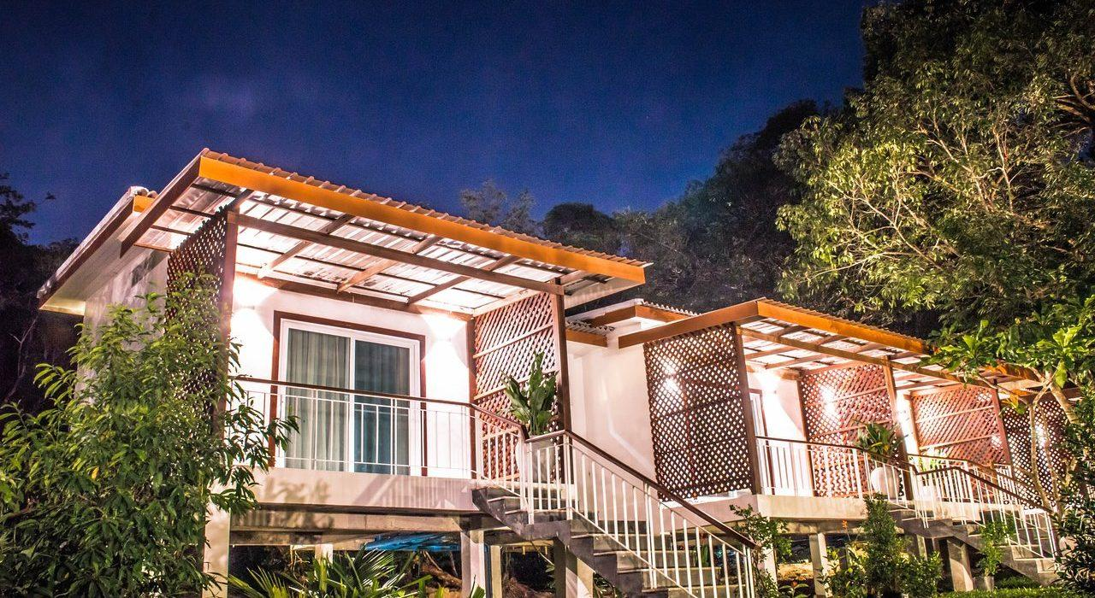
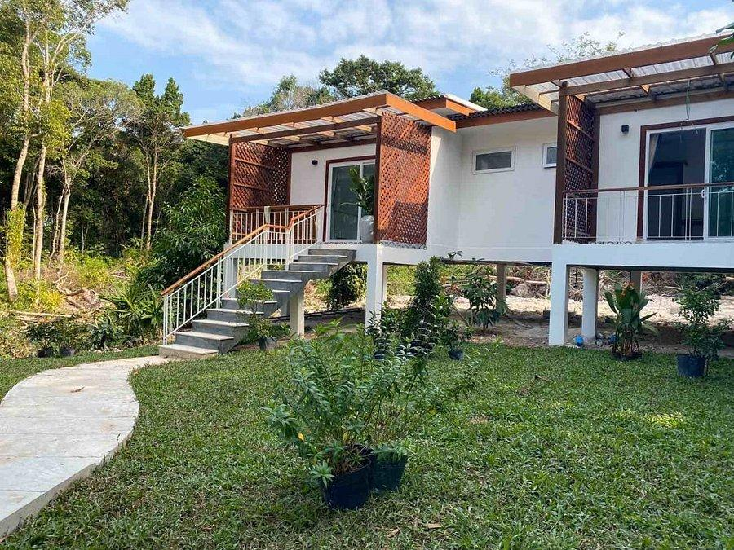
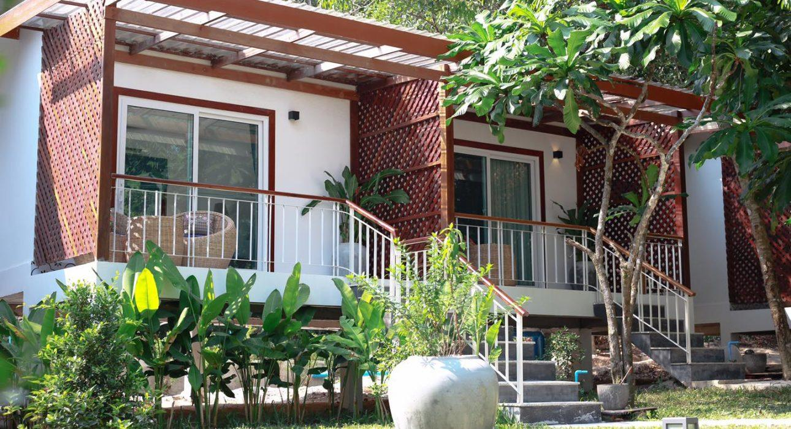

Restaurant photos
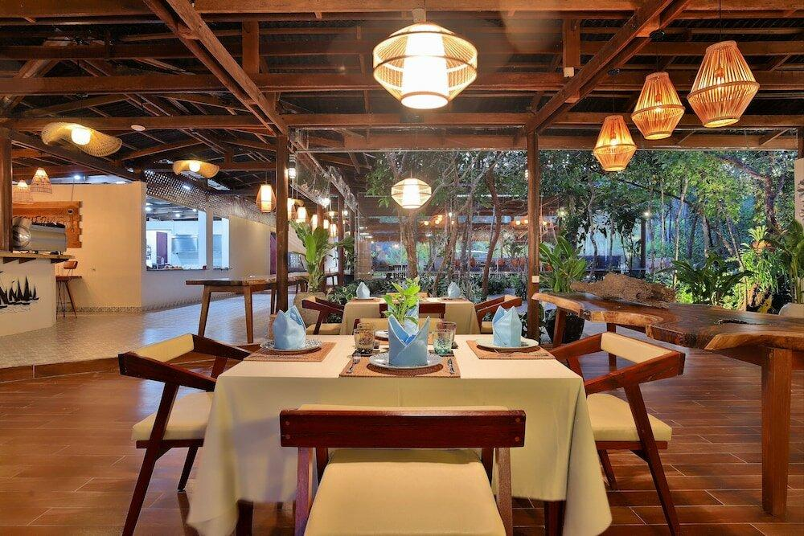
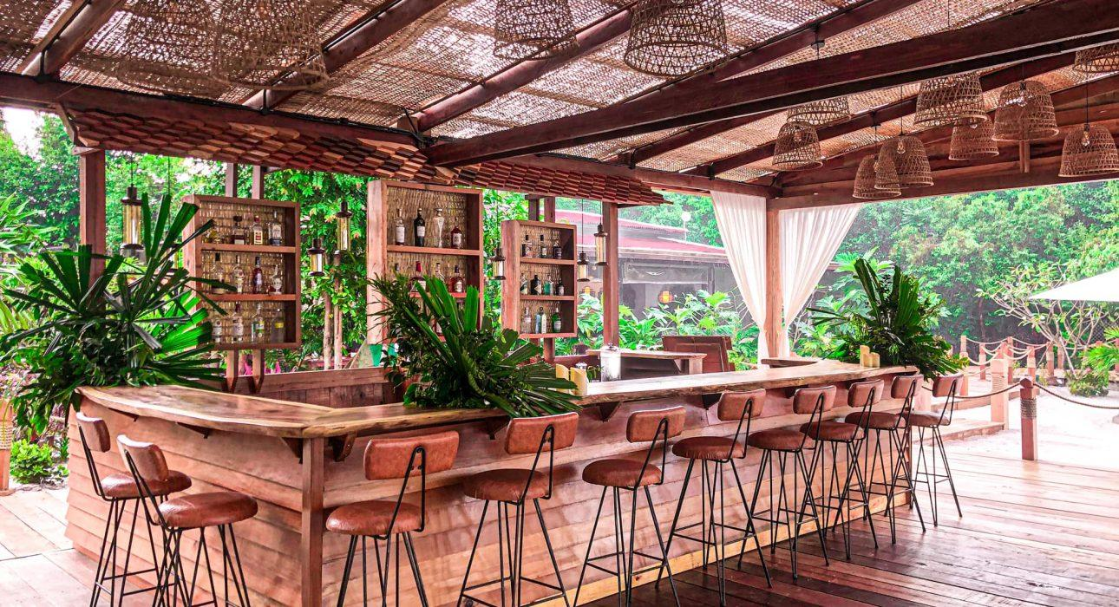
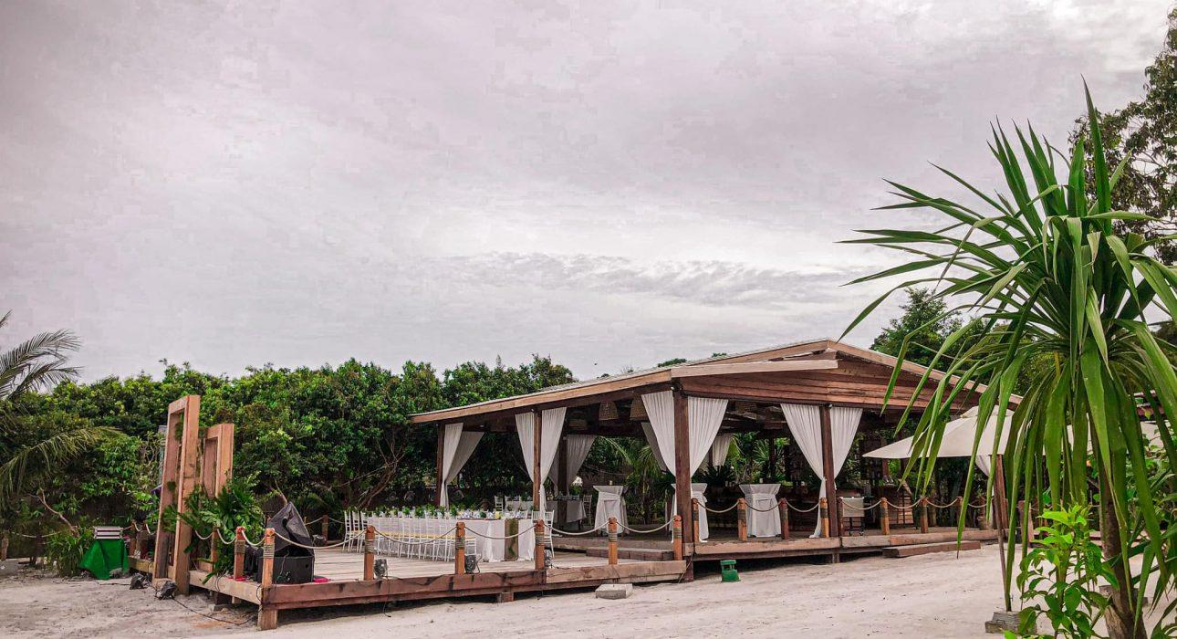

Services & facilities photos
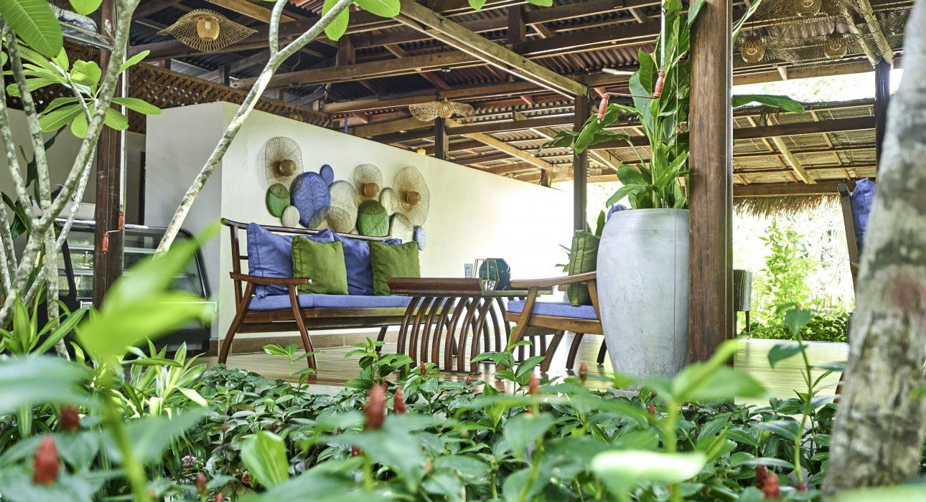
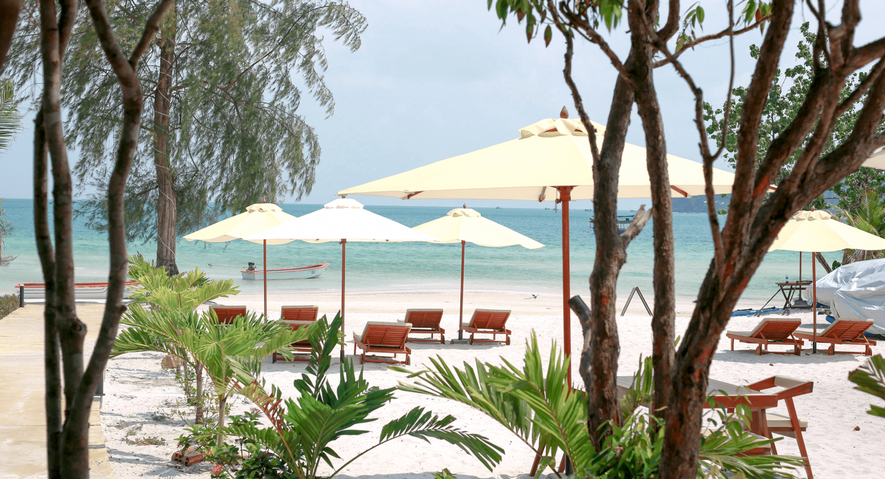
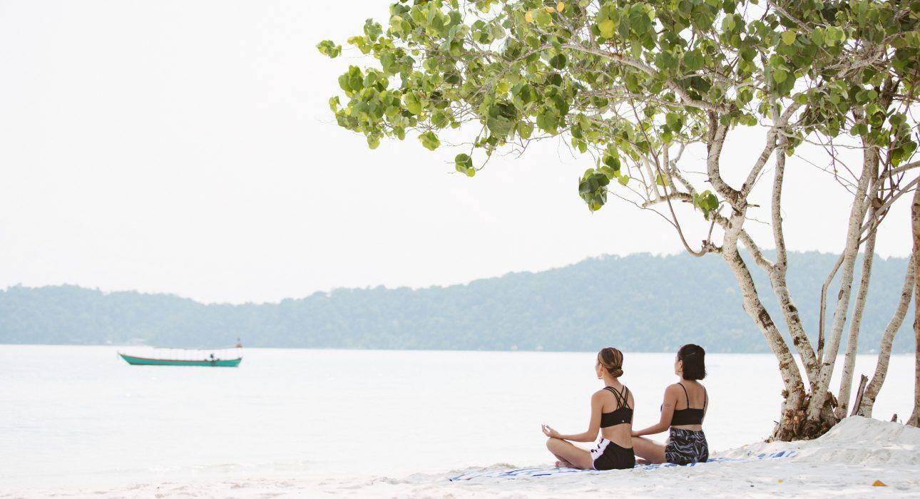
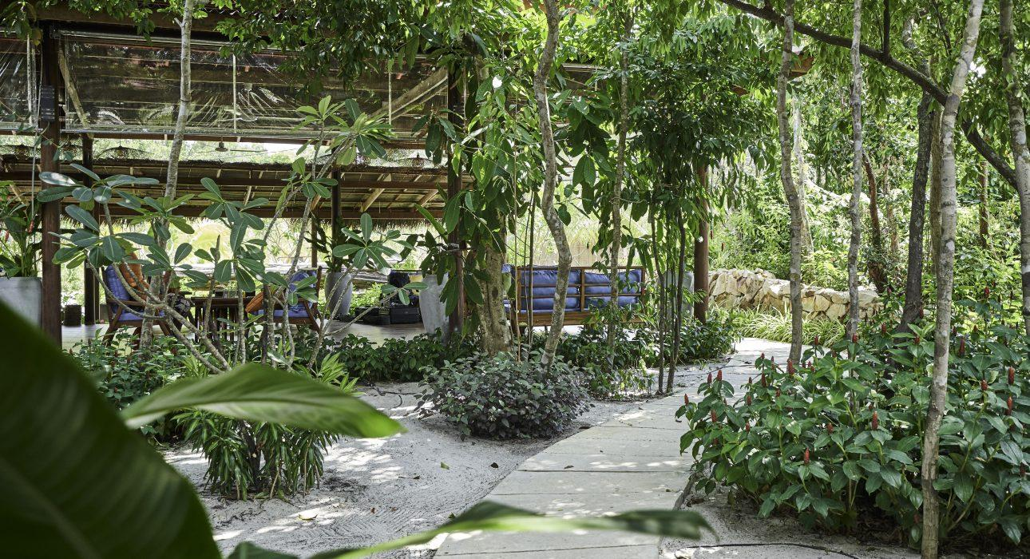
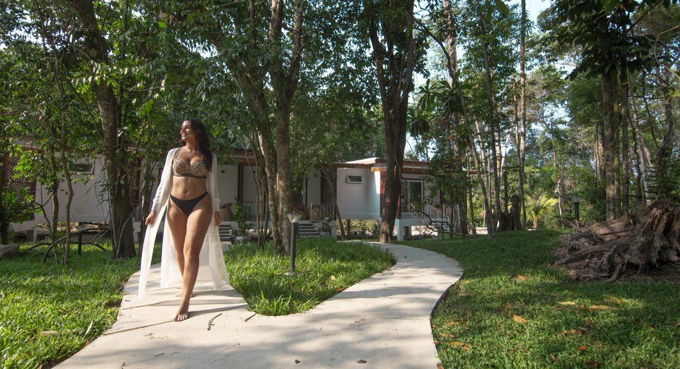

Easia Travel Head Office

